Bread board for Acorn Electron / BBC / Master / Atom

Board description
For simple circuits or just for testing purposes you can use this bread board for the Acorn Electron (via a Plus1 cartridge slot) or the BBC / Master / Atom (with 1 MHz bus conversion board). The board has four banks of five rows with 36 pins each.

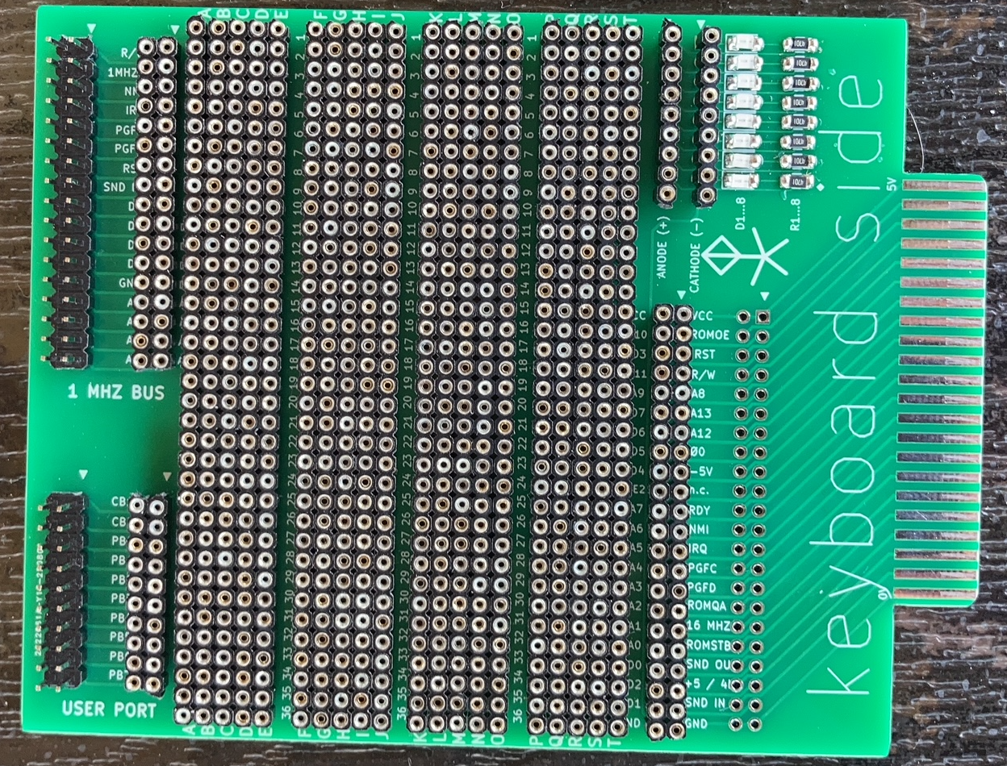
There are connections between the User port socket and user port holes, between the 1 MHz bus socket and the 1 MHz bus holes and between the edge connector and the 44 holes for the Electron Plus1 cartridge slot.
Optionally you can add a 44 pin header so the board can be connected to the Electron break-out and riser board (but this generally only works reliable for I/O devices running at 1 MHz; ROMS accessed at 2 MHz might fail). Also eight SMD leds with series resistors can be added. The leds are not connected to Vcc or GND so you can use both active high and active low levels to control the leds.

Building guidelines
To build the bread board you can use either side to mount the components. Just mind that if you mount them at the keyboard side then pin 1 is not really pin 1 of the headers! In that case don’t use boxed headers with a slot and take care when connecting other boards to the 1 MHz bus and/or user port connector because the rows are swapped! So you might also to do the swapping at the holes to correct this.

When you decide to add the LED’s and the series resistors then solder them in the first place. These components are always at the keyboard side.
The female socket strips are 40 pins each, so remove 4 pins from twenty strips. Use the remaining four pins to fixate the headers. This makes it easier to solder them to the board and assures that the female strips are in the correct positions and distances.
In the picture below you can see some of these fixation strips:
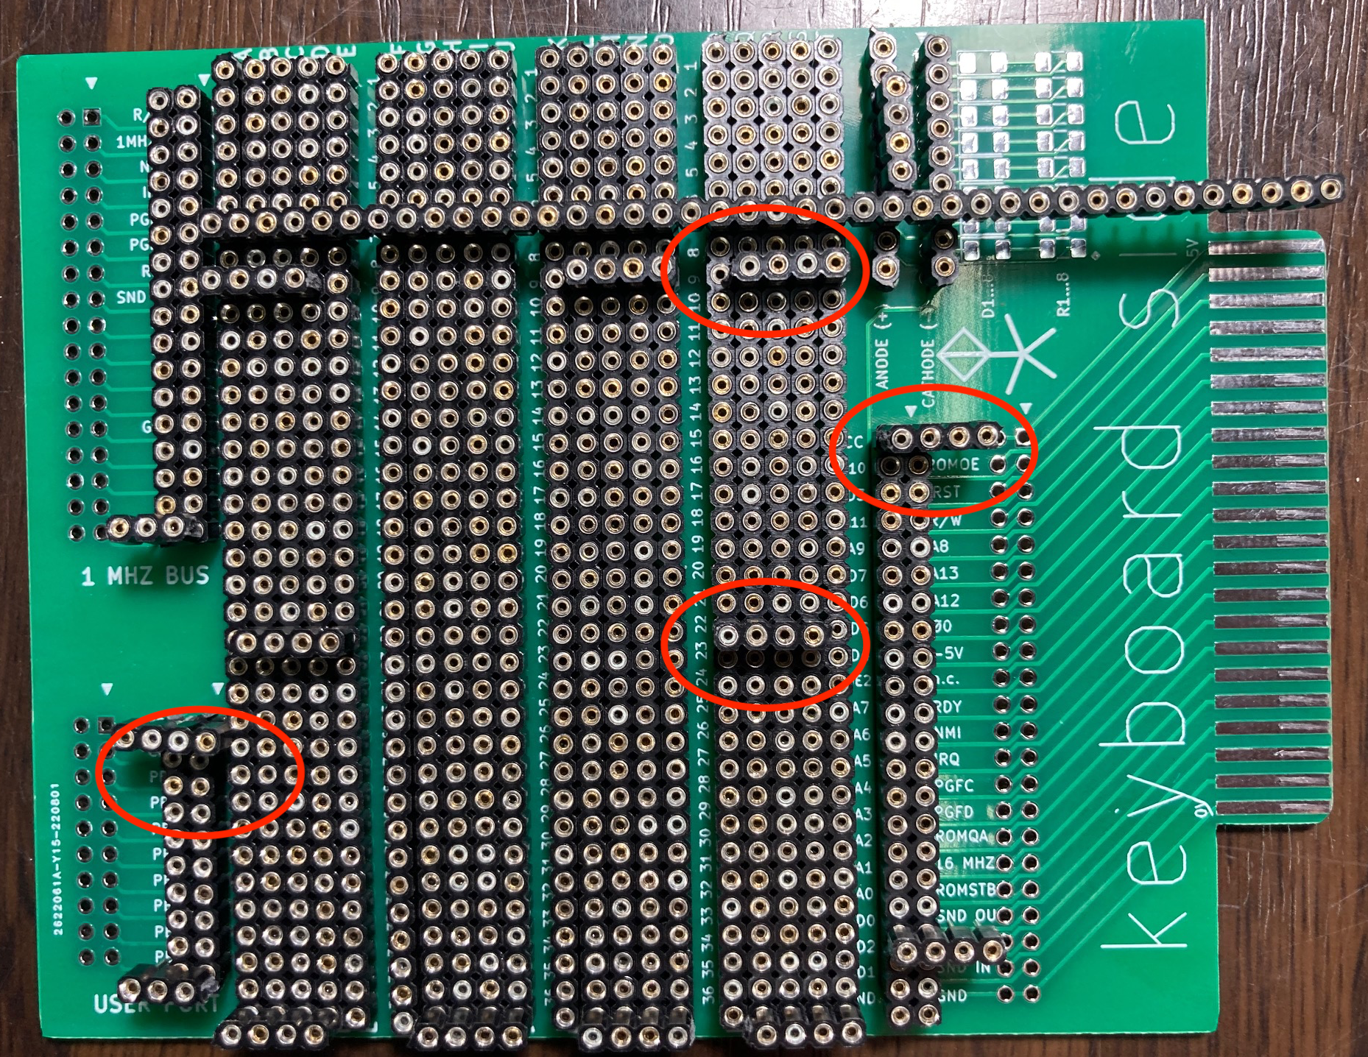
Take your time to solder the pins, there are about 1,000 pins to solder :-)
After the female strips are soldered you can add the (options) headers for the user port, 1 MHz bus and the edge connector. If you add this last header you can connect the bread board with a flat cable to a break-out and riser board. That makes it easier to do some measurements.

Example circuit: user port

In the picture below you see a user port with a 6522 VIA and a 74LS138 address decoder. In this example the VIA can be accessed at &FC4x.
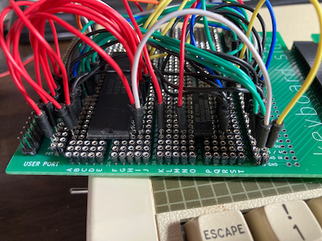
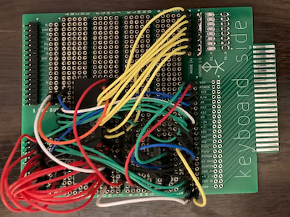

Of course you can also use this break out board without the female header strips to build a permanent circuit if you have a simple design in mind. That save you the trouble of creating a printed circuit board.

