Capstone Project Report
E-commerce Database Analytics
Problem Statement No. 3 | MySQL 8.0 | SQL Analytics
Submitted in partial fulfilment of the requirement of the degree of
BACHELOR OF TECHNOLOGY (DATA SCIENCE)
Semester- III
to
K.R Mangalam University
by
Jayesh Shrivastava (2501420043) Section-A

Submitted to
Swati Ma'am

Department of Computer Science and Engineering
School of Engineering and Technology
K.R Mangalam University, Gurugram- 122001, India
7 November 2026
DECLARATION

I hereby declare that this project report is my original work and has not been submitted elsewhere. The information presented here is true and correct to the best of my knowledge.

(Signature)
Jayesh Shrivastava
Roll No: 2501420043
Date: 7 November 2026
CERTIFICATE
This is to certify that the Project Report entitled, “E-commerce Database Analytics” submitted by “Jayesh Shrivastava (2501420043)” to K.R Mangalam University, Gurugram, India, is a record of bonafide project work carried out by the student under my supervision and guidance and is worthy of consideration for the partial fulfilment of the degree of Bachelor of Technology in Data Science of the University.
<Signature of Internal supervisor>
<Name and designation of supervisor>

Date: 7 November 2026
- Introduction
This is my capstone project report. I worked on Problem Statement 3, which asks for a database for an e-commerce marketplace where sellers list products, customers place orders and customers write reviews. On top of the database I had to write SQL queries that answer business questions (sales trends, top products, customer satisfaction, cohorts) and then make the queries faster using indexes and views.
I built everything in MySQL 8.0 using only SQL. I did not have real shop data, so I generated a synthetic data set with SQL itself: 50 sellers, 5,000 customers, 2,000 products, 50,000 orders, 100,000 order lines and 9,994 reviews. The data is made with a deterministic function, so if someone runs my scripts again they get exactly the same rows. The scripts and the full outputs are in my GitHub repository: https://github.com/AtomicTsuki/capstone-database-management-system
The report follows the order in which I did the work: schema design, sample data, sales and satisfaction queries, cohort analysis, indexing with EXPLAIN, views, and window functions.
Please note: the text, tables and SQL outputs in this report come from my scripted run on the database shop (50,000 orders). The Workbench screenshots in Section 7 were taken later on my local server using a smaller copy of the project (database ecommerce_db, 20,000 orders), so some numbers and object names in the screenshots are different. Numbers should be compared inside one run only.
- Objectives
- Design a schema for product listings, seller information and customer reviews, using primary keys, foreign keys, CHECK and UNIQUE constraints.
- Write queries for sales trends, top-selling products and customer satisfaction scores.
- Do a cohort analysis of customer behaviour and explain how it can help marketing.
- Create composite indexes on orders(customer_id, order_date) and products(category_id, price), plus a FULLTEXT index on product title and description, and compare the plans with EXPLAIN.
- Show with an example why an index on a low-selectivity column (order status) does not help.
- Build a seller performance view and a customer lifetime value view, simulate a materialized view with a summary table, and compare a view with a summary table.
- Use window functions: RANK, LAG, a 3-month moving average, MIN() OVER for the first-purchase cohort, and NTILE(4).
- Work Done
3.1 Schema design
I used seven tables: categories (with an optional parent for a category tree), sellers, customers, products, orders, order_items and reviews. Foreign keys keep the data consistent, CHECK constraints guard prices, quantities and ratings (1 to 5), and a UNIQUE key on (product_id, customer_id) lets a customer review a product only once. The ER diagram is given below.
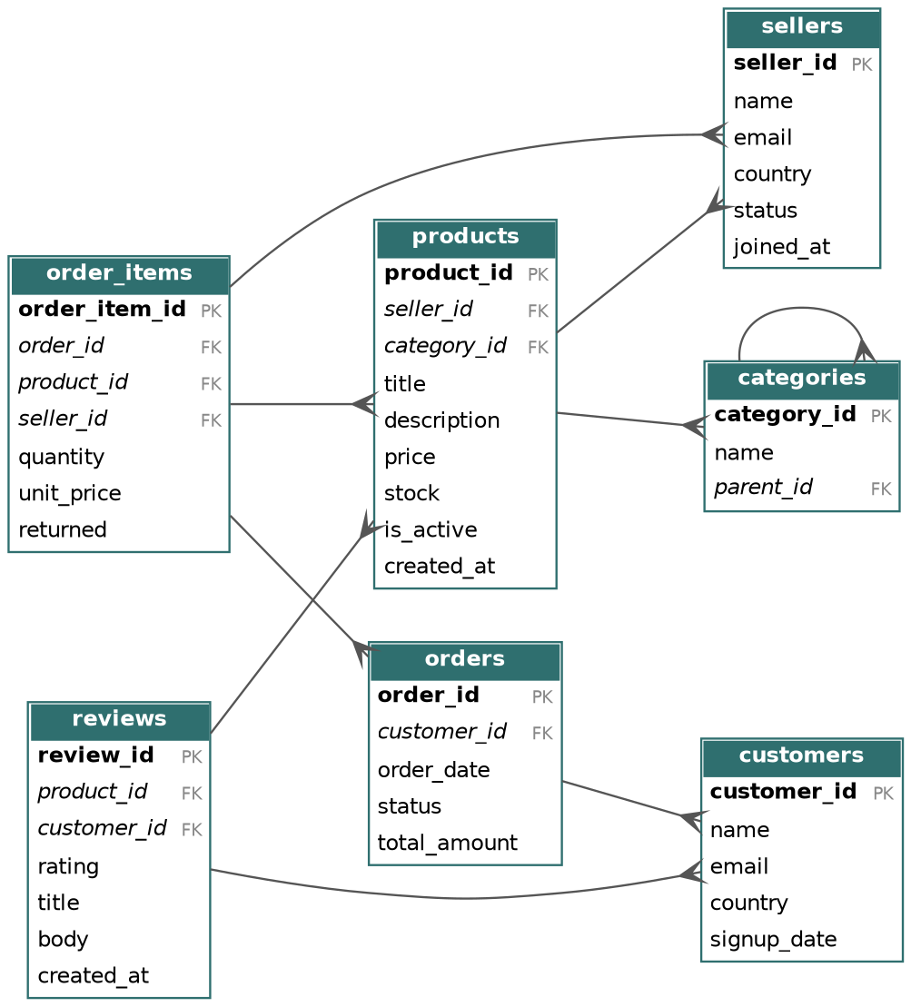
Figure 1: Entity-relationship diagram (bold = primary key, italic = foreign key)
Table | What it stores | Important constraints
categories | Product categories, optional parent_id | UNIQUE name; self-referencing FK
sellers | Seller name, email, country, status | UNIQUE email; status is an ENUM
customers | Customer name, email, country, signup date | UNIQUE email
products | Product listings with price and stock | FK to seller and category; CHECK price >= 0
orders | One row per order with status and total | FK to customer; status ENUM
order_items | Lines of an order (product, quantity, price) | FK to order, product, seller; CHECK quantity > 0
reviews | Rating (1-5), title and text | CHECK rating 1-5; UNIQUE (product_id, customer_id)

A few design decisions I took on purpose:
- order_items.unit_price stores the price at the time of sale, so a later price change does not change old orders.
- order_items.seller_id is intentionally denormalised (seller at the time of sale), so seller sales do not need an extra join.
- order_items.returned records returns per line, which makes the seller return rate easy to calculate.
This is the reviews table as an example of the constraints:
CREATE TABLE reviews (
review_id BIGINT UNSIGNED NOT NULL AUTO_INCREMENT,
product_id INT UNSIGNED NOT NULL,
customer_id INT UNSIGNED NOT NULL,
rating TINYINT UNSIGNED NOT NULL CHECK (rating BETWEEN 1 AND 5),
title VARCHAR(150) NULL,
body TEXT NULL,
created_at DATE NOT NULL,
PRIMARY KEY (review_id),
UNIQUE KEY uq_review_once (product_id, customer_id),
CONSTRAINT fk_reviews_product FOREIGN KEY (product_id) REFERENCES products (product_id),
CONSTRAINT fk_reviews_customer FOREIGN KEY (customer_id) REFERENCES customers (customer_id)
) ENGINE=InnoDB;
After creating the tables in Workbench I ran SHOW TABLES and DESCRIBE to check them (Screenshot 1.1 in Section 7).
3.2 Sample data
The data is generated with SQL only. First I made a helper table seq with the numbers 1 to 100,000 using a recursive CTE. Then I wrote a function rnd() that turns a salt and a number into a repeatable value between 0 and 1. I did not use RAND(seed) because sequential seeds give correlated values.
CREATE FUNCTION rnd(salt VARCHAR(16), n BIGINT) RETURNS DOUBLE DETERMINISTIC NO SQL
RETURN CONV(SUBSTRING(MD5(CONCAT(salt, ':', n)), 1, 8), 16, 10) / 4294967296;
I made the data a bit realistic on purpose: some sellers are bigger than others, many products are cheap and few are expensive, popular products get more sales, and order dates follow the signup date with a delay that decays over time (so retention curves look normal). The order status is 70% delivered, 15% shipped, 10% returned and 5% cancelled. This also gives me a low-selectivity column for the indexing demo.
I also made one base view, v_sales_lines, that defines net revenue in one place: cancelled orders are left out and returned lines count as 0. All later queries use this view, so the numbers stay consistent.
CREATE OR REPLACE VIEW v_sales_lines AS
SELECT oi.order_item_id, o.order_id, o.customer_id, o.order_date,
DATE_SUB(o.order_date, INTERVAL DAYOFMONTH(o.order_date) - 1 DAY) AS order_month,
oi.product_id, p.category_id, oi.seller_id, oi.quantity,
oi.quantity * oi.unit_price AS gross_revenue,
IF(oi.returned = 1, 0, oi.quantity * oi.unit_price) AS net_revenue,
oi.returned
FROM order_items oi
JOIN orders o ON o.order_id = oi.order_id
JOIN products p ON p.product_id = oi.product_id
WHERE o.status <> 'cancelled';
3.3 Sales trends, top products and customer satisfaction
Sales trend. The monthly query gives orders, units, net revenue and revenue per order for each month. The peak month is 2024-10 with 1,301,011 net revenue. Revenue fades in the later months because the generated data has no new signups after late 2024, so this is just an effect of the synthetic data.
SELECT order_month,
COUNT(DISTINCT order_id) AS orders,
SUM(quantity) AS units,
ROUND(SUM(net_revenue), 2) AS net_revenue,
ROUND(SUM(net_revenue) / COUNT(DISTINCT order_id), 2) AS revenue_per_order
FROM v_sales_lines
GROUP BY order_month
ORDER BY order_month;
Top 10 products by net revenue. The best-selling product is Organic Keyboard 10 (Sports) with 169,572.
ID | Title | Category | Units | Net revenue | Return %
10 | Organic Keyboard 10 | Sports | 398 | 169,572.18 | 4.0
2 | Stainless Headphones 2 | Sports | 672 | 138,205.26 | 8.0
17 | Premium Bottle 17 | Home & Kitchen | 291 | 121,156.75 | 4.6
7 | Ergonomic Keyboard 7 | Garden | 483 | 117,317.02 | 10.7
35 | Premium Backpack 35 | Books | 274 | 114,349.58 | 6.6
20 | Stainless Speaker 20 | Beauty | 285 | 96,699.76 | 6.1
79 | Ergonomic Keyboard 79 | Garden | 222 | 93,852.00 | 7.5
6 | Wireless Keyboard 6 | Fashion | 437 | 92,632.32 | 6.6
34 | Organic Backpack 34 | Sports | 252 | 87,865.38 | 12.6
53 | Premium Bottle 53 | Toys | 207 | 84,634.36 | 8.9

Customer satisfaction. I measured satisfaction per product from the 9,994 reviews (overall average rating 3.47). For each product I calculated the average rating, the percentage of positive reviews (4 to 5 stars), a satisfaction index (positive % minus negative %), and a Bayesian rating. The Bayesian rating pulls products with only a few reviews towards the global average, so a product with three 5-star reviews cannot beat a product with fifty 4.8-star reviews. I used m = 10 pseudo-reviews:
bayes_rating = (n / (n + 10)) * avg_rating + (10 / (n + 10)) * global_avg
Product | Reviews | Avg rating | Satisfaction index | Bayes rating
Portable Lamp 27 | 11 | 4.82 | 100.0 | 4.18
Ergonomic Headphones 1 | 26 | 4.42 | 88.5 | 4.16
Ergonomic Headphones 37 | 10 | 4.80 | 100.0 | 4.14
Ergonomic Headphones 397 | 9 | 4.89 | 100.0 | 4.14
Organic Bottle 124 | 11 | 4.73 | 90.9 | 4.13
Top 5 products by Bayesian rating (only products with at least 3 reviews)
Satisfaction by category is shown below. Home & Kitchen, Toys, Books and Garden are rated a little higher than the other four categories.
Category | Reviews | Avg rating | Positive %
Home & Kitchen | 1,220 | 3.60 | 55.1
Toys | 1,222 | 3.60 | 54.7
Books | 1,287 | 3.59 | 54.9
Garden | 1,244 | 3.58 | 54.6
Sports | 1,263 | 3.37 | 46.4
Electronics | 1,260 | 3.35 | 46.4
Beauty | 1,283 | 3.34 | 44.5
Fashion | 1,215 | 3.34 | 46.4

3.4 Cohort analysis
I grouped customers by the month of their first non-cancelled purchase (their cohort) and then counted how many of them bought again 1, 2, 3 ... months later. For cohorts with at least 100 customers (up to Dec 2025) the average retention is 79.7% after 1 month, 61.9% after 3 months and 37.6% after 6 months. A view v_customer_cohort_activity does the first step using MIN() OVER:
CREATE OR REPLACE VIEW v_customer_cohort_activity AS
SELECT customer_id, order_month, cohort_month,
TIMESTAMPDIFF(MONTH, cohort_month, order_month) AS month_offset, revenue
FROM (
SELECT customer_id, order_month, revenue,
MIN(order_month) OVER (PARTITION BY customer_id) AS cohort_month
FROM (SELECT customer_id, order_month, SUM(net_revenue) AS revenue
FROM v_sales_lines GROUP BY customer_id, order_month) m
) x;
The retention matrix (first six cohorts and first six months, in %) is below. The full matrix has 28 cohorts and is in the outputs folder of the repository.
Cohort | Cohort size | m1 | m2 | m3 | m4 | m5 | m6
2023-01 | 137 | 81.8 | 79.6 | 66.4 | 53.3 | 52.6 | 46.0
2023-02 | 179 | 84.4 | 73.7 | 66.5 | 49.7 | 50.3 | 35.8
2023-03 | 216 | 78.7 | 71.8 | 62.5 | 51.9 | 46.3 | 36.6
2023-04 | 222 | 83.3 | 66.7 | 62.6 | 47.7 | 42.8 | 35.6
2023-05 | 240 | 82.1 | 74.2 | 61.7 | 52.9 | 47.1 | 34.6
2023-06 | 213 | 81.2 | 68.5 | 57.3 | 51.6 | 43.2 | 37.6

I also calculated the cumulative revenue per customer for each cohort (to see how fast a cohort pays back) and the average days between the first and second order. For the first twelve cohorts the second order comes after about 14 to 21 days on average.
How this helps marketing:
- A big drop after the first month means the first 30 days matter most, so a second-purchase offer or onboarding email in days 7 to 21 makes sense.
- If one cohort has better month-3 retention, I can look at which campaign or channel brought those customers and spend more on it.
- Cumulative revenue per customer shows how quickly a cohort pays back its acquisition cost.
- Days to the second order tells when to send a win-back message, just before the usual gap ends.
3.5 Indexing and EXPLAIN
For the composite indexes I put the equality column first and the range or sort column second. That way MySQL can jump to one customer's orders, read them already sorted by date and skip the filesort. For text search I used a FULLTEXT index, because a LIKE '%word%' search can never use a normal B-tree index.
CREATE INDEX idx_orders_customer_date ON orders (customer_id, order_date);
CREATE INDEX idx_products_category_price ON products (category_id, price);
ALTER TABLE products ADD FULLTEXT INDEX ft_products_title_desc (title, description);
I compared the plans before and after each index with EXPLAIN, and the real run time with EXPLAIN ANALYZE:
Query | Without the index | With the index
Orders of one customer in a date range | type ALL, about 50,250 rows, Using filesort, actual time about 11 ms | type range using idx_orders_customer_date, 8 rows, no filesort, actual time about 0.04 ms
Products in a category within a price range | type ALL, 2,000 rows, Using filesort, actual time about 0.63 ms | type range using idx_products_category_price, 41 rows, no filesort, actual time about 0.09 ms
Keyword search 'wireless' | type ALL, 2,000 rows (LIKE '%wireless%') | type fulltext using ft_products_title_desc

When the composite index on orders was created, MySQL dropped the old single-column foreign key index by itself, because the left part of the composite index (customer_id) can do the same job. I checked this with SHOW INDEX.
Low-selectivity example. The column orders.status has only 4 distinct values over 50,000 rows, so its selectivity is about 0.0001. 'delivered' is about 70% of the rows, so an index on status would have to do around 35,000 separate lookups. I created the index, forced it, and compared it with a normal table scan:
Query | Rows | Share | Result
status = 'delivered' | 34,843 | 69.7% | Table scan: 14.4 ms. Forced index: 30.4 ms (about twice as slow).
status = 'cancelled' | 2,479 | 5.0% | Optimizer uses the index, which is worth it for a small share of rows.

So an index only pays off when it narrows the result to a small part of the table. The optimizer's row estimate can be wrong, so I always checked with EXPLAIN ANALYZE. After the test I dropped the status index, because every extra index also slows down INSERT and UPDATE and uses space.
3.6 Views and the simulated materialized view
I made two views. v_seller_performance gives total sales (net of returns), units sold, average rating, review count and return rate per seller. v_customer_ltv gives lifetime value, order count, average order value and active days per customer. In the seller view, sales and reviews are summed in two separate subqueries. If I joined them directly, each sale would be repeated once per review and the sales total would be wrong (join fan-out).
Top 5 sellers from the view:
Seller | Name | Total sales | Units sold | Avg rating | Reviews | Return %
1 | Seller 1 | 1,969,694.93 | 12,937 | 3.41 | 655 | 3.40
4 | Seller 4 | 1,090,679.23 | 6,034 | 3.35 | 332 | 3.67
18 | Seller 18 | 1,021,465.41 | 5,270 | 3.45 | 269 | 6.54
3 | Seller 3 | 1,002,840.80 | 6,708 | 3.51 | 349 | 3.94
7 | Seller 7 | 1,001,377.59 | 6,011 | 3.39 | 307 | 4.10

MySQL has no native materialized view, so I simulated one. seller_performance_summary is a normal table that is filled by the stored procedure sp_refresh_seller_performance(). The procedure builds a new table on the side and then swaps it in with one RENAME, so readers never see an empty or half-filled table. An event runs it every hour.
CREATE PROCEDURE sp_refresh_seller_performance()
BEGIN
DROP TABLE IF EXISTS seller_performance_new;
DROP TABLE IF EXISTS seller_performance_old;
CREATE TABLE seller_performance_new LIKE seller_performance_summary;
INSERT INTO seller_performance_new
(seller_id, seller_name, total_sales, units_sold, avg_rating,
review_count, return_rate_pct, refreshed_at)
SELECT seller_id, seller_name, total_sales, units_sold, avg_rating,
review_count, return_rate_pct, NOW()
FROM v_seller_performance;
RENAME TABLE seller_performance_summary TO seller_performance_old,
seller_performance_new TO seller_performance_summary;
DROP TABLE seller_performance_old;
END;

CREATE EVENT IF NOT EXISTS ev_refresh_seller_performance
ON SCHEDULE EVERY 1 HOUR STARTS CURRENT_TIMESTAMP
DO CALL sp_refresh_seller_performance();
Reading the top 10 sellers took about 289 ms from the view and about 0.31 ms from the summary table, because the view recalculates everything from 100,000 order lines every time. The trade-off between the two is in the table below.
 | View | Summary table (simulated materialized view)
Freshness | Always current | Old until the next refresh
Read cost | Re-runs joins and aggregates on every query | Cheap read, can be indexed
Maintenance | None | Refresh job, monitoring and swap logic
Storage | None | Duplicates the aggregated data
Best for | Small data, ad-hoc analysis, real-time correctness | Heavy aggregations read often where 'as of the last hour' is fine

3.7 Window functions
I used all five window functions asked in the problem statement:
- RANK() partitioned by category gives the top 3 products per category. RANK gives ties the same rank, so a category can return more than 3 rows (ROW_NUMBER() gives exactly 3).
- LAG() gives the previous month's revenue so I can calculate month-over-month growth.
- AVG() over a 3-row frame gives the 3-month moving average. ROWS counts physical rows, so this is correct only when no month is missing, which is true for my data.
- MIN() OVER (PARTITION BY customer_id) gives each customer's first purchase date, which is the cohort.
- NTILE(4) splits customers into four spending quartiles.
RANK() OVER (PARTITION BY category_id ORDER BY revenue DESC) AS rnk
LAG(revenue) OVER (ORDER BY order_month) AS prev_month_revenue
AVG(revenue) OVER (ORDER BY order_month ROWS BETWEEN 2 PRECEDING AND CURRENT ROW)
MIN(order_date) OVER (PARTITION BY customer_id) AS first_purchase_date
NTILE(4) OVER (ORDER BY total_spend DESC) AS spend_quartile
Revenue growth and moving average for the first six months:
Month | Revenue | Previous month | MoM growth % | 3-month avg
2023-01 | 170,717.57 | NULL | NULL | 170,717.57
2023-02 | 376,445.68 | 170,717.57 | 120.5 | 273,581.63
2023-03 | 642,341.72 | 376,445.68 | 70.6 | 396,501.66
2023-04 | 742,659.61 | 642,341.72 | 15.6 | 587,149.00
2023-05 | 881,485.16 | 742,659.61 | 18.7 | 755,495.50
2023-06 | 941,819.45 | 881,485.16 | 6.8 | 855,321.41

Top 3 products by revenue in three of the categories (RANK):
Category | Product | Revenue | Rank
Beauty | Stainless Speaker 20 | 96,699.76 | 1
Beauty | Wireless Bottle 156 | 81,038.10 | 2
Beauty | Stainless Speaker 236 | 66,307.95 | 3
Books | Premium Backpack 35 | 114,349.58 | 1
Books | Portable Headphones 3 | 68,640.00 | 2
Books | Ergonomic Keyboard 187 | 63,151.40 | 3
Electronics | Stainless Backpack 104 | 63,600.96 | 1
Electronics | Stainless Speaker 128 | 58,712.00 | 2
Electronics | Wireless Lamp 96 | 54,503.16 | 3

Spending quartiles (quartile 1 = top spenders). The top 25% of customers produce 41.2% of the net revenue.
Quartile | Customers | Min spend | Max spend | Avg spend | % of revenue
1 | 1,250 | 7,530.03 | 31,058.47 | 9,673.30 | 41.2
2 | 1,250 | 5,499.04 | 7,527.57 | 6,438.43 | 27.4
3 | 1,249 | 3,833.63 | 5,495.07 | 4,670.40 | 19.9
4 | 1,249 | 16.30 | 3,833.33 | 2,710.13 | 11.5
- Skills Learned
- Designing a normalised schema with primary keys, foreign keys, CHECK and UNIQUE constraints, and knowing when to denormalise on purpose.
- Writing analytical SQL with joins, GROUP BY, CTEs, views and subqueries.
- Using window functions (RANK, LAG, moving average, MIN OVER, NTILE) instead of self-joins.
- Doing cohort and retention analysis and turning the numbers into marketing ideas.
- Reading EXPLAIN and EXPLAIN ANALYZE output and choosing composite indexes (equality column first, range column second).
- Understanding index selectivity and why an index on a column like order status can make a query slower.
- Using FULLTEXT search (natural language and boolean mode) and knowing its limits.
- Writing stored procedures and scheduled events, and simulating a materialized view in MySQL.
- Generating repeatable test data with SQL and checking it with count queries.
- Debugging common MySQL errors (1046 and 1175) and keeping the project on GitHub.
- Tools & Technologies
Tool / technology | What I used it for
MySQL 8.0 (InnoDB) | Database server for the schema, data and all queries
MySQL Workbench | Running queries, EXPLAIN / EXPLAIN ANALYZE, and taking the screenshots
SQL only | CTEs, window functions, views, stored procedures, events, FULLTEXT search
Recursive CTE + rnd() function | Generating repeatable synthetic data
Graphviz | Drawing the ER diagram
GitHub | Keeping the scripts and the full outputs (outputs/ folder) of the project
- Challenges and how you overcome
Problem | What happened | How I solved it
Error 1046: no database selected | My first CREATE TABLE run for order_items and reviews failed because I had not run USE ecommerce_db. | I selected the database and ran the script again. The first draft of reviews also had no UNIQUE key, which I added later.
Error 1175: safe update mode | My first refresh procedure used DELETE FROM without a WHERE clause, and Workbench blocked it. | I changed it to TRUNCATE TABLE, created the procedure again and the CALL worked.
Random data looked correlated | RAND(seed) with sequential seeds gives values that are related to each other. | I wrote my own rnd() function using MD5, which is also repeatable.
Wrong sales totals | Joining sales and reviews together repeats each sale once per review (join fan-out). | I summed sales and reviews in separate subqueries and joined the results.
Index made a query slower | The index on orders.status was about twice as slow for 'delivered' (70% of rows). | I checked with EXPLAIN ANALYZE, understood selectivity, and dropped the index.
Few reviews top the ranking | A product with only a few 5-star reviews came above well-reviewed products. | I used a Bayesian rating that pulls small samples towards the global average.
Warning on FULLTEXT index | Creating the FULLTEXT index showed one warning in Workbench. | It was only InnoDB adding its hidden FTS_DOC_ID column, so it was not an error.
Empty table during refresh | TRUNCATE followed by INSERT leaves the summary table empty for a moment. | My scripted version builds a new table and swaps it with RENAME. In Workbench I used TRUNCATE to keep it simple.
- Results

Speed-up results. Averages of 30 runs on MySQL 8.0 in the same session (warm cache). The exact times depend on the machine, so the important part is the difference between with and without optimisation.
Query | Without | With | Speed-up | Optimisation
Orders of one customer in a date range | 8.94 ms | 0.20 ms | 44x | Composite index
Products in a category and price range | 0.92 ms | 0.32 ms | 2.8x | Composite index
Keyword search 'wireless' (2,000 rows only) | 2.54 ms | 1.71 ms | 1.5x | FULLTEXT
Top 10 sellers: view vs summary table | 289.1 ms | 0.31 ms | 943x | Summary table

Key findings (from the synthetic data):
- Best-selling product by net revenue: Organic Keyboard 10 (Sports), 169,572.
- Largest seller: Seller 1 with 1,969,695 net sales, average rating 3.41 and return rate 3.4%.
- Average cohort retention is 79.7% after 1 month, 61.9% after 3 months and 37.6% after 6 months.
- The top 25% of customers generate 41.2% of the net revenue.
- An index on the low-selectivity status column made the 'delivered' query about twice as slow as a table scan, while composite indexes gave large speed-ups.
Screenshots. The screenshots below were taken in MySQL Workbench on my local server. As written in the Introduction, they use a smaller copy of the project (database ecommerce_db, 20,000 orders), and a few object names are different from the text pages:
Item | Text pages (database shop) | Screenshots (ecommerce_db)
Composite indexes | idx_orders_customer_date, idx_products_category_price | idx_orders_cust_date, idx_products_cat_price
Views | v_seller_performance, v_customer_ltv | vw_seller_performance, vw_customer_lifetime_value
Summary table / procedure | seller_performance_summary, sp_refresh_seller_performance | summary_seller_performance, sp_refresh_seller_summary
Refresh method | Builds a new table and swaps it with RENAME, run by an hourly event | TRUNCATE + INSERT (scheduled event not shown)

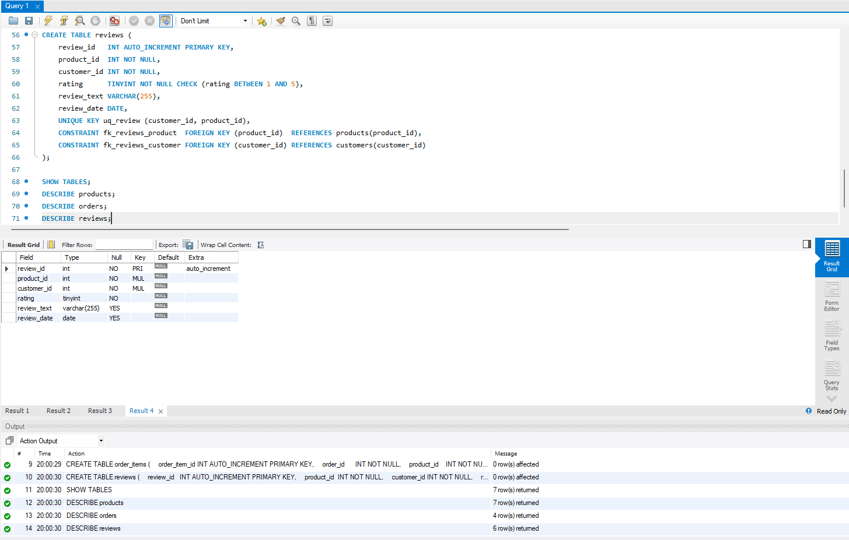
Screenshot 1.1: Schema check in MySQL Workbench
I ran SHOW TABLES (7 tables) and DESCRIBE on products, orders and reviews to check the tables. The reviews table has the 1-5 CHECK on rating, foreign keys, and a UNIQUE key on (customer_id, product_id).
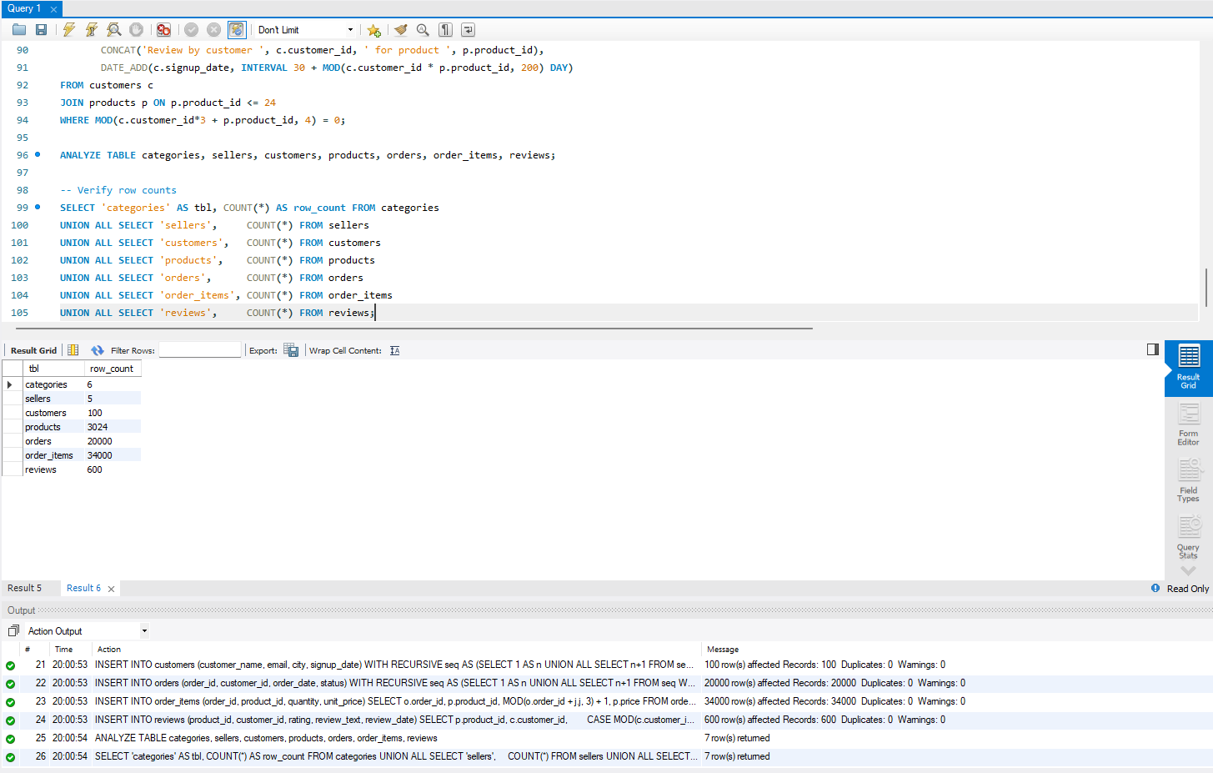
Screenshot 2.1: Row counts after loading the sample data
After the INSERTs I ran ANALYZE TABLE and a UNION ALL count query: 6 categories, 5 sellers, 100 customers, 3,024 products, 20,000 orders, 34,000 order items and 600 reviews, with 0 warnings.
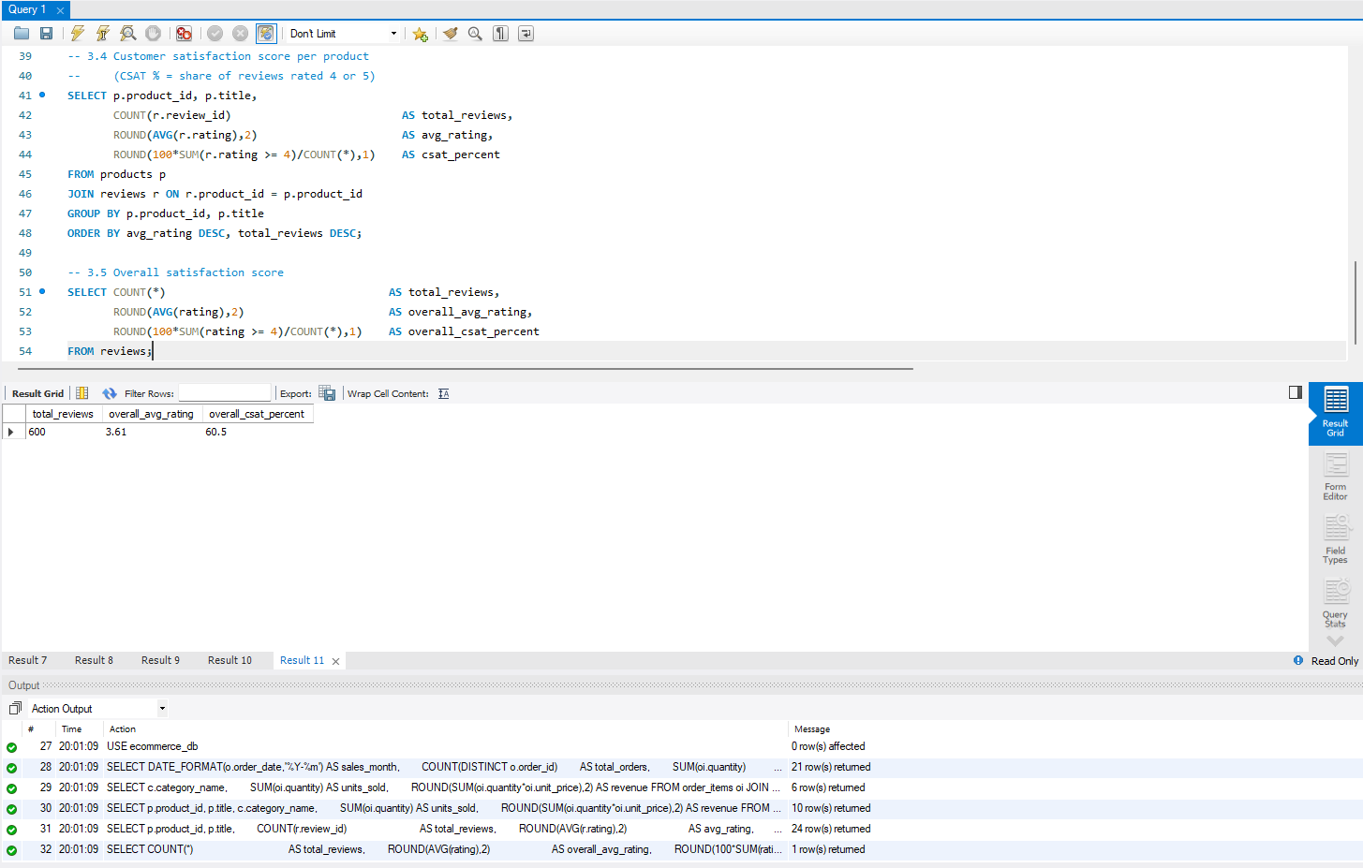
Screenshot 3.1: Customer satisfaction score
Overall there are 600 reviews, an average rating of 3.61 and a CSAT of 60.5% (CSAT = share of reviews rated 4 or 5).
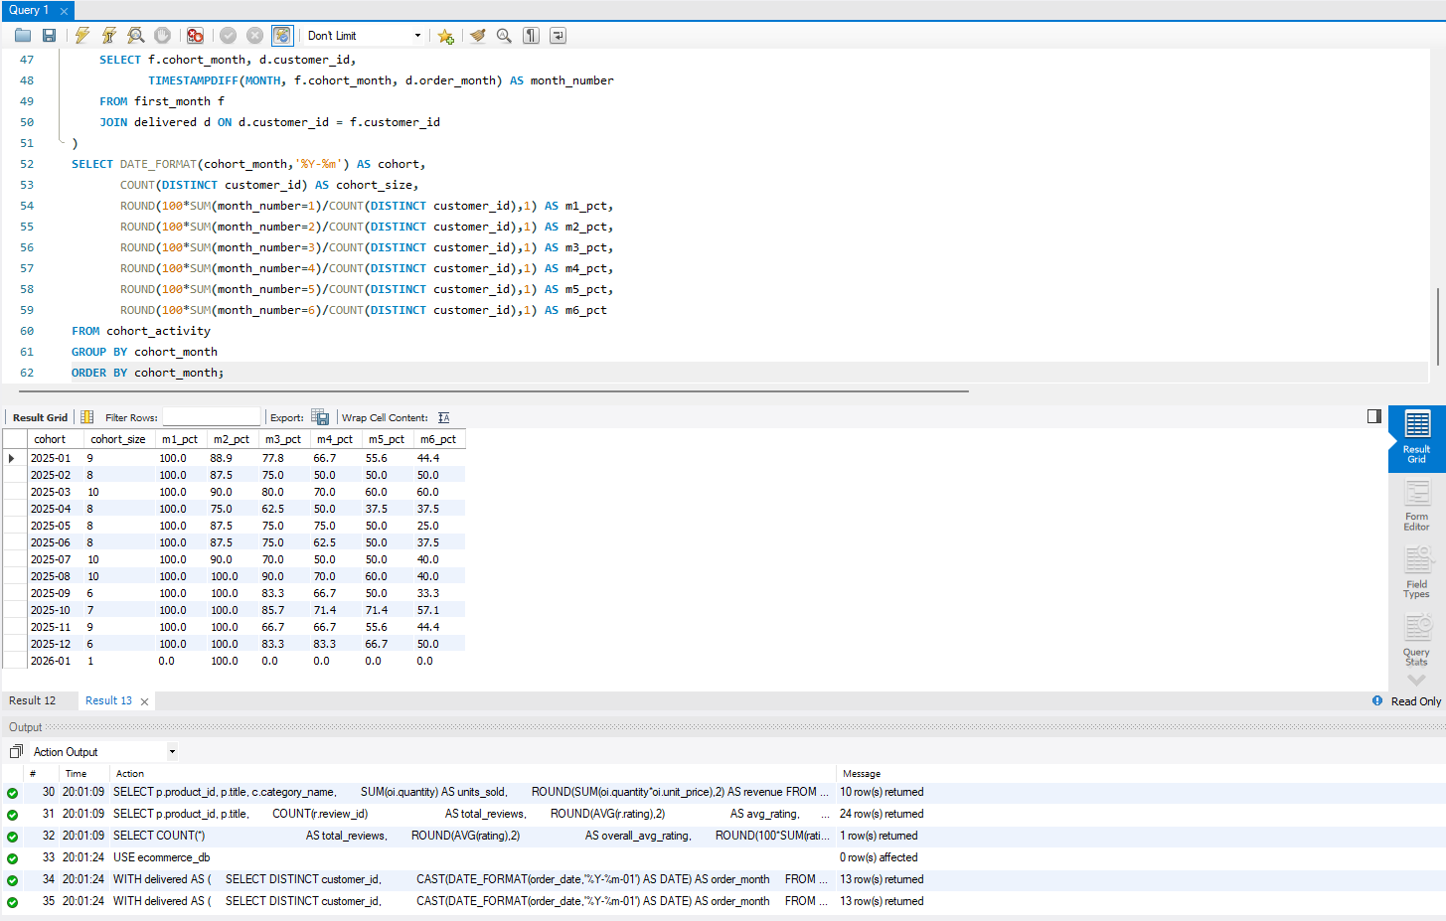
Screenshot 4.1: Cohort retention matrix
Customers are grouped by the month of their first purchase (delivered orders only). For example the 2025-01 cohort (9 customers) is at 88.9% in month 2 and 44.4% by month 6. The 2026-01 cohort has only one customer, so it does not tell us much.
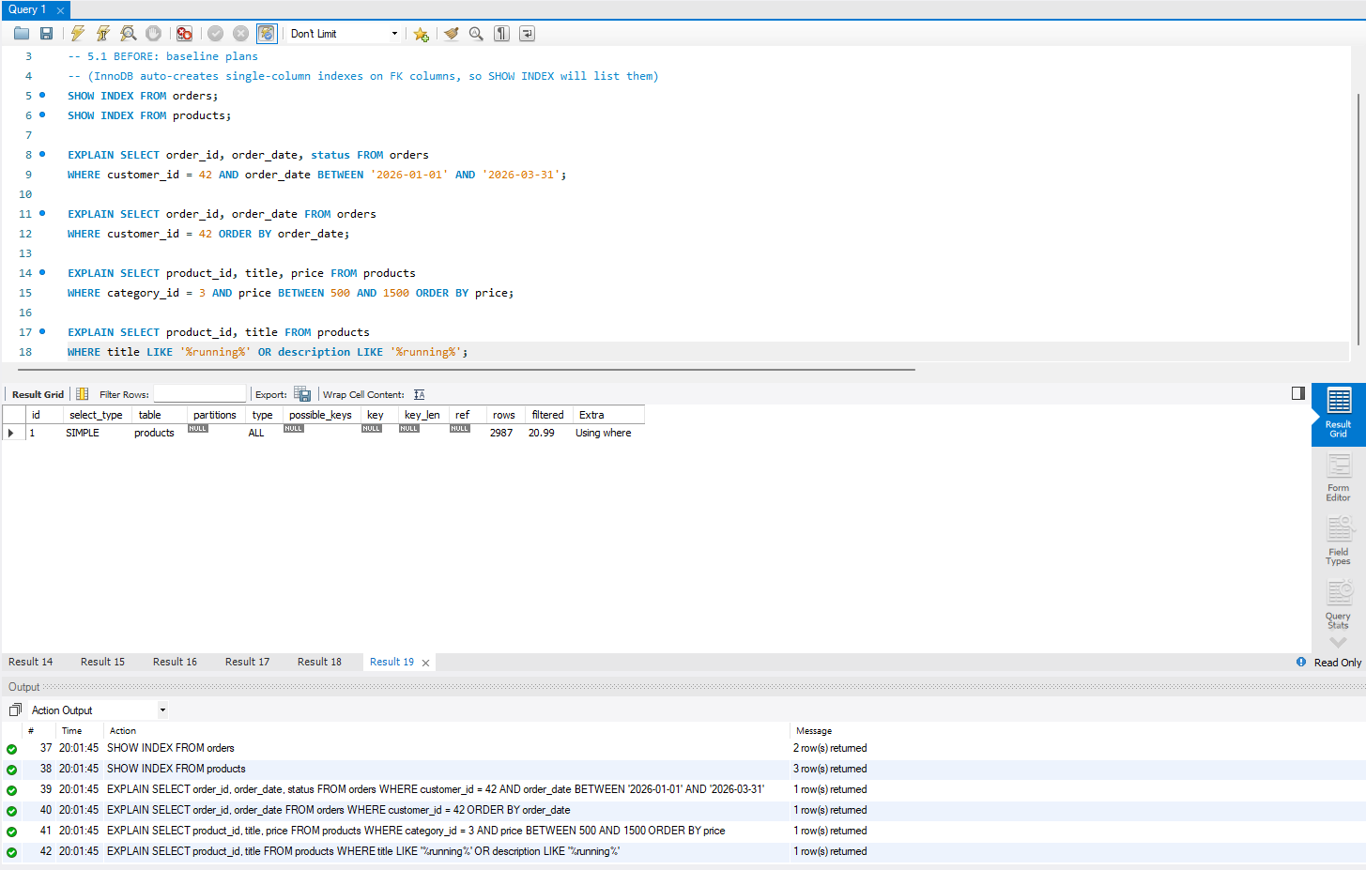
Screenshot 5.1: Baseline execution plans, before indexing
Before adding indexes, SHOW INDEX shows only the primary and foreign key indexes. The LIKE '%running%' search is a full table scan (type = ALL, about 2,987 rows).
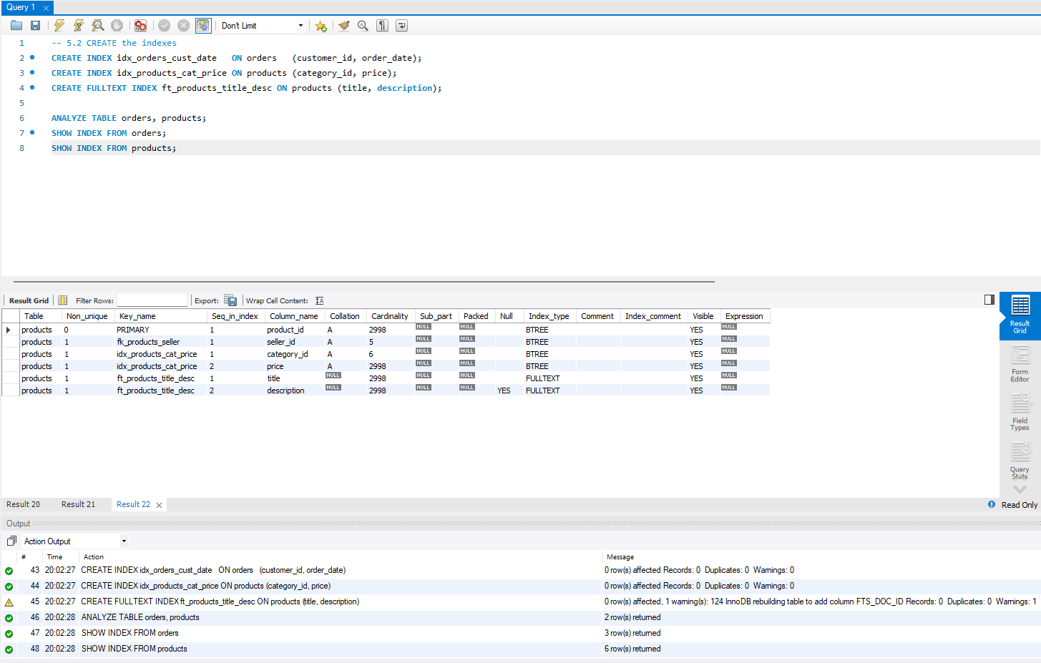
Screenshot 5.2: Creating the composite and FULLTEXT indexes
I created idx_orders_cust_date, idx_products_cat_price and the FULLTEXT index ft_products_title_desc. The one warning is InnoDB rebuilding the table to add FTS_DOC_ID.
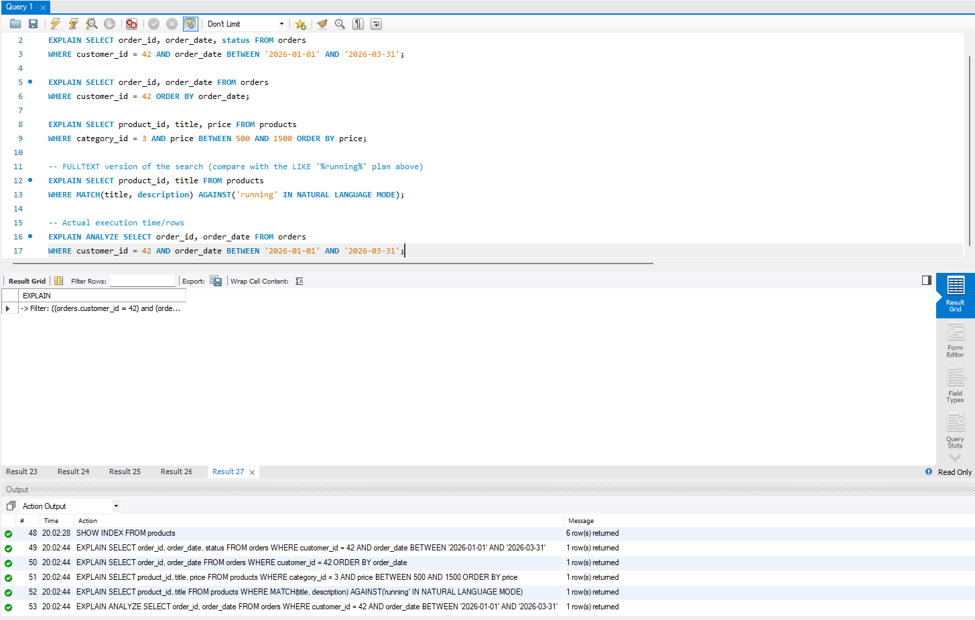
Screenshot 5.3: Execution plans after indexing
I ran EXPLAIN again for the same queries, added a MATCH ... AGAINST version of the search, and finished with EXPLAIN ANALYZE on the orders query.
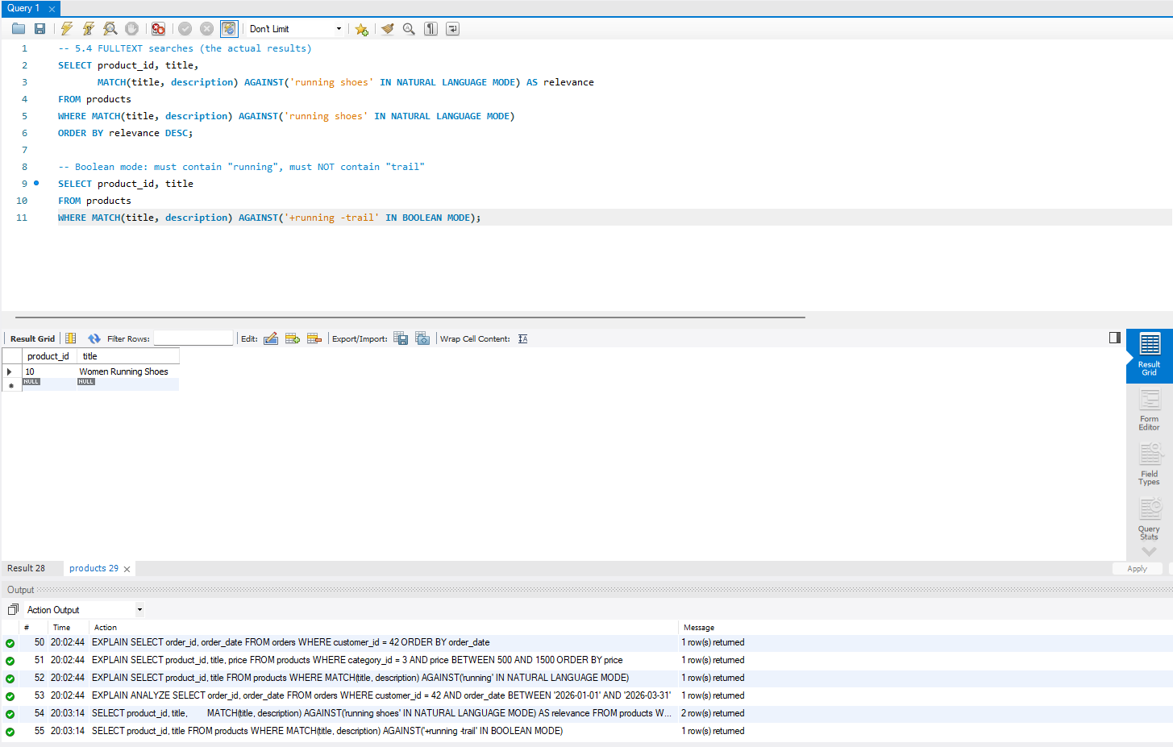
Screenshot 5.4: FULLTEXT search in action
The natural-language search for 'running shoes' returned 2 rows ordered by relevance. The BOOLEAN MODE query ('+running -trail') returned one product, Women Running Shoes.
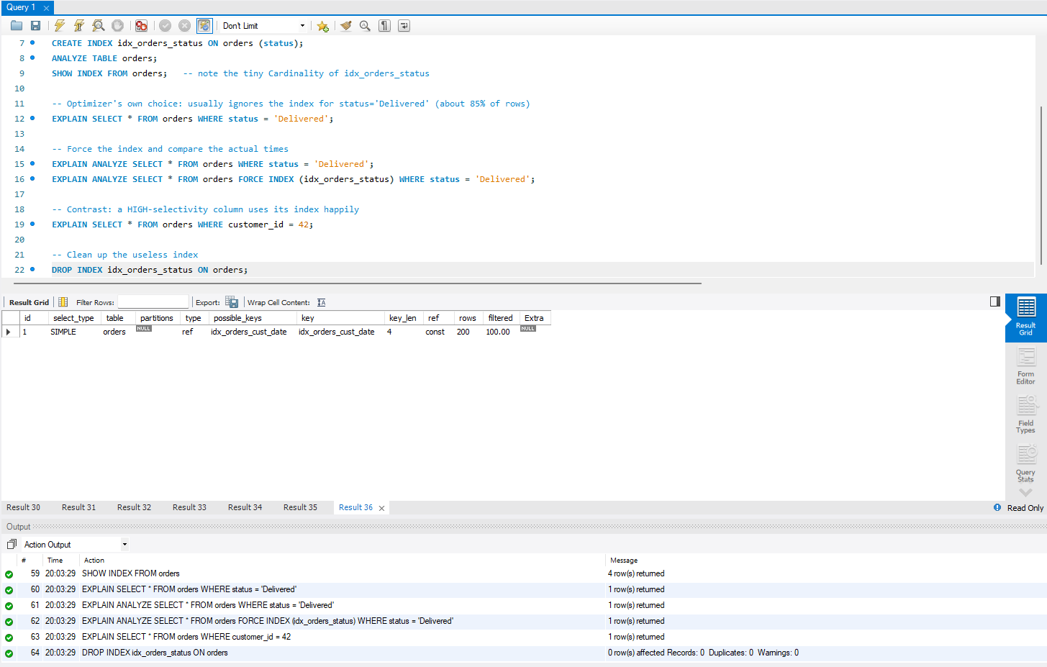
Screenshot 5.5: Low-selectivity index on orders.status
I created the status index, compared EXPLAIN and EXPLAIN ANALYZE with and without FORCE INDEX, and dropped it again. The result shown is the customer_id = 42 lookup, which uses idx_orders_cust_date.
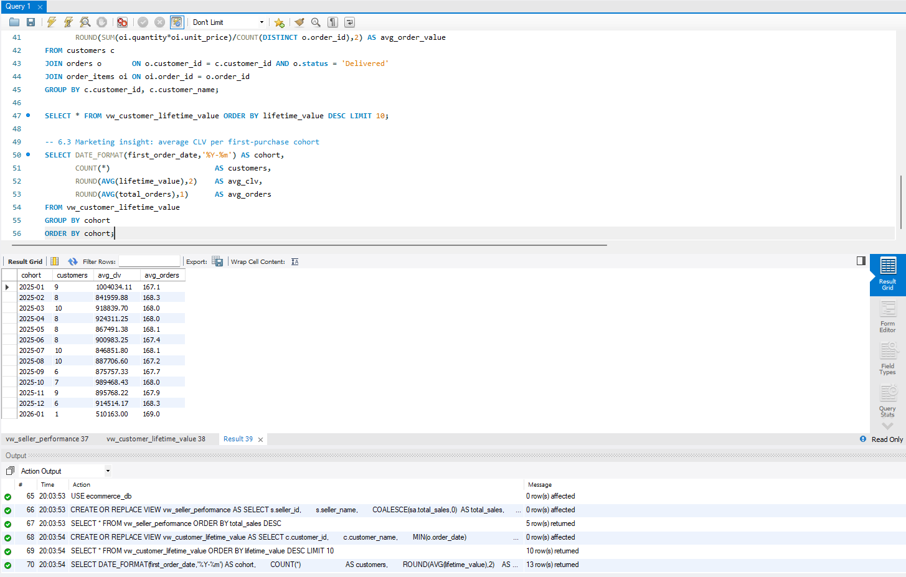
Screenshot 6.1: Seller performance and customer lifetime value views
I created both views and queried them. The result shown is a marketing query on the lifetime value view: average lifetime value and orders for each first-purchase month cohort.
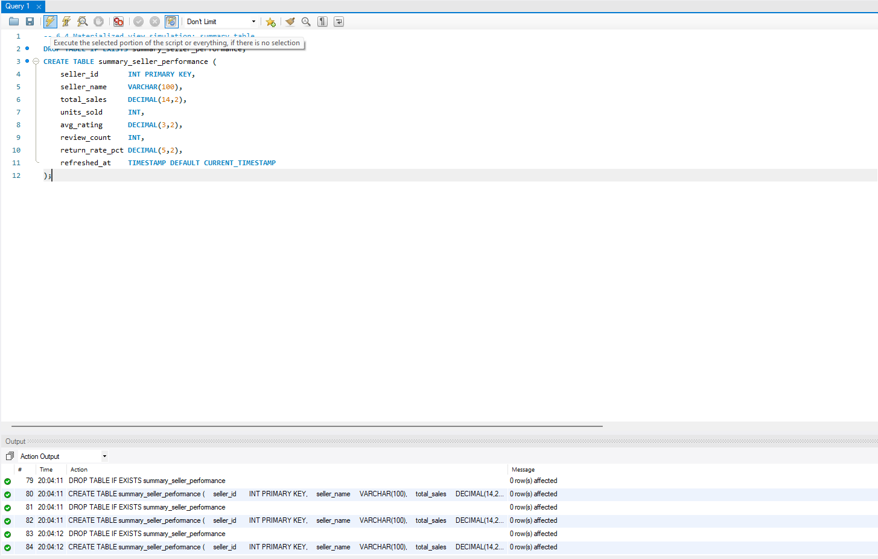
Screenshot 6.2: Summary table for the materialized view simulation
The summary table stores the seller figures plus a refreshed_at timestamp so I can see how old the numbers are. The output log shows I recreated it a few times while getting the definition right.
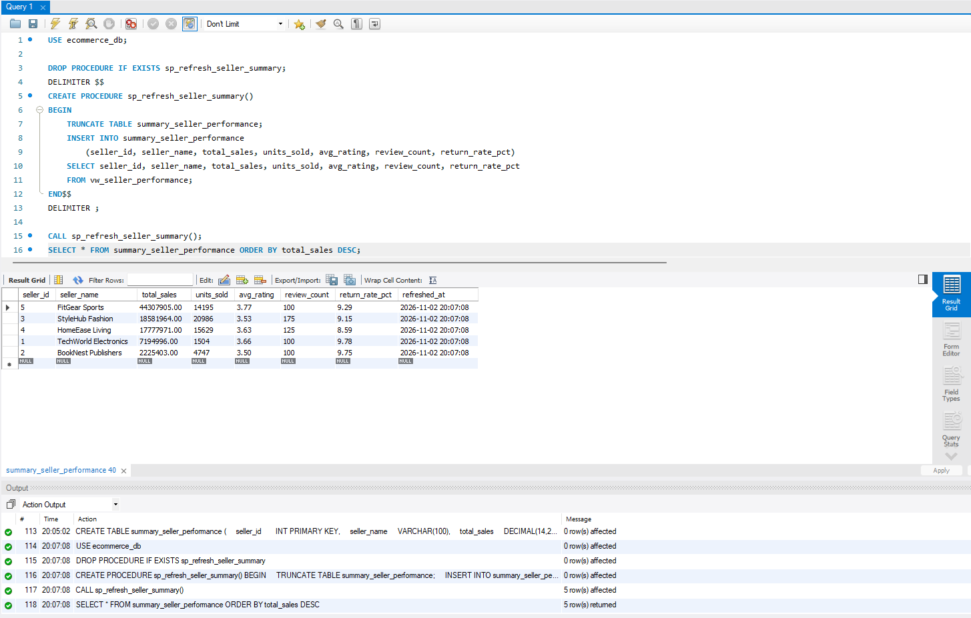
Screenshot 6.3: Refresh stored procedure
sp_refresh_seller_summary() empties the summary table with TRUNCATE and refills it from the view. After CALL it reported 5 rows affected and the table can be read instantly.
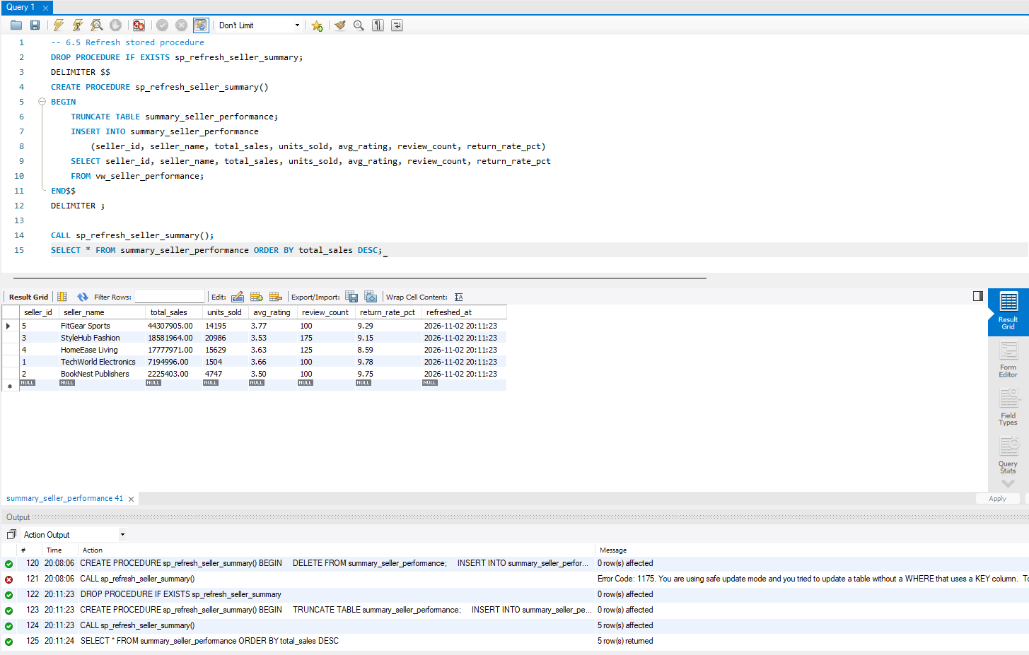
Screenshot 6.4: Fixing Error 1175 (safe update mode)
My first procedure used DELETE FROM without WHERE and failed with Error 1175. I switched to TRUNCATE TABLE, created the procedure again and it worked.
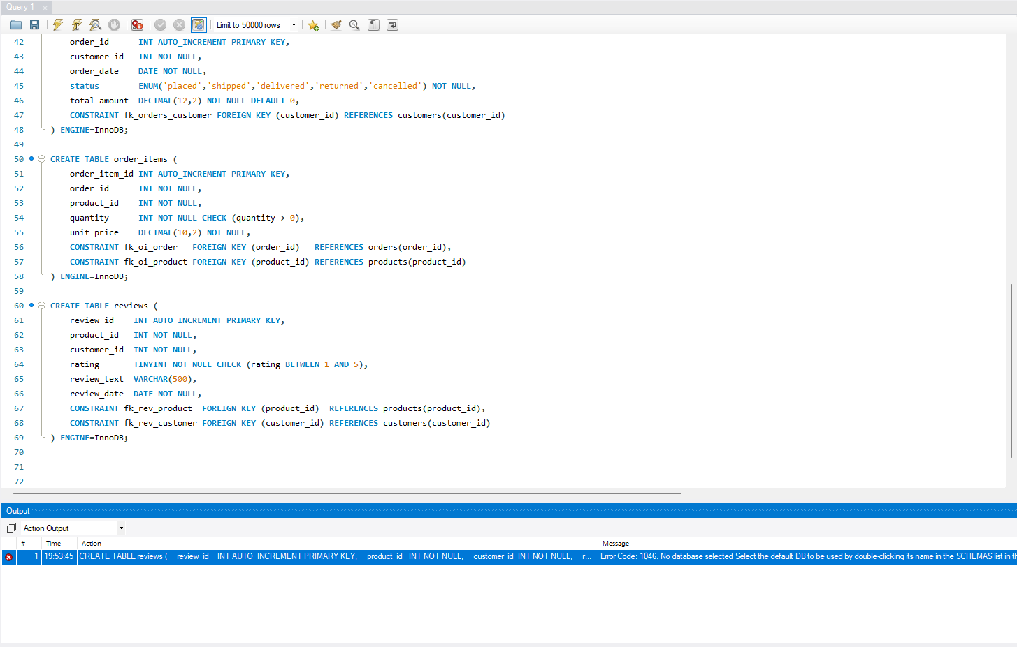
Appendix A: Troubleshooting my first attempt at the schema
The first run of the order_items and reviews CREATE TABLE statements failed with Error 1046 (no database selected) because I had not run USE ecommerce_db. This first draft also had no UNIQUE key on reviews yet.
- Conclusion
In this project I built a normalised marketplace database in MySQL and wrote SQL analytics for sales, customer satisfaction and customer behaviour. I checked my index choices with EXPLAIN and EXPLAIN ANALYZE. The composite indexes removed full table scans and filesorts, FULLTEXT replaced the wildcard search, and the index on the low-selectivity status column turned out to be a bad idea. A view always shows current data, while a refreshed summary table is much faster to read but can be a bit old. Window functions gave me rankings, growth, moving averages, cohorts and quartiles without any self-joins.
The biggest thing I learned is that I should measure a query before and after changing it, because my own guess about the status index was wrong.
Limitations: the data is synthetic, the speed tests come from a small data set on one machine, and the summary table is rebuilt completely each time instead of being updated step by step. In future I would test the same queries on real data and make the refresh incremental (only the recent months).

