Министерство образования Республики Беларусь

Учреждение образования

БЕЛОРУССКИЙ ГОСУДАРСТВЕННЫЙ УНИВЕРСИТЕТ

ИНФОРМАТИКИ И РАДИОЭЛЕКТРОНИКИ

Факультет компьютерных систем и сетей

Кафедра электронных вычислительных машин

ОТЧЕТ

по лабораторной работе №3

по дисциплине АОКС

Вариант №859

|  |  |
| --- | --- |
| Выполнил студент группы № 950503  Преподаватель | Ященко В. П.  Марцинкевич В.А. |

Минск 2022

**Практическая часть:**

**Рабочие конфигурации:**

Server:

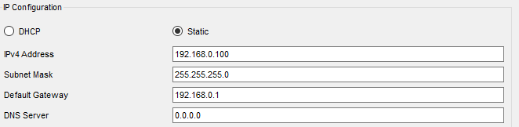

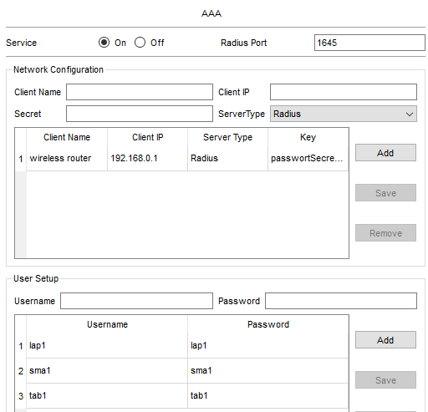

Router:

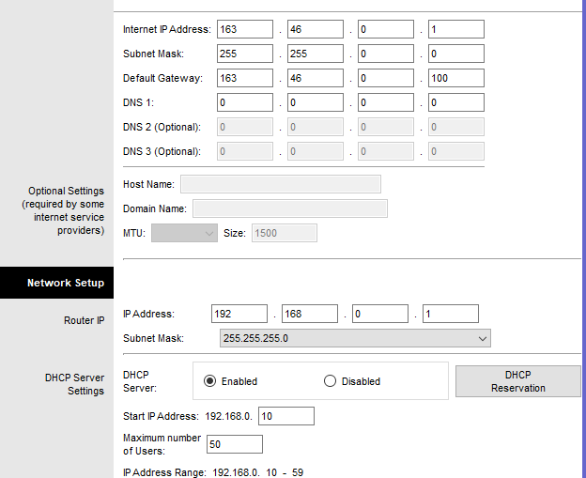

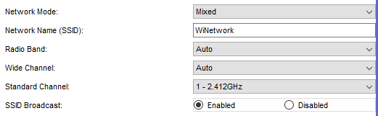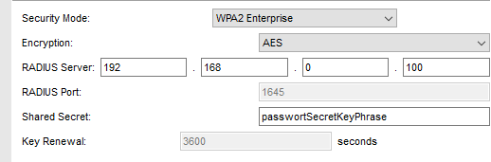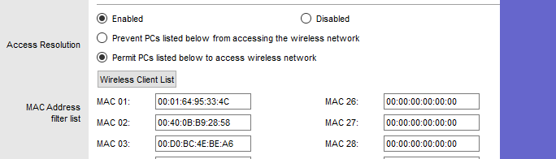

Laptop1:

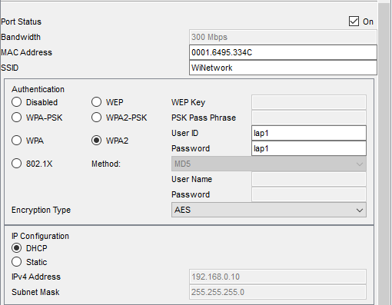

Smartphone1:

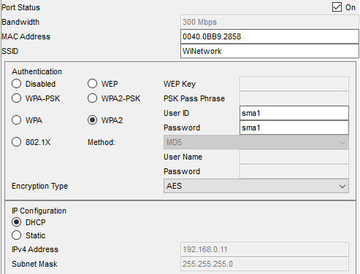

Tablet1:

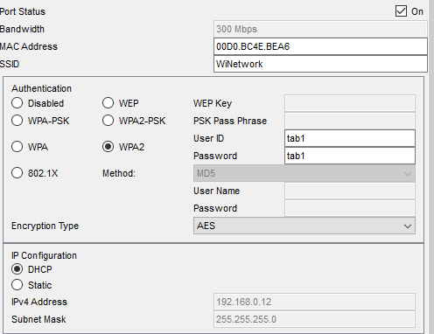

Конфигурация на Root коммутаторе

Current configuration : 3401 bytes

version 16.3.2

no service timestamps log datetime msec

no service timestamps debug datetime msec

no service password-encryption

hostname Switch

!

no ip cef

ip routing

!

no ipv6 cef

!

!spanning-tree mode pvst

spanning-tree vlan 10,20,100-101 priority 24576

!

interface Port-channel3

switchport trunk native vlan 100

switchport trunk allowed vlan 10,20,30,100-101

switchport mode trunk

!

interface Port-channel6

switchport trunk native vlan 100

switchport trunk allowed vlan 10,20,30,100-101

switchport mode trunk

!

interface Port-channel7

switchport trunk native vlan 100

switchport trunk allowed vlan 10,20,30,100-101

switchport mode trunk

!

interface GigabitEthernet1/0/1

!

interface GigabitEthernet1/0/2

!

interface GigabitEthernet1/0/3

switchport trunk native vlan 100

switchport trunk allowed vlan 10,20,30,100-101

switchport mode trunk

channel-protocol lacp

channel-group 3 mode active

!

interface GigabitEthernet1/0/4

switchport trunk native vlan 100

switchport trunk allowed vlan 10,20,30,100-101

switchport mode trunk

channel-protocol lacp

channel-group 3 mode active

!

interface GigabitEthernet1/0/5

!

interface GigabitEthernet1/0/6

switchport trunk native vlan 100

switchport trunk allowed vlan 10,20,30,100-101

switchport mode trunk

channel-protocol lacp

channel-group 6 mode active

!

interface GigabitEthernet1/0/7

switchport trunk native vlan 100

switchport trunk allowed vlan 10,20,30,100-101

switchport mode trunk

channel-protocol lacp

channel-group 6 mode active

!

interface GigabitEthernet1/0/8

switchport trunk native vlan 100

switchport trunk allowed vlan 10,20,30,100-101

switchport mode trunk

channel-protocol lacp

channel-group 7 mode active

!

interface GigabitEthernet1/0/9

switchport trunk native vlan 100

switchport trunk allowed vlan 10,20,30,100-101

switchport mode trunk

channel-protocol lacp

channel-group 7 mode active

…

interface Vlan1

no ip address

shutdown

!

interface Vlan10

mac-address 0002.4a9a.c601

ip address 133.138.10.100 255.255.255.128

!

interface Vlan20

mac-address 0002.4a9a.c602

ip address 146.85.169.182 255.255.255.248

!

interface Vlan30

mac-address 0002.4a9a.c603

ip address 163.46.0.100 255.255.128.0

!

interface Vlan100

mac-address 0002.4a9a.c604

ip address 99.146.203.190 255.255.255.192

!

interface Vlan101

mac-address 0002.4a9a.c605

ip address 103.105.96.100 255.255.224.0

!

ip classless

ip route 133.138.10.0 255.255.255.128 Vlan10

ip route 146.85.169.176 255.255.255.248 Vlan20

ip route 99.146.203.128 255.255.255.192 Vlan100

На всех коммутаторах на trunk портах прописан switchport trunk allowed vlan 10,20,30,100-101  
Новая топология

: 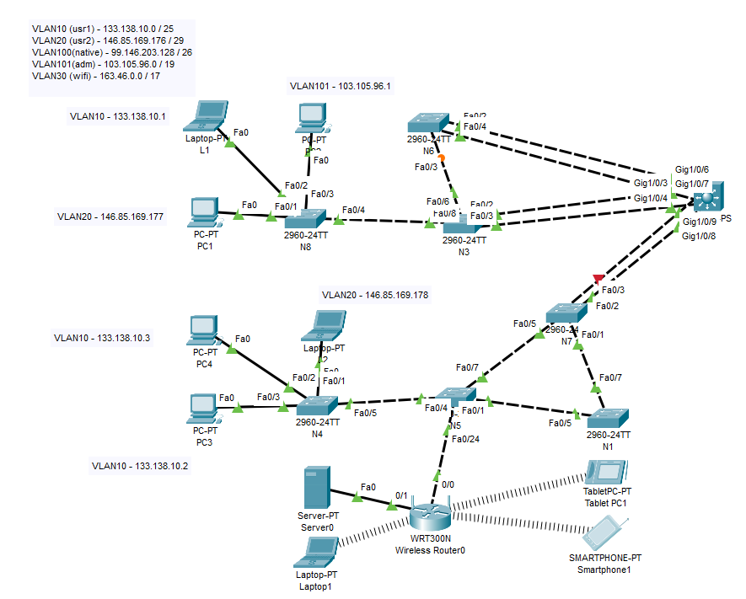

ip route 103.105.96.0 255.255.224.0 Vlan101

!

ip flow-export version 9

!

line con 0

line aux 0

line vty 0 4

login

!

End