Министерство образования Республики Беларусь

Учреждение образования

БЕЛОРУССКИЙ ГОСУДАРСТВЕННЫЙ УНИВЕРСИТЕТ

ИНФОРМАТИКИ И РАДИОЭЛЕКТРОНИКИ

Факультет компьютерных систем и сетей

Кафедра электронных вычислительных машин

ОТЧЕТ

по лабораторной работе №4

по дисциплине АОКС

Вариант №859

|  |  |
| --- | --- |
| Выполнил студент группы № 950503  Преподаватель | Ященко В. П.  Марцинкевич В.А. |

Минск 2022

Рабочие конфигурации:

**Local router:**

LocalRouter(config-router)#nw

LocalRouter(config-router)#ne

LocalRouter(config-router)#network 58.50.59.176

LocalRouter(config-router)#do sh run

Building configuration...

Current configuration : 1277 bytes

version 15.1

no service timestamps log datetime msec

no service timestamps debug datetime msec

no service password-encryption

hostname LocalRouter

no ip cef

no ipv6 cef

username ISPRouter password 0 123456789

username LocalRouter password 0 123456789

license udi pid CISCO2811/K9 sn FTX1017BR46-

spanning-tree mode pvst

interface FastEthernet0/0

ip address 58.50.59.178 255.255.255.240

duplex auto

speed auto

interface FastEthernet0/1

no ip address

duplex auto

speed auto

shutdown

interface Serial1/0

ip address 188.51.174.65 255.255.255.248

encapsulation ppp

ppp authentication chap

interface Serial1/1

no ip address

clock rate 2000000

shutdown

interface Serial1/2

no ip address

clock rate 2000000

shutdown

interface Serial1/3

no ip address

clock rate 2000000

shutdown

interface Vlan1

no ip address

shutdown

router rip

version 2

network 58.0.0.0

network 188.51.0.0

ip classless

ip route 133.138.10.0 255.255.255.128 58.50.59.177

ip route 146.85.169.176 255.255.255.252 58.50.59.177

ip route 163.46.0.0 255.255.128.0 58.50.59.177

ip route 0.0.0.0 0.0.0.0 188.51.174.66

ip flow-export version 9

line con 0

line aux 0

line vty 0 4

login

end

**ISPRouter:**

no service timestamps log datetime msec

no service timestamps debug datetime msec

no service password-encryption

hostname ISPRouter

no ip cef

no ipv6 cef

username ISPRouter password 0 123456789

username LocalRouter password 0 123456789

username dialup password 0 dialup

license udi pid CISCO2811/K9 sn FTX1017WQ46-

spanning-tree mode pvst

interface FastEthernet0/0

ip address 79.211.71.145 255.255.255.248

duplex auto

speed auto

interface FastEthernet0/1

no ip address

duplex auto

speed auto

shutdown

interface Modem0/3/0

ip address 78.211.71.145 255.255.255.248

no keepalive

interface Modem0/3/1

no ip address

interface Serial1/0

ip address 188.51.174.66 255.255.255.248

encapsulation ppp

ppp authentication chap

clock rate 2000000

interface Serial1/1

no ip address

clock rate 2000000

shutdown

interface Serial1/2

no ip address

clock rate 2000000

shutdown

interface Serial1/3

no ip address

clock rate 2000000

shutdown

interface Vlan1

no ip address

shutdown

router rip

version 2

network 79.0.0.0

network 188.51.0.0

ip classless

ip route 133.138.10.0 255.255.255.128 188.51.174.65

ip route 146.85.169.176 255.255.255.252 188.51.174.65

ip route 163.46.0.0 255.255.128.0 188.51.174.65

ip route 79.211.71.144 255.255.255.248 188.51.174.65

ip flow-export version 9

line con 0

line aux 0

line vty 0 4

login

end

На Root был добавлен default gateway: 

Конфигурация pc:

**DialPC**

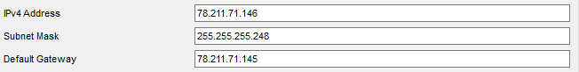

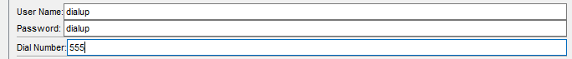

PC5:

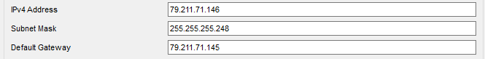

Cloud0:

