CSS326 Project Proposal
Project name: Pet Hotel and Care System
Group Members:
- Mr. Nattapat Ungphakorn 6722771522 Frontend / UI
- Mr. Kittiphat Khumsawad 6722774252 DB Design / Backend
Project Description
The pet accommodation and grooming industry is expanding rapidly. However, many local pet hotels still depend on paper or messaging apps such as LINE to manage reservations. This inconvenient approach can lead to overbooking and calculation errors when owners board multiple pets together in a single room.

Users and Roles
User (Pet Owner):
- Registers via a secure personal account.
- Manages personal pet profiles.
- Browses available rooms and submits reservation requests with multi-pet selection and optional grooming services.
- Views booking histories and monitors daily care activity feeds in real time.
- Cancels upcoming reservations prior to check-in according to hotel policy.
Administrator (Front Desk / Care Staff):
- Monitors overall occupancy schedules and current room status.
- Checks in arriving pets and reviews behavior patterns.
- Logs daily routine activities (meals, potty breaks, medication) into the system.
- Executes checkouts and triggers automated billing procedures.
- Maintains room inventories, pricing tiers, and maintenance states.
Developer:
- Manages user access levels and assigns administrative roles.
- Monitors database connection pool metrics and audit logs.
- Maintains, tests, and modifies stored procedures and triggers directly on the MySQL server.

User Flows
[User Flow]
[Admin Flow]
[Developer Flow]

User Interface Mockups
Page 1: Customer Booking & Pet Care Portal – used by User (Pet Owner)
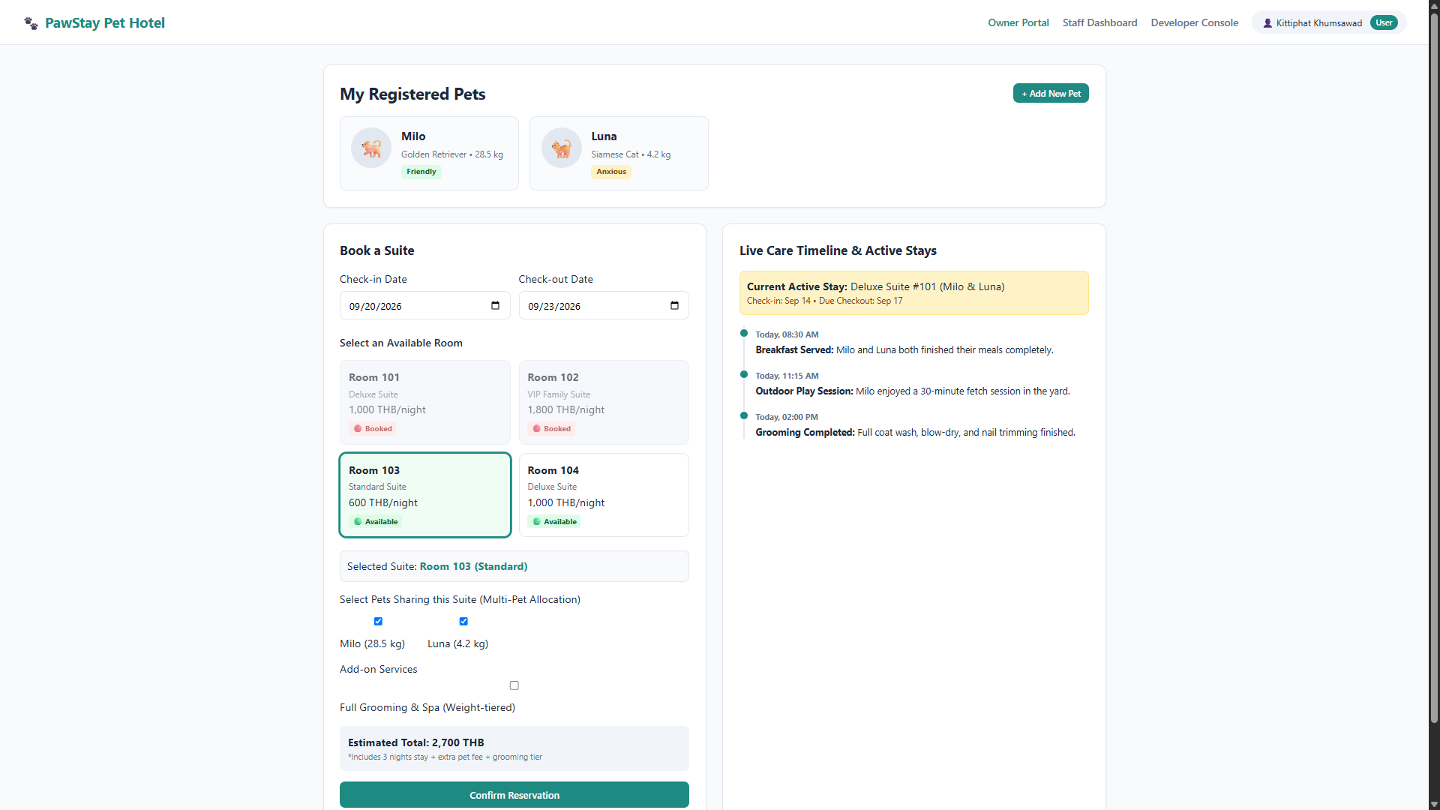
Operations on this page:
- Create: Adds new pet profiles (pets) and creates room reservations (bookings, booking_pets).
- Read: Displays registered pets (pets), browses available rooms (rooms), and views active booking details and care timelines (bookings, daily_logs).
- Update: Edits pet details, weight, and medical notes (pets).
- Delete: Removes a registered pet (pets) or cancels an upcoming reservation (bookings).

Page 2: Operations & Front Desk Dashboard – used by Administrator (Staff)
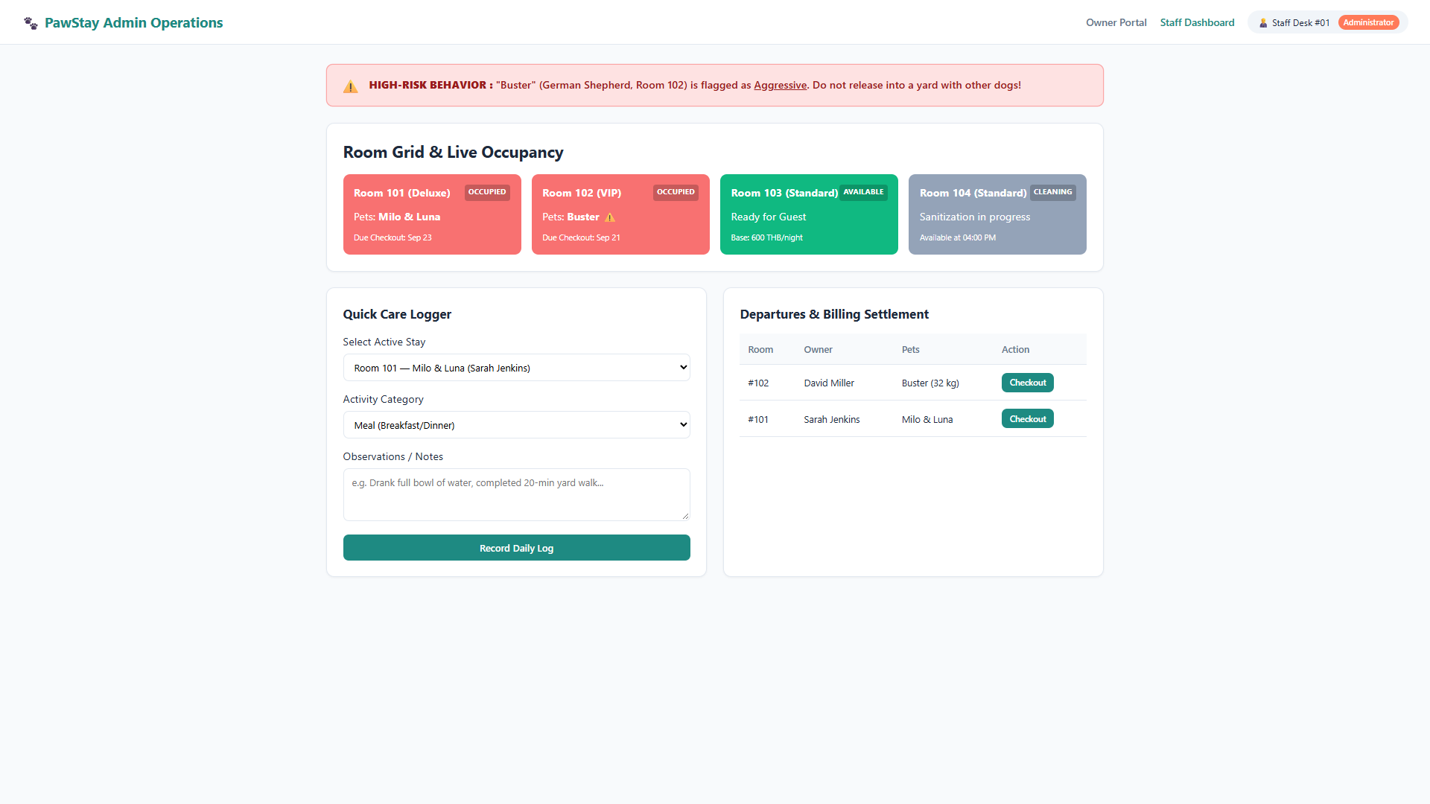
Operations on this page:
- Create: Records routine care entries such as meals and walks (daily_logs).
- Read: Views live room status grids (rooms), checks behavioral hazard alerts (pets), and reviews guest departure lists (bookings, booking_pets).
- Update: Changes booking and room statuses, and runs the checkout billing Stored Procedure (bookings, rooms).
- Delete: Removes erroneous care log entries (daily_logs).

Entities List, Relationship Sets & ER Diagram
Entities List (6 Entities):
- Users – user_id (PK), name, email, password_hash, phone, role
- Pets – pet_id (PK), user_id (FK), name, species, breed, weight_kg, behavior_status, medical_notes
- Rooms – room_id (PK), room_number, room_type, max_capacity, base_price_per_night, status
- Bookings – booking_id (PK), user_id (FK), room_id (FK), check_in_date, check_out_date, total_price, booking_status
- BookingPets – booking_pet_id (PK), booking_id (FK), pet_id (FK), has_grooming, grooming_duration_mins, extra_charge
- DailyLogs – log_id (PK), booking_id (FK), pet_id (FK), log_time, activity_type, details

Relationship Sets:
- Users (1) ─── (N) Pets: One pet owner can register multiple pets.
- Users (1) ─── (N) Bookings: One customer can place multiple reservations over time.
- Rooms (1) ─── (N) Bookings: One room can host different bookings over non-overlapping time slots.
- Bookings (M) — (N) Pets: Many-to-Many relationship allowing several pets from one household to occupy a single reservation, resolved via the junction table booking_pets.
- Bookings (1) ─── (N) DailyLogs: One booking accumulates multiple routine logs throughout the stay.
ER Diagram
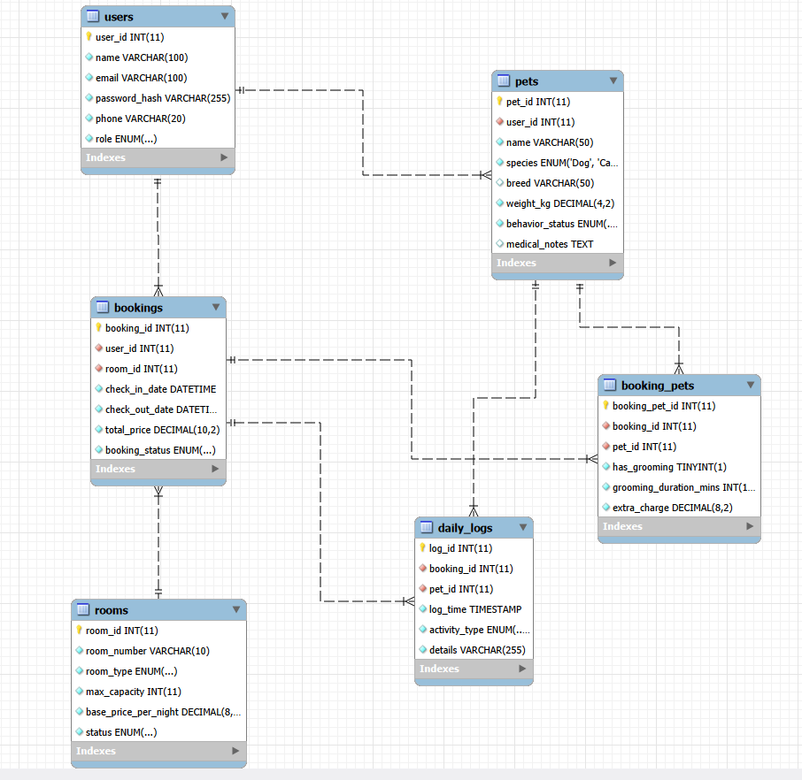

Physical Design for MySQL
Table | Column | Data type | Nullable | Key | References | Notes
users | user_id | INT AUTO_INCREMENT | No | PK
users | name | VARCHAR(100) | No
users | email | VARCHAR(100) | No |  |  | UNIQUE
users | password_hash | VARCHAR(255) | No |  |  | bcrypt hash
users | phone | VARCHAR(20) | No
users | role | ENUM('User', 'Admin', 'Developer') | No |  |  | DEFAULT 'User'
pets | pet_id | INT AUTO_INCREMENT | No | PK
pets | user_id | INT | No | FK | users.user_id | ON DELETE RESTRICT
pets | name | VARCHAR(50) | No
pets | species | ENUM('Dog', 'Cat') | No
pets | breed | VARCHAR(50) | Yes
pets | weight_kg | DECIMAL(4,2) | No |  |  | Max 99.99 kg
pets | behavior_status | ENUM('Friendly', 'Aggressive', 'Anxious', 'High-Energy') | No |  |  | DEFAULT 'Friendly'
pets | medical_notes | TEXT | Yes
rooms | room_id | INT AUTO_INCREMENT | No | PK
rooms | room_number | VARCHAR(10) | No |  |  | UNIQUE
rooms | room_type | ENUM('Standard', 'Deluxe', 'Suite') | No
rooms | max_capacity | INT | No |  |  | DEFAULT 1
rooms | base_price_per_night | DECIMAL(8,2) | No |  |  | Price per night
rooms | status | ENUM('Available', 'Occupied', 'Maintenance') | No |  |  | DEFAULT 'Available'
bookings | booking_id | INT AUTO_INCREMENT | No | PK
bookings | user_id | INT | No | FK | users.user_id | ON DELETE RESTRICT
bookings | room_id | INT | No | FK | rooms.room_id | ON DELETE RESTRICT
bookings | check_in_date | DATETIME | No |  |  | Check-in timestamp
bookings | check_out_date | DATETIME | No |  |  | Check-out timestamp
bookings | total_price | DECIMAL(10,2) | No |  |  | DEFAULT 0.00
bookings | booking_status | ENUM('Pending', 'Confirmed', 'Completed', 'Cancelled') | No |  |  | DEFAULT 'Pending'
booking_pets | booking_pet_id | INT AUTO_INCREMENT | No | PK
booking_pets | booking_id | INT | No | FK | bookings.booking_id | ON DELETE CASCADE, UNIQUE(booking_id, pet_id)
booking_pets | pet_id | INT | No | FK | pets.pet_id | ON DELETE RESTRICT, UNIQUE(booking_id, pet_id)
booking_pets | has_grooming | BOOLEAN | No |  |  | DEFAULT FALSE
booking_pets | grooming_duration_mins | INT | No |  |  | DEFAULT 0
booking_pets | extra_charge | DECIMAL(8,2) | No |  |  | DEFAULT 0.00
daily_logs | log_id | INT AUTO_INCREMENT | No | PK
daily_logs | booking_id | INT | No | FK | bookings.booking_id | ON DELETE CASCADE
daily_logs | pet_id | INT | No | FK | pets.pet_id | ON DELETE RESTRICT
daily_logs | log_time | TIMESTAMP | No |  |  | DEFAULT CURRENT_TIMESTAMP
daily_logs | activity_type | ENUM('Meal', 'Potty', 'Walk', 'Medication', 'General') | No
daily_logs | details | VARCHAR(255) | No

CRUD Plan
Operation | Page | Table(s) | What the person does
Create (INSERT) | index.html | pets | The pet owner fills out the registration modal with their pet's name, breed, weight, and behavior flag, then clicks "Save Pet" to add it to their account.
Create (INSERT) | index.html | bookings, booking_pets | The pet owner chooses check-in/out dates, selects an available suite, checks which pets will share the room, and clicks "Confirm Reservation".
Create (INSERT) | admin.html | daily_logs | The staff member selects an active guest, picks an activity type (e.g., Meal, Walk), types care observations, and clicks "Record Daily Log".
Read (SELECT) | index.html | rooms | The pet owner views the real-time suite selector grid to see which rooms are marked Available or Booked for the chosen dates.
Read (SELECT) | index.html | bookings, daily_logs | The pet owner checks their active booking card to read live timeline updates (feeding, walks, medication) posted by staff.
Read (SELECT) | admin.html | rooms, pets | The staff member reviews the floor grid to see room occupancy and checks the red alert banner for pets flagged as Aggressive.
Read (SELECT) | dev.html | users | The developer opens the access control table to inspect all registered accounts, emails, and assigned permission levels.
Update | index.html | pets | The pet owner opens their pet's profile modal to update the weight, medical notes, or behavior status.
Update | admin.html | bookings, rooms | The staff member clicks "Checkout" for a departing guest, which runs the billing Stored Procedure, marks the booking Completed, and frees the room.
Update | dev.html | users | The developer selects a different privilege level (User, Admin, Developer) from the dropdown to update that user's system role.
Delete | index.html | bookings, booking_pets | The pet owner clicks "Cancel" on an upcoming reservation to cancel the booking and remove its linked pet allocation records.
Delete | index.html | pets | The pet owner clicks "Delete" on a pet profile card to remove a pet that has no active booking history.
Delete | admin.html | daily_logs | The staff member clicks the remove icon next to an incorrect routine care entry to delete it from the daily feed.

Technology, Stored Procedure and Trigger
Layer | Choice | Notes
Front end | HTML5 / CSS3 / Vanilla JavaScript | Lightweight SPA using native fetch(); served statically by Express without extra UI frameworks.
Server | Node.js with Express | Modular architecture (routes/, controllers/, db.js) using a shared mysql2 connection pool (connectionLimit: 10).
Database | MySQL 8 | Normalized 3NF schema (6 tables); strictly uses ? placeholders to prevent SQL injection.
Stored procedure | sp_finalize_and_calculate_bill(IN p_booking_id INT) | Calculates nights, extra-pet surcharges, and weight-based grooming fees; updates total_price and sets booking_status to 'Completed'.
Trigger | AFTER UPDATE ON bookings (trg_after_booking_status_change) | Syncs room status automatically: sets 'Occupied' when Confirmed, and reverts to 'Available' when Completed/Cancelled.
Security | bcrypt | Hashes passwords before saving to prevent plaintext leaks; enforces 3-tier role access (User, Admin, Developer) via middleware.

Timeline
Weeks | Month | Date | Plan
Week 7 | Sep | 18 | Project proposal: first version Thu 17, presentation Fri 18 in your slot (Lab 7)
Week 8 |  | 25 | Midterm week (no class). Revised final proposal by Fri 25 Sep, 23:59
Week 9 | Oct | 2 | Set up MySQL physical schema, initialize Express backend with connection pooling (db.js), and implement user authentication with bcrypt password hashing and 3-tier RBAC.
Week 10 |  | 9 | Build RESTful API endpoints and controllers for pet management and suite bookings, ensuring all SQL statements use ? parameterized placeholders.
Week 11 |  | 16 | Implement and verify database automation on MySQL: deploy Trigger trg_after_booking_status_change and Stored Procedure sp_finalize_and_calculate_bill.
Week 12 |  | 23* | Connect frontend mockups (index.html, admin.html, dev.html) to Express APIs using vanilla JavaScript fetch() calls; verify room availability and behavioral alert displays.
Week 13 |  | 30 | Conduct end-to-end CRUD testing across all 6 tables, test error-handling boundaries, and verify RBAC. Consultation on projects (Lab 12): bring your problems
Week 14 | Nov | 6 | Project Demonstration (Lab 13)
Week 15 |  | 13 | No Lab (Final Exam)

