Blood Bank Management System
Software Requirements Specification
Part A Software Requirements Specification
Course UE24CS341A Software Engineering
Document identifier BBMS SRS 1.0
Version 1.0 29 September 2026
Nimay Balal PES1UG24CS301
Nikita Mankani PES1UG24CS300
Niyatee Singh PES1UG24CS305
Nishitha S PES1UG24CS304

Document Control
Item | Value
Document title | Software Requirements Specification
Document identifier | BBMS SRS 1.0
Version | 1.0
Status | Submission copy
Prepared by | Nimay Balal, Nikita Mankani, Niyatee Singh and Nishitha S
Course | UE24CS341A Software Engineering
System scope | Web application for donor, donation, screening, inventory and hospital request management

Revision History
Version | Date | Description | Authors
1.0 | 29 September 2026 | Complete part a software requirements specification for Part 1 submission | Project team

Approval Record
Role | Name | Signature | Date
Faculty evaluator
Team representative

Table of Contents

1 Introduction

1.1 Purpose
This Software Requirements Specification defines the behaviour, interfaces, constraints and quality requirements of the Blood Bank Management System. It provides the baseline for design, implementation, testing and acceptance.

1.2 Scope
The system supports one or more blood-bank branches under one deployment. It maintains donor and donation records, applies configurable eligibility rules, tracks laboratory screening and component inventory, accepts hospital blood requests, records cross-matching and issuance, sends operational notifications and produces audit and management reports.
The first implementation may operate at one branch. The data model and access controls retain branch identifiers so that additional branches can be enabled without replacing the core design.

1.3 Intended Audience
The intended readers are the course evaluator, project team, student developers and student testers. Operational stakeholders include donors, blood-bank staff, hospital staff and system administrators.

1.4 Definitions and Abbreviations
Term | Meaning
API | Application Programming Interface
Blood unit | A uniquely identified whole-blood collection or derived component tracked by the system
Component | A blood product such as red cells, platelets or plasma
CSRF | Cross-Site Request Forgery
FR | Functional Requirement
NFR | Non-Functional Requirement
RBAC | Role-Based Access Control
RTM | Requirements Traceability Matrix
SRS | Software Requirements Specification
UTC | Coordinated Universal Time

1.5 References
The normative and project references are listed in the References section at the end of this document.

1.6 Document Conventions
The word shall indicates a mandatory and testable requirement. Functional requirements use FR identifiers, non-functional requirements use NFR identifiers and security requirements use SEC identifiers. Priorities indicate implementation importance for the academic prototype.

2 Overall Description

2.1 Product Perspective
The product is a role-based web application backed by a relational database. It centralizes records that may otherwise be kept in separate registers or spreadsheets. Browser clients communicate with the application over HTTPS. The application sends email through a configured provider and stores encrypted backups in restricted storage.

2.2 Product Functions
- Register donors and maintain consent, contact and medical-history information.
- Evaluate eligibility through configurable rules and active deferrals.
- Schedule donation appointments with branch and slot capacity controls.
- Record collection, component preparation, laboratory testing and unit state changes.
- Search inventory and manage hospital blood requests, reservations, cross-matches and issuance.
- Generate alerts, reports, backups and audit records.

2.3 User Classes
User class | Main responsibilities | Access level
Donor | Profile, eligibility, appointments and personal history | Own records only
Blood Bank Staff | Screening, donation, testing, inventory, requests and issue | Assigned branch operations
Hospital Staff | Availability search, request submission and request tracking | Hospital requests and restricted stock view
System Administrator | Accounts, roles, branches, configuration and reports | Administrative data without routine clinical editing

2.4 Operating Environment
- Server operating system: Linux.
- Application: Python and Django served by Gunicorn behind Nginx.
- Database: PostgreSQL through the Django object-relational mapper.
- Client: Supported desktop or mobile browser with JavaScript and cookies enabled.
- Deployment: Docker containers may be used, but containerization is not required for the academic prototype.

2.5 Design Constraints
- Server-side authorization is mandatory for protected operations.
- All persistent clinical and inventory records use database transactions and referential integrity.
- Eligibility, shelf-life and notification thresholds remain configurable because approved rules may change.
- The interface uses forms and tables suitable for a semester-scale implementation.

2.6 Assumptions and Dependencies
- Each hospital and staff account is verified by an administrator before activation.
- Laboratory results are entered by authorized staff; direct analyser integration is outside the first release.
- The deployment provides working email, database and backup services.
- A qualified authority approves operational eligibility and retention rules before deployment.

2.7 Items Outside Scope
- Payment processing and insurance claims.
- Direct control of laboratory analysers or storage hardware.
- Biometric or national identity integration.
- Automated clinical diagnosis or replacement of professional cross-match review.

3 External Interface Requirements

3.1 User Interfaces
Role-specific dashboards present only permitted actions. Forms display mandatory-field markers, inline validation and a summary of submission errors. Tables support paging, filtering and clear empty states. Destructive actions require confirmation. Status values use text labels and do not rely on colour alone.

3.2 Hardware Interfaces
No dedicated hardware interface is required for the first release. Staff use standard desktop or tablet input devices. Barcode support may be added later through keyboard-compatible scanners.

3.3 Software Interfaces
Interface | Purpose | Failure handling
PostgreSQL | Persistent transactional storage | Rollback transaction and log a database error
SMTP email provider | Appointments and operational notifications | Record failure and retry through a scheduled task
Backup storage | Encrypted database backup retention | Alert administrator and preserve prior successful backups

3.4 Communication Interfaces
Browser traffic uses HTTPS. API payloads use JSON encoded as UTF-8. Server-generated timestamps use ISO 8601 UTC format. Email transport uses the configured authenticated and encrypted provider connection.

4 System Requirements

4.1 Requirement Quality Rules
Every requirement has one identifier, one primary behaviour and one verification reference. Quantitative limits are included where acceptance depends on time, load, retention or viewport size. Configurable values are identified instead of being embedded in application code.

4.2 Functional Requirements
Table 1 Functional requirements
ID | Requirement | Priority | Verification
FR-01 | The system shall register a donor after validating mandatory identity, contact, consent and medical history fields. | High | Inspection and TC-F01
FR-02 | The system shall maintain one donor profile per registered email address and shall reject a duplicate active profile. | Medium | TC-F01
FR-03 | The system shall evaluate donor eligibility using administrator-configured rules for age, weight, donation type, donation interval, deferrals and screening responses. | High | TC-F02
FR-04 | The system shall display each failed eligibility rule and shall prevent appointment confirmation when any blocking rule fails. | High | TC-F02
FR-05 | The system shall allow an eligible donor to create, reschedule or cancel an appointment for an available branch and time slot. | High | TC-F03
FR-06 | The system shall prevent appointment capacity from exceeding the configured capacity of a time slot. | High | TC-F03
FR-07 | The system shall display the authenticated donor's donation history, appointment history and eligibility date. | Medium | TC-F04
FR-08 | The system shall allow authorized staff to record temporary or permanent donor deferrals with reason, start date, end date when applicable and approving staff member. | High | TC-F05
FR-09 | The system shall assign a unique donation identifier and unique blood unit identifier to every recorded donation and derived component. | High | TC-F06
FR-10 | The system shall record collection time, volume, blood group, component type, collector and source donor for each blood unit. | High | TC-F06
FR-11 | The system shall store laboratory results for the configured mandatory transfusion-transmitted infection test panel for each unit. | High | TC-F07
FR-12 | The system shall prevent a unit from entering the Available state until all mandatory test results are recorded as acceptable by authorized staff. | High | TC-F07
FR-13 | The system shall place a unit in Quarantined state when any mandatory screening result is reactive, indeterminate or incomplete. | High | TC-F07
FR-14 | The system shall manage unit states as Collected, Testing, Available, Reserved, Issued, Quarantined, Expired or Discarded and shall reject an invalid state transition. | High | TC-F08
FR-15 | The system shall calculate expiry from collection time, component type and the configured shelf-life rule. | High | TC-F08
FR-16 | The system shall mark an unissued unit Expired when its expiry time is reached and shall exclude it from available stock. | High | TC-F08
FR-17 | The system shall allow authorized users to search available stock by blood group, component, branch and expiry date. | High | TC-F09
FR-18 | The system shall notify designated staff when available stock falls below a configured threshold or when a unit enters the configured near-expiry period. | Medium | TC-F10
FR-19 | The system shall allow hospital staff to create a request containing blood group, component, quantity, priority, required-by time and clinical reference. | High | TC-F11
FR-20 | The system shall support Pending, Approved, Partially Fulfilled, Fulfilled, Rejected and Cancelled request states and shall record the actor and time of every transition. | High | TC-F11
FR-21 | The system shall allow hospital staff to cancel only a Pending request and shall require blood bank staff to cancel a request after approval. | Medium | TC-F12
FR-22 | The system shall allow authorized staff to reserve compatible Available units for an approved request without assigning one unit to more than one active request. | High | TC-F13
FR-23 | The system shall record cross-match outcome before a reserved unit is issued. | High | TC-F13
FR-24 | The system shall complete unit issuance and request status update in one database transaction. | High | TC-F13
FR-25 | The system shall authenticate Donor, Blood Bank Staff, Hospital Staff and System Administrator accounts before protected functions are accessed. | High | TC-S01
FR-26 | The system shall allow a system administrator to create, deactivate and assign one approved role to a user account. | High | TC-S02
FR-27 | The system shall allow a system administrator to manage branches, time-slot capacities, eligibility rules, shelf-life rules and stock thresholds. | Medium | TC-F14
FR-28 | The system shall generate inventory, expiry, donation, request and audit reports for a selected date range and branch. | Medium | TC-F15
FR-29 | The system shall send appointment reminders and request-status notifications through the configured email service and shall record delivery success or failure. | Low | TC-F16
FR-30 | The system shall write an audit event for authentication, deferral, screening, inventory, request, issuance, configuration and account-management changes. | High | TC-S03

4.3 Non-Functional Requirements
Table 2 Non-functional requirements
ID | Requirement | Quality area | Verification
NFR-01 | For at least 95 percent of search and dashboard requests, the server shall return a response within 3 seconds with 100 concurrent authenticated users in the defined test environment. | Performance | TC-N01
NFR-02 | The system shall complete a stock reservation transaction within 5 seconds under the same load and shall prevent duplicate reservation under concurrent requests. | Performance | TC-N02
NFR-03 | The monthly service availability target shall be 99.0 percent, excluding planned maintenance announced at least 24 hours in advance. | Reliability | Operational review
NFR-04 | A scheduled encrypted backup shall run every 24 hours, retain seven daily copies and four weekly copies, and support restoration within 4 hours during the acceptance test. | Recovery | TC-N03
NFR-05 | The system shall preserve committed donation, screening, reservation and issuance data after an application restart. | Reliability | TC-N04
NFR-06 | The interface shall support the latest two major versions of Chrome, Edge and Firefox and viewport widths from 360 to 1440 pixels without horizontal scrolling on standard forms. | Compatibility | TC-N05
NFR-07 | A first-time staff user shall complete donor lookup and appointment check-in within 5 minutes using the supplied task instructions and without developer assistance. | Usability | TC-N06
NFR-08 | The application shall separate presentation, business rules and data-access code into documented modules with automated unit tests for eligibility, unit state transitions and request state transitions. | Maintainability | Code review
NFR-09 | The database schema shall support multiple branches while enforcing branch-level access restrictions for operational users. | Scalability | TC-S02
NFR-10 | The application shall record dates and times in UTC and display them in the branch time zone configured by the administrator. | Data integrity | TC-N07
NFR-11 | The system shall not expose medical-history or screening-result fields in availability search results or hospital-facing reports. | Privacy | TC-S04
NFR-12 | The system shall support retention and export rules configured to match the approved institutional and regulatory record-retention policy. | Compliance | Inspection

5 Data Requirements

5.1 Core Data Entities
The core entities are User, Donor, Branch, Appointment, Deferral, Donation, BloodUnit, LabResult, BloodRequest, Reservation, CrossMatch, Issue, Notification and AuditEvent. Every clinical and inventory record has a stable identifier and creation timestamp.

5.2 Data Integrity Rules
- A blood unit identifier is unique and cannot be reused.
- A lab result references one valid blood unit and one configured test type.
- An issued unit references one issue transaction and cannot return to Available state.
- A reserved unit belongs to at most one active request.
- Deletion of clinical, inventory and audit records is disabled through normal application functions.

5.3 Retention and Privacy
Retention periods are configuration values approved by the institution. Export and archival processes preserve identifiers, timestamps and audit references. Availability searches expose stock counts and unit suitability fields but do not expose donor medical history or laboratory details to hospital accounts.

6 Security Objectives and Requirements

6.1 Security Objectives
- Protect the confidentiality of donor, medical and request information.
- Preserve the integrity of screening, inventory, cross-match and issuance records.
- Permit each role to perform only authorized actions within its assigned scope.
- Maintain accountable and reviewable records of security-sensitive and operational changes.
- Support recovery from data loss without exposing backup contents.

6.2 Security Requirements
Table 3 Security requirements
ID | Requirement | Verification
SEC-01 | The system shall enforce server-side authorization for every protected action according to the role-permission matrix. | TC-S02
SEC-02 | The system shall store passwords using Django's approved adaptive password hashing mechanism and shall never store or log a plain-text password. | Code review
SEC-03 | The system shall lock an account for 15 minutes after five consecutive failed login attempts within 10 minutes and shall record the event. | TC-S01
SEC-04 | The system shall expire an authenticated session after 15 minutes of inactivity and shall invalidate the session after logout or account deactivation. | TC-S05
SEC-05 | The production deployment shall redirect HTTP to HTTPS and shall transmit authenticated traffic only over TLS. | Configuration inspection
SEC-06 | The system shall protect state-changing requests against cross-site request forgery and shall validate and encode user-controlled input before storage or display. | TC-S06
SEC-07 | Audit records shall include actor ID, event type, UTC timestamp, affected record ID and outcome and shall not be editable through normal application roles. | TC-S03
SEC-08 | Database backups shall be encrypted and accessible only to the backup service account and designated administrator. | TC-N03
SEC-09 | The system shall display only the minimum donor and patient information required for the current role and task. | TC-S04
SEC-10 | The system shall return a generic authentication failure message that does not reveal whether an email address is registered. | TC-S01

6.3 Role Permission Matrix
Table 4 Role permission matrix
Capability | Donor | Blood Bank Staff | Hospital Staff | Administrator
Own profile and appointments | Create and update | View for operations | No access | Account status only
Donor medical history | Own record | Authorized view and update | No access | No routine access
Laboratory results | No access | Create and view | No access | No routine access
Inventory | No access | Full branch operations | Restricted availability | Reports and configuration
Blood requests | No access | Approve and fulfil | Create and track own hospital | Reports only
Accounts and configuration | No access | No access | No access | Create and manage
Audit records | No access | Restricted read | No access | Read and export

7 Use Case Model

7.1 Actors
The primary actors are Donor, Blood Bank Staff, Hospital Staff and System Administrator. Email and scheduled-task services support system behaviour but are not human actors.
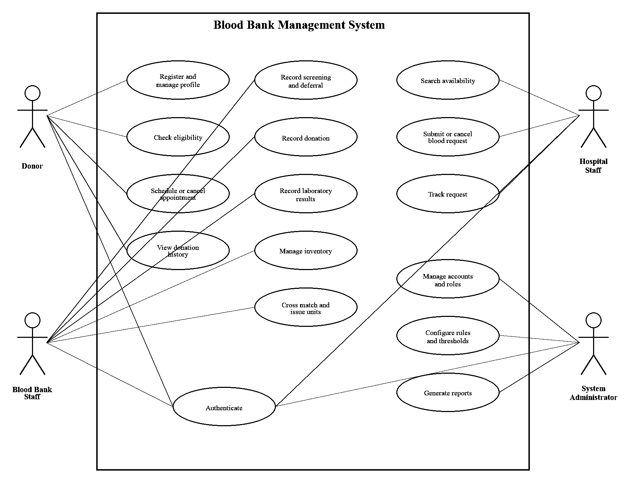
Figure 1 UML use case diagram

7.2 Detailed Use Cases

UC-01 Check Donor Eligibility
Field | Specification
Primary actor | Donor or Blood Bank Staff
Preconditions | An identified donor profile exists.
Trigger | An eligibility check is requested.
Main flow | The system loads current profile data, donation history, active deferrals and configured rules. It evaluates each rule and returns Eligible or Not Eligible with reasons.
Alternate and exception flow | Missing mandatory data produces an Incomplete decision. Rule-service failure produces no eligibility approval.
Postconditions | The decision and evaluation time are recorded.

UC-02 Record Donation and Units
Field | Specification
Primary actor | Blood Bank Staff
Preconditions | The donor is checked in and approved for donation.
Trigger | Staff record a completed collection.
Main flow | The system validates collection data, creates one donation identifier, creates unique component unit identifiers and sets each unit to Collected.
Alternate and exception flow | Duplicate identifiers or invalid volume values are rejected.
Postconditions | Donation and unit records exist with an audit event.

UC-03 Record Screening Results
Field | Specification
Primary actor | Blood Bank Staff
Preconditions | A unit exists in Testing state.
Trigger | Staff submit laboratory results.
Main flow | The system validates the test panel. An acceptable complete panel permits release to Available. A reactive, indeterminate or incomplete panel produces Quarantined status.
Alternate and exception flow | Unauthorized access, missing test type or invalid result value is rejected.
Postconditions | The unit status and audit record are updated.

UC-04 Submit Blood Request
Field | Specification
Primary actor | Hospital Staff
Preconditions | The hospital account is active.
Trigger | Hospital staff submit required blood details.
Main flow | The system validates group, component, quantity, priority, required-by time and clinical reference, then creates a Pending request.
Alternate and exception flow | Missing data is rejected. Duplicate client submission returns the existing request when the idempotency key matches.
Postconditions | A traceable Pending request exists.

UC-05 Reserve and Issue Blood Units
Field | Specification
Primary actor | Blood Bank Staff
Preconditions | An Approved request and compatible Available units exist.
Trigger | Staff select units for fulfilment.
Main flow | The system atomically reserves units, records cross-match results and issues acceptable units. The request becomes Partially Fulfilled or Fulfilled.
Alternate and exception flow | Failed cross-match releases the unit according to policy. Concurrent reservation conflict rejects the later request.
Postconditions | Unit and request states agree and an audit event exists.

UC-06 Manage Accounts and Roles
Field | Specification
Primary actor | System Administrator
Preconditions | The administrator is authenticated.
Trigger | An account is created, changed or deactivated.
Main flow | The system validates the role, branch scope and account status before saving the change.
Alternate and exception flow | The final active administrator cannot be deactivated through the interface.
Postconditions | The account change and audit event are stored.

8 Requirements Traceability
Table 5 Requirements traceability matrix
Requirement | Design allocation | Verification
FR-01 | Donor Service | Inspection and TC-F01
FR-02 | Donor Service | TC-F01
FR-03 | Donor Service | TC-F02
FR-04 | Donor Service | TC-F02
FR-05 | Donor Service | TC-F03
FR-06 | Donor Service | TC-F03
FR-07 | Donor Service | TC-F04
FR-08 | Donor Service | TC-F05
FR-09 | Donation and Screening Service | TC-F06
FR-10 | Donation and Screening Service | TC-F06
FR-11 | Donation and Screening Service | TC-F07
FR-12 | Donation and Screening Service | TC-F07
FR-13 | Donation and Screening Service | TC-F07
FR-14 | Donation and Screening Service | TC-F08
FR-15 | Donation and Screening Service | TC-F08
FR-16 | Donation and Screening Service | TC-F08
FR-17 | Inventory and Request Service | TC-F09
FR-18 | Inventory and Request Service | TC-F10
FR-19 | Inventory and Request Service | TC-F11
FR-20 | Inventory and Request Service | TC-F11
FR-21 | Inventory and Request Service | TC-F12
FR-22 | Inventory and Request Service | TC-F13
FR-23 | Inventory and Request Service | TC-F13
FR-24 | Inventory and Request Service | TC-F13
FR-25 | Authentication, Administration or Reporting | TC-S01
FR-26 | Authentication, Administration or Reporting | TC-S02
FR-27 | Authentication, Administration or Reporting | TC-F14
FR-28 | Authentication, Administration or Reporting | TC-F15
FR-29 | Authentication, Administration or Reporting | TC-F16
FR-30 | Authentication, Administration or Reporting | TC-S03
NFR-01 | Cross-cutting architecture | TC-N01
NFR-02 | Cross-cutting architecture | TC-N02
NFR-03 | Cross-cutting architecture | Operational review
NFR-04 | Cross-cutting architecture | TC-N03
NFR-05 | Cross-cutting architecture | TC-N04
NFR-06 | Cross-cutting architecture | TC-N05
NFR-07 | Cross-cutting architecture | TC-N06
NFR-08 | Cross-cutting architecture | Code review
NFR-09 | Cross-cutting architecture | TC-S02
NFR-10 | Cross-cutting architecture | TC-N07
NFR-11 | Cross-cutting architecture | TC-S04
NFR-12 | Cross-cutting architecture | Inspection
SEC-01 | Security architecture | TC-S02
SEC-02 | Security architecture | Code review
SEC-03 | Security architecture | TC-S01
SEC-04 | Security architecture | TC-S05
SEC-05 | Security architecture | Configuration inspection
SEC-06 | Security architecture | TC-S06
SEC-07 | Security architecture | TC-S03
SEC-08 | Security architecture | TC-N03
SEC-09 | Security architecture | TC-S04
SEC-10 | Security architecture | TC-S01

References
[1] ISO IEC IEEE 29148 2018, Systems and software engineering, Life cycle processes, Requirements engineering.
[2] IEEE 829 2008, Standard for Software and System Test Documentation, used as the course-aligned document structure. The standard has been superseded by the ISO IEC IEEE 29119 series.
[3] IEEE 1016 2009, Standard for Information Technology, Systems Design, Software Design Descriptions.
[4] Ministry of Health and Family Welfare, Government of India, National Standards for Blood Centres, Annexure 4 Criteria for Selection of Blood Donor.
[5] Central Drugs Standard Control Organization, Drugs and Cosmetics Act 1940 and Rules 1945, Schedule F provisions for blood banks.
[6] eRaktKosh, Ministry of Health and Family Welfare, overview of centralized donor, testing, inventory and notification functions.
[7] Django Software Foundation, Django documentation for authentication, security and database transactions.

Appendix A Compliance Checklist
Deliverable requirement | Location in this document | Status
SRS in IEEE-aligned format | Sections 1 to 8 | Complete
Introduction and descriptive SRS sections | Sections 1 to 3 | Complete
Clear functional and non-functional requirements | Section 4 | Complete
At least one UML use-case diagram | Section 7, Figure 1 | Complete
At least two security objectives and requirements | Section 6 | Complete
Traceability with test plan | Section 8 | Complete

