Blood Bank Management System
Software Architecture and Design Specification
Part C Software Architecture and Design Specification
Course UE24CS341A Software Engineering
Document identifier BBMS SADS 1.0
Version 1.0 29 September 2026
Nimay Balal PES1UG24CS301
Nikita Mankani PES1UG24CS300
Niyatee Singh PES1UG24CS305
Nishitha S PES1UG24CS304

Document Control
Item | Value
Document title | Software Architecture and Design Specification
Document identifier | BBMS SADS 1.0
Version | 1.0
Status | Submission copy
Prepared by | Nimay Balal, Nikita Mankani, Niyatee Singh and Nishitha S
Course | UE24CS341A Software Engineering
System scope | Architecture, components, data model, security controls, interactions and APIs

Revision History
Version | Date | Description | Authors
1.0 | 29 September 2026 | Complete part c software architecture and design specification for Part 1 submission | Project team

Approval Record
Role | Name | Signature | Date
Faculty evaluator
Team representative

Table of Contents

1 Introduction

1.1 Purpose
This specification describes the architecture, components, data model, security controls, interactions, APIs and error-handling design used to satisfy the requirements defined in the Software Requirements Specification, document identifier BBMS SRS 1.0.

1.2 Design Scope
The design covers a Django and PostgreSQL web application deployed behind Nginx. It focuses on a semester-scale system while preserving clear module boundaries and branch-aware data for later growth.

1.3 Design Principles
- Keep business rules outside browser templates and database views.
- Enforce authorization and validation on the server.
- Use transactions for reservation, issue and other multi-record state changes.
- Keep eligibility and shelf-life rules configurable and auditable.
- Expose the minimum information required for each role.

2 Architectural Drivers
Driver | Design response
Sensitive donor and medical data | RBAC, branch scope, HTTPS, minimal disclosure and audit logging
Inventory integrity | State machine, database constraints and transactional reservation and issue
Changing operational rules | Configuration tables and rule service
Semester implementation scope | Modular monolith rather than distributed services
Future branch expansion | Branch identifiers and scoped queries in the initial schema
Testability | Service-layer functions and explicit component interfaces

3 Architecture Description

3.1 Selected Pattern
The system uses a layered modular monolith. Browser-facing views call service-layer modules, service modules apply business rules and data-access code uses the Django object-relational mapper. This pattern is appropriate for a small team because deployment remains simple while domain boundaries remain testable.

3.2 Layer Responsibilities
Layer | Responsibilities
Presentation | Django views, templates, forms, API serializers and role-specific navigation
Application services | Use-case orchestration, authorization checks and transaction boundaries
Domain services | Eligibility, unit lifecycle, compatibility, request workflow and alert rules
Data access | Django models, query services, constraints and migrations
Infrastructure | Email, scheduled tasks, logs, backups, Nginx and database connections

3.3 Component Diagram
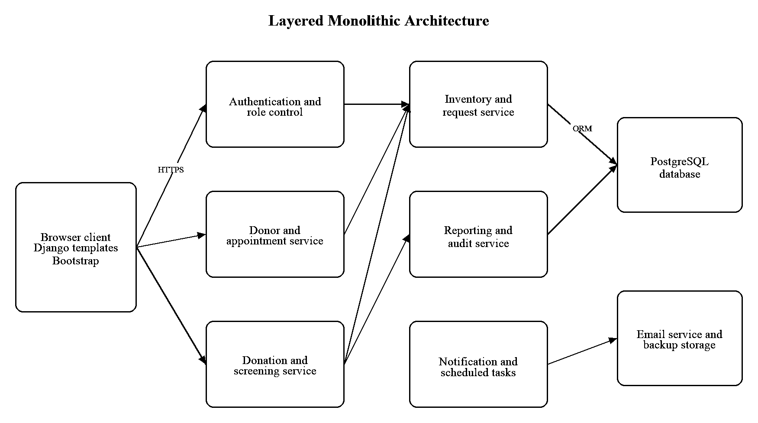
Figure 1 Component diagram

3.4 Deployment View
A browser connects to Nginx over HTTPS. Nginx forwards application traffic to Gunicorn workers running Django. Django uses a restricted database account to connect to PostgreSQL. Scheduled tasks share application code but run under a separate process. Email and backup storage use distinct restricted credentials.

4 Component Design
Component | Main responsibilities | Requirement allocation
Authentication and Role Control | Login, lockout, sessions, account status and authorization | FR-25, FR-26, SEC-01 to SEC-05, SEC-10
Donor and Appointment Service | Profiles, eligibility, deferrals, slots and donor history | FR-01 to FR-08
Donation and Screening Service | Collection, components, test panel and quarantine | FR-09 to FR-13
Inventory and Request Service | Unit states, expiry, search, requests, reservation, cross-match and issue | FR-14 to FR-24
Administration Service | Branches, configurable rules and thresholds | FR-27
Reporting and Audit Service | Reports and append-only application audit events | FR-28, FR-30, SEC-07
Notification and Task Service | Email, reminders, alerts, expiry task and backup trigger | FR-18, FR-29, NFR-04

4.1 Unit State Machine
Current state | Permitted next states | Condition
Collected | Testing or Discarded | Testing begins or collection is rejected
Testing | Available, Quarantined or Discarded | Mandatory panel and review determine outcome
Available | Reserved, Expired or Discarded | Request allocation, time expiry or authorized disposal
Reserved | Available, Issued or Expired | Reservation release, successful issue or expiry
Issued | None | Terminal state
Quarantined | Discarded | Authorized disposal
Expired | Discarded | Authorized disposal
Discarded | None | Terminal state

4.2 Request State Machine
Current state | Permitted next states
Pending | Approved, Rejected or Cancelled
Approved | Partially Fulfilled, Fulfilled or Cancelled
Partially Fulfilled | Fulfilled or Cancelled
Fulfilled | None
Rejected | None
Cancelled | None

5 Data Design
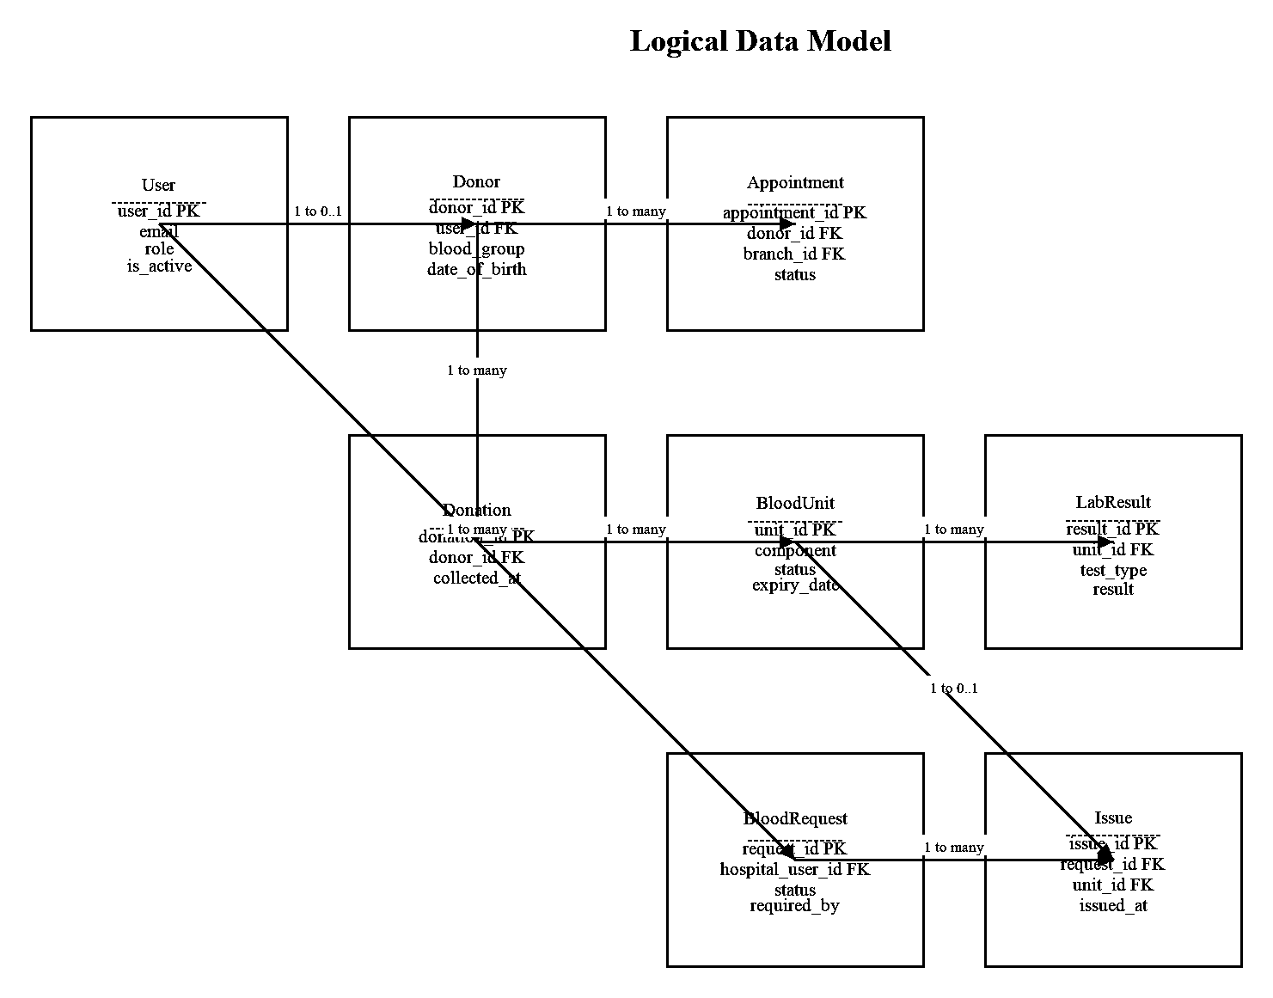
Figure 2 Logical data model

5.1 Database Constraints
- Unique constraints protect account email, donation ID and unit ID.
- Foreign keys prevent orphaned donation, result, request and issue records.
- Database checks restrict enumerated state values and positive quantities.
- A conditional unique constraint prevents more than one active reservation for a unit.
- Transactional service methods lock candidate unit rows during reservation and issue.

5.2 Audit Design
AuditEvent stores actor, branch, event type, affected record type, affected record ID, UTC timestamp, outcome and a structured summary of changed fields. Application roles have no update or delete path for this table. Database and backup access remain restricted to service accounts and designated administrators.

6 Security Architecture

6.1 Trust Boundaries
- The public network ends at Nginx, which terminates HTTPS and forwards only expected traffic.
- The Django application is the only normal path to the database.
- Email and backup services use separate credentials and receive only required data.
- Browser input is untrusted and is validated at form, serializer and service boundaries.

6.2 Authentication and Session Design
Django authentication provides password hashing and session management. The login service applies generic errors and account lockout. Session middleware applies inactivity timeout. Deactivation invalidates active sessions through a recorded account-status change.

6.3 Authorization Design
Each application service checks the account role, active status and branch scope before reading or changing protected records. Templates hide unauthorized actions, but server checks remain authoritative. Object-level filters prevent access by guessed identifiers.

6.4 Input and Output Protection
Django forms and serializers validate type, length, range and permitted values. CSRF tokens protect browser state changes. Templates use automatic output escaping. File upload is outside the initial release, which reduces the attack surface.

6.5 Logging Backup and Recovery
Security events and operational changes create structured audit records without passwords or unnecessary medical details. Backups are encrypted, access-controlled and periodically restored in the acceptance environment. Restoration evidence includes completion time and record comparison.

7 Sequence Design
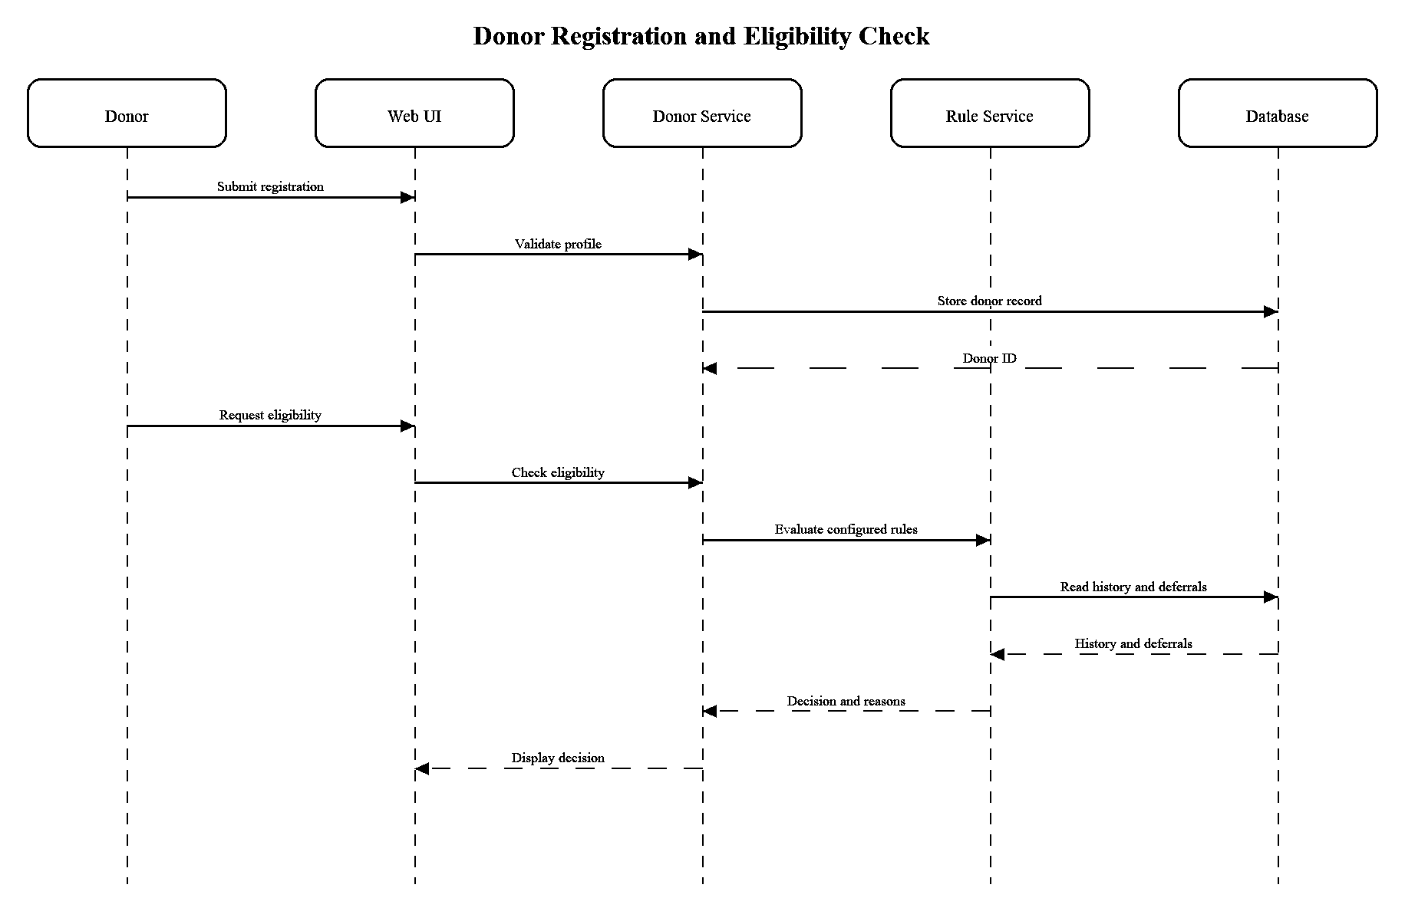
Figure 3 Sequence diagram for registration and eligibility
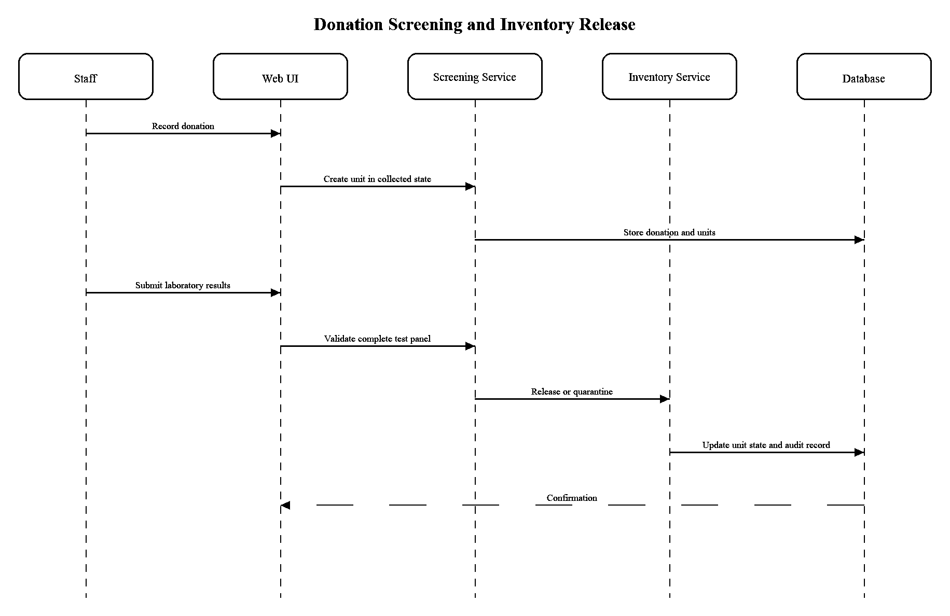
Figure 4 Sequence diagram for screening and inventory release
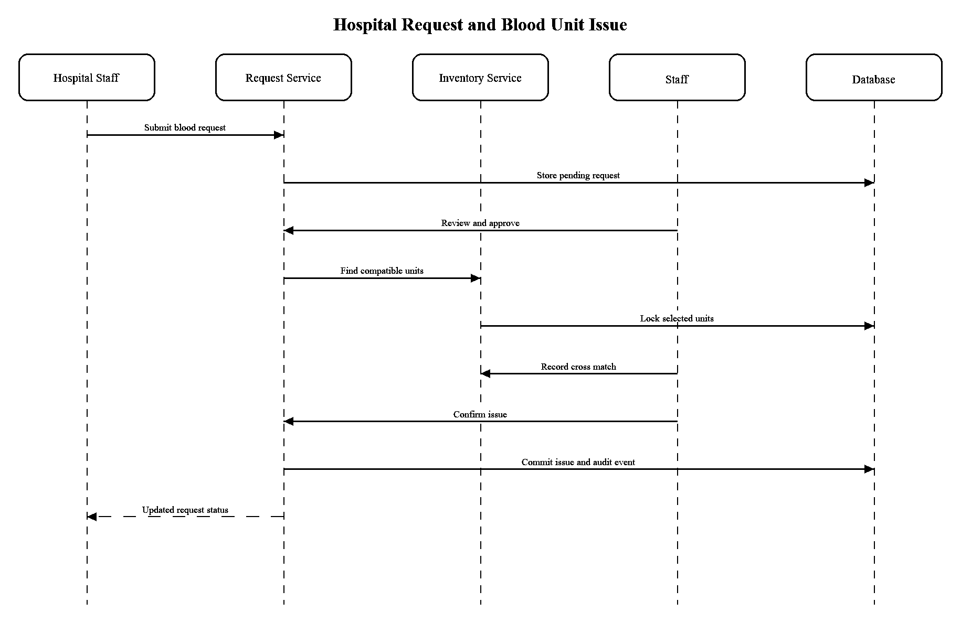
Figure 5 Sequence diagram for request and issue

8 API Design

8.1 API Conventions
- The base path is /api/v1 and payloads use JSON.
- Authentication uses the same secure session as the web application for the first release.
- State-changing requests require CSRF protection and a valid authorized session.
- Validation errors use a stable error code and field-level details.
- Reservation and issue endpoints accept an idempotency key to reduce duplicate processing.

8.2 Endpoint Summary
Table 1 API endpoint summary
Method | Path | Role | Purpose | Responses
POST | /api/v1/auth/login | Public | Authenticate an account and create a session | 200, 400, 401, 423
POST | /api/v1/donors | Public | Register a donor profile | 201, 400, 409
GET | /api/v1/donors/{id}/eligibility | Donor or Staff | Return eligibility decision and reasons | 200, 403, 404
POST | /api/v1/appointments | Donor | Create an appointment | 201, 400, 409
PATCH | /api/v1/appointments/{id} | Donor or Staff | Reschedule or cancel an appointment | 200, 400, 403, 409
POST | /api/v1/donations | Staff | Record a donation and component units | 201, 400, 403, 409
POST | /api/v1/units/{id}/lab-results | Staff | Record a screening result | 201, 400, 403, 409
GET | /api/v1/inventory | Staff or Hospital Staff | Search authorized stock information | 200, 400, 403
POST | /api/v1/requests | Hospital Staff | Create a blood request | 201, 400, 403
PATCH | /api/v1/requests/{id}/status | Staff | Approve, reject or cancel a request | 200, 400, 403, 409
POST | /api/v1/requests/{id}/reserve | Staff | Reserve compatible units atomically | 200, 400, 403, 409
POST | /api/v1/issues | Staff | Issue cross-matched units | 201, 400, 403, 409
GET | /api/v1/reports/inventory | Admin or Staff | Generate an inventory report | 200, 400, 403

8.3 Standard Error Body
An API error contains code, message, field_errors when relevant, correlation_id and timestamp. Messages do not expose stack traces, database details, password status or the existence of an unregistered account.

9 Error Handling
Condition | System response | HTTP or UI result | Audit or log
Invalid field input | Reject before service execution | 400 with field errors | Application log for repeated abuse only
Unauthenticated access | Do not execute operation | 401 or login redirect | Authentication event
Unauthorized access | Do not disclose protected record | 403 with generic message | Security audit event
Missing record | Return stable not-found response | 404 | Normal request log
State or concurrency conflict | Rollback and return current state | 409 | Operational audit event
Email failure | Record failure and schedule bounded retry | Primary transaction remains committed | Integration log
Database failure | Rollback transaction and show correlation ID | 500 with generic message | Error log and administrator alert

9.1 Exception Handling Rules
- Domain exceptions represent validation, authorization, state-transition and conflict errors.
- Views translate known exceptions into stable user messages and status codes.
- Unexpected exceptions are logged once with a correlation ID and produce a generic response.
- Transactions roll back whenever one step of reservation or issue fails.
- No exception message contains a password, secret, full medical history or database query.

10 Design Traceability
Requirement group | Primary components | Design evidence
FR-01 to FR-08 | Donor and Appointment Service | Use case UC-01, state validation and Figure 3
FR-09 to FR-13 | Donation and Screening Service | UC-02, UC-03 and Figure 4
FR-14 to FR-24 | Inventory and Request Service | State tables, UC-04, UC-05 and Figure 5
FR-25 to FR-30 | Authentication, Administration, Reporting and Audit | Role matrix, API and error-handling design
NFR-01 to NFR-12 | All layers and deployment | Performance limits, constraints, backup and compatibility design
SEC-01 to SEC-10 | Security architecture | Sections 6.1 to 6.5 and TC-S01 to TC-S03

11 Design Decisions and Limitations
- A modular monolith avoids the operational cost of distributed services while retaining service boundaries.
- PostgreSQL is selected to remove the earlier unresolved database choice and to support constraints and transactions.
- Clinical analyser integration, barcode printing and national identity integration remain future work.
- The design requires professional approval of eligibility, shelf-life and retention configuration before operational use.

References
[1] ISO IEC IEEE 29148 2018, Systems and software engineering, Life cycle processes, Requirements engineering.
[2] IEEE 829 2008, Standard for Software and System Test Documentation, used as the course-aligned document structure. The standard has been superseded by the ISO IEC IEEE 29119 series.
[3] IEEE 1016 2009, Standard for Information Technology, Systems Design, Software Design Descriptions.
[4] Ministry of Health and Family Welfare, Government of India, National Standards for Blood Centres, Annexure 4 Criteria for Selection of Blood Donor.
[5] Central Drugs Standard Control Organization, Drugs and Cosmetics Act 1940 and Rules 1945, Schedule F provisions for blood banks.
[6] eRaktKosh, Ministry of Health and Family Welfare, overview of centralized donor, testing, inventory and notification functions.
[7] Django Software Foundation, Django documentation for authentication, security and database transactions.

Appendix A Compliance Checklist
Deliverable requirement | Location in this document | Status
Component diagram and description | Section 3.3, Figure 1 and Section 4 | Complete
Architecture pattern | Section 3.1 | Complete
Architecture traceability | Section 10 | Complete
Security architecture | Section 6 | Complete
At least two UML sequence diagrams | Section 7, Figures 3 to 5 | Complete
API design | Section 8 | Complete
Error handling | Section 9 | Complete

