1 有一个记录学生信息的文件，每一行记录一名学生的信息，格式入下 学号\t 姓名\t 性别\t 分数 1\t 分数 2\t 分数 3\n. 要求：（1）读取文件的内容，串成一个链表。 （2）按照总分递减排序将结果保存到原文件。

typedef struct node{

int num;

char name[20];

float score1;

float score2;

float score3;

float sum;

struct node* next;

}stu,*pstu;

void tailIn(pstu* pphead, pstu* pptail, stu s)

{

float sum;

pstu pcur, ppre, pnew;

pnew = (pstu)malloc(sizeof(stu));

memset(pnew, 0, sizeof(stu));

strcpy(pnew->name, s.name);

pnew->num = s.num;

pnew->score1 = s.score1;

pnew->score2 = s.score2;

pnew->score3 = s.score3;

sum = s.score1 + s.score2 + s.score3;

pnew->sum = sum;

pcur = *pphead;

ppre = *pphead;

if (NULL == pcur) {

*pphead = pnew;

*pptail = pnew;

}

else if (sum < pcur->sum) {

pnew->next = pcur;

*pphead = pnew;

}

else {

while (pcur != NULL) {

if (pcur->sum > sum) {

ppre->next = pnew;

pnew->next = pcur;

break;

}

ppre = pcur;

pcur = pcur->next;

}

if (NULL == pcur)

{

(*pptail)->next = pnew;

*pptail = pnew;

}

}

}

int main() {

stu s = { 10001,"xiaoxiao",95.03,98.99,90.20 };

//stu s = { 0 };

FILE* fp = fopen("d:\\text.txt", "r+");

int ret,retse,count=0;

pstu phead = NULL, ptail = NULL;

if (NULL == fp) {

perror("fopen");

}

while ((ret = fscanf(fp,"%d%s%f%f%f", &s.num, s.name, &s.score1, &s.score2, &s.score3))!= EOF) {

tailIn(&phead, &ptail,s);

printf("ret is: %d\n", ret);

count++;

//if (count == 4) break;

}

retse = fseek(fp, 0, SEEK_SET);

for (int i = 0; i < count; i++) {

fprintf(fp,"%d %s %5.2f %5.2f %5.2f %5.2f\n", phead->num, phead->name, phead->score1, phead->score2, phead->score3, phead->sum);

phead = phead->next;

}

return 0;

}

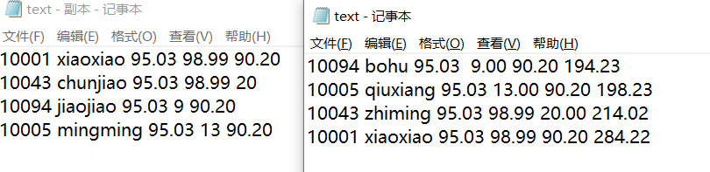

2 建树及调整过程

