1 九九乘法表

#include <stdio.h>

int main()

{

for (int i = 1; i < 10; i++)

{

for (int j = 1; j < 10; j++)

{

printf("%d\*%d=%2d\t", i, j, i \* j); // \t为转义符“Tab”键

}

printf("\n");

}

return 0;

}

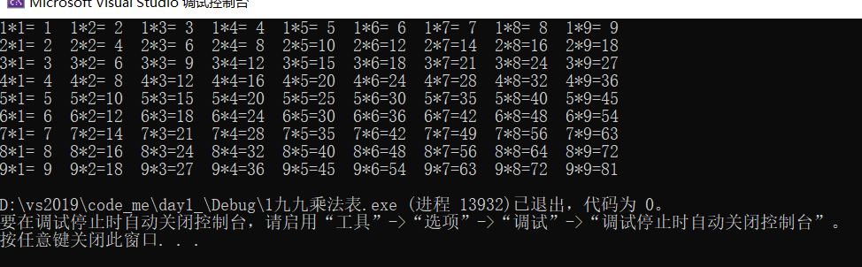

2.1 打印失心菱形

#include <stdio.h>

#include <stdlib.h>

int main() {

int i; // 当前行

int j; // 当前列

int n = 10;

for (int i = 1; i <= n / 2 + 1; i++) {

for (int j = 1; j <= n / 2 + 1 - i; j++) {

printf(" ");

}

for (int j = 0; j < 2 \* i - 1; j++) {

if (j % 2 == 0) printf(" ");

else printf("\*");

}

printf("\n");

}

for (int i = n / 2; i >= 1; i--) {

for (int j = 1; j <= n / 2 + 1 - i; j++) {

printf(" ");

}

for (int j = 0; j < 2 \* i - 1; j++) {

if (j % 2 == 0) printf(" ");

else printf("\*");

}

printf("\n");

}

printf("\n");

return 0;

}

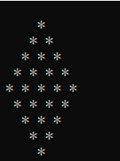

2.2 打印空心菱形

#include <stdio.h>

#include <stdlib.h>

int main() {

int i; // 当前行

int j; // 当前列

for (int i = 5; i >= 1; i--)

{

for (int j = 1; j <= 9; j++)

{

if ((j == i) || (j + i == 10 ))

{

printf("\*");

}

else

printf(" ");

}

printf("\n");

}

for (int i = 2; i <= 5; i++)

{

for (int j = 1; j <= 9; j++)

{

if ((j == i) || (j + i == 10))

{

printf("\*");

}

else

printf(" ");

}

printf("\n");

}

printf("\n");

return 0;

}

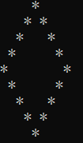

2.3

#include <stdio.h>

#include <stdlib.h>

int main() {

int i; // 当前行

int j; // 当前列

int n = 20;

for (int i = 1; i <= n / 2 + 1; i++) {

if (i <= 7)continue;

for (int j = 1; j <= n / 2 + 1 - i; j++) {

printf(" ");

}

for (int j = 0; j < 2 \* i - 1; j++) {

int comI = i;

//if (i == 8 && (j >= 8 || j <= 12) || i == 9 && (j >= 9 || j <= 11)) continue;

if (j % 2 == 0) printf(" ");

else if (comI==8 && (j>=6 && j<=10 )) continue;

else printf("\*");

}

printf("\n");

}

for (int i = n / 2; i >= 1; i--) {

for (int j = 1; j <= n / 2 + 1 - i; j++) {

printf(" ");

}

for (int j = 0; j < 2 \* i - 1; j++) {

if (j % 2 == 0) printf(" ");

else printf("\*");

}

printf("\n");

}

printf("\n");

return 0;

}

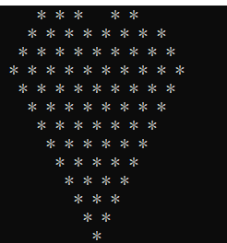

3.1 有序数列

#include <stdio.h>

#include <stdlib.h>

int main()

{

int a1[] = { 1, 2, 3, 5, 6, 7, 8, 9, 10, 11, };

int a2[] = { 1, 3, 4, 6, 7, 8, 9, 10, 11, };

int l1 = sizeof(a1) / sizeof(int);

int l2 = sizeof(a2) / sizeof(int);

for (int now1 = 0, now2 = 0; (now1 < l1) && (now2 < l2);) {

if (a1[now1] == a2[now2]) {

printf("%d ", a1[now1]);

now1++;

now2++;

}

else if (a1[now1] < a2[now2])

now1++;

else

now2++;

}

printf("\n");

system("pause");

return 0;

}

