1. Client (Unity)

* UI

Maybe, there are no issue and question.

* Script
  + CanvasManger.cs

There are only button feature.

* + Authentication.cs

Login Api: http://127.0.0.1:13756/account/login

Register API: http://127.0.0.1:13756/account/create

Login function: public void OnLoginClick()

Register Function: public void OnCreateClick()

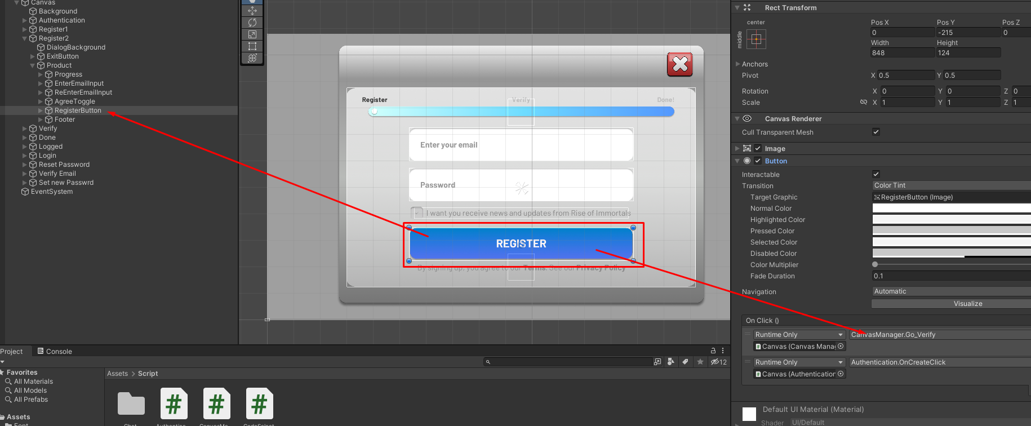

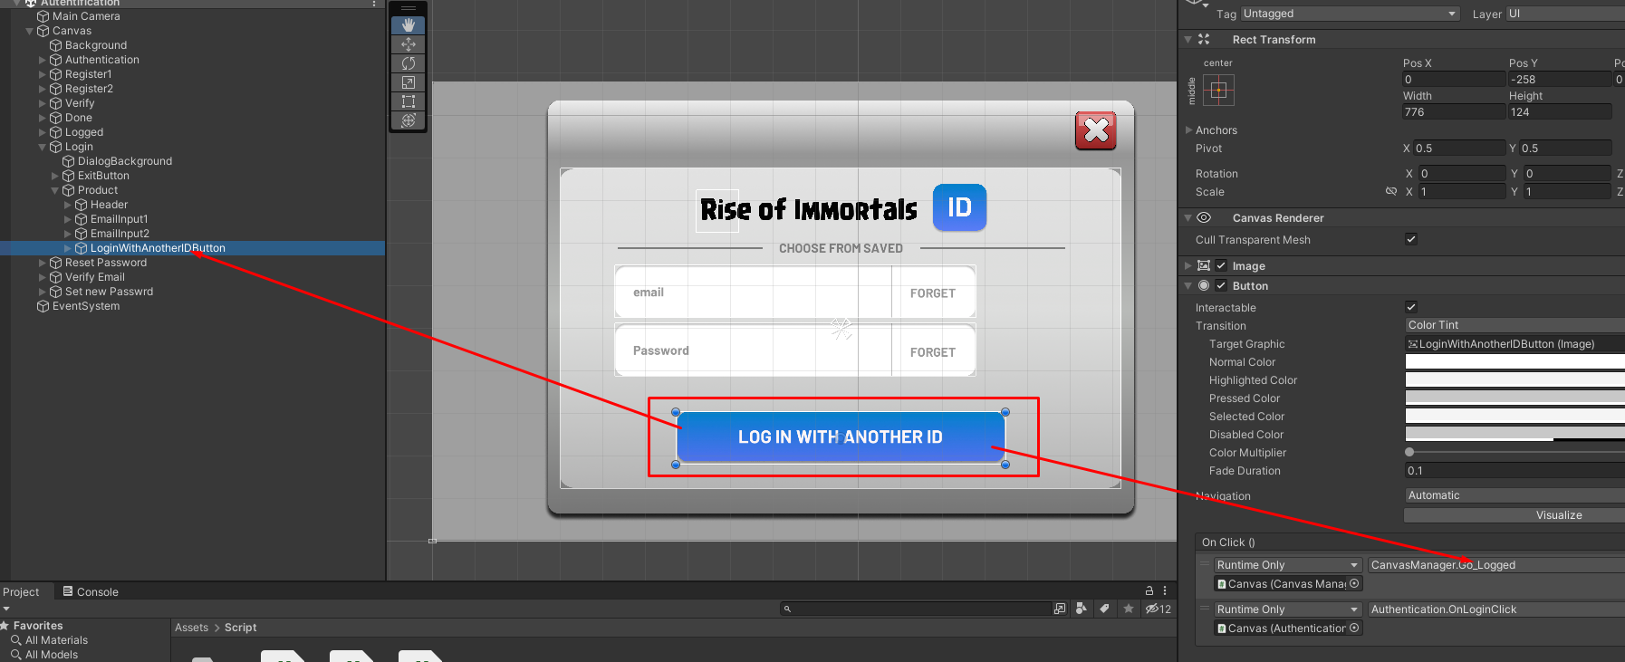

Server Request Code:

        WWWForm form = new WWWForm();

        form.AddField("REmail", Username);

        form.AddField("RPassword", Password);

        UnityWebRequest request = UnityWebRequest.Post(LoginEndpoint, form);

        var handler = request.SendWebRequest();

1. Backend

* Authentication
  + Model

    email: String,

    password: String,

    planername: String,

    playerlevel: Number,

    level: Number,

    gold: Number,

    elixir: Number,

    blackelixir: Number,

    gem: Number,

    maxgold: Number,

    maxlixir: Number,

    ownedbuildings: [],

    lastAuthentication: Date,

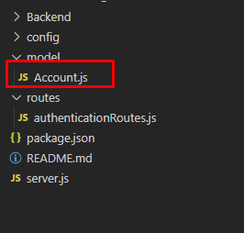

* + Routes (API)

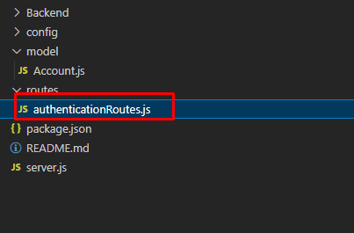

* + - Test API

Route: /

Method: Get

Result: “server is working”

* + - Login API

Route: /account/login

Method: Post

Request Data:

REmail: String // email address

RPassword: String // password

Result:

Error Message: “Invalid Credentials!”

Success Message: Account Data.

* + - Register API

Route: /account/Create

Method: Post

Request Data:

REmail: String // email address

RPassword: String // password

Result:

Error Message: “Invalid Credentials!” or “Username is Already Taken”

Success Message: Account Data.

Saving Data:

email : request value

password : request value

planername : “”

playerlevel : 1

level : 1

gold : 1000

elixir : 1000

blackelixir : 1000

gem : 5000

maxgold : 100000

maxlixir : 10000000

ownedbuildings : [{id: 1, pos:[{x:21, y:21}]}]

lastAuthentication : created Data.

* + - Get account Infomation API

Route: /account/info

Method: Get

Request Parameter:

Id : account unique _ID

Format: http://127.0.0.1:13756/account/info?id=637aadb301db7d54442ecab5

Result:

Error Message: “Invalid Get Info!” or “There is no that user info”

Success Message: Account Data.

* + - Update account API

Route: /account/update

Method: Post

Request Data:

                        id, (you have to send account id)

                        planername,

                        playerlevel,

                        level,

                        gold,

                        elixir,

                        blackelixir,

                        gem,

                        maxgold,

                        maxlixir,

                        ownedbuildings

Result:

Error Message: “Invalid Credentials!”

Success Message: “Update Successfully”.

* Chatting box system
  + Client (unity)

ChatbBox.unity (Scene)

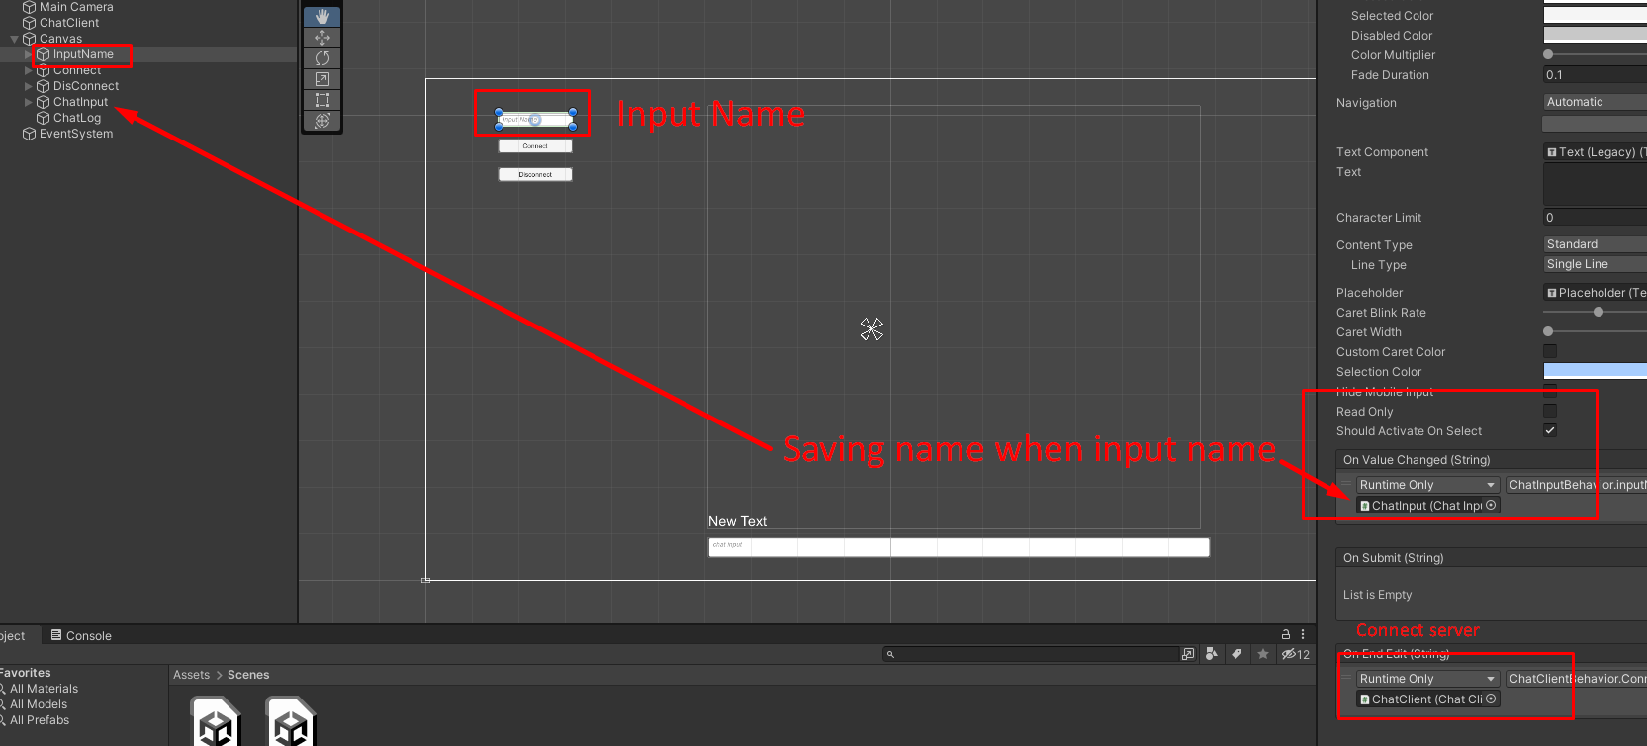

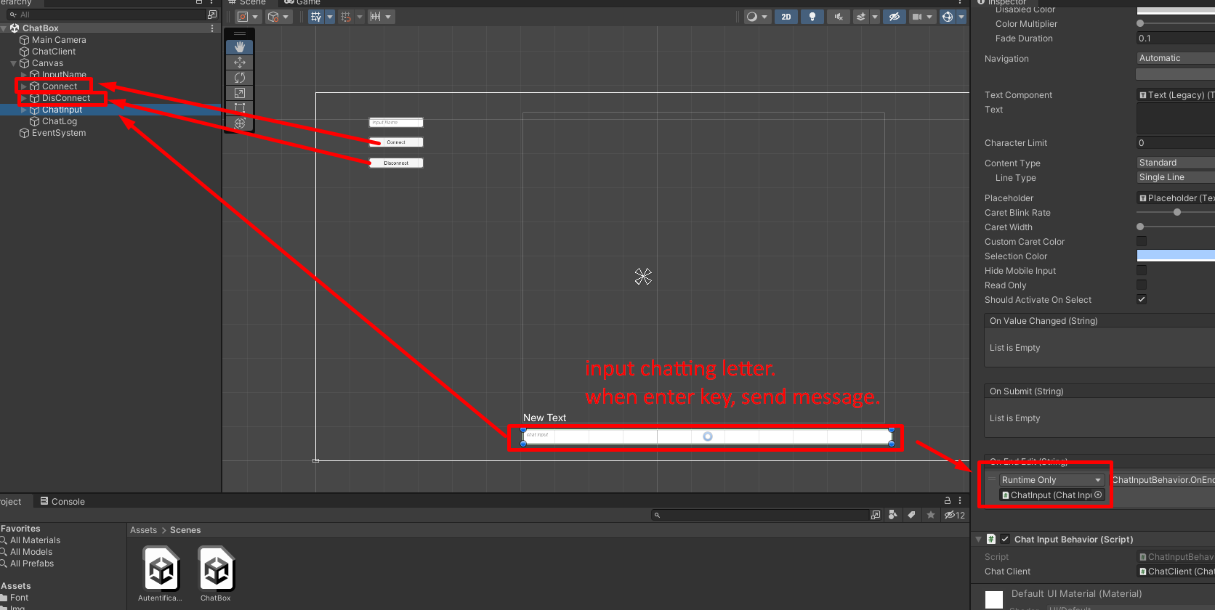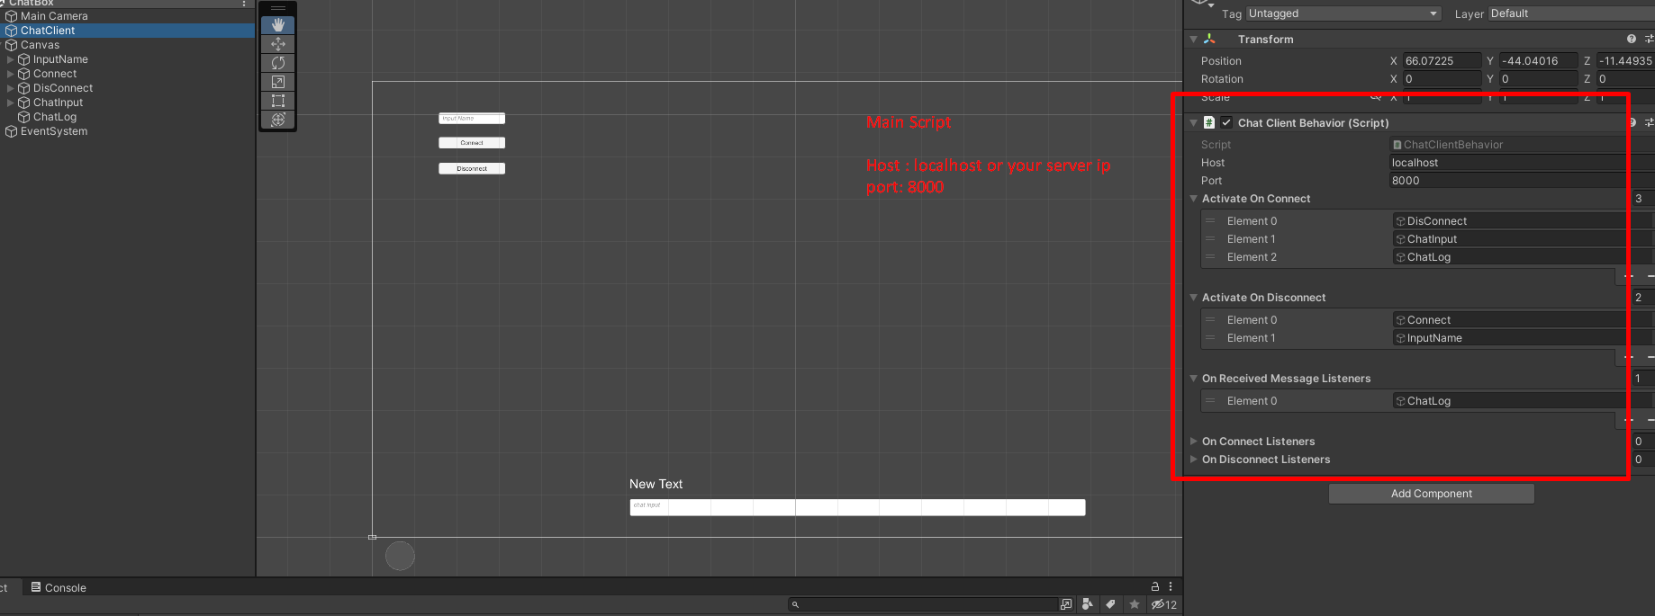

* Script (c#)
  + ChatClientBehavior
    - Functions

Connect()

Send()

Disconnect()

…

* + ChatInputBehavior
    - Functions

OnEndEdit()

* + ChatLogBehavior
    - OnReceiveMessage(string s)
* Backend Server (Node)

Port: 8000