IPD Admission
Feature Documentation
Story · Entry Channels · Scenario Diversity · Reference Tables · Data Flow Diagram
Scope
This document covers only the Admission phase — the first of the eight phases in the IPD cycle (from "someone decides the patient needs inpatient care" through to a registered Admission record awaiting bed assignment). Bed allocation and everything after it is out of scope here; see IPD_Complete_Workflow_Functional_Requirements.docx for the full cycle, and IPD_Full_Cycle.pptx for a one-slide-per-phase visual map. Nothing described here is built yet — this is planning and specification only.

1. Story
Four admissions, told as they'd actually happen, to show what this phase looks like from the inside — however it starts, it ends at the same place: a registered Admission record, awaiting a bed.

1.1 The emergency admission
It's 11:40pm. A 58-year-old man walks into the ER doubled over with abdominal pain. The ER physician examines him, orders a bedside ultrasound and bloodwork, and diagnoses acute cholecystitis — the gallbladder needs to come out, and he needs to be admitted tonight, not scheduled for next week.
The doctor doesn't wait for paperwork. He requests admission — type: emergency — right from the ER. That request becomes an Admission record, status requested, with a provisional diagnosis attached. The two investigation orders he already placed stay linked to this Admission even though no bed exists for it yet.
While the patient is still being stabilized, the admission desk starts registration in parallel: identity, next of kin, insurance details, admission consent. None of this blocks anything clinical. When registration completes, the Admission moves to admitted (awaiting bed), a consent record is created, and bed allocation — the next phase — picks up.

1.2 The elective admission
A different patient has been seeing her doctor in OPD for two weeks about a hernia that isn't improving. At today's follow-up, the doctor decides it's time: she needs surgery, and that means an inpatient stay. He requests admission — type: elective — directly from her existing appointment record, so this new episode stays linked to the visit that led to it.
Because nothing here is urgent, the sequence is calmer: the front desk completes full registration before anything else happens. Only once that's done does the Admission move to admitted (awaiting bed). The clinical picture was already captured by the doctor at the point of request — the two paths converge on the same record shape, just in a different order.

1.3 The other paths, briefly
Two more patients, entering the same phase from different directions — neither of them starting with a doctor already standing in front of them.
A nurse doing evening rounds notices a patient's breathing has gotten worse over her shift. She isn't the one who decides whether this patient gets admitted — but she can flag it. She logs an admission referral: patient, what she's observed, why she's concerned. It lands with a doctor for review. He examines the patient, agrees, and requests admission himself — the referral is now linked to a real Admission record. If he'd disagreed, the referral would simply close with his reasoning attached, and nothing else would happen.
Separately, a man walks into the hospital lobby and tells the front desk he wants to be admitted — he's been feeling unwell for days and has decided today is the day. The front desk can't admit him on the strength of that alone. What they can do is log the same kind of referral a nurse would, and route him to a doctor for an ad hoc review. Once the doctor examines him and agrees admission is warranted, a nurse sits with him and walks through what's about to happen — what the stay will involve, what he's consenting to — before the front desk captures that consent and completes registration. Nobody at the front desk ever creates an Admission out of thin air; a doctor's decision always sits underneath it.
The pattern underneath every story
Every admission — however it starts — becomes exactly one thing: an Admission record in status requested, created by a doctor, which becomes admitted once registration and consent are captured. What changes between channels is only how a doctor ends up making that decision, and whether anything has to happen before the patient's consent can be captured. See Section 2 for the full picture.

2. Entry Channels
An admission can start from six different places — a doctor mid-consult, a nurse's concern, a patient walking in, a patient's own app, or an ER exam. All six converge on the same two-step process already described in Sections 3.1–3.2 (create the request, then complete registration). This section explains how each channel reaches that point, and what has to happen first.

2.1 Two gates, not one process per channel
Rather than build a separate workflow per channel, there are exactly two checks that apply depending on how an admission started:
- Clinical review gate — every admission needs a doctor's decision before it becomes a real Admission request. When a doctor is already the one deciding (in a consult, on a ward round, examining someone in the ER), this gate is automatically satisfied — there's nothing separate to pass. When someone other than a doctor raises the possibility (a nurse's concern, a patient asking at the front desk), it has to be reviewed and approved by a doctor first.
- Informed approval gate — every non-emergency admission needs the patient's explicit, informed consent before registration completes. For referral-sourced admissions specifically, a nurse walks the patient through what's about to happen before that consent is captured — not just a signature, an actual explanation.

2.2 Channel comparison
Channel | Who initiates | Clinical review gate | Approval gate | Fast path?
Doctor, in-consult | Doctor (OPD, ward round, or examining in ER) | Already satisfied — the requesting doctor is the reviewer | Standard consent captured at registration (3.2) | No, unless also emergency
Nurse escalation | Nurse, via an Admission Referral | Required — a doctor reviews the referral before any request exists | Nurse explains the plan; patient approves before registration | No
Walk-in patient request | Patient, via front desk logging a referral | Required — front desk cannot admit on a patient's request alone | Nurse explains the plan; patient approves before registration | No
Patient app — planned procedure | Patient, confirming a date for a procedure a doctor already recommended | Already satisfied by the doctor's prior recommendation | Standard consent captured at registration (3.2) | No
Patient app — emergency alert | Patient, submitting before arrival | Not a review request — an alert only, see 2.3 | N/A until the patient physically arrives | Converts to the channel below on arrival
Emergency / MLC arrival | ER doctor, on examination | Doctor decides on the spot — no separate referral step | Consent captured as soon as practical; never blocks care | Yes — bypasses both gates

2.3 The patient-app channels, specifically
[FACT] A planned-procedure request through the app only makes sense once a doctor has already recommended the procedure — the app lets the patient pick and confirm a date within that plan, the same way appointment booking already works. It doesn't let a patient originate an admission a doctor hasn't discussed with them.
[HOSPITAL-SPECIFIC DECISION] An emergency submission through the app is an alert, not an admission — it notifies the hospital that this patient is inbound with an emergency so staff can prepare. It never creates an Admission record by itself. The moment the patient physically arrives, this is the same Emergency / MLC arrival channel as anyone who didn't use the app — an ER doctor examines them and makes the actual decision.

2.4 What a nurse can and can't do here
A nurse can raise an Admission Referral — flagging a patient, with reasoning, for a doctor's review. A nurse cannot create an Admission request themselves; that action belongs to a doctor in every channel, without exception. This mirrors how the rest of the system already treats clinical orders: a nurse acts on and around a doctor's decisions, but doesn't originate them.

2.5 Not yet decided
[OPEN QUESTION] Minor / guardian admission — who signs consent, and how a guardian's identity is captured and verified, isn't defined yet. This applies across every channel, not just referral-sourced ones.
[OPEN QUESTION] Medico-legal cases (MLC) — assault, road traffic accidents, poisoning, and similar cases usually carry extra reporting obligations in most hospital settings. There's no MLC flag or associated workflow yet; an MLC currently just follows the Emergency arrival fast path with nothing to mark it as one.

3. Diversity — Scenario Variations
Section 2 covered who can start an admission and what has to happen first. This section covers how the admission itself varies once it exists.

3.1 Variations the design already accounts for
Dimension | Variations | What actually differs
Admission type | emergency / elective / day_care / referral | Stored as a single admission_type field on the same Admission record — not separate tables or separate workflows. It changes sequencing, not structure.
Sequencing | Emergency vs. everything else | Emergency admissions can have a bed allocated before registration paperwork is complete. Every other type completes registration first.
Origin | Standalone request vs. linked to an existing OPD appointment vs. linked to an Admission Referral | source_appointment_id and the referral link (2.2) let the two episodes read as one continuous story instead of disconnected records.
Payer / billing basis | Self-pay / insured / corporate | Read directly from the patient's existing payer_type and insurance_provider fields rather than re-asked at admission.
Cancellation window | Reachable from requested or admitted; never from active | Once a bed is occupied, the request can no longer be silently withdrawn — it has to go through discharge/transfer instead.

3.2 Not yet decided
These are real variations a hospital will encounter, and the current design doesn't yet say how they're handled — carried forward from Section 2.5 since they cut across every channel.
[OPEN QUESTION] Minor / guardian admission consent — see 2.5.
[OPEN QUESTION] Medico-legal cases (MLC) — see 2.5.
[HOSPITAL-SPECIFIC DECISION] Consent scope — admission_treatment is proposed as one added consent type, recorded the same way DPDP/HIE consent already is. The actual wording, scope, and whether it needs to be re-captured per admission or once per patient is a hospital policy decision, not a technical one.

4. Tables

4.1 Admission — entity fields
Field | Type | Notes
id | PK
admission_number | varchar, unique per branch | Generated via the existing NNTM sequence generator (entity="admission"), same mechanism as UHID/invoice/lab numbers.
patient_id | FK → patient
admission_type | enum | emergency / elective / day_care / referral
department_id | FK → department
attending_doctor_id | FK → staff (doctor) | The requesting / admitting doctor
reason_for_admission / provisional_diagnosis | text
source_appointment_id | FK → OPD appointment, nullable | Set when the admission originates from an existing OPD visit
source_referral_id | FK → Admission Referral, nullable | Set when the admission originates from a nurse escalation or walk-in review (4.2)
expected_discharge_date | date, nullable | Planning estimate, not a hard constraint
status | enum | requested / admitted / active / discharge_initiated / discharged / cancelled — see 4.3

4.2 Admission Referral — entity fields (new)
One table covers every channel that needs a doctor's review before an Admission request can exist — a nurse's escalation, a walk-in patient's request, and a patient's app-submitted planned or emergency notice. They're the same shape (someone raises it, a doctor disposes of it), so they share one table rather than three.
Field | Type | Notes
id | PK
patient_id | FK → patient
source_channel | enum | nurse_escalation / patient_walkin / patient_app_planned / patient_app_emergency_alert
raised_by_staff_id | FK → staff, nullable | Set for nurse_escalation and patient_walkin (front desk logs it on the patient's behalf)
reason | text | Why admission may be needed
status | enum | pending_review / approved / declined / alert_only — see 4.4
reviewing_doctor_id | FK → staff (doctor), nullable | Set once a doctor picks it up for review
decision_reason | text, nullable | Required when status = declined
resulting_admission_id | FK → admission, nullable | Set when status = approved and the doctor's request has been created
created_at / decided_at | timestamps

4.3 Admission — status states
State | Entered when | Who moves it | Can move to
requested | Doctor requests admission | Requesting / admitting doctor | admitted, cancelled
admitted (awaiting bed) | Registration & consent complete, no bed yet | Admission / front desk | active, cancelled
active | A bed has been allocated | Bed allocation (next phase) | discharge_initiated
discharge_initiated | Discharge process has begun | Attending doctor | discharged
discharged | All discharge gates closed, patient has left | Nurse confirming departure | closed (read-only)
cancelled | Request withdrawn before bed use | Requesting doctor / admission desk | — terminal

4.4 Admission Referral — status states (new)
State | Entered when | Who moves it | Can move to
pending_review | Nurse escalation or walk-in request logged | Nurse / front desk | approved, declined
approved | Doctor reviews and agrees admission is warranted | Reviewing doctor | — terminal (linked to a new Admission)
declined | Doctor reviews and disagrees | Reviewing doctor | — terminal
alert_only | Patient submits an app emergency alert | System (on submission) | — terminal; superseded by a real Admission once the patient arrives and is examined

4.5 Roles & responsibilities in this phase
Role | Responsibility here | Can do | Cannot do
Requesting / admitting doctor | Decides admission is needed; supplies the clinical basis for it; reviews referrals raised by others | Create admission request; review and approve/decline a referral | Cannot complete registration or capture consent — that belongs to the admission desk
Nurse | Flags patients who may need admission; explains the plan to referral-sourced patients before consent | Raise an Admission Referral; explain admission plan to patient | Cannot create an Admission request or approve/decline a referral
Front Desk / Admission Desk | Registers the patient and captures consent; logs walk-in requests for doctor review | Capture demographics, payer details, consent; log a referral for a walk-in patient; move requested → admitted | Cannot create the admission request itself, cannot approve/decline a referral, cannot write clinical notes
Patient / family | Provides identity and payer information; gives informed consent/approval; may submit app requests | Confirm identity, sign consent/approval; submit a planned-procedure date or emergency alert via app | Cannot create an Admission request or bypass doctor review for a non-emergency request

4.6 API endpoints touched in this phase
Method | Endpoint | Purpose | Precondition
POST | /ipd/admission-referrals | Log a referral (nurse escalation, walk-in, or app submission) | Patient + source_channel required
POST | /ipd/admission-referrals/{id}/review | Doctor approves or declines a referral | Reviewing doctor required; decision_reason required if declining
POST | /ipd/admissions | Create admission request (status=requested) | Requesting doctor + patient required
POST | /ipd/admissions/{id}/admit | Complete registration, move to admitted (awaiting bed) | Consent must be captured; if referral-sourced, nurse explanation precedes consent
GET | /ipd/admissions/{id} | Full admission detail | —

5. Data Flow Diagram
A level-1 data flow diagram covering every entry channel from Section 2. Three processes: P0 handles referral intake and doctor review for the nurse-escalation, walk-in, and app-submitted channels; P1 and P2 are the same two-step admission process described throughout this document. It stops where the Admission record reaches admitted (awaiting bed); bed allocation is shown only as a downstream handoff.
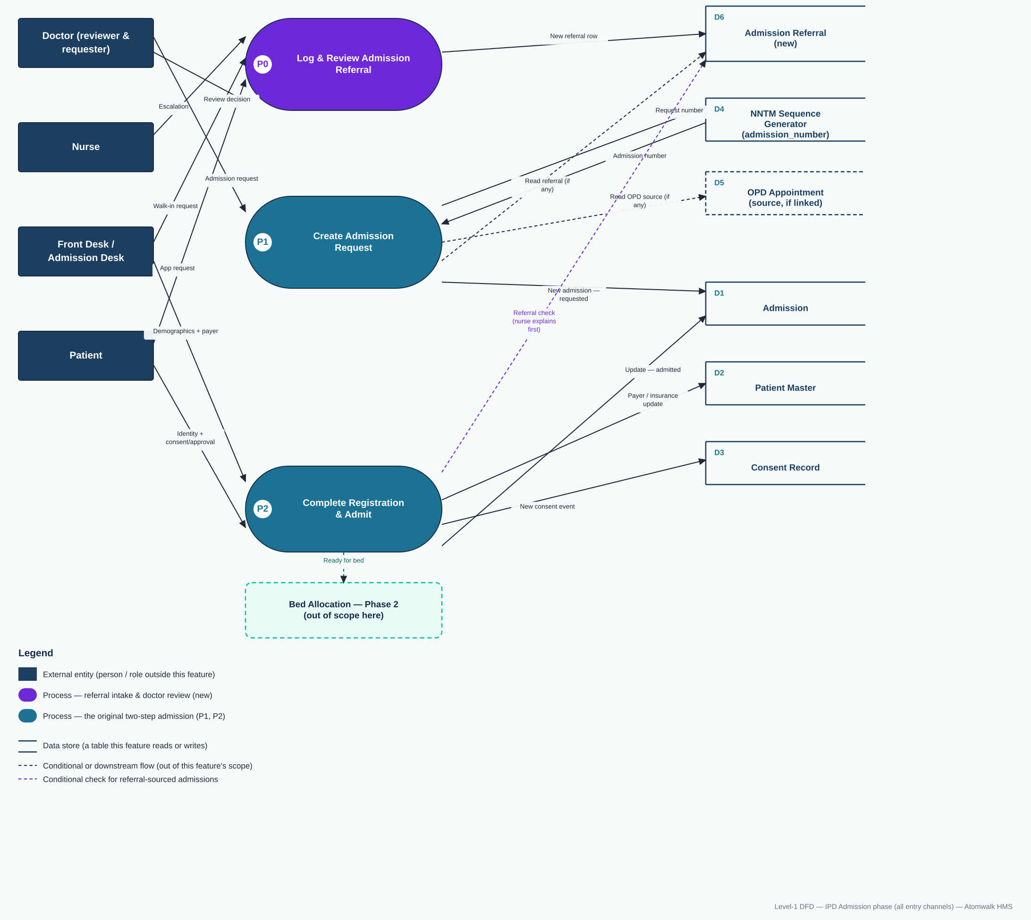

5.1 Flow reference
# | From | To | Data
1 | Nurse | P0 Log & Review Admission Referral | Escalation: patient may need admission, reason and observations
2 | Front Desk / Admission Desk | P0 | Walk-in request: patient asking to be admitted, no doctor order yet
3 | Patient | P0 | App submission: planned-procedure date request, or an emergency alert
4 | Doctor | P0 | Clinical review decision: approve or decline, with reason
5 | P0 | D6 Admission Referral | New referral row — status = pending_review, then updated to approved / declined / alert_only
6 | Doctor | P1 Create Admission Request | Patient, admission type, department, doctor, reason, expected discharge date
7 | P1 | D4 NNTM Sequence Generator | Request next admission_number
8 | D4 NNTM Sequence Generator | P1 | Admission number
9 | P1 | D5 OPD Appointment (conditional) | Read source_appointment_id, only if the admission originates from an OPD visit
10 | P1 | D6 Admission Referral (conditional) | Read the approved referral's context, only if this request originated from one
11 | P1 | D1 Admission | New Admission row — status = requested
12 | Front Desk / Admission Desk | P2 Complete Registration & Admit | Demographics, payer / insurance details
13 | Patient | P2 | Identity confirmation + signed consent / approval
14 | P2 | D6 Admission Referral (conditional) | Read whether this admission is referral-sourced — if so, a nurse explains the plan before consent is captured
15 | P2 | D2 Patient Master | Read / update payer_type, insurance_provider
16 | P2 | D3 Consent Record | New consent event — type = admission_treatment
17 | P2 | D1 Admission | Update Admission — status = admitted (awaiting bed)
18 | P2 | Bed Allocation (next phase, out of scope) | Admission ready for bed assignment

