IPD Admission
Feature Documentation
Story · Entry Channels · Scenario Diversity · Reference Tables · Data Flow Diagram
Scope
This document covers only the Admission phase — from a doctor deciding a patient needs inpatient care through to a registered Admission record awaiting bed assignment. Bed allocation and everything after it is out of scope here. Nothing described here is built yet — this is planning and specification only.

1. Story
One rule underneath everything below: only a doctor can order an admission. Front desk is who actually logs it and completes registration — never the other way around.

1.1 The emergency admission
It's 11:40pm. A 58-year-old man walks into the ER doubled over with abdominal pain. The ER physician examines him, orders a bedside ultrasound and bloodwork, and diagnoses acute cholecystitis — the gallbladder needs to come out, and he needs to be admitted tonight.
The doctor orders the admission — type: emergency — and front desk logs it immediately, before any paperwork is done. That becomes an Admission record, status requested, with a provisional diagnosis attached. The investigation orders already placed stay linked to this Admission even though no bed exists for it yet.
While the patient is still being stabilized, front desk registers him in parallel: identity, next of kin, insurance details. A nurse explains what's happening to the family as soon as there's a moment to. When registration completes, the Admission moves to admitted (awaiting bed), and bed allocation — the next phase — picks up.

1.2 The elective admission
A different patient has been seeing her doctor in OPD for two weeks about a hernia that isn't improving. At today's follow-up, the doctor decides it's time: she needs surgery, and that means an inpatient stay. He orders the admission — type: elective — from her existing appointment, and front desk logs the request against it, so this new episode stays linked to the visit that led to it.
Before front desk completes registration, a nurse sits with her and explains what the doctor has ordered and why — what the stay will involve, roughly how long, what happens next. Only once she's confirmed her identity and given consent does the Admission move to admitted (awaiting bed).

1.3 The walk-in
A man walks into the hospital lobby and tells the front desk he wants to be admitted — he's been feeling unwell for days and has decided today is the day. Front desk can't admit him on the strength of that alone; they ask him to see a doctor first. Once a doctor has examined him and agrees admission is warranted, the doctor orders it — front desk logs the request exactly as they would for any other case. A nurse explains the plan to him before front desk captures his consent and completes registration.
Nobody at the front desk ever creates an Admission out of thin air, and no admission happens without a doctor's order sitting underneath it somewhere.
The pattern underneath every story
A doctor orders it. Front desk logs and registers it. A nurse explains it to the patient before consent is captured. However the patient got in front of that doctor — a scheduled visit, an ER exam, or a walk-in who had to be seen first — the record that comes out the other end is identical.

2. Entry Channels
What varies between admissions isn't the process — it's how the patient ended up in front of a doctor in the first place. All four paths below lead to the same doctor's order, logged by front desk the same way.
How it starts | What happens before a doctor decides
Doctor already seeing the patient | OPD consult, ward round, or an ER exam — the doctor is already the one making the call. Nothing has to happen first.
Walk-in patient requests admission | Front desk cannot admit on the patient's request alone. The patient is seen by a doctor first; only then can an order exist.
Patient app — planned procedure | Usable only once a doctor has already recommended a procedure. The app lets the patient pick and confirm a date, the same way appointment booking already works — it doesn't let a patient originate an order a doctor hasn't made.
Patient app — emergency alert | Notifies the hospital that this patient is inbound with an emergency so staff can prepare. It is not an Admission record — the moment the patient arrives, an ER doctor examines them and makes the actual decision.

2.1 What a nurse does here
A nurse explains the doctor's admission order to the patient — what it means, what to expect — before front desk captures consent. A nurse does not order an admission and cannot escalate a patient toward one; that decision belongs to a doctor in every channel, without exception.

2.2 Not yet decided
[OPEN QUESTION] Minor / guardian admission — who signs consent, and how a guardian's identity is captured and verified, isn't defined yet.
[OPEN QUESTION] Medico-legal cases (MLC) — assault, road traffic accidents, poisoning, and similar cases usually carry extra reporting obligations in most hospital settings. There's no MLC flag or workflow yet; an MLC currently just follows the Emergency path with nothing to mark it as one.

3. Diversity — Scenario Variations
How the admission record itself varies, once a doctor's order exists.
Dimension | Variations | What actually differs
Admission type | emergency / elective / day_care / referral | One field on the Admission record — not separate tables or workflows. Changes sequencing, not structure.
Sequencing | Emergency vs. everything else | Emergency admissions can have a bed allocated before registration paperwork is complete. Every other type completes registration first.
Origin | Standalone order vs. linked to an existing OPD appointment | source_appointment_id lets the two episodes read as one continuous story instead of disconnected records.
Payer / billing basis | Self-pay / insured / corporate | Read directly from the patient's existing payer_type and insurance_provider fields rather than re-asked at admission.
Cancellation window | Reachable from requested or admitted; never from active | Once a bed is occupied, the request can no longer be silently withdrawn — it has to go through discharge/transfer instead.

3.1 Not yet decided
[OPEN QUESTION] Minor / guardian admission consent — see 2.2.
[OPEN QUESTION] Medico-legal cases (MLC) — see 2.2.
[HOSPITAL-SPECIFIC DECISION] Consent scope — admission_treatment is proposed as one added consent type, recorded the same way DPDP/HIE consent already is. Whether it's re-captured per admission or once per patient is a hospital policy decision, not a technical one.

4. Tables

4.1 Admission — entity fields
Field | Type | Notes
id | PK
admission_number | varchar, unique per branch | Generated via the existing NNTM sequence generator (entity="admission"), same mechanism as UHID/invoice/lab numbers.
patient_id | FK → patient
admission_type | enum | emergency / elective / day_care / referral
department_id | FK → department
ordering_doctor_id | FK → staff (doctor) | The doctor who ordered the admission — distinct from who logs it (always front desk)
logged_by_staff_id | FK → staff (front desk) | Who actually created this record
reason_for_admission / provisional_diagnosis | text
source_appointment_id | FK → OPD appointment, nullable | Set when the admission originates from an existing OPD visit
expected_discharge_date | date, nullable | Planning estimate, not a hard constraint
status | enum | requested / admitted / active / discharge_initiated / discharged / cancelled — see 4.2

4.2 Admission — status states
State | Entered when | Who moves it | Can move to
requested | Front desk logs the doctor's order | Front desk | admitted, cancelled
admitted (awaiting bed) | Registration & consent complete, no bed yet | Front desk | active, cancelled
active | A bed has been allocated | Bed allocation (next phase) | discharge_initiated
discharge_initiated | Discharge process has begun | Ordering / attending doctor | discharged
discharged | All discharge gates closed, patient has left | Nurse confirming departure | closed (read-only)
cancelled | Request withdrawn before bed use | Ordering doctor / front desk | — terminal

4.3 Roles & responsibilities
Role | Can do | Cannot do
Doctor | Order an admission for a patient — the clinical decision underneath every case | Cannot log the Admission record or complete registration — that belongs to front desk
Front Desk / Admission Desk | Log the admission request on a doctor's order; capture demographics, payer details, consent; move requested → admitted | Cannot admit a patient without a doctor's order, cannot write clinical notes
Nurse | Explain the doctor's admission order to the patient before consent is captured | Cannot order an admission or escalate a patient toward one
Patient / family | Confirm identity, sign consent; submit a planned-procedure date or emergency alert via app | Cannot originate an admission without a doctor's order

4.4 API endpoints
Method | Endpoint | Purpose | Precondition
POST | /ipd/admissions | Log admission request (status=requested) | Ordering doctor + patient required; called by front desk
POST | /ipd/admissions/{id}/admit | Complete registration, move to admitted (awaiting bed) | Consent must be captured
GET | /ipd/admissions/{id} | Full admission detail | —

5. Data Flow Diagram
Two entities, two processes, two data stores — a doctor's order in, an admission ready for a bed out.
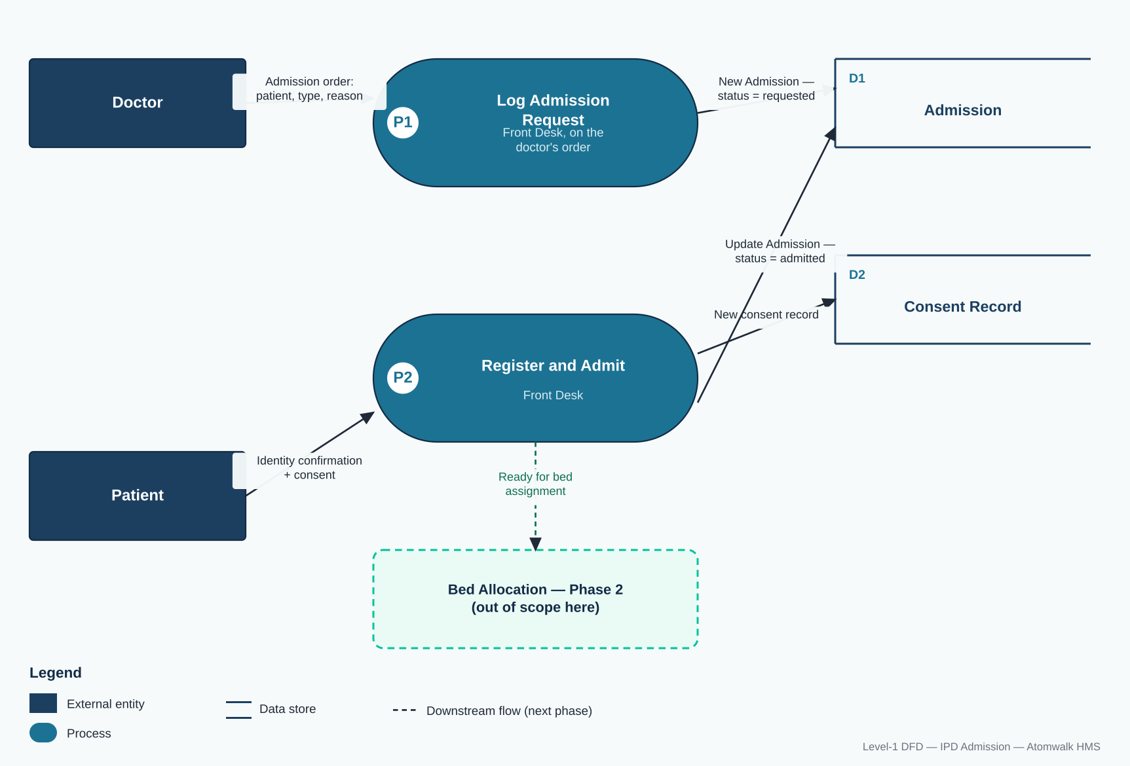

5.1 Flow reference
# | From | To | Data
1 | Doctor | P1 Log Admission Request (Front Desk) | Admission order: patient, type, reason
2 | P1 | D1 Admission | New Admission row — status = requested
3 | Patient | P2 Register & Admit (Front Desk) | Identity confirmation + consent
4 | P2 | D2 Consent Record | New consent record
5 | P2 | D1 Admission | Update Admission — status = admitted (awaiting bed)
6 | P2 | Bed Allocation (next phase, out of scope) | Ready for bed assignment

