- GIT assignment creating 2 branches and merging
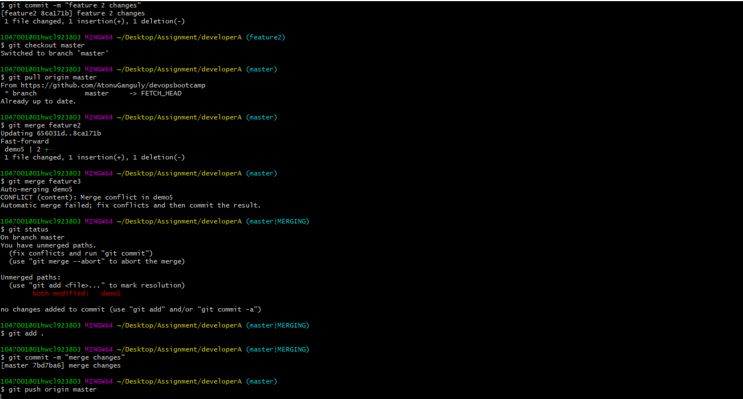

- AWS Free Tier- Ec2 Instance Creation
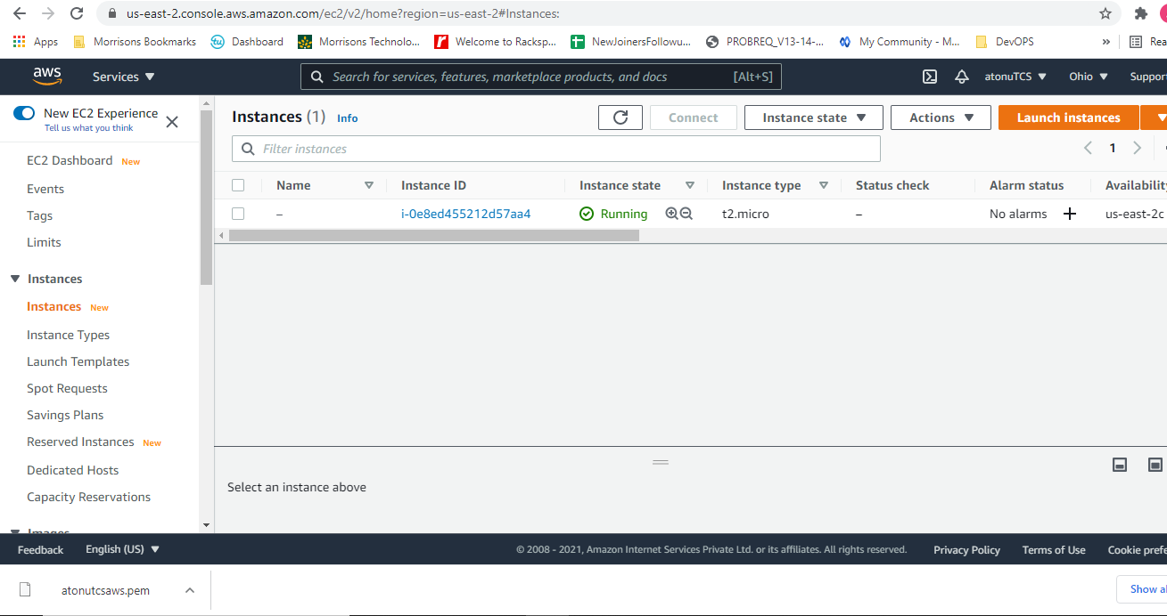
- Ubuntu open
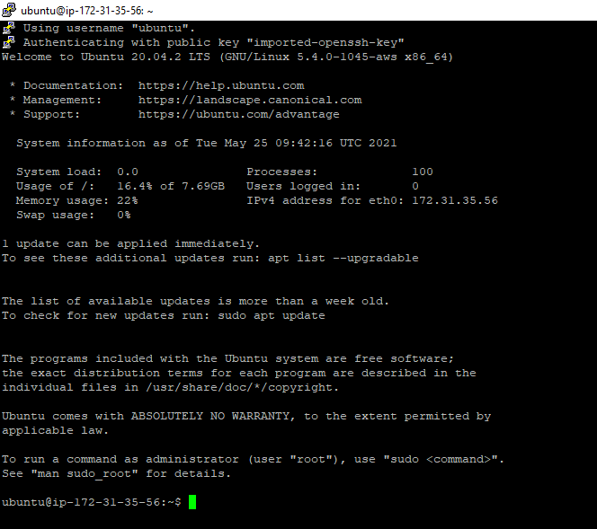

- Setting Jenkins on Ubuntu Ec2
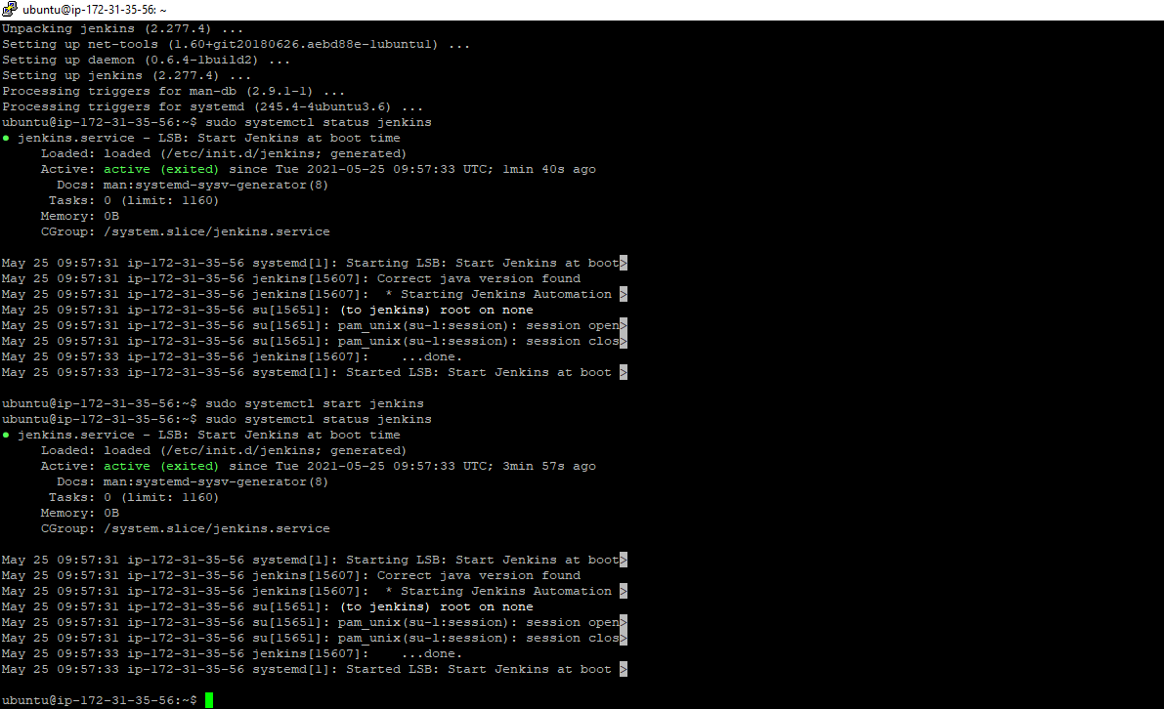
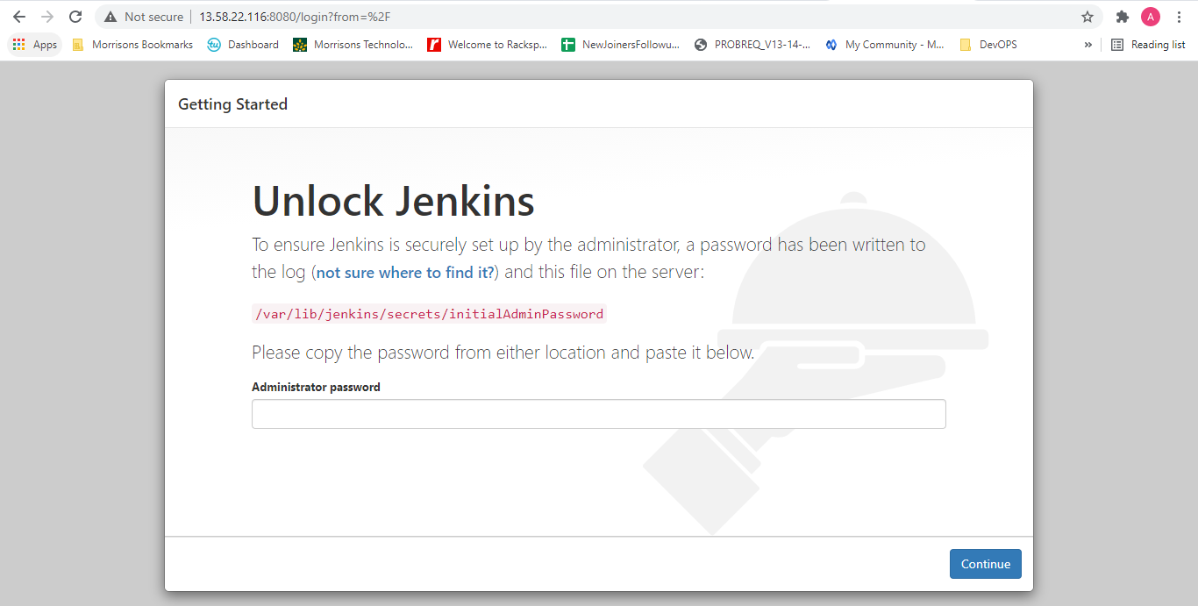
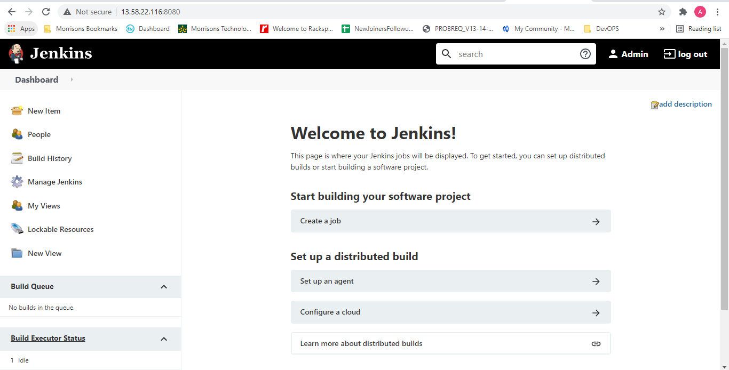
- Tomcat 9 installation

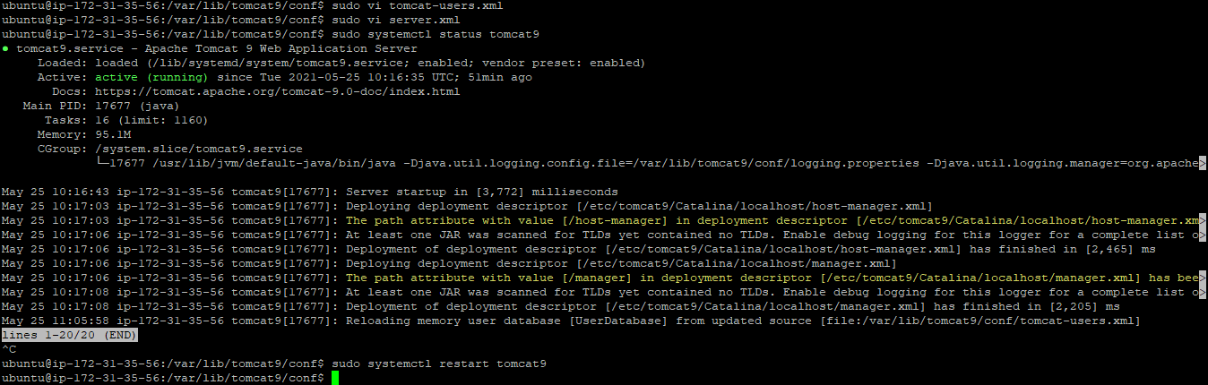
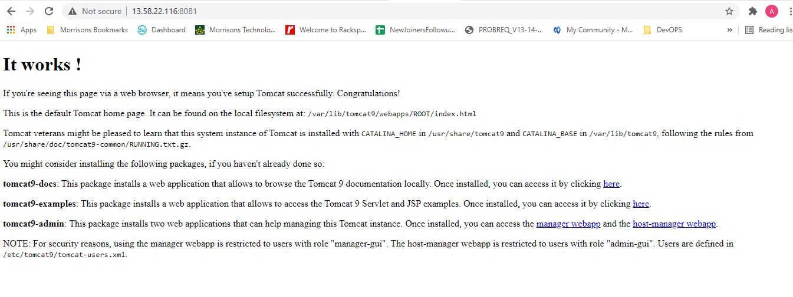
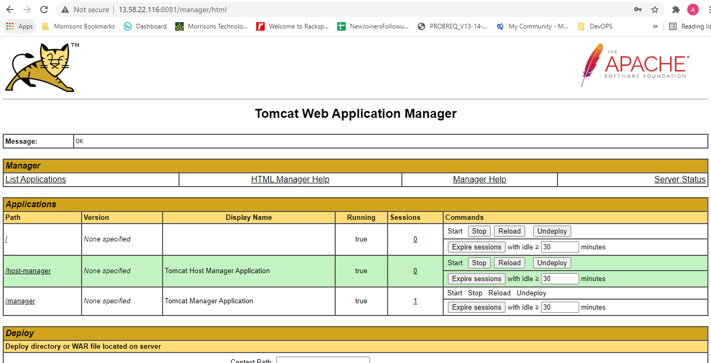
- Installed Pugins in Jenkins
Copy artifact, Deploy war/ear containers
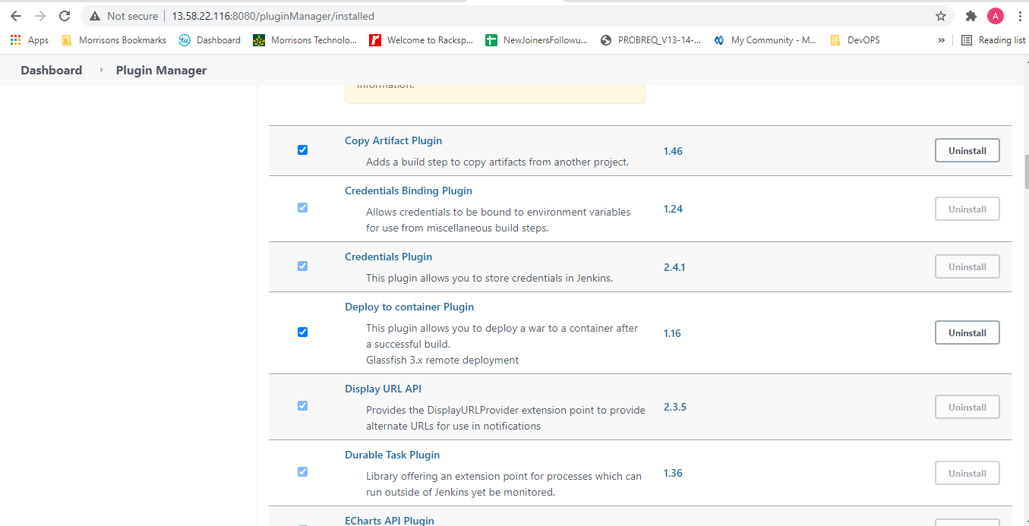
- Add tomcat and Jenkin user to sudo
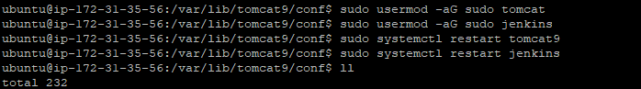
- Updated Tomcat Users, in user in /var/lib/tomcat9/conf/tomcat-users.xml
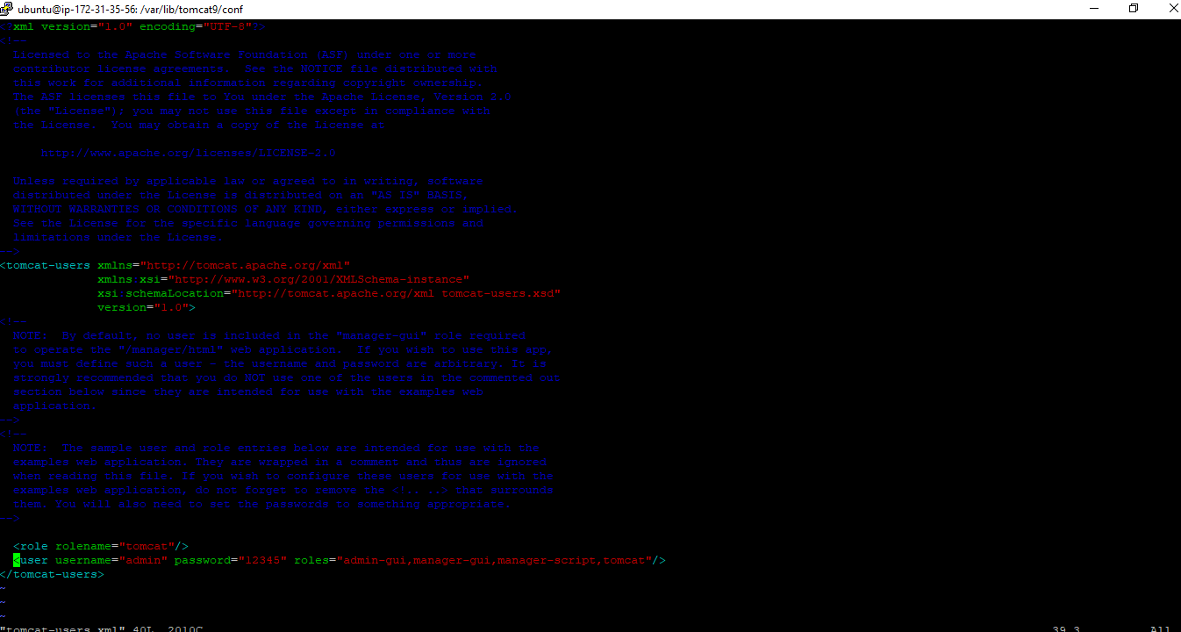

8. Updated Tomcat http and https port /var/lib/tomcat9/conf/server.xml
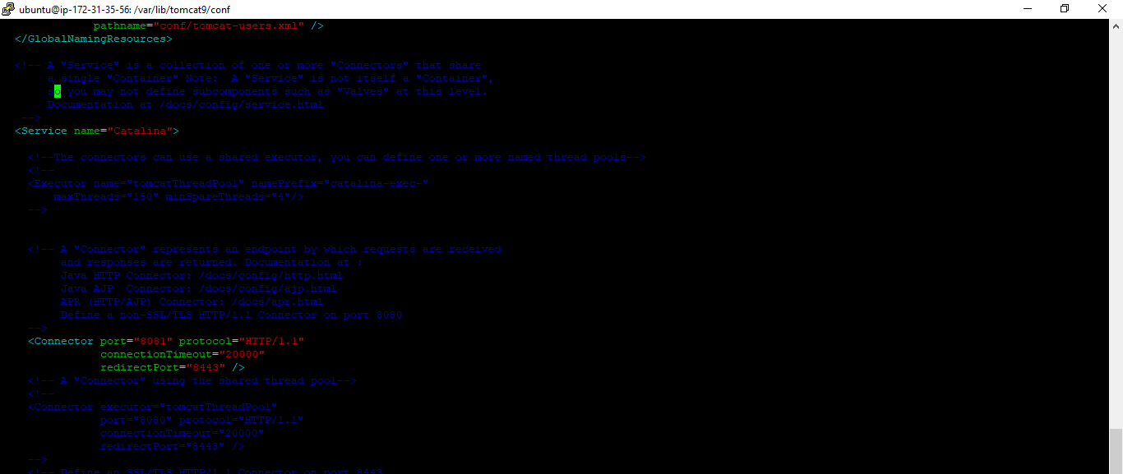

- Create Jobs in Jenkins
