- AWS Free Tier- Ec2 Instance Creation for docker
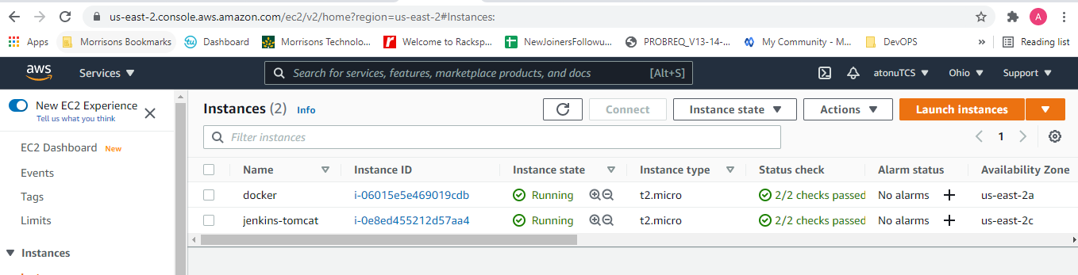
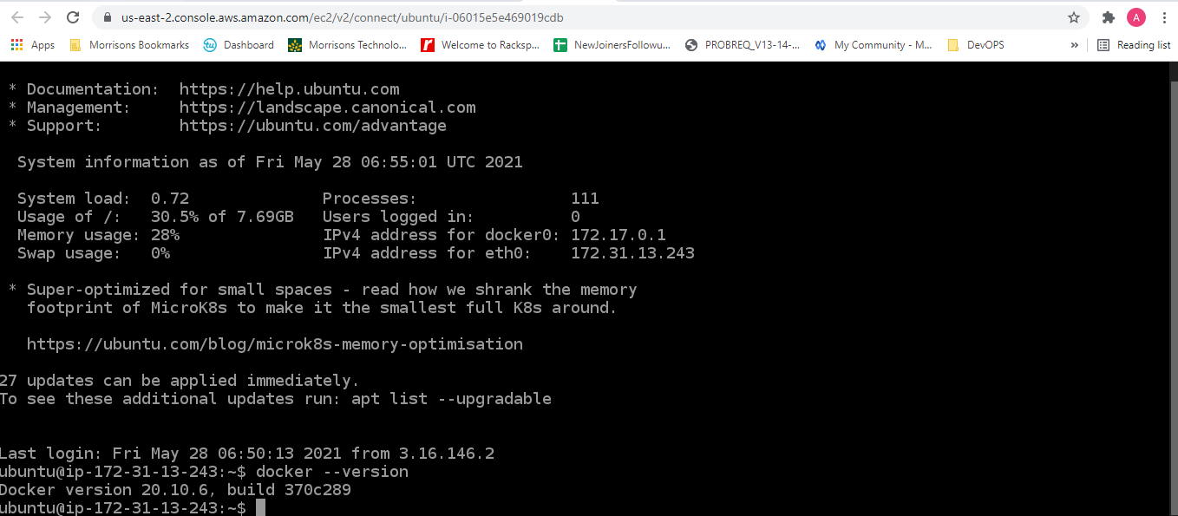
- Adding docker container as Jenkins Slave

- Building Project from https://github.com/AtonuGanguly/bootcamp10

