Case Study Submission Template

1. Name : Atonu Ganguly

2. Employee Id : 1047001

3. Email Id : atonu.ganguly@tcs.com

4. Your Git Repository URL: https://github.com/AtonuGanguly/batch10

5. Attach the screenshot of your Dockerfile.
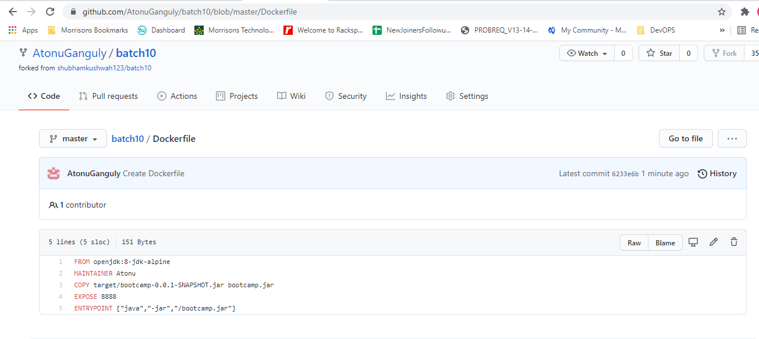

- Attach the screenshot of your Jenkinsfile.
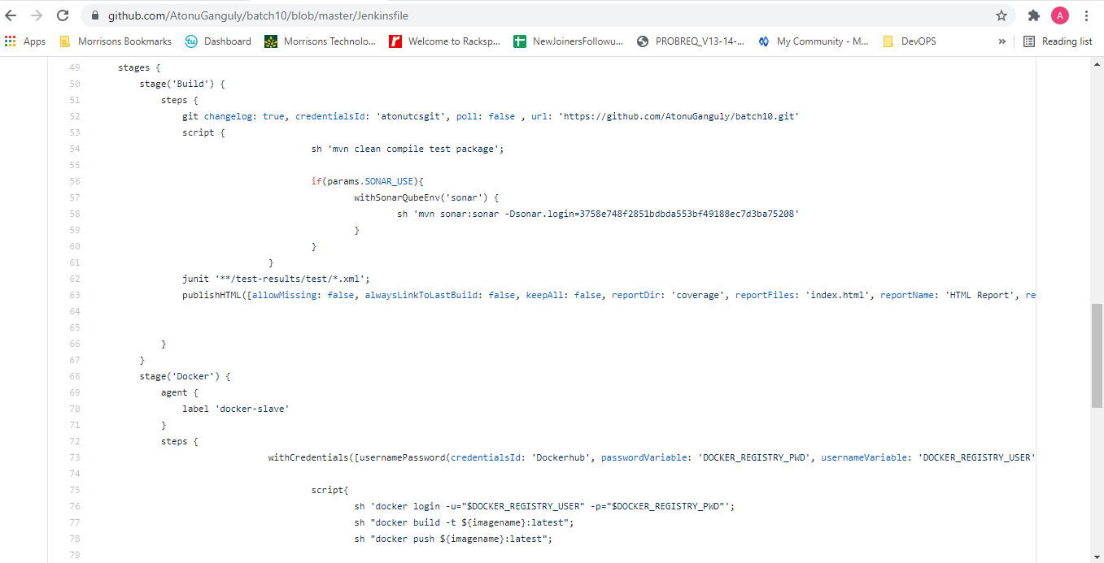

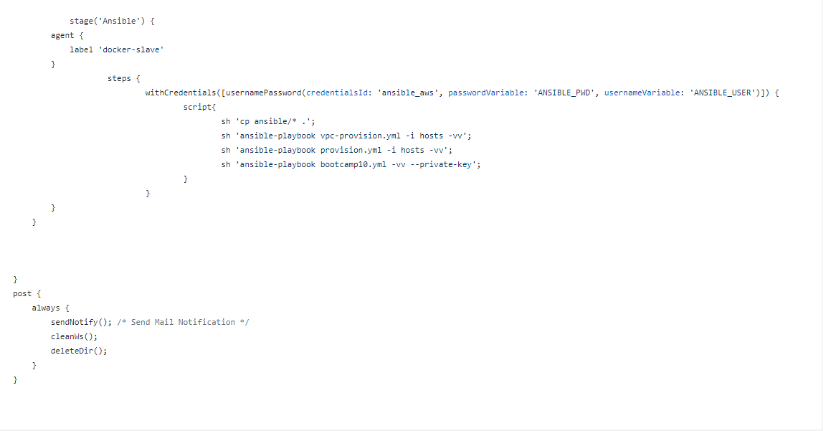

7. Upload your Jenkins Log file in the Repo.(Complete log file should display your name on top).

- Attach the screenshot of Jenkinspipeline job status. (All boxes should be green)
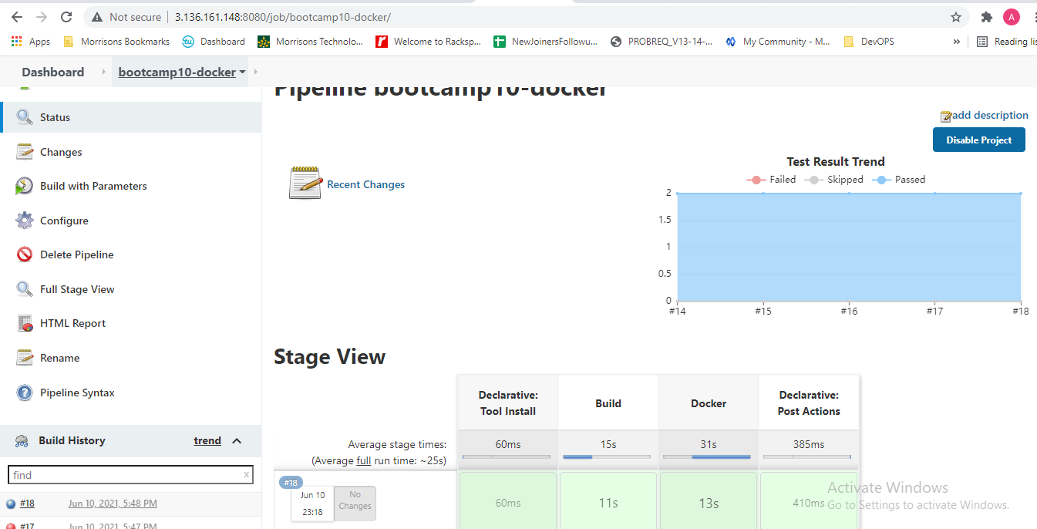

9. Attach screenshots of email notification for the Jenkins build.
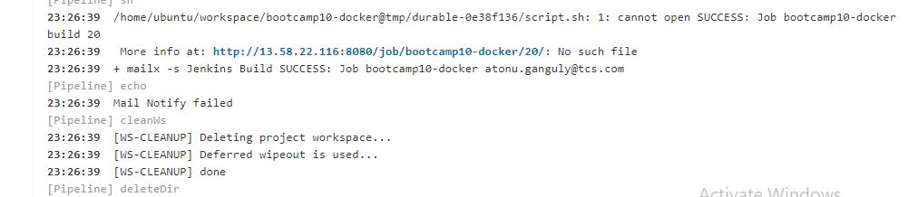
- Attach screenshot of the SonarQube Report
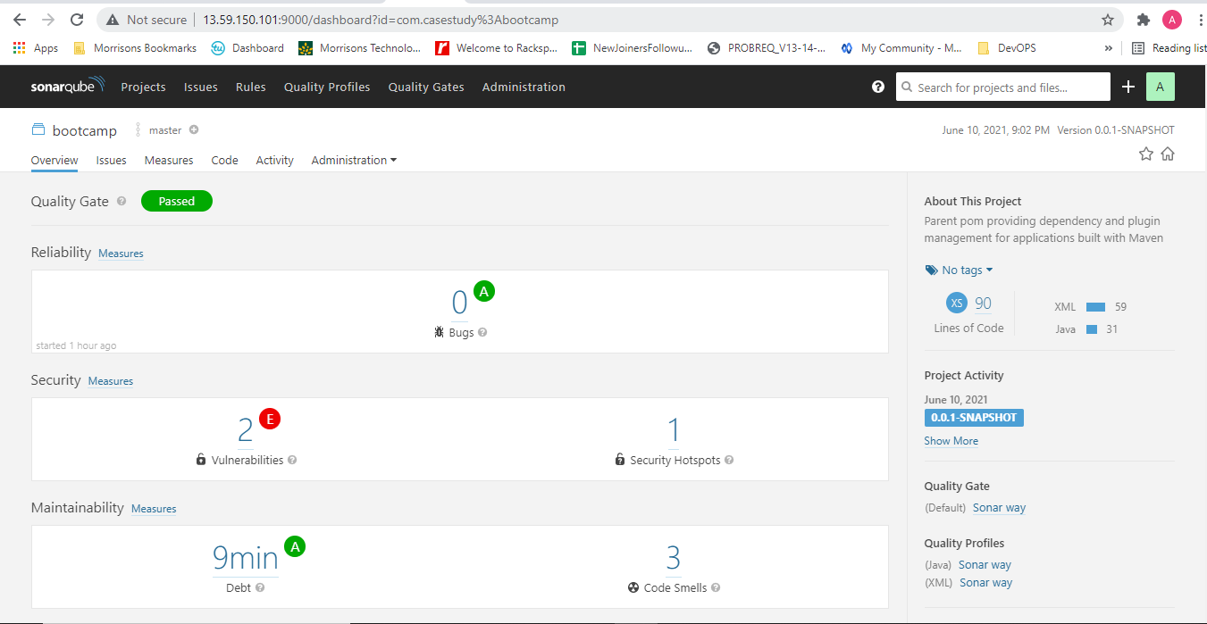

- Attach screenshot of the AppScan Report.
NA

12. Attach screenshot of your Ansible Playbookexecution logs.
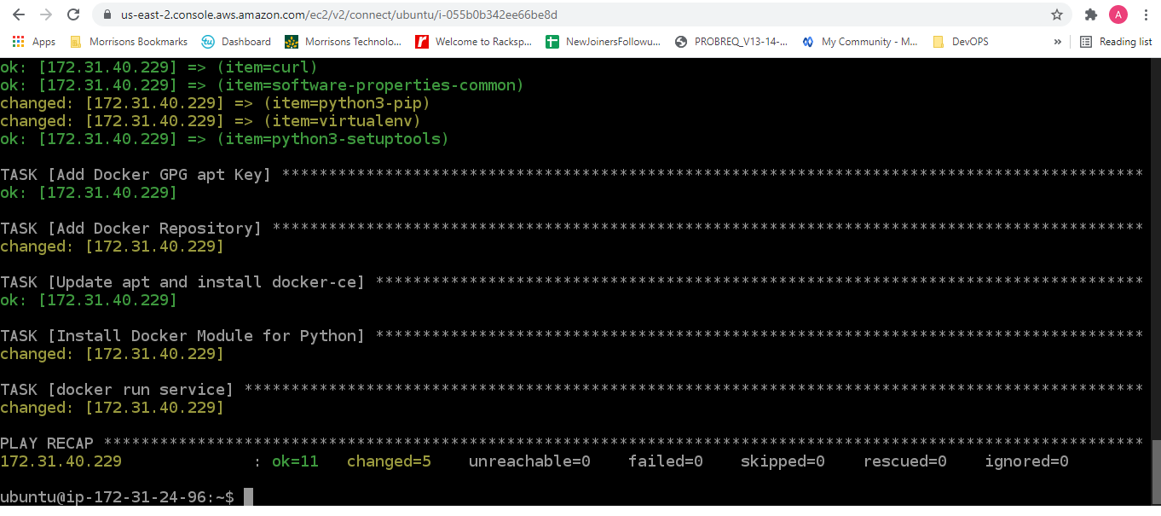
13. Attach screenshot of the working application home page on AWS/GCP/Azure.

