- AWS Free Tier- Ec2 Instance for Ansible

- Ubuntu Ansible installaton and slave addition
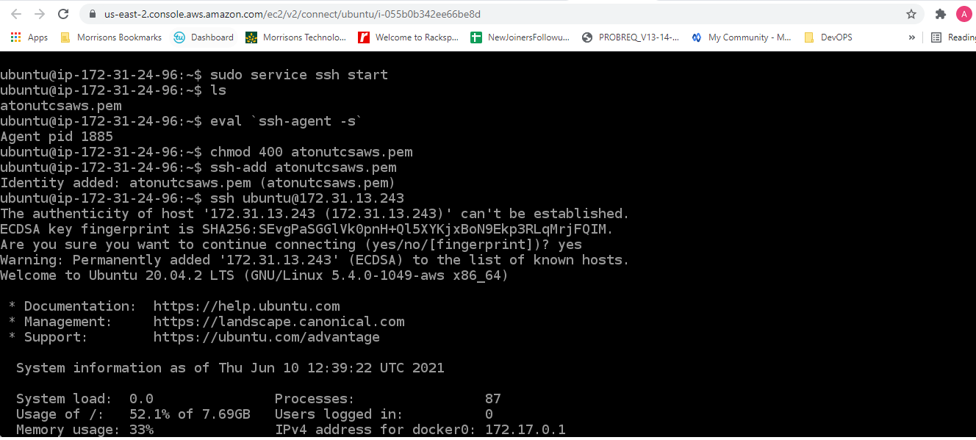

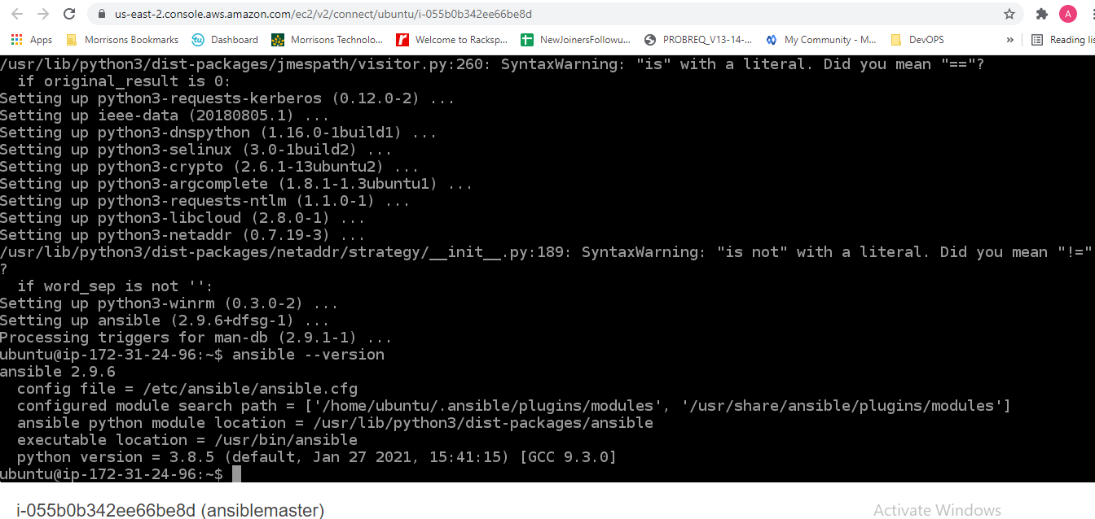

3. Connect to Ansible Slave passwordless
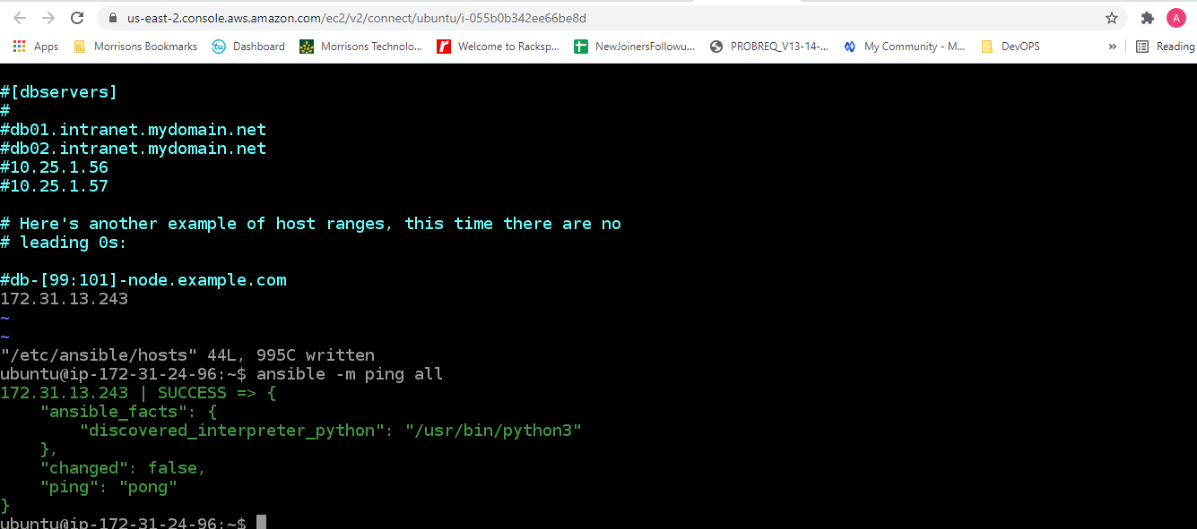
- Running ansible tasks
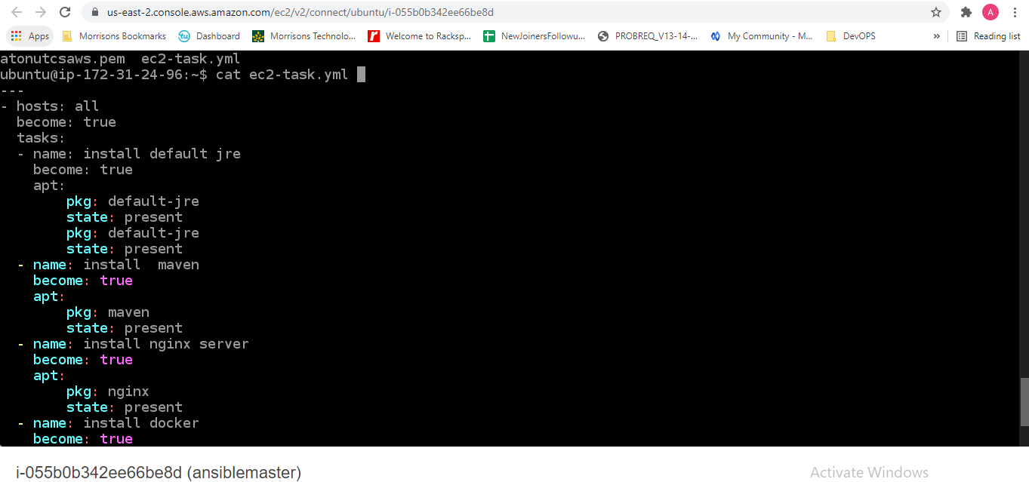
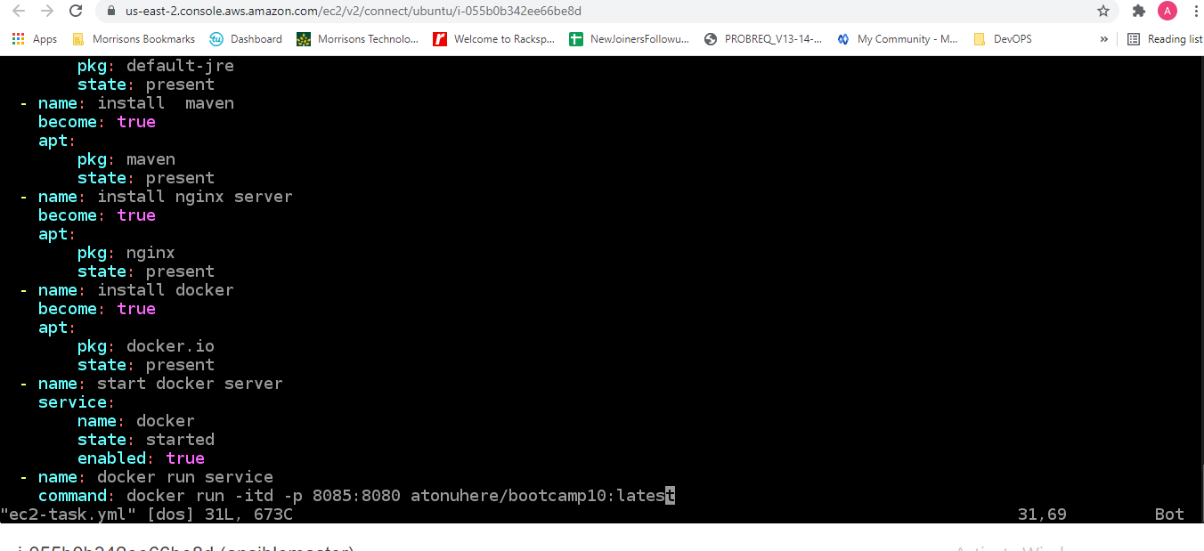

5.

