Exploration Missions
Chronomaze · Neon Studio · Mobile MMORPG
Juwon Lee · Game Designer · System spec author (list data by Kim Pyeong-jik)

OVERVIEW
Role | System spec author (Quest_Adventure.xml framework, UI logic, reward rules); mission list data by another designer
System | Exploration Missions — a passive always-active progression layer tied to map exploration
Platform | Mobile (Android / iOS)
Stack | Unity · Quest_Adventure.xml · MissionCategory.xml · Lang.xml
Scale | 650+ individual missions across 6 worlds, covering all 200+ maps

DESIGN INTENT
Exploration Missions solve a common MMORPG problem: players complete the main quest and then have no reason to revisit earlier zones. The system gives every map a persistent set of objectives — collect X items, reach Y% exploration, find Z collectibles — that reward players for going off the beaten path.
The key design decision was to make missions always active, with no opt-in required. This keeps the system lightweight for casual players while still surfacing enough reward hooks to pull completionists back into every corner of the world.
The system was also designed to integrate directly with the map and minimap — exploration fog, mission markers, and reward indicators all sync to the same per-map data, making it a natural extension of the navigation layer rather than a separate feature.

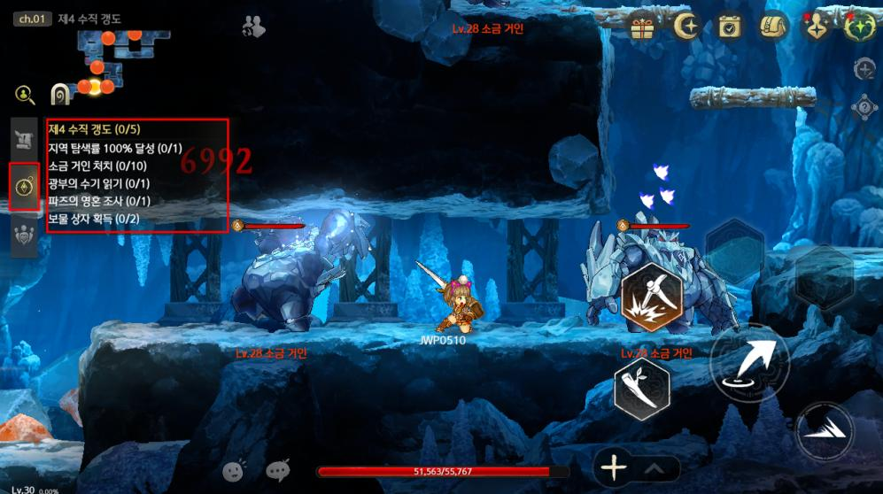
Exploration mission UI — world category view with mission list
SYSTEM ARCHITECTURE
Two-Tier Structure
- World missions: up to 6 objectives per world (e.g. 'Collect X treasure chests in Knights' Garden') — reward on 50% and 100% completion (2 payouts total)
- Zone missions: up to 6 objectives per individual map zone — reward on 100% completion (1 payout)
- Both tiers always active; no accept/abandon flow
- World corridors and transition zones also receive mission sets — no map is left empty

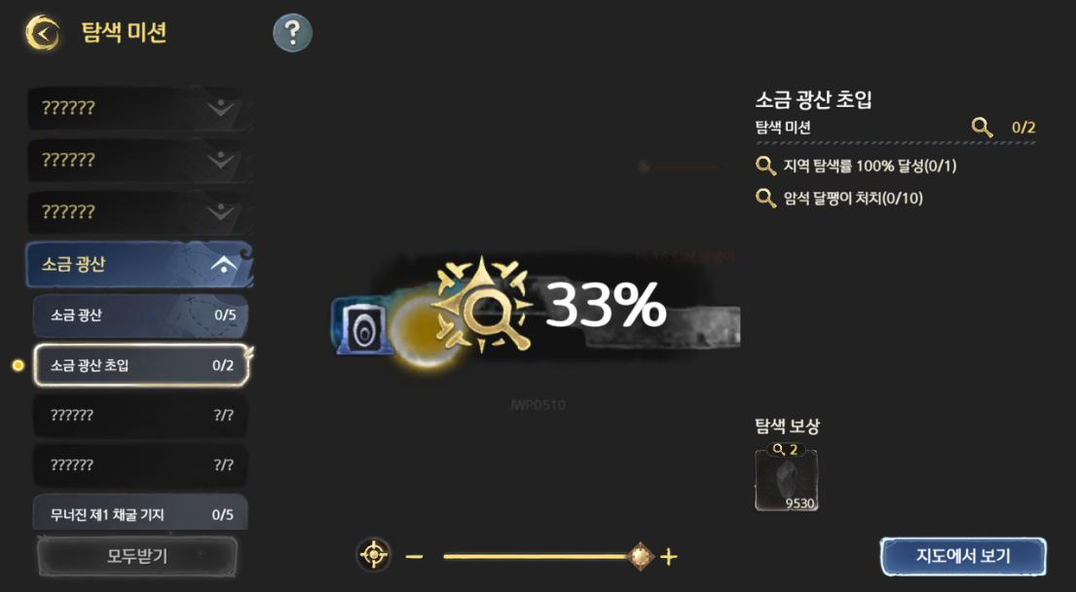
Zone mission detail — progress indicators and reward icons
Reward States
Each mission entry carries up to three reward icons (HalfReward, FullReward, and zone-level reward). Each icon has three visual states:
- Claimable — colour icon with red dot; tap to claim immediately
- Already claimed — colour icon with green checkmark; tap for tooltip
- Not yet reached — greyscale icon; tap for tooltip showing remaining progress
A 'Claim All' button in the UI lets players sweep all pending rewards in one tap. If none are available, the button is greyscaled and tapping it shows a system message.

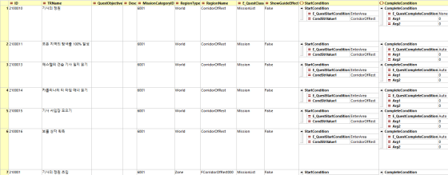
Reward icon states — claimable, claimed, not yet reached
Completion Popup
- Triggers automatically when a MissionList is fully completed while the player is in the field
- Suppressed during dungeons, visual scenes, and cutscenes — queued and shown on return to field
- Popup displays the MissionList's TRName; auto-dismisses after a short delay

UI BREAKDOWN
The Exploration Mission UI opens from Main Menu → Exploration Missions, or from the HUD compass icon. It is a full-screen panel with three main regions.
Left Panel — World & Zone List
World categories | One button per world, sorted by MissionCategory.xml ID ascending; accordion expand/collapse
Zone list | Sorted by Quest_Adventure.xml ID ascending within each world; shows progress as X/Y count
Unvisited zones | Displayed as ?????? in greyscale — no interaction until first visit
Current location | Yellow circle marker on the player's current zone
Red dot | Appears on world category button and individual zone entry when a reward is claimable
Completed zones | Greyed out after all rewards collected

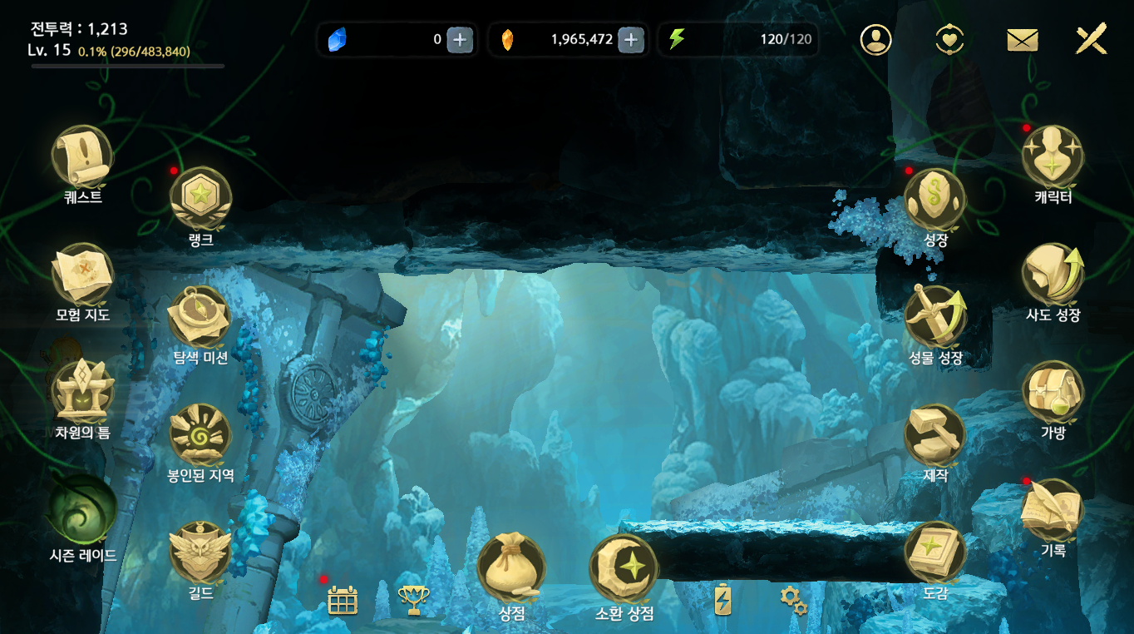
Full UI — list panel, map view, and mission detail panel
Centre Panel — Map View
Map image | Displays the minimap of the selected zone, scaled to fill the area
Exploration fog | Synced to the player's actual fog-of-war progress per map
Pinch zoom | Supports pinch to zoom; zoom bar updates in real-time
My Location button | Jumps map camera to the player's current zone at the appropriate zoom level
View in Map | Button that opens the full Map/Minimap UI with the camera position preserved
Off-grid zones | Zones not connected to the world map do not show a map image

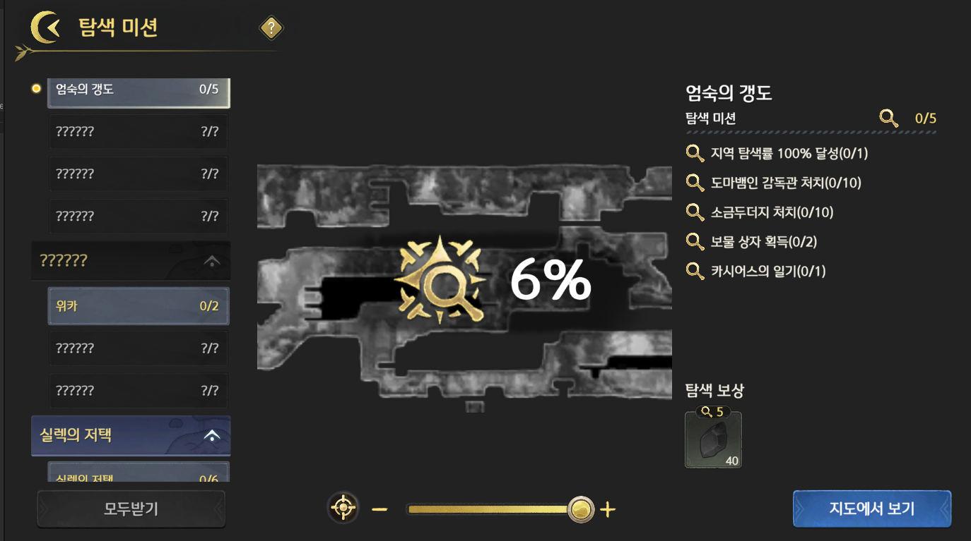
Map view panel — exploration fog sync
Right Panel — Mission Detail
Mission list | Shows each objective with CondScript text, current count / required count
Completed items | Checkbox icon appears to the left of each completed objective
Reward icons | Up to 3 icons per zone/world; full three-state logic (see above)
Claim All | Available in the top-right; sweeps all claimable rewards in one action

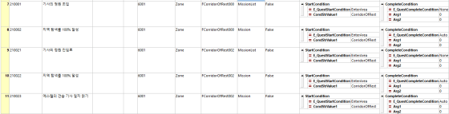
Mission detail panel — objectives with progress counters
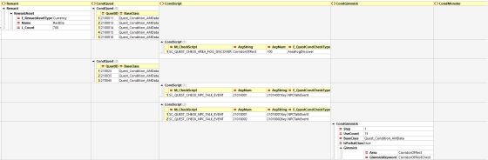
Reward icon row — mid-completion state
DATA & XML IMPLEMENTATION
Exploration missions are built on the same Quest framework used elsewhere in the game, extended with mission-specific fields. I authored the full XML spec and handled data entry.
Quest_Adventure.xml — Key Fields
ID | Integrity key
TRName | Display name shown in the mission list and completion popup
MissionCategory | Links to MissionCategory.xml — determines which world category this entry appears under
QuestClass | MissionList (reward-bearing parent entry) or Mission (individual objective)
Reward | Reward data on MissionList entries; supports HalfReward and FullReward thresholds
CondScript | Mission objective condition — uses the same scripting system as quest objectives
CondGimmick | Alternative condition input for gimmick-based objectives
RegionName | Groups zone missions under their parent world in the UI list

SCALE
The mission list covers all playable content in the game at launch. Data below is from the mission list sheet.
Knights' Garden | 56 missions (individual objectives)
Spring Waterway | 129 missions
Salt Mines | 134 missions
Silex Mansion | 110 missions
Burning Furnace | 113 missions
Scholar's Library | 114 missions
Total | 650+ missions across 200+ maps

DESIGN NOTES
- The two-tier world/zone structure was chosen to give players two feedback loops: a quick per-zone win (100% complete) and a longer world-level arc (50% / 100%)
- Integrating with the map fog system required close coordination with the map/minimap spec — the same per-map fog data drives both systems, avoiding duplication
- The 'always active' rule eliminates the need for an accept/abandon UI, which simplifies the engineering surface considerably
- Corridor and transition zones get missions too — this was intentional to reward thorough explorers rather than punishing them for finding optional paths
- Quest_Adventure.xml reuse meant the system could be implemented without a new data architecture — significant engineering saving for a small team

Juwon Lee · quierado@gmail.com · linkedin.com/in/juwon-lee-5b3097219

