Map & Minimap
Chronomaze · Neon Studio · Mobile MMORPG
Juwon Lee · Game Designer · Sole author

OVERVIEW
Role | Sole author — full spec from initial design through implementation handoff
System | Map (Adventure Map) & Minimap — navigation and exploration tracking layer
Platform | Mobile (Android / iOS)
Stack | Unity · WorldMap.xml · Map.xml · shader-based fog system
Scope | Covers all 200+ maps across 11 worlds; shared data layer with Exploration Missions

DESIGN INTENT
Chronomaze is a large side-scrolling MMORPG with 200+ maps spread across 11 worlds. Without a strong navigation layer, players get lost and disengage. The Map and Minimap system solves two problems at once: it gives players a clear picture of where they are and where to go, while using a fog-of-war mechanic to turn the act of exploration into its own reward.
The system is also the data backbone for Exploration Missions — the per-map fog progress drives mission completion, so the two systems share the same exploration state without duplication.

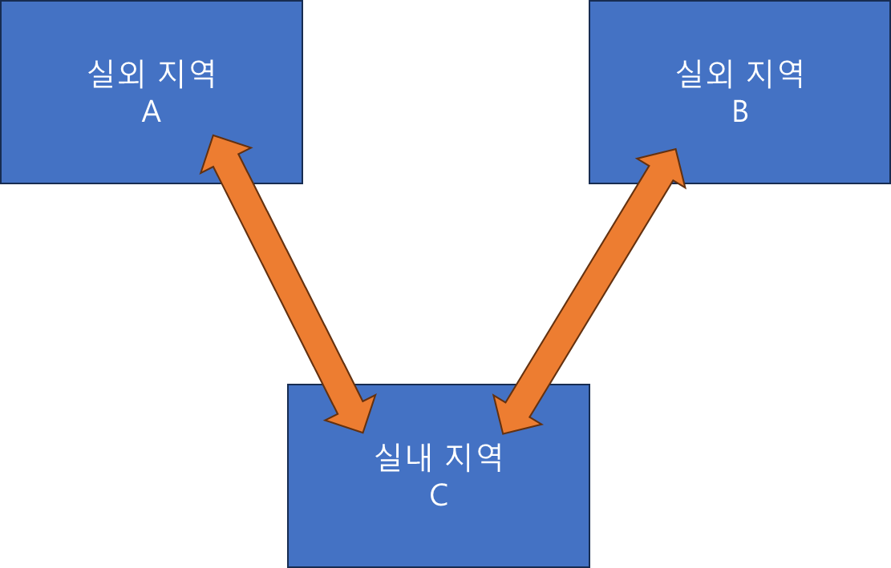
Adventure Map — full world view with fog and icons
SYSTEM ARCHITECTURE
Two Components
- Minimap (HUD): always-visible panel in the top-left corner showing the current zone; click to open the Adventure Map
- Adventure Map (full-screen): shows the full connected world, scrollable and pinch-zoomable, with all navigation icons and the Dimensional Gate list
Fog of War
Fog is the core exploration mechanic. Each zone is divided into fog sectors. As the player moves through a sector, it clears — revealing the map image in colour underneath. Fog is stored per-player and persists between sessions.
- Fog is rendered using a greyscale shader on the base terrain image — no separate fog asset needed
- Exploration percentage = sectors cleared / total sectors in zone, displayed as an integer percentage at the centre of each zone image
- Hidden terrain (secret paths) rendered as impassable until cleared — the base map image is authored without revealing them
- First-time world visits trigger a silhouette state (outline only, no map detail) — transitioning to full fog state on entry (marked as future dev at spec time)

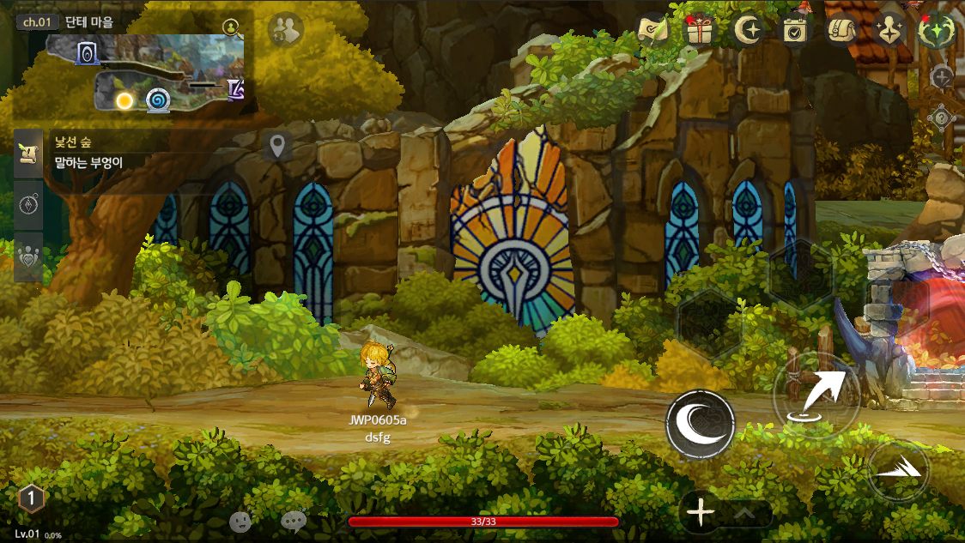
Fog system — cleared (colour) vs. unexplored (grey) areas
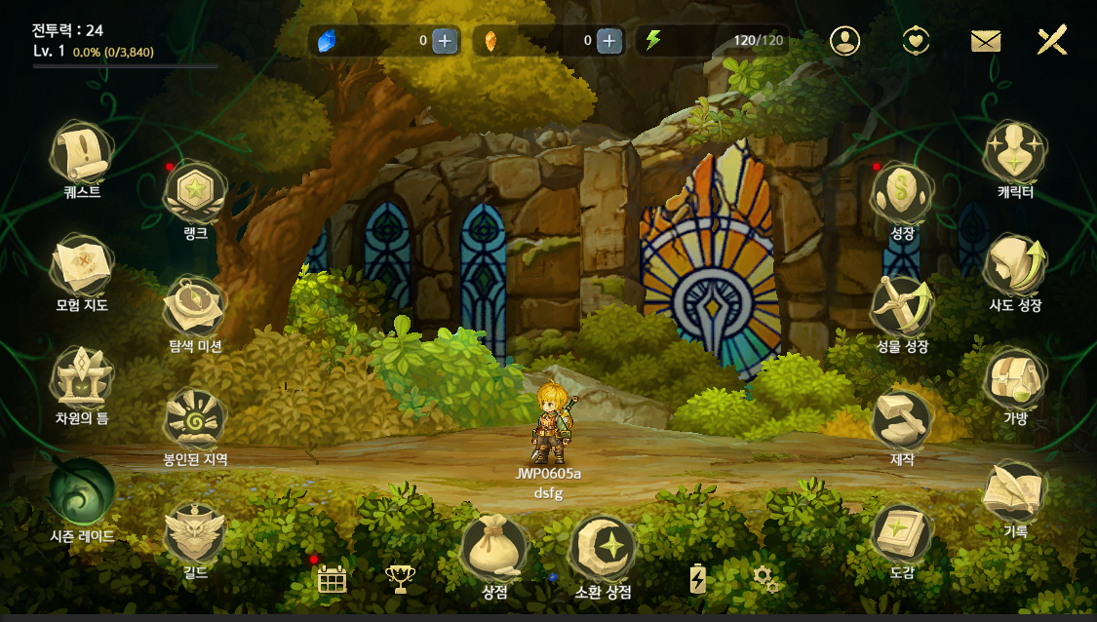
Exploration percentage display per zone
Icon System
Icons are layered on the map in priority order (lower number = renders on top when overlapping). Activation state determines whether an icon appears in colour or greyscale.

Icon | Minimap | Adventure Map
Player character | ✓ | ✓
Shop NPC | ✓ | ✓
Dimensional Gate | ✓ | ✓ (greyscale if unactivated)
Time Gate | ✓ | ✓
Dark Temple | ✓ | ✓ (greyscale if unactivated)
Dungeon entrance | ✓ | ✓ (greyscale if unactivated)
Warp point | ✓ | ✗
Quest / Sub-quest | ✓ | ✓ (always visible, ignores fog)
Monster | ✓ | ✗
Gimmick object | ✗ | ✗
Indoor zone indicator | ✓ | ✗ (proxied to last outdoor warp)

- On the minimap, icons only appear when the player is within a set distance — except quest icons and warp icons which are always shown
- Warp icons are hidden if the sector containing them is still fogged

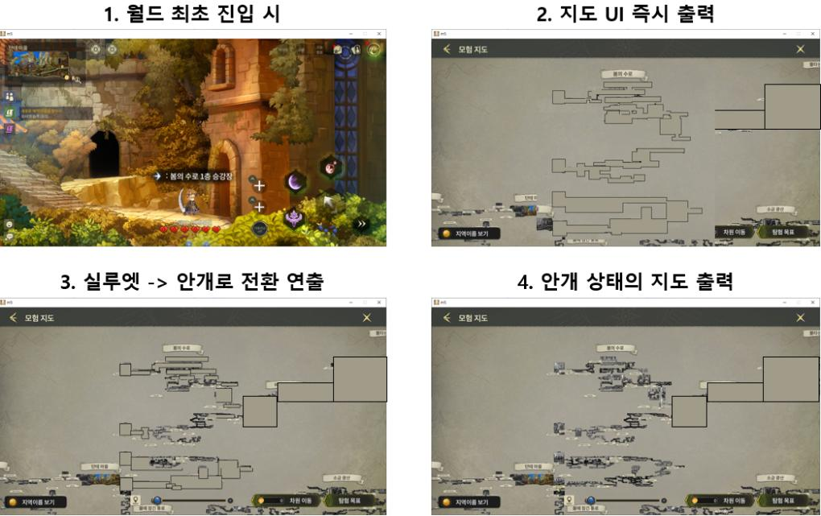
Icon layering — quest, warp, dimensional gate overlapping
Dimensional Gate Integration
The Adventure Map doubles as the Dimensional Gate travel interface. A collapsible slider panel lists all gates grouped by world; selecting a gate highlights it on the map and enables the teleport button.
- Teleporting via the Adventure Map costs Diamonds (not Shards — different currency from the field shortcut)
- Inactive gates shown as '???' in the list; teleport button greyed with error message
- Two-way sync: clicking a gate icon on the map selects the corresponding list entry, and vice versa
- Slider panel auto-expands when any gate is selected from the map

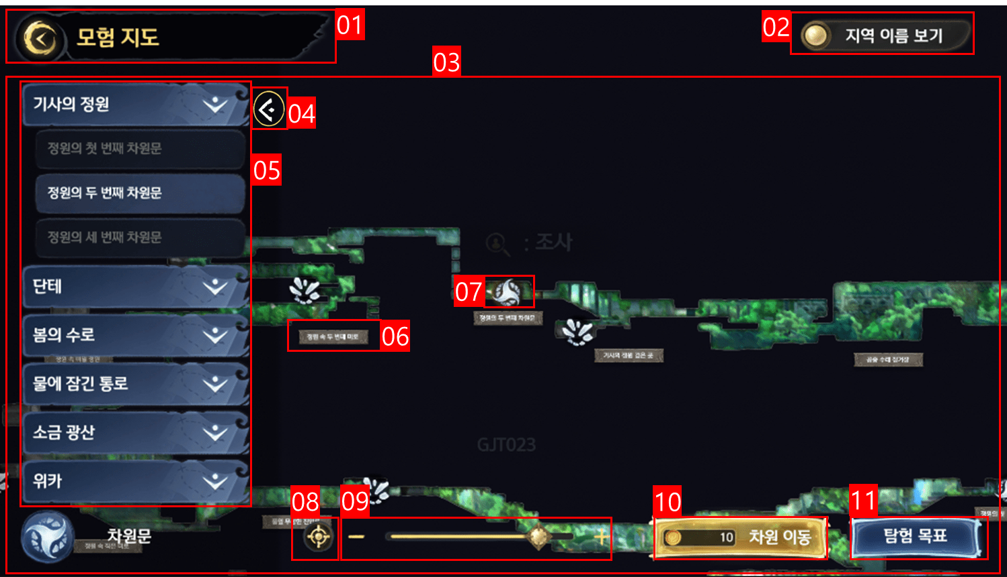
Adventure Map with dimensional gate list (slider panel open)
MINIMAP DETAIL
The minimap is a persistent HUD element showing the player's current zone. It uses the same map image and fog data as the Adventure Map — no separate render pass.
Camera Behaviour
- Camera is locked within the zone boundaries (screen-lock constraint)
- When the player reaches the midpoint of the minimap area, the camera begins to track them — zones smaller than the minimap display area show a static image
- Only mid-ground props are rendered in the minimap image; foreground, background, and colliders are excluded
Image Production Pipeline
- Art team captures the zone at a fixed camera setting once the level is finalled
- Image retouched to remove hidden terrain and optimise clarity
- Converted to power-of-2 dimensions for texture memory optimisation
- Adventure Map reuses the same image at a smaller scale — zones are stitched together to form the full world map background

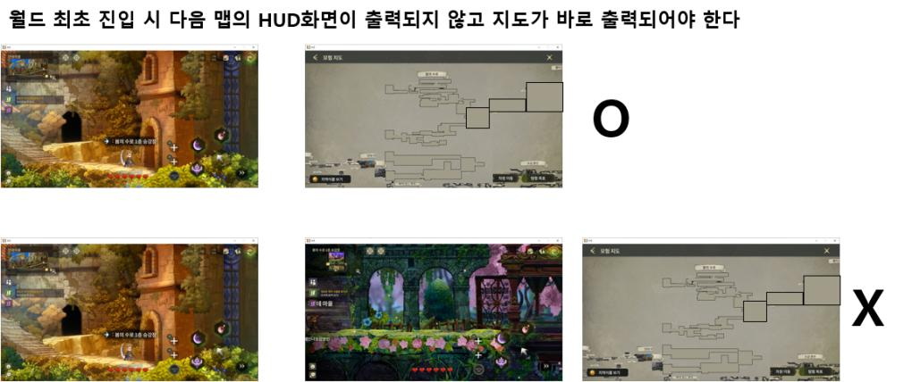
Minimap — HUD position and zone detail
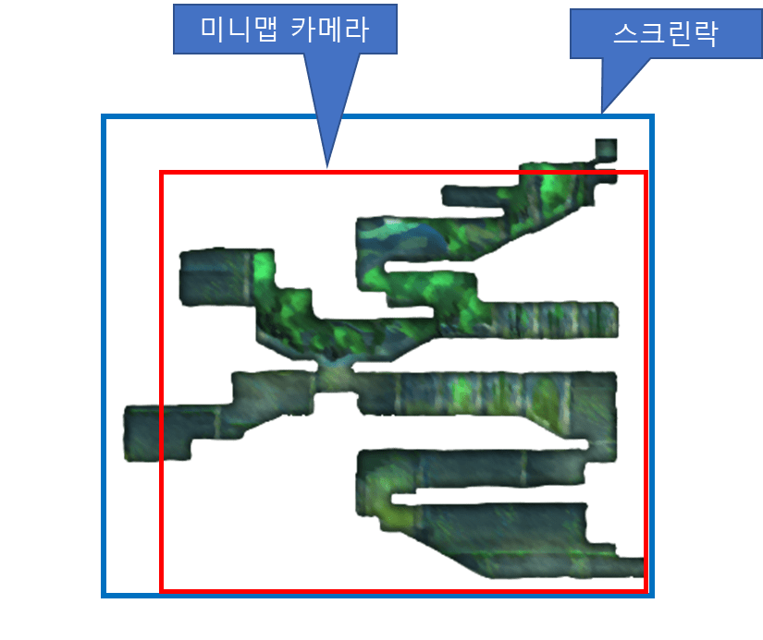
Minimap image stitching — individual zones assembled into world map
UI Elements
Zone name | TRName from Map.xml; displayed top-right of minimap
Nearby Users | Button opens the Nearby Players UI
Channel display | Shows current channel; tap to open channel select popup
Recommended CP | I_CombatPower from Map.xml — shown as 'Recommended CP: {N}'

INDOOR ZONE HANDLING
Indoor zones (e.g. guild halls, dungeon lobbies) are not part of the world map graph. The system needs to represent the player's position even when they're off the map.
- When in an indoor zone, the player's icon is shown at the last outdoor warp point used to enter
- If multiple entry warps exist, the most recently used one is tracked
- Chain entries (A → C → D) track back to the last outdoor zone — player always has a valid outdoor reference point
- Edge case: if the player restarts inside an indoor zone, ParentMapPositionID in Map.xml provides the fallback outdoor position

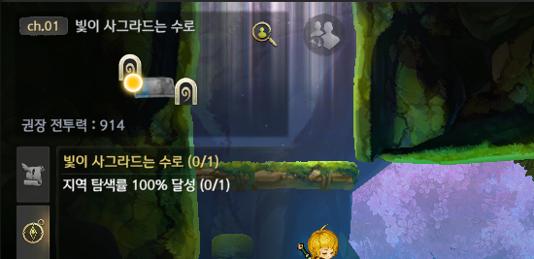
Indoor zone — player icon proxied to last outdoor warp
DATA & XML
WorldMap.xml
- ZoneNode entries define which zones appear on the world map and how they connect
- Zones absent from ZoneNode are treated as indoor zones and get the proxy-icon treatment
Map.xml
- TRName — zone display name
- I_CombatPower — recommended CP shown in minimap HUD
- ParentMapPositionID — fallback outdoor position for zones reached via indoor chains

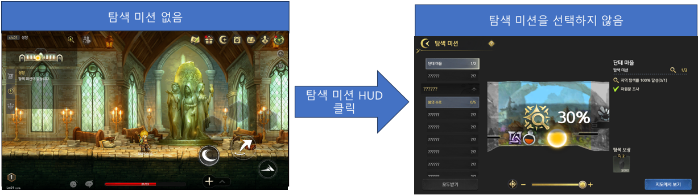
WorldMap.xml — zone connection structure
DESIGN NOTES
- Shared fog state between Adventure Map and Exploration Missions was a deliberate architecture decision — one data write drives both systems, reducing server load and eliminating sync bugs
- The greyscale shader approach for fog means the art team only needs to produce one map image per zone; no separate 'fogged' version is required
- The silhouette state (world outline only for unvisited worlds) was designed to build anticipation — spec was written with the full transition flow, but flagged as future dev to ship on time
- Icon priority ordering was specified explicitly to handle the many overlapping cases in dense areas; without this, engineers would have had to make arbitrary decisions
- The 'View in Exploration Missions' button in the Adventure Map and the 'View in Map' button in Exploration Missions create a bidirectional link between the two systems — players can move freely between them without losing context

Juwon Lee · quierado@gmail.com · linkedin.com/in/juwon-lee-5b3097219

