Please answer the following questions，and send your answers (this file) by email to 18640538206@163.com by 2025-10-17 10: 20, Beijing Time. Please rename this file by the given format: NLP-quiz-2-学号-姓名.
Student Number： 20237067 Name: 李天宇

- Which metric is used to evaluate the performance of a language model without being applied to downstream tasks? (5 marks) Answer: ___B___
- Precision
- Perplexity
- Recall
- F1

- Given a Unknown Word “hellogworld” and a sequence “The word hellogworld looks like a concatenation of hello and world by a character g” , how to learn its word embedding? Describe two effective methods. (10 marks)

Solution 1:
用BPE/Wordpiece/UnigramLM等子词分词，把hellogworld切成若干子片段（如 hello、g、world或更细的子词/词片）。
令这些子词各自有嵌入 e1,e2...，将未知词嵌入设为这些子词嵌入的加权和/平均/拼接后过一层非线性变换
使用Transformer，让模型直接以这些子词在该句上下文中的表示（最后一层隐藏态）作为该未知词的上下文化向量

Solution 2:

使用fastText 风格的字符 n-gram，将hellogworld的所有字符n-gram映射到向量并求和/平均

- Given a context-free grammar and a string “I prefer a book to money”, derive a parsing three for the sentence (15 marks)
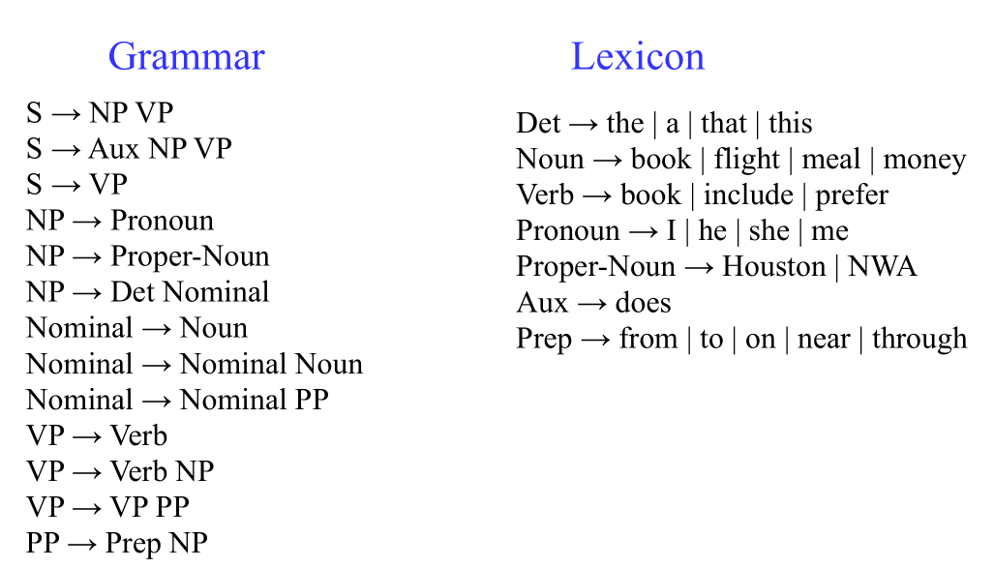
Answer: (draw your parsing tree here)

S-->NP
| |--->Pronoun : I
|
\-->VP
|-->VP
| |-->Verb : perfer
| |--->NP
| |-->Det : a
| |-->Nominal
| |-->Noun : book
|
|--->PP
|--->Prep : to
|--->NP
|--->Noun : money

- Which option is NOT a typical application of RNN? (5 marks)
Answer:____D____
- Sequence labeling
- Sequence classification
- Sequence generation
- Sequence Spell Correction

