We have finally decided on the brand name. It’s xoera. Hillol is in love with Vietnam!!!

Change the package name to com.atravesar.xoera.xoeracustomer.

1. Can we have a DateTime picker similar to the Addison Lee one?
2. Current Booking/History contents:
3. Pickup Date
4. Pickup Time
5. Booking Ref
6. Vehicle Type
7. Pickup Address
8. Via Address
9. Dropoff Address
10. Price

**Actions**

1. Book Again
2. Book Return
3. Track Driver (Only in current bookings)
4. Cancel Booking (Only in current bookings)
5. Add ‘Contact’ option in the menu (I have not done the service method yet)

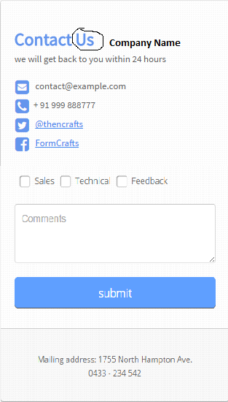

Show a confirmation popup if successful.

Keep the company name, email, phone, Facebook link, twitter link and address in variables. I am going to add a service method to retrieve these. You can call the endpoint on launch to fill these.

1. Setup GCM service. Follow instructions on <https://developers.google.com/cloud-messaging/registration>.

Use Sender ID: 784705604148

I have attached the configuration (json).

I will add a service method so that you can send the token to the server.

1. Instead of just adding ‘Home’ address, I was thinking can we make something like ‘My places’ so that the customer can add ‘work’ or other places. We can add ‘My places’ in the menu.

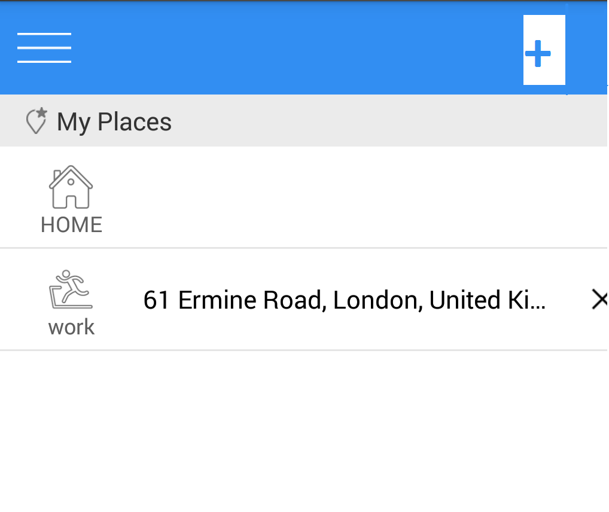

We can keep ‘Home’ fixed and let the customer add/delete other places.

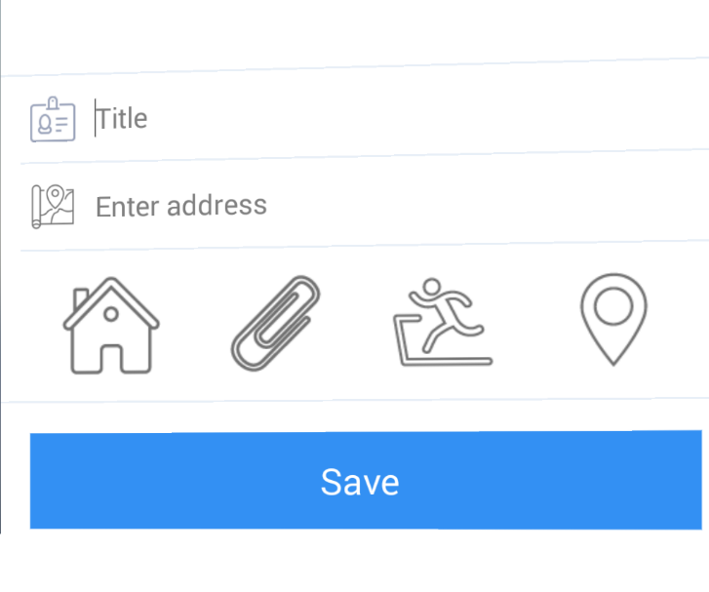

We don’t need to provide icon options. We can use ‘Home’ icon for ‘home’ and ‘location’ icon for others.

1. When the via address is visible hide the ‘+’ icon on dropoff address and show ‘-’ on via.