Modelling Assignment: Ontology for local library.
- Introduction.

The aim of this report is to develop and test a prototype of ontology for a local library which needs to implement an AI-powered software to improve its service delivery and have a faster and more efficient research system.
The library at the moment has a disorganised collection of books that needs to be better organized and optimized to offer a better service to the community.
The report will present and draft a prototype of ontology that could be implemented in the library new AI-powered software.
For this task it has been decided to use Web Ontology Language (OWL in this report) and the free ontology editor Protégé.
The main reason to use the OWL is because it enables a semantic reasoning that would not be possible with a traditional database. As highlighted by Alti et al. (2013: 6), OWL architecture “is context-aware but suffered from a semantic-based quality evaluation for achieving an efficient framework”.

- Ontology Design.

The design of this ontology, especially in the definition of classes and their hierarchy, follows the top-down development process that, as explained by Noy and McGuinness (2001: 6) “starts with the definition of the most general concepts in the domain and subsequent specialization of the concepts”.
Nine different classes have been defined and implemented (in alphabetical order):
- AgeCategory
- Author
- AvailabilityStatus
- Book
- BookFormat
- Genre
- Language
- PhysicalLocation
- UniqueIdentifier
The purpose of those classes is to start from the nine most general concepts, for a library system. These nine classes represent the core search criteria identified for library users: finding books by author, genre, availability, format, language, location, and target audience.
in Fig. 1 (Appendix A) it can be seen the starting structure of the ontology.
Looking at Fig. 2 (Appendix A) the hierarchy of each of the main classes could be noticed. For the dimension of the library and for the number of books stored, this classification and sub-classification should be enough to perform quick and optimised research.
One of the main divisions has been between FictionBook book and NonFictionBook (both sub-classes of the main class Book) and the reason is that it was one of the clear requirements from the library.
To have this division even more clear, a disjoint axiom has been used. It can be seen clearly in Fig. 3 (Appendix A) that the sub-class FictionBook is disjointed from the NonFictionBook sub-class and vice-versa. This because no book of “Fiction” can be at the same time “Non-Fiction”. Other disjoint axioms have been used for the Language class: for simplicity a book can only be written in one language.
Classes and sub-classes have been disjointed at the end of the design of the classes because it’s usually best to keep classes non-disjoint at first and make them disjoint later, once the model is clearer. (Debellis, 2021: 17).
- Properties and Restrictions.
Object properties have been created for each class in a way that the research could be faster and more effective. The list of properties created can be found in Fig. 4 (Appendix A).
For example, a property writtenBy has been created for the class Book with a ranges intersection with the class Author (a book is written by an author). At the same time the inverse property isAuthorOf has been created with the opposite criteria: the domain is Author and has ranges intersection with the class Book (an author is the writer of a book). This construction will allow the customer to search by author and by book having the same results.

At the same time, for each book recorded in the system, Data Properties have been created to store valuable information such as title, publicationYear, Description, IdentifierValue. Those Data Properties, together with the Object Properties are giving precise research option in order to classify the stock of book as effectively as possible.

Object properties and Data Properties evidence can be found in Fig. 5 (Appendix A).

To make the research more rigorous, restrictions have been added. An example can be found in Fig. 6 (Appendix A) where, for the sub-class FictionBook, the universal restriction “hasGenre only FictionGenre” has been added so that is clear that a fiction book can only have fiction as a genre and not a genre belonging to the NonFictionBook sub-class.

The last part of the design is related to the Defined Classes. Four defined classes have been created as sub-classes of the main class Book:

- AvailableBook
- BorrowedBook
- ItalianBook
- TeenAgerBook
Those classes are helping the research grouping, for example, all the books currently available in the library (AvailableBook). Details of the Defined Classes setting can be found in Fig. 7 (Appendix A).
- Testing of the Ontology draft.
Three types of tests have been done to verify the functioning of the ontology design:
- Test on Defined Classes: clicking on the defined class “ItalianBook” we could see (Fig. 8, Appendix A) that the instance reported is correct. “Sonnets” in fact is the only book written in Italian language.
- DL Query: after going into the “DL Query” tab on Protégé, we have tested the “AvailableBook” and the result was also correct: the two only available book in our “test library” are “Sonnets” and “Steve Jobs”. See Fig. 9 (Appendix A).

- SPARQL Query: This has been the most complex query of the three. It has been requested to search the titles of the books written by the author Walter Isaacson, their physical location and their availability. In Fig. 10 (Appendix A) it can be found the results, that are correct.

- Conclusions and Recommendations.

The draft of ontology created in Protégé with OWL can be considered functional and retrieving the correct results after the testing performed in the section 4 of this report.

Nevertheless, the ontology would need to be implemented with all the data of the publications available in the stock of the library, more quality and accuracy test should be performed, and a deep review of object properties should be done.
It can be said that, at the current status, it could represent a good base for a AI-powered software for records research purposes.

References:

Alti, A., Boukerram, A. & Roose, P. (2013) Ontology and tool support for quality service management. Journal of systems and information technology. [Online] 15 (1), 4–23. Available from: https://www-emerald-com.uniessexlib.idm.oclc.org/jsit/article/15/1/4/246850/Ontology-and-tool-support-for-quality-service [Accessed 10th January 2026].
Debellis, M. (2021) New Protégé Pizza Tutorial. (Online) Available from: https://tinyurl.com/NewPizzaTutorialV3-2 [Accessed 12th January 2026].
Noy, N. F. & McGuinness, D. L. (2001) Ontology Development 101: A Guide to Creating Your First Ontology [Online]. Available from: http://protege.stanford.edu/publications/ontology_development/ontology101.pdf [Accessed 10th January 2026].

APPENDIX A.
Protégé Screenshots.
Fig. 1 Nine Main Classes.
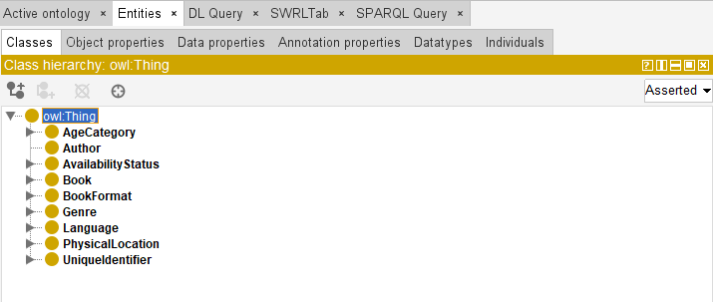

Fig. 2 Classes and Subclasses (Hierarchy).
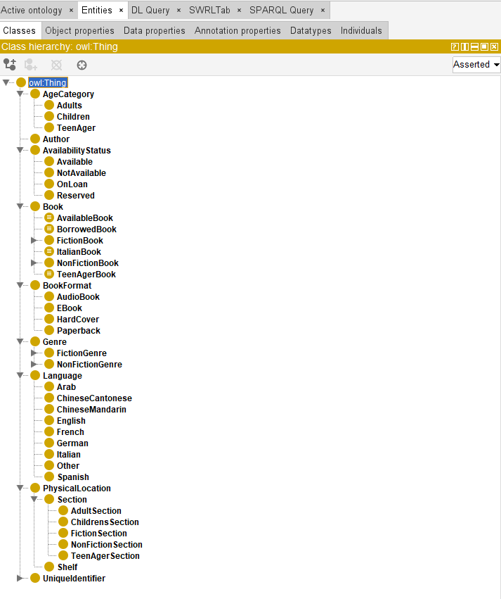

Fig. 3 Disjoint With (sub-class FictionBook).
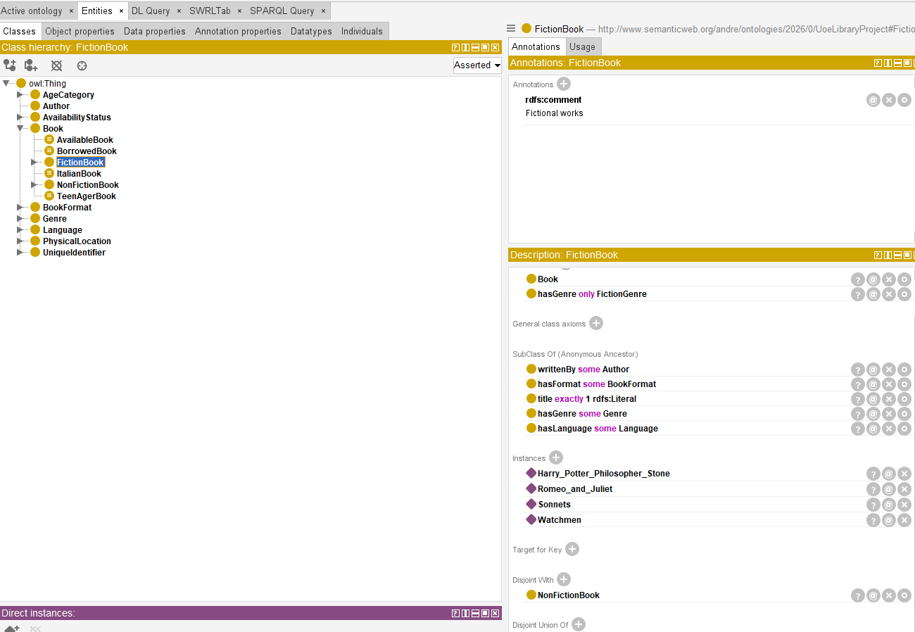

Fig. 4 Object Properties.
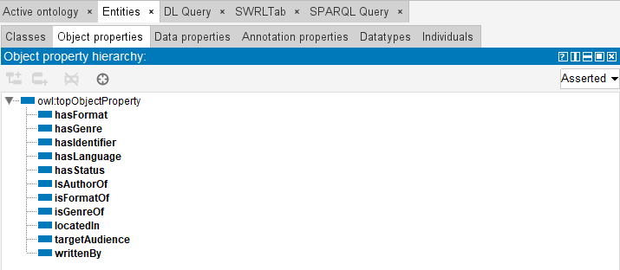

Fig. 5 Data Properties.
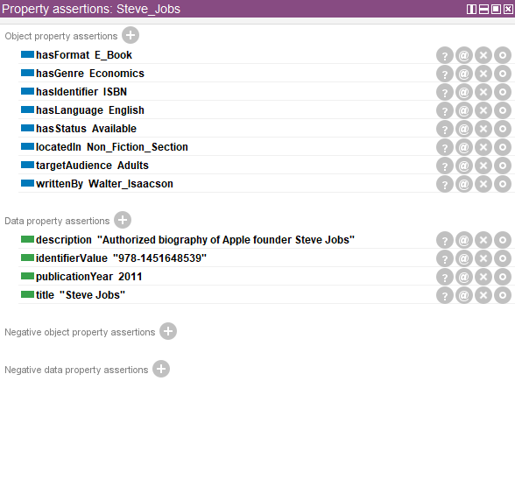

Fig. 6 Data Restriction.
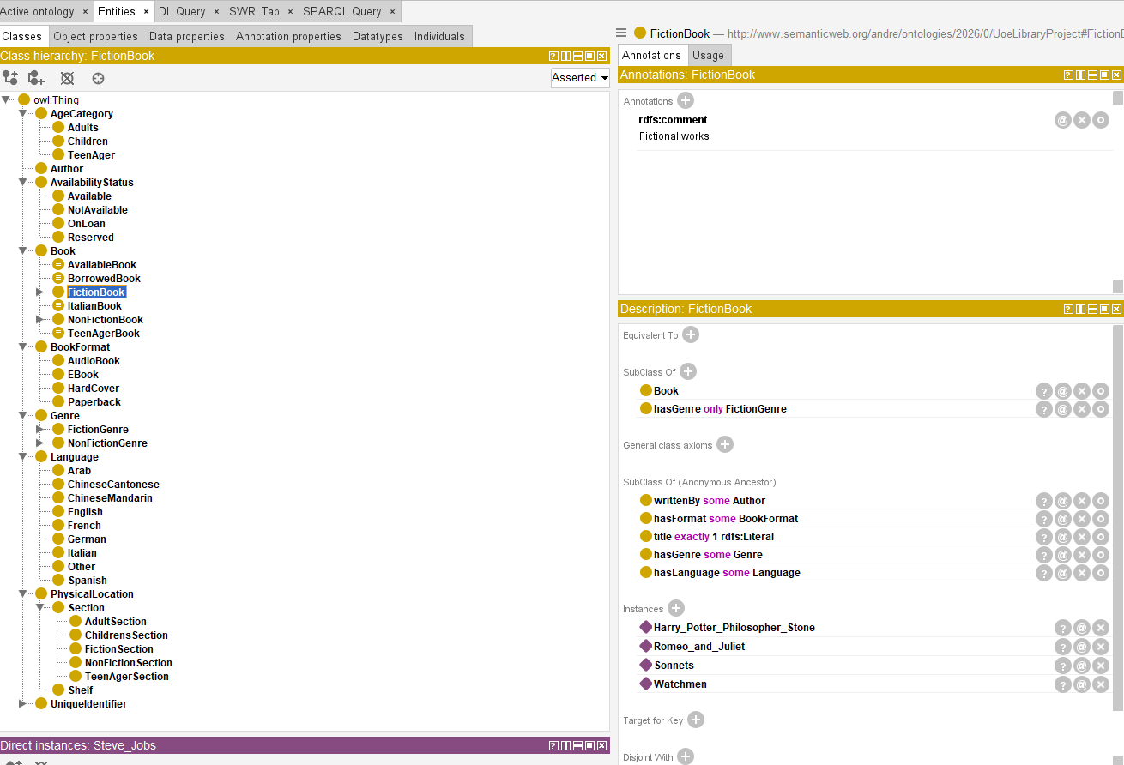
Fig. 7 Defined Class.
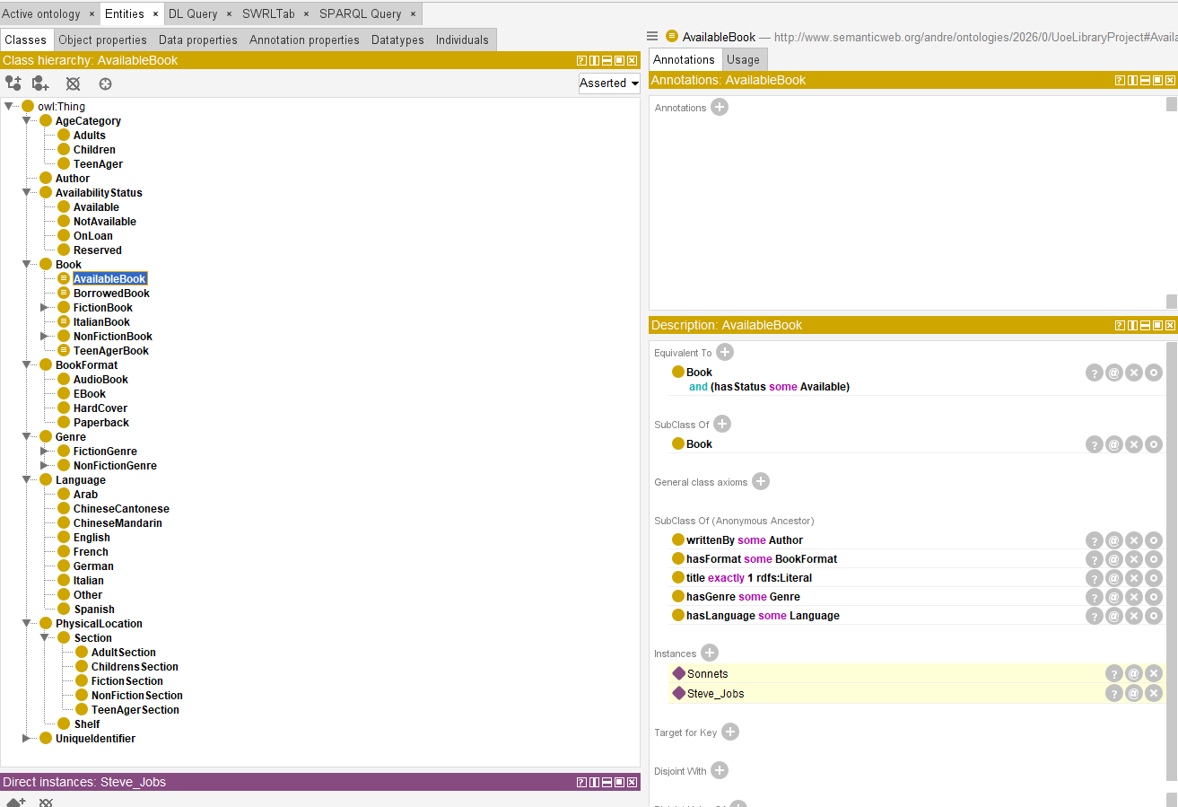

Fig. 8 Testing Defined Class.
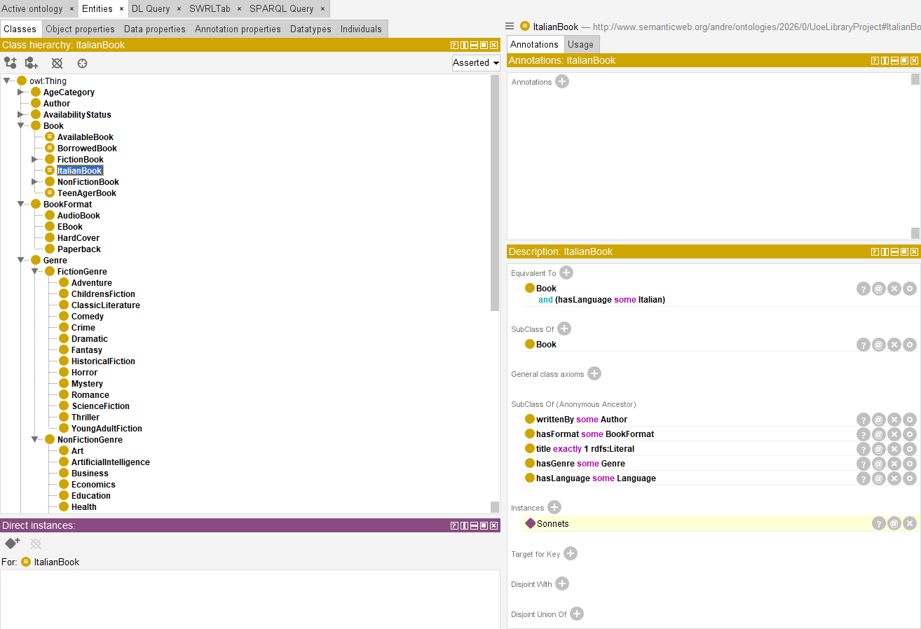
Fig. 9 DL Query Test.
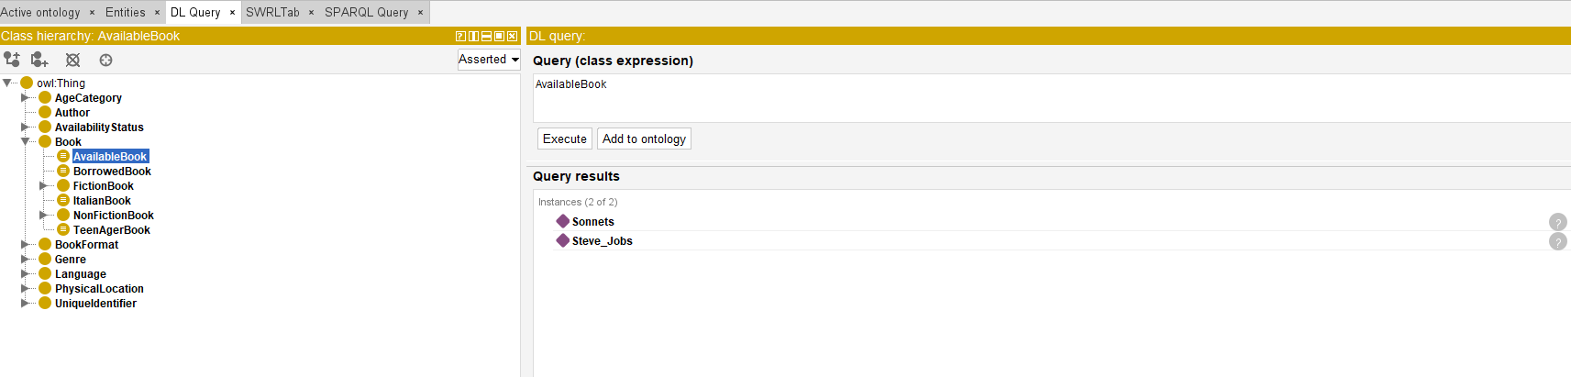
Fig. 10 SPARQL Query Test.
