# 作业介绍：

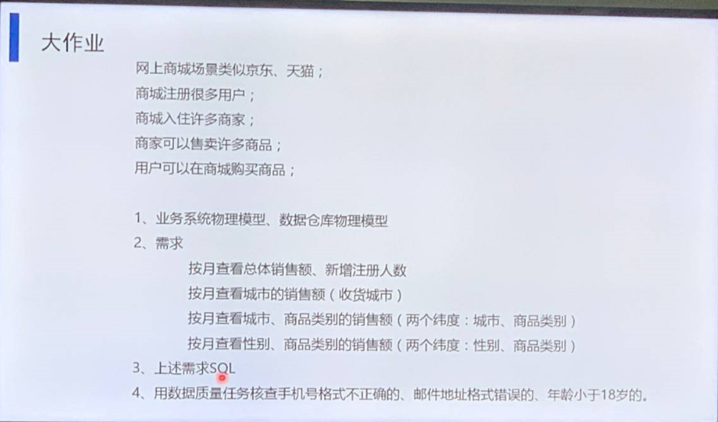

# 作业回答：

## 设计业务系统的数据物理模型

### 设计：

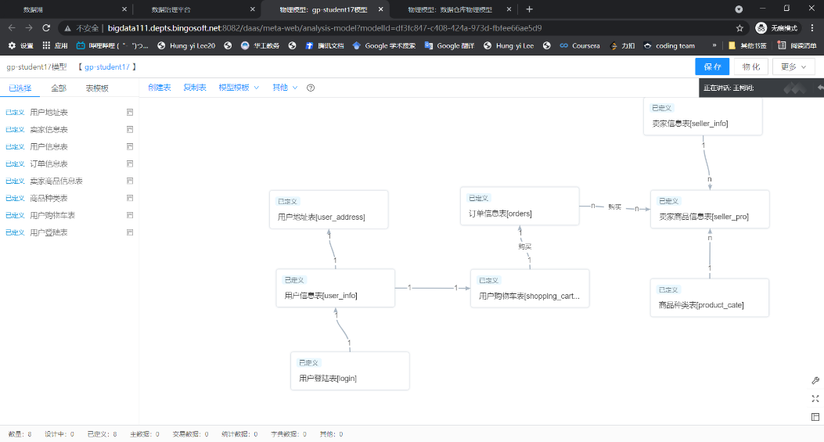

### 建表语句：

--用户信息表

drop table if exists homework.user_info;

create table homework.user_info

(

user_id INT primary key,

phone_number VARCHAR(11),

user_name VARCHAR(5),

ID_Number VARCHAR(18),

Register_time DATE,

pet_name VARCHAR(12),

sex VARCHAR(2),

age int,

email VARCHAR(12)

);

-- Add comments to the table

comment on table homework.user_info

is '用户信息表';

-- Add comments to the columns

comment on column homework.user_info.user_id

is '用户id';

comment on column homework.user_info.phone_number

is '手机号码';

comment on column homework.user_info.user_name

is '用户姓名';

comment on column homework.user_info.ID_Number

is '身份证号码';

comment on column homework.user_info.Register_time

is '注册时间';

comment on column homework.user_info.pet_name

is '用户昵称';

comment on column homework.user_info.sex

is '用户性别';

comment on column homework.user_info.AGE

is '用户年龄';

comment on column homework.user_info.email

is '邮箱地址';

--用户地址表

drop table if exists homework.user_address;

create table homework.user_address

(

user_id int primary key,

provience VARCHAR(5),

city VARCHAR(5),

county VARCHAR(5),

specific_address VARCHAR(10)

);

-- Add comments to the table

comment on table homework.user_address

is '用户地址表';

-- Add comments to the columns

comment on column homework.user_address.user_id

is '用户id';

comment on column homework.user_address.provience

is '省份';

comment on column homework.user_address.city

is '市';

comment on column homework.user_address.county

is '县';

comment on column homework.user_address.specific_address

is '具体地址';

--用户登陆表

drop table if exists homework.login;

create table homework.login

(

user_id INT primary key ,

phone_number VARCHAR(11),

passwords VARCHAR(10)

);

-- Add comments to the table

comment on table homework.login

is '用户登陆表';

-- Add comments to the columns

comment on column homework.login.user_id

is '用户id';

comment on column homework.login.phone_number

is '用户账号';

comment on column homework.login.passwords

is '用户密码';

--用户购物车表

drop table if exists homework.shopping_cart;

create table homework.shopping_cart

(

user_id INT ,

sku_id INT ,

numbers INT,

total_price INT

);

-- Add comments to the table

comment on table homework.shopping_cart

is '用户购物车表';

-- Add comments to the columns

comment on column homework.shopping_cart.user_id

is '用户id';

comment on column homework.shopping_cart.sku_id

is '商品id';

comment on column homework.shopping_cart.numbers

is '商品数量';

comment on column homework.shopping_cart.total_price

is '总价格';

--订单表

drop table if exists homework.orders;

create table homework.orders

(

id INT primary key,

user_id INT ,

sku_id INT ,

numbers INT,

total_prices INT,

order_month_time INT

);

-- Add comments to the table

comment on table homework.orders

is '订单信息表';

comment on column homework.orders.id

is '订单id';

comment on column homework.orders.user_id

is '用户id';

comment on column homework.orders.sku_id

IS '商品id';

comment on column homework.orders.numbers

IS '商品数量';

comment on column homework.orders.total_prices

IS '总价格';

comment on column homework.orders.order_month_time

IS '创建订单时间';

--销售额总表

DROP TABLE IF EXISTS homework.sales;

CREATE TABLE homework.sales

(

sex varchar(2),

months int,

city varchar(4),

category varchar(4),

pro_sum int

);

-- Add comments to the table

comment on table homework.sales

is '销售信息总表';

comment on column homework.sales.sex

IS '性别';

comment on column homework.sales.months

IS '月份';

comment on column homework.sales.city

IS '城市';

comment on column homework.sales.category

IS '商品类别';

comment on column homework.sales.pro_sum

IS '销售总额';

--按城市分类的销售表

DROP TABLE IF EXISTS homework.sale_city;

CREATE TABLE homework.sale_city

(

city VARCHAR(4),

months int,

pro_sum int

);

-- Add comments to the table

comment on table homework.sale_city

is '城市商品销售总表';

comment on column homework.sale_city.city

IS '城市';

comment on column homework.sale_city.months

IS '月份';

comment on column homework.sale_city.pro_sum

IS '总额';

--按性别分类的销售表

DROP TABLE IF EXISTS homework.sale_sex;

CREATE TABLE homework.sale_sex

(

sex VARCHAR(2),

months int,

pro_sum int

);

-- Add comments to the table

comment on table homework.sale_sex

is '按性别分类商品销售总表';

comment on column homework.sale_sex.sex

IS '性别';

comment on column homework.sale_sex.months

IS '月份';

comment on column homework.sale_sex.pro_sum

IS '销售总额';

--按商品类别分的销售总额表

DROP TABLE IF EXISTS homework.sale_cate;

CREATE TABLE homework.sale_cate

(

category VARCHAR(4),

months int,

pro_sum int

);

-- Add comments to the table

comment on table homework.sale_cate

is '按商品类别商品销售总表';

comment on column homework.sale_cate.category

IS '商品类别';

comment on column homework.sale_cate.months

IS '月份';

comment on column homework.sale_cate.pro_sum

IS '销售总额';

--商家信息

DROP TABLE IF EXISTS homework.seller_info;

CREATE TABLE homework.seller_info

(

seller_id INT PRIMARY KEY,

name VARCHAR(5),

account VARCHAR(10),

passwords VARCHAR(10)

);

-- Add comments to the table

comment on table homework.seller_info

is '卖家信息表';

comment on column homework.seller_info.seller_id

IS '卖家id';

comment on column homework.seller_info.passwords

IS '密码';

comment on column homework.seller_info.account

IS '账户';

--商品种类表

DROP TABLE IF EXISTS homework.product_cate;

CREATE TABLE homework.product_cate

(

spu_id int PRIMARY KEY,

product_name VARCHAR(5),

category VARCHAR(4)

);

-- Add comments to the table

comment on table homework.product_cate

is '商品种类表';

comment on column homework.product_cate.spu_id

IS 'id';

comment on column homework.product_cate.product_name

IS '商品名称';

comment on column homework.product_cate.category

IS '商品类别';

--卖家商品信息表

DROP TABLE IF EXISTS homework.seller_pro;

CREATE TABLE homework.seller_pro

(

sku_id int PRIMARY KEY,

spu_id int ,

seller_id int ,

numbers int,

prices int

);

-- Add comments to the table

comment on table homework.seller_pro

IS '卖家商品信息表';

comment on column homework.seller_pro.sku_id

IS '商品id';

comment on column homework.seller_pro.spu_id

IS '商品类别id';

comment on column homework.seller_pro.seller_id

IS '商家id';

comment on column homework.seller_pro.numbers

IS '库存量';

comment on column homework.seller_pro.prices

IS '价格';

drop table if exists homework.users_allinfo;

create table homework.users_allinfo

(

months int,

users_new_register int,

users_registered int

);

-- Add comments to the table

comment on table homework.users_allinfo

is '用户信息统计表';

-- Add comments to the columns

comment on column homework.users_allinfo.months

is '月份';

comment on column homework.users_allinfo.users_new_register

is '新增注册人数';

comment on column homework.users_allinfo.users_registered

is '用户总数';

## 设计数据仓库物理模型：

### 设计：

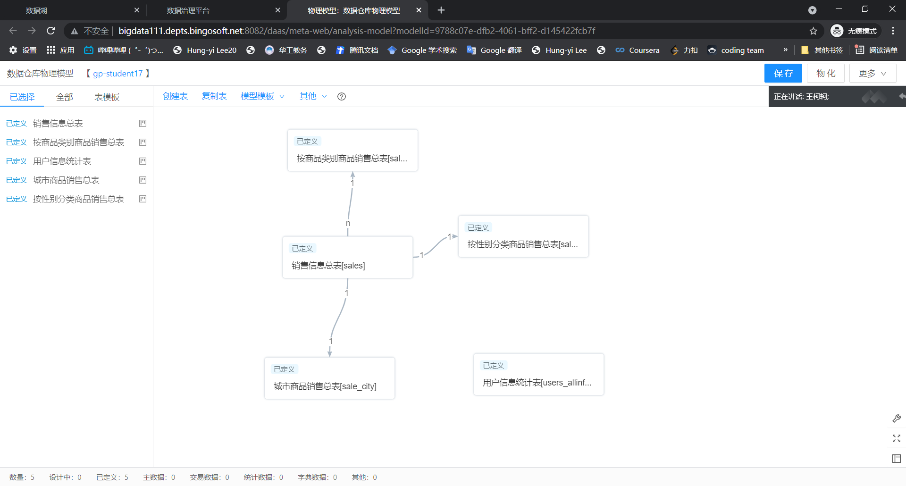

### 物化：

使用系统的右上角的功能

## 质量管理：

### 添加规则：

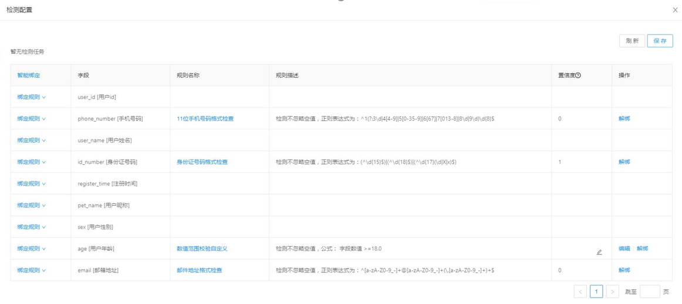

### 查看检测报告：

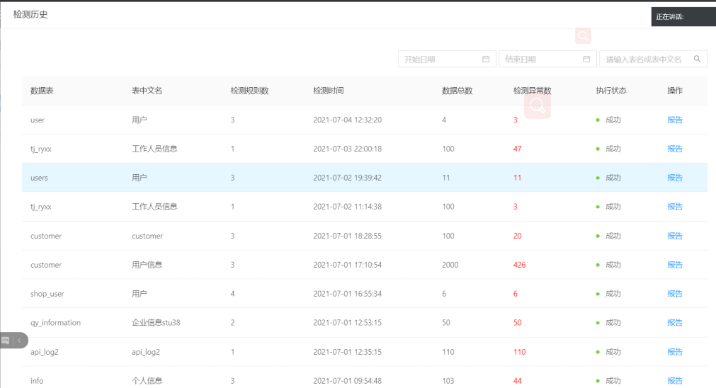

## 业务查询

### 查询语句：

--按月查看总体销售额

select months, sum(pro_sum)

from homework.sales

group by months;

--按月查看新增注册人数

select months,users_new_register

from homework.users_allinfo

order by months;

--按月查看城市销售额

select months,city,pro_sum

from homework.sale_city;

--按月查看城市、商品类别的销售额

select homework.sale_city.months,city,category, homework.sale_city.pro_sum

from homework.sale_city,homework.sale_cate

where homework.sale_city.months = homework.sale_cate.months;

--按月查看性别、商品类别的销售额

select homework.sale_sex.months,sex,category,homework.sale_sex.pro_sum

from homework.sale_sex,homework.sale_cate

where homework.sale_sex.months = homework.sale_cate.months;