BLYNK

Blynk was designed for the Internet of Things. It can control hardware remotely, it can display sensor data, it can store data, vizualize it and do many other cool things.

There are three major components in the platform:

* **Blynk App** - allows to you create amazing interfaces for your projects using various widgets we provide.
* **Blynk Server** - responsible for all the communications between the smartphone and hardware. You can use our Blynk Cloud or run your [private Blynk server](https://docs.blynk.cc/#blynk-server) locally. It’s open-source, could easily handle thousands of devices and can even be launched on a Raspberry Pi.
* **Blynk Libraries** - for all the popular hardware platforms - enable communication with the server and process all the incoming and outcoming commands.

Now imagine: every time you press a Button in the Blynk app, the message travels to  the Blynk Cloud, where it magically finds its way to your hardware. It works the same in the opposite direction and everything happens in a blynk of an eye.

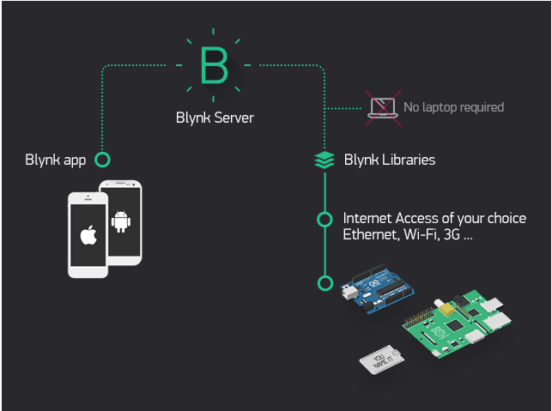

Features

* Similar API & UI for all supported hardware & devices
* Connection to the cloud using:
  + WiFi
  + Bluetooth and BLE
  + Ethernet
  + USB (Serial)
  + GSM
* Set of easy-to-use Widgets
* Direct pin manipulation with no code writing
* Easy to integrate and add new functionality using virtual pins
* History data monitoring via SuperChart widget
* Device-to-Device communication using Bridge Widget
* Sending emails, tweets, push notifications, etc.
* new features are constantly added!

You can find [example sketches](https://github.com/blynkkk/blynk-library/tree/master/examples) covering basic Blynk Features. They are included in the library. All the sketches are designed to be easily combined with each other.

What do I need to Blynk?

At this point you might be thinking: **“Ok, I want it. What do I need to get started?”** – Just a couple of things, really:

#### **1. Hardware**.

An Arduino, Raspberry Pi, or a similar development kit.

**Blynk works over the Internet.** This means that the hardware you choose should be able to connect to the internet. Some of the boards, like Arduino Uno will need an Ethernet or Wi-Fi Shield to communicate, others are already Internet-enabled: like the ESP8266, Raspberri Pi with WiFi dongle, Particle Photon or SparkFun Blynk Board. But even if you don’t have a shield, you can connect it over USB to your laptop or desktop (it’s a bit more complicated for newbies, but we got you covered). What’s cool, is that the [list of hardware](https://docs.blynk.cc/#supported-hardware) that works with Blynk is huge and will keep on growing.

#### **2. A Smartphone**.

The Blynk App is a well-designed interface builder. It works on both iOS and Android.

Getting Started

Let’s get you started in 5 minutes (reading doesn’t count!). We will switch on an LED connected to your Arduino using the Blynk App on your smartphone.

Connect an LED as shown here:

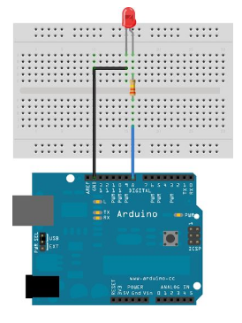

Getting Started With The Blynk App

1. Create a Blynk Account

After you download the Blynk App, you’ll need to create a New Blynk account. This account is separate from the accounts used for the Blynk Forums, in case you already have one.

We recommend using a **real** email address because it will simplify things later.

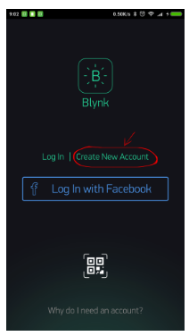

#### Why do I need to create an account?

An account is needed to save your projects and have access to them from multiple devices from anywhere. It’s also a security measure.

You can always set up your own [Private Blynk Server](https://docs.blynk.cc/#blynk-server) and have full control

Create a New Project

After you’ve successfully logged into your account, start by creating a new project.

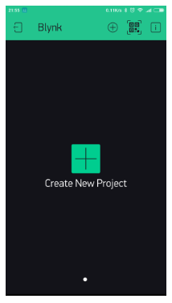

Choose Your Hardware

Select the hardware model you will use. Check out the [list of supported hardware](https://docs.blynk.cc/#supported-hardware)!

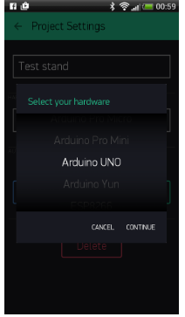

Auth Token

**Auth Token** is a unique identifier which is needed to connect your hardware to your smartphone. Every new project you create will have its own Auth Token. You’ll get Auth Token automatically on your email after project creation. You can also copy it manually. Click on devices section and selected required device :

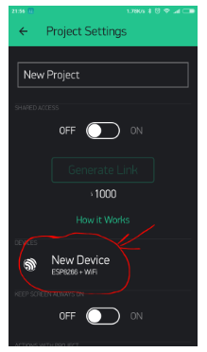

**NOTE:** Don’t share your Auth Token with anyone, unless you want someone to have access to your hardware.

It’s very convenient to send it over e-mail. Press the e-mail button and the token will be sent to the e-mail address you used for registration. You can also tap on the Token line and it will be copied to the clipboard.

Now press the **“Create”** button.

Add a Widget

Your project canvas is empty, let’s add a button to control our LED.

Tap anywhere on the canvas to open the widget box. All the available widgets are located here. Now pick a button.

**Widget Box**

**Drag-n-Drop** - Tap and hold the Widget to drag it to the new position.

**Widget Settings** - Each Widget has it’s own settings. Tap on the widget to get to them.

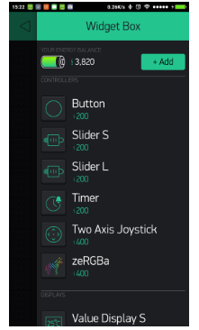

Run The Project

When you are done with the Settings - press the **PLAY** button. This will switch you from EDIT mode to PLAY mode where you can interact with the hardware. While in PLAY mode, you won’t be able to drag or set up new widgets, press **STOP** and get back to EDIT mode.

You will get a message saying “Arduino UNO is offline”. We’ll deal with that in the next section.

Getting Started With Hardware

How To Use an Example Sketch

You should by now have the Blynk Library installed on your computer. If not - [click here](https://docs.blynk.cc/#downloads-blynk-library).

Example sketches will help you get your hardware online quickly and major Blynk features.

Open the example sketch according to the hardware model or shield you are using.

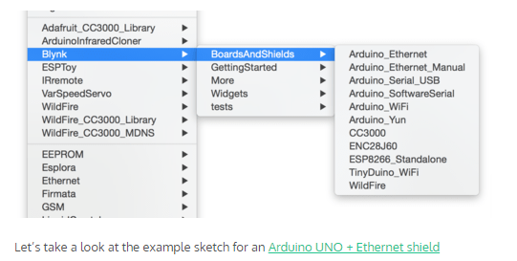

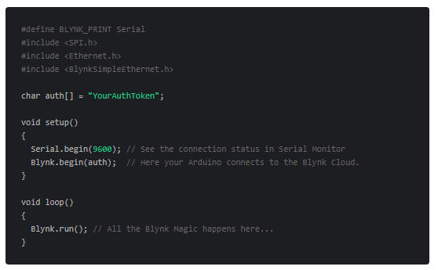

Auth Token

In this example sketch, find this line:

char auth[] = "YourAuthToken";

This is the [Auth Token](https://docs.blynk.cc/" \l "getting-started-getting-started-with-application-4-auth-token) that you emailed yourself. Please check your email and copy it, then paste it inside the quotation marks.

It should look similar to this:

char auth[] = "f45626c103a94983b469637978b0c78a";

Upload the sketch to the board and open Serial Terminal. Wait until you see something like this:

Blynk v.X.X.X

Your IP is 192.168.0.11

Connecting...

Blynk connected!

**Congrats! You are all set! Now your hardware is connected to the Blynk Cloud!**

Blynking

Go back to the Blynk App, push the button and turn the LED on and off! It should be Blynking

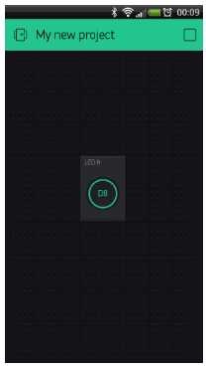

Check out [other example sketches](https://github.com/blynkkk/blynk-library/tree/master/examples).

Feel free to experiment and combine different examples together to create your own amazing projects.

For example, to attach an LED to a [PWM](http://www.arduino.cc/en/Tutorial/Fading)-enabled Pin on your Arduino, set the slider widget to control the brightness of an LED. Just use the same steps described above.