# Automatic Transmission Controller

## Name : **Atri Mondal** Unique Id : **2005382**

## Introduction

The Flow diagram below represents the Power Flow in the drivetrain. Non-linear differential equations are used to model the engine, 4 speed transmission and vehicle. The Logic of the Transmission Control Unit (TCU) was better suited for Stateflow and have thus been represented by a chart.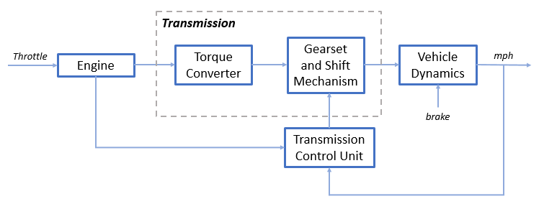

## Design Logic

### Equation 1

The throttle opening is one of the inputs to the engine. The engine is connected to the impeller of the torque converter which couples it to the transmission.

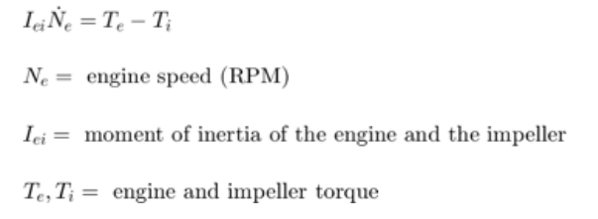

### Equation 2

The input-output characteristics of the torque converter can be expressed as functions of the engine speed and the turbine speed. Here, the direction of power flow is always assumed to be from the impeller to the turbine.

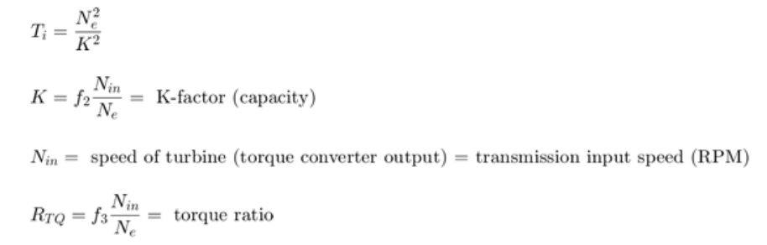

### Equation 3

The transmission model is implemented via static gear ratios, assuming small shift times.

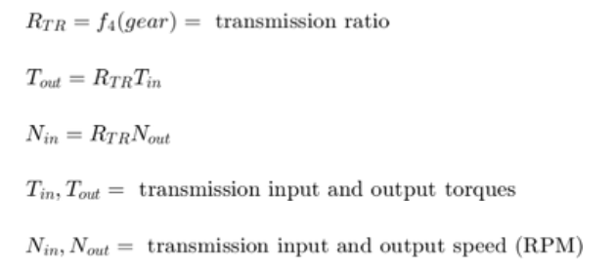

### Equation 4

The final drive, inertia, and a dynamically varying load constitute the vehicle dynamics.

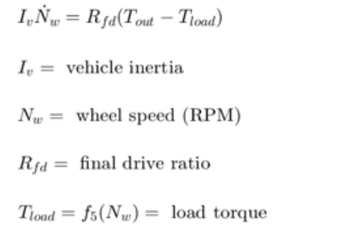

### Equation 5

The load torque includes both the road load and brake torque. The road load is the sum of frictional and aerodynamic losses.

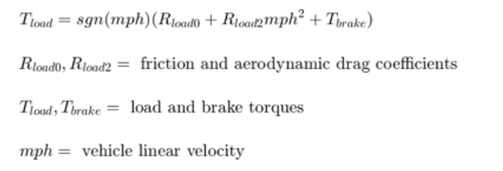

The model programs the shift points for the transmission according to the schedule shown in the figure below. For a given throttle in a given gear, there is a unique vehicle speed at which an upshift takes place. The simulation operates similarly for a downshift.

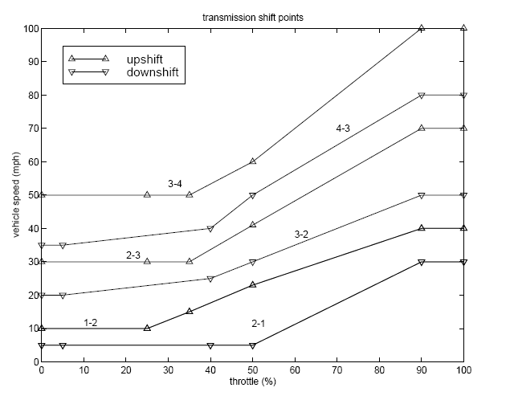

## Modelling

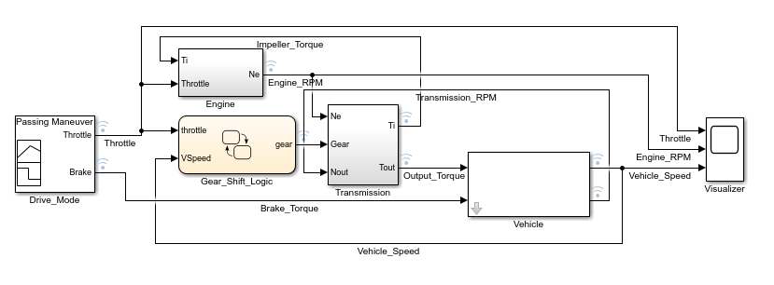

The Simulink model is composed of modules which represent the engine, transmission, and the vehicle, with an additional shift logic block to control the transmission ratio. User inputs to the model are in the form of throttle (percent) and brake torque (ft-lb). The user inputs Throttle and Brake Torque using the Drive Mode interface.

### Input

The Input is given by the Drive_Mode Block that is a masked **Signal Builder** Block and has 4 Modes to choose from :

* Passing Maneuver
* Gradual Acceleration
* Hard Braking
* Coasting

### Engine

The composite Engine subsystem consists of a **Two-Dimensional Look Up Table** that interpolates engine torque versus throttle and engine speed.

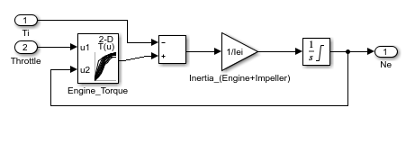

### Transmission

The Torque_Converter and the Transmission_Ratio blocks make up the Transmission subsystem, as shown below.

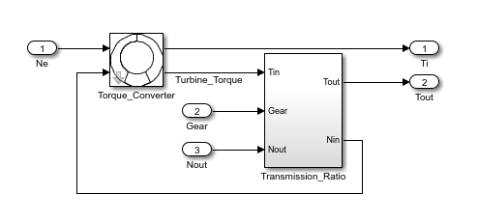

The Torque_Converter is a masked subsystem, which implements Equation 2. The mask requires a vector of speed ratios (Nin/Ne) and vectors of K-factor (f2) and torque ratio (f3). This figure shows the implementation of the Torque_Converter subsystem.

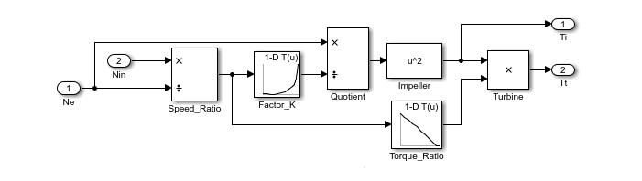

The transmission ratio block determines the ratio shown in Table 1 and computes the transmission output torque and input speed, as indicated in Equation 3. The figure that follows shows the block diagram for the subsystem that realizes this ratio in torque and speed.

Transmission gear ratios

Gear Rtr = Nin/Ne

1 2.393

2 1.450

3 1.000

4 0.677

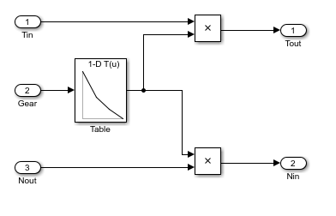

### Gear Selection

The Stateflow block labeled Gear_Shift_Logic implements gear selection for the transmission. Two dashed AND states keep track of the gear state and the state of the gear selection process. The overall chart is executed as a discrete-time system, sampled every 40 milliseconds.

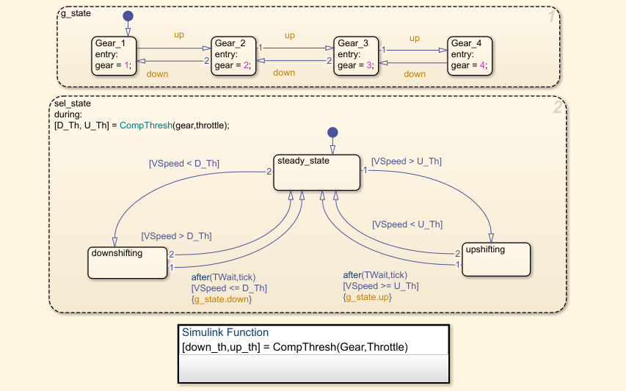

The sel_state (always active) begins by performing the computations indicated in its during function. The model computes the upshift and downshift speed thresholds as a function of the instantaneous values of gear and throttle. While in steady_state, the model compares these values to the present vehicle speed to determine if a shift is required. If so, it enters one of the confirm states (upshifting or downshifting), which records the time of entry.

If the vehicle speed no longer satisfies the shift condition, while in the confirm state, the model ignores the shift and it transitions back to steady_state. This prevents extraneous shifts due to noise conditions. If the shift condition remains valid for a duration of TWait ticks, the model transitions through the lower junction and, depending on the current gear, it broadcasts one of the shift events. Subsequently, the model again activates steady_state after a transition through one of the central junctions. The shift event, which is broadcast to the g_state, activates a transition to the appropriate new gear.

### Vehicle

The Vehicle subsystem uses the net torque to compute the acceleration and integrate it to compute the vehicle speed, per Equation 4 and Equation 5. The parameters entered in the mask menu are the final drive ratio, the polynomial coefficients for drag friction and aerodynamic drag, the wheel radius, vehicle inertia, and initial transmission output speed. The **MATLAB Function** Road_Load_Fcn computes road load based on friction and aerodynamic drag coefficients.

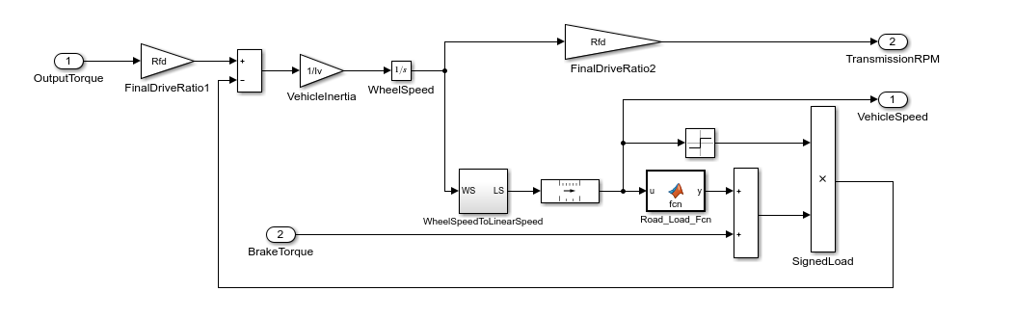

### Solver

Since the output does not exhibit a difference in scaling, we can use any non stiff solver such as the variable step size ode45 (Dormand Prince) which is based on the Runge Kutta (4,5) integration method. But since in this model we can safely account for all signal frequencies and ensure that they are less than solver frequency we will be using the fixed step size solver ode5 (Dormand Prince). This saves some computational time and has also been tested to give accurate output in our particular case.

## Results

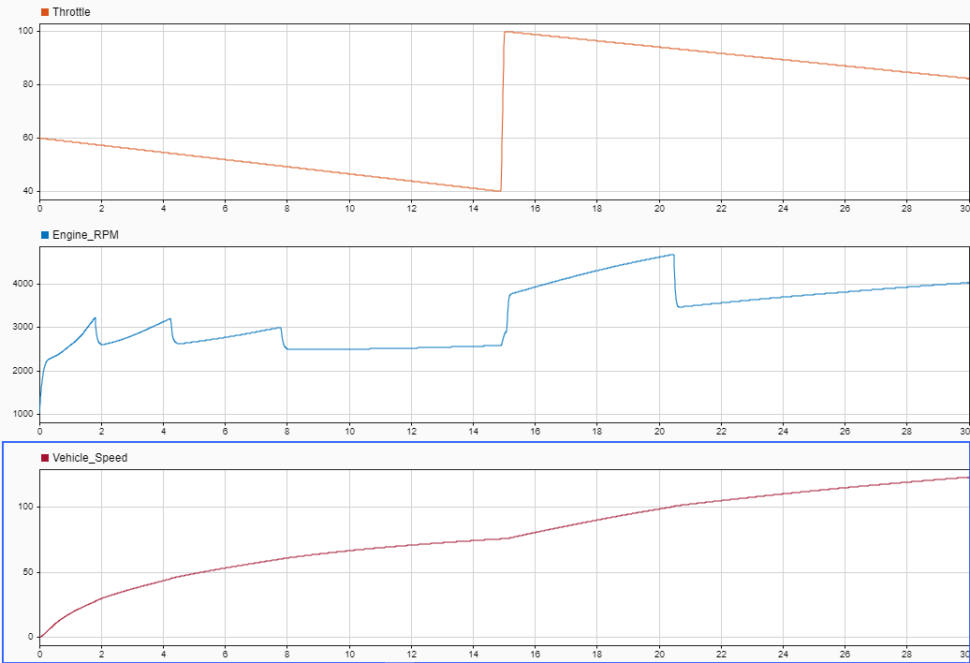

The first simulation (passing maneuver) is demonstated in **Data Inspector** output which uses the throttle schedule

**Time (sec) Throttle (%)**

0 60

14.9 40

15 100

100 0

200 0

The first column corresponds to time; the second column corresponds to throttle opening in percent. In this case no brake is applied (brake torque is zero). The vehicle speed starts at zero and the engine at 1000 RPM. The following figure shows the plot for the baseline results, using the default parameters. As the driver steps to 60% throttle at t=0, the engine immediately responds by more than doubling its speed. This brings about a low speed ratio across the torque converter and, hence, a large torque ratio. The vehicle accelerates quickly (no tire slip is modeled) and both the engine and the vehicle gain speed until about t = 2 sec, at which time a 1-2 upshift occurs. The engine speed characteristically drops abruptly, then resumes its acceleration. The 2-3 and 3-4 upshifts take place at about four and eight seconds, respectively. The vehicle speed remains much smoother due to its large inertia. At t=15sec, the driver steps the throttle to 100% as might be typical of a passing maneuver. The transmission downshifts to third gear and the engine jumps from about 2600 RPM to about 3700 RPM. The engine torque thus increases somewhat, as well as the mechanical advantage of the transmission. With continued heavy throttle, the vehicle accelerates to about 100 mph and then shifts into overdrive at about t = 21 sec. The vehicle cruises along in fourth gear for the remainder of the simulation.