Thrustmaster Top Gun, WCS MK II HOTAS
& Rudder System

Objective:

Convert Thrustmaster WCS MK II into base unit for Top Gun Flightstick and custom rudder pedals for use with modern games on a Linux system. Peripherals attach to WCS MK II and it connects to PC via USB.

Specifications:

Top Gun
2 Axes, 4 Buttons, 4 Pos POV hat (Analog)
15 pin DSUB output
WCS MK II
1 Axis, 6 buttons, 2 on-off-on rocker switches, 1 on-off rocker switch
15 pin DSUB input (for Top Gun)
6 Pin mini din (MD-60S) input for rudder
USB A Output
Rudder Pedals
1 axis, 1 button
6 Pin mini din (MD-60S)
Components:
x1 Pro Micro Microcontroller running NicoHood\HID Library https://github.com/NicoHood/HID/wiki
x2 MC74HC165A 8 bit PISO shift registers for button scanning
x2 MD-60S Connectors for rudder connection

Process:

Joystick pots need to be rewired to allow for direct reading of the pots, they currently have signal and VCC connections. VCC must be moved to an outer position, signal must be moved to the wiper and a ground must be added. Throttle will be entirely rewired, switches and buttons are all common grounded.
Pinouts
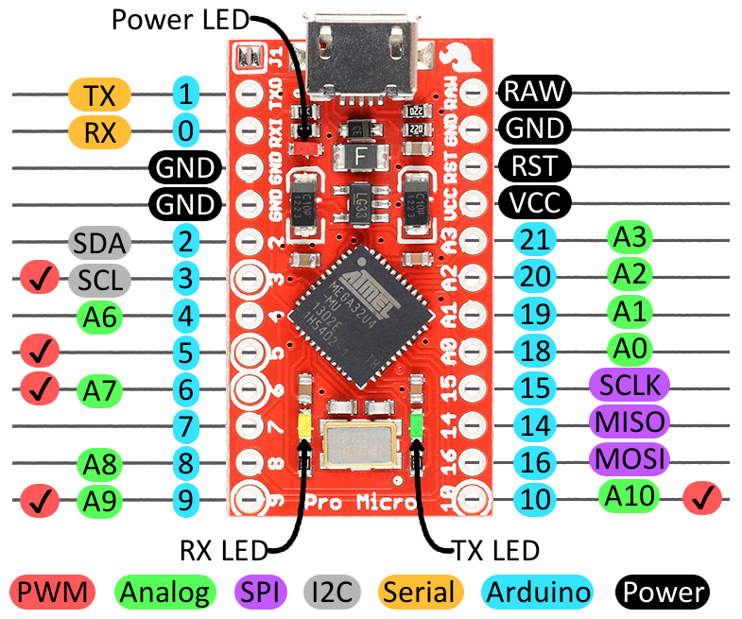

Analog | Digital
A0) Flightstick X | MISO) SR Data out (SR Pin 9 or 7 for inverse)
A1) POV Hat | SCLK) SR Clock (SR Pin 2)
A2) Flightstick Y | 10) SR Shift/Load (SR Pin 1)
A9) Throttle
A3) Rudder
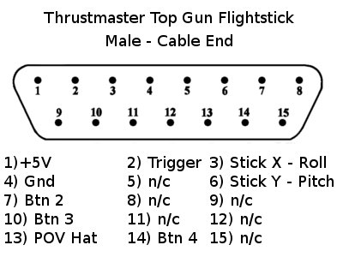
gnd - yellow | btn1 – red | btn2 – purple | btn3 – blue | btn4 – green | vcc - orange & brown
Function Description

A button is pressed which pulls its corresponding data line low, setting the shift register input to low, the microcontroller shifts in 2 bytes of data from the shift registers inverted output via SPI and processes it by bit-masking to determine which buttons are pressed, this should be executed as many times per second as possible.

