Solving Simple Problems in C

LAB 02
SECTION 3

Jack morrison

SUBMISSION DATE:

02/03/23

Problem 1
Really easy just added some printf statements. See image 1 (top left)

Problem 2
Part 1: Just manually copied the given code. See image 1 (top right)
Part 2: Added a new variable z and scanned it in then used it to calculate volume
See image 1 (bottom left)

Problem 3
Each of the print statements had some problems, the first formatted an int as a double, the second had the correct format but didn’t add the result as an parameter to printf, and the third formatted a double as an int.

Correct statements:
printf("The value of 77/5 is %d, using integer math.\n", integer_result);
printf("The value of 2+3 is %d.\n", integer_result);
printf("The value of 1.0/22.0 is %lf.\n", decimal_result);

Problem 4
See image 1 (bottom right) for output.
A few of the statements did integer division and then assigned them to a double variable, which effectively truncates the value after the decimal point. Statements c, g, and h did that. For the rest the differences come down to the order of operations, and parenthesis.
For l the solution is to use the formula for the area of a circle with M_PI from the math library
double radius = v / M_PI / 2; where v is the circumference
double l = M_PI * pow(radius, 2);
For m the solution is to multiply the number of feet n by 0.3048 to get the number of meters
double m = v * 0.3048; where v is the distance in feet
For n the solution is similar to m translate the equation into code
double n = (v – 32.0) / 1.8; where v is the degrees in fahrenheit

Problem 5
The Pythagorean Theorem basically is c = which can be directly translated into code as
double c = sqrt(pow(a, 2) + pow(b, 2));
OR
double c = sqrt((a * a) + (b * b));
From there it is trivial to print out c with %lf and you’re done.

Analysis
Theses problems were trying to teach basic c coding concepts, and help you learn how to solve and analyze programming problems. They were pretty basic problems but given how early into the course we are that makes sense.

Design
Designing these solutions was very simple in fact there really wasn’t much design to it. My favorite one was problem 4 because I had a good time fitting all the stuff into one print statement.

Testing
I ran problem 4 and 5 like 3 times each to get the working correctly, and the rest worked immediately.

Screen Shots
Image: 1
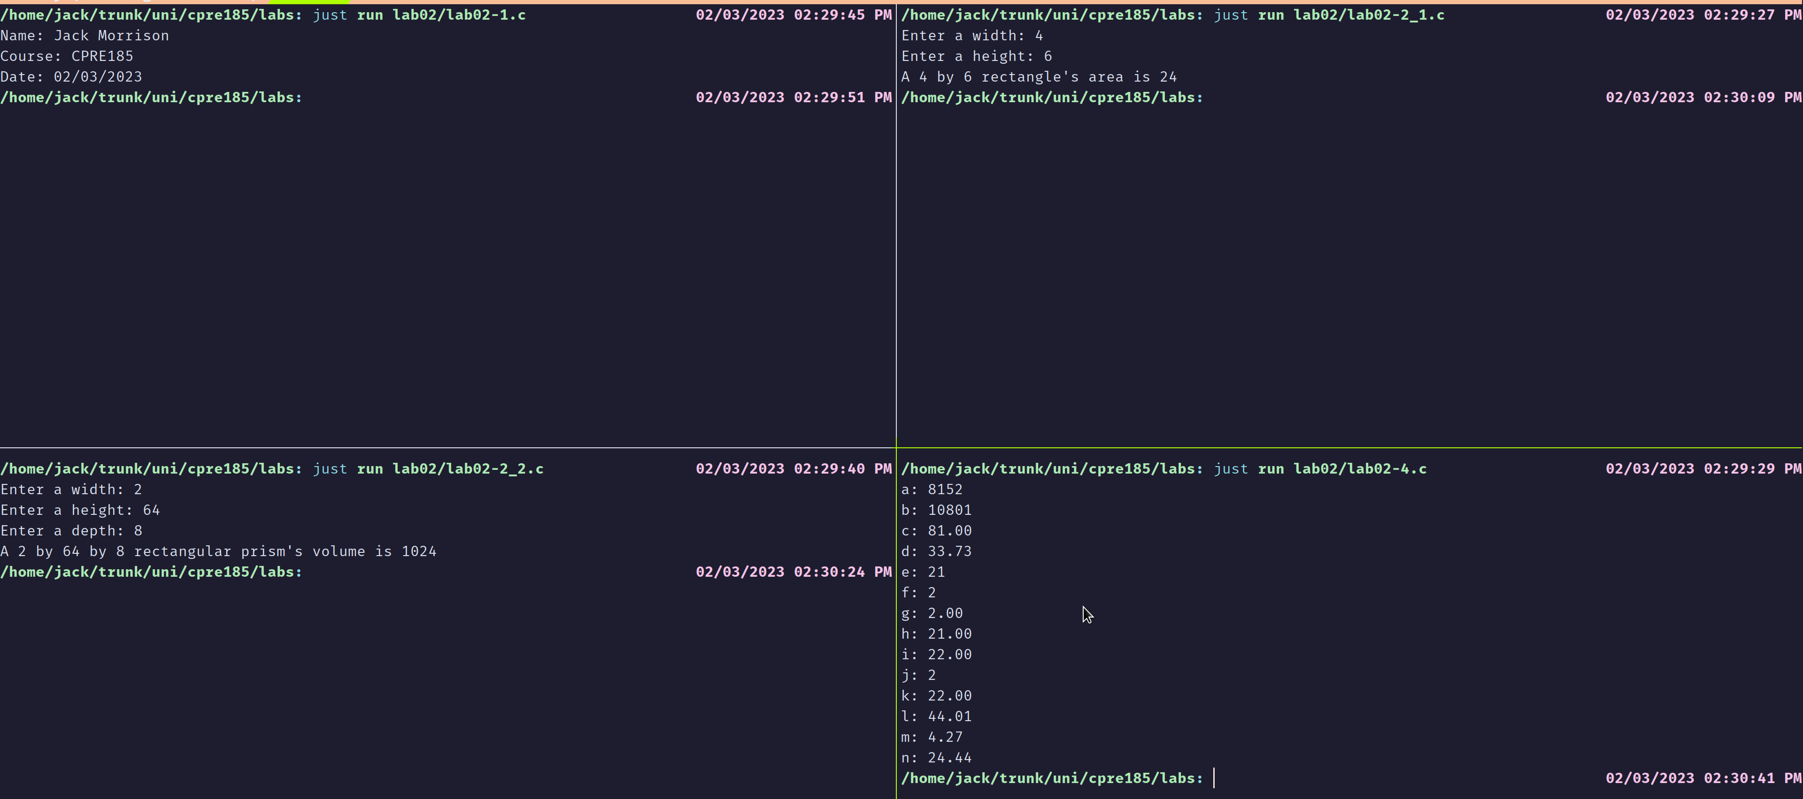
Image: 2
