Writing an Assembler for the i281 CPU

Jack Morrison
Department of Computer Engineering, Iowa State University
CPR E 281: Digital Logic
Dr. Alexander Stoytchev
December 8, 2022

The main goal of my final project was to create from scratch an assembler for the i281 assembly instruction set. I could have set about acomplishing this many ways, however the approach I took was to split the compiler / assembler into 3 major parts. These are the topic of this paper the abstract syntax tree (AST) and accompanying parser, intermediate representation (IR) and static analyzer, and finally the verilog compiler. These are the main pieces that make up the complete compiler tool along with some other minor components. These where the pieces I decided to break the problem into and from there build the final product. The language that this compiler is written in is rust a systems programming language designed for memory safety and speed. This was my choice of language because I like writing programs in it, but also because rust has many benefits for writing large projects. With all that in mind the first thing I did was start work on the AST.

The Abstract Syntax Tree
The abstract syntax tree (AST) is something that I knew existed before beginning work on this project but had little knowledge on how to implement. To start I began studying other ASTs my main inspiration actually came from the rust syn crate (crates in rust are packages). Syn is huge as it is designed to cover the entire rust programming language, and I only need to implement a small assembly language so I looked at how syn represented different data structures. I started by creating primitive types: Ident, keyword, opcode, oper, register, and literal. These are typically a single logical item. An ident being an identifier of some kind, oper being either an addition or subbtration operator, and a literal being either a single byte or an array of bytes or not set. Literals are the most complex of the primitive types but I would still classify it as primitive because while it has many types it still only consists of one logical piece. Below is a diagram of how a literal is designed, and an image of the code that defines the literal.
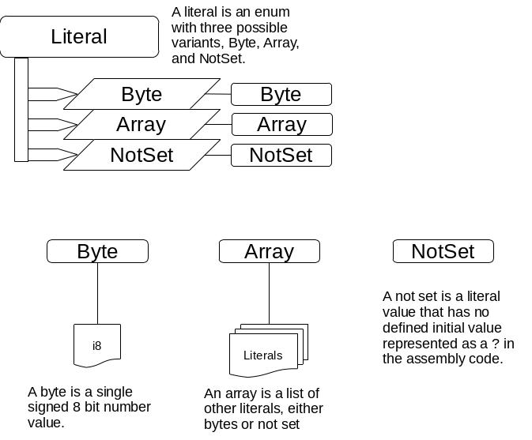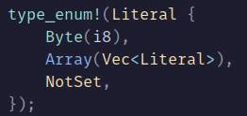
That type_enum! thing is a rust macro it is used to take in rust syntax and generate extra code from it. In this case it creates three things as well as the literal enum. Each of the things inside the curly braces is a variant of the enum the macro creates a new struct for each of them and gives what is inside the parenthesis to it as struct fields. So the Byte(i8) creates a new struct named Byte with a field 0 that has type i8 which is a signed 8 bit integer. The Array is interesting as it contains a vector of literals meaning it can contain a list of Bytes and NotSets. It can also technically contain arrays, however the parser will never insert an array into an array. The macro does a lot more than this but here is an idea of what the the macro generates in terms of structure.
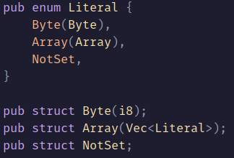
The macro also implements useful traits and other functionality that would expand into several more lines of code for each variant. This layout is useful for how the parser is implemented which I will cover more later.
The AST has some primitive types but I still had to figure out how to structure the overall layout of the assembly into code. The way I decided to do this was to look at the two main segments of the assembly the data block and the code block. These two blocks are the two largest pieces of any assembly file, and are the first splitting point. Then the data segment contains a list of variables and the code segment contains a list of labels and instructions. These two segments are the fundamental structure of the AST. Everything is accessed through the root but then through either the data or code segments. Below is a diagram of the root of the AST and the two segments.
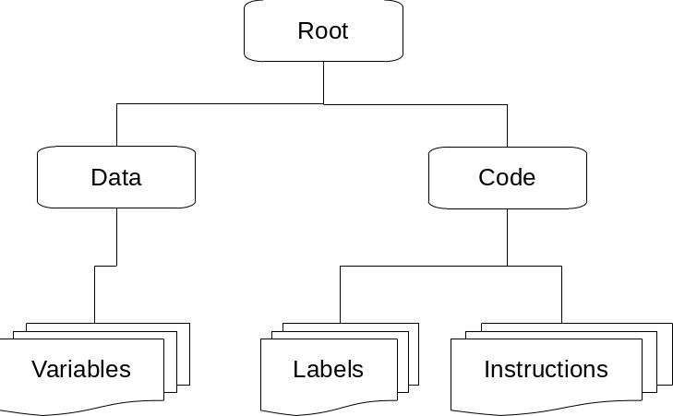
A variable consists of an ident which is the name of the variable and the literal value that it is assigned. Labels also consist of an ident which is the name of the label and a code address that is the instruction index starting at zero for the first instruction. An Instruction is an enum with one variant for each uniquely functioning instruction. So the assembly has the opcodes BRE and BRZ but there is only a BRE variant on the instruction because they do the same thing. Here is a diagram of the instruction enum.
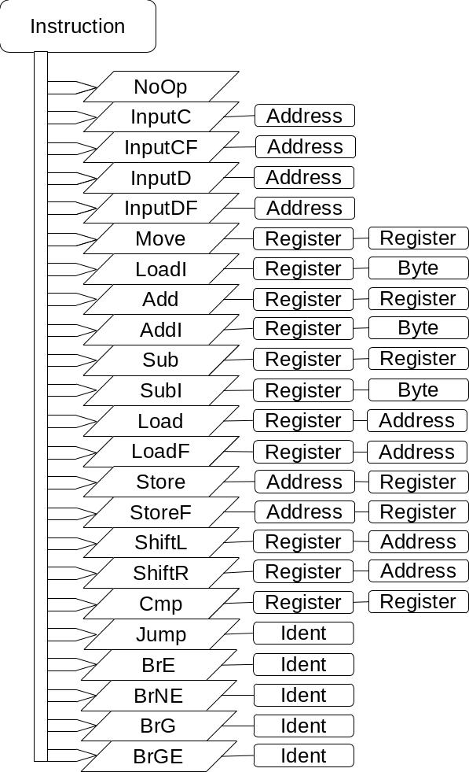
There is a lot going on in that diagram, an instruction is one of it’s many variants for example load. Each variant has different data associated with it load has a register and an address as fields. The last diagram I want to mention here is for the address type. In the assembly an address is a pair of brackets that then contains an expression that can contain at most a reference to a variable, a register for offset and a constant to add to the variable address. The AST this is layed out in an interesting way there are two important enums the first is the AddressItem which has three variants each being one of the possible things that an address expression can contain. The next is the AddressExpr enum which has two variants either Item or Expr. When it is the variant Item it just contains one of the values that the address can be, however when it is Expr it contains an Item an oper and another AddressExpr. Essentially the AddressExpr is a self referential enum in one case and in the other it is just an AddressItem. The expr variant has an AddressItem on the left hand side of a binary operator either addition or subtraction and then another AddressExpr on the right hand side of the binary operator which could be just another AddressItem or there may be another expression. The AddressExpr enum is similar to a tree of nodes but the tree only grows on the right hand side of the expression and you can crawl the tree until you reach an AddressItem on the right hand side at which point you have reached the end.
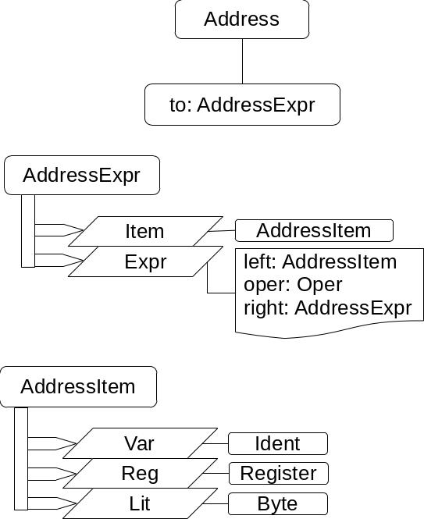

Parsing Into The AST
Having the AST layed out in code is nice but meaningless if you cannot construct it from the assembly input. So when I was designing the AST I did not just come up with how best to model things in my brain all at once, really I was writing the parsing code at the same time as the AST. This helped me to understand how to lay out the structure and the easiest way to parse things. The first way I went about parsing was to create a custom iterator that would iterate over every token in a given input. The iterator would take an input as a stream of characters and iterator over strings build from those characters from a set of rules defining what makes up one token. For instance all whitespace was a delimiter for tokens. There were also a set of rules for unique tokens that may not be seperated by whitespace from other tokens like puntuation. This approach worked and I did in fact get it to parse all of the example assembly files. There were however several downsides to this approach, it was ugly, hard to reason about, required lots of code to parse single things, and also did a lot of heap allocation. Admittedly that last problem didn’t really affect the performance of the parser much. It required a lot of peeking into bytes and backing up and rebuilding tokens. So I decided to use a rust crate (library) that I had heard about for parsing input called nom. Now nom calls itself a parser-combinator library, what that means is it provides a suite of functions that take input and parse a specific thing from that input then return the next bit of input and the result of the parser. Then you combine these functions to do much more complex parsing whith expressive functional syntax, and your code essentially becomes the grammar for your input. Here is the code to parse the entire data segment.
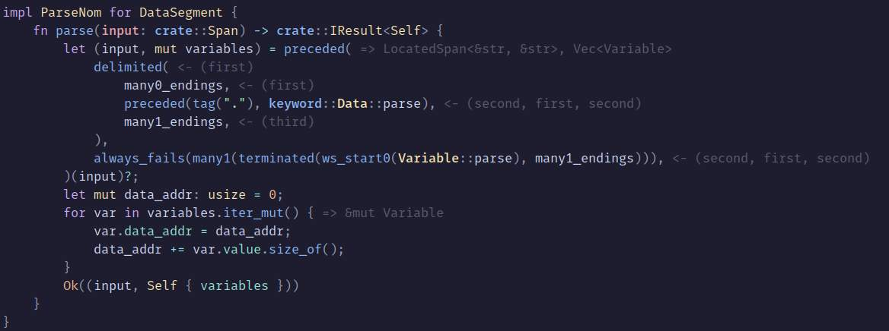
All that grayed ouy text are inline type hints not real text you can ignore it, but the key things to look at are in the first half of the parse function. The parsing is implemented via a trait that any item that can be parsed will implement. In rust a trait is similar to an interface in Java where types can implement multiple traits. So it uses the implementations of parse on the data keyword and the variable struct to construct an array of variables.

