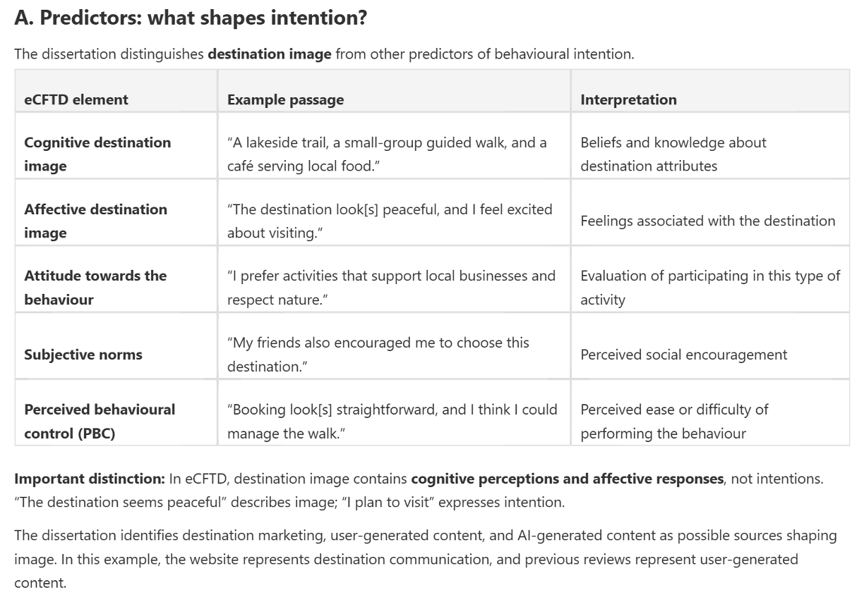
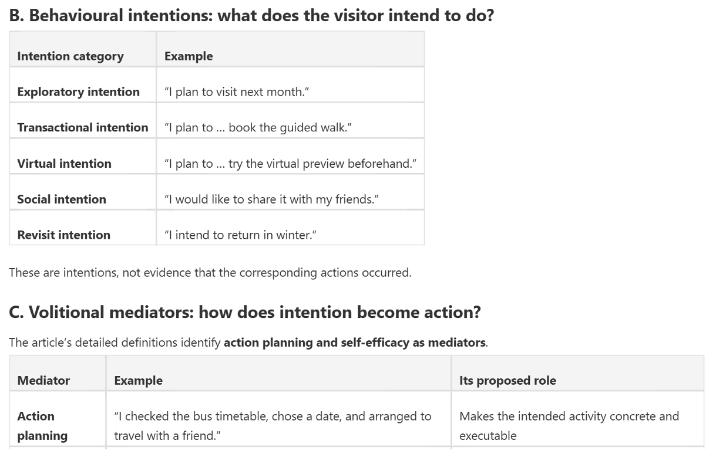
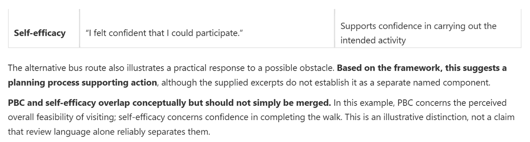
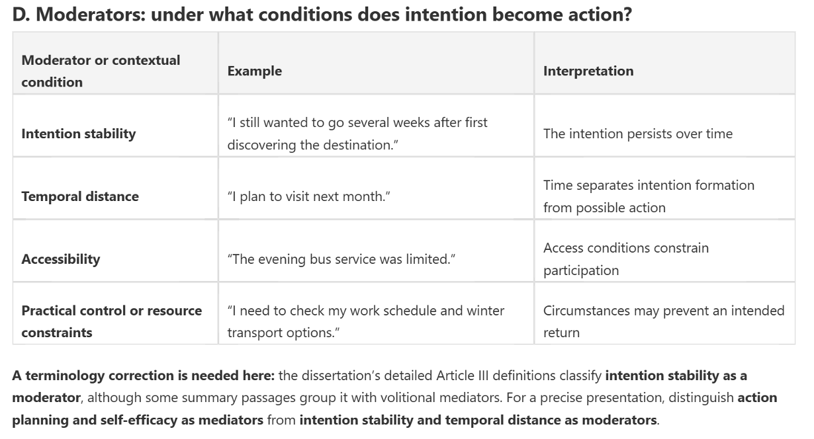
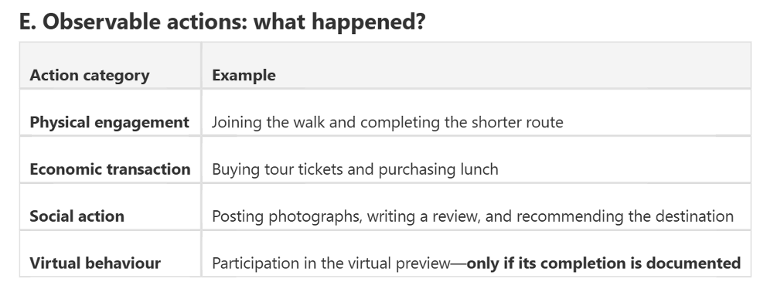

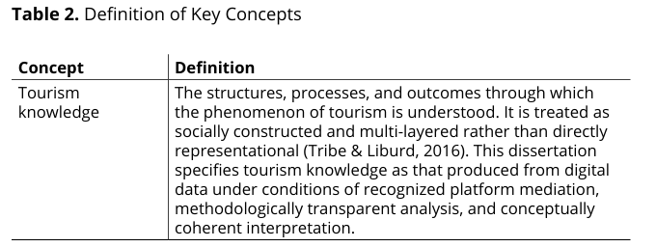
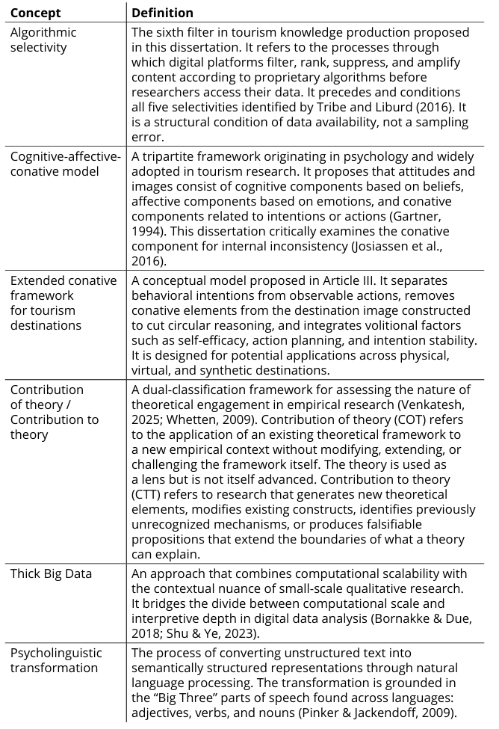

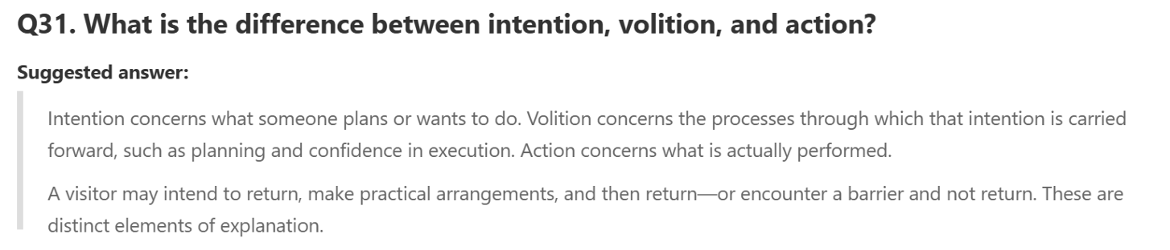
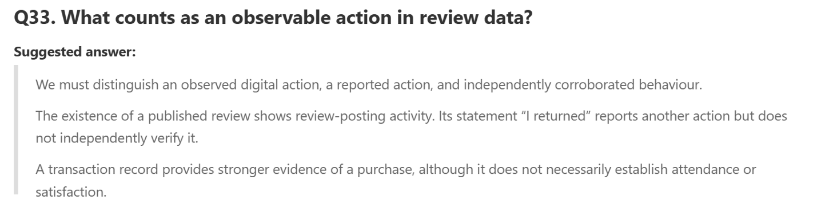
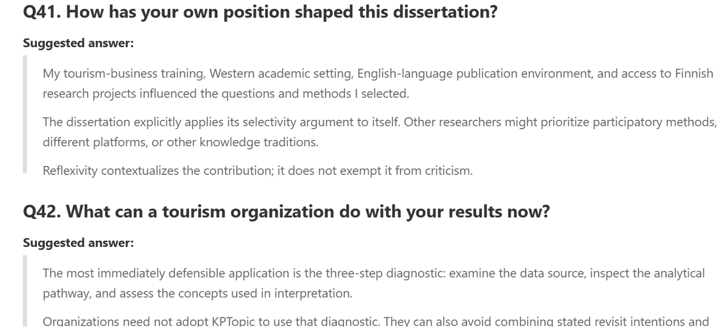

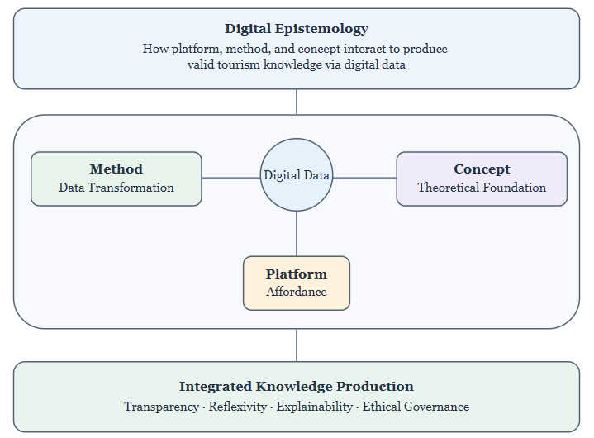
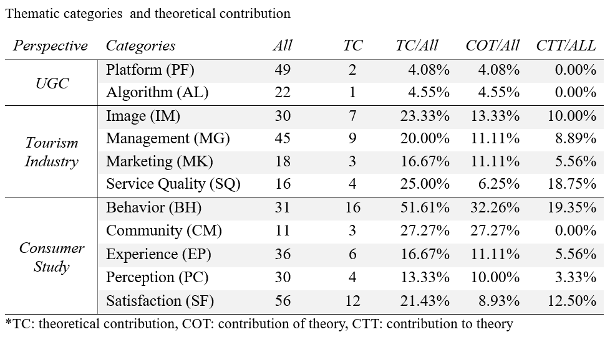

TF-IDF = TF*IDF (1 LDA)
Where, TF = $\frac{term frequency in document}{total amount of terms in document}$
and IDF = log($\frac{documents number in corpus}{documents number in coprus cantian the term +1}$)

C-TF-ICF = ${tf}_{x,c }* log(1 +\frac{A}{f_{x}})$ (2 BERTopic)
Where, ${tf}_{x,c }$= frequency of word X in class C, $f_{x}$ = frequency of word x across all classes and A = average number of words per class.

$Q = \sum_{ij}{\left(A_{ij}-γ\frac{k_{i}^{out}k_{j}^{in}}{m}\right)}δ\left(σ_{i},σ_{j}\right)$ (3 Traag's leidenalg)
Where A is the adjacency matrix， $k_{i}^{out}$ and $k_{j}^{in}$ refers to respectively the outdegree and indegree of node i, and $A_{ij}$ refers to an edge from i to j， $σ_{i}$ denotes the community of node i and $δ\left(σ_{i},σ_{j}\right)$ = 1 if $σ_{i}$=$σ_{j}$ and 0 otherwise, m is the total number of edges in the network.



