00 FRAME

01 standard
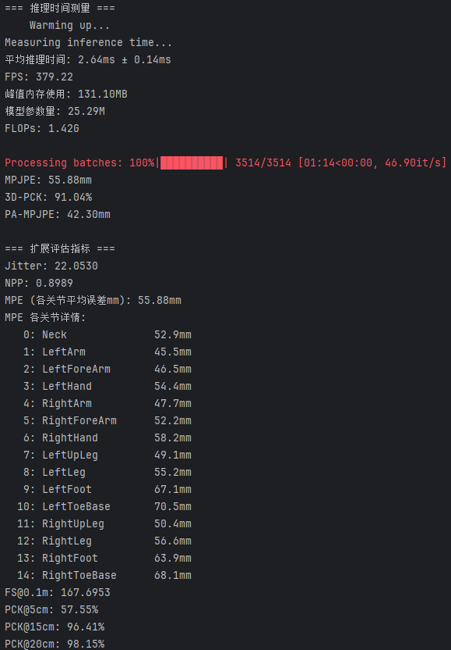
02 LJTS
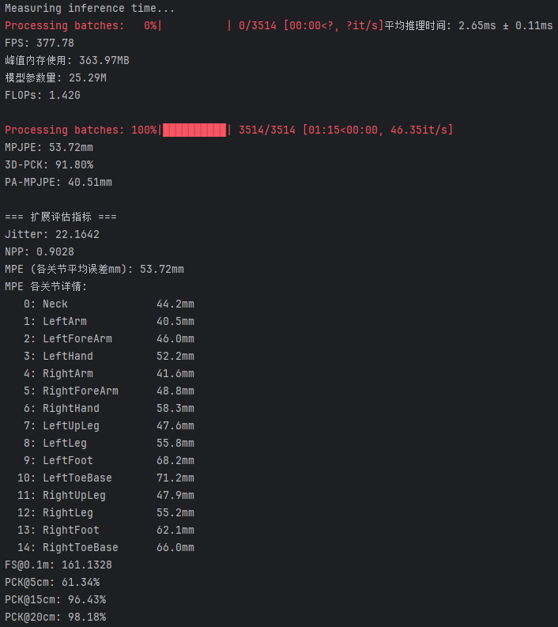

03 JATR
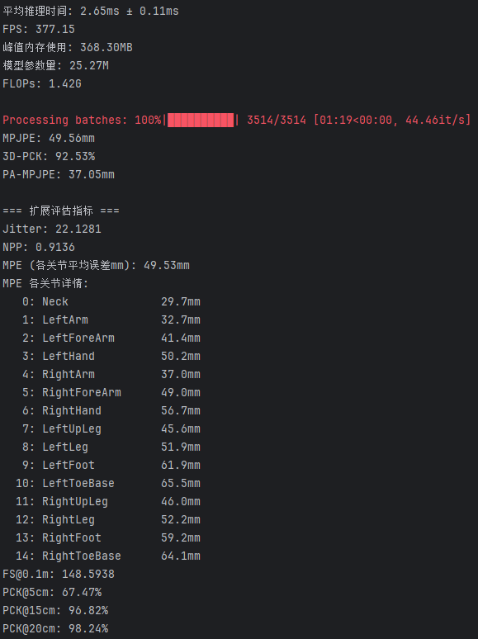
04 ViewReliability
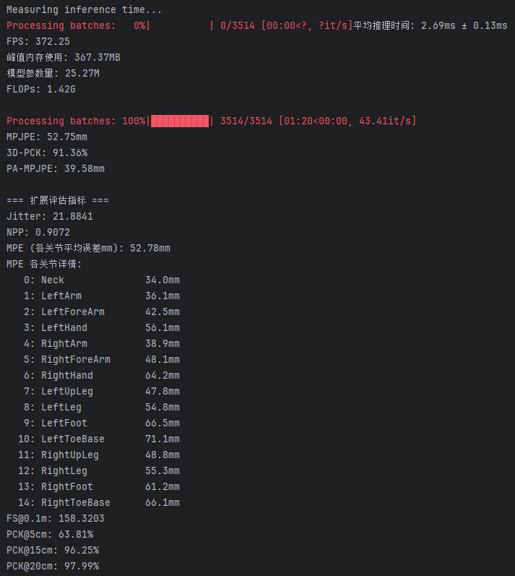
05 ViewReliability_pro
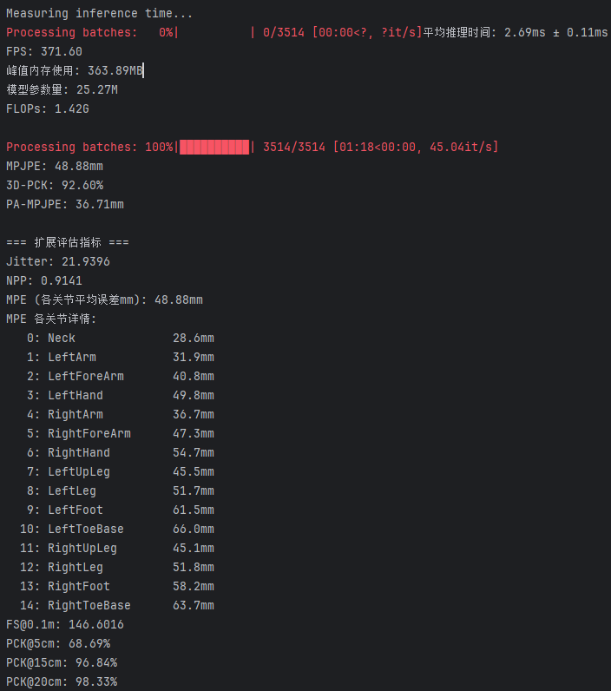
Abla_01 no struct_w
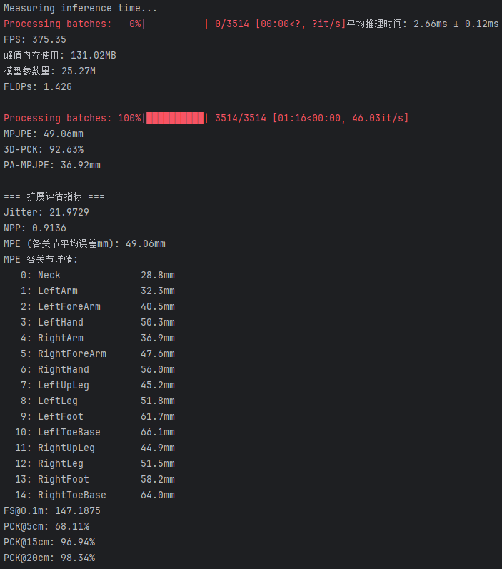

Abla_02 struct_scale=0
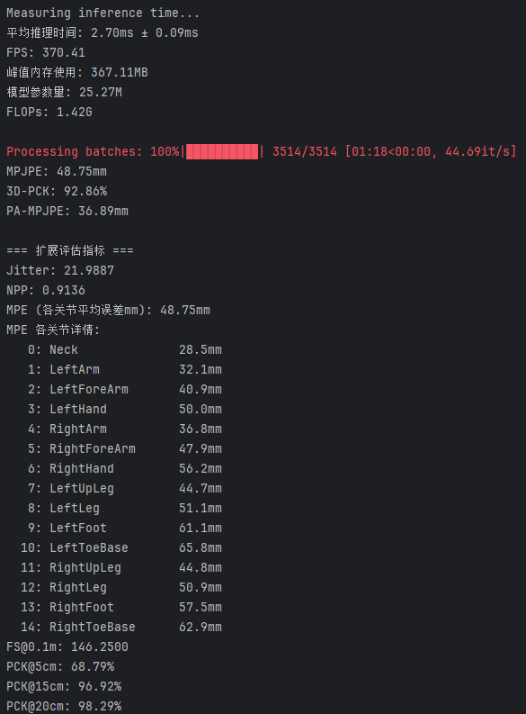
Abla_03 struct_scale=0
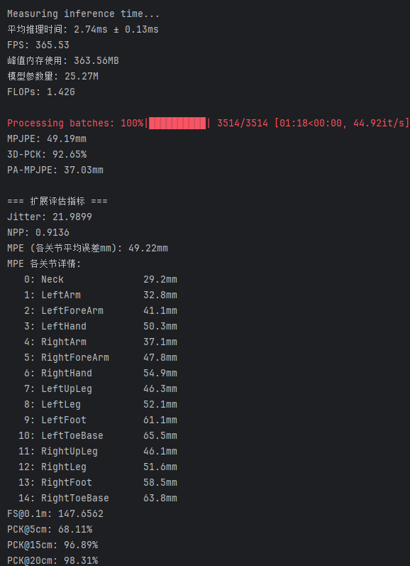

Abla_04 用 L2 距离而不是向量
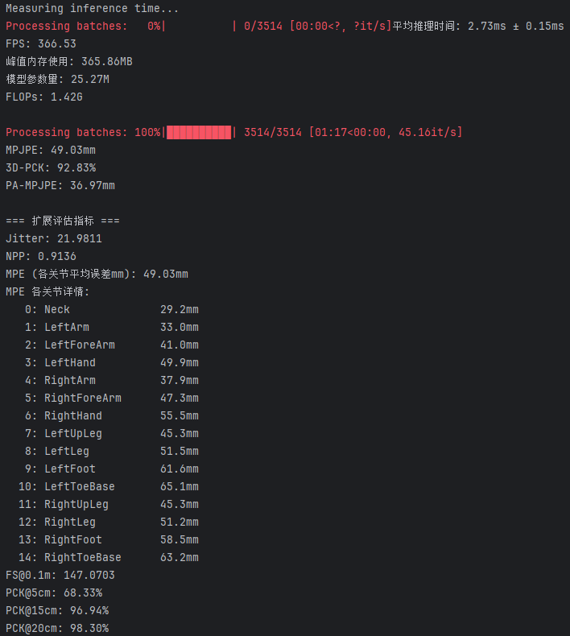
Abla_05 不同视角独立参考（弱对照）
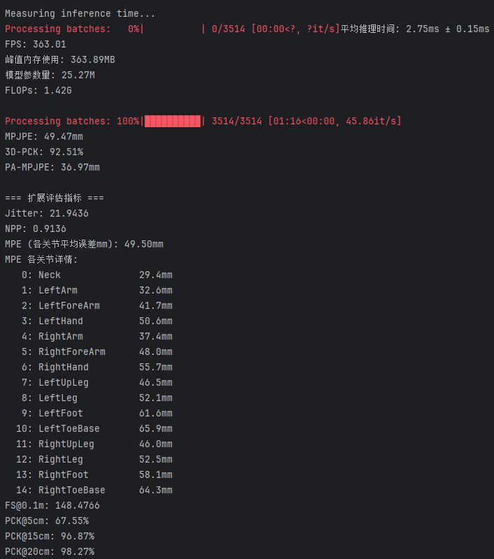

Abla_06 不做 view 维度归一化
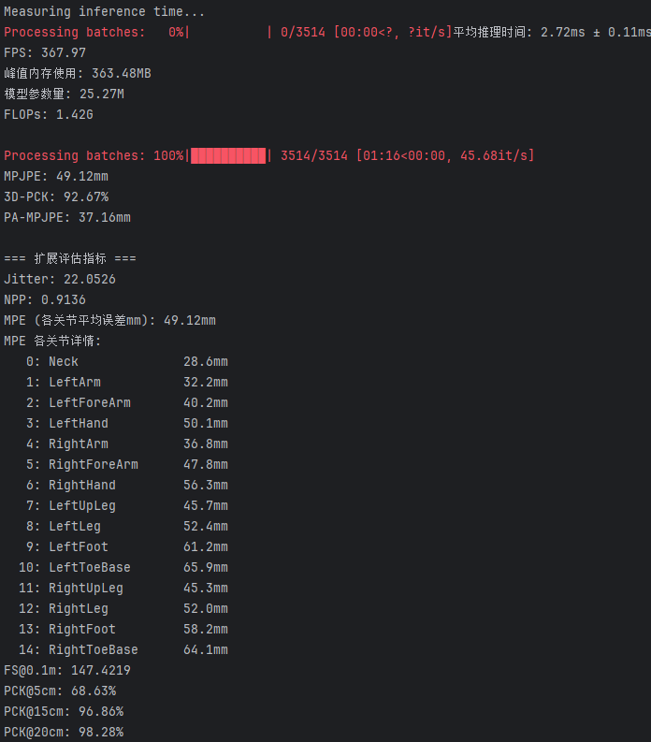

Abla_07 Softmax 融合（替代 Sigmoid + normalize）
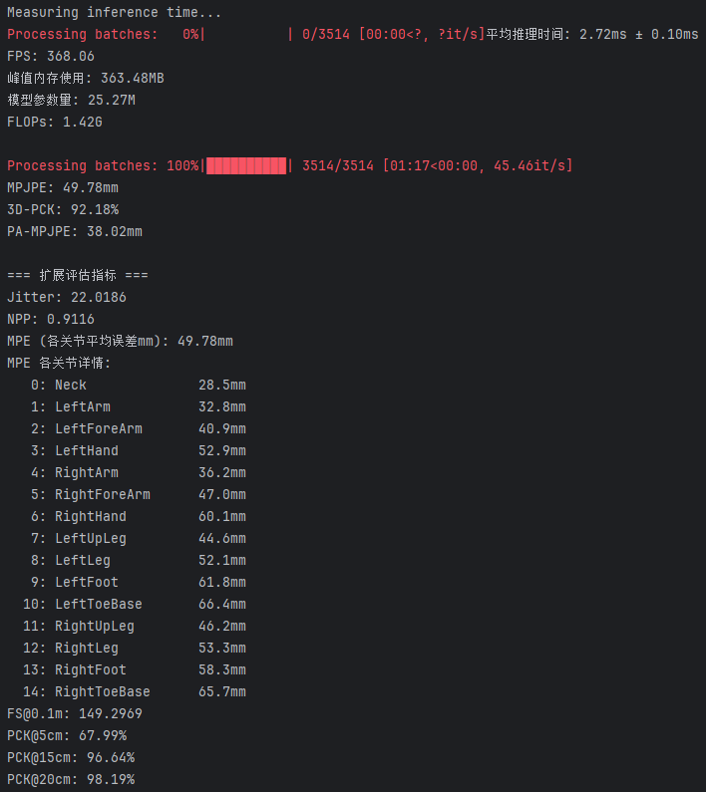
Hyper_01 self.struct_scale = 0.1
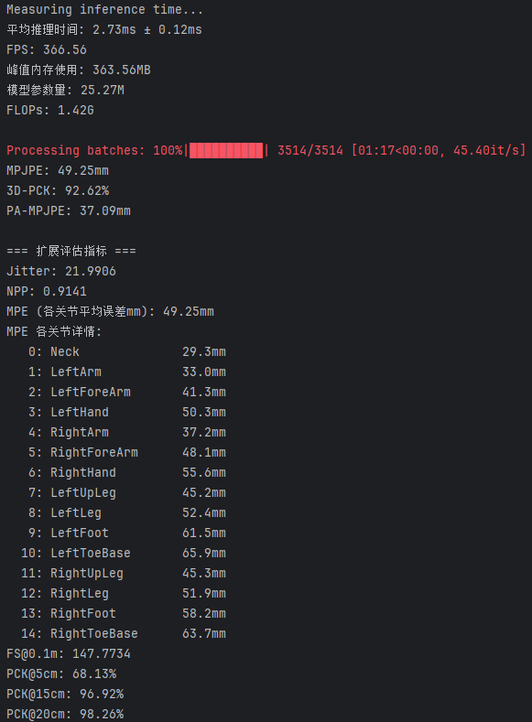

Hyper_02 self.struct_scale = 0.05
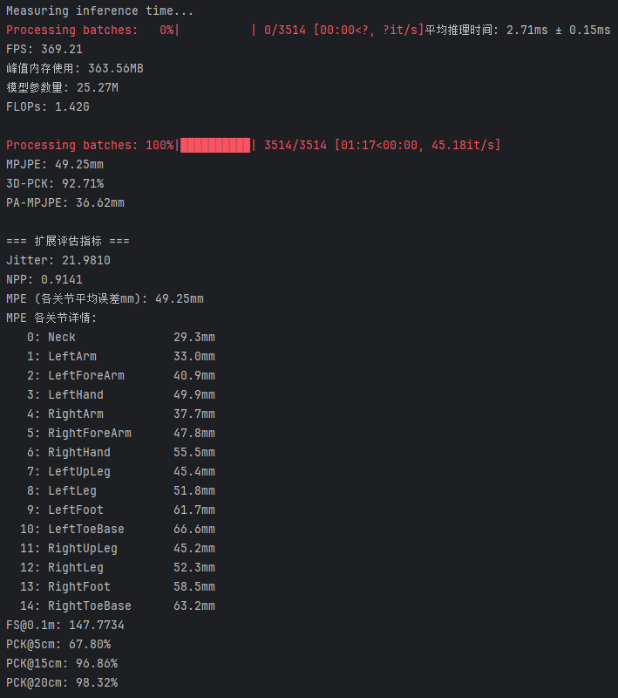
Hyper_03 self.struct_scale = 0.2
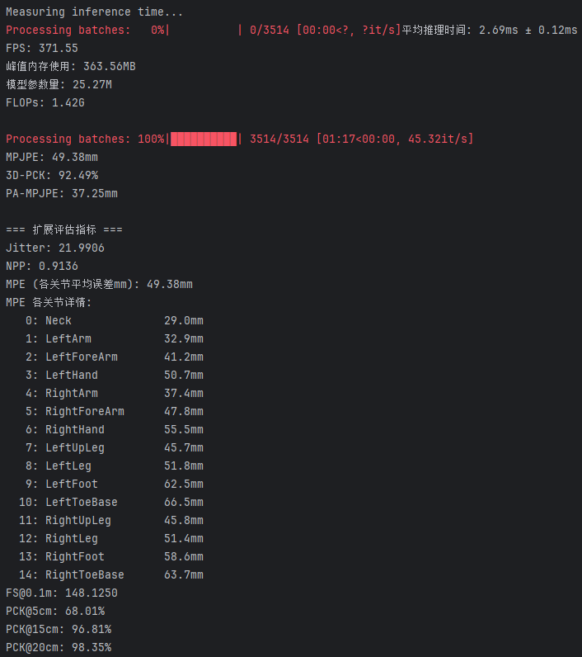

Hyper_04 self.struct_scale = 0.5
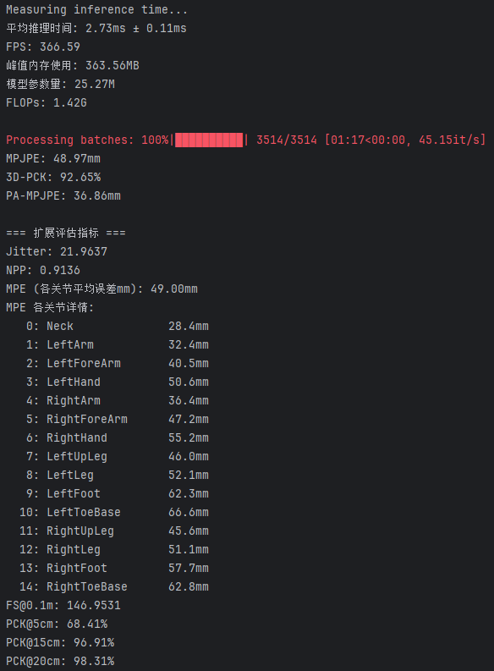
Hyper_05 w = torch.sigmoid(w)
