2025.11.5 (001)
Checkpoints: 源backbone、 源stf
单stf: MPJPE: 47.16mm / 3D-PCK: 93.06% / PA-MPJPE: 36.54mm

2025.11.5 (002)
Checkpoints: 源backbone、 源backbone上训的stf
单backbone: MPJPE: 72.94mm / 3D-PCK: 78.72% / PA-MPJPE: 43.46mm
单stf: MPJPE: 48.25mm / 3D-PCK: 92.88% / PA-MPJPE: 36.58mm
End to end: 50.31mm / 2.24 ± 0.03

2025.11.10 (003)
Checkpoints: 源backbone、 源backbone上训的stf + KTP
单stf: MPJPE: 54.28mm / 3D-PCK: 91.20% / PA-MPJPE: 41.21mm

2025.11.10 (004)
Checkpoints: 源backbone、 源backbone上训的stf + Stable1KTP
单stf: MPJPE: 53.00mm / 3D-PCK: 91.33% / PA-MPJPE: 40.14mm
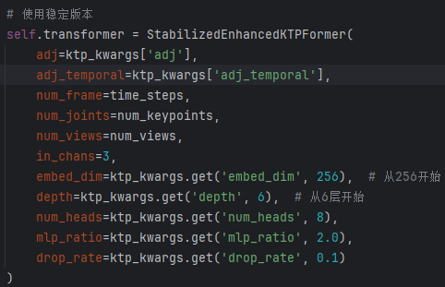

2025.11.10 (005)
Checkpoints: 源backbone、 源backbone上训的stf + Stable2KTP
单stf: MPJPE: 52.44mm / 3D-PCK: 91.62% / PA-MPJPE: 40.80mm
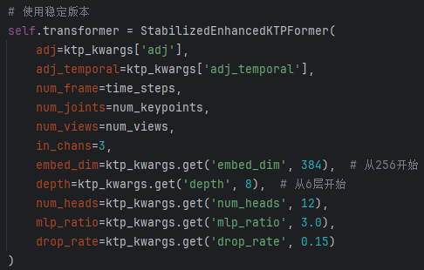

2025.11.11 (006)
Checkpoints: 源backbone、 源backbone上训的stf + GraphConv(disable)
单stf: MPJPE: 49.94mm / 3D-PCK: 92.48% / PA-MPJPE: 39.01mm

2025.11.11 (007)
Checkpoints: 源backbone、 源backbone上训的stf + GraphConv
单stf: MPJPE: 49.84mm / 3D-PCK: 92.48% / PA-MPJPE: 38.59mm

2025.11.12(008)
Checkpoints: 源backbone、 源backbone上训的stf + 强化可学习可学习图卷积
Epochs:4
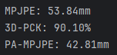

2025.11.12(009)
Checkpoints: 源backbone、 源backbone上训的stf + 强化可学习可学习图卷积
Epochs:8
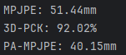

2025.11.13(010)
Checkpoints: 源backbone、 源backbone上训的stf + 强化可学习图卷积
Epochs:8
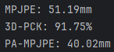

2025.11.13(011) standard
Checkpoints: 源backbone、 源backbone上训的stf + LearnableConv(disabled)
Trainable params: 25.3 M
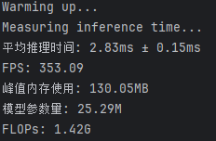
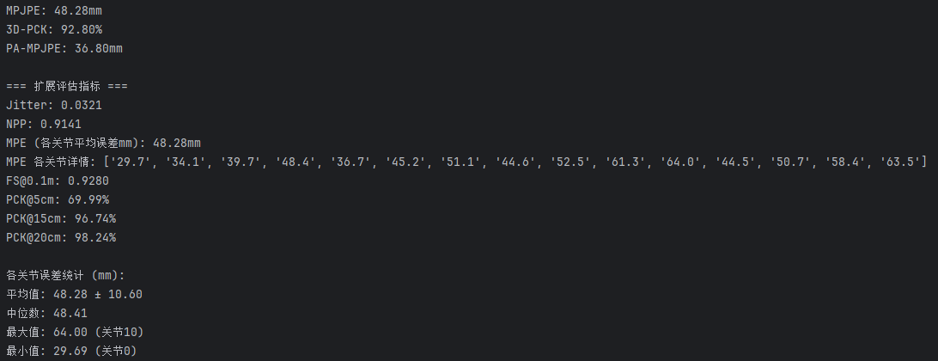

2025.11.13(012)
Checkpoints: 源backbone、 源backbone上训的stf + LearnableConv
Epoch: 4
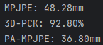

2025.11.13(013)
Checkpoints: 源backbone、 源backbone上训的stf + LearnableConv
Epoch: 8
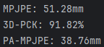

2025.11.13(014)
Checkpoints: 源backbone、 源backbone上训的stf + LearnableConv
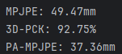
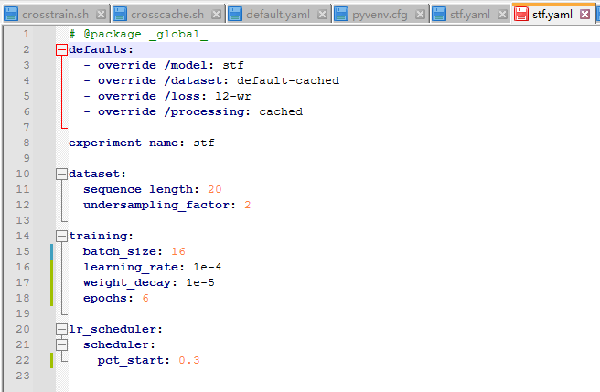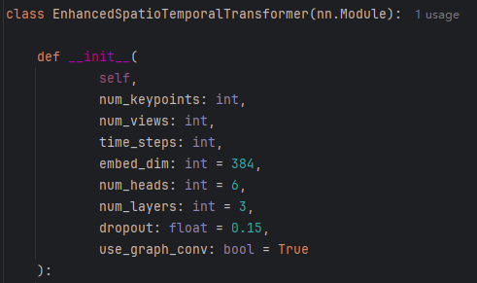

2025.11.14(015)
Checkpoints: 源backbone、 源backbone上训的stf + LearnableConv
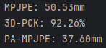
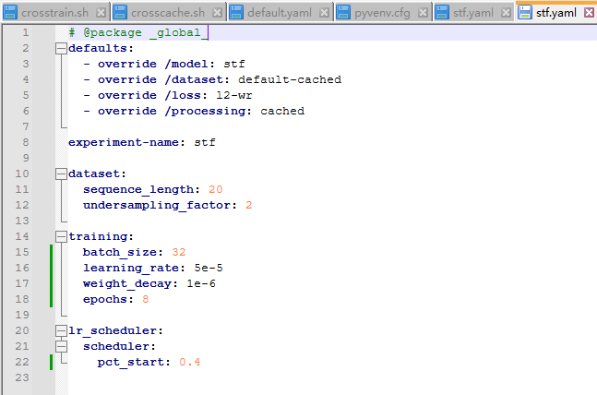
2025.11.14(016) SOTA
Checkpoints: 源backbone、 源backbone上训的stf + LearnableConv(learnable weight)
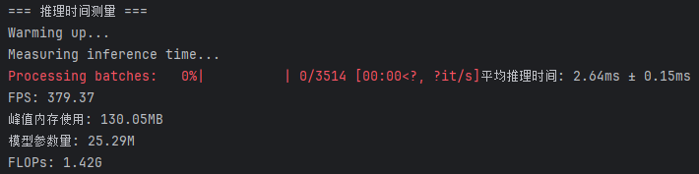
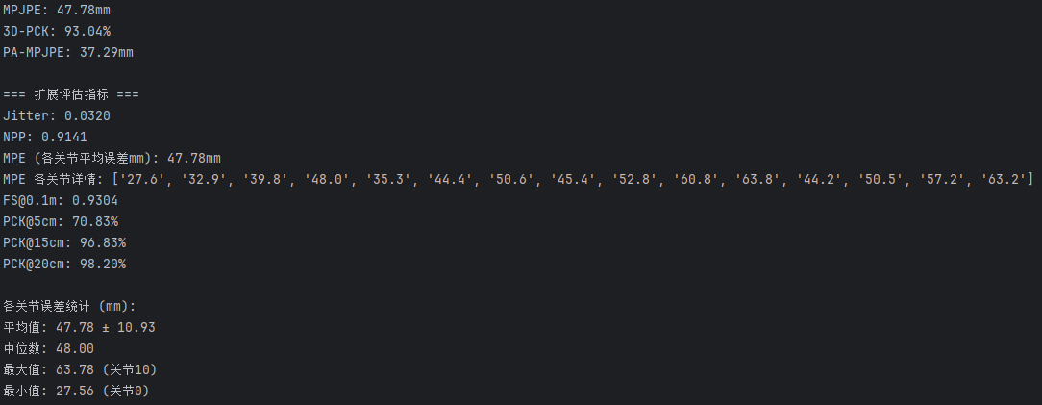
2025.11.15(017)
Checkpoints: 源backbone、 源backbone上训的stf + LearnableConv(learnable weight) + STAtt
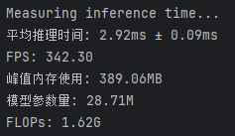
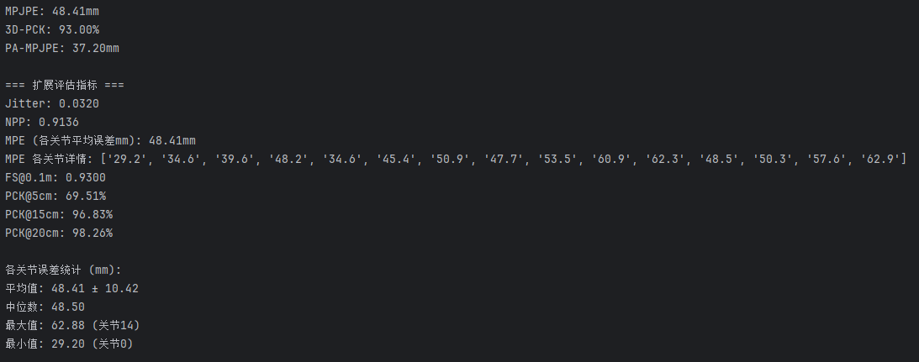
2025.11.16(018)
Checkpoints: 源backbone、 源backbone上训的stf + LearnableGraphConv + LearnableTemporalConv
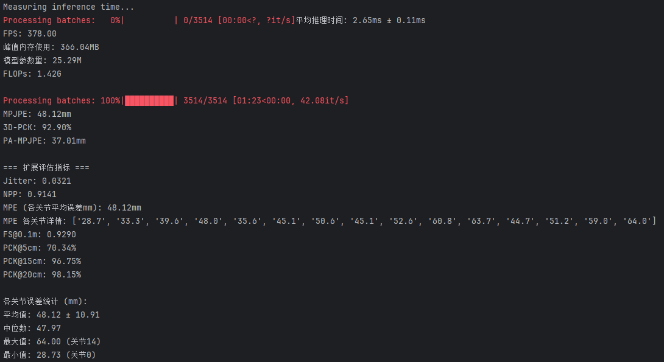
2025.11.17(019)
Checkpoints: 源backbone、 源backbone上训的stf + LearnableTemporalConv
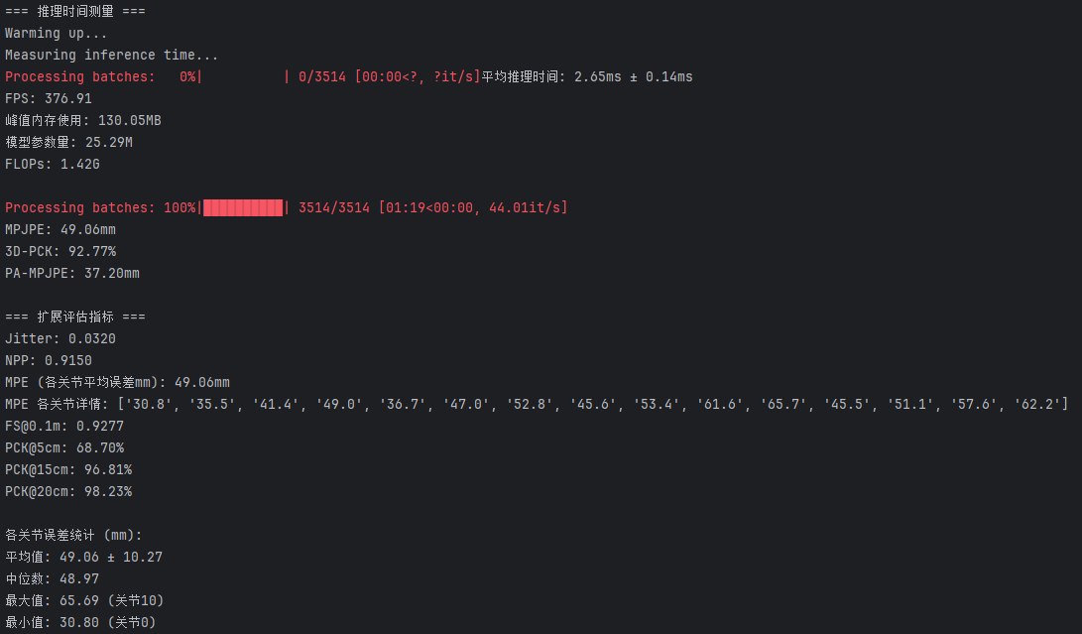

2025.11.17(020)
Checkpoints: 源backbone、 源backbone上训的stf + LearnableTemporalConv + MultiScaleTemporalAttention
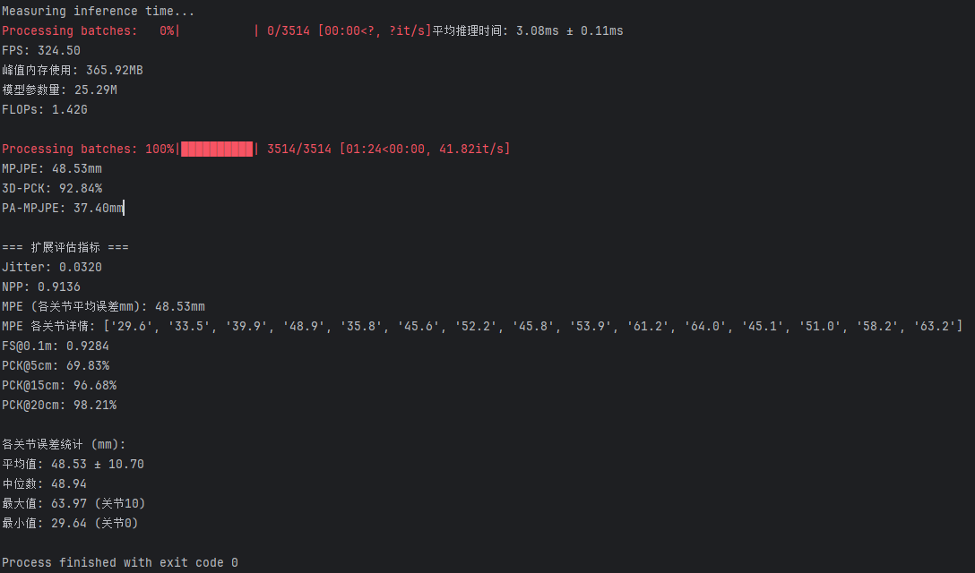

2025.11.17(021)
Checkpoints: 源backbone、 源backbone上训的深度监督stf + LearnableTemporalConv + MultiScaleTemporalAttention

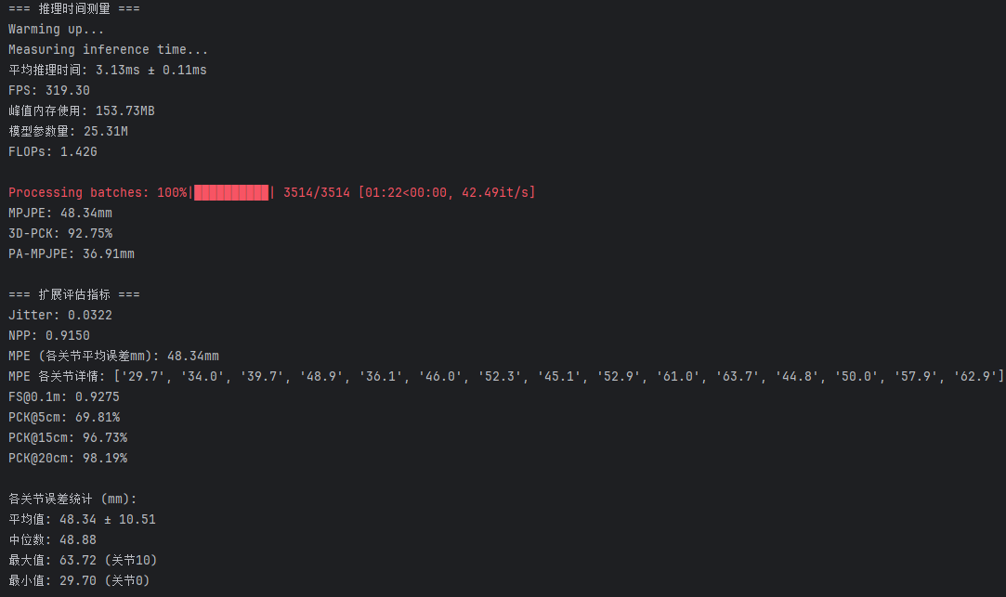

2025.11.17(022)
Checkpoints: 源backbone、 源backbone上训的深度监督stf + LearnableTemporalConv + TemporalRefiner
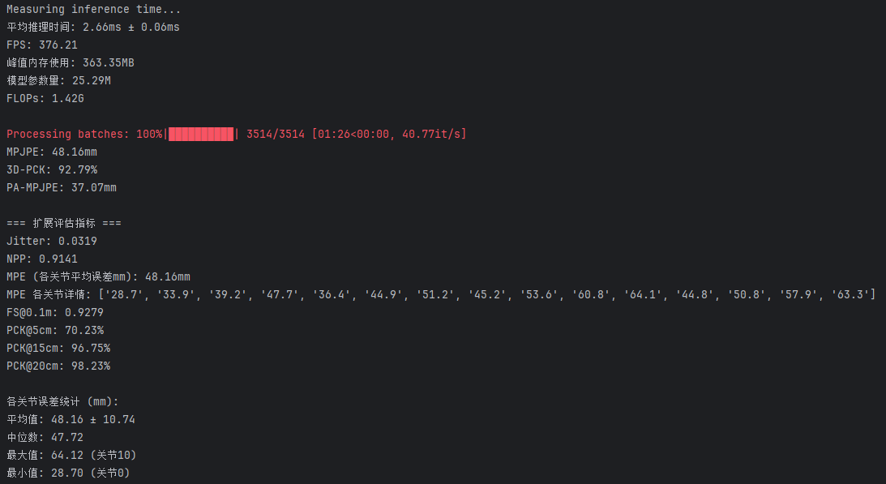

并联：
