# Yet Another BDM Organizer v0.1.4

This tool helps with editing BDM files for Xenoverse 2, which are responsible for all the damage information when linked to a BAC entry.

This is not a guide on what each entry means. This is just a tool to make editing them easier. For a more comprehensive guide to that, please refer to the [Skill/Moveset Editing Manual](https://docs.google.com/document/d/18gaAbNCeJyTgizz5IvvXzjWcH9K5Q1wvUHTeWnp8M-E/edit#heading=h.88v2nbsynbav)

Features include:

* Copying/Pasting/Adding/Deleting entries
* Find/Replace entries by value
* Shared clipboard between different instances of the BDM organizer

## Getting Started

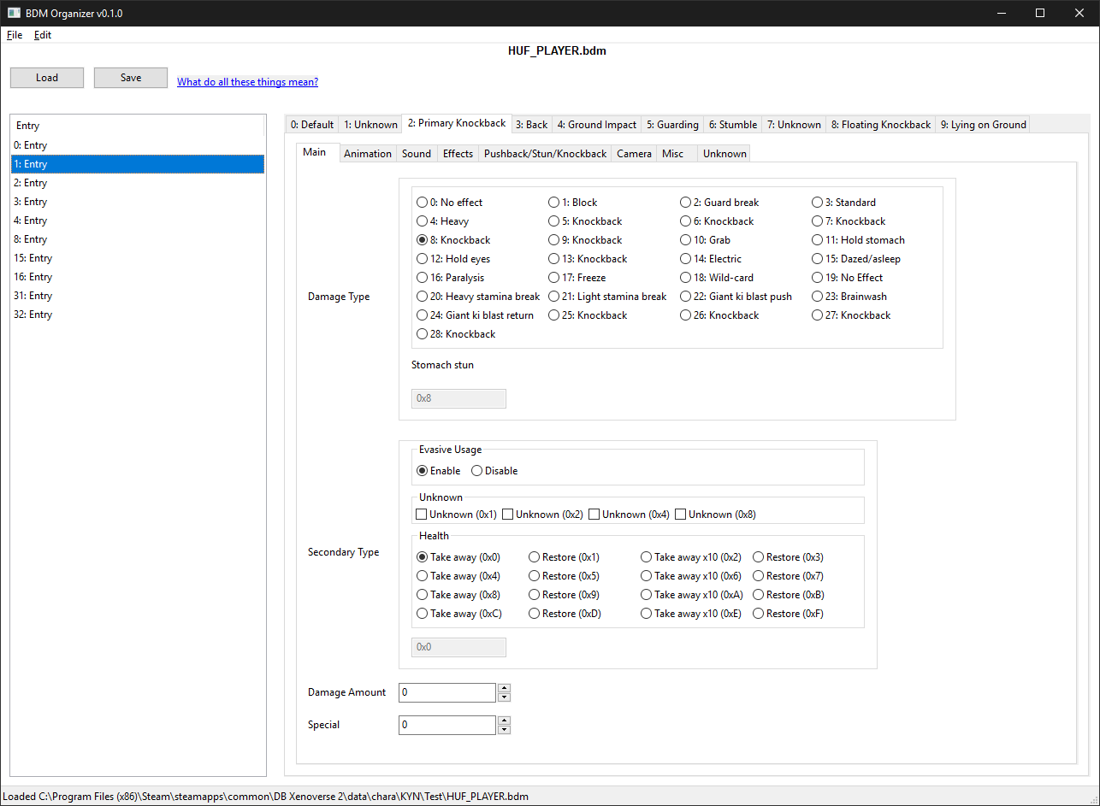

To load a BDM, just click on the **Load** button or drag a file onto the window

To save a BDM, just click on the **Save** button

The left side is list of all the BDM Entries, with numbers to be used when filling out the BDM Id in the BAC files.  
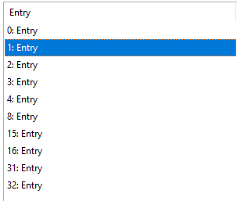

### Entry Panel

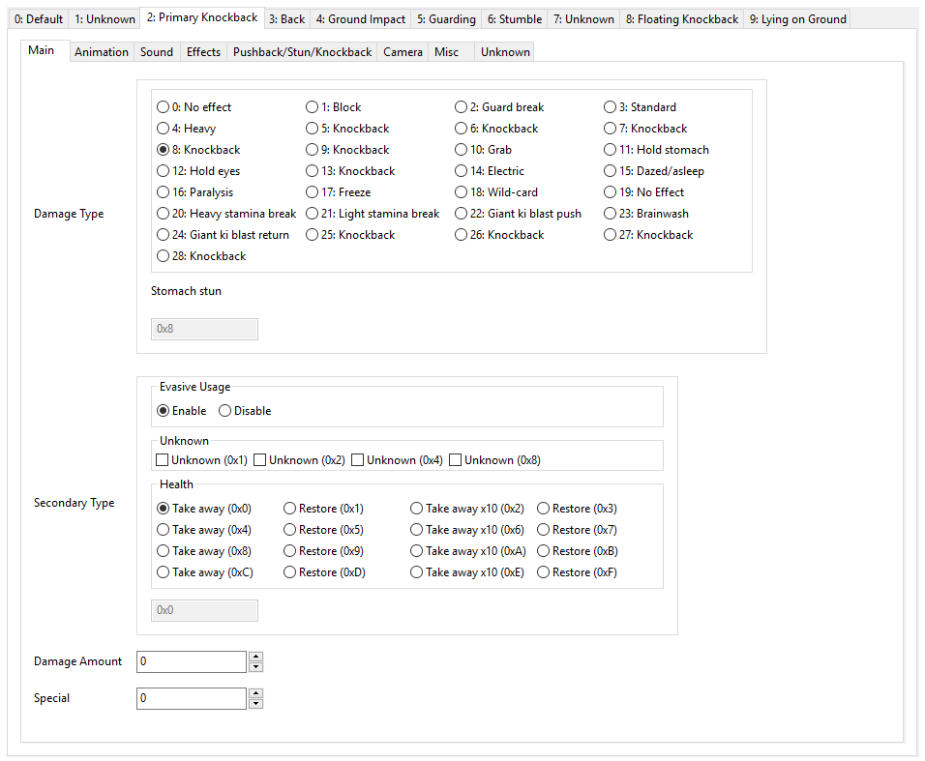

This shows the 9 different types of Sub Entries, each with its own set of values organized across different pages.. Please refer to the [Skill/Moveset Editing Manual](https://docs.google.com/document/d/18gaAbNCeJyTgizz5IvvXzjWcH9K5Q1wvUHTeWnp8M-E/edit#heading=h.88v2nbsynbav) for an explanation of these. Changing these values is straightforward. The Radioboxes/Checkboxes have a hex entry below thats useful for cross referencing XML entries from other tools.

## 

## 

## 

## New Entry

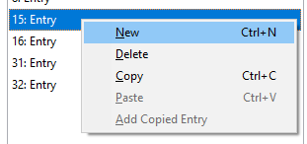

Will add a new Entry with the given Entry ID as selected in the following window

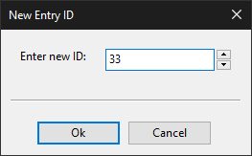

By Default, this will pick the highest unused ID, but you can use any other ID as long as its unused.

## Deleting

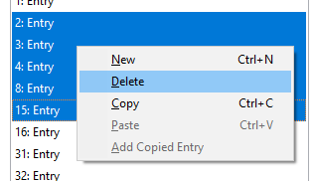

You can delete as many entries as you want

## Copying

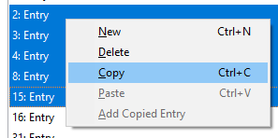

You can copy as many entries as you want.

## Pasting

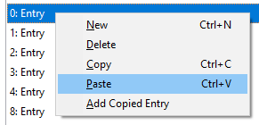

You can paste as many entries as you want. If there are many entries to paste, the tool will select more entries and ask if it is ok to replace them  
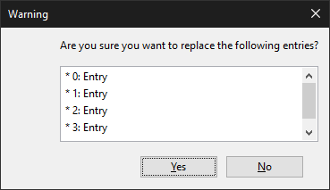

## Find/Replace

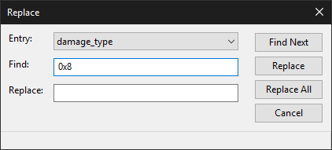

Open either in the **Edit Menu** or **Ctrl+F** for find and **Ctrl+H** for replace. Replace is shown here (Find is identical except no option to replace)

Example of usage: Changing the Effect Skill ID to something different.

## Convert for Skill Editor

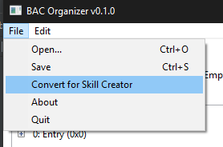

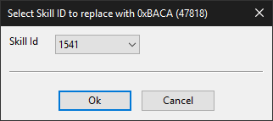

Replaces the selected **Skill ID** with **0xBACA**, which is required for creating new Skills with Eternity’s XV2 Skill Creator

## Credits

* Smithers,LazyBones, & Jackal - For the Skill/Moveset guide and the research into what each BDM field does, as well as the Hex Structure.