Lab 4

|  |
| --- |
| Lab Tasks |
| Submission Date: 23-04-19 |

Generate an OLTP system report which displays the following results:

1. Total sales in a month (Use only order table).
2. Profit/loss in a month (Use product (to account for purchasing costs), expenditure as well as order tables).
3. Highest selling product of the month (By highest sold quantity)
4. Lowest selling product of the month (By lowest sold quantity)

Hint: Create a report table to hold all the above results from queries after they are executed in the stored procedure and then create a stored procedure in the similar manner as shown above.

Solution:

Product table:

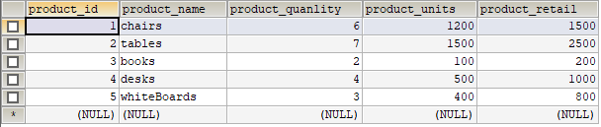

Order_details table:

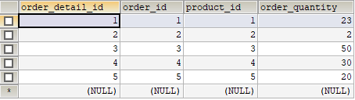

Order table:

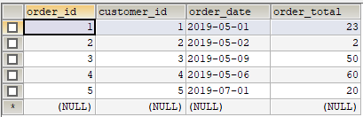

Expenditure table:

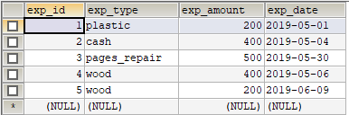

Customer table

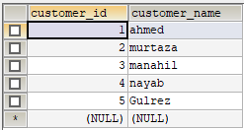

Executed Queries for all above tasks:

1)SELECT SUM(exp_amount) FROM expenditure WHERE `exp_date` LIKE '2019-05-04' AND '2019-05-09';

2)SELECT SUM(order_total) AS totalSale FROM `order` WHERE `order_date` LIKE '2019-07%';

3)SELECT (SUM(product.product_retail)-(SUM(product.product_units)+SUM(expenditure.exp_amount))) AS Profit_Loss FROM

product product INNER JOIN expenditure expenditure ON product.product_id= expenditure.exp_id WHERE expenditure.exp_date IN

(SELECT order.order_date FROM `order` `order` HAVING order.order_date BETWEEN '2019-05-04' AND '2019-05-09');

4)SELECT product.product_name FROM product product INNER JOIN order_details order_details ON

product.product_id=(SELECT order_details.product_id WHERE order_details.order_quantity=

(SELECT MAX(order_details.order_quantity) FROM order_details order_details));

5)SELECT product.product_name FROM product product INNER JOIN order_details order_details ON

product.product_id=(SELECT order_details.product_id WHERE order_details.order_quantity=

(SELECT MIN(order_details.order_quantity) FROM order_details order_details))

INSERT INTO result(`type`) VALUES (lowest_sale_product'),('highest_sale_product');

Report of all above task:

DELIMITER $$

CREATE

/*[DEFINER = { user | CURRENT_USER }]*/

PROCEDURE `reportdb`.`report`()

/*LANGUAGE SQL

| [NOT] DETERMINISTIC

| { CONTAINS SQL | NO SQL | READS SQL DATA | MODIFIES SQL DATA }

| SQL SECURITY { DEFINER | INVOKER }

| COMMENT 'string'*/

BEGIN

SELECT @total_expend:=SUM(exp_amount) AS total_expend FROM expenditure WHERE `exp_date` LIKE '2019-05-01' AND '2019-05-30';

INSERT INTO result(total_expend) VALUES (@total_expend);

SELECT @total_sale:=SUM(order_total) AS total_sale FROM `order` WHERE `order_date` LIKE '2019-05%';

INSERT INTO result(total_sale) VALUES (@total_sale);

SELECT @profit_loss:=(SUM(product.product_retail)-(SUM(product.product_units)+SUM(expenditure.exp_amount))) AS Profit_Loss FROM

product product INNER JOIN expenditure expenditure ON product.product_id= expenditure.exp_id WHERE expenditure.exp_date IN

(SELECT order.order_date FROM `order` `order` HAVING order.order_date BETWEEN '2019-05-01' AND '2019-05-30');

INSERT INTO result(profit_loss) VALUES (@profit_loss);

SELECT * FROM result;

SELECT @low_sale_product:=product.product_name FROM product product INNER JOIN order_details order_details ON

product.product_id=(SELECT order_details.product_id WHERE order_details.order_quantity=(SELECT MIN(order_details.order_quantity)

FROM order_details order_details));

INSERT INTO result(lowest_sale_product) VALUES (@low_sale_product);

SELECT * FROM result;

SELECT @high_sale_product:=product.product_name FROM product product INNER JOIN order_details order_details ON

product.product_id=(SELECT order_details.product_id WHERE order_details.order_quantity=

(SELECT MAX(order_details.order_quantity) FROM order_details order_details));

INSERT INTO result(high_sale_product) VALUES (@high_sale_product);

SELECT * FROM result;

END$$

DELIMITER ;

