COMP 452

TME 2
Pathfinding and Decision Making

Jason Bishop
3042012

June 15, 2015

Introduction

For TME 2, two similar ant games have been developed. In part 1, an ant tries to get from the start location to the goal location. The user is allowed to select the various tiles in a 16x16 grid. First, the user selects a location for the start position. This can be any location on the game board. Once the location has been selected, pressing the 'Enter' button will allow the user to then select the goal location. Naturally, this cannot be the same as the start location. Pressing the 'Enter' button at this point will allow the user to configure the rest of the tiles on the board. When the user clicks the tile, it will cycle between 4 terrain types. All tiles begin with the open type, which have a 0 movement cost for the ant. A bright green tile indicates a grass tile, with a movement cost of 1. The dark green colour represents the swamp tile, with a movement cost of 2. Finally, there is the obstacle tile, represented as a black tile with a red X. The ant cannot move through this tile. Once the board is configured to the user's liking, pressing the 'Enter' key a final time will place the ant on the home position and an animation will begin showing the pathfinding process. This process uses an A* pathfinding algorithm to find the route to the goal. The results of the final path are displayed to the right of the screen. Pressing the 'esc' key will exit the game at any time.

In part 2, a colony of ants tries to get food and water to grow their colony. However, there is also poison around that will kill the ants. The colony simulation begins by having the user select the number of ants in the starting colony. Using the up and down arrows, the user can select between 1-20 ants (inclusive). Pressing the 'Enter' key then begins the simulation. The game board in this case is a 20x20 grid of randomly selected tiles. A random home location is chosen for the colony where all new ants begin. Randomly scattered across the grid are 3 different tile types – food, water, and poison. Each ant begins searching for food by randomly moving about the grid. Once food has been found, the ant will find a path home using the same A* algorithm used in part 1. This will produce a new ant for the colony. The ant then randomly searches for water and when found, begins the food search again. However, if at any time the ant runs into a poison tile, it will die and be removed from the colony. The simulation continues until the user exits the game with the 'esc' key. The total number of ants, as well as numbers of living and dead can be found at the top of the screen. You can see an identification number for each ant in the upper right corner as well as a letter code describing the current behaviour.
This is also color coded to help tell what each ant is doing. Searching for food is a magenta 'F', searching for water is a blue 'W', and bringing food home is a red 'H'.

Compile and Run

This game was developed in Java using the Eclipse IDE. The project source code can be opened in Eclipse and run easily using the part1 or part2 package. Otherwise, the MainPanel.java file for each package should be run from the command line, making sure that the relative file directory is preserved so that the program can access the game files and images. The MainPanel.java file can be found under the main directory in the src folder in either the part1 or part2 package.

A* Pathfinding Algorithm

The A* pathfinding algorithm used in both part 1 and part 2 is the same as described in the textbook for this course. The graph is set up that returns a connection between each tile in the board. In part 1, if the tile is an obstacle, no connections are returned. In part 2, the same applies to the poison tiles. The algorithm uses simple ArrayList types to hold the open and closed lists. The heuristic is very simplistic and returns a value that indicates the distance between two tiles.

State Machine

Here is the state machine diagram for part 2:

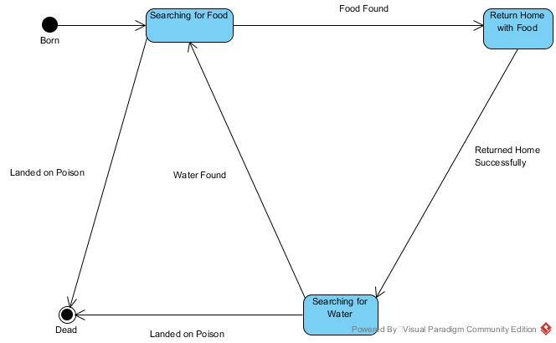

Bugs and Known Issues

In part 1, testing has shown no major bugs. However, there are some issues that could be addressed to improve the program. The most obvious is that there is no graphical representation of the final path chosen by the algorithm. The user must look at the information panel to determine the route. Additionally, if the route is too long, it may not fit in the size allotted in the information panel. Also, the ant does not actually follow the path once it has been determined.

In part 2, there is a bug that often occurs when the ant has found food and is returning home. The ant will skip forward several steps on the path home within a single frame. However, the path is still found and followed properly. Another issue is that it can be difficult to determine the current behaviour of each ant. There is some small text in the upper right corner, but it can be difficult to read when the ants are moving quickly. Also, there is no way of telling how many ants occupy a current tile, since only one ant is shown per tile. Finally, there is no indication of when an ant is born, or how many ants have died on a particular tile. Many of these improvements would help make the program more user friendly.

