The Skyrim Database

Steven Bouwkamp, Joshua Crum,

Caitlin Crowe, and Bryce Hutton

CIS 353 (01)

Dr. Jamal Alsabbagh

Winter 2017

Table of Contents

Database Requirements 2

Entities 2

NPC 2

Quests 2

Weapons 3

WeaponType 3

Monsters 3

Locations 4

BCNF Relational Schema 5

Integrity Constraints 6

# Database Requirements

Our database will be on the role-playing video game Skyrim. As with many role-playing games, there exists a large amount of items, actors, locations, and quests. Many of these, by the nature of the type of game, are related to each other and can be modeled nicely by a database. For example, a weapon can be of a certain type and multiple weapons can exist in the same location. There also exists the notion of ownership within the game to be able to differentiate two of the exact same entities apart. An example of this ownership would be in the case of enchantments, which are directly tied to the weapon that it affects.

The goal is to model these types of relationships that are found within the game and implement them into our database. The main entities that will be within the database are as follow and are described further below: WeaponType, Weapon, Enchantment, NPC, Quests, Monster, Locations, QuestStarted.

# Entities

NPC**:** All NPCs can be one of two types: Essential or non-essential. All NPCs have a name and gender. Every NPC has a unique reference ID. NPC must be of a single race from the ten possible races that are found within the game’s characters. All NPC also have a class, such as merchant, bandit, mage, or civilian. All NPC's have a level and a location that they currently are in.

NPC's have four multivalued attributes, CharacterSkills, CharacterMagic, CharacterStats, CharacterFaction. CharacterSkills will have any skills that the character has, such as stealing or swordsmanship. CharacterMagic will have all the spells that the character has, such as alteration or destruction. CharacterStats will have all the stats the character has, such as health, mana, and stamina. CharacterFaction will list any of the factions that the character is a part of.

Quests**:** In the game, each quest has a QuestName, which uniquely identifies the Quest, as well as refID, which shows which NPC gives the quest. There is also timeStarted, which shows when the quest was started, and QuestLocated, which shows the Locations that the Quest can be.

Weapons**:** In Skyrim, there are many different weapons. Each weapon needs to be of one WeaponType, and each WeaponType can have multiple weapons. Each Weapon has a wID, which identifies that specific weapon. A weapon can be in one location, which is denoted by locationID, or be owned by one character, shown by refID. Each character and location can contain more than one weapon. Weapons have attack, which is a value that shows how much damage they can do to a target. wepValue shows how much money a weapon is worth. soulCharge shows how many times you can use that weapon before needing to refill its magic. Weight shows how much the weapon weighs. Material shows what type of material the weapon is made out of.

WeaponType**:** Each weapon is of a WeaponType, each WeaponType can have many Weapons, but each Weapon needs to have only one type. WeaponType have Wield, which tells if the weapon requires two hands or one hand. They have DamageType, which tells what type of damage it does, such as sharp or blunt. It has wName, which identifies what type of weapon it is, such as sword or mace. It has speed, which controls how fast weapons of that type swing, stagger, which controls how much it causes a target to pause before continuing action, and stamina, which details how many times it can be used in a row without stopping. Material shows what type of material the WeaponType is, such as steel, iron, or ebony.

Monsters**:** There are many kinds of monsters that can be found within Skyrim, some examples being bears, wolves, and dragons. All monsters have an id that is unique to that monster, and refID determines whether the monster is a summoned monster. Monsters also have some amount of health. They have monsterLevel, which determines what level the monster is, such as level 1 or level 30. Loot determines how much loot the monster can drop, and it is determined by the monster's level. LocationID determines the location that the monster is in. There is also bounty, which determines how much of a bounty is put on you for killing the monster, such in the case that you kill a chicken. soulSize determines how big the soul of the monster is. duration and timeSummoned show how long the monster stays summoned, and when it was summoned, but only in the case that it is a summoned monster.

Locations**:** Locations can be of different types, such as regions, cities, shops, and rooms. Some locations will have multiple locations inside of them, and some locations will be inside of other locations, but there can be locations that have nothing in them and aren’t part of other locations. Locations have locationID, which identifies them, the weather of the location, and the type of location. Each location can have monsters in it, and each monster needs to be in one location. Each location can have NPCs in it, and each NPC needs to be in one location. Locations also have weapons inside of them, and there can be many weapons for a location but a weapon can only be in one location. Locations can also have many different quests in them, and quests can also be in many different locations.

# ER Diagram

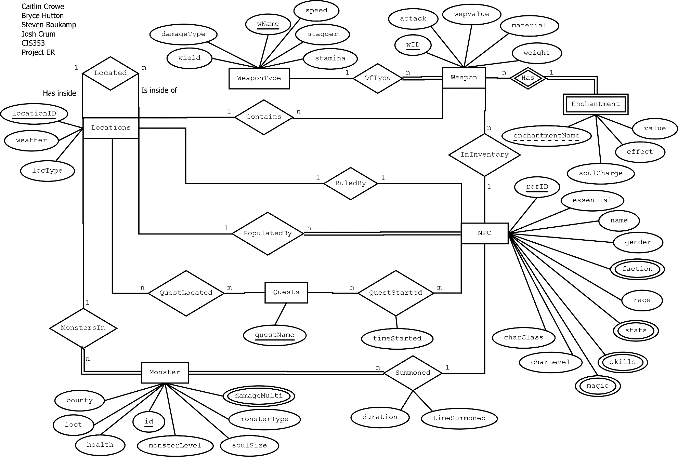

# BCNF Relational Schema

**WeaponType**(wName, speed, stagger, stamina, damageType, wield)

**Weapon**(wID, attack, wepValue, weight, material, locationID, refID, wName)

**Enchantment**(wID, enchantmentName, soulCharge, effect, value)

**NPC**(refID, essential, name, gender, race, charLevel, charClass, locationID )

**Quests**(questName)

**Monster**(id, health, monsterLevel, loot, monsterType, bounty, soulSize, locationID, refID, duration, timeSummoned)

**Locations**(locationID, weather, locType, locatedIn)

**DamageMulti(**id**,** value)

**CharacterSkills**(refID, skills)

**CharacterMagic**(refID, magic)

**CharacterStats**(refID, stats)

**CharacterFaction**(refID, faction)

**QuestStarted**(questName, refID, timeStarted)

**QuestsLocated**(locationID, questName)

# Integrity Constraints

|  |  |  |
| --- | --- | --- |
| IC name & table(s) | IC type | English statement |
| SKY_c1  NPC Table | Key | The primary key of the entity NPC is refID. |
| SKY_c6  NPC Table | Foreign Key | Every location that a NPC can be in must be a valid location. |
| SKY_c4  NPC Table | 1-attribute | Levels of a character must be between 1 and 100. |
| SKY_m4  Monster Table | 2-attribute, 1-row | Check that low level monsters do not drop a large amount of loot. |