ATTAY RASOOL => 18p-0046
Professor Name => SHAKIR ULLAH SHAH
Subject Name => Computer organization & Assembly Language

StopWatch
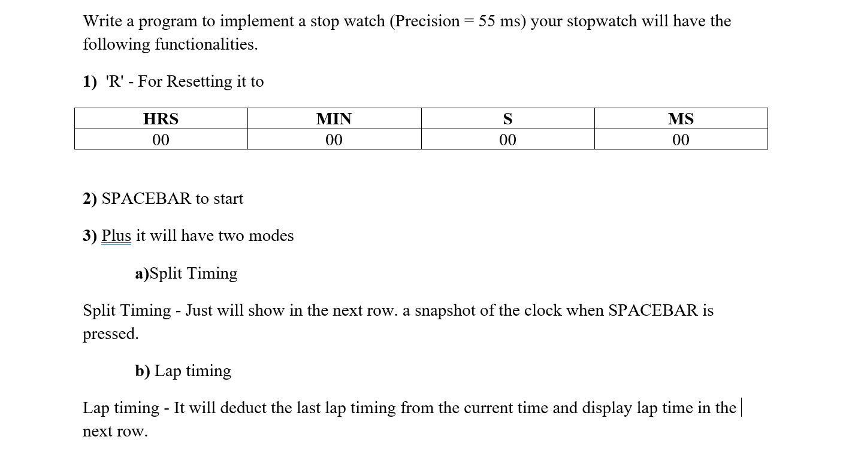

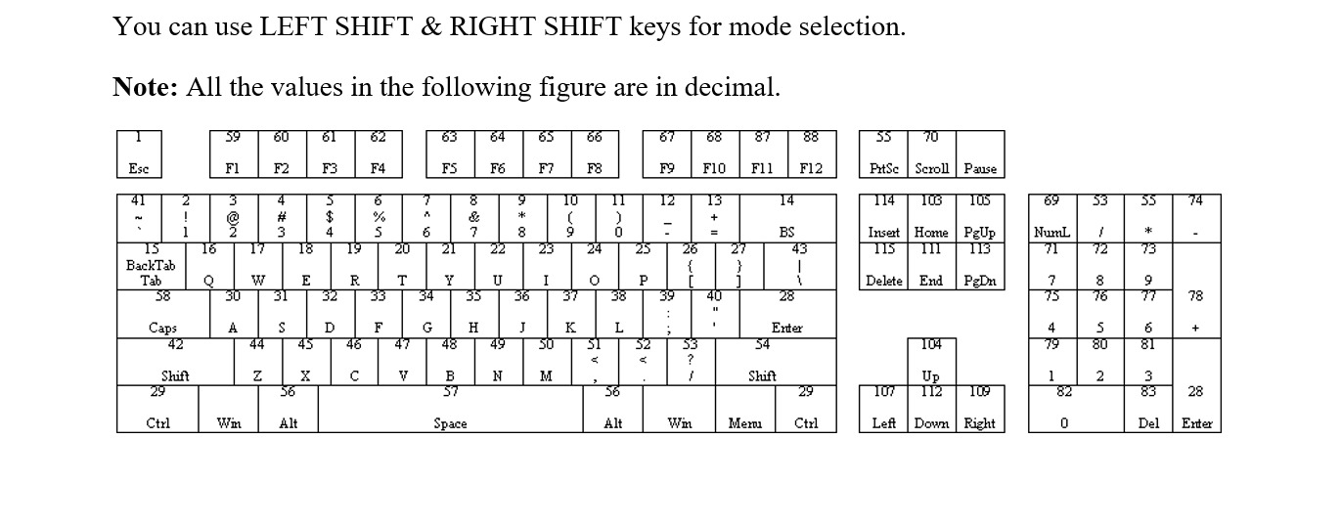

Prototype:
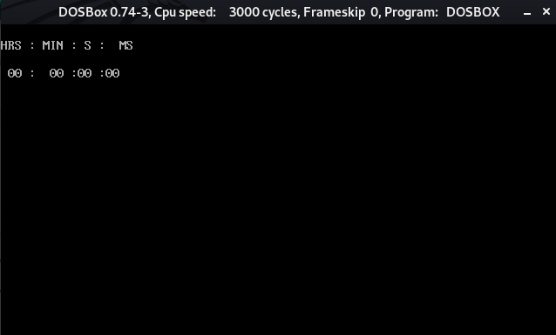

Press spacebar to start.
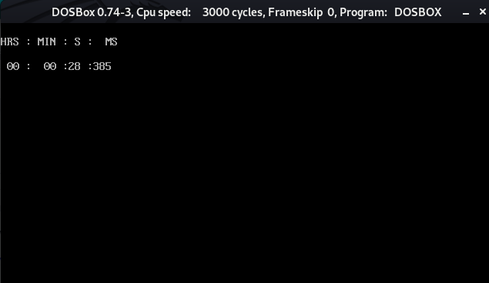
F for reset.

