READYRENTALS ONLINE

Maintenance Work Order Platform
CLIENT HANDOVER & OPERATIONS GUIDE
A practical reference for the application, VPS deployment, daily operation, data protection, and recovery.
Document control | Value
Document version | 1.1
Prepared | 24 September 2026
Client organization | ReadyRentalsOnline · https://readyrentalsonline.com
Developed by | Muhammad Attayab Ashraf · Automivex
Developer website | https://www.automivex.com
Developer support | attayabpc2@gmail.com · +92 317 4026038 · social@automivex.com
Deployment model | Single VPS · Docker Compose · Caddy HTTPS · PostgreSQL · local file volume

Operational reference. Contains no production credentials. Keep it with authorized project administrators.

Contents
• 1. Executive summary and ownership
• 2. Product capabilities and account roles
• 3. Work-order lifecycle
• 4. Architecture and network boundaries
• 5. Data model, persistence, and retention
• 6. Security and privacy controls
• 7. Production configuration reference
• 8. Initial deployment and release procedure
• 9. Routine operations and troubleshooting
• 10. Backup, restore, and disaster recovery
• 11. Developer workflow and code map
• 12. API and network reference
• 13. Handover checklist and known limitations
• Appendices: operations quick reference, glossary, change history
How to use this guide: This guide describes the implementation in this repository. Supply real domains, provider settings, credentials, backup destinations, and recovery targets during deployment. Validate a restore before relying on the backups.

1. Executive summary and ownership
ReadyRentalsOnline is a property-maintenance work-order application. Office staff create and track work orders. A technician opens a private token link on a phone, records the work, adds notes and photo evidence, and collects tenant and technician signatures. The API generates a PDF report and sends it by email when the work order is signed off.
The production deployment is a Docker Compose stack on one VPS. Caddy accepts public web traffic and obtains TLS certificates. The React frontend is served by Nginx; the FastAPI API connects privately to PostgreSQL. PostgreSQL records and uploaded files persist in separate named Docker volumes backed by the VPS disk. Application email uses the configured SMTP provider. Twilio SMS is optional.
Area | Current implementation
Web client | React 18 + TypeScript; built into a production Nginx image.
API | FastAPI + SQLModel; Python 3.11 container; Alembic schema migrations.
Database | PostgreSQL 16 Alpine; named persistent volume.
Files | VPS-local storage volume for photos, signatures, and generated PDFs; no S3 is required.
Ingress | Caddy reverse proxy with automatic HTTPS for separate app and API hostnames.
Notifications | SMTP for completion reports; optional Twilio for worker links.
Account roles | Owner and Admin. Existing legacy Manager-role records migrate to Admin.

Availability: One VPS is a single failure domain, not a high-availability design. VPS loss, disk failure, exhausted disk, or host outage can take the service offline. Use encrypted off-site backups and practice recovery on an isolated system.

1.1 Project ownership and technical support
This application was developed for ReadyRentalsOnline by Muhammad Attayab Ashraf and Automivex, a software development company. The contact details below are the developer’s company and personal support contacts. No client-personal contact details are included in this handover.
Responsibility | Contact
Developer | Muhammad Attayab Ashraf
Software company | Automivex · https://www.automivex.com
Personal technical contact | attayabpc2@gmail.com · +92 317 4026038
Company contact | social@automivex.com
Client organization | ReadyRentalsOnline · https://readyrentalsonline.com

Support hygiene: Share a redacted error, application version/commit, deployment method, browser or server details, and steps to reproduce. Never send .env files, passwords, database URLs, JWTs, worker links, SMTP credentials, or Twilio tokens by email.

2. Product capabilities and account roles
• Owner and Admin sign in to the office dashboard with JWT-based sessions.
• Office users create work orders, assign technicians, set priority, and view the organization’s work orders.
• The worker flow runs from a token link; technicians and tenants do not need office accounts.
• Tasks support notes, before/after photos, resolution state, and explicit photo-skip selections.
• The API collects tenant and technician signatures, creates a PDF report, and sends completion email.
• The Owner can create/remove office Admin accounts and view audit events and activity statistics.
• Admin and Owner can create or archive checklist categories. Categories are archived, not hard-deleted.
• Optional Twilio SMS can deliver the worker link; manual link sharing remains available.
Role | Permissions evidenced by current API and frontend
Owner | All office work-order and category features; creates/removes Admin accounts; views audit logs; may delete signed-off work orders; can filter by creator.
Admin | Office work-order and category features; can download reports, share/resend/regenerate worker links, and email signed reports; cannot manage accounts, view audit logs, or delete signed-off orders.
Technician / tenant | No office account. A person holding the work-order token can perform the worker actions allowed by the current status.

Role migration: There is no separate Manager permission role in the current application. The database migration converts existing legacy Manager accounts to Admin so their login and work-order access continue. Historical migration files retain the old value only to support upgrades from older databases.

Office users are not isolated to their own work orders: the API returns the organization’s work orders to any authenticated Admin or Owner. “My work orders” and Owner creator filters are dashboard filters, not per-user access-control boundaries.

3. Work-order lifecycle
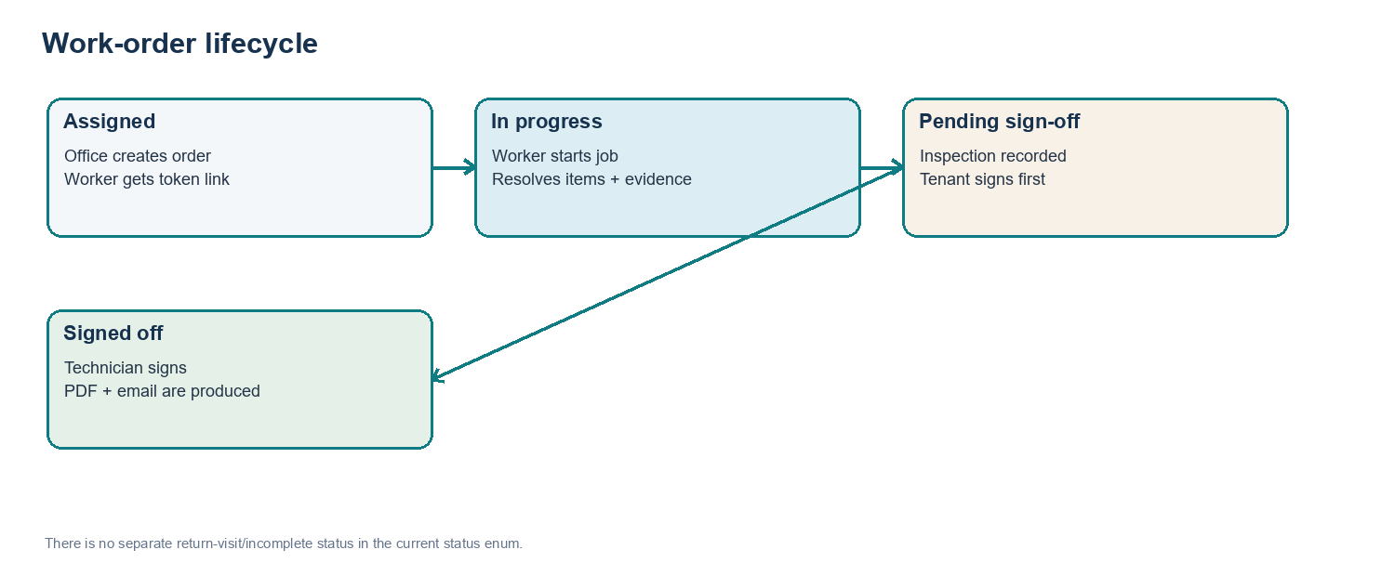
Figure 1. Implemented work-order status progression
A newly created work order is assigned. Starting the job records its start time and moves it to in_progress. The worker updates tasks, notes, inspection information, and evidence. Completion requires resolved tasks, inspection information, and before/after photos for each item or an explicit no-picture selection. The tenant signs before the technician. The technician’s signature finalizes the order, generates the PDF, and queues the completion email task.
Status | Meaning and constraints
assigned | Created by an office user; worker can open and start it.
in_progress | Worker can update eligible item data and evidence.
completed_pending_signoff | Completion checks passed and tenant sign-off is pending/recorded before technician sign-off.
signed_off | Finalized, PDF generated, and write-locked; Owner-only work-order deletion is permitted.

Current workflow limit: The current WorkOrderStatus enum has four states. It has no distinct incomplete, return-visit, or reopen status. Confirm the workflow fits business operations before relying on older descriptions of an incomplete-return process.

3.1 Worker-link handling
The worker link is a bearer credential: possession of the token URL grants access to the associated worker endpoints. Share it only with the intended technician/tenant. Regenerating the link replaces the previous token; signed-off orders cannot regenerate it. Treat links as credentials and avoid including them in support messages or public channels.

4. Architecture and network boundaries
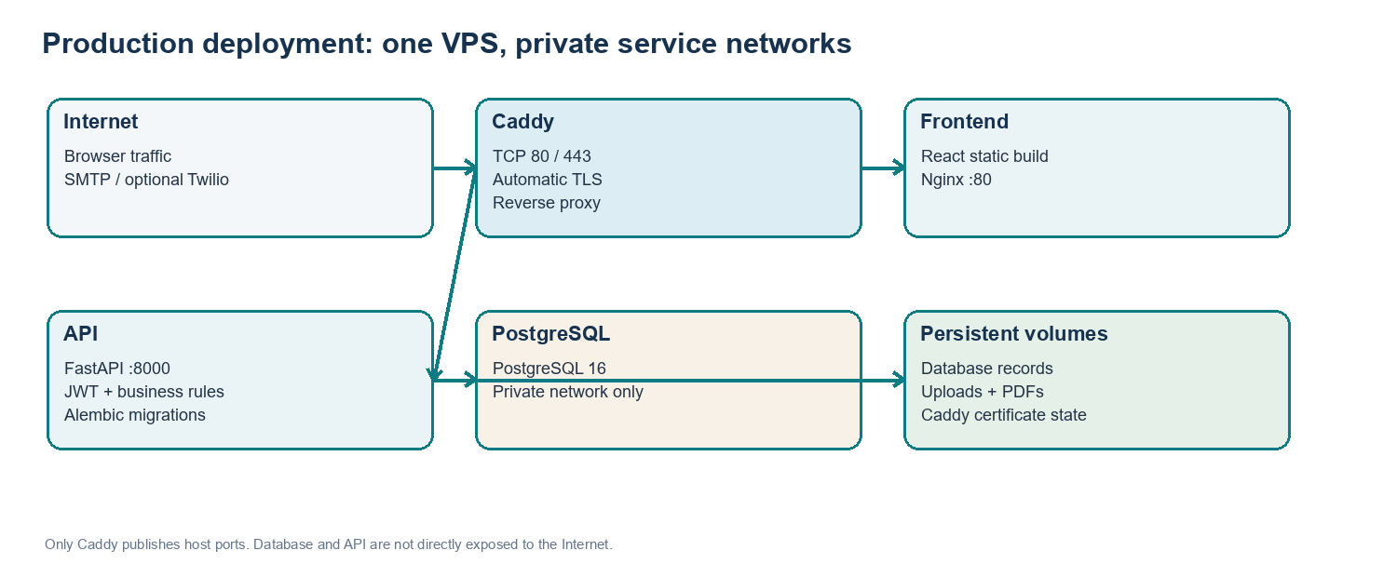
Figure 2. Production services and private Docker networks
Service | Purpose | Exposure / persistence
caddy | HTTPS ingress and reverse proxy | Host TCP 80/443 and UDP 443; persistent caddy_data and caddy_config.
frontend | Serves the React build using Nginx | Container port 80 on proxy network only; no persistent application data.
api | Auth, work-order rules, PDF, notifications, and file routes | Container port 8000 on proxy + internal DB networks; uploads_data volume.
postgres | Relational data | Container port 5432 on internal database network only; postgres_data volume.
init_uploads | Initializes uploads volume ownership and permissions | One-shot Alpine container; no network.

4.1 Request paths
• Office browser: https://<DOMAIN> -> Caddy -> frontend Nginx.
• Browser API calls: https://<API_DOMAIN> -> Caddy -> FastAPI api:8000.
• API-to-database: postgres:5432 over the Compose database network; the port is not published on the VPS host.
• API-to-files: /app/storage_data, mounted from readyrentals_uploads_data.
• Outbound email/SMS: API container connects to configured SMTP and optional Twilio services.

4.2 Build and startup
The frontend Dockerfile builds with Node 22 Alpine and serves the compiled Vite output from Nginx. VITE_API_BASE_URL is injected at image build time, so changing API_DOMAIN requires rebuilding the frontend. The API uses Python 3.11 slim and installs system libraries used by PDF generation. Its container command runs alembic upgrade head before starting Uvicorn. Compose waits for PostgreSQL health and upload-volume initialization before starting the API.

5. Data model, persistence, and retention
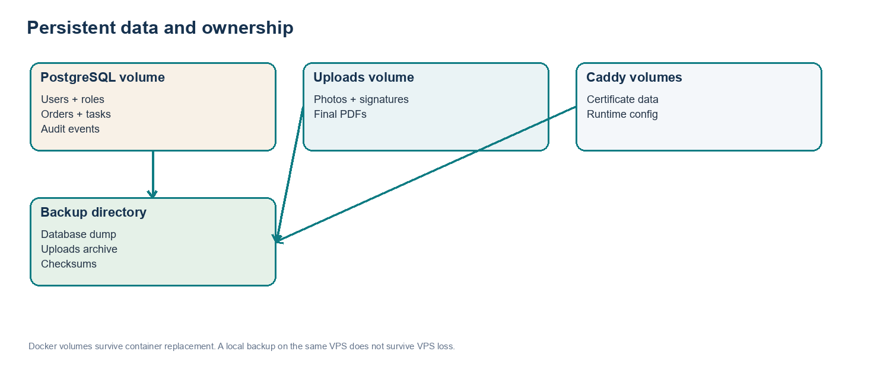
Figure 3. Primary persistent data and backup destinations
Storage | Contents | Retention / cleanup
readyrentals_postgres_data | Users, roles, work orders, task items, priorities, categories, audit logs. | Survives container replacement. No automatic work-order or audit retention job.
readyrentals_uploads_data | Work-order photos, signatures, and finalized PDFs. | Work-order assets are removed when Owner deletes the order; no age-based cleanup or total quota.
readyrentals_caddy_data/config | Caddy certificate and configuration state. | Persist these volumes. Deleting certificate state can trigger re-issuance and provider rate limits.
VPS backups/ | Timestamped DB dump, uploads.tar.gz, and SHA256SUMS. | Local script prunes old timestamped backups after successful capture; same-VPS storage only.

5.1 Deletion behavior
Owner deletion of a work order removes the complete work-orders/<id>/ storage prefix (photos, signatures, PDFs, and leftover replaced-photo files) before deleting the row. If file-prefix cleanup fails, deletion aborts and preserves the database order for retry. The audit trail records deletion separately and remains. Removing an Admin reassigns work orders created by that account to the Owner rather than deleting those work orders. Category removal sets is_active=false so existing order history remains meaningful.

5.2 Capacity planning
MAX_UPLOAD_MB is 10 MB in the production template. Allowed worker photo types are PNG, JPEG, and WEBP. Uploaded images are stored in their submitted form; the application does not resize or compress them. Each task has before and after photo slots, plus signatures and a PDF per completed order. Estimate disk from real order volume and photo sizes, include container images, database growth, logs, and local backup archives, and monitor free space in the Docker data root. There is no total upload quota or automatic file-age deletion.
Important: Deleting old local backup directories saves disk space but can remove the only recovery copy if off-site Restic is not configured. Do not prune Docker volumes as a disk-space fix.

6. Security and privacy
Control | Current implementation and operator responsibility
HTTPS | Caddy obtains certificates for public app/API domains. DNS and inbound TCP 80/443 must reach the VPS.
Network | Only Caddy publishes ports. Keep API/PostgreSQL un-published; do not expose their container ports publicly.
Passwords | Office account passwords are bcrypt-hashed. Use unique accounts and strong, unique passwords.
JWT | Signed with JWT_SECRET, default expiry 480 minutes. Browser token is stored in localStorage; protect user devices and shared-browser access.
Owner setup | OWNER_CODE is required for initial Owner setup. Generate a long random value and store it securely.
Worker token | Worker URL is a bearer credential without a separate worker login or token expiry. Regenerate a leaked link where supported.
Files | Local /files route is served by StaticFiles without office-account JWT authorization. Anyone who obtains an asset URL may be able to access it.
Secrets | Keep .env.production out of Git; chmod 600 on VPS. Redact database URLs, JWTs, SMTP/Twilio keys, and tokens in tickets/logs.
Resource/log limits | Compose has no explicit service memory limits or Docker log-size rotation. Configure host monitoring and bounded logging.
Backups | VPS-local backup is not disaster protection. Configure encrypted off-site backup and prove recovery by restoring.

Privacy review: Orders can contain names, phone numbers, addresses, notes, signatures, and property images. ReadyRentalsOnline should define access expectations, retention/deletion policy, incident handling, and any applicable privacy requirements. This document is an implementation handover, not a legal compliance determination.

7. Production configuration reference
Start from .env.production.example on the VPS. The populated .env.production file is a secret and is intentionally not included in this document. Production Compose pins storage to a local VPS volume and SMTP email. Twilio settings are optional.
Variable(s) | Purpose and guidance
DOMAIN / API_DOMAIN | Public app and API hostnames; use hostnames without https:// and point DNS A records to the VPS.
ACME_EMAIL | Monitored address for Caddy certificate account notices.
POSTGRES_DB / POSTGRES_USER | Application database name and login.
POSTGRES_PASSWORD | Unique random DB password. Do not reuse JWT or owner secrets.
JWT_SECRET | Independent random signing key; rotating it invalidates current office sessions.
JWT_ALGORITHM / JWT_EXPIRE_MINUTES | Template uses HS256 and 480 minutes (8 hours). Keep code and setting compatible.
OWNER_CODE | Independent secret used to register/claim the first Owner account.
OWNER_NAME / OWNER_EMAIL | Owner defaults used by application configuration and notification recipient resolution.
EMAIL_BACKEND | Production Compose requires smtp.
MAIL_FROM / MAIL_FROM_NAME | Sender address and display name authorized by the SMTP provider.
SMTP_HOST / PORT / USER / PASSWORD | Provider submission host, port, and SMTP credentials; prefer provider-issued app credentials.
SMTP_STARTTLS / SMTP_SSL | Match the provider. Typical submission is 587 + STARTTLS or 465 + implicit TLS; do not enable both.
STORAGE_BACKEND / STORAGE_LOCAL_DIR | Compose forces local and /app/storage_data, backed by uploads_data.
MAX_UPLOAD_MB | Per-photo size limit; production template uses 10 MB.
TWILIO_ACCOUNT_SID / AUTH_TOKEN / FROM_NUMBER | Optional SMS config. Leave all blank to disable. Use SMS-capable E.164 sender number.
COMPANY_NAME / PHONE / EMAIL / WEBSITE | Brand/contact values printed in generated report and completion email template.

Generate secrets: Run openssl rand -hex 32 separately for POSTGRES_PASSWORD, JWT_SECRET, and OWNER_CODE. Use three distinct values. Protect .env.production with chmod 600. Avoid commands that print the expanded Compose config into shared logs.

8. Initial deployment and release procedure

8.1 Preconditions
• Ubuntu VPS with Docker Engine and Docker Compose plugin installed; cPanel is not required.
• DNS A records for app and API domains point to the VPS public IPv4 address.
• Host/provider firewall allows inbound TCP 80 and 443. UDP 443 is optional for HTTP/3.
• Valid SMTP submission credentials and an authorized sender mailbox are available.
• VPS disk capacity covers database, uploads, images, logs, and backup retention.

8.2 Initial setup
On the VPS, as an operator authorized to manage Docker:
sudo mkdir -p /opt/readyrentals
sudo chown "$(id -u):$(id -g)" /opt/readyrentals
# Copy/clone the reviewed project into /opt/readyrentals
cd /opt/readyrentals
cp .env.production.example .env.production
nano .env.production
chmod 600 .env.production
docker compose --env-file .env.production -f compose.production.yaml config --quiet
docker compose --env-file .env.production -f compose.production.yaml up -d --build
docker compose --env-file .env.production -f compose.production.yaml ps
Replace every example domain, secret, SMTP value, owner default, and company branding value. Verify DNS before starting Caddy. After all containers are healthy, open https://<DOMAIN>, register the first Owner using OWNER_CODE, and store account credentials in an approved password manager. Verify https://<API_DOMAIN>/health and complete an end-to-end work order, SMTP email, and optional SMS check.
Production safety: Never run docker compose down -v on the production project. The -v flag removes named volumes and can erase the database, uploads, and Caddy state. A normal docker compose up -d --build retains named volumes.

8.3 Release / update
Use a reviewed source revision and keep a recent verified backup before a release:
cd /opt/readyrentals
git pull
docker compose --env-file .env.production -f compose.production.yaml config --quiet
docker compose --env-file .env.production -f compose.production.yaml up -d --build
docker compose --env-file .env.production -f compose.production.yaml ps
The API container applies Alembic migrations at startup. Review migration files before deploying. A change to API_DOMAIN requires a frontend image rebuild because VITE_API_BASE_URL is baked into that image. After environment-only API settings change, recreate the API service so it receives the new values.

9. Routine operations and troubleshooting
Task | Command / first check
Service status | docker compose --env-file .env.production -f compose.production.yaml ps
Recent service logs | docker compose --env-file .env.production -f compose.production.yaml logs --tail=100 api caddy
Follow logs | docker compose --env-file .env.production -f compose.production.yaml logs -f --tail=100
Recreate API after env change | docker compose --env-file .env.production -f compose.production.yaml up -d --force-recreate api
Rebuild deployment | docker compose --env-file .env.production -f compose.production.yaml up -d --build
Health | curl -fsS https://<API_DOMAIN>/health
Disk | df -h; docker system df (inspect volume use; do not prune blindly)

Symptom | Checks
Browser cannot reach API | API health/logs, Caddy logs, DNS, TLS, CORS origin, and rebuild frontend if API_DOMAIN changed.
Certificate not issued | Both DNS records, inbound TCP 80/443, host firewall, ACME_EMAIL, and Caddy logs.
Login rejected | Credentials, Owner registration, PostgreSQL health, browser clock, and whether JWT_SECRET changed.
Completion email missing | SMTP host/port/TLS/auth, verified sender, provider policy/firewall, API logs, and work-order notification error field.
SMS missing | All Twilio fields, sender capability, E.164 recipient, account restrictions, and Twilio Console. API acceptance is not delivery confirmation.
Photo or PDF missing | Uploads volume mount/permissions, disk space, asset URL, and whether the order was deleted.
API fails after release | Startup/migration logs, DB health, required env values, and migration compatibility before rollback.

10. Backup, restore, and disaster recovery
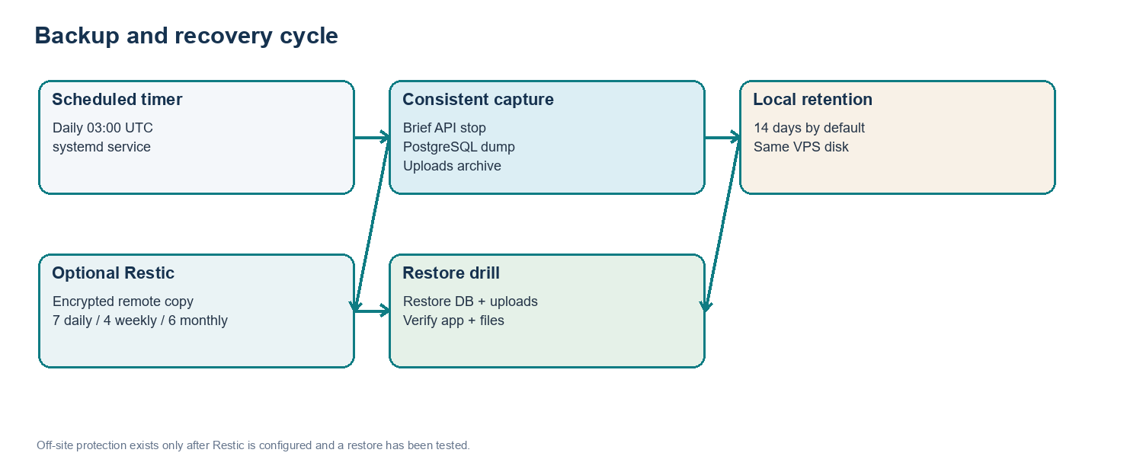
Figure 4. Backup capture, retention, and recovery verification
ops/backup-production.sh creates timestamped backup folders under backups/ by default. It obtains a non-overlapping lock, briefly stops API writes so the database and uploads capture align, writes a PostgreSQL custom-format dump and a tar.gz of readyrentals_uploads_data, writes SHA256SUMS, then restarts the API. A shell trap attempts to restart the API if capture fails after it has stopped.
• The included systemd timer runs daily at 03:00 UTC with up to 15 minutes of randomized delay and catches up after downtime.
• Local retention defaults to 14 days through LOCAL_RETENTION_DAYS. Local archives use VPS disk and are lost with the VPS/disk.
• When RESTIC_REPOSITORY, RESTIC_PASSWORD_FILE, Restic, and required repository credentials are configured, the script encrypts and sends the backup folder off-site, then retains 7 daily, 4 weekly, and 6 monthly snapshots.
• If Restic is unset, the script prints a warning; backups remain only on the VPS. This does not protect from VPS loss.
• The script backs up PostgreSQL and uploads, not .env.production, Caddy volumes, source code, or VPS configuration. Back those up separately and securely.

10.1 Install scheduled backups
After the project is deployed at /opt/readyrentals, run as root:
install -m 0644 ops/readyrentals-backup.service /etc/systemd/system/
install -m 0644 ops/readyrentals-backup.timer /etc/systemd/system/
systemctl daemon-reload
systemctl enable --now readyrentals-backup.timer
systemctl list-timers readyrentals-backup.timer
For off-site storage, install/configure Restic and create /etc/readyrentals-backup.env with RESTIC_REPOSITORY, RESTIC_PASSWORD_FILE, and the backend-specific credentials. Restrict both files to root (chmod 600). Keep the only Restic password somewhere separate from the only encrypted repository. Run a backup and restore test before treating the remote copy as usable.

10.2 Restore policy and drill
• Choose a recovery point and preserve current data before overwriting anything.
• Prefer a separate VPS or fresh volumes for first restore tests. Restore database and uploads as a matched timestamp pair.
• Verify SHA256SUMS before extraction and use the project’s exact named volumes and deployment revision.
• Start API and check /health; sign in; inspect representative orders; open representative photos, signatures, and PDFs; complete a test workflow.
• Record snapshot timestamp, restore start/end, validation results, and estimated data-loss window before switching DNS/traffic.
Destructive operation: A production restore replaces live database records and uploaded files. Rehearse the exact commands on an isolated copy first, keep a pre-restore backup, and confirm recovery authorization. Do not run destructive pg_restore, database-drop, or volume-cleanup commands against the only production copy without a reviewed recovery plan.

10.3 Recovery objectives
RPO and RTO are not formally established by the application. A daily backup can leave a data-loss window approaching one day plus timer delay. Actual recovery time depends on VPS replacement, archive size, download speed, and practice. ReadyRentalsOnline and the operator should agree targets and test recovery against them.

11. Developer workflow and code map
Location | Responsibility
frontend/src/features/ | Login, Owner/Admin pages, dashboard, work-order screens, worker flow, audit screens.
frontend/src/api/ | Typed request helpers, auth token storage, endpoint and response types.
backend/app/models.py | SQLModel tables, Owner/Admin user roles, work-order status values.
backend/app/routers/ | Auth, office work orders, categories, Owner-only admin/audit, token-based worker routes.
backend/app/services/work_orders.py | Work-order lifecycle, PDF orchestration, notifications, and cleanup rules.
backend/app/services/storage.py | Local/S3 storage abstraction; production Compose selects local storage.
backend/app/services/notifications.py | SMTP and optional Twilio message delivery.
backend/alembic/versions/ | Database schema history and migrations, including legacy Manager-to-Admin conversion.
compose.production.yaml / Caddyfile | Production containers, networks, volumes, host ports, and hostname routing.
ops/backup-production.sh + systemd units | Database/uploads capture and daily timer definitions.

Local development: backend uses pytest with an isolated SQLite test database; frontend uses npm ci and npm run build. Production uses PostgreSQL and Docker Compose. Review schema/data migrations and take a verified backup before releases. Do not place secrets or real customer data in test fixtures.

12. API and network reference
Method / route | Purpose | Auth
POST /auth/login | Office account login and JWT | Public
POST /auth/register-owner | Initial Owner registration/claim using OWNER_CODE | Owner code
GET /auth/me | Current account identity and role | JWT
GET/POST/DELETE /admins | List/create/remove office Admin accounts | Owner only
GET /audit-logs, /audit-logs/stats | Audit events and aggregate activity | Owner only
/work-orders | Create, list, read, patch, delete, PDF, share/resend, email report | Owner/Admin JWT
/checklist-categories | List/create/archive categories | Owner/Admin JWT
/wo/{token}/* | Worker start, task update, photos, progress, completion, signatures, PDF | Bearer URL token
GET /health | Liveness response | Public
/files/* | Local static work-order files | No office-account JWT on local StaticFiles path; URL possession may expose asset

12.1 Public host ports
Port | Service | Firewall guidance
TCP 80 | Caddy HTTP challenge/redirect | Public inbound required for ACME/redirect.
TCP 443 | Caddy HTTPS | Public inbound required.
UDP 443 | Caddy HTTP/3 | Optional; can be blocked if unused.
TCP 80 internal | Nginx frontend | Compose proxy network only.
TCP 8000 internal | FastAPI | Compose networks only; not a host-published port.
TCP 5432 internal | PostgreSQL | Internal DB network only; do not publish publicly.
SMTP outbound | API SMTP submission | Allow provider-approved outbound submission port, often 587 or 465.

13. Handover checklist and known limitations
• ReadyRentalsOnline confirms ownership/access to source repository, VPS, DNS, SMTP provider, optional Twilio account, and off-site backup repository.
• All domains, .env.production values, owner credentials, and company PDF branding are confirmed; secrets are in a password manager.
• Owner account is registered; office Admin accounts are individually assigned and verified.
• Production stack health, TLS, work-order lifecycle, PDF download, SMTP email, and optional SMS have been checked.
• Daily systemd backup timer is installed/enabled; operator reviewed service status and checksum output.
• Encrypted off-site Restic is configured and an isolated restore drill has passed.
• Client and operator agree retention/deletion, disk alerts, patch cadence, restore owner, incident path, RPO, and RTO.
Known limit | Current state / decision for the client
Worker/file privacy | Worker URL is a bearer token; local /files is not protected by office JWT. Confirm acceptable exposure or plan private file authorization.
Retention | No automatic work-order, audit, or upload age cleanup. Owner manually deletes work orders; define business/legal policy.
SMS delivery evidence | Optional Twilio call has no persisted provider SID or delivery callback. Initial acceptance does not prove delivery.
Photo storage | Original uploads retained, max 10 MB per photo from template; no image resizing or total volume quota.
Single VPS | No high availability, managed database, or automatic failover. Agree maintenance and recovery plan.
Host hardening | No Compose resource limits or Docker log-size caps. Add host-level monitoring, alerts, and log rotation.
Workflow states | Four states only; no distinct incomplete-return workflow. Confirm this fits field operations.

Appendix A. Backup operations quick reference
Action | Command / check
Run backup manually | cd /opt/readyrentals && sudo ops/backup-production.sh
Timer state | systemctl status readyrentals-backup.timer
Last job output | systemctl status readyrentals-backup.service; journalctl -u readyrentals-backup.service
Next scheduled run | systemctl list-timers readyrentals-backup.timer
Check a local archive | cd /opt/readyrentals/backups/<UTC timestamp> && sha256sum -c SHA256SUMS
Inspect volumes | docker volume ls; confirm the project volume names before any recovery operation.
Health check | curl -fsS https://<API_DOMAIN>/health

Appendix B. Glossary
Term | Meaning
ACME | Protocol Caddy uses to obtain and renew TLS certificates.
Bearer token | Secret token whose possession grants access to an API or worker flow.
Docker named volume | Docker-managed persistent storage surviving container replacement.
JWT | Signed token used by office accounts to authenticate API requests.
RPO | Recovery Point Objective: acceptable data-loss window measured in time.
RTO | Recovery Time Objective: target time to restore service after disruption.
Restic | Optional backup client that encrypts and sends archives to a configured repository.
SMTP | Protocol/API used by the application to submit outbound email.

Appendix C. Change history
Version | Date | Change
1.0 | 24 Sep 2026 | Initial project, deployment, and operations handover.
1.1 | 24 Sep 2026 | Rebuilt after role cleanup; documented Owner/Admin roles, legacy role migration, and corrected developer/client attribution. Developer contacts are Muhammad Attayab Ashraf / Automivex only; client identified as ReadyRentalsOnline.

End of guide: For developer or technical support, contact Muhammad Attayab Ashraf at attayabpc2@gmail.com or +92 317 4026038, or Automivex at social@automivex.com and https://www.automivex.com.

