Atte Karppinen D18123298

PART 1.

Importing csv to mongoDB using studio 3t – tool:

Competition – city, year, sport, discipline, event, event_gender (no medal as shown in the image)

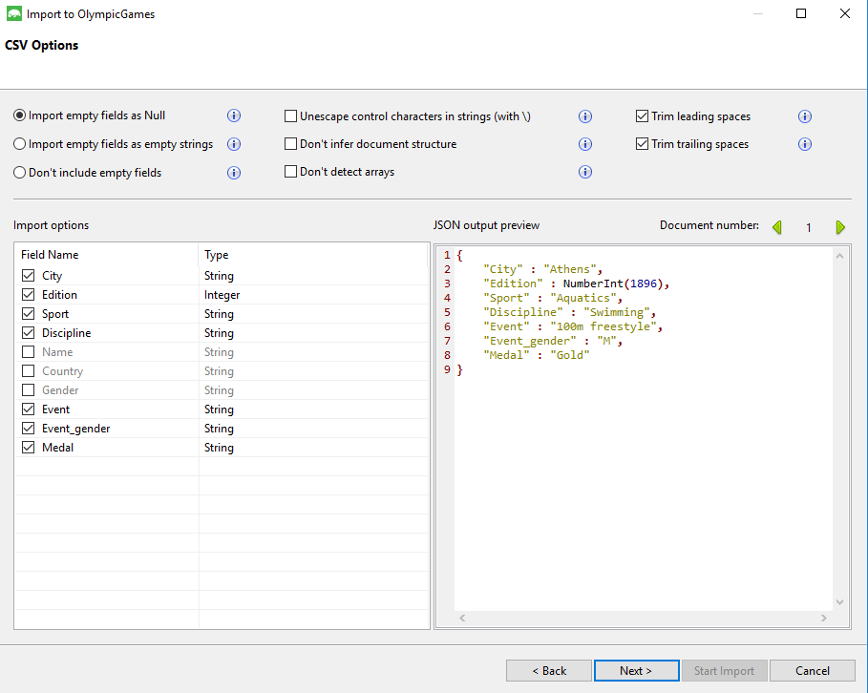

Athlete – name, country, gender, medal

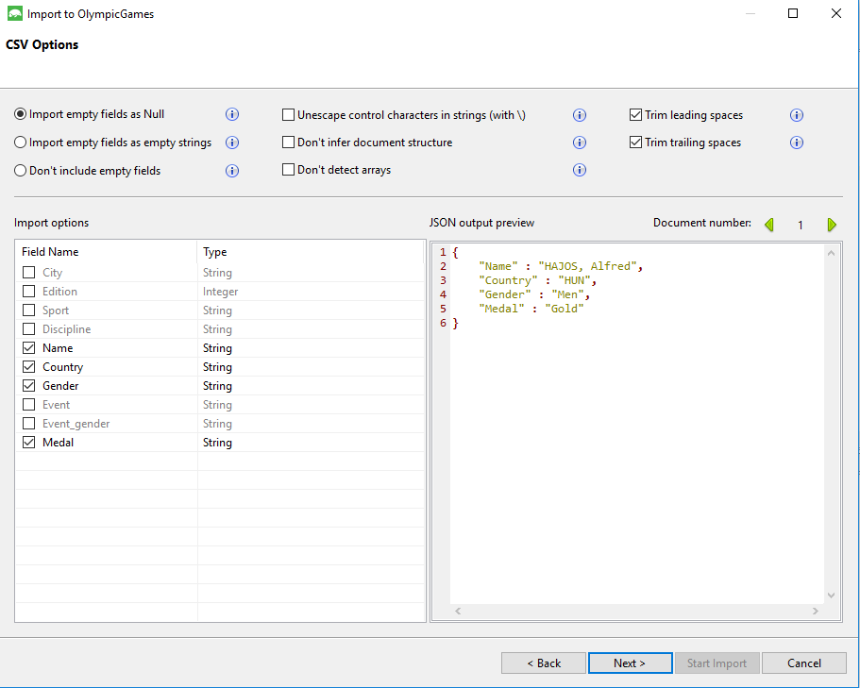

PART 2. OlympicsToMongo.py

PART 3. AND 4. Collections.txt