Competition – city, year, sport, discipline, event, event_gender (no medal as shown in the image)

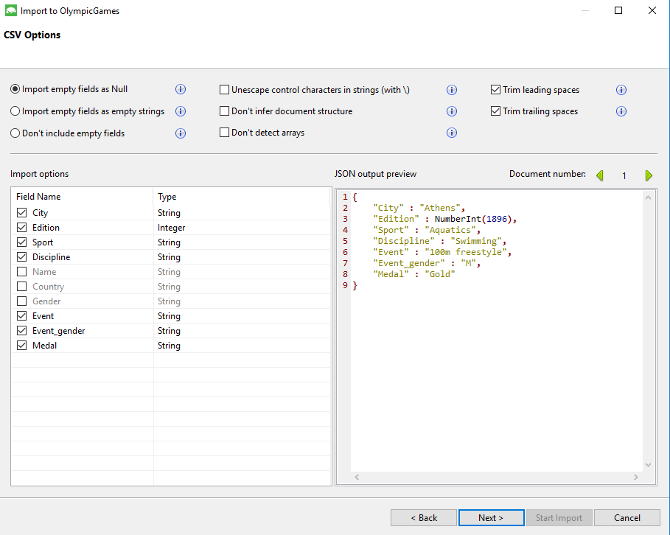

Athlete – name, country, gender, medal

