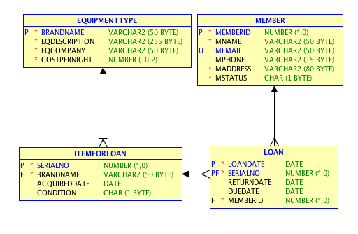An ICT library chain rents out equipment to club members. Each branch has a stock of equipment for rental. Members of the chain can rent equipment from any of their branches. Members have a membership card with a unique memberId. Gold status members have a status of 'G' while ordinary members have a status of 'O'. To borrow a piece of equipment, the member gives the serial number of the item they have chosen and their membership card. The administrator notes the unique SerialNo and gets the corresponding piece of equipment from the store. The administrator records the memberId, SerialNo, loandate, duedate and returns the card and equipment to the member. The member pays in full for the loan in advance. When the loan is finished the member returns the equipment and the administrator records the returndate. If the equipment is overdue, penalties are due on the loan. Equipment can have a status of current (C), damaged (D), lost (L) or archived (A).

First I created view named ESSENTIAL:

CREATE OR REPLACE VIEW ESSENTIAL AS (

SELECT MEMBER.MNAME, ITEMFORLOAN.BRANDNAME,

LOAN.RETURNDATE, EQUIPMENTTYPE.EQCOMPANY,

LOAN.LOANDATE, EQUIPMENTTYPE.COSTPERNIGHT

FROM MEMBER

JOIN LOAN ON LOAN.MEMBERID = MEMBER.MEMBERID

JOIN ITEMFORLOAN ON ITEMFORLOAN.SERIALNO = LOAN.SERIALNO

JOIN EQUIPMENTTYPE ON EQUIPMENTTYPE.BRANDNAME = ITEMFORLOAN.BRANDNAME

);

|  |  |  |
| --- | --- | --- |
| 1 | Write SQL to list member names (MNAME) and BRANDNAMEs they have borrowed more than once.  SELECT MNAME, BRANDNAME, COUNT(*)  FROM ESSENTIAL  GROUP BY MNAME, BRANDNAME  HAVING COUNT(*) > 1; | 20 marks |
| 2 | Write SQL to list the Brandnames of items for loan that have never been borrowed.  SELECT BRANDNAME FROM ITEMFORLOAN  WHERE SERIALNO NOT IN (  SELECT SERIALNO FROM LOAN  ); | 20 marks |
| 3 | Write SQL to list the names of members who have borrowed iPads (BRANDNAME has iPad in it), but never watches (BRANDNAME has watch in it).  SELECT MNAME FROM ESSENTIAL  WHERE BRANDNAME LIKE '%iPad%'  MINUS  SELECT MNAME FROM ESSENTIAL  WHERE BRANDNAME LIKE '%Watch%'; | 20 marks |
| 4 | Write SQL to list the names of members who have borrowed all equipment types provided by Dell (eqcompany = 'Dell').  ‘List the names of members where there is no type of equipment from Dell they haven’t borrowed’  SELECT MNAME FROM ESSENTIAL  WHERE NOT EXISTS (  SELECT BRANDNAME  FROM ESSENTIAL  WHERE NOT EXISTS (  SELECT EQCOMPANY  FROM ESSENTIAL  WHERE EQCOMPANY = 'Dell'  )  ); | 20 marks |
| 5 | Write SQL to list member names (MNAME) and the total penalty amount owed each has incurred for items that have been borrowed but not returned (returndate is null). *Remember SYSDATE is the current date.*  SELECT MNAME, ROUND(SYSDATE - LOANDATE) * COSTPERNIGHT AS Penalty  FROM ESSENTIAL  WHERE RETURNDATE IS NULL; | 20 marks |