# 1.0 Use Case Modelling

The first iteration of the Use Case model is a simple diagram with only one or at most two use cases and a use case description for each

It can cover the complete system functionality in summary form

System Name

(Automated Sales System)

Actor

(Student)

## 1.1 Use Case Description

The use case description is developed from analysing the description of the use case. This is the statement of the goal of the use case.

For the first iteration this will be a description of the how the system operates.

Use Cases focus on functional requirements and specific system behaviour.

|  |  |  |  |  |
| --- | --- | --- | --- | --- |
| **USE CASE** | | 1. | Try on clothes with mobile app | |
| **Description of Goal in Context** | | The user will be able to use smartphone to visualize how some clothing would fit and look like. | | |
| **Preconditions** | | The user owns a smartphone (with a camera) and has downloaded the app.  Database already includes clothing items. | | |
| **Post Conditions, Success End Condition** | | The user can view oneself fitted with new clothing. | | |
| **DESCRIPTION** | | The user uses smartphone to take a video of a himself/herself or some other person. Data is sent to servers and then sent back fitted with different clothing. The user can now view himself/herself from smartphone screen with new clothing. | | |
| **Main Flow** | | | | |
| **Step** | **Action** | | | **Alternate** |
| n.1.1 | User downloads the app and opens it. | | |  |
| n.1.2 | System creates connection between phone and servers. | | |  |
| n.1.3 | System offers different clothes to try on. | | |  |
| n.1.4 | System opens camera’s video feed and sends data to servers. | | |  |
| n.1.5 | System calculates target size and position and fits clothes on top of the target. | | |  |
| n.1.6 | System sends modified data to user’s phone. | | |  |
| n.1.7 | System offers option to select new piece of cloth or to quit the app. | | |  |
| n.1.8 | End use case. | | |  |
|  | | | | |
| **EXCEPTIONS or ERROR Flow Description** | | | | |
| **Step** | **Branching Action**  < Exception number m of Use Case n> | | | **Alternate** |
| 1.2.1 | **User has no internet connection**  System tries to make the connection between phone and servers. Limited to 5 reconnection attempts. | | |  |
| 1.2.2 | Connection made: go to MF 1.3.  Connection failed: Exit the app with user message to check connection and start the app again. END USE CASE. | | |  |
| 1.4.1 | **System doesn’t have permission to use end device’s camera**  System demands the permission. | | |  |
| 1.4.2 | Permission not granted: Urge the user to give permission in the settings. Otherwise exit the app. END USE CASE.  Permission granted: Go to MF 1.4 | | |  |

## Iteration 2

From the main flow of iteration 1 a number of use cases can be identified

These form the basis for the functional specifications of the system.

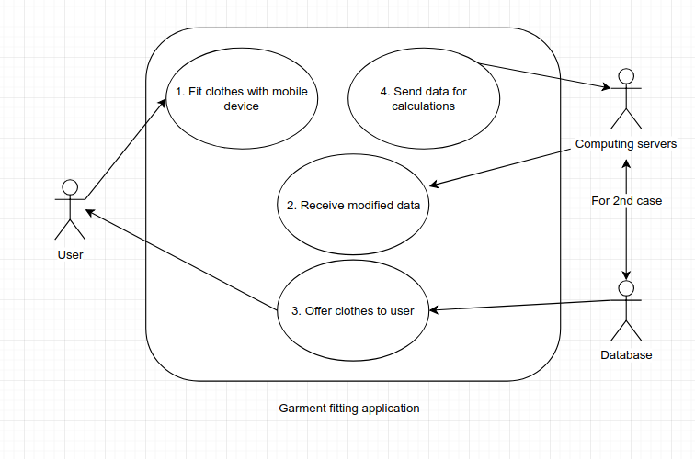

!! IGNORE THE ARROW GOING TO USER FROM 3rd USE CASE !!

|  |  |  |  |  |
| --- | --- | --- | --- | --- |
| **USE CASE** | | 1. | Fit clothes with mobile device | |
| **Description of Goal in Context** | | The user will be able to use smartphone to visualize how some clothing would fit and look like. | | |
| **Preconditions** | | The user owns a smartphone (with a camera) and has downloaded the app.  Some clothing already exists in the database. | | |
| **Post Conditions, Success End Condition** | | The user can view oneself fitted with new clothing. | | |
| **DESCRIPTION** | | The user uses smartphone to take a video of a himself/herself or some other person. The user can view himself/herself from smartphone screen with new clothing. | | |
| **Main Flow** | | | | |
| **Step** | **Action** | | | **Alternate** |
| n.1.1 | User downloads the app and opens it. | | |  |
| n.1.2 | System makes connection between user’s device and server/database. | | |  |
| n.1.3 | User chooses a garment he/she wishes to try on. | | |  |
| n.1.4 | User can view himself/herself with the new garment. | | |  |
| n.1.5 | End use case. | | |  |
|  | | | | |
| **EXCEPTIONS or ERROR Flow Description** | | | | |
| **Step** | **Branching Action**  < Exception number m of Use Case n> | | | **Alternate** |
| 1.1.1 | **User has no internet connection**  App store handles this exception. | | |  |
| 1.3.1 | **User can’t find garment selection**  Check internet connection and then connection to the server/database. Go to MF 1.2 | | |  |
| 1.4.1 | **User can’t view himself/herself with new clothes**  Check connection and try to resend modified data from the servers. Go to MF 2 | | |  |

|  |  |  |  |  |
| --- | --- | --- | --- | --- |
| **USE CASE** | | 2. | Receive modified data | |
| **Description of Goal in Context** | | User’s device receives data that has been calculated in the server. Data should include information about user’s size and location of body parts with new garments glued on top. | | |
| **Preconditions** | | Successful connection has been established with user’s device and server/database. Video feed has been successfully sent to server and calculations have been made. | | |
| **Post Conditions, Success End Condition** | | User’s device has received all required data from the server. | | |
| **DESCRIPTION** | | Server queries the database for the right garment. After that server calculates target’s size and glues the re-sized garment to right spot and sends that data to user’s device. | | |
| **Main Flow** | | | | |
| **Step** | **Action** | | | **Alternate** |
| n.2.1 | System verifies connection. | | |  |
| n.2.2 | Server queries right garment/garments from the database. | | |  |
| n.2.3 | Server calculates and recognizes certain points from the video data. | | |  |
| n.2.4 | System calculates target size and position and fits clothes on top of the target. | | |  |
| n.1.5 | System sends modified data to user’s phone. | | |  |
| n.1.6 | End use case. | | |  |
|  | | | | |
| **EXCEPTIONS or ERROR Flow Description** | | | | |
| **Step** | **Branching Action**  < Exception number m of Use Case n> | | | **Alternate** |
| 2.2.1 | **Request doesn’t yield results**  Go to EF 3.2.1 | | |  |
| 2.4.1 | **Server cannot recognize crucial points**  Return error message and urge the user to try again. Go to MF 4.2 | | |  |

|  |  |  |  |  |
| --- | --- | --- | --- | --- |
| **USE CASE** | | 3. | Offer clothes to the user | |
| **Description of Goal in Context** | | Database provides different garments for the user to try on. | | |
| **Preconditions** | | Connection has been established between user’s device and server/database. | | |
| **Post Conditions, Success End Condition** | | Whole garment selection is provided to user neatly and organized. | | |
| **DESCRIPTION** | | When user starts the application or user has finished viewing himself/herself wearing the previous clothing. | | |
| **Main Flow** | | | | |
| **Step** | **Action** | | | **Alternate** |
| n.3.1 | User’s device send request to database to retrieve the clothing collection. | | |  |
| n.3.2 | Database sends the collection to the user’s device. | | |  |
| n.3.3 | System offers different clothes to try on. | | |  |
| n.3.4 | End use case. | | |  |
|  | | | | |
| **EXCEPTIONS or ERROR Flow Description** | | | | |
| **Step** | **Branching Action**  < Exception number m of Use Case n> | | | **Alternate** |
| 3.2.1 | **Request doesn’t yield results**  Verify connection. | | |  |
| 3.2.2 | Successful connection: system checks database.  Unsuccessful connection: reconnect (attempt 5 times). | | |  |
| 3.2.3 | Connection made: re-send the query, go to MF 3.2  Valid database: try sending the query again. If error, send crash report and exit the application. Else go to MF 3.2  Invalid database: send crash report and exit the application. | | |  |
| 3.3.1 | **Offered garment doesn’t exist anymore**  While using the app, the garment has been removed from database. Solution, go to MF 3.1 | | |  |

|  |  |  |  |  |
| --- | --- | --- | --- | --- |
| **USE CASE** | | 4. | Send data for calculations | |
| **Description of Goal in Context** | | User’s device sends video (data) to computing server for processing. | | |
| **Preconditions** | | The user has the app up and running and has granted the app the permission to use camera. Also, connection to the servers have been made. | | |
| **Post Conditions, Success End Condition** | | The computing server receives valid data. | | |
| **DESCRIPTION** | | The user uses smartphone to take a video of a himself/herself or some other person. Data is sent to servers and checked for validity. | | |
| **Main Flow** | | | | |
| **Step** | **Action** | | | **Alternate** |
| n.4.1 | System verifies the connection between user and servers is working. | | |  |
| n.4.2 | Mobile device sends data (video) to the computing server. | | |  |
| n.4.3 | System verifies that the data is valid. | | |  |
| n.4.4 | End use case. | | |  |
|  | | | | |
| **EXCEPTIONS or ERROR Flow Description** | | | | |
| **Step** | **Branching Action**  < Exception number m of Use Case n> | | | **Alternate** |
| 4.2.1 | **User has no internet connection**  System tries to make the connection between phone and servers. Limited to 5 re-connection attempts. | | |  |
| 4.2.2 | Connection made: go to MF 4.2.  Connection failed: Exit the app with user message to check connection and start the app again. | | |  |
| 4.3.1 | **Data is malformed or otherwise unreadable**  Return error message to user’s device and urge to try again. | | |  |

Analysis class, collaboration diagram and Design classes

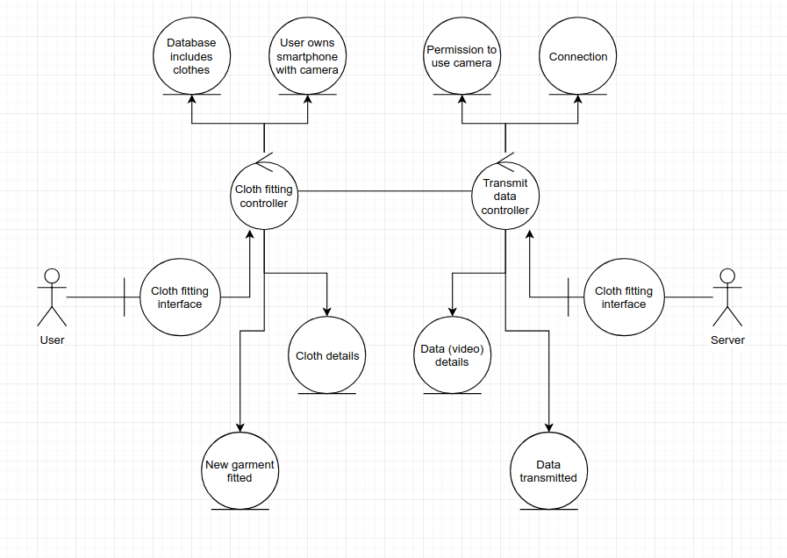

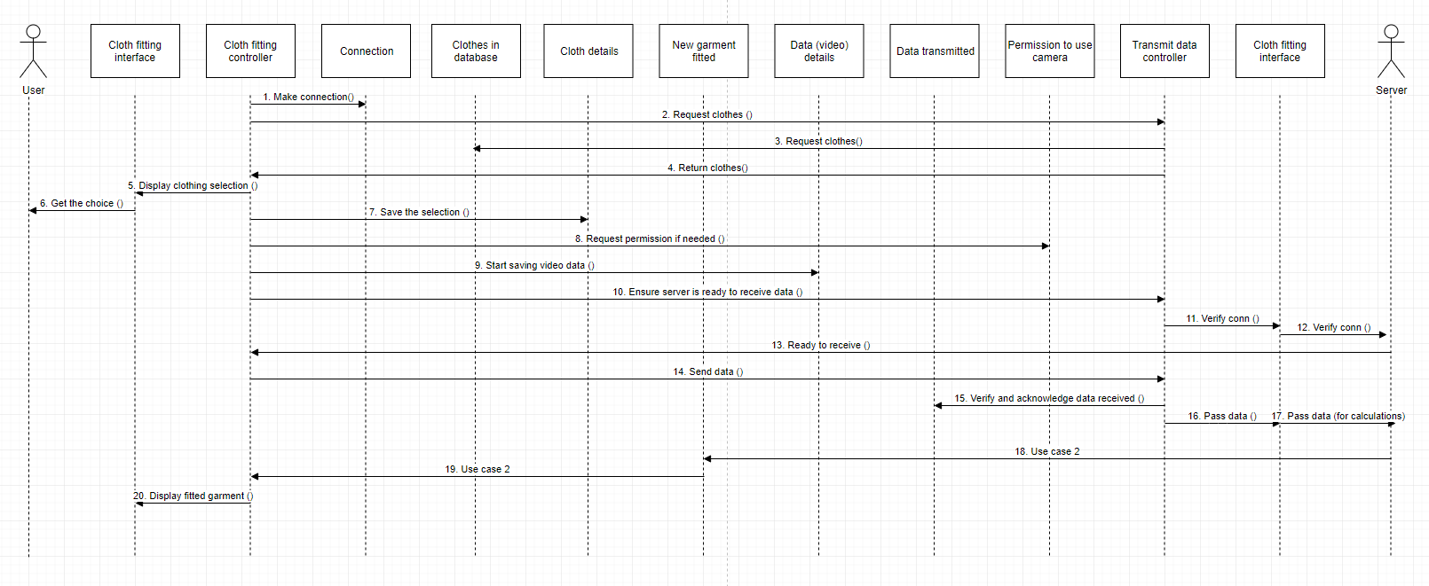

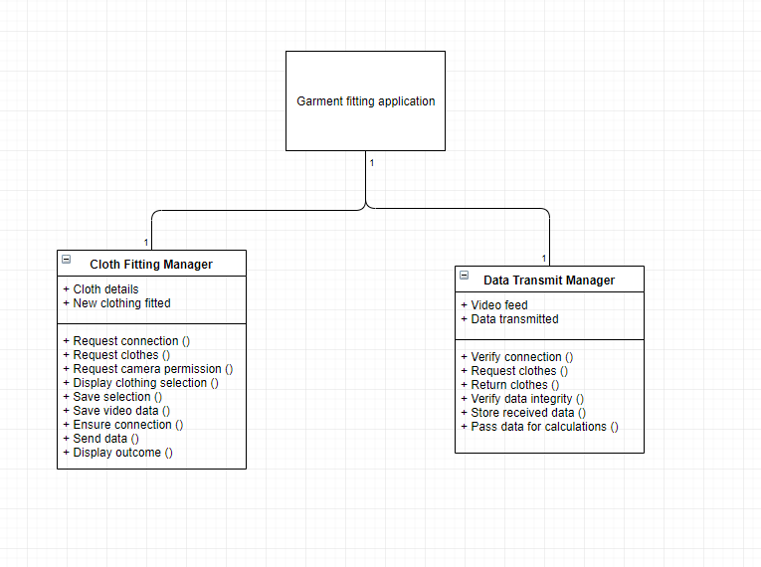

## Iteration 3

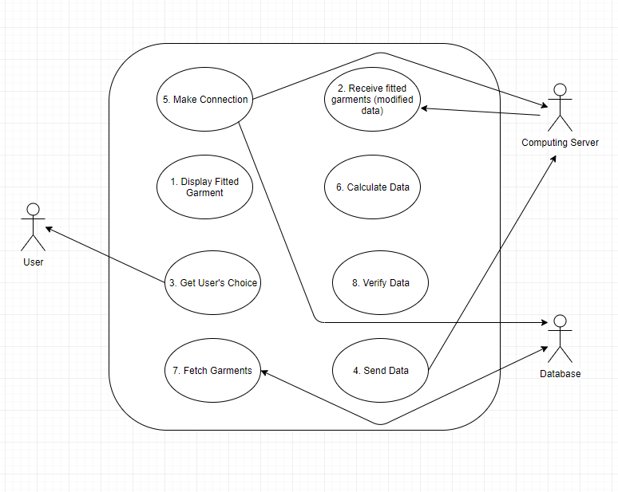

|  |  |  |  |  |
| --- | --- | --- | --- | --- |
| **USE CASE** | | 1. | Display Fitted Garment | |
| **Description of Goal in Context** | | The user will be able to use smartphone to visualize how some clothing would fit and look like. | | |
| **Preconditions** | | The user owns a smartphone (with a camera) and has downloaded the app.  Video data has been manipulated to include the garment and that data has been received. | | |
| **Post Conditions, Success End Condition** | | The user can view oneself fitted with new clothing. | | |
| **DESCRIPTION** | | After the program has handled some data the user can view himself/herself from smartphone screen with new garment. | | |
| **Main Flow** | | | | |
| **Step** | **Action** | | | **Alternate** |
| n.1.1 | System displays the user with fitted garment | | |  |
| n.1.2 | User can view himself/herself with the new garment. | | |  |
| n.1.3 | User closes the app or proceeds with another garment. | | |  |
| n.1.4 | End use case. | | |  |
|  | | | | |
| **EXCEPTIONS or ERROR Flow Description** | | | | |
| **Step** | **Branching Action**  < Exception number m of Use Case n> | | | **Alternate** |
| 1.1.1 | **System fails to display anything**  Go to MF 2.1 | | |  |
| 1.3.1 | **System doesn’t provide garments to select**  Verify connection: Go to MF 5.1 if needed. | | |  |
| 1.3.2 | Working connection: Go to MF 7.1 and then MF 3.1  Otherwise return error message and close the application. | | |  |

|  |  |  |  |  |
| --- | --- | --- | --- | --- |
| **USE CASE** | | 2. | Receive fitted garments (modified data) | |
| **Description of Goal in Context** | | User’s device receives data that has been calculated in the server. Data should include information about user’s size and location of body parts with new garment glued on top. | | |
| **Preconditions** | | Successful connection has been established with user’s device and server/database. Video feed has been successfully sent to server and calculations have been made. | | |
| **Post Conditions, Success End Condition** | | User’s device has received all required data from the server. | | |
| **DESCRIPTION** | | User’s device receives data it once sent, modified. | | |
| **Main Flow** | | | | |
| **Step** | **Action** | | | **Alternate** |
| n.2.1 | System verifies connection. | | |  |
| n.2.2 | Server side starts transmitting data. | | |  |
| n.2.3 | User’s device receives data and handles it to be ready for displaying. | | |  |
| n.2.4 | End use case. | | |  |
|  | | | | |
| **EXCEPTIONS or ERROR Flow Description** | | | | |
| **Step** | **Branching Action**  < Exception number m of Use Case n> | | | **Alternate** |
| 2.2.1 | **Server doesn’t start transmission.**  Retry once. Otherwise send error message to user and close application. | | |  |

|  |  |  |  |  |
| --- | --- | --- | --- | --- |
| **USE CASE** | | 3. | Get user’s choice | |
| **Description of Goal in Context** | | Get and store user’s choice regarding garments. | | |
| **Preconditions** | | Garments has been fetched from the database. | | |
| **Post Conditions, Success End Condition** | | User has selected ONE garment and that choice is stored. | | |
| **DESCRIPTION** | | User chooses category and garment inside that category he/she wishes to try on. | | |
| **Main Flow** | | | | |
| **Step** | **Action** | | | **Alternate** |
| n.3.1 | System presents the categories to the user. | | |  |
| n.3.2 | System presents the garment to the user. | | |  |
| n.3.3 | System stores user’s choice. | | |  |
| n.3.4 | End use case. | | |  |
|  | | | | |
| **EXCEPTIONS or ERROR Flow Description** | | | | |
| **Step** | **Branching Action**  < Exception number m of Use Case n> | | | **Alternate** |
| 3.2.1 /  3.2.2 | **No categories or garments to display**  Go to MF 7.1 | | |  |
|  | If unsuccessful, Close application with an error message. | | |  |

|  |  |  |  |  |
| --- | --- | --- | --- | --- |
| **USE CASE** | | 4. | Send data | |
| **Description of Goal in Context** | | User’s device sends video (data) to computing server for processing. | | |
| **Preconditions** | | The user has the app up and running and has granted the app the permission to use camera. Also, connection to the servers have been made. | | |
| **Post Conditions, Success End Condition** | | The computing server receives valid data. | | |
| **DESCRIPTION** | | The user uses smartphone to take a video of a himself/herself or some other person. Data is sent to servers and checked for validity. | | |
| **Main Flow** | | | | |
| **Step** | **Action** | | | **Alternate** |
| n.4.1 | System verifies the connection between user and servers is working. | | |  |
| n.4.2 | Mobile device sends data (video) to the computing server. | | |  |
| n.4.3 | System verifies that the data is valid. | | |  |
| n.4.4 | End use case. | | |  |
|  | | | | |
| **EXCEPTIONS or ERROR Flow Description** | | | | |
| **Step** | **Branching Action**  < Exception number m of Use Case n> | | | **Alternate** |
| 4.2.1 | **User has no internet connection**  System tries to make the connection between phone and servers. Limited to 5 re-connection attempts. | | |  |
| 4.2.2 | Connection made: go to MF 4.2.  Connection failed: Exit the app with user message to check connection and start the app again. | | |  |
| 4.3.1 | **Data is malformed or otherwise unreadable**  Return error message to user’s device and urge to try again. | | |  |

|  |  |  |  |  |
| --- | --- | --- | --- | --- |
| **USE CASE** | | 5. | Make connection | |
| **Description of Goal in Context** | | User’s device makes connection to computing server and database. This case should also be used to verify connection exists and works. | | |
| **Preconditions** | | User’s device has a working internet connection and has the app running. | | |
| **Post Conditions, Success End Condition** | | User’s device is connected to server and database. | | |
| **DESCRIPTION** | | As app starts, at the same time it starts connecting to server and database. | | |
| **Main Flow** | | | | |
| **Step** | **Action** | | | **Alternate** |
| n.5.1 | App attempts to make a connection to server/database. | | |  |
| n.5.2 | Server/database returns status code. | | |  |
| n.5.3 | End use case. | | |  |
|  | | | | |
| **EXCEPTIONS or ERROR Flow Description** | | | | |
| **Step** | **Branching Action**  < Exception number m of Use Case n> | | | **Alternate** |
| 5.1.1 | **User has no internet connection**  App returns notification message to check internet connection. | | |  |
| 5.2.1 | **Server/database returns failed connection attempt status code**  App returns notification message to check internet connection. | | |  |

|  |  |  |  |  |
| --- | --- | --- | --- | --- |
| **USE CASE** | | 6. | Calculate data | |
| **Description of Goal in Context** | | Data that has been sent from user’s device should include footage of a person/body part. Server calculates user’s chosen garment on top of that person/body part. | | |
| **Preconditions** | | User has granted the app permission to use camera and video feed has been successfully sent to server. Also, data has been verified to include human being/body part (Check Use Case 8). | | |
| **Post Conditions, Success End Condition** | | Algorithm recognises necessary shapes from the video data and successfully attaches selected garment on top of the target. | | |
| **DESCRIPTION** | | Server queries the database for the matching garment that the user has selected. After that server calculates target’s size and attaches the re-sized garment to right spot. | | |
| **Main Flow** | | | | |
| **Step** | **Action** | | | **Alternate** |
| n.6.1 | Server ensures working connection between it and database. | | |  |
| n.6.2 | Server queries right garment from the database. | | |  |
| n.6.3 | Server calculates and recognizes certain points from the video data. Such as a torso or a leg for example. | | |  |
| n.6.4 | System calculates target size and position and fits the garment on top of the target. | | |  |
| n.6.5 | End use case. | | |  |
|  | | | | |
| **EXCEPTIONS or ERROR Flow Description** | | | | |
| **Step** | **Branching Action**  < Exception number m of Use Case n> | | | **Alternate** |
| 6.2.1 | **Request doesn’t yield results**  Go to EF 3.2.1 | | |  |
| 6.3.1 | **Server cannot recognize crucial points**  Return error message and urge the user to try again. | | |  |

|  |  |  |  |  |
| --- | --- | --- | --- | --- |
| **USE CASE** | | 7. | Fetch garments | |
| **Description of Goal in Context** | | User’s device fetches every garment from the database. | | |
| **Preconditions** | | Connection has been established between user’s device and database. | | |
| **Post Conditions, Success End Condition** | | Whole garment selection is sent to user’s device. | | |
| **DESCRIPTION** | | When user starts the application or user has finished viewing himself/herself wearing the previous garment, system fetches garments from the database. | | |
| **Main Flow** | | | | |
| **Step** | **Action** | | | **Alternate** |
| n.7.1 | User’s device send request to database to retrieve the garments. | | |  |
| n.7.2 | Database sends the garments to the user’s device. | | |  |
| n.7.3 | End use case. | | |  |
|  | | | | |
| **EXCEPTIONS or ERROR Flow Description** | | | | |
| **Step** | **Branching Action**  < Exception number m of Use Case n> | | | **Alternate** |
| 7.1.1 | **Request doesn’t yield results**  Verify connection. | | |  |
| 7.1.2 | Successful connection: re-send the query.  Unsuccessful connection: reconnect (attempt 5 times). | | |  |
| 7.1.3 | If no matches in the database, exist application with a error message. | | |  |
| 7.2.1 | **Offered garment doesn’t exist anymore**  While using the app, the garment has been removed from database. Solution is to start again from MF 7.1 | | |  |

|  |  |  |  |  |
| --- | --- | --- | --- | --- |
| **USE CASE** | | 8. | Verify data | |
| **Description of Goal in Context** | | On the server side it is verified that video feed truly is of a human being and that data is not malformed. (Boolean value). | | |
| **Preconditions** | | User has granted the app permission to use camera and video feed has been successfully sent to server | | |
| **Post Conditions, Success End Condition** | | Data has been verified to be readable and human being or at least one body part has been recognised from the video feed. | | |
| **DESCRIPTION** | | This can be thought as a one, but very important, function in data calculation. Since it could be slow and demanding to try to recognise human or body parts from the video feed, instead that is achieved using machine learning, object recognition. | | |
| **Main Flow** | | | | |
| **Step** | **Action** | | | **Alternate** |
| n.8.1 | System verifies that data is readable and proceeds forward. | | |  |
| n.8.2 | System verifies that data is indeed of a human being or a body part | | |  |
| n.8.3 | System returns Boolean value regarding the result. | | |  |
| n.8.4 | End use case. | | |  |
|  | | | | |
| **EXCEPTIONS or ERROR Flow Description** | | | | |
| **Step** | **Branching Action**  < Exception number m of Use Case n> | | | **Alternate** |
| 8.1.1 | **Data is not readable**  Return error message, urging to try again. | | |  |
| 8.2.1 | **System cannot determine what’s in the video**  Return error message and remind that user should take video of him/herself or some other person. | | |  |

Analysis class, collaboration diagram and design class model