Stated spending responses to transfers across forms and amounts
Zelin Liu, Yinghao Pan*
Liu: National School of Development, Peking University (zlliu2026@nsd.pku.edu.cn). Pan: Renmin University of China (panyinghao@ruc.edu.cn). * Corresponding author.

Abstract
Transfer programmes vary both the resources households receive and the ways those resources can be used. We examine these dimensions in a randomized survey experiment in China with 5,480 adults assigned to hypothetical cash, food vouchers or medical-account credits of RMB 200, 1,000 or 5,000. Medical credits and larger transfers reduce the probability of reporting additional spending above 75% of the transfer. Cash exhibits the steepest observed decline, from 13.4% to 5.3%. Evidence that amount gradients differ by form is less secure: the post hoc omnibus interaction has Holm-adjusted P=0.181 and joint min-P-adjusted P=0.082 across 21 tests. Income scaling and food-expenditure diagnostics do not identify a mechanism, while response-style screening mainly widens uncertainty. The results distinguish average form and amount effects from an uncertain interaction in the high-spending tail. They concern stated responses to bundled transfer scenarios, without establishing realized spending effects or a psychological mechanism.

Introduction
How much additional income becomes additional consumption is central to the design of fiscal transfers. Research on the marginal propensity to consume (MPC) has documented variation across households, payments and economic circumstances.^{1,2,3,4,5,6,7,8,9} A practical policy choice, however, involves more than the amount disbursed. Governments can provide unrestricted cash, vouchers with an expiry date, or resources credited to an account for designated expenditure. The same face value can therefore carry different opportunities for substitution, different time constraints and different meanings for recipients. Comparing transfer forms at a single amount leaves open whether their differences persist when the amount changes.
Two bodies of evidence motivate studying form and amount together. Experimental and survey research finds that responses depend on the size and nature of income gains, without establishing a universal monotonic rule for every population or outcome.^{6,10,11} Research on cash and in-kind transfers, food assistance and shopping vouchers examines how restrictions and programme design affect expenditure.^{12,13,14,15} Studies of benefit labels and fungibility additionally show why economically similar resources may be allocated differently.^{16,17,18} These literatures provide reasons to expect variation, but a form contrast in one programme cannot determine the form-by-amount profile of another. In particular, spending at food retailers is not the same outcome as additional total consumption.
Theoretical accounts also differ in what they require. Under full fungibility, a restriction that never binds need not change consumption, provided other relevant transfer attributes are equal. Mechanical restrictions can matter when a transfer exceeds spending that would otherwise occur in the permitted category. Such an account makes baseline expenditure relevant; it does not deliver an unconditional sign for every form-by-amount interaction. Mental accounting can make labels and representations matter even without a binding constraint.^{19,20,21} Work on windfalls, denominations and planning supplies possible reasons for amount-dependent responses,^{22,23,24,25,26} but observing a declining cash gradient would not identify any one of these processes. A useful empirical design must first distinguish an interaction from average form and amount effects, and then ask which more specific explanations the measurements can assess.
We use a three-by-three randomized vignette experiment in China. Each respondent receives one hypothetical scenario crossing Cash, Food or Medical with RMB 200, 1,000 or 5,000. The outcome is additional total spending relative to the respondent’s prior plan, reported in six ordered bins. The common response scale permits comparisons of the full distribution, midpoint-coded averages and threshold probabilities. Between-person randomization identifies responses to the implemented scenarios; it does not isolate labels from expiry, liquidity or use restrictions.
The measurement boundary is equally important. Survey-based spending responses have an established empirical role,^{1,5,6,7,27} but they are not transaction records. Recent work demonstrates that elicitation wording can change both response levels and their relationship with payment size,²⁸ and transaction-linked comparisons caution against assuming individual stated and observed MPCs coincide.²⁹ Our direct percentage-bin question has no common explicit spending horizon, and its explanatory wording varies by form. The study consequently measures a distribution of stated responses to specific vignettes.
We organize the evidence in three steps. First, we establish the distributions and marginal effects of the randomized factors. Second, we estimate whether amount gradients differ across forms, retaining all seven previously examined outcome codings in a fixed 21-test family. Third, we directly test the restrictions behind income scaling, food-expenditure classification and response-style sensitivity. The study was not preregistered, and the high-spending focus was developed after examination of these data. The analysis therefore separates reproducible descriptive patterns from claims that remain sensitive to inferential choices.

Results

Average effects of form and amount
The delivered dataset contains 5,497 respondents, of whom 5,480 are recorded as adults. The adult cells contain 580–634 respondents. Figure 1 displays all six response categories, rather than only the threshold with the clearest pattern. Medical has lower midpoint-coded spending than Cash on average across the three amounts, while Food is closer to Cash. Amount changes also redistribute probability across bins, so a summary mean does not describe the complete response.
Table 1 reports equal-weight marginal contrasts from the nine cell means. Averaging over amounts, Medical lowers the highest-category response by 4.17 percentage points relative to Cash (95% pointwise CI −5.84 to −2.51; Holm-adjusted P<0.001 in the six-test main-effect family). The Food–Cash difference is −1.16 points (−2.99 to 0.66; adjusted P=0.213). Averaging over forms, RMB 1,000 and RMB 5,000 lower the highest-category probability by 2.70 and 4.15 points relative to RMB 200, respectively (adjusted P=0.006 and <0.001). These marginal effects are well defined even if an interaction is present. They establish effects of the implemented form and amount assignments on this stated outcome, without assuming a common form ranking at every amount.

The high-spending profile and its uncertainty
Cash’s highest-category probability falls from 13.4% at RMB 200 to 9.0% at RMB 1,000 and 5.3% at RMB 5,000 (Fig. 2a). The corresponding Food probabilities are 9.8%, 6.9% and 7.5%; Medical probabilities are 6.0%, 5.2% and 3.9%. On a linear probability trend over equally spaced log amounts, the estimated slopes per fivefold increase are −4.05, −1.14 and −1.04 percentage points for Cash, Food and Medical.
The Cash–Food slope difference is −2.90 points (pointwise CI −5.18 to −0.63), and the Cash–Medical difference is −3.00 points (−5.04 to −0.97). Nominal evidence is appreciable, but the inferential conclusion depends on multiplicity treatment. Across seven outcome codings and three interaction tests per outcome, the omnibus interaction has nominal P=0.0090, Holm-adjusted P=0.181 and joint min-P-adjusted P=0.082. Cash–Food has adjusted P=0.224 and 0.105, respectively; Cash–Medical has adjusted P=0.079 and 0.039. Bonferroni simultaneous intervals across the 21-test family include zero for both scalar contrasts (−6.43 to 0.63 and −6.16 to 0.15 points). We therefore do not interpret the single min-P rejection as a generally established form-by-amount interaction. The intervals remain compatible with both no differential trend and economically meaningful differences in the stated-response scale.
The larger Cash decline is not confined to the probability-difference scale. From RMB 200 to RMB 5,000, estimated risk ratios are 0.398 for Cash, 0.768 for Food and 0.654 for Medical; the corresponding odds ratios are 0.364, 0.749 and 0.640. These descriptive comparisons show that proximity to zero alone is not a sufficient arithmetic explanation of the observed ranking of declines. They do not establish different structural mechanisms or remove the uncertainty in cross-form comparisons.
At RMB 5,000, the Food point estimate exceeds Cash by 2.17 points (pointwise CI −0.63 to 4.97; six-contrast Holm-adjusted P=0.387; Fig. 2b). Thus the plotted profiles cross, but the data do not establish a reversal in the population ordering. Neither a positive Food advantage nor equivalence follows from this interval. Food and Medical are retained separately throughout because their uses and time rules differ.

Sample sensitivity and population coverage
The amount-slope contrasts retain similar point estimates in the full, adult and response-style-screened samples, while uncertainty increases in the smaller samples (Fig. 3a). The sample excluding constant responses has a smaller nominal omnibus P=0.0036 than the full-sample P=0.0080, but it is not selected as the primary sample on that basis. Direct comparisons of adults who pass and fail the Q1 and Q2 screens yield nominal interaction P=0.927 and 0.994, respectively (both adjusted P=1.000). These findings do not prove equal effects; they show why a significant result in one nested sample and a nonsignificant result in another cannot establish attenuation.
The common-scale specification display retains all pre-defined sample and amount representations (Supplementary Fig. 1). Population calibration illustrates a different limitation. Joint age-by-education weights based on the 2020 Chinese census reduce the effective sample size from 5,480 to 315, with a maximum normalized weight of 51.2. Capping normalized weights at 10 raises the effective sample size to 1,191 but leaves substantial discrepancies from the target cells. Weighted interaction intervals are wide and include zero (Supplementary Fig. 2). The sample contains only 90 adults aged 60 or above, and no respondent above 81, so even broad matched categories do not restore coverage within them. We interpret weighting as a sensitivity analysis, not a national population estimate.

Income scaling and food expenditure constrain interpretation
Replacing nominal amount with amount divided by income is a restricted model, not a direct test of mental accounting. In an unrestricted logit model with form-specific log-amount and log-income terms, the pure nominal-amount model sets all three income slopes to zero; the ratio model requires each income slope to equal the negative of its corresponding amount slope. The nominal-only restriction is rejected in the seven-test diagnostic family (adjusted P=0.030). The ratio restriction is not rejected after adjustment (P=0.176), but that is not evidence that it is correct. A direct form-by-amount-by-income interaction also lacks clear evidence (P=0.471 nominal; adjusted P=1.000).
Held-out prediction offers a complementary, limited comparison. With fixed folds, the ratio model reduces log loss by 0.172% relative to nominal amount; the unrestricted model improves it by 0.295%. The alternative income-band mapping gives the same ranking. These are small descriptive prediction gains, without a threshold declaring a psychological theory passed or failed. Income carries some information, but the comparisons neither isolate a relative-scale mechanism nor justify stating that relative scale performs worse than nominal amount.
For Cash and Food, we next use the lower bound of reported monthly food expenditure, multiplied by six, to classify respondents whose usual expenditure would exceed every assigned amount. This is a conservative proxy for inframarginality under stable spending and comparable eligible purchases, not a measurement of counterfactual purchases. The Food–Cash trend difference is 1.33 points in the classified group (95% pointwise CI −1.35 to 4.01; n=2,806) and 8.00 points in the remaining group (3.83 to 12.18; n=815; Fig. 3b). Their direct difference is −6.67 points (−11.63 to −1.71; nominal P=0.0084, Holm-adjusted P=0.0504).
This result makes an exclusionary claim about mechanical restrictions untenable. It suggests that baseline spending classification may matter, but its adjusted uncertainty, coarse expenditure measure and observational subgroup definition preclude mechanism identification. The remaining group is not necessarily constrained: failure to exceed a lower-bound criterion does not establish bindingness. A separate decomposition of amount and food-expenditure interactions does not reject the ratio-only restriction (adjusted P=1.000), which likewise supplies no positive proof of that model.

Discussion
This experiment separates two levels of evidence that are easily conflated. Average assignment to Medical rather than Cash, and to larger rather than smaller amounts, changes the probability of a very high stated spending response. The stronger observed compression under Cash poses a further question about whether form differences depend on amount. That interaction is less securely estimated: one pairwise contrast passes the joint min-P procedure, while the omnibus interaction and all Holm-adjusted interaction tests remain above 0.05. The scientific conclusion must accommodate that distinction.
The distributional presentation matters because form effects can concern different parts of a response distribution. A change in the highest bin need not imply a proportional shift in every household’s spending, and a midpoint-coded average imposes values within broad intervals. We therefore retain the complete bins, marginal contrasts and profiles together. These results define a concrete replication target: the difference between Cash and each restricted form in the change of the high-spending probability over a fixed amount range. They do not establish that the effect is unique to the upper tail; previous cross-threshold comparisons did not provide multiplicity-adjusted support for tail specificity.
The mechanism diagnostics change the interpretation rather than complete a causal chain. The food-expenditure comparison is compatible with a role for restrictions and does not support claiming they have been ruled out. At the same time, retrospective expenditure bands cannot reveal whether an individual would actually substitute permitted purchases under a real programme. Labelling, liquidity, expiry and planning could also affect responses. Findings on labels, food assistance and transfer design make these possibilities plausible,^{11,13,15,16,18} but plausibility is not evidence that any one process generates the present pattern. Intended allocation, perceived spendability and planning horizon were not measured or randomized.
The income results similarly distinguish statistical information from a behavioural explanation. Allowing income to enter improves fit, yet the restrictions imposed by a ratio of amount to income are not singled out by the data. The direction of an income association is also context dependent. In historical descriptive Cash regressions, income rank is positively associated with the highest response bin (2.41 points per standard deviation; 95% CI 0.97–3.84; nine-test Holm-adjusted P=0.006), whereas the emergency-fundraising association is less secure after adjustment (P=0.063). These associations are not positive controls for validity, and the Cash amount gradient is part of the studied phenomenon rather than an independent validation. Prior work also documents that observables need not explain much of realized MPC variation.³⁰ Failure to find stable moderators here cannot establish universal behaviour.
Several features limit what can be transported beyond the experiment. Transfers were hypothetical and answers were not financially incentivized. The question asks directly about extra total spending in percentage bins and provides yuan examples, without a shared explicit horizon. Medical credits are long-lived while Food expires after six months. Wording for the lowest category differs across forms, and questions about food and medical expenses precede the scenarios. Because wording can itself interact with amount,²⁸ holding wording constant within form does not by itself validate the amount gradient as a realized-consumption response. The results also depend on an online sample with limited demographic coverage. Weighting cannot repair unmeasured selection or missing support.
Finally, this is a single dataset with a substantial history of exploratory analysis. The focused family offers an interpretable comparison of a fixed set of hypotheses; it does not erase the earlier search or convert a post hoc claim into a preregistered result. Restricting further analysis is therefore part of the evidential conclusion. Independent work could randomize form and amount using actual resources, hold expiry and liquidity constant when testing labels, and measure spending over a common period. Under the present design, the defensible contribution is a transparent distributional account of stated transfer responses, with clear average effects and a specific but unresolved interaction.

Methods

Design and measurement
The questionnaire specifies random assignment to exactly one of nine form-by-amount scenarios. Delivered assignment fields agree with assignment reconstructed from the nonmissing scenario response. Full-sample cell counts are 619, 595 and 584 for Cash; 614, 620 and 602 for Food; and 615, 612 and 636 for Medical, in increasing amount order. Adult counts are 618, 592 and 580; 613, 619 and 599; and 614, 611 and 634, respectively. Historical balance checks across 41 observed variables found no Benjamini–Hochberg-adjusted imbalance. These checks do not substitute for allocation logs or prove balance on unobserved characteristics.
Food is a non-cashable voucher for food and daily needs, valid for six months. Medical credits are designated for medical expenditure and remain valid long term. The six spending categories are essentially no increase, less than 10%, 10–25%, 25–50%, 50–75%, and more than 75%. We retain the last label as written; its yuan example runs from 75% to 100%, so the questionnaire does not unambiguously measure responses above 100%. The ordinal code is 1–6; midpoint coding assigns 0, 0.05, 0.175, 0.375, 0.625 and 0.875. Threshold indicators use the observed ordered categories, without interpolation. “Any spending” denotes a category above “essentially no increase,” not an independently verified positive expenditure.
The questionnaire appendix identifies Tencent’s survey platform as the source of background fields Q41–Q49. It does not document the recruitment frame, field dates, invitation denominator, incentives, prospective sample-size calculation, stopping rule or platform allocation algorithm. The supplied data cannot recover these details. Author confirmation is required before submission; a completion rate cannot be calculated from the number of delivered records alone.

Samples and screening
The primary analysis includes recorded ages 18–100 (n=5,480); observed adult ages end at 81. The full sample, including 17 recorded minors, is retained only as a historical numerical comparison. Exclusion from analysis does not resolve documentation requirements for original data collection.
Response-style screens use 15 zero-to-ten attitude items from Q1–Q13, including three Q3 subitems. The constant-response exclusion also removes duplicate identifiers and leaves 5,171 adults. Q1 requires within-person sample standard deviation at least 1 and at least four distinct responses (n=2,715). Q2 requires standard deviation at least 1.5, at least five distinct responses, and at most 80% of responses at 0 or 10 (n=1,208). These are sample labels, not the questionnaire’s first two questions. Items precede the scenarios in the questionnaire and screening code does not use treatment or outcome. Exact administration timestamps and advance exposure to the scenario are not documented. The screens can select genuine response styles or attitudes as well as response effort, and have no independent validation as quality measures.

Estimands and multiplicity
Marginal form effects average the relevant cell differences equally over the three amounts; amount effects average equally over the three forms. A saturated nine-cell linear model supplies HC3 uncertainty. The six-test highest-category main-effect family contains form and amount omnibus tests and two reference contrasts for each factor. A separate six-test family contains Food–Cash and Medical–Cash contrasts at each amount. Holm correction is applied within each family. Other outcome codings accompany them descriptively and do not constitute new confirmatory findings.
The interaction model is Y=α+βF Food+βM Medical+γz+δF Food×z+δM Medical×z+ε, where z=−1, 0, 1 at RMB 200, 1,000 and 5,000. Its slopes are linear projections across these assigned doses, not an assumed global dose-response law. For each of seven outcomes, we test δF=δM=0, δF=0 and δM=0. These 21 tests form the focused interaction family. Scalar results are oriented Cash minus the other form. Holm adjustment is the default multiplicity protection; Bonferroni intervals use the same family size of 21. All other intervals are pointwise unless explicitly labelled.
The supplementary joint min-P procedure estimates the joint HC3 covariance of the 14 interaction coefficients across the seven outcomes from unrestricted residual influence contributions. Ten thousand centered Gaussian draws approximate their joint estimation-error distribution. Each draw is converted to 21 marginal two-sided normal or chi-square Wald P values with the appropriate degrees of freedom. The minimum P in each draw calibrates each observed P; the Monte Carlo count uses an add-one correction. This is asymptotic simultaneous inference, not exact randomization inference. It avoids using different statistic scales in one maximum and does not impose a common constrained null across incompatible links. It also does not account for every earlier research decision.
We evaluated the procedure with 1,000 complete estimator and HC3-covariance refits in each of three fixed multinomial scenarios: a pooled null, additive probability main effects, and a partial-null scenario with an intermediate-bin Food interaction. Each simulated dataset used 999 calibration draws. Estimated min-P family error rates were 0.055, 0.053 and 0.041, with exact binomial intervals covering 0.05; corresponding Holm rates were 0.027, 0.025 and 0.022. These finite simulations support limited calibration checks, not a universal finite-sample guarantee. Full algorithms, intervals and power results are in Supplementary Table 5.
The earlier 1,500-test set mixed outcomes and contrasts with sample, link and amount specifications. It is retained as a historical sensitivity diagnostic. On the same saved null-score structure, converting every statistic to its marginal P changes the full-sample focal omnibus adjustment from 0.414 to 0.370, rather than resolving the interaction. Its differing null models and location/scale restrictions limit interpretation. Descriptive specification plots use common probability contrasts and display overlapping sample estimates without treating them as independent replications.

Diagnostic models
Seven adult highest-category tests share Holm correction: the nominal-income exclusion restriction, the relative-scale restriction, the two-coefficient income triple interaction, the food-classification triple interaction, the food-ratio restriction, and two joint pass/fail triple interactions. Lower-order terms are included. Income restrictions use logit models with sandwich uncertainty; the other diagnostics use linear probability models with HC3 uncertainty. Classification is based on six times the lower bound of monthly food expenditure exceeding RMB 5,000. For the continuous food model, 145 Cash/Food adults with zero lower bounds are excluded, leaving 3,476. Since a lower bound is the denominator, the constructed transfer-to-expenditure ratio is an upper bound on the ratio to the unobserved actual expenditure.
Income bands are mapped using two fixed schemes, with the original M1 scheme primary and M2 a descriptive sensitivity. Five folds are stratified by randomized cell using the same original allocation for all prediction comparisons. Training and validation are separate; column scaling is estimated only in training folds. Unpenalized logistic models compare additive form and amount, form-specific nominal amount, form-specific amount/income, unrestricted income-plus-amount, and the full triple interaction. We report log loss and differences without a 1% pass/fail rule or an inferential interval that ignores shared training sets.

Population calibration
We transcribed national single-age and grouped counts from Table 4-1 of the 2020 census.³¹ Counts for ages 18 and 19 are combined with ages 20–29, followed by 30–44, 45–59 and 60 or above. Education is grouped as junior secondary or less, high/secondary vocational, and tertiary. Twelve joint cells have sample support, although this coarse support does not imply adequate coverage within cells. Uncapped weights are target cell proportions divided by sample proportions. Capped weights take min(λw,10), with λ chosen to retain a mean of one. Thus the capped solution deliberately sacrifices exact target balance. We report effective sample size, weight ranges, cell discrepancies and sensitivity intervals conditional on these calibration weights; they do not include uncertainty from the nonprobability recruitment process.

Ethics and informed consent
[AUTHOR CONFIRMATION REQUIRED: approving committee or exemption, identifier, informed-consent procedure, and documentation covering the recorded minors.]

Data availability
Aggregate source tables underlying the figures and analyses accompany this manuscript package. Conditions for access to de-identified respondent-level data require author confirmation, including consent and privacy restrictions. No respondent-level data are included in the accompanying public code package.

Code availability
Analysis and figure-generation code, fixed analysis definitions and reproduction instructions accompany the manuscript package in the nc_evidence_revision results directory. A versioned repository link is listed in the accompanying source manifest; an archival identifier remains to be supplied before submission.

Acknowledgements
[AUTHOR CONFIRMATION REQUIRED: funding and acknowledgements.]

Author contributions
[AUTHOR CONFIRMATION REQUIRED: contributions of Z.L. and Y.P.]

Competing interests
The authors declare no competing interests.

References
1. Shapiro, M. D. & Slemrod, J. Consumer response to tax rebates. Am. Econ. Rev. 93, 381–396 (2003).
2. Johnson, D. S., Parker, J. A. & Souleles, N. S. Household expenditure and the income tax rebates of 2001. Am. Econ. Rev. 96, 1589–1610 (2006).
3. Parker, J. A., Souleles, N. S., Johnson, D. S. & McClelland, R. Consumer spending and the economic stimulus payments of 2008. Am. Econ. Rev. 103, 2530–2553 (2013).
4. Misra, K. & Surico, P. Consumption, income changes, and heterogeneity: evidence from two fiscal stimulus programs. Am. Econ. J. Macroecon. 6, 84–106 (2014).
5. Jappelli, T. & Pistaferri, L. Fiscal policy and MPC heterogeneity. Am. Econ. J. Macroecon. 6, 107–136 (2014).
6. Fuster, A., Kaplan, G. & Zafar, B. What would you do with $500? Spending responses to gains, losses, news, and loans. Rev. Econ. Stud. 88, 1760–1795 (2021).
7. Jappelli, T. & Pistaferri, L. Reported MPC and unobserved heterogeneity. Am. Econ. J. Econ. Policy 12, 275–297 (2020).
8. Parker, J. A. Why don't households smooth consumption? Evidence from a $25 million experiment. Am. Econ. J. Macroecon. 9, 153–183 (2017).
9. Kaplan, G., Violante, G. L. & Weidner, J. The wealthy hand-to-mouth. Brookings Pap. Econ. Act. 2014, 77–138 (2014).
10. Andreolli, M. & Surico, P. ‘Less Is More’: consumer spending and the size of economic stimulus payments. Am. Econ. J. Macroecon. 18, 34–68 (2026).
11. Boehm, J., Fize, E. & Jaravel, X. Five facts about MPCs: evidence from a randomized experiment. Am. Econ. Rev. 115, 1–42 (2025).
12. Cunha, J. M. Testing paternalism: cash versus in-kind transfers. Am. Econ. J. Appl. Econ. 6, 195–230 (2014).
13. Hastings, J. & Shapiro, J. M. How are SNAP benefits spent? Evidence from a retail panel. Am. Econ. Rev. 108, 3493–3540 (2018).
14. Kan, K., Peng, S.-K. & Wang, P. Understanding consumption behavior: evidence from consumers' reaction to shopping vouchers. Am. Econ. J. Econ. Policy 9, 137–153 (2017).
15. Bonomo, T., Ruffini, K. J. & Schanzenbach, D. W. Is a dollar a dollar? How transfer design shapes household spending. NBER Working Paper 35698, https://doi.org/10.3386/w35698 (2026).
16. Abeler, J. & Marklein, F. Fungibility, labels, and consumption. J. Eur. Econ. Assoc. 15, 99–127 (2017).
17. Kooreman, P. The labeling effect of a child benefit system. Am. Econ. Rev. 90, 571–583 (2000).
18. Beatty, T. K. M., Blow, L., Crossley, T. F. & O'Dea, C. Cash by any other name? Evidence on labeling from the UK Winter Fuel Payment. J. Public Econ. 118, 86–96 (2014).
19. Thaler, R. H. Mental accounting and consumer choice. Mark. Sci. 4, 199–214 (1985).
20. Shefrin, H. M. & Thaler, R. H. The behavioral life-cycle hypothesis. Econ. Inq. 26, 609–643 (1988).
21. Thaler, R. H. Mental accounting matters. J. Behav. Decis. Mak. 12, 183–206 (1999).
22. Arkes, H. R. et al. The psychology of windfall gains. Organ. Behav. Hum. Decis. Process. 59, 331–347 (1994).
23. Milkman, K. L. & Beshears, J. Mental accounting and small windfalls: evidence from an online grocer. J. Econ. Behav. Organ. 71, 384–394 (2009).
24. Raghubir, P. & Srivastava, J. The denomination effect. J. Consum. Res. 36, 701–713 (2009).
25. Bernard, R. Mental accounting and the marginal propensity to consume. Deutsche Bundesbank Discussion Paper 13/2023 (2023).
26. Boutros, M. Windfall income shocks with finite planning horizons. J. Financ. Econ. 176, 104174 (2026).
27. Drescher, K., Fessler, P. & Lindner, P. Helicopter money in Europe: new evidence on the marginal propensity to consume across European households. Econ. Lett. 195, 109416 (2020).
28. Crossley, T. F., Fisher, P., Levell, P. & Low, H. Eliciting the marginal propensity to consume in surveys. Federal Reserve Bank of Chicago Working Paper 2026-04 (2026).
29. Ueda, K. The reality of consumption: comparing self-reported and observed marginal propensity to consume. Econ. Lett. 247, 112179 (2025).
30. Lewis, D., Melcangi, D. & Pilossoph, L. Latent heterogeneity in the marginal propensity to consume. Rev. Econ. Stud. 93, 3274–3302 (2026).
31. National Bureau of Statistics of China. China Population Census Yearbook 2020, Table 4-1, Population aged 3 and above by age, sex and educational attainment. https://www.stats.gov.cn/sj/pcsj/rkpc/7rp/zk/html/A0401.jpg (accessed 3 October 2026).

Table 1 Marginal effects of the randomized factors
Outcome and contrast | Estimate and 95% CI (pp) | Nominal P | Holm P
Midpoint  food-cash | -1.98 (-3.71, -0.26) | 0.024 | —
Midpoint  medical-cash | -4.91 (-6.56, -3.26) | <0.001 | —
Midpoint  1000-200 | -1.75 (-3.46, -0.04) | 0.045 | —
Midpoint  5000-200 | -2.74 (-4.42, -1.07) | 0.001 | —
>75%  food-cash | -1.16 (-2.99, 0.66) | 0.213 | 0.213
>75%  medical-cash | -4.17 (-5.84, -2.51) | <0.001 | <0.001
>75%  1000-200 | -2.70 (-4.49, -0.91) | 0.003 | 0.006
>75%  5000-200 | -4.15 (-5.86, -2.43) | <0.001 | <0.001
>75% form omnibus | 2 df | <0.001 | <0.001
>75% amount omnibus | 2 df | <0.001 | <0.001
N=5,480. Equal-weight contrasts over the other randomized factor; HC3 pointwise intervals. Midpoint values are descriptive approximations to stated spending shares, expressed in percentage points. Holm adjustment applies to the six >75% tests only; midpoint tests are descriptive. Full seven-outcome results are in main_effects.csv. No local family supplies whole-paper error control.

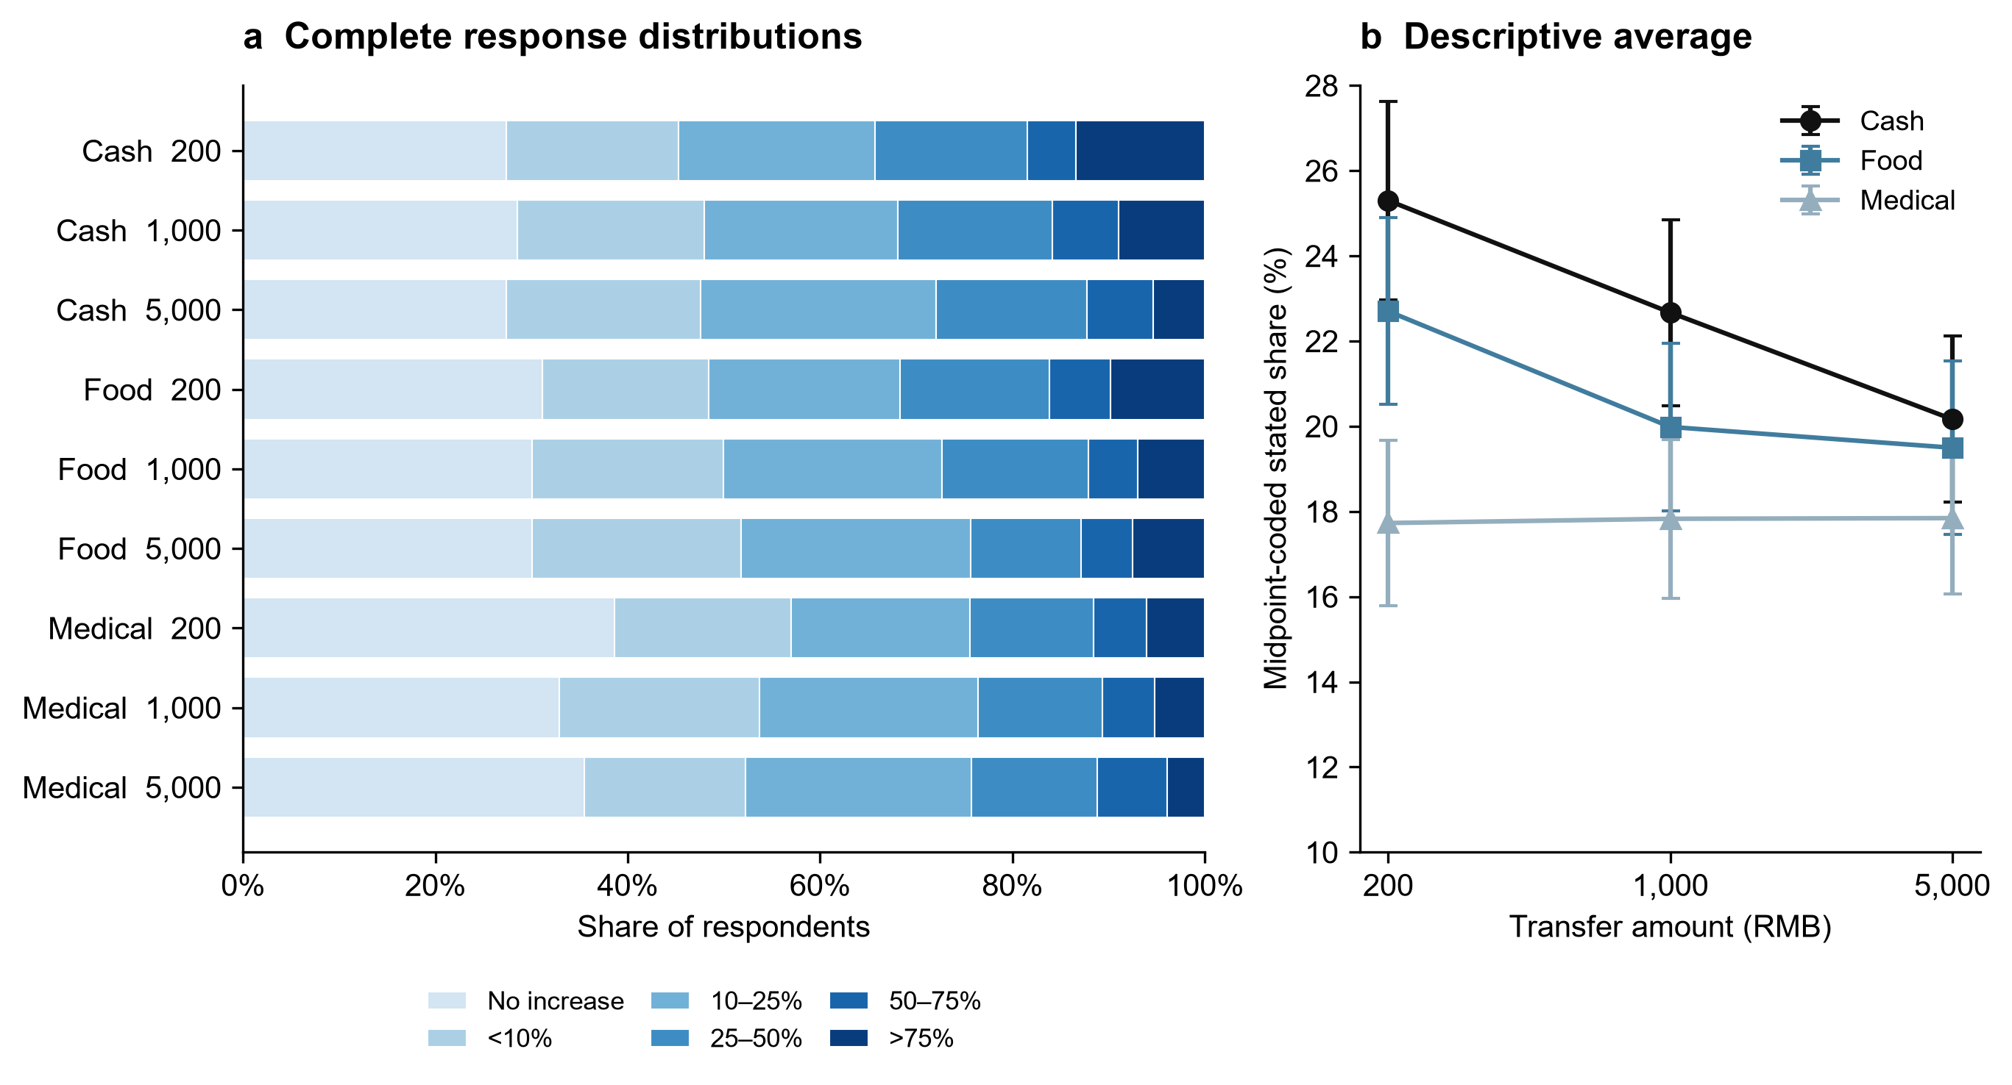
Figure 1. Full response distributions and midpoint-coded averages. a, Unconditional six-category distributions for adults in all nine randomized cells. Shading runs from light for the lowest category to dark for the highest. The first category means essentially no increase. b, Midpoint-coded stated spending shares with pointwise 95% normal intervals based on cell sample variances. Cash, Food and Medical adult cell sizes at RMB 200/1,000/5,000 are 618/592/580, 613/619/599 and 614/611/634. Lines connect independent randomized groups, not within-person trajectories. Source: distribution.csv and profiles.csv.

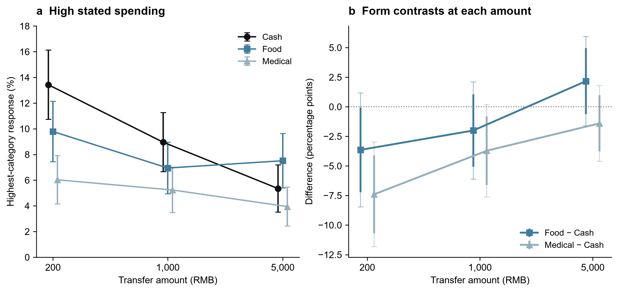
Figure 2. High-spending probabilities and form contrasts. a, Probability of choosing the >75% response bin in each adult cell; error bars are pointwise 95% normal intervals. Cell sizes are as in Fig. 1. b, Food–Cash and Medical–Cash differences at each amount from saturated cell means with HC3 uncertainty. Thick intervals are pointwise 95%; thin capped intervals are Bonferroni simultaneous 95% intervals for the six displayed contrasts. The Food point estimate crosses Cash but its difference at RMB 5,000 remains uncertain. Source: profiles.csv and form_contrasts.csv.

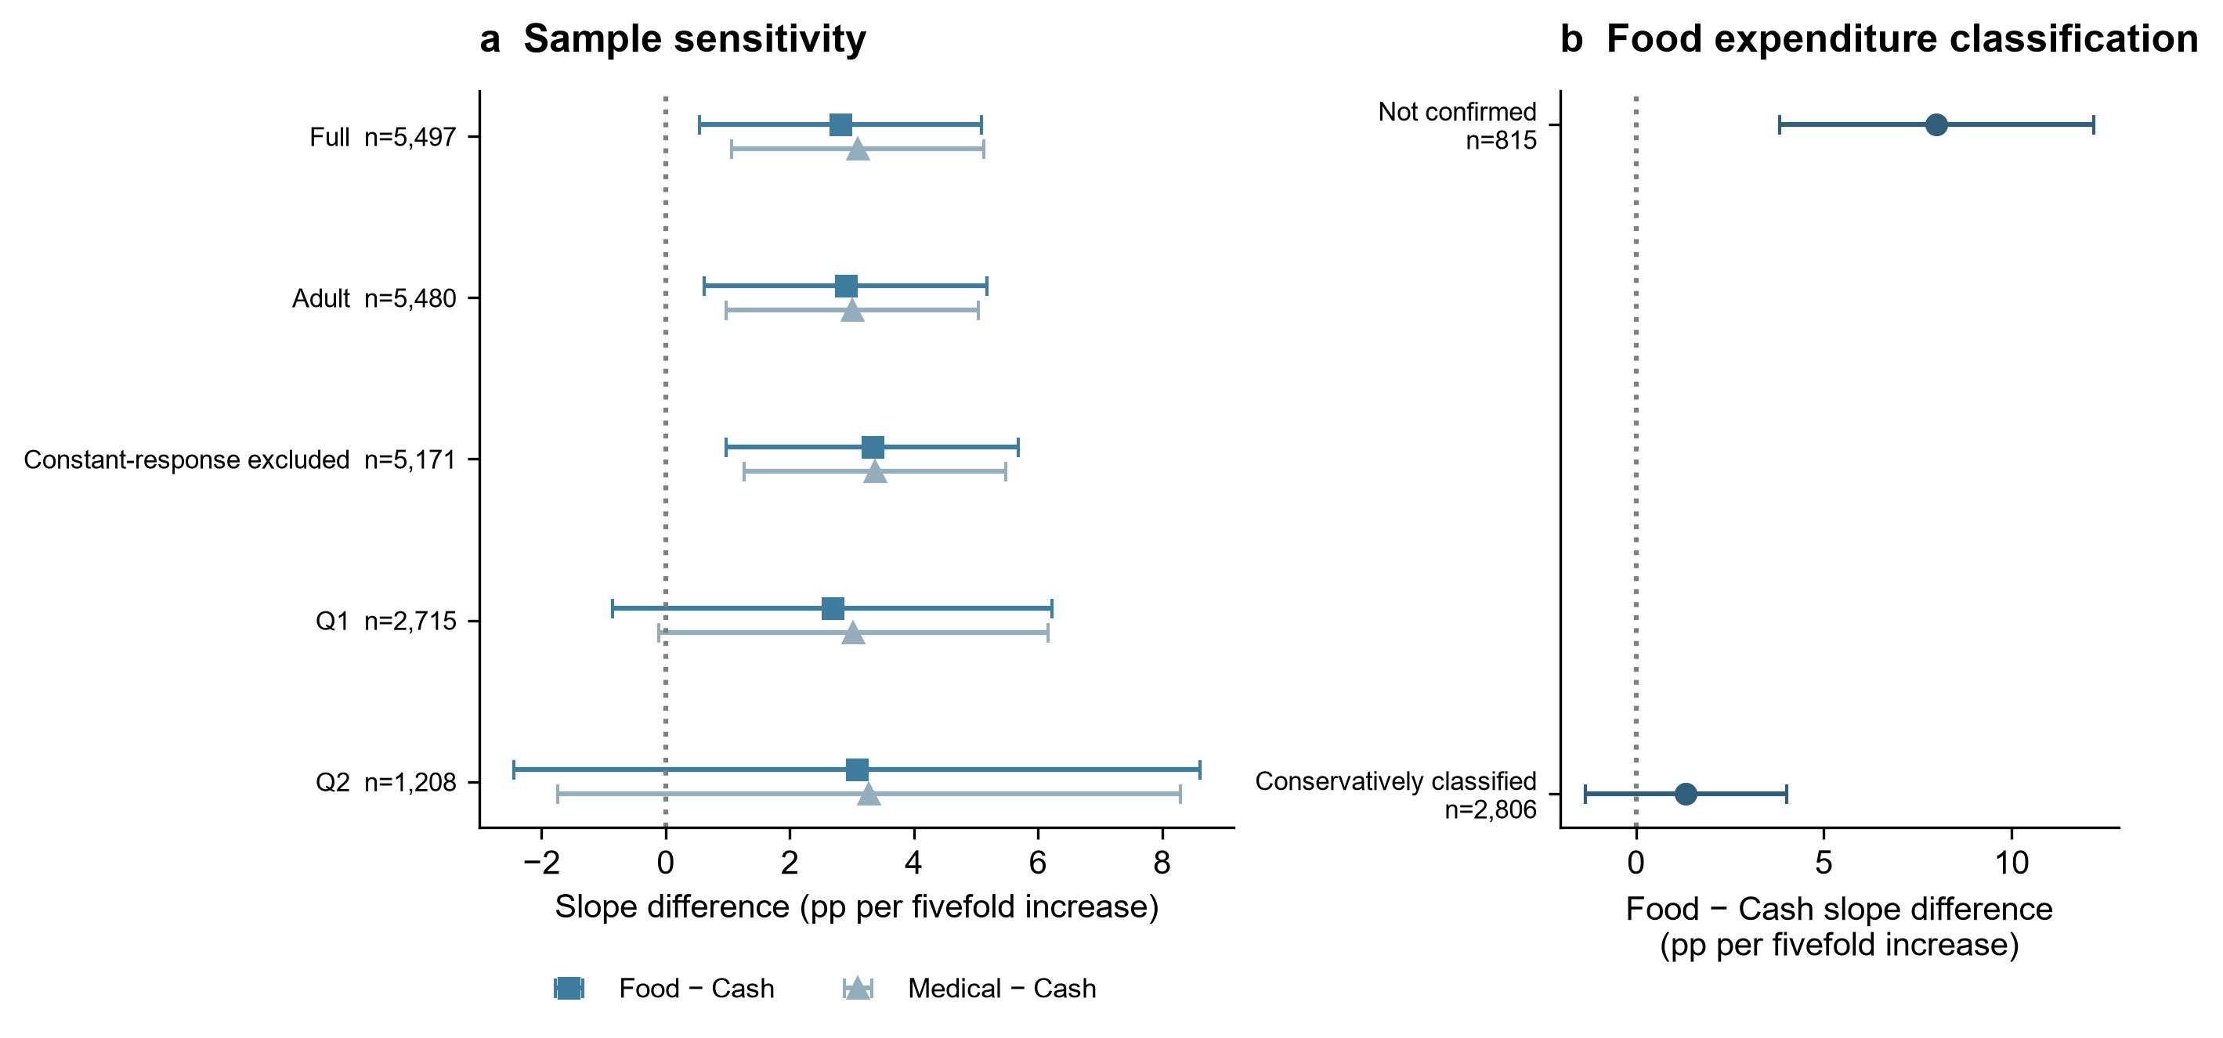
Figure 3. Sample sensitivity and food-expenditure classification. a, Food–Cash and Medical–Cash slope differences per fivefold amount increase across the full, adult, constant-response-excluded, Q1 and Q2 samples. The samples overlap; the figure is not a sequence of independent replications. b, Food–Cash slope differences among Cash/Food adults whose six-month lower-bound food expenditure exceeds RMB 5,000 and the remaining adults. Classification assumes stable expenditure and comparable eligible purchases. Not confirmed does not mean binding. All bars are pointwise 95% HC3 intervals. The direct between-group triple-interaction test has nominal P=0.0084 and Holm-7 P=0.0504. Source: figure3a_source.csv and mechanism_details.csv.

