**ADMIN PANEL**

* **Login Form**

Please add validations and password icon for eye.

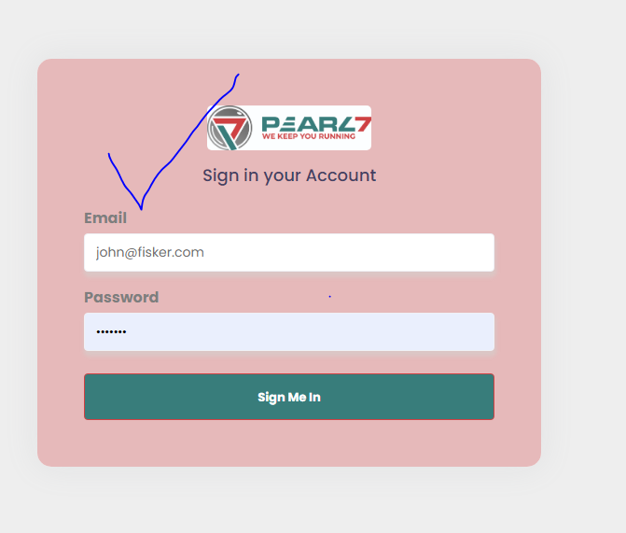

* **Dashboard**

Subscribe is doing

Newsletter

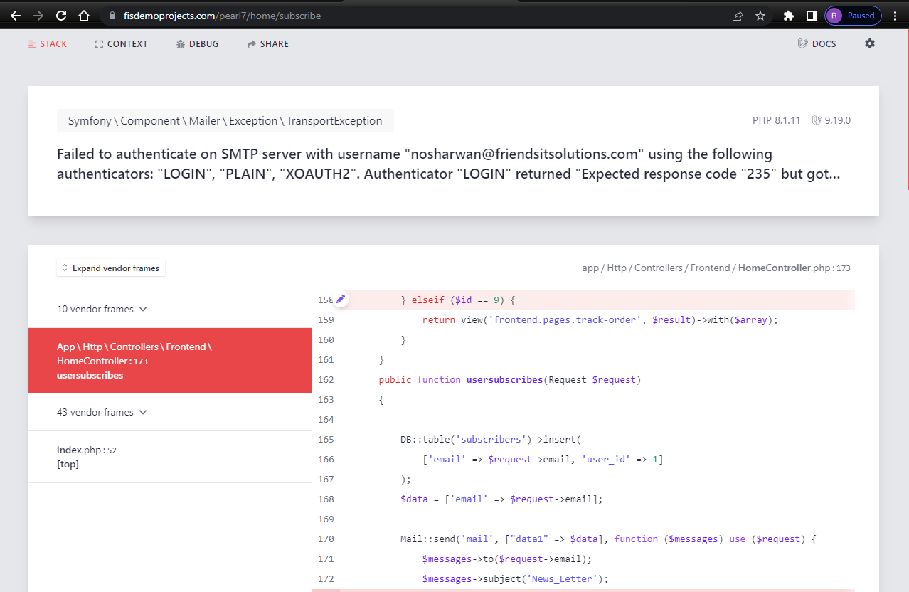

* **Contact Us**

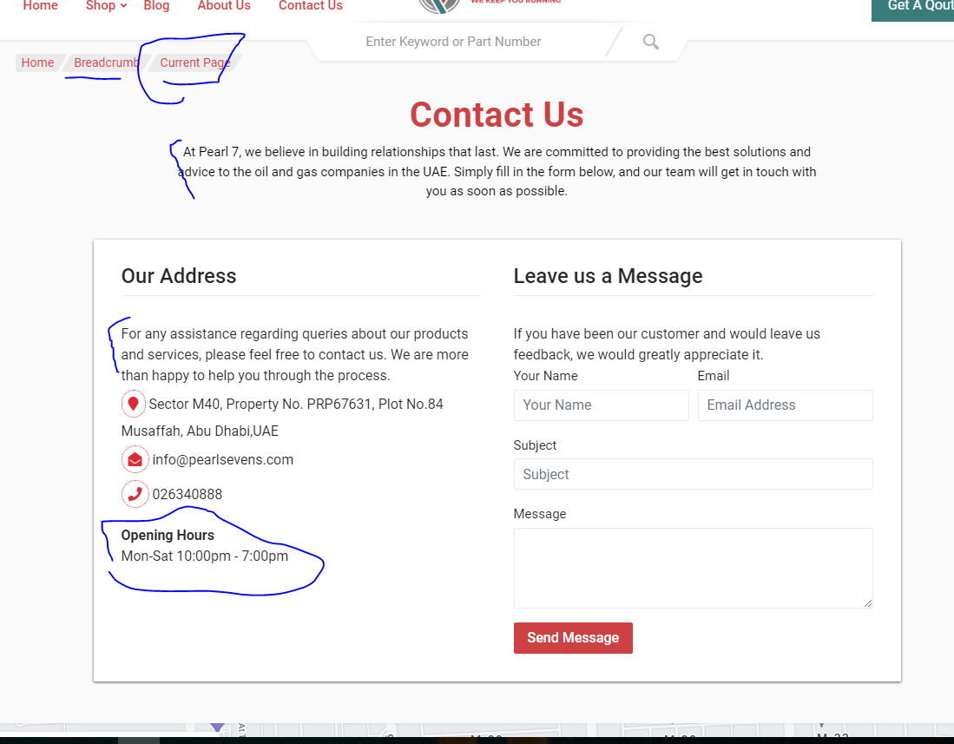

**General Setting:**