**Committee:**

1. **Category:**

When we delete category its sub-category won’t delete

1. **Category List:**

Title is not dynamic / remove title field

In Edit Image not updating

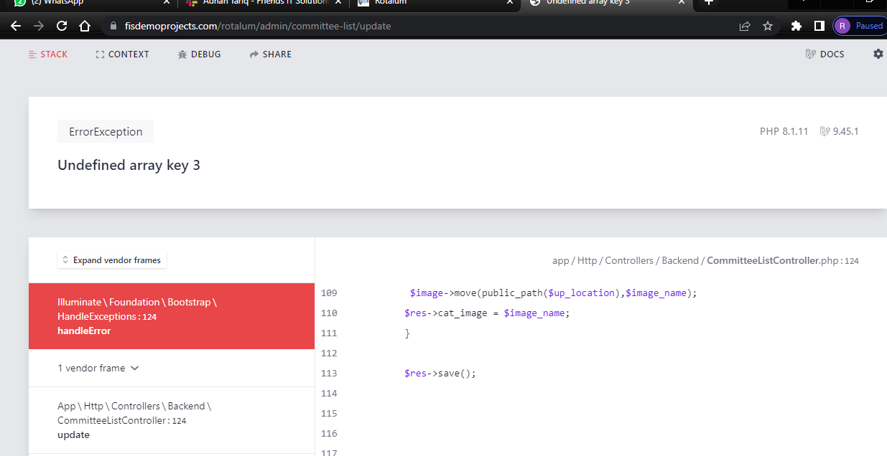

And also if we want to remove some list in list there’s not no option of delete member.

Add Validation if sub-category record is already present

**Contact Form:**

Remove contact form text.

Update button text i.e., update

In contact form page remove Add button

When we go to contact in setting it directly go to contact form.

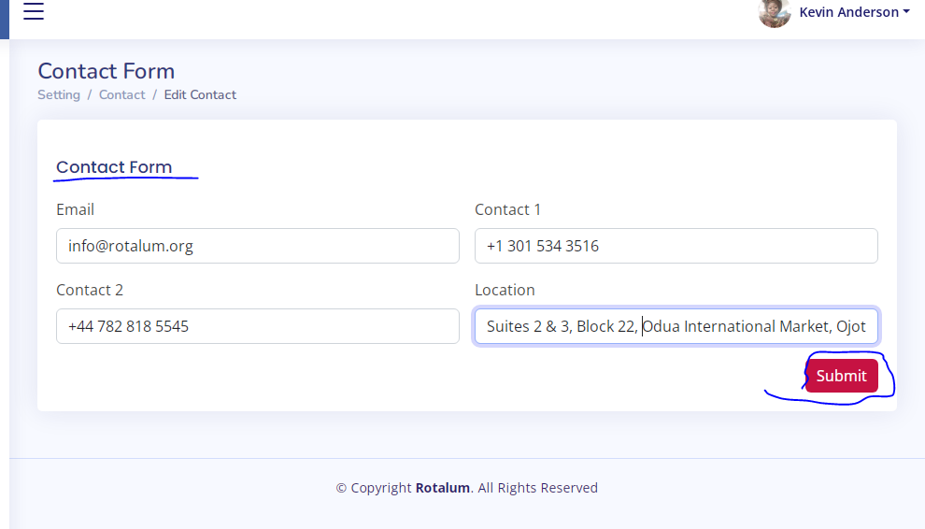

**Members Area:**

Edit Profile / change password not working it gives 404 error.

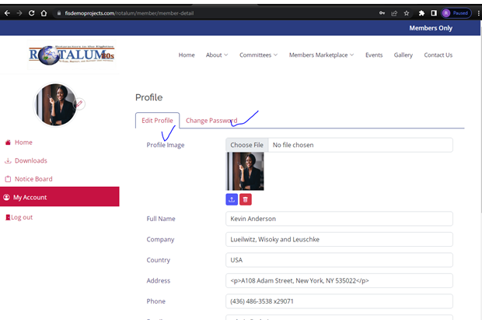

**About us:**

**North America executive committee;**

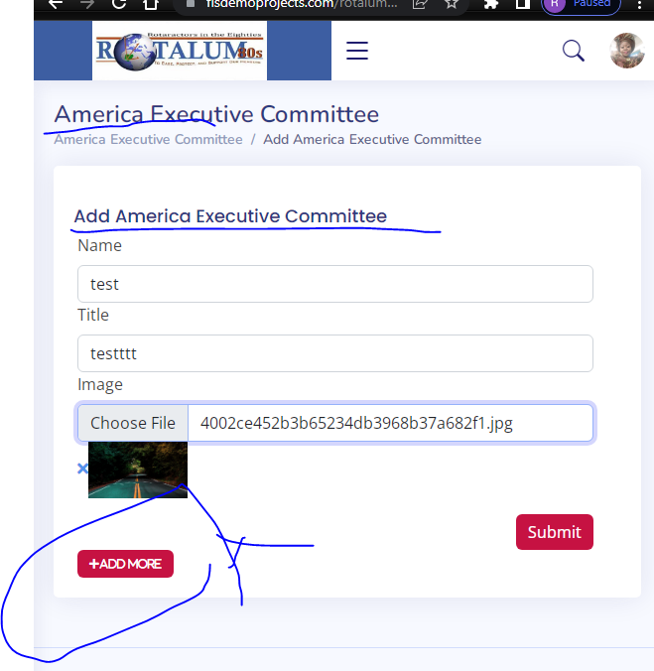

Remove this Add more button

Add North America

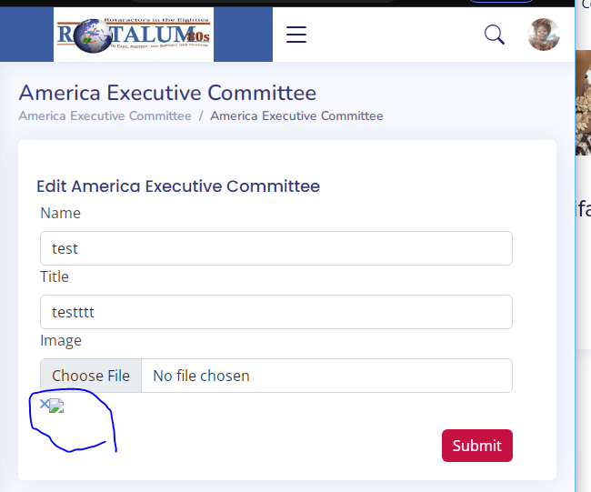

Edit:

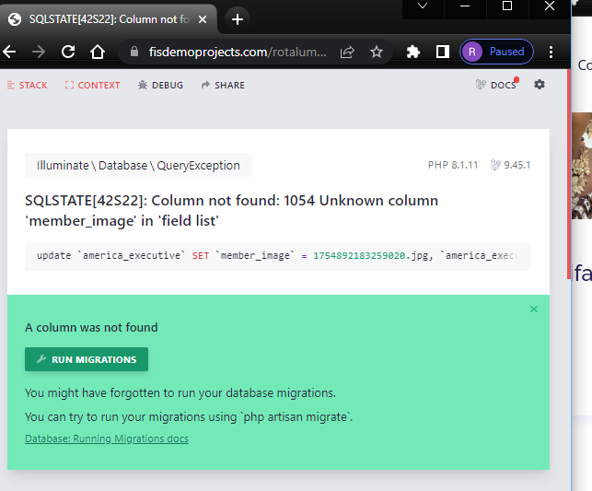

**Europe Executive Committee:**

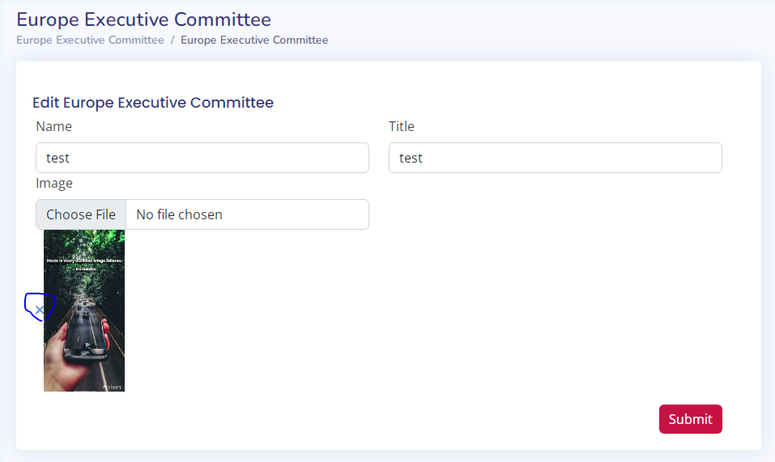

Edit:



Global Committee:

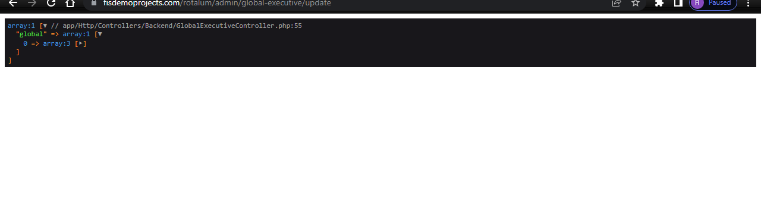

**Board of trustees:**

