[UNIVERSITY LOGO]
[Name of University]
Department of [Computer Science / Software Engineering]
MEDISYNIX
An AI-Powered Medical Assistant
Final Year Project Report (FYP-1)
Development Project
Submitted by
Student Name | Roll Number
[Student Name 1] | [Roll No. 1]
[Student Name 2] | [Roll No. 2]
[Student Name 3] | [Roll No. 3]

Supervised by
[Supervisor Name], [Designation]
Session [20XX – 20XX]
September 2026

Declaration
We hereby declare that this project report, titled "Medisynix: An AI-Powered Medical Assistant", is our own work and has not been submitted, in whole or in part, for any other degree or qualification at this or any other institution. The work described here was carried out by us under the supervision of [Supervisor Name]. All sources of information and all third-party tools and services used in this project have been acknowledged and cited in the text and listed in the references.
We also declare that the AI features described in this report are intended for informational and educational purposes only. They do not provide medical diagnosis or treatment and are not a substitute for consultation with a qualified healthcare professional.
Signature: ______________________ [Student Name 1] ([Roll No. 1])
Signature: ______________________ [Student Name 2] ([Roll No. 2])
Signature: ______________________ [Student Name 3] ([Roll No. 3])
Certificate of Approval
It is certified that the Final Year Project (FYP-1) report titled "Medisynix: An AI-Powered Medical Assistant", submitted by [Student Name 1], [Student Name 2] and [Student Name 3], has been examined and found satisfactory in scope and quality for the partial fulfilment of the requirements of the degree of Bachelor of Science in [Computer Science / Software Engineering].
______________________________ ______________________________
Supervisor FYP Coordinator
[Supervisor Name] [Coordinator Name]
______________________________ ______________________________
External Examiner Head of Department
[Examiner Name] [HoD Name]
Acknowledgement
First of all, we are grateful to Allah Almighty for giving us the strength and patience to complete this work.
We would like to thank our supervisor, [Supervisor Name], for their guidance throughout this project. Their questions during our review meetings often showed us gaps we had not noticed, and their insistence on safety and honesty in anything related to health shaped the way Medisynix handles AI advice.
We are also thankful to the faculty of the Department of [Computer Science / Software Engineering] for the knowledge and skills that made this project possible, and to the FYP committee for their feedback.
We thank the family members, friends and healthcare workers who gave their time to talk to us about how they look for medical information and what they would expect from a tool like this. Their answers influenced many of our design decisions.
Finally, we thank our parents for their constant support, encouragement and patience during the long nights of coding and writing.
Abstract
Patients in Pakistan often turn to general web searches or informal advice when they have a health question, and the answers they find are not always reliable or relevant to the hospitals they actually use. Practical information, such as which services a hospital offers or how to book an appointment, is also spread across many sources. Medisynix is a web-based medical assistance platform that addresses this problem by combining a knowledge-grounded AI assistant with a personal health profile and everyday care-management tools.
The platform supports three roles: patients, doctors and administrators. Its central feature is an AI Doctor built on Chatbase and grounded in the publicly available information of Aga Khan University Hospital and Al Shifa Hospital. It is offered in two modes: a General AI Doctor for anonymous questions and a Personal AI Doctor that works alongside the patient's saved health profile. Around the assistant, Medisynix provides secure registration and login with role-based access, a health profile with automatic Body Mass Index calculation, a dashboard with status indicators for vital signs, appointment booking and management, medication tracking, medical record storage, a doctor directory and dashboards for doctors and administrators. The system is built with Next.js, React and Tailwind CSS on the front end, Next.js API routes on Node.js on the back end, and MongoDB Atlas for storage, with a local fallback store for resilience. Sessions are protected with JSON Web Tokens and passwords with bcrypt.
The project follows an incremental development model. At the end of FYP-1 the core platform, authentication and the AI Doctor are working, and about 30 % of the planned implementation is complete. The system was tested at unit, integration, acceptance and security level: 14 of 14 unit tests, 40 of 41 API integration tests, 18 of 19 acceptance tests and 39 of 39 security regression tests passed. A security review against the OWASP Top 10 found access-control and configuration weaknesses, all of which were fixed and verified. The remaining functional defects and the planned work for FYP-2 are documented in this report.
Keywords: AI medical assistant, healthcare chatbot, retrieval-augmented generation, Chatbase, Next.js, MongoDB, patient health record, e-health.
Table of Contents
Chapter 1: Introduction
1.1 Introduction
1.2 Problem Statement
1.3 Proposed Solution
1.4 Main Objectives
1.5 Assumptions & Constraints
1.5.1 Assumptions
1.5.2 Constraints
1.6 Project Scope
1.7 Software Development Life Cycle Model
1.8 Report Organization
Chapter 2: Requirements Analysis
2.1 Literature Review / Related Work
2.1.1 Conversational agents in healthcare
2.1.2 Symptom checkers and triage tools
2.1.3 Large language models in medicine
2.1.4 Retrieval-augmented and knowledge-grounded assistants
2.1.5 Digital health platforms in Pakistan
2.1.6 Comparison and research gap
2.2 Stakeholders List
2.3 Requirements Elicitation
2.4 Functional Requirements
2.5 Non-functional Requirements
2.6 Requirements Traceability Matrix
2.7 Use Case Descriptions
Chapter 3: System Design
3.1 Use Case Design
3.2 Activity Diagram
3.2.1 Login and role-based redirection
3.2.2 AI Doctor consultation
3.2.3 Appointment management
3.2.4 Health profile update
3.3 Sequence Diagram
3.3.1 User login
3.3.2 Personal AI Doctor session
3.3.3 Health profile update
3.3.4 Password reset
3.4 Software Architecture Diagram
3.4.1 Deployment view
3.4.2 Data flow
3.5 Class Diagram
3.6 Database Diagram
3.7 Collaboration Diagram
3.8 User Interface Design
Chapter 4: System Testing
4.1 Test Cases Design
4.2 Unit / Integration / Acceptance Testing
4.2.1 Unit testing
4.2.2 Integration testing
4.2.3 Performance observations
4.2.4 Acceptance testing
4.3 Security Testing
4.4 Defect Log
4.5 Test Summary
Chapter 5: Implementation (30 %)
5.1 Work Breakdown Structure (WBS)
5.2 Team Roles and Responsibilities
5.3 Tools and Technologies
5.4 Implementation Details
5.4.1 Project structure and code base
5.4.2 Authentication and session management
5.4.3 AI Doctor integration
5.4.4 Guide assistant with model fallback
5.4.5 Health profile, BMI and metrics history
5.4.6 Dashboard health signal
5.4.7 Appointments and the fallback data store
5.4.8 Password reset
5.4.9 Doctor and administrator dashboards
5.5 Screenshots of Prototype / System
5.5.1 Public pages
5.5.2 Patient module
5.5.3 Doctor and administrator modules
5.6 Challenges During Implementation
5.7 Progress Summary and Plan for FYP-2
Chapter 6: References
List of Figures
Figure 1.1. Context view of the proposed Medisynix solution
Figure 1.2. Incremental development model followed for Medisynix
Figure 2.1. Distribution of functional requirements by MoSCoW priority
Figure 3.1. Use case diagram of Medisynix
Figure 3.2. Activity diagram for login and role-based redirection
Figure 3.3. Activity diagram for an AI Doctor consultation
Figure 3.4. Activity diagram for appointment management
Figure 3.5. Activity diagram for updating the health profile
Figure 3.6. Sequence diagram for user login
Figure 3.7. Sequence diagram for a Personal AI Doctor session
Figure 3.8. Sequence diagram for updating the health profile
Figure 3.9. Sequence diagram for forgotten password and reset
Figure 3.10. Software architecture of Medisynix
Figure 3.11. Deployment diagram
Figure 3.12. Level-1 data flow diagram (patient processes)
Figure 3.13. Class diagram of Medisynix
Figure 3.14. Database diagram (entity relationship view of MongoDB collections)
Figure 3.15. Collaboration diagram for booking an appointment
Figure 3.16. Collaboration diagram for a Personal AI Doctor session
Figure 4.1. Integration test results by module
Figure 4.2. Median response times measured on a local production build
Figure 5.1. Work breakdown structure of Medisynix
Figure 5.2. Estimated effort distribution across WBS work packages
Figure 5.3. Project schedule (Gantt chart)
Figure 5.4. Lines of code by top-level folder
Figure 5.5. Tracked files by type
Figure 5.6. Number of REST endpoints per functional area
Figure 5.7. Repository activity by commit day (lines added and removed, log scale)
Figure 5.8. Landing page: hero section
Figure 5.9. Landing page: features section
Figure 5.10. Landing page: "How it works" and live assistant
Figure 5.11. Login page
Figure 5.12. Registration page
Figure 5.13. Forgot password page
Figure 5.14. Patient dashboard
Figure 5.15. Patient health profile
Figure 5.16. AI Doctor selection page
Figure 5.17. General AI Doctor page
Figure 5.18. General AI Doctor answering a question about AKUH cardiology services
Figure 5.19. Personal AI Doctor page with health profile banner
Figure 5.20. Personal AI Doctor giving safety-conscious guidance for a patient with asthma
Figure 5.21. Symptom checker results
Figure 5.22. Find a Doctor page
Figure 5.23. Doctor profile page
Figure 5.24. My Appointments page
Figure 5.25. Medications page with reminders
Figure 5.26. Medical records page
Figure 5.27. Upload medical report page
Figure 5.28. Doctor workspace
Figure 5.29. Doctor: upload patient medical report
Figure 5.30. Doctor profile page
Figure 5.31. Administrator dashboard
Figure 5.32. Status of planned features at the end of FYP-1
List of Tables
Table 1.1. Project scope of Medisynix
Table 1.2. Comparison of SDLC models considered
Table 2.1. Feature comparison of related systems
Table 2.2. Stakeholders of Medisynix
Table 2.3. Key needs identified during elicitation
Table 2.4. Functional requirements
Table 2.5. Non-functional requirements
Table 2.6. Requirements traceability matrix
Table 2.7. Use case description: UC-01 Register Account
Table 2.8. Use case description: UC-02 Login and Role-based Redirection
Table 2.9. Use case description: UC-03 Reset Forgotten Password
Table 2.10. Use case description: UC-04 Consult General AI Doctor
Table 2.11. Use case description: UC-05 Consult Personal AI Doctor
Table 2.12. Use case description: UC-07 Manage Health Profile
Table 2.13. Use case description: UC-08 Book and Manage Appointment
Table 2.14. Use case description: UC-15 View Platform Statistics
Table 3.1. Actors of the system
Table 3.2. Class responsibilities
Table 3.3. Data dictionary: users collection
Table 3.4. Data dictionary: healthmetrics collection
Table 3.5. Data dictionary: appointments collection
Table 3.6. Data dictionary: medical_records and medications collection
Table 4.1. Test case template with a worked example (TC-15)
Table 4.2. Unit test cases and results
Table 4.3. API integration test cases and results
Table 4.4. Acceptance test cases and results
Table 4.5. Security regression tests and results
Table 4.6. Defect log at the end of FYP-1
Table 4.7. Summary of test results
Table 5.1. Team roles and responsibilities
Table 5.2. Tools and technologies used
Table 5.3. Main folders of the code base
Table 5.4. Reference ranges used for dashboard status badges
Table 5.5. Work planned for FYP-2
List of Abbreviations
AI | Artificial Intelligence
AKUH | Aga Khan University Hospital
API | Application Programming Interface
BMI | Body Mass Index
CDP | Chrome DevTools Protocol
CRUD | Create, Read, Update, Delete
CSS | Cascading Style Sheets
DFD | Data Flow Diagram
ERD | Entity Relationship Diagram
FR | Functional Requirement
FYP | Final Year Project
HTTP(S) | Hypertext Transfer Protocol (Secure)
JSON | JavaScript Object Notation
JWT | JSON Web Token
KB | Knowledge Base
LLM | Large Language Model
MoSCoW | Must have, Should have, Could have, Won't have
NFR | Non-functional Requirement
RAG | Retrieval-Augmented Generation
REST | Representational State Transfer
RTM | Requirements Traceability Matrix
SDLC | Software Development Life Cycle
UI / UX | User Interface / User Experience
UML | Unified Modeling Language
WBS | Work Breakdown Structure

Introduction

Introduction
Most people in Pakistan do not start their healthcare journey in a clinic. They start it on a phone. Someone wakes up with a fever that will not go down, or a parent notices a rash on a child, and the first thing they do is search online, ask a relative on WhatsApp, or call whoever in the family "knows about medicine". The answers they get are a mix of good advice, outdated advice and the occasional scare story. Even simple practical questions, such as which hospital has a cardiology clinic, what the visiting hours are, or how to book an appointment, often take several phone calls to settle.
At the same time, the tools available to ordinary patients have changed a great deal in the last few years. Large language models can now hold a sensible conversation about symptoms, explain a lab result in plain words and point a person towards the right kind of care [1], [2]. Hospitals publish more information online than ever before. What is missing is a single place where a patient can ask a question, get an answer that is grounded in trustworthy hospital information, keep a record of their own health data and then take the next step, whether that is booking an appointment or simply knowing when to go to the emergency room.
Medisynix is our attempt to build that place. It is a web-based medical assistance platform developed as our Final Year Project (FYP). The platform has three kinds of users, namely patients, doctors and administrators, and it brings together an AI medical assistant, a personal health profile, appointment booking, medication tracking, medical record storage and simple health analytics. The AI assistant is powered by Chatbase and has been configured around the publicly available information of two well-known hospitals, Aga Khan University Hospital (AKUH) in Karachi and Al Shifa Hospital. Instead of answering from the open internet, the assistant answers from a curated knowledge base, which makes its replies more specific and easier to verify.
The platform offers two modes of AI consultation. The General AI Doctor answers anonymous, one-off questions without touching any personal data. The Personal AI Doctor is linked to the patient's saved health profile (age, gender, conditions, medications and allergies) so the guidance can take that context into account. Around these two assistants we built the rest of the patient experience: a dashboard that summarises vital signs with clear status badges, a health profile that calculates Body Mass Index (BMI) automatically, an appointment module with booking, rescheduling and cancellation, and pages for medications, records and consultations. Doctors get a workspace and a report upload tool, and administrators get a dashboard with platform statistics.
This report covers the first phase of the project (FYP-1). In this phase we gathered requirements, designed the system, built the core platform and the AI assistant integration, and tested what we had built. Roughly a third of the planned implementation is complete and working. The rest, including real AI analysis of uploaded reports, a fully functional doctor workspace and administrative user management, is planned for FYP-2 and is described honestly throughout this report so that the reader can see exactly where the project stands.

Problem Statement
Patients who need basic medical guidance or hospital-specific information face three connected problems.
Unreliable information. General web searches return results that are not tailored to the patient and are often written for a different country and health system. Popular symptom checkers are known to vary widely in accuracy [3], [4], and general-purpose chatbots can produce confident but wrong answers, a problem usually called hallucination [5]. A worried patient has no easy way to tell which answer to trust.
Scattered hospital information. Details such as which departments a hospital runs, how to find a specialist, and where to book an appointment are spread across hospital websites, social media pages and phone lines. For a patient who is already unwell, finding this information is tiring and slow.
No personal context. Existing chat tools treat every conversation as if it were the first. A patient with asthma, a known penicillin allergy or a long-term medication has to repeat that history every time, and if they forget to mention it the advice they receive may not fit their situation. At the same time, there is rarely a simple place where patients can keep their own vital signs, medications, appointments and reports together.
In short, there is no single, easy-to-use platform that combines trustworthy, hospital-grounded AI guidance with a patient's own health profile and the practical tools needed to act on that guidance.

Proposed Solution
We propose Medisynix, a responsive web application that gives each type of user a dedicated space and places a knowledge-grounded AI assistant at the centre of the patient experience. The solution is built on Next.js and React for the interface and server-side API routes, MongoDB for persistent storage, JSON Web Tokens (JWT) for session management, and Chatbase for the conversational AI. Figure 1.1 shows how the main parts of the solution relate to each other.
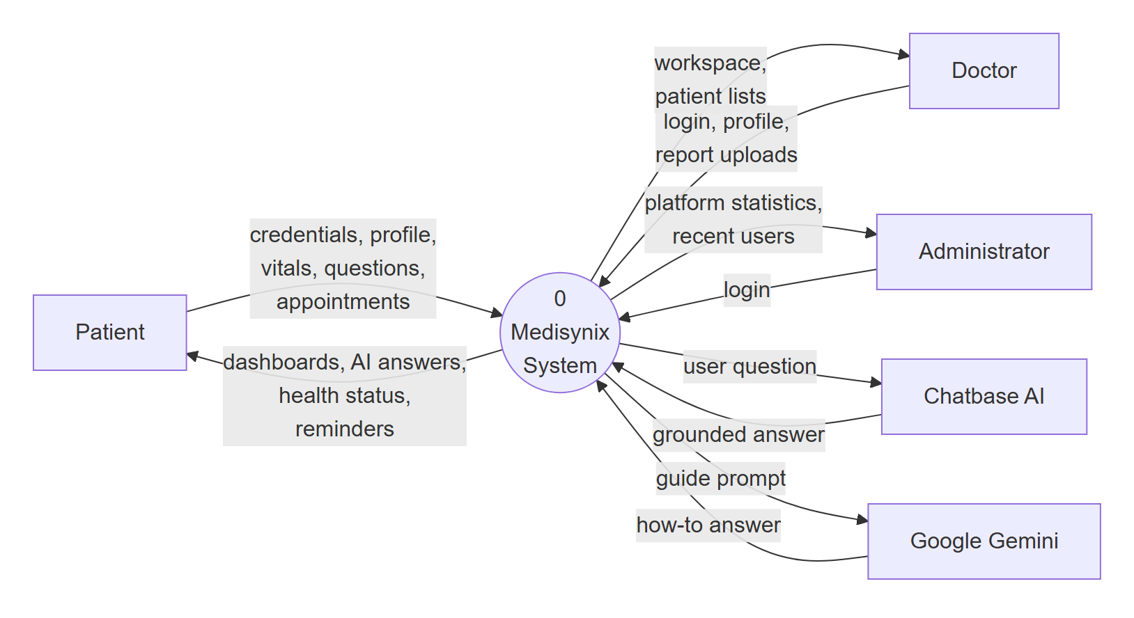
Figure 1.1. Context view of the proposed Medisynix solution
The main components of the proposed solution are listed below.
- AI Doctor (General and Personal). Two Chatbase agents trained on AKUH and Al Shifa Hospital content. The General AI Doctor keeps no personal data. The Personal AI Doctor opens a short-lived session token and shows the patient's saved health profile next to the chat, so that relevant details can be taken into account.
- Role-based accounts. Patients can register themselves. Doctors and administrators use accounts created by the platform. After login the user is sent to the dashboard for their role, and pages belonging to other roles are blocked.
- Health profile and dashboard. Patients record height, weight, blood pressure, heart rate, glucose level, allergies, conditions and medications. The system calculates BMI and shows each vital sign with a simple status such as Normal, Elevated or High, together with a short rule-based "health signal" that explains how it was reached.
- Care management tools. Appointment booking with reschedule and cancel options, a medication list with daily reminders, medical record upload and listing, consultation history and a doctor directory.
- Doctor and administrator dashboards. A clinician workspace and a report upload tool for doctors, and a statistics dashboard for administrators.
- Resilient data layer. When the MongoDB cluster cannot be reached, key features such as login, appointments and health metrics fall back to a local JSON store so the platform stays usable during development and demonstrations.

Main Objectives
The objectives we set out in our proposal, and which guided the work in FYP-1, are as follows.
- To design and develop a web-based medical assistance platform with separate, protected areas for patients, doctors and administrators.
- To integrate a conversational AI assistant whose answers are grounded in a curated knowledge base of AKUH and Al Shifa Hospital information, rather than in open web content.
- To offer both an anonymous General AI Doctor and a Personal AI Doctor that uses the patient's saved health profile.
- To allow patients to record and monitor their vital signs, with automatic BMI calculation and easy-to-read status indicators.
- To provide practical care tools: appointment booking and management, medication tracking, and medical record storage.
- To secure user accounts using hashed passwords, token-based sessions and role-based access to pages and API routes.
- To show clear medical disclaimers everywhere AI guidance appears, so that users understand the assistant is not a replacement for a qualified doctor.
- To test the platform at unit, integration and acceptance level and document the results, including known defects, for completion in FYP-2.

Assumptions & Constraints

Assumptions
- Users have a device with a modern web browser (Chrome, Edge, Firefox or Safari) and a reasonably stable internet connection.
- Users can read English. The interface and the AI assistant currently work in English only.
- The information published by AKUH and Al Shifa Hospital, which was used to build the Chatbase knowledge base, is accurate at the time it was collected.
- Patients enter their own health data honestly. The system does not verify vital signs against any medical device.
- Third-party services (Chatbase, MongoDB Atlas, Vercel and Google Gemini) remain available on their free or student tiers for the duration of the project.
- Doctor and administrator accounts are created by the project team rather than through public sign-up.

Constraints
- Medical and legal constraint. Medisynix is an academic project. It must not diagnose conditions or prescribe medication, and every AI screen must carry a disclaimer.
- Budget. The project has no budget for paid APIs, so we rely on free tiers. This limits the number of AI messages per month and the size of the knowledge base.
- Time. FYP-1 covers roughly one semester. Features were prioritised using MoSCoW so that the most important ones were built first.
- Data access. We have no access to real hospital systems or patient records. All clinical data in the system is either entered by test users or is sample data.
- Team size and skills. The team is small, so we chose a single JavaScript stack (React, Next.js, Node.js) to avoid switching between languages.
- Third-party control. The behaviour of the Chatbase agents depends on Chatbase's own models and settings, which we can configure but not fully control.

Project Scope
Table 1.1 summarises what is inside and what is outside the scope of Medisynix. The scope was agreed with our supervisor at the proposal stage and adjusted slightly during development, mainly when we moved the AI assistant from a direct Gemini integration to Chatbase.
Table 1.1. Project scope of Medisynix
In Scope | Out of Scope
Web application for patients, doctors and administrators | Native Android or iOS applications
General and Personal AI Doctor using Chatbase, grounded in AKUH and Al Shifa Hospital information | Formal medical diagnosis, prescriptions or treatment plans
Patient registration, login, logout and password reset | Integration with real hospital information systems (HIS / EMR)
Health profile with vitals, BMI calculation and medical history | Connection to wearable devices or medical sensors
Appointment booking, rescheduling and cancellation | Online payment for consultations
Medication list, reminders and medical record listing | Video or audio consultations with doctors
Patient dashboard with health status indicators and analytics | Insurance claims and billing
Doctor workspace and administrator statistics dashboard | Languages other than English (planned as a future improvement)
Rule-based symptom checker and guide assistant | Certification under medical device regulations

Software Development Life Cycle Model
We followed an Incremental model [6] with short, Agile-style review cycles inside each increment. The overall requirements were collected at the start, then the system was split into increments that could each be designed, built, tested and shown to our supervisor before moving on. Figure 1.2 shows the increments we planned.
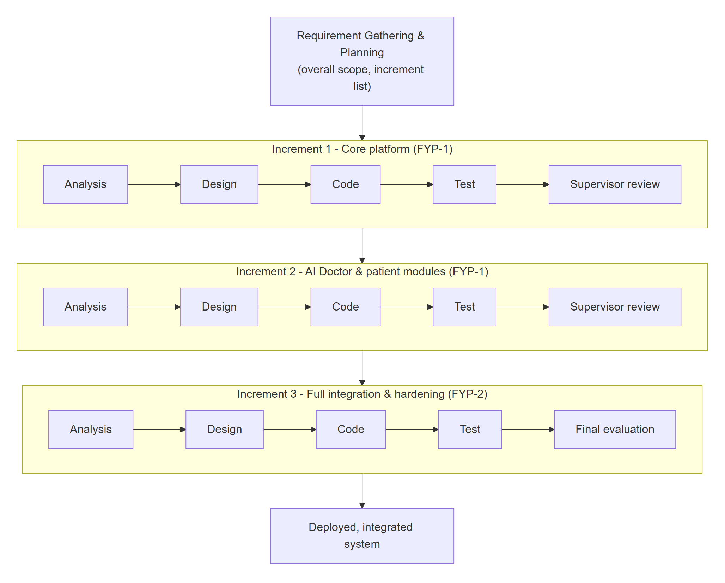
Figure 1.2. Incremental development model followed for Medisynix
We considered the Waterfall, Spiral and pure Scrum models before settling on this approach. Table 1.2 compares them against the needs of our project.
Table 1.2. Comparison of SDLC models considered
Criterion | Waterfall | Spiral | Scrum | Incremental (chosen)
Handles changing requirements | Poorly | Well | Very well | Well
Working software early | No | Partly | Yes | Yes
Fits university milestones (FYP-1 / FYP-2) | Partly | Partly | Needs adapting | Yes
Documentation overhead | High | High | Low | Moderate
Risk handling | Late | Strong | Moderate | Moderate
Suits a small student team | Yes | No | Partly | Yes

The incremental model suited us for three reasons. First, the university divides the project into two evaluated phases, and increments map naturally onto them. Second, our biggest technical risk was the AI assistant, and splitting the work let us try an approach, learn from it and change direction. This is exactly what happened: our first increment called the Google Gemini API directly, but problems with API keys, rate limits and response quality led us to move the medical assistant to Chatbase in the second increment. Third, each increment produced something we could demonstrate, which made supervisor meetings far more useful than showing only documents.
Within each increment we worked in one-to-two week cycles. At the start of a cycle we picked a small set of features from the backlog. At the end we tested them, merged them into the main branch on GitHub and noted anything that needed to be carried over.

Report Organization
The remainder of this report is organised as follows. Chapter 2 reviews related work and presents the requirements, including stakeholders, functional and non-functional requirements, the traceability matrix and detailed use case descriptions. Chapter 3 presents the system design through UML diagrams, the software architecture and the database design. Chapter 4 explains how the system was tested and reports the results. Chapter 5 describes the implementation, including the work breakdown, team roles, tools, key implementation details, screenshots of the working system and the challenges we faced. The report closes with the list of references.

Requirements Analysis
This chapter describes the groundwork behind Medisynix. We first review existing research and products in the area of AI-assisted healthcare, then identify the people who have a stake in the system, explain how requirements were gathered, and finally list the functional and non-functional requirements together with their traceability and the detailed use cases.

Literature Review / Related Work
Before writing any code we spent several weeks reading about healthcare chatbots, symptom checkers and large language models in medicine, and trying out the health apps that people around us actually use. This section summarises what we learned and how it shaped the design of Medisynix.

Conversational agents in healthcare
Conversational agents are not new to healthcare. Laranjo et al. [7] carried out a systematic review of conversational agents used in health and found that most early systems were rule-based or relied on fixed dialogue trees. Patients generally found them easy to use, but the studies were small and very few evaluated safety in a rigorous way. The review also pointed out that agents that allow unconstrained natural language input carry more risk, because the system may misunderstand what the user meant.
Doctors themselves have mixed views. In a survey of 100 physicians, Palanica et al. [8] found that most believed chatbots could help with simple administrative tasks such as scheduling appointments, finding clinic locations and giving medication reminders. They were much less comfortable with chatbots handling complex medical questions or emotional support, and many worried that patients might self-diagnose incorrectly. This was an important lesson for us. It pushed Medisynix towards hospital information, navigation and general guidance, and away from anything that looks like a diagnosis.

Symptom checkers and triage tools
Online symptom checkers are one of the most widely used forms of digital health advice. Semigran et al. [3] audited 23 symptom checkers using 45 standard patient vignettes. The correct diagnosis was listed first in only about a third of cases, although triage advice (whether to seek care, and how urgently) was appropriate more often. A later study by Gilbert et al. [4] compared eight popular apps with general practitioners using 200 clinical vignettes and found large differences between apps; the best performer, Ada, came close to the doctors on condition coverage, while several others fell well short. Commercial systems such as Babylon's triage tool [9] and Ada [10] combine a structured question flow with a probabilistic medical knowledge model.
Two points from this work influenced us. First, even well-funded symptom checkers are far from perfect, so a student project must not present its output as a diagnosis. Our symptom checker is therefore clearly labelled as a simple rule-based tool with a prominent disclaimer. Second, accurate triage (knowing when to see a doctor) is often more useful to a patient than naming the exact condition, which is why our assistant and dashboard focus on next steps and warning signs.

Large language models in medicine
Large language models (LLMs) changed the picture quickly. Singhal et al. [1] showed that a medically tuned LLM (Med-PaLM) could reach a passing score on questions in the style of the US Medical Licensing Examination, and that its long-form answers were rated much closer to clinician answers than those of a general model. Lee, Bubeck and Petro [2] described both the promise and the risks of GPT-4 as a medical chatbot, noting that it can write clear explanations and draft clinical notes, but also that it can make subtle errors that sound convincing. Ayers et al. [11] compared chatbot and physician replies to real patient questions posted on a public forum; evaluators preferred the chatbot answers in most cases, rating them as both higher in quality and more empathetic.
The main weakness of LLMs is hallucination, where the model produces fluent text that is not supported by facts. Ji et al. [5] surveyed this problem across natural language generation tasks and showed that it is common and hard to detect. In medicine a hallucinated answer can be harmful, so any system that uses an LLM needs a way to keep answers grounded.

Retrieval-augmented and knowledge-grounded assistants
Retrieval-augmented generation (RAG), introduced by Lewis et al. [12], addresses hallucination by first retrieving relevant passages from a trusted document collection and then asking the model to generate an answer based on those passages. Answers become more specific and can be traced back to their source, and the knowledge can be updated simply by changing the documents rather than retraining the model.
Chatbase [13] is a hosted platform built on this idea. A developer uploads documents or website links, Chatbase indexes them, and an embeddable chatbot answers questions using that content with an underlying LLM. We chose Chatbase for Medisynix because it gave us a knowledge-grounded assistant without the cost of hosting our own vector database and model, and because it can be embedded directly in a web page. The knowledge base for our two agents was built from the public pages of Aga Khan University Hospital [14] and Al Shifa Hospital. We still use Google's Gemini API [15] for the smaller guide assistant that explains how to use the platform.

Digital health platforms in Pakistan
In Pakistan, several platforms already help patients find and book doctors. Marham [16] and oladoc [17] let patients search doctors by specialty and city, read reviews and book in-clinic or online consultations. Sehat Kahani [18] connects patients with female doctors through video consultations, which also creates work for women doctors who are not practising in clinics. These platforms are strong on doctor discovery and booking, but they do not offer an AI assistant grounded in specific hospital information, and they do not give the patient a personal health dashboard that feeds into AI guidance. The World Health Organization's global digital health strategy [19] encourages exactly this kind of patient-centred digital service, provided that privacy, safety and equity are handled carefully.

Comparison and research gap
Table 2.1 compares Medisynix with the systems discussed above on the features that matter most for our target users.
Table 2.1. Feature comparison of related systems
Feature | Ada | Babylon | Marham | oladoc | Sehat Kahani | General chatbot | Medisynix
AI health conversation | Yes | Yes | No | No | No | Yes | Yes
Answers grounded in local hospital data | No | No | No | No | No | No | Yes
Uses personal health profile | Partly | Yes | No | No | Partly | No | Yes
Doctor search | No | Yes | Yes | Yes | Yes | No | Yes
Appointment booking | No | Yes | Yes | Yes | Yes | No | Yes
Vitals dashboard with status | No | Partly | No | No | No | No | Yes
Medication tracking | No | Partly | No | No | No | No | Yes
Focus on Pakistani users | No | No | Yes | Yes | Yes | No | Yes
Free for patients | Yes | No | Partly | Partly | No | Partly | Yes

The gap we identified is the combination of three things in one place: an AI assistant that answers from the information of specific local hospitals rather than the open web, a personal health profile that the assistant can use, and the everyday tools (appointments, medications, records) that let a patient act on what they have learned. None of the systems we reviewed offers all three for Pakistani patients. Medisynix does not try to compete with the clinical depth of Ada or the doctor networks of Marham and oladoc. It focuses on trustworthy, hospital-specific guidance and a simple, connected patient experience.

Stakeholders List
We identified the stakeholders listed in Table 2.2. Primary stakeholders use the system directly; secondary stakeholders are affected by it or provide services it depends on.
Table 2.2. Stakeholders of Medisynix
Stakeholder | Type | Role / Interest | Main Expectations
Patients | Primary | Main users of the platform. Ask health questions, manage their profile, book appointments and track medications. | Clear and trustworthy answers, ease of use, privacy of their health data.
Doctors | Primary | Use the clinician workspace and report upload tools. Receive appointment requests. | Well-prepared patients, organised appointment lists, minimal extra admin work.
Administrators | Primary | Monitor the platform, users and overall activity. | Accurate statistics, control over accounts and system health.
Hospitals (AKUH, Al Shifa) | Secondary | Source of the information in the AI knowledge base. | Their information is represented correctly and patients are directed to official channels.
Project supervisor | Secondary | Guides the team and evaluates progress. | Sound engineering process, complete documentation, working demonstrations.
FYP evaluation committee | Secondary | Assesses the project at mid and final evaluations. | Clear problem definition, meaningful contribution, quality of the report and system.
Development team | Primary (builders) | Design, implement, test and document the system. | Achievable scope, reliable tools and services, timely feedback.
Service providers (Chatbase, MongoDB Atlas, Vercel, Google) | Secondary | Provide the AI, database, hosting and guide-assistant services. | Use of their services within terms and free-tier limits.

Requirements Elicitation
Requirements were gathered over roughly five weeks using several complementary techniques. No single technique gives a full picture, so we combined them and cross-checked the results.
- Informal interviews. We spoke with family members, classmates and people who regularly visit hospitals for chronic conditions. We asked how they currently look for health information, what frustrates them and what they would want from an assistant. A recurring theme was distrust of general internet answers, combined with a willingness to trust information that came from a hospital they already knew.
- Conversations with healthcare workers. We had short, informal conversations with healthcare professionals known to team members. Their message was consistent: an assistant should help patients prepare for a visit and understand next steps, but must not pretend to diagnose. This became requirement FR-11 and non-functional requirement NFR-12.
- Study of existing systems. We used Marham, oladoc, Ada and a general-purpose chatbot as ordinary users and noted what worked well and what was missing (see Table 2.1).
- Document analysis. We read the public websites of AKUH and Al Shifa Hospital to understand what information patients most often need, such as departments, services, doctor search and visiting information. These pages later formed the Chatbase knowledge base.
- Brainstorming and prototyping. Within the team we sketched the dashboards, then built quick prototypes of the patient dashboard and AI Doctor selection screen and showed them to our supervisor. Feedback from these reviews shaped details such as the two-mode AI Doctor selection and the health profile banner on the Personal AI Doctor page.
Table 2.3 summarises the main needs that came out of elicitation and the requirements they led to.
Table 2.3. Key needs identified during elicitation
Need expressed by stakeholders | Source | Resulting requirement(s)
Answers that can be trusted, preferably from a known hospital | Patient interviews | FR-10, NFR-12
Not having to repeat one's medical history in every conversation | Patient interviews | FR-09, FR-14
An assistant must support, not replace, the doctor | Doctors and nurse | FR-11, NFR-12
A quick way to see whether one's readings are normal | Patients with chronic conditions | FR-15, FR-16, FR-18
Easy booking and medication reminders | Patients, study of Marham/oladoc | FR-19, FR-20, FR-21
Keeping reports and records in one place | Patients | FR-22, FR-25
An overview of platform usage | Supervisor feedback | FR-30
Privacy when asking quick, anonymous questions | Patients | FR-08, NFR-04

Each requirement was then given a priority using the MoSCoW method (Must have, Should have, Could have, Won't have in this phase). Figure 2.1 shows how the functional requirements are spread across these priorities. Must-have requirements were built first, which is why the core platform and AI Doctor are the most complete parts of the system at the end of FYP-1.
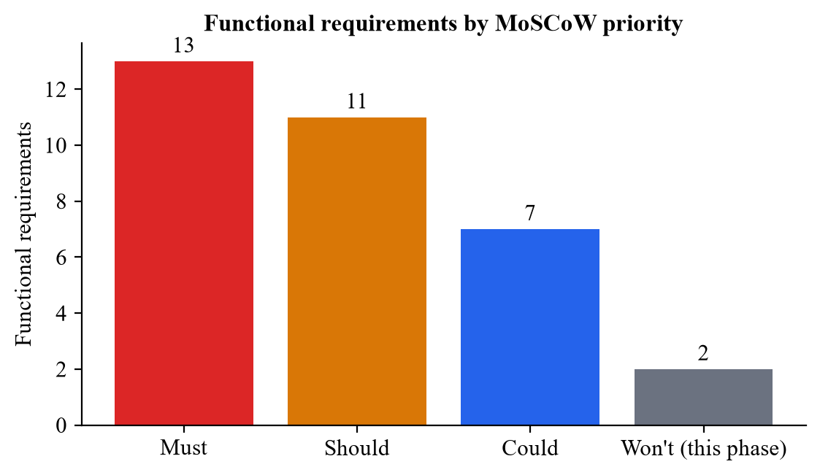
Figure 2.1. Distribution of functional requirements by MoSCoW priority

Functional Requirements
The functional requirements of Medisynix are listed in Table 2.4. They are grouped by module and numbered so that they can be traced to use cases, design artefacts and test cases.
Table 2.4. Functional requirements
ID | Module | Requirement | Priority
FR-01 | Accounts | The system shall allow a patient to register with first name, last name, email, password, password confirmation and acceptance of the terms. | Must
FR-02 | Accounts | The system shall enforce a password of at least 8 characters containing an uppercase letter, a lowercase letter, a digit and a special character, and shall check that both password fields match. | Must
FR-03 | Accounts | The system shall authenticate users by email, password and user type, and redirect them to the dashboard of their role. | Must
FR-04 | Accounts | The system shall allow a logged-in user to log out, which removes the stored session. | Must
FR-05 | Accounts | The system shall let a user request a password reset; it shall create a random token valid for one hour and always reply with the same generic message. | Should
FR-06 | Accounts | The system shall let a user set a new password (minimum 8 characters) using a valid, unexpired reset token. | Should
FR-07 | Accounts | The system shall block access to dashboards of other roles and send unauthenticated users to the login page. | Must
FR-08 | AI Doctor | The system shall provide a General AI Doctor chat that answers health questions without using any personal data and allows the user to start a new chat. | Must
FR-09 | AI Doctor | The system shall provide a Personal AI Doctor that opens a one-hour session token and displays the patient's saved health profile beside the chat. | Must
FR-10 | AI Doctor | The AI Doctor shall answer from a knowledge base built from Aga Khan University Hospital and Al Shifa Hospital information. | Must
FR-11 | AI Doctor | Every AI screen shall display a medical disclaimer and advise users to contact emergency services in an emergency. | Must
FR-12 | AI Doctor | The system shall provide a guide assistant that answers questions about how to use the platform and redirects medical questions to the AI Doctor. | Could
FR-13 | AI Doctor | The system shall provide a symptom checker that accepts comma-separated symptoms and lists possible conditions ranked by match percentage. | Could
FR-14 | Health Profile | The system shall allow a patient to view and edit personal information (name, phone, date of birth, gender, blood type) and medical history (allergies, conditions, medications). | Must
FR-15 | Health Profile | The system shall allow a patient to record height, weight, blood pressure, heart rate and glucose level. | Must
FR-16 | Health Profile | The system shall calculate BMI from height and weight and classify it as Underweight, Normal weight, Overweight or Obese. | Should
FR-17 | Health Profile | The system shall keep a history of health metric entries and return the ten most recent. | Should
FR-18 | Dashboard | The patient dashboard shall show each vital sign with a status badge and a rule-based health signal that explains how it was reached. | Should
FR-19 | Appointments | The system shall allow a patient to book an appointment by choosing a doctor, a date not earlier than today, a time slot and a reason. | Must
FR-20 | Appointments | The system shall let a patient reschedule or cancel an appointment and view appointments under Upcoming, Past and Cancelled tabs. | Should
FR-21 | Medications | The system shall let a patient add a medication (name, dosage, frequency, prescriber, start and end date, instructions), show current and past medications, and list today's reminders. | Should
FR-22 | Records | The system shall let a patient add a medical record (title, type, date, provider, findings, file) and search and filter the list of records. | Should
FR-23 | Records | The system shall display a patient's consultation history with diagnosis, prescription and follow-up details. | Could
FR-24 | Doctors | The system shall let a patient search doctors by name, specialty and city, and view a doctor's profile. | Should
FR-25 | Reports | The system shall let a patient upload a medical image or lab report and receive a plain-language explanation with a confidence indicator. | Could
FR-26 | Analytics | The system shall show the patient charts of assistant usage, query categories and clinic visits. | Could
FR-27 | Doctor | The system shall provide doctors with a workspace listing today's appointments, new patient requests and flagged items. | Should
FR-28 | Doctor | The system shall allow a doctor to upload a report for a selected patient. | Could
FR-29 | Doctor | The system shall allow a doctor to view and edit professional profile details. | Should
FR-30 | Admin | The system shall show administrators the total users, doctors, patients and consultations, plus recently registered users, refreshed every 60 seconds. | Must
FR-31 | Admin | The system shall allow an administrator to view and edit their profile. | Could
FR-32 | Admin | The system shall allow an administrator to create, edit and deactivate user accounts. | Won't (FYP-2)
FR-33 | Messaging | The system shall allow patients to exchange messages with their doctors. | Won't (FYP-2)

Non-functional Requirements
The non-functional requirements in Table 2.5 describe the qualities the system must have rather than specific functions. Some of these, such as security and safety, were among the most discussed topics in our supervisor meetings, because a health application that leaks data or gives dangerous advice would be worse than no application at all.
Table 2.5. Non-functional requirements
ID | Category | Requirement
NFR-01 | Usability | A new patient should reach the AI Doctor from the dashboard in no more than two clicks. All pages must remain usable on screens down to 360 px wide.
NFR-02 | Performance | Non-AI API requests should respond in under 500 ms (median) when the database is reachable. Public pages should render in under 3 seconds on a normal broadband connection.
NFR-03 | Security | Passwords must be stored only as bcrypt hashes (cost factor 10). Sessions use signed JWTs that expire (7 days for login, 1 hour for AI Doctor sessions). Reset tokens are stored as SHA-256 hashes and expire after one hour.
NFR-04 | Privacy | The General AI Doctor must not send or store personal data. Secrets (database URI, JWT secret, API keys) must be kept in environment variables and never committed to the repository.
NFR-05 | Availability | Login, appointments, health metrics and administrator statistics must keep working with a local fallback store if the database is unreachable.
NFR-06 | Reliability | Invalid input must return a clear 4xx response instead of crashing the server; malformed JSON must be handled gracefully.
NFR-07 | Maintainability | Code is organised by feature (app, components, lib, models, pages/api). A single JavaScript stack is used for the front end and back end.
NFR-08 | Portability | The application must run on Windows, macOS and Linux with Node.js and deploy to Vercel without code changes.
NFR-09 | Scalability | API routes are stateless so that more serverless instances can be added. MongoDB Atlas can be scaled independently.
NFR-10 | Compatibility | The platform must work on the latest two versions of Chrome, Edge, Firefox and Safari.
NFR-11 | Accessibility | Form fields must have visible labels, text must keep sufficient contrast, and interactive elements must be reachable by keyboard.
NFR-12 | Safety & Ethics | The AI must not give definitive diagnoses or medication doses, must encourage professional consultation and must point to emergency services for urgent symptoms.
NFR-13 | Legal | Only test or sample data may be used during development; no real patient health information is to be stored.

Requirements Traceability Matrix
The traceability matrix in Table 2.6 links each functional requirement to the use case that realises it, the main source files that implement it, and the test cases that verify it. Test case identifiers beginning with UT are unit tests, TC are API integration tests and AT are acceptance tests (see Chapter 4). A dash means that the requirement has not yet been implemented or tested and is carried forward to FYP-2.
Table 2.6. Requirements traceability matrix
FR | Use Case | Implementation (main files) | Test Cases | Status
FR-01 | UC-01 | RegisterForm.jsx, pages/api/auth/register.js | TC-05, UT-08 | Done
FR-02 | UC-01 | RegisterForm.jsx, models/User.js | UT-01, UT-02 | Done
FR-03 | UC-02 | LoginForm.jsx, pages/api/auth/login.js, AuthContext.jsx | TC-06, TC-07, UT-11–13, AT-02 | Done
FR-04 | UC-02 | AuthContext.jsx, DashboardLayout.jsx | AT-19 | Done
FR-05 | UC-03 | app/api/auth/forgot-password/route.js | TC-08, TC-09, AT-04 | Done
FR-06 | UC-03 | app/api/auth/reset-password/route.js | TC-10, TC-11 | Done
FR-07 | UC-02 | AuthContext.jsx, DashboardLayout.jsx, lib/jwt.js | AT-18, ST-05–15 | Done
FR-08 | UC-04 | ai-doctor/general/page.jsx, api/doctor/init | TC-12, TC-13, AT-07 | Done
FR-09 | UC-05 | ai-doctor/personal/page.jsx, api/doctor/health-data | TC-14, TC-15, AT-08 | Done
FR-10 | UC-04, UC-05 | Chatbase agents (external configuration) | AT-07, AT-08 | Done
FR-11 | UC-04, UC-05 | AI Doctor pages, Disclaimer.jsx | AT-06, AT-07 | Done
FR-12 | UC-04 | app/api/guide/route.js | TC-17, TC-18, TC-19 | Partial
FR-13 | UC-06 | symptom-checker/page.jsx | AT-09 | Done
FR-14 | UC-07 | patient/profile/page.jsx, api/patient/update-profile | TC-27 | Done
FR-15 | UC-07 | patient/profile/page.jsx, models/HealthMetric.js | TC-30, TC-31 | Done
FR-16 | UC-07 | api/patient/update-profile/route.js | AT-05 | Done
FR-17 | UC-07 | pages/api/patient/get-health-metrics.js | TC-31 | Done
FR-18 | UC-12 | PatientDashboardContent.jsx | AT-05 | Done
FR-19 | UC-08 | patient/appointments/page.jsx, api/patient/appointments | TC-28, UT-14, AT-12 | Done
FR-20 | UC-08 | patient/appointments/page.jsx | TC-29, AT-12 | Partial
FR-21 | UC-09 | patient/medications/page.jsx, api/patient/medications | TC-25 | Partial
FR-22 | UC-10 | patient/upload, patient/records, api/patient/*-record | TC-20–TC-24 | Partial
FR-23 | UC-10 | patient/consultations/page.jsx, api/patient/consultations | TC-26 | Partial
FR-24 | UC-11 | find-doctor/page.jsx, doctor/[id]/page.jsx, api/doctors | TC-01–TC-04, AT-10, AT-11 | Done
FR-25 | UC-13 | patient/upload-report/page.jsx | AT-14 | Prototype
FR-26 | UC-12 | patient/analytics/page.jsx | AT-13 | Defect
FR-27 | UC-14 | DoctorDashboardContent.jsx | AT-15 | Prototype
FR-28 | UC-13 | doctor/upload-report/page.jsx | AT-16 | Prototype
FR-29 | UC-14 | doctor/profile/page.jsx | – | Partial
FR-30 | UC-15 | AdminDashboardContent.jsx, api/admin/dashboard-stats | TC-32, TC-33, UT-06, UT-07, AT-17, ST-05–07 | Done
FR-31 | UC-15 | admin/profile/page.jsx | – | Partial
FR-32 | – | – | – | FYP-2
FR-33 | – | patient/chat/page.jsx (UI only) | – | FYP-2

Use Case Descriptions
This section gives fully dressed descriptions of the most important use cases. The complete set of use cases and actors is shown in the use case diagram in Chapter 3 (Figure 3.1). To keep the chapter readable we describe in full the use cases that carry the most business logic; the remaining ones follow the same pattern.
Table 2.7. Use case description: UC-01 Register Account
Use Case ID | UC-01
Use Case Name | Register Account
Primary Actor | Patient
Secondary Actor(s) | None
Description | A new patient creates an account so that they can use the personal features of Medisynix.
Trigger | The visitor clicks "Get started" or "Create a new account".
Pre-conditions | The visitor is not logged in. The email address is not already registered.
Post-conditions | A patient account exists with a bcrypt-hashed password, a session token is issued and the patient is taken to the patient dashboard.
Normal Flow | 1. Visitor opens the registration page.  2. System shows fields for first name, last name, email, password, confirm password, user type and a terms checkbox.  3. Visitor fills in the form and ticks the terms checkbox.  4. System validates the fields in the browser (email format, password strength, matching passwords).  5. System sends the data to POST /api/auth/register.  6. Server checks that the user type is patient and that the email is not already used.  7. Server saves the user; the password is hashed before saving.  8. Server returns a JWT and user details.  9. System stores the session and redirects to the patient dashboard.
Alternative / Exception Flows | 4a. Validation fails: the relevant error message is shown and the form is not submitted.  6a. User type is doctor or admin: server returns 403 "Only patient registration is allowed".  6b. Email already registered: server returns 409 and the message is shown.  7a. Database unavailable: the account is saved in the local fallback store instead.
Related Requirements | FR-01, FR-02, NFR-03
Priority | High

Table 2.8. Use case description: UC-02 Login and Role-based Redirection
Use Case ID | UC-02
Use Case Name | Login and Role-based Redirection
Primary Actor | Patient, Doctor, Administrator
Secondary Actor(s) | None
Description | A registered user signs in and is taken to the dashboard for their role.
Trigger | The user clicks "Log in".
Pre-conditions | The user has an account.
Post-conditions | A valid session (JWT) is stored in the browser and the user sees their own dashboard.
Normal Flow | 1. User opens the login page.  2. User enters email and password and selects the user type.  3. System sends POST /api/auth/login.  4. Server finds the user by email and checks that the user type matches.  5. Server compares the password with the stored bcrypt hash.  6. Server returns a token valid for 7 days and the user's name and role.  7. AuthContext saves the session and redirects to /dashboard/patient, /dashboard/doctor or /dashboard/admin.
Alternative / Exception Flows | 4a. No user with this email, or wrong user type: 401 "Invalid credentials".  5a. Wrong password: 401 "Invalid credentials" (the same message, so attackers cannot tell which part was wrong).  4b. Database unavailable: server checks the static demo accounts instead.  7a. User later opens a dashboard of another role: they are redirected back to their own dashboard.
Related Requirements | FR-03, FR-04, FR-07
Priority | High

Table 2.9. Use case description: UC-03 Reset Forgotten Password
Use Case ID | UC-03
Use Case Name | Reset Forgotten Password
Primary Actor | Patient, Doctor, Administrator
Secondary Actor(s) | Email service (planned)
Description | A user who has forgotten their password sets a new one using a time-limited link.
Trigger | The user clicks "Forgot password?" on the login page.
Pre-conditions | The user knows the email address of their account.
Post-conditions | The password is replaced with a new bcrypt hash and the reset token is removed.
Normal Flow | 1. User enters email and account type on the Forgot Password page.  2. System sends POST /api/auth/forgot-password.  3. Server generates a 32-byte random token, stores its SHA-256 hash and an expiry time one hour ahead.  4. Server returns a generic "If your email is registered…" message.  5. User opens the reset link, which contains the token and email.  6. User enters and confirms a new password of at least 8 characters.  7. System sends POST /api/auth/reset-password.  8. Server finds the user by email, hashed token and unexpired time, saves the new hashed password and deletes the token fields.  9. System shows "Password reset successful" and a link to log in.
Alternative / Exception Flows | 1a. Email or account type missing: 400 with a clear message.  3a. No such user: the same generic message is returned, so the response does not reveal which emails are registered.  8a. Token invalid or expired: 400 "Invalid or expired token".  Note: in FYP-1 the reset link is logged on the server instead of being emailed; sending the email is planned for FYP-2.
Related Requirements | FR-05, FR-06, NFR-03
Priority | Medium

Table 2.10. Use case description: UC-04 Consult General AI Doctor
Use Case ID | UC-04
Use Case Name | Consult General AI Doctor
Primary Actor | Patient
Secondary Actor(s) | Chatbase AI agent
Description | The patient asks general health or hospital questions without sharing personal data.
Trigger | The patient selects "General AI Doctor" on the AI Doctor page.
Pre-conditions | The patient is logged in.
Post-conditions | The patient has received answers; no personal data has been sent to the AI.
Normal Flow | 1. Patient opens the AI Doctor page and chooses General AI Doctor.  2. System calls POST /api/doctor/init with doctorType = general and the patient's login token.  3. Server verifies the login token and returns a signed session token valid for one hour.  4. System stores the token and opens the General AI Doctor page.  5. Page checks that the token belongs to the general mode.  6. System loads the Chatbase chat window and the disclaimer.  7. Patient types a question.  8. Chatbase answers using the AKUH and Al Shifa knowledge base.  9. Patient may continue the conversation or click "Start New Chat" to reset it.
Alternative / Exception Flows | 2a. Invalid doctor type: server returns 400.  2b. No valid login token: server returns 401.  5a. Token missing, invalid or for the other mode: patient is sent back to the selection page.  8a. Question is outside the knowledge base: the assistant says so and suggests contacting the hospital or a doctor.
Related Requirements | FR-08, FR-10, FR-11, NFR-04, NFR-12
Priority | High

Table 2.11. Use case description: UC-05 Consult Personal AI Doctor
Use Case ID | UC-05
Use Case Name | Consult Personal AI Doctor
Primary Actor | Patient
Secondary Actor(s) | Chatbase AI agent
Description | The patient consults the AI with their saved health profile shown alongside the chat.
Trigger | The patient selects "Personal AI Doctor".
Pre-conditions | The patient is logged in. Ideally the health profile has been filled in.
Post-conditions | The patient has received guidance that can take their profile into account.
Normal Flow | 1. Patient chooses Personal AI Doctor.  2. System calls POST /api/doctor/init with doctorType = personal and the patient's login token.  3. Server takes the user ID from the verified login token, creates a health record if none exists and returns a one-hour token.  4. System opens the Personal AI Doctor page and checks the token.  5. Page requests GET /api/doctor/health-data with the token.  6. Server returns the saved health data (age, gender, conditions, medications, allergies).  7. Page shows the data as a "Your Health Profile" banner and loads the Chatbase chat.  8. Patient asks a question and mentions relevant profile details.  9. Assistant replies with guidance that respects the profile and includes safety advice.
Alternative / Exception Flows | 5a. Token used for general mode: server returns 403.  6a. No health data saved: banner shows "No health data saved yet" and suggests updating the profile.  6b. Database unavailable: banner is hidden and the chat still works.
Related Requirements | FR-09, FR-10, FR-11, FR-14
Priority | High

Table 2.12. Use case description: UC-07 Manage Health Profile
Use Case ID | UC-07
Use Case Name | Manage Health Profile
Primary Actor | Patient
Secondary Actor(s) | None
Description | The patient updates personal details, vital signs and medical history.
Trigger | The patient clicks "Edit Profile" on the Health Profile page.
Pre-conditions | The patient is logged in.
Post-conditions | The user record, the AI health data and a new health metric entry are saved.
Normal Flow | 1. Patient opens Health Profile and clicks Edit Profile.  2. Patient edits personal information, height, weight, blood pressure, heart rate, glucose and medical history.  3. System calculates BMI and its category as the values are typed.  4. Patient clicks Save.  5. System sends POST /api/patient/update-profile with the session token.  6. Server verifies the token, updates the user record and upserts the health data used by the Personal AI Doctor.  7. Server inserts a new health metric entry with BMI and BMI status.  8. System calls POST /api/patient/update-health-metrics and refreshes the dashboard.  9. System shows "Profile updated successfully".
Alternative / Exception Flows | 5a. Token missing or invalid: 401 and an error message.  3a. Height or weight missing: BMI is not calculated.  6a. User not found by ID: server tries other identifiers (user ID string, email) before creating a fallback record.
Related Requirements | FR-14, FR-15, FR-16, FR-17
Priority | High

Table 2.13. Use case description: UC-08 Book and Manage Appointment
Use Case ID | UC-08
Use Case Name | Book and Manage Appointment
Primary Actor | Patient
Secondary Actor(s) | None
Description | The patient books a new appointment and can later reschedule or cancel it.
Trigger | The patient clicks "Book Appointment".
Pre-conditions | The patient is logged in.
Post-conditions | The appointment is stored with status upcoming, rescheduled or cancelled.
Normal Flow | 1. Patient opens My Appointments; the system loads existing appointments.  2. Patient clicks Book Appointment.  3. Patient selects a doctor, a date (today or later), a time slot and enters a reason.  4. System sends POST /api/patient/appointments.  5. Server saves the appointment with status "upcoming".  6. System adds it to the Upcoming tab and to the local session.  7. To reschedule, the patient chooses a new date and time and the system sends PUT with the new values.  8. To cancel, the patient confirms and the system sends PUT with status "cancelled".
Alternative / Exception Flows | 3a. Date in the past or reason empty: form does not submit.  5a. Database unavailable: appointment is saved in the fallback store.  4a. Patient ID missing: server returns 400.
Related Requirements | FR-19, FR-20
Priority | High

Table 2.14. Use case description: UC-15 View Platform Statistics
Use Case ID | UC-15
Use Case Name | View Platform Statistics
Primary Actor | Administrator
Secondary Actor(s) | None
Description | The administrator monitors the number of users by role and recent registrations.
Trigger | The administrator logs in or opens the Admin Dashboard.
Pre-conditions | The user is logged in as administrator.
Post-conditions | Current statistics are displayed and refreshed every 60 seconds.
Normal Flow | 1. Administrator opens the Admin Dashboard.  2. System sends GET /api/admin/dashboard-stats.  3. Server counts all users, doctors, patients and non-cancelled appointments.  4. Server returns the five most recently registered users.  5. System shows statistic cards and the Recent Users table.  6. Every 60 seconds the system repeats steps 2–5.
Alternative / Exception Flows | 3a. Database unavailable: statistics are calculated from the fallback store.  2a. Non-GET request: server returns 405.
Related Requirements | FR-30
Priority | Medium

System Design
With the requirements settled, we moved on to design. We wanted a design that a small team could build within a semester but that would not have to be thrown away in FYP-2. This chapter presents that design using standard UML diagrams: use cases, activity, sequence, class and collaboration diagrams. It also covers the overall software architecture and the database design. All diagrams were drawn from the code that now exists, so they describe the system as it is actually built rather than as an idealised plan.

Use Case Design
Figure 3.1 shows the use case diagram of Medisynix. There are three human actors and one external system actor. Patients have the widest set of use cases, since the platform is built mainly for them. Doctors and administrators share the login and password reset use cases and each has a dashboard and profile of their own. Chatbase appears as an external actor because the two AI Doctor use cases depend on it.
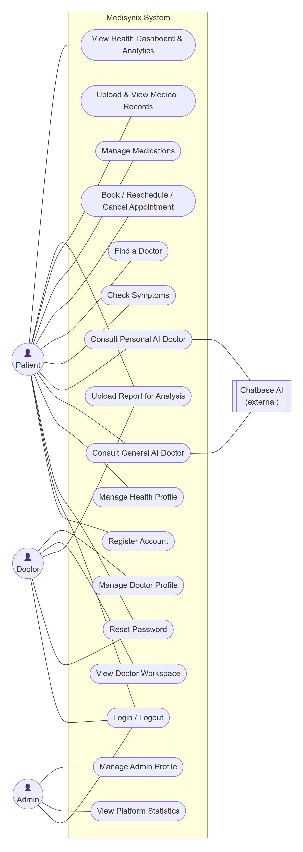
Figure 3.1. Use case diagram of Medisynix
Table 3.1 describes each actor briefly.
Table 3.1. Actors of the system
Actor | Type | Description
Patient | Primary, human | Registers on the platform, maintains a health profile, uses the AI Doctor and manages appointments, medications and records.
Doctor | Primary, human | Uses the clinician workspace to see appointments and requests, uploads reports for patients and maintains a professional profile.
Administrator | Primary, human | Monitors platform statistics and recent registrations and maintains an administrator profile.
Chatbase AI | Secondary, external system | Hosts the General and Personal AI Doctor agents and answers questions using the AKUH and Al Shifa Hospital knowledge base.

Activity Diagram
Activity diagrams show the flow of work in a process, including decisions and alternative paths. We drew activity diagrams for the four processes that contain the most decisions: logging in, consulting the AI Doctor, managing appointments and updating the health profile.

Login and role-based redirection
Figure 3.2 shows how a login request moves through the system. Two decisions are worth pointing out. The first is the database check: if MongoDB cannot be reached, the server does not simply fail but checks the local demo account store, which kept the system usable during development and demonstrations whenever the database connection was not available. The second is the final branch on user type, which sends each role to its own dashboard.
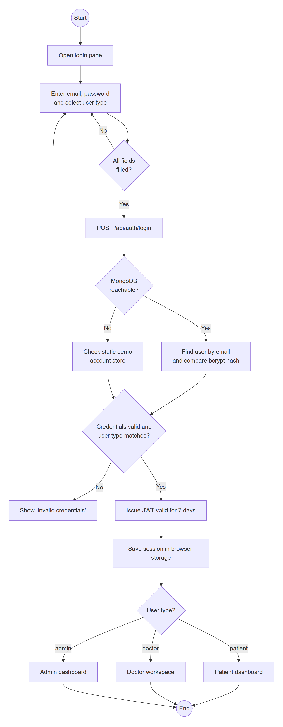
Figure 3.2. Activity diagram for login and role-based redirection

AI Doctor consultation
Figure 3.3 shows the AI Doctor process. Both modes begin with a call to the session initialisation endpoint. The personal mode additionally makes sure a health record exists and then loads the profile banner. The loop at the bottom represents an ordinary conversation, and the "Start new chat" branch reloads the chat window with a fresh session.
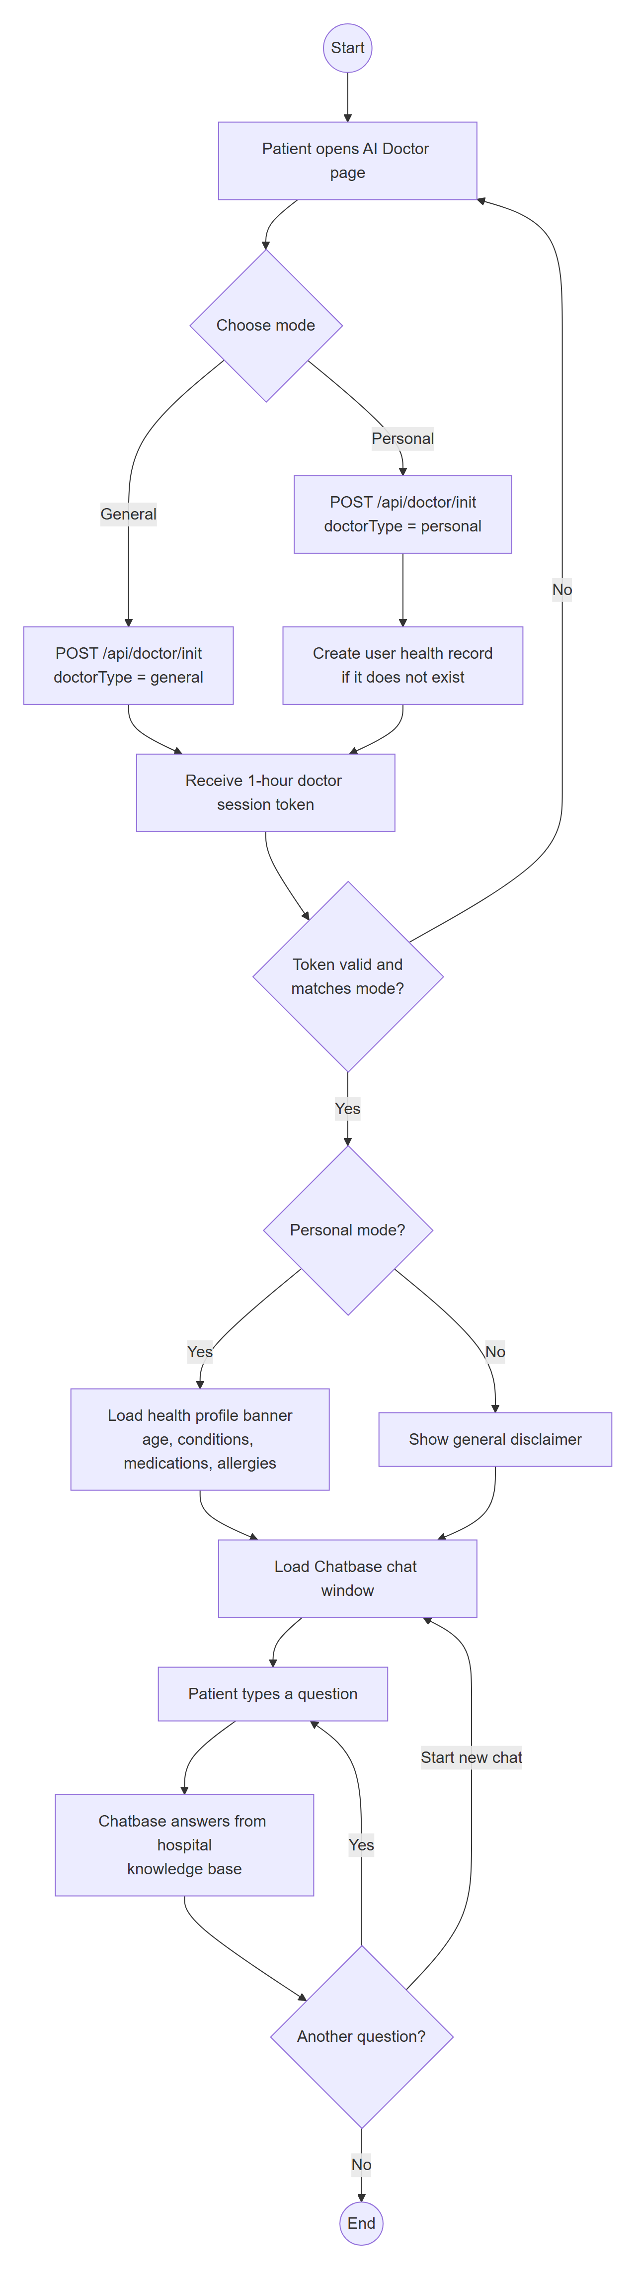
Figure 3.3. Activity diagram for an AI Doctor consultation

Appointment management
Figure 3.4 covers booking, rescheduling and cancelling appointments. The date check prevents bookings in the past. All three actions end by updating both the list on screen and the copy of the appointments kept in the user's local session, so the dashboard stays in sync.
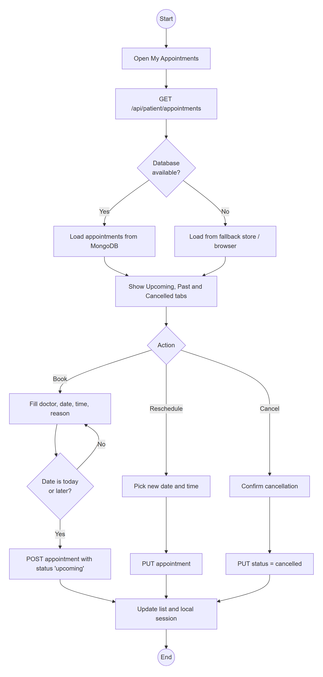
Figure 3.4. Activity diagram for appointment management

Health profile update
Figure 3.5 shows what happens when a patient saves their profile. A single save updates three places: the main user record, the health data used by the Personal AI Doctor, and the time-stamped history of health metrics that feeds the dashboard.
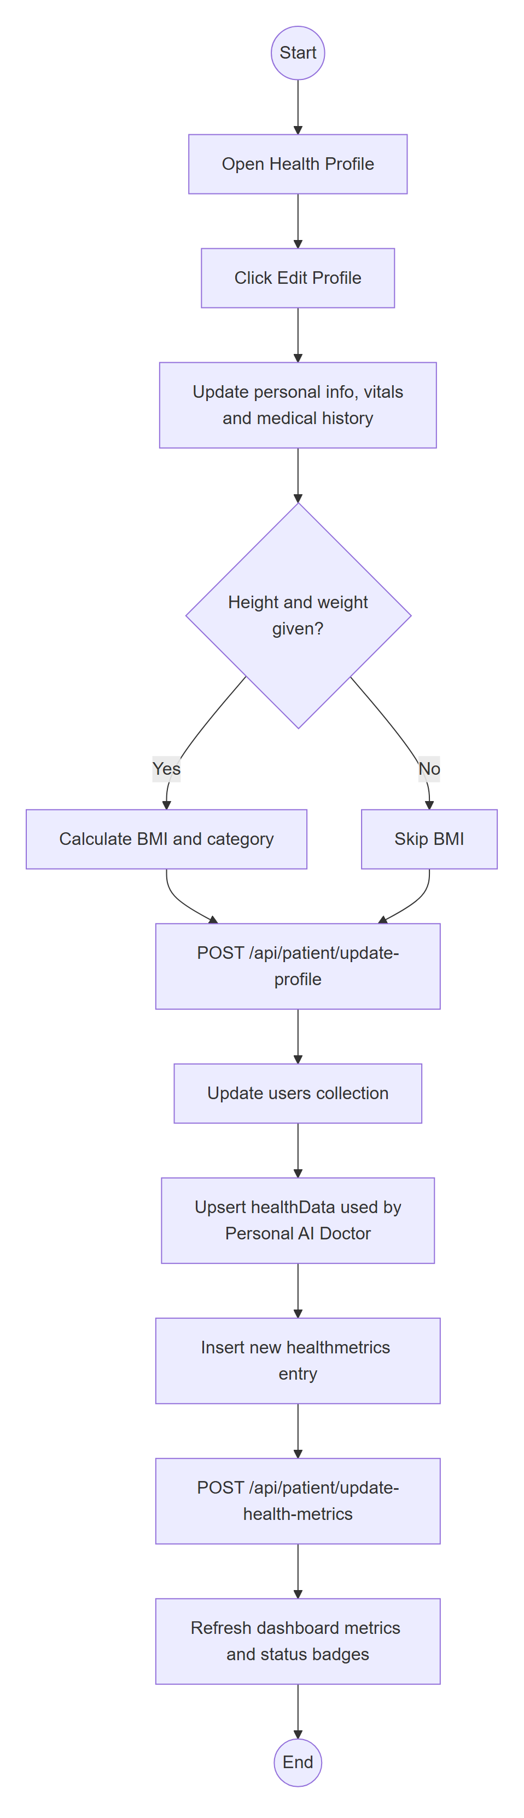
Figure 3.5. Activity diagram for updating the health profile

Sequence Diagram
Sequence diagrams show how objects interact over time for a particular scenario. We chose four scenarios that together touch almost every layer of the system.

User login
Figure 3.6 shows the login sequence, including the two alternative fragments: one for the database fallback and one for invalid credentials. Note that the same "Invalid credentials" message is used whether the email or the password was wrong, so an attacker cannot use the login form to discover which emails are registered.
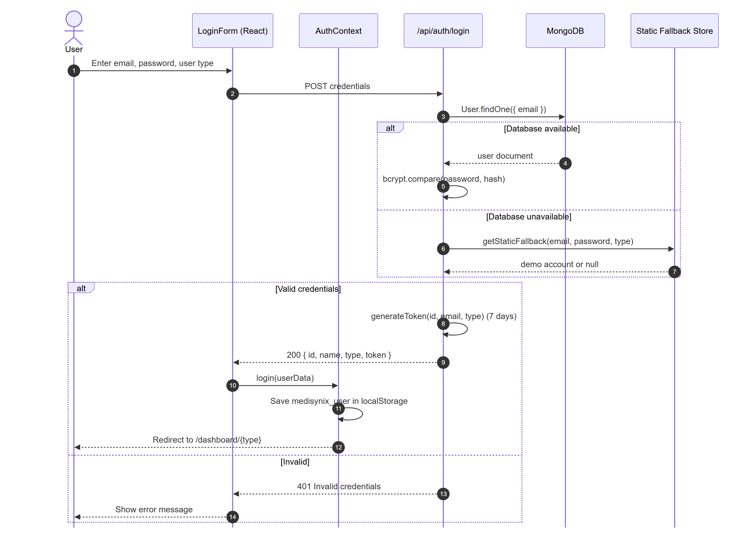
Figure 3.6. Sequence diagram for user login

Personal AI Doctor session
Figure 3.7 follows a patient from choosing the Personal AI Doctor to receiving an answer. The session can only be started with a valid login token, and the server takes the user ID from that token rather than from the request, so a patient cannot open a session for someone else. The session token issued by /api/doctor/init carries the doctor type, and both the page and the health-data endpoint check it. This prevents a general-mode token from being used to read personal health data.
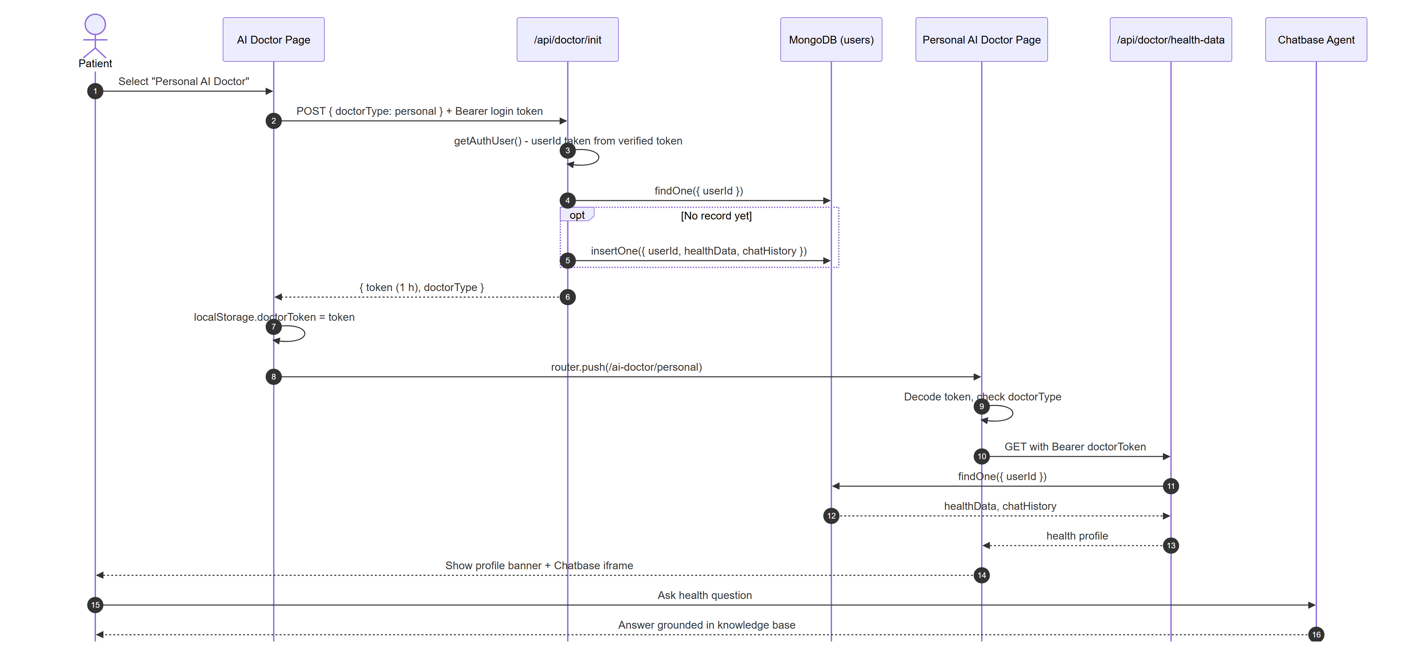
Figure 3.7. Sequence diagram for a Personal AI Doctor session

Health profile update
Figure 3.8 shows the messages exchanged when the profile is saved. The profile endpoint is protected by the login token; after it succeeds, the page updates the local session and records a new health metric entry.
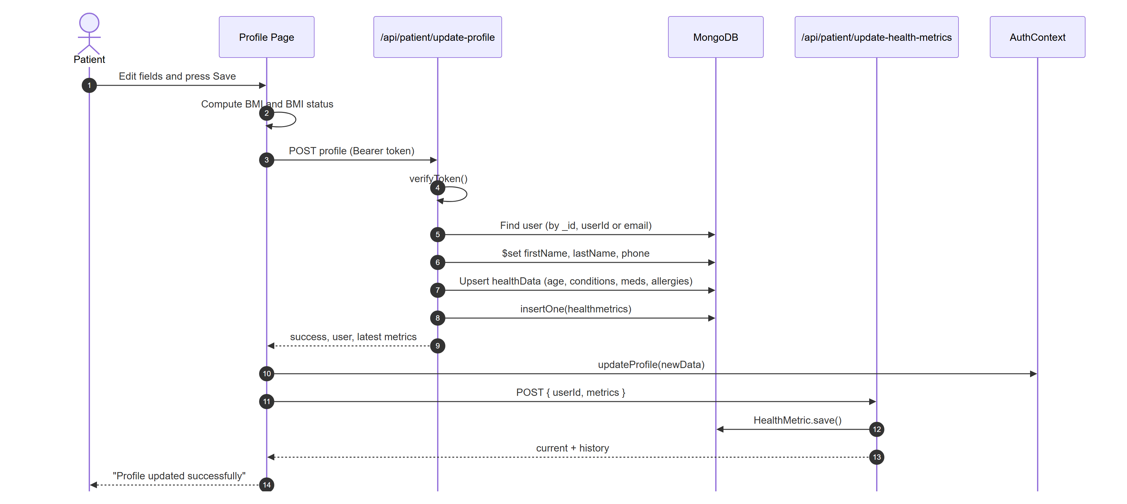
Figure 3.8. Sequence diagram for updating the health profile

Password reset
Figure 3.9 shows the two-step password reset. Only a hash of the reset token is ever stored, so even someone who could read the database would not be able to use a pending reset link.
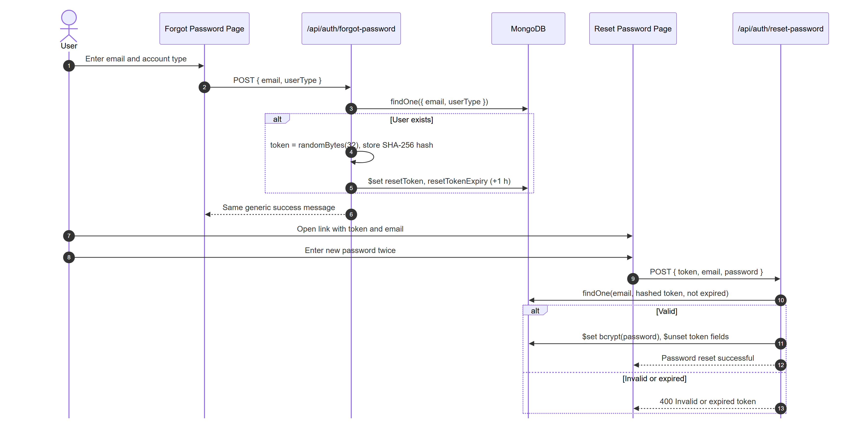
Figure 3.9. Sequence diagram for forgotten password and reset

Software Architecture Diagram
Medisynix follows a three-tier architecture, with an additional group of external AI services. Figure 3.10 shows the tiers and how they communicate.
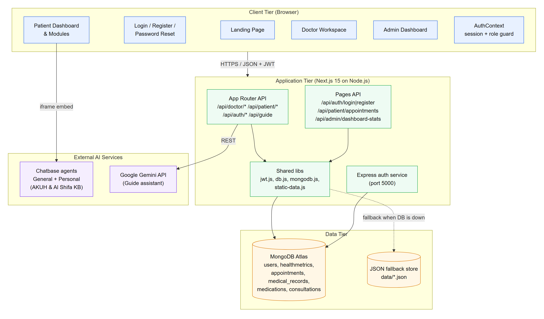
Figure 3.10. Software architecture of Medisynix
- Client tier. React [20] pages rendered by Next.js run in the browser. AuthContext holds the logged-in user, stores the session in local storage and protects routes by role. The AI Doctor pages embed the Chatbase agents in an iframe.
- Application tier. Next.js 15 serves the pages and hosts the API. Newer endpoints use the App Router (app/api//route.js) and older ones use the Pages Router (pages/api/.js); both call shared helpers in the lib folder for tokens, database connections and the fallback store. Every protected route verifies the caller's token on the server and checks that the requested data belongs to the caller, unless the caller is an administrator. A small Express service in the auth folder runs on port 5000; it came from an earlier prototype and is kept for legacy routes.
- Data tier. MongoDB Atlas [21] stores users, health metrics, appointments, medical records, medications, consultations and AI Doctor profiles. A JSON file store in the data folder acts as a fallback when the database is not reachable.
- External AI services. Two Chatbase agents provide the General and Personal AI Doctor. The Google Gemini API powers the guide assistant, with automatic fallback from gemini-2.5-flash to gemini-2.5-flash-lite when the first model is rate-limited.
We chose this architecture because it keeps the whole system in one code base and one language. Next.js [22] lets the same project serve pages and API routes, which removes the need to deploy a separate back end. It also deploys naturally to Vercel, where each API route runs as a serverless function. The downside, which we discuss in Chapter 5, is that mixing the App Router and Pages Router in one project caused some confusion about where a given endpoint lives.

Deployment view
Figure 3.11 shows how the system is deployed. The browser talks to the Next.js application on Vercel over HTTPS and loads the Chatbase chat directly from Chatbase. The Next.js server connects to MongoDB Atlas over TLS and to the Gemini API over HTTPS. Secrets such as the database URI, the JWT secret and the Gemini API key are supplied as environment variables and are not stored in the repository.
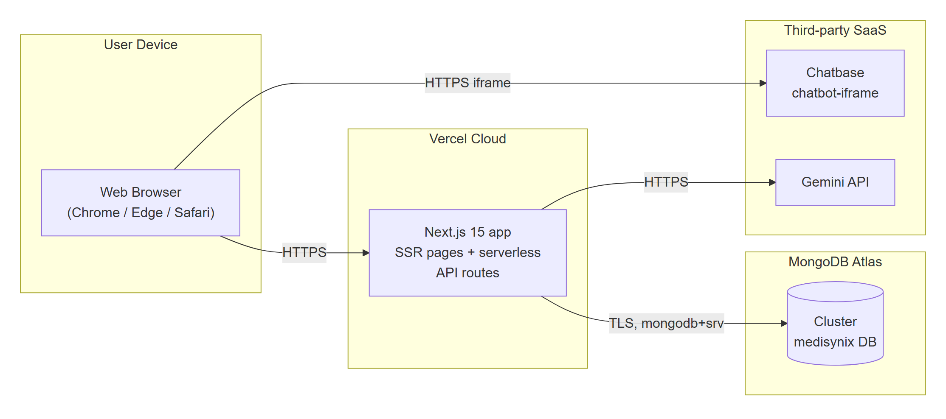
Figure 3.11. Deployment diagram

Data flow
Figure 3.12 shows the level-1 data flow diagram for the patient side of the system. It complements the context diagram in Chapter 1 (Figure 1.1) by showing the six main processes and the data stores each one reads and writes.
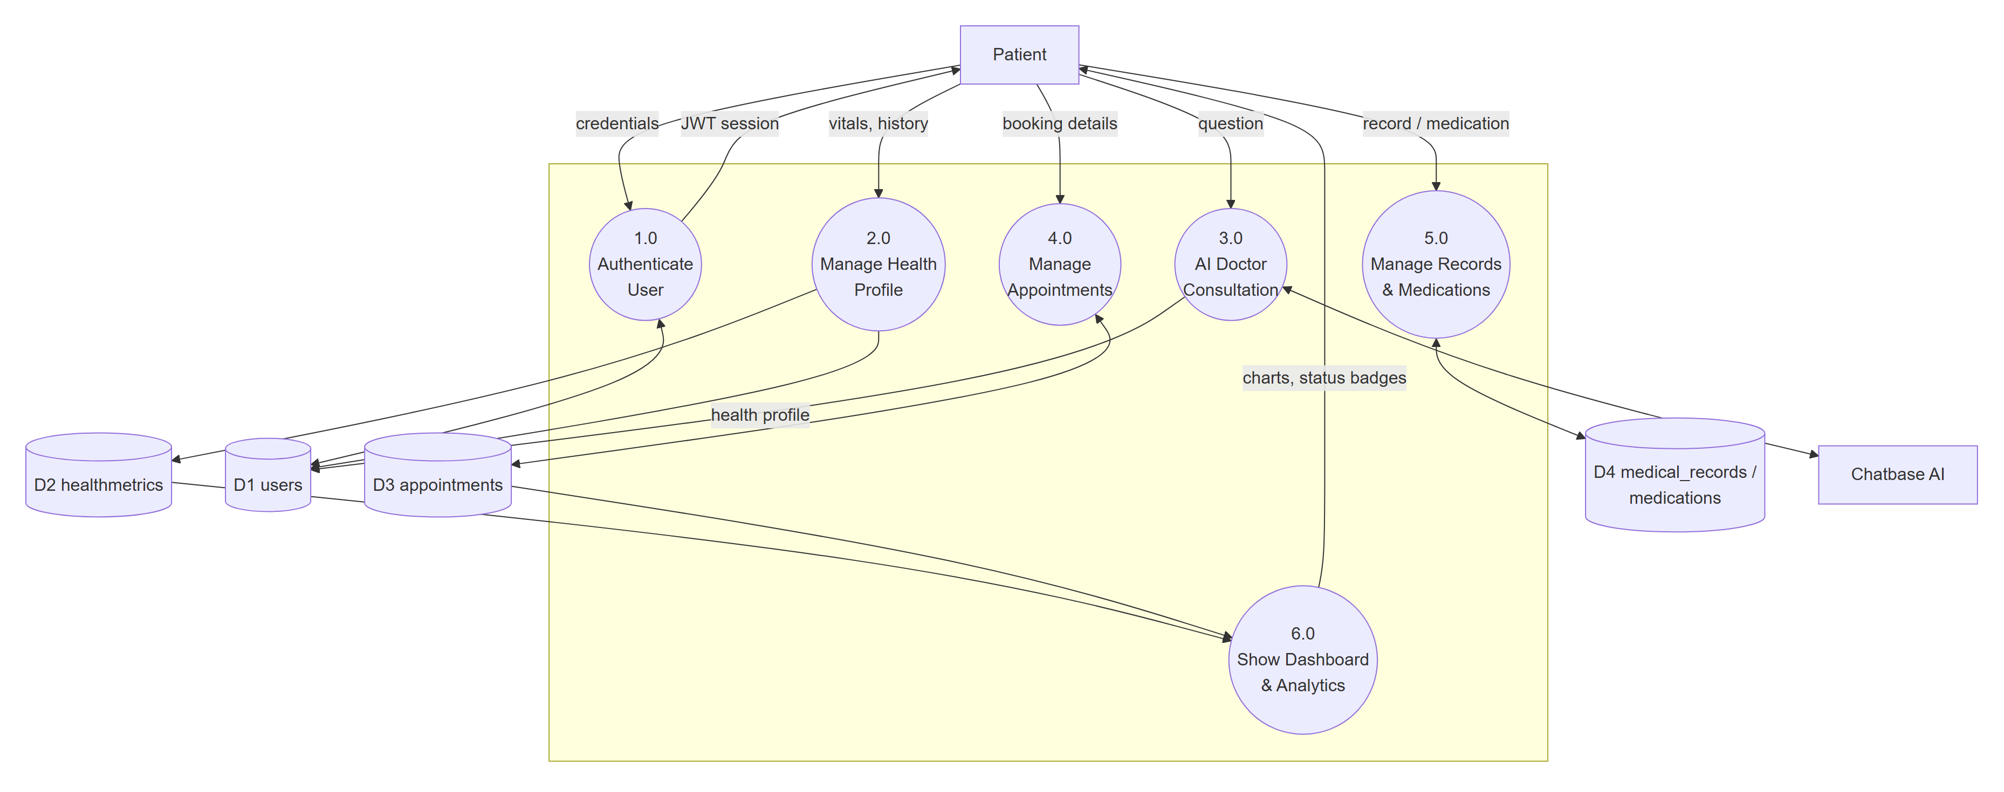
Figure 3.12. Level-1 data flow diagram (patient processes)

Class Diagram
Because Medisynix is written in JavaScript, most of its "classes" are Mongoose schemas and plain data shapes rather than classes with many methods. The class diagram in Figure 3.13 still captures the important structure: the User base type specialised into Patient, Doctor and Admin; the entities a patient owns; and the two objects that manage sessions (AuthContext on the client and the AI Doctor session token).
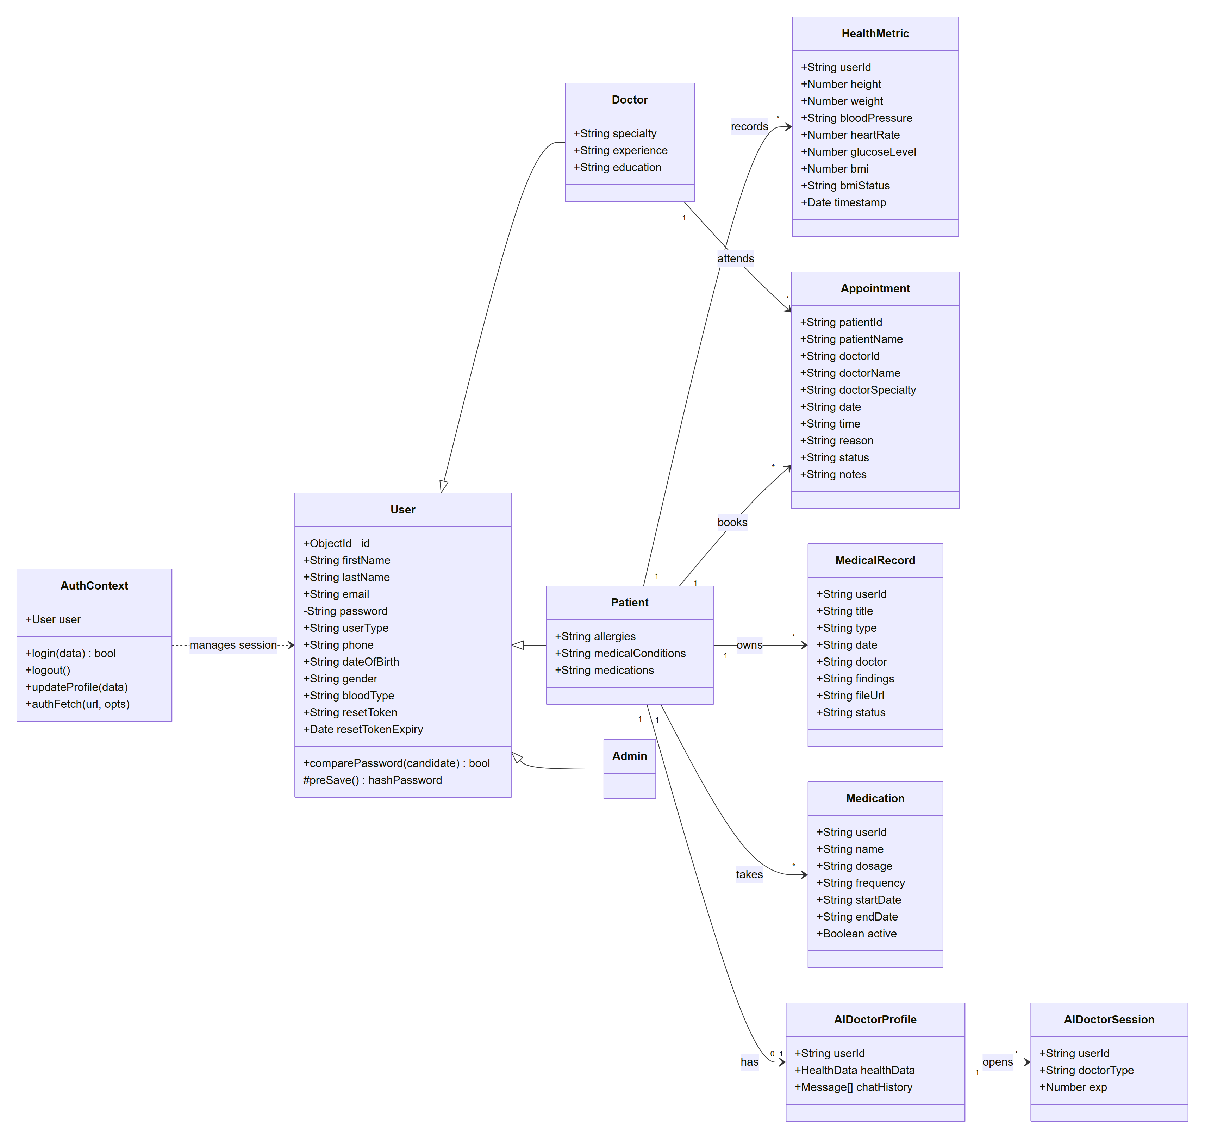
Figure 3.13. Class diagram of Medisynix
Table 3.2 summarises the responsibility of each class.
Table 3.2. Class responsibilities
Class | Responsibility | Implemented in
User | Common identity and login data. Hashes the password automatically before saving and compares passwords at login. | models/User.js
Patient / Doctor / Admin | Role-specific fields (medical history for patients; specialty, experience and education for doctors). Stored in the same collection and distinguished by userType. | models/User.js
HealthMetric | One time-stamped reading of a patient's vitals, including calculated BMI and BMI status. | models/HealthMetric.js
Appointment | A booking between a patient and a doctor with date, time, reason and status. | models/Appointment.js
MedicalRecord | Metadata and file link for a lab result, image, prescription or other record. | medical_records collection
Medication | A medicine with dosage, frequency and start and end dates; active is derived from the end date. | medications collection
AIDoctorProfile | Health data and chat history used by the Personal AI Doctor. | users collection (medisynix DB)
AIDoctorSession | Signed token carrying user ID, doctor type and a one-hour expiry. | app/api/doctor/init/route.js
AuthContext | Client-side session: login, logout, profile updates, authenticated fetch and role-based route protection. | contexts/AuthContext.jsx

Database Diagram
We used MongoDB, a document database, because health data varies a lot from one patient to another and we expected the schema to change as the project grew. Some collections are defined with Mongoose schemas that enforce types and validation; others are accessed directly through the MongoDB driver. Figure 3.14 shows the collections and their relationships. Although MongoDB does not enforce foreign keys, each collection stores the owning user's ID, and indexes on these fields keep look-ups fast.
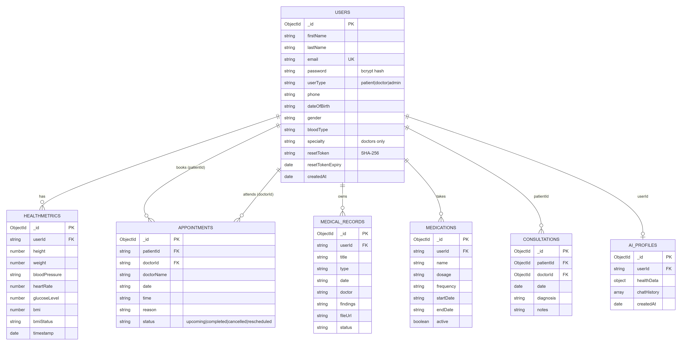
Figure 3.14. Database diagram (entity relationship view of MongoDB collections)
The data dictionaries below describe the main collections in detail.
Table 3.3. Data dictionary: users collection
Field | Type | Constraints | Description
_id | ObjectId | Primary key | Unique identifier created by MongoDB.
firstName, lastName | String | Required, trimmed | User's name.
email | String | Required, unique, lowercase, email pattern | Login identifier.
password | String | Required, min 8 characters | bcrypt hash (cost 10) created by a pre-save hook.
userType | String | patient | doctor | admin | Role that decides which dashboard is shown.
phone, dateOfBirth, gender, bloodType | String | Optional; gender is male, female or other | Personal and medical details.
allergies, medicalConditions, medications | String | Optional | Medical history (patients).
specialty, experience, education | String | Optional | Professional details (doctors).
resetToken, resetTokenExpiry | String, Date | Optional | SHA-256 hash of the reset token and its expiry time.
createdAt, updatedAt | Date | createdAt defaults to now | Audit timestamps.

Table 3.4. Data dictionary: healthmetrics collection
Field | Type | Constraints | Description
userId | String | Required, indexed | Owner of the reading.
height, weight | Number | Optional (cm, kg) | Used to calculate BMI.
bloodPressure | String | Optional, e.g. "120/80" | Systolic/diastolic pressure.
heartRate, glucoseLevel | Number | Optional (bpm, mg/dL) | Vital signs.
bmi, bmiStatus | Number, String | Calculated | BMI rounded to one decimal and its category.
timestamp | Date | Defaults to now; compound index with userId | When the reading was saved.

Table 3.5. Data dictionary: appointments collection
Field | Type | Constraints | Description
patientId, patientName | String | Required, patientId indexed | Patient who booked.
doctorId, doctorName, doctorSpecialty | String | doctorName required | Doctor being visited.
date, time | String | Required | Appointment slot.
reason, notes | String | Optional | Reason for the visit and notes.
status | String | upcoming | completed | cancelled | rescheduled; default upcoming | Current state of the booking.
createdAt, updatedAt | Date | – | Audit timestamps.

Compound indexes on (patientId, status), (doctorId, status) and date support the most common queries: a patient's upcoming appointments and a doctor's schedule.
Table 3.6. Data dictionary: medical_records and medications collection
Field | Type | Constraints | Description
userId | String | Required | Owner of the record or medication.
title, type, date | String | Required for records | Record name, category (lab, imaging, prescription, consultation, surgery, other) and date.
doctor, findings, fileUrl, status | String | Optional | Provider, key findings, file link and review status.
name, dosage, frequency, startDate | String | Required for medications | Medication details.
endDate, instructions, prescribedBy | String | Optional | Further medication details.
active | Boolean | Derived from endDate | Whether the medication is current.

Collaboration Diagram
Collaboration (communication) diagrams show the same kind of interaction as sequence diagrams, but they emphasise which objects are linked rather than the exact timing. Figure 3.15 shows the objects involved in booking an appointment, including the fallback path to the static data store, and Figure 3.16 shows the objects involved in opening a Personal AI Doctor session.
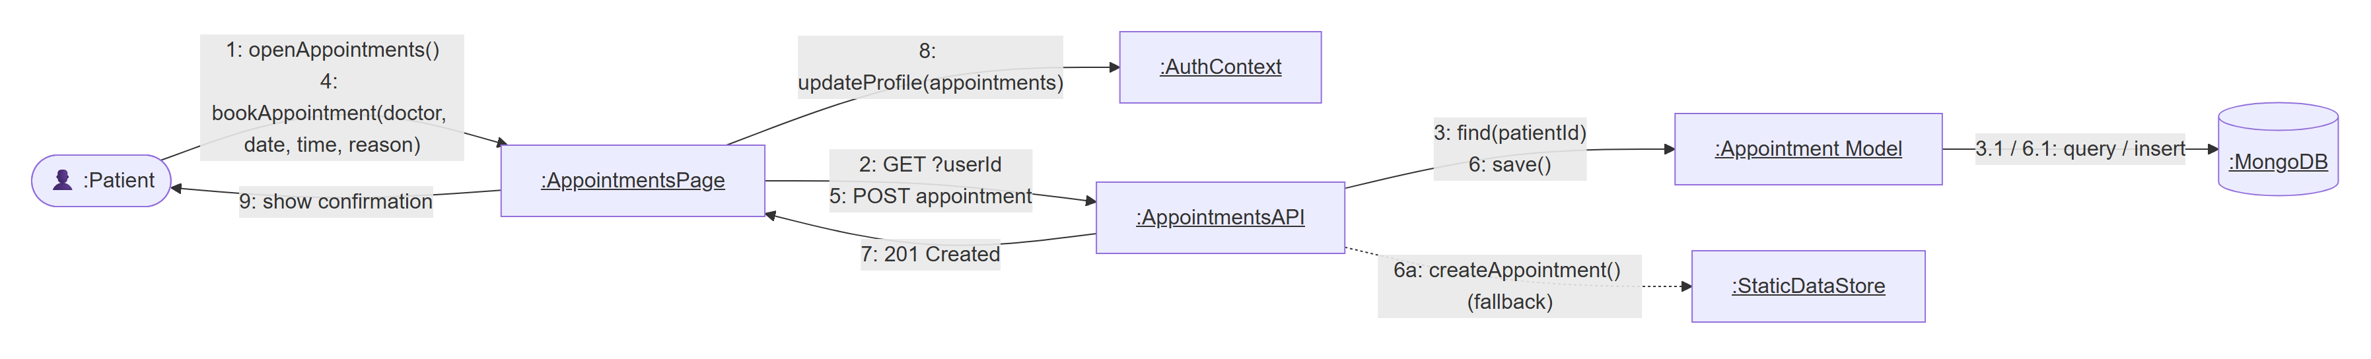
Figure 3.15. Collaboration diagram for booking an appointment
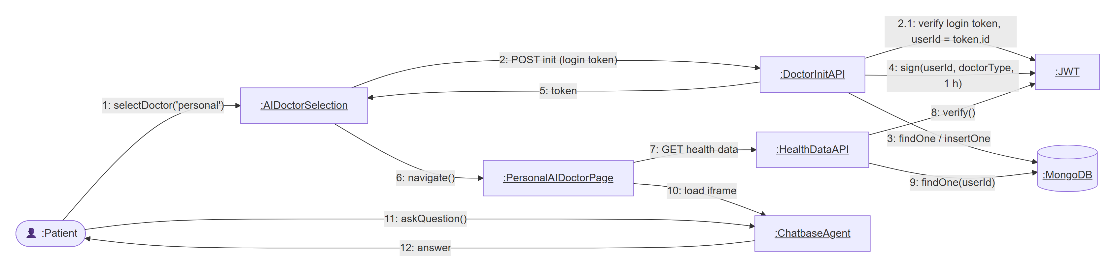
Figure 3.16. Collaboration diagram for a Personal AI Doctor session

User Interface Design
The interface was designed around a few simple rules that came from our elicitation sessions. Each role has a fixed sidebar so that users always know where they are. The most important actions appear as large "quick action" tiles at the top of the dashboard. Medical values are always shown with a coloured status (green for normal, amber for elevated, red for high) and a short text label, so that the meaning does not depend on colour alone. Every page that shows AI output carries a disclaimer in plain words. We used Tailwind CSS with a calm blue and green palette and the Heroicons icon set, and all layouts collapse into a single column on phones. Screenshots of the implemented interface are given in Section 5.5.

System Testing
Testing was not something we left to the end. Each increment finished with a round of testing before we moved on, and at the end of FYP-1 we ran a complete test pass on the system as it stands. This chapter describes how the test cases were designed and reports the results of unit, integration and acceptance testing. We have tried to report failures as plainly as successes: a test that fails today is useful, because it tells us exactly what to fix first in FYP-2.

Test Cases Design
We designed test cases mainly with black-box techniques, since most of our tests exercise the system from the outside, through its API or its user interface. For the small number of library functions that hold core logic we also wrote white-box unit tests.
- Equivalence partitioning. Inputs were split into valid and invalid classes, for example a correct doctor type (general, personal) versus any other value, or a request with a token, without a token, or with a forged token.
- Boundary value analysis. Limits such as the minimum password length of 8 characters and appointment dates that must not be earlier than today were tested at and around the boundary.
- Error guessing. From experience we added cases such as malformed JSON bodies, unsupported HTTP methods and a valid token used for the wrong AI Doctor mode.
- Scenario-based testing. Acceptance tests follow realistic user journeys, such as a patient asking the AI Doctor about a hospital service.
Every test case has an identifier, a short description, the input or steps, the expected result, the actual result and a pass or fail status. Table 4.1 shows the template with one fully worked example; the remaining test cases are reported in compact tables in the following sections.
Table 4.1. Test case template with a worked example (TC-15)
Test Case ID | TC-15
Module | AI Doctor
Title | Personal health data cannot be read with a General AI Doctor token
Requirement(s) | FR-09, NFR-03, NFR-04
Pre-condition | Servers running; a General AI Doctor session token obtained through POST /api/doctor/init (TC-13).
Test Steps | 1. Send GET /api/doctor/health-data with header Authorization: Bearer <general token>.  2. Record the status code and message.
Test Data | Token payload: { userId: "patient-1", doctorType: "general" }
Expected Result | HTTP 403 with the message "This endpoint is only for Personal AI Doctor".
Actual Result | HTTP 403, "This endpoint is only for Personal AI Doctor".
Status | Pass
Tested on | Local development server, Windows 11, Node.js 26, Next.js 15

Unit / Integration / Acceptance Testing

Unit testing
Unit tests target individual functions in the lib folder that the rest of the system depends on: password hashing, the fallback data store, token creation and verification, and the fallback login logic. They were written with Node.js's built-in test runner (node:test) and run against a copy of the data folder, so that running the tests never changes the project's real data files. Table 4.2 lists the unit tests. All 14 passed.
Table 4.2. Unit test cases and results
ID | Function under test | Input | Expected result | Status
UT-01 | hashPassword() | Plain password "Sample@123" | A bcrypt hash starting with $2a$10$, different from the input | Pass
UT-02 | comparePassword() | Correct and wrong-case password against the same hash | true for the correct one, false for the wrong one | Pass
UT-03 | findUserByEmail() | "ADMIN@MEDISYNIX.COM" (upper case) | Admin account found (case-insensitive) | Pass
UT-04 | findUserByEmail() | Unknown email | undefined | Pass
UT-05 | getAllDoctors() | – | At least 3 users, all of type doctor with a specialty | Pass
UT-06 | getDashboardStats() | – | total = doctors + patients + 1 admin; consultations = 0 | Pass
UT-07 | getRecentUsers(2) | Limit 2 | Exactly 2 users, newest first | Pass
UT-08 | createUser() | New patient data | ID of the form patient-<timestamp>; user can be found afterwards | Pass
UT-09 | generateToken() / verifyToken() | Patient payload | Decoded token keeps id and type; exp − iat = 7 days | Pass
UT-10 | verifyToken() | Token with altered signature | null (rejected) | Pass
UT-11 | getStaticFallback() | Valid email, password and role | Account object with type patient and full name | Pass
UT-12 | getStaticFallback() | Valid email, wrong password | null | Pass
UT-13 | getStaticFallback() | Valid credentials, wrong role (doctor) | null | Pass
UT-14 | createAppointment() / getUserAppointments() | New booking for a test patient | Booking returned in the patient's list | Pass

A shortened version of one of the unit tests is shown below to illustrate the style.
test('UT-10 verifyToken rejects a tampered token', () => {
const t = generateToken({ id: 'x', email: 'a@b.c', userType: 'patient' });
const bad = t.slice(0, -3) + 'abc'; // change the signature
assert.equal(verifyToken(bad), null); // must be rejected
});

Integration testing
Integration tests check that the API routes, shared libraries and data layer work together. We wrote a small Node.js script that sends real HTTP requests to a production build of the application (the Next.js server and the Express service) and compares each response with the expected status code. The final run took place after the security fixes described in Section 4.3, so requests to protected endpoints carry a valid session token for the relevant demo account. The script ran 41 test cases, of which 40 passed. Table 4.3 lists every case and Figure 4.1 summarises the results by module.
Table 4.3. API integration test cases and results
ID | Module | Test case | Request | Exp. | Act. | Result
TC-01 | Doctors | List all doctors | GET /api/doctors | 200 | 200 | Pass
TC-02 | Doctors | Get doctor by valid id | GET /api/doctors/doctor-1 | 200 | 200 | Pass
TC-03 | Doctors | Get doctor by unknown id | GET /api/doctors/xyz-999 | 404 | 404 | Pass
TC-04 | Doctors | Reject unsupported method | POST /api/doctors | 405 | 405 | Pass
TC-05 | Auth | Block doctor self-registration | POST /api/auth/register | 403 | 403 | Pass
TC-06 | Auth | Reject GET on login endpoint | GET /api/auth/login | 405 | 405 | Pass
TC-07 | Auth | Reject login for unknown account | POST /api/auth/login | 401 | 401 | Pass
TC-08 | Auth | Forgot password without email | POST /api/auth/forgot-password | 400 | 400 | Pass
TC-09 | Auth | Forgot password without user type | POST /api/auth/forgot-password | 400 | 400 | Pass
TC-10 | Auth | Reset password with missing fields | POST /api/auth/reset-password | 400 | 400 | Pass
TC-11 | Auth | Reset password shorter than 8 chars | POST /api/auth/reset-password | 400 | 400 | Pass
TC-12 | AI Doctor | Init session with invalid doctor type | POST /api/doctor/init | 400 | 400 | Pass
TC-13 | AI Doctor | Init General AI Doctor session (logged in) | POST /api/doctor/init | 200 | 200 | Pass
TC-14 | AI Doctor | Health data without token | GET /api/doctor/health-data | 401 | 401 | Pass
TC-15 | AI Doctor | Health data with General token (wrong mode) | GET /api/doctor/health-data | 403 | 403 | Pass
TC-16 | AI Doctor | Clear history with General token | DELETE /api/doctor/history | 403 | 403 | Pass
TC-17 | Guide | Guide assistant with empty message | POST /api/guide | 400 | 400 | Pass
TC-18 | Guide | Guide assistant with malformed JSON | POST /api/guide | 400 | 400 | Pass
TC-19 | Guide | Guide assistant answers a how-to question | POST /api/guide | 200 | 500 | Fail
TC-20 | Records | Get records without token | GET /api/patient/records | 401 | 401 | Pass
TC-21 | Records | Get records with forged token | GET /api/patient/get-records | 401 | 401 | Pass
TC-22 | Records | Upload record without token | POST /api/patient/upload-record | 401 | 401 | Pass
TC-23 | Records | Update record with forged token | PUT /api/patient/update-record | 401 | 401 | Pass
TC-24 | Records | Delete record without token | DELETE /api/patient/delete-record?recordId=1 | 401 | 401 | Pass
TC-25 | Medications | Add medication without token | POST /api/patient/medications | 401 | 401 | Pass
TC-26 | Consultations | List consultations without token | GET /api/patient/consultations | 401 | 401 | Pass
TC-27 | Profile | Update profile without token | POST /api/patient/update-profile | 401 | 401 | Pass
TC-28 | Appointments | List appointments without userId | GET /api/patient/appointments | 400 | 400 | Pass
TC-29 | Appointments | Unsupported DELETE on appointments | DELETE /api/patient/appointments | 405 | 405 | Pass
TC-30 | Health Metrics | Get metrics without userId | GET /api/patient/get-health-metrics | 400 | 400 | Pass
TC-31 | Health Metrics | Get own metrics (patient token) | GET /api/patient/get-health-metrics?userId=patient-1 | 200 | 200 | Pass
TC-32 | Admin | Dashboard statistics (admin token) | GET /api/admin/dashboard-stats | 200 | 200 | Pass
TC-33 | Admin | Reject POST on statistics | POST /api/admin/dashboard-stats | 405 | 405 | Pass
TC-34 | Express Auth | Express server health route | GET express:5000/ | 200 | 200 | Pass
TC-35 | Express Auth | Protected route without x-auth-token | GET express:5000/api/auth | 401 | 401 | Pass
TC-36 | Express Auth | Register with invalid email | POST express:5000/api/users | 400 | 400 | Pass
TC-37 | Pages | Public page / loads | GET / | 200 | 200 | Pass
TC-38 | Pages | Public page /login loads | GET /login | 200 | 200 | Pass
TC-39 | Pages | Public page /register loads | GET /register | 200 | 200 | Pass
TC-40 | Pages | Public page /forgot-password loads | GET /forgot-password | 200 | 200 | Pass
TC-41 | Pages | Public page /reset-password loads | GET /reset-password | 200 | 200 | Pass

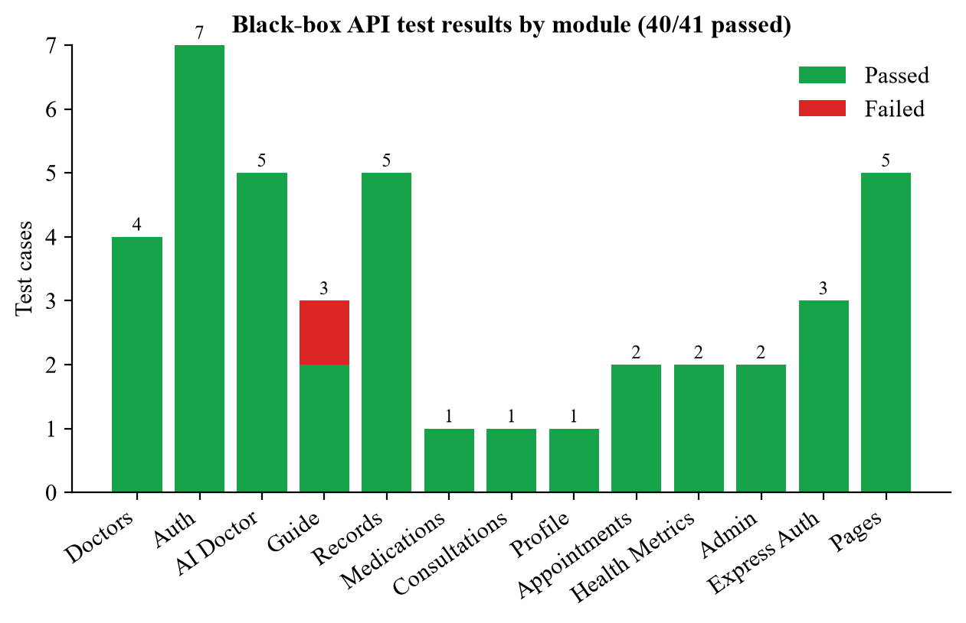
Figure 4.1. Integration test results by module
The one failure, TC-19, is a configuration problem rather than a coding error: the guide assistant needs a Gemini API key, and the key was not set in the test environment. The endpoint did behave sensibly, returning a clear message that tells the administrator which setting is missing. We have kept the test marked as failed because a user would still not get an answer.
The integration tests also revealed something the unit tests could not: during testing the MongoDB Atlas cluster could not be reached from our network. The endpoints that support the fallback store (login, appointments, health metrics and administrator statistics) kept working and flagged their responses with "fallback: true". The endpoints that talk to MongoDB directly without a fallback returned authentication errors before ever reaching the database, which is the correct behaviour for requests without a valid token.

Performance observations
As part of integration testing we measured response times by calling selected endpoints five times each after a warm-up call. Figure 4.2 shows the median, with the range as error bars. Pages and endpoints that do not touch the database, such as the landing page, the doctor directory and AI Doctor session start, answer in under 20 ms on the production build. Endpoints that first try MongoDB and then fall back take just over 2 seconds, which is exactly the connection timeout we configured. In other words, the fallback works, but it costs two seconds per request whenever the database is down. When the database is reachable these endpoints are expected to meet the 500 ms target in NFR-02; confirming this against a live cluster is part of the FYP-2 test plan.
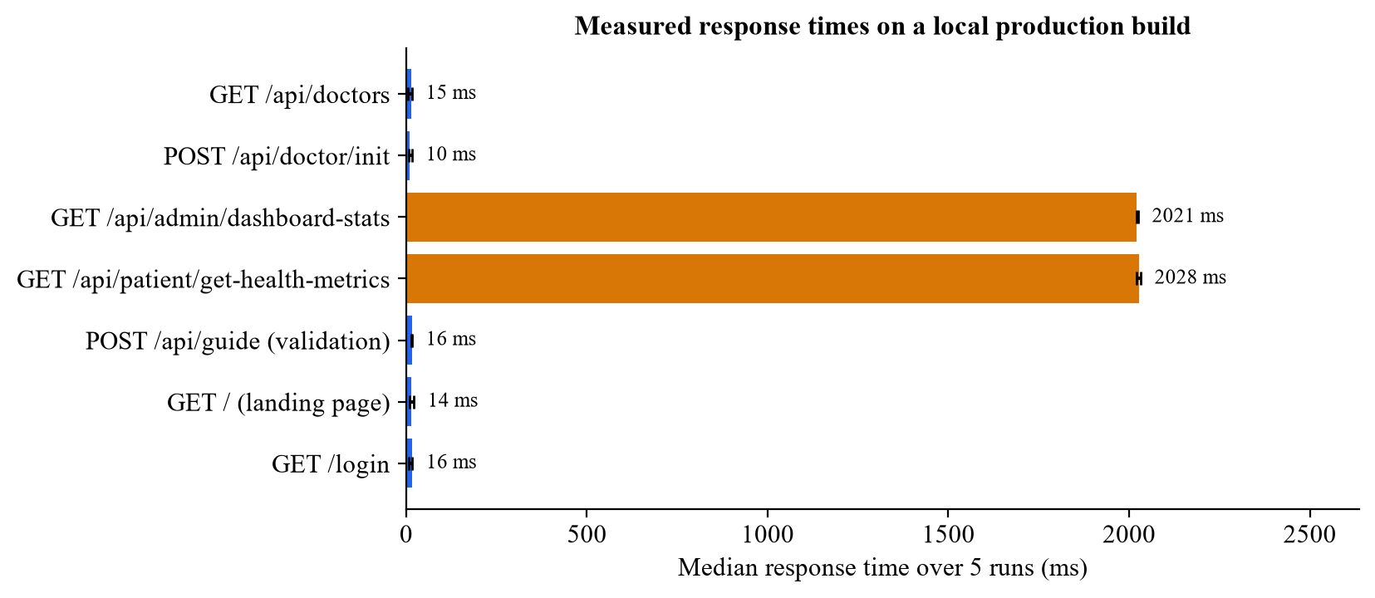
Figure 4.2. Median response times measured on a local production build

Acceptance testing
Acceptance tests follow the journeys a real user would take. They were carried out in a headless Chrome browser driven by a script, which let us capture a screenshot of every step (many of these appear in Section 5.5). Patient, doctor and administrator sessions were created with the demo accounts that ship with the project. No new accounts were created on any external service. Table 4.4 lists the 19 acceptance tests; 18 passed and 1 failed.
Table 4.4. Acceptance test cases and results
ID | Scenario | Expected result | Actual result | Status
AT-01 | Visitor opens the landing page | Hero section, features, "How it works", live assistant and disclaimer are shown | All sections displayed; live Chatbase widget loaded | Pass
AT-02 | Visitor opens the login page | Email, password, user type fields and "Forgot password?" link | As expected | Pass
AT-03 | Visitor opens the registration page | Name, email, password, confirmation, role and terms fields | As expected | Pass
AT-04 | Visitor opens Forgot Password | Email and account type fields with submit button | As expected | Pass
AT-05 | Patient opens the dashboard | Greeting, quick actions, health metrics, AI health signal, appointments and reports | All panels rendered; empty states shown where no data exists | Pass
AT-06 | Patient opens AI Doctor | Choice of General and Personal AI Doctor with feature lists and disclaimers | As expected | Pass
AT-07 | Patient asks the General AI Doctor "What cardiology services are available at Aga Khan University Hospital?" | Relevant answer based on AKUH information with advice to verify on official pages | Answer described AKUH cardiology services and pointed to the Health Services page and Find a Doctor | Pass
AT-08 | Patient asks the Personal AI Doctor about starting running with mild asthma | Personalised, safety-conscious guidance; profile banner shown | Guidance covered asthma control, action plan, warm-up and warning signs. Banner showed "No health data saved yet" because the database was unreachable during the test | Pass (remark)
AT-09 | Patient enters "fever, headache, cough, body aches" in the Symptom Checker | Ranked list of possible conditions with match percentages and disclaimer | Influenza, Migraine and Common Cold listed with percentages and disclaimer | Pass
AT-10 | Patient opens Find a Doctor | Doctor cards with filters for specialty and city | Six doctors listed with filters, fees and time slots | Pass
AT-11 | Patient opens a doctor profile | Profile with about, services, hours, reviews and booking widget | As expected for doctor 1 | Pass
AT-12 | Patient opens My Appointments | Tabs for Upcoming, Past and Cancelled and a Book Appointment button | As expected; empty state shown | Pass
AT-13 | Patient opens Analytics | Charts of assistant usage, query categories and visits | Page failed with a client-side exception | Fail
AT-14 | Patient opens Upload Report | Choice of medical image or lab report | As expected (analysis itself is a prototype) | Pass
AT-15 | Doctor opens the workspace | Statistics, today's appointments, AI insights, requests and patient search | As expected with sample data | Pass
AT-16 | Doctor opens Upload Patient Report | Patient selection and report type steps | As expected | Pass
AT-17 | Administrator opens the dashboard | Statistic cards and recent users | Cards show 5 users, 3 doctors, 1 patient and 0 consultations; the five most recent users are listed with names and roles (re-tested after fixing D-04) | Pass
AT-18 | Unauthenticated visitor opens /dashboard/patient; patient opens /dashboard/admin and /dashboard/doctor | Redirect to /login; redirect back to /dashboard/patient | Redirected to /login, then to /dashboard/patient in both cases | Pass
AT-19 | Patient clicks Logout | Session removed and user taken out of the dashboard | Stored session cleared; user left the dashboard | Pass

The two AI Doctor tests (AT-07 and AT-08) deserve a comment. In both cases the assistant stayed within its role. It gave practical, hospital-specific information in the first case and careful, safety-first guidance in the second. It did not attempt a diagnosis, and it advised the user to confirm details with the hospital or a clinician. This is the behaviour we asked for in FR-11 and NFR-12.

Security Testing
Because Medisynix stores health information, we carried out a dedicated security review near the end of FYP-1. We read every API route with the OWASP Top 10 [23] in mind, paying particular attention to broken access control, injection, cryptographic failures and security misconfiguration, and we ran npm audit on the dependencies. The review found several serious problems, logged as D-12 to D-19 in Table 4.6. The most important was that some API routes trusted a user ID supplied by the browser, so a logged-in patient could read or change another patient's appointments and health metrics simply by editing a URL.
All of these problems were fixed before this report was finalised. The main changes were:
- One source of truth for tokens. A single helper (lib/jwt.js) now signs and verifies every token. It refuses to run in production without a JWT_SECRET, and all hard-coded fallback secrets were removed.
- Server-side authorisation. Every protected route verifies the login token and checks that the caller owns the requested data, or is an administrator. The AI Doctor session is bound to the logged-in user rather than to an ID sent by the browser.
- Input hardening. Authentication routes reject non-string values, which blocks MongoDB operator injection; registration rules are enforced on the server; the record search escapes regular-expression characters; error responses no longer include internal details.
- Less exposure. Diagnostic endpoints were removed, the reset link is no longer returned in API responses, third-party IP lookups and sensitive console logging were removed, and standard security headers were added.
- Dependencies. Seven unused packages were removed and the remaining ones updated, including Next.js from 15.2.6 to 15.5.26.
We then wrote 39 security regression tests and ran them against a production build of the fixed application. They are listed in Table 4.5; all 39 passed. The test tokens were signed with the application's own secret for the demo accounts, which let us act as two different patients and as an administrator.
Table 4.5. Security regression tests and results
ID | Check | Expected | Actual | Result
ST-01 | GET /api/test returns 404 (diagnostic endpoint removed) | 404 | 404 | Pass
ST-02 | GET /api/db-test returns 404 (removed) | 404 | 404 | Pass
ST-03 | GET /api/mongo-test returns 404 (removed; used to list user emails) | 404 | 404 | Pass
ST-04 | GET /api/test-module-format returns 404 (removed) | 404 | 404 | Pass
ST-05 | Admin statistics without a token | 401 | 401 | Pass
ST-06 | Admin statistics with a patient token | 403 | 403 | Pass
ST-07 | Admin statistics with an admin token | 200 | 200 | Pass
ST-08 | Appointments without a token | 401 | 401 | Pass
ST-09 | Patient B reads patient A's appointments | 403 | 403 | Pass
ST-10 | Patient reads own appointments | 200 | 200 | Pass
ST-11 | Patient B books an appointment in patient A's name | 403 | 403 | Pass
ST-12 | Health metrics without a token | 401 | 401 | Pass
ST-13 | Patient B reads patient A's health metrics | 403 | 403 | Pass
ST-14 | Patient reads own health metrics | 200 | 200 | Pass
ST-15 | Patient B updates patient A's health metrics | 403 | 403 | Pass
ST-16 | AI Doctor session start without a login token | 401 | 401 | Pass
ST-17 | AI Doctor session start while logged in | 200 | 200 | Pass
ST-18 | Session is bound to the logged-in user, not to the userId in the request body | caller's ID | caller's ID | Pass
ST-19 | Health data endpoint rejects a login token that is not an AI Doctor session | 401 | 401 | Pass
ST-20 | Records endpoint rejects a token signed with the old hard-coded secret | 401 | 401 | Pass
ST-21 | Records search with regex metacharacters is handled safely | 200/500* | 500* | Pass
ST-22 | Profile update without a token | 401 | 401 | Pass
ST-23 | Login with a MongoDB operator ({"$ne": null}) as the email | 400 | 400 | Pass
ST-24 | Forgot password with a MongoDB operator as the email | 400 | 400 | Pass
ST-25 | Forgot password with a normal email | 200/500* | 500* | Pass
ST-26 | Forgot password response contains no reset link or token | none | none | Pass
ST-27 | Reset password with an object instead of a token string | 400 | 400 | Pass
ST-28 | Registration with a weak password is rejected by the server | 400 | 400 | Pass
ST-29 | Registration as doctor is still blocked | 403 | 403 | Pass
ST-30 | Landing page loads | 200 | 200 | Pass
ST-31 | X-Frame-Options header present | DENY | DENY | Pass
ST-32 | X-Content-Type-Options header present | nosniff | nosniff | Pass
ST-33 | Referrer-Policy header present | set | set | Pass
ST-34 | Permissions-Policy header present | set | set | Pass
ST-35 | Strict-Transport-Security header present | set | set | Pass
ST-36 | X-Powered-By header hidden | absent | absent | Pass
ST-37 | Express: create city without a token | 401 | 401 | Pass
ST-38 | Express: delete city without a token | 401 | 401 | Pass
ST-39 | Express: CORS refuses an unknown origin | no header | no header | Pass

In Table 4.5, results marked * returned HTTP 500 because the MongoDB cluster could not be reached during the test run. What these checks confirm is that the request passed authentication and input validation safely and that no data or internal details were returned.
A few items were deliberately left for FYP-2 because they need larger changes: moving session tokens from browser storage into HTTP-only cookies, rate-limiting login attempts, and upgrading to Next.js 16 to clear the one remaining npm audit finding (a PostCSS issue that only affects the build step). The credentials that were exposed in the repository history early in the project also have to be rotated by the team, since removing a file from the latest commit does not remove it from Git history.

Defect Log
Testing, a line-by-line review of the code and the security review produced the defect log in Table 4.6. Severity reflects the effect on a user: High means a feature cannot be used, Medium means it works incorrectly or incompletely, and Low means a minor problem. Items marked "Code review" were found by reading the code and confirmed by tracing the logic, rather than by an executed test. All security defects are now fixed; the functional defects that remain open are scheduled for FYP-2.
Table 4.6. Defect log at the end of FYP-1
ID | Severity | Description | Found by | Status
D-01 | High | Patient analytics page crashes: a helper component uses a colour palette defined inside another function (out of scope). | AT-13 | Open
D-02 | High | Upload Medical Record calls getAuthToken(), which does not exist in AuthContext (the function is getToken), so submission fails. | Code review | Open
D-03 | High | Uploaded files are not stored; only a temporary browser URL is saved, which stops working after reload. | Code review | Open
D-04 | Medium | Admin dashboard did not display statistic cards: the fallback statistics returned an undefined consultation count, and the recent-user list lost names and roles. | AT-17 | Fixed
D-05 | Medium | Appointments are saved as doctorName / doctorSpecialty but displayed as doctor / specialty, so the doctor name appears blank. | Code review | Open
D-06 | Medium | Chat with Doctors crashes when doctor 4 or 5 is selected because no sample conversation exists for them. | Code review | Open
D-07 | Medium | Doctor report upload crashes for lab reports (result has no probability value). | Code review | Open
D-08 | Medium | Guide assistant returns 500 when GEMINI_API_KEY is not configured. | TC-19 | Open (configuration)
D-09 | Medium | Several sidebar links for doctor and admin (Patients, AI Analysis, Users, Reports, Settings) lead to pages not yet built. | Code review | Planned FYP-2
D-10 | Low | Removing a medication only updates the screen and uses the wrong ID field. | Code review | Open
D-11 | Low | Registration form offers Doctor and Admin roles, which the server rejects with 403. | TC-05 | Open
D-12 | Security | Appointments, health metrics and administrator statistics APIs had no server-side authentication or ownership checks, so any user ID could be read or changed (insecure direct object reference). | Security review | Fixed
D-13 | Security | AI Doctor sessions trusted a user ID sent by the browser, allowing a Personal AI Doctor session to be opened for another patient. | Security review | Fixed
D-14 | Security | Profile update could match another user by an email address in the request body and overwrite their profile. | Security review | Fixed
D-15 | Security | Hard-coded fallback JWT secrets in several routes and a Gemini API key in commented-out source code. | Security review | Fixed (key to be revoked)
D-16 | Security | Diagnostic endpoints (/api/test, /api/db-test, /api/mongo-test) exposed collection names and user emails without authentication. | Security review | Fixed (removed)
D-17 | Security | Forgot-password returned the reset link outside production; login and reset inputs accepted MongoDB query operators; raw error messages and stack traces were returned to clients. | Security review | Fixed
D-18 | Privacy | Registration page sent every visitor's IP address and location to a third-party service; tokens and health data were written to the console. | Security review | Fixed
D-19 | Security | npm audit reported 41 vulnerable packages (6 critical), mostly in unused dependencies and an older Next.js release. | npm audit | Fixed (1 build-time finding left)

Test Summary
Table 4.7 brings the results together. Overall, 111 of 113 executed test cases passed. The core of the system (authentication, role protection, the AI Doctor, the health profile and the doctor directory) is stable, and all security defects found during the review have been fixed and verified. The functional defects that remain are in secondary pages that were built quickly as prototypes, and they are the first items on our FYP-2 plan.
Table 4.7. Summary of test results
Test level | Tool / method | Executed | Passed | Failed | Pass rate
Unit | node:test | 14 | 14 | 0 | 100%
Integration (API) | Node.js HTTP script | 41 | 40 | 1 | 98%
Acceptance (UI) | Headless Chrome (CDP) script | 19 | 18 | 1 | 95%
Security regression | Node.js HTTP script | 39 | 39 | 0 | 100%
Total | – | 113 | 111 | 2 | 98%

Implementation (30 %)
This chapter describes how Medisynix was built. It covers how the work was broken down and shared within the team, the tools and technologies we used, the implementation of the most important modules, screenshots of the working system and the challenges we ran into. At the end of FYP-1 around 30 % of the planned implementation is complete, in line with the university's expectation for this phase. The core platform, authentication, the AI Doctor and the main patient features are working; several doctor and administrator features exist as interface prototypes and will be completed in FYP-2.

Work Breakdown Structure (WBS)
We broke the project into six top-level work packages, each divided into smaller deliverables that could be assigned to one person and finished within a cycle. Figure 5.1 shows the work breakdown structure.
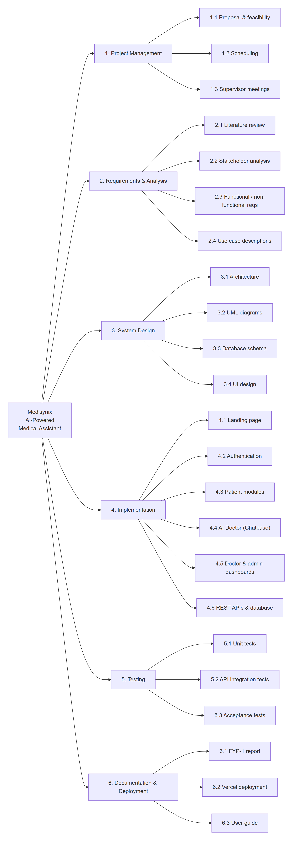
Figure 5.1. Work breakdown structure of Medisynix
Figure 5.2 shows how we estimate the total effort of FYP-1 was divided between these packages. The figures are estimates reconstructed from our weekly notes rather than precise time logs, but they give a fair picture: implementation took the largest share, and documentation and design together took almost as much.
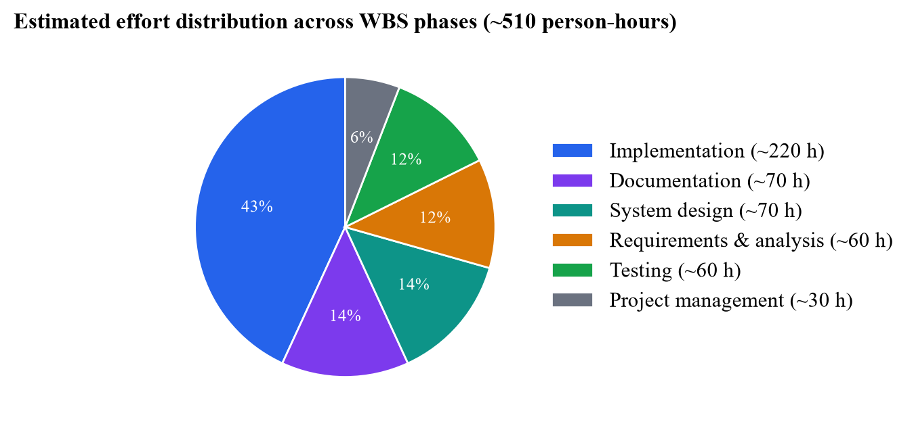
Figure 5.2. Estimated effort distribution across WBS work packages
The schedule we followed is shown as a Gantt chart in Figure 5.3. Implementation of the first increment started early in June 2026, in parallel with the later part of the design work. The second increment, which introduced Chatbase, ran through July and August. September was spent on testing, a redesign of the landing page, bug fixes and this report.
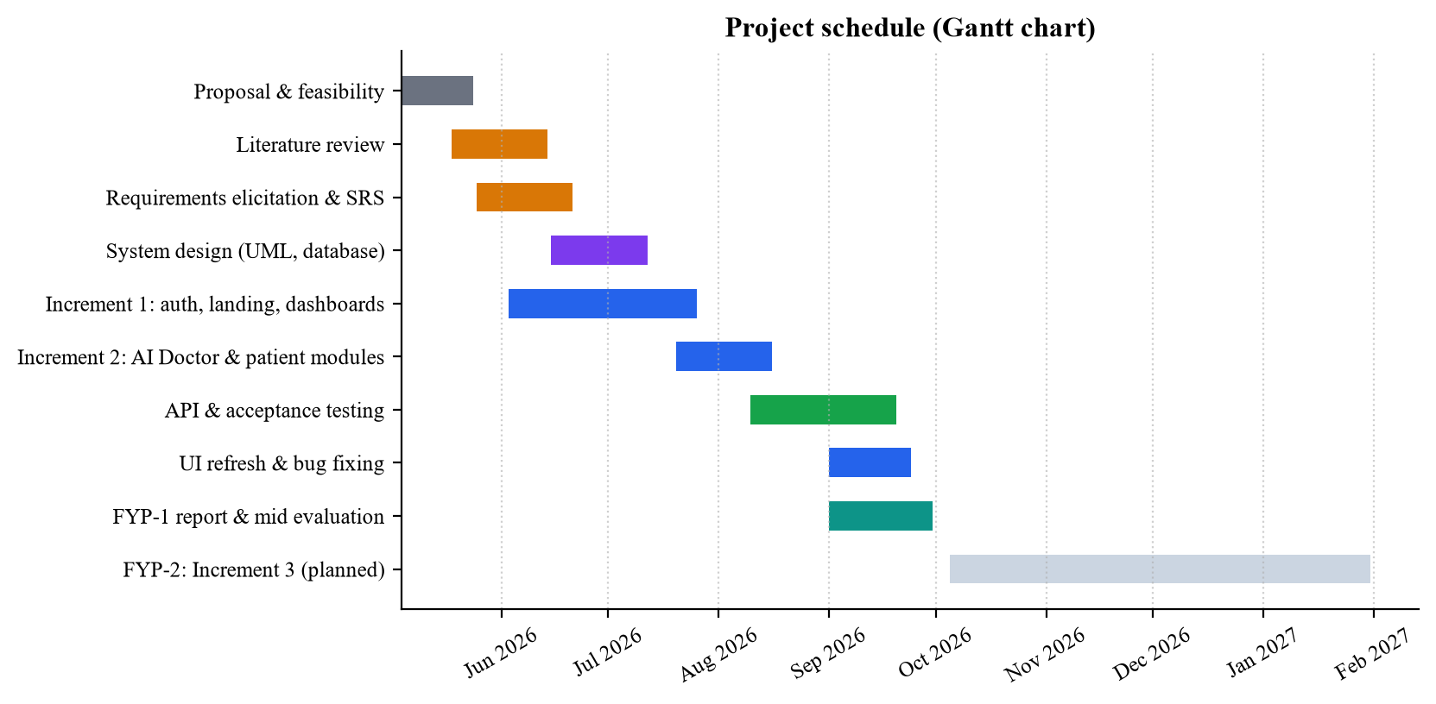
Figure 5.3. Project schedule (Gantt chart)

Team Roles and Responsibilities
Table 5.1 shows how responsibilities were divided. Every member took part in requirement gathering, testing and writing this report, but each had a main area of ownership so that decisions could be made quickly.
Table 5.1. Team roles and responsibilities
Member | Role | Main Responsibilities
[Student Name 1]  [Roll No.] | Team Lead, Back-end and AI Integration | Project planning and supervisor meetings; MongoDB design and API routes; authentication and JWT; Chatbase agent setup and AI Doctor pages; environment and deployment configuration.
[Student Name 2]  [Roll No.] | Front-end and UI/UX Developer | Landing page (hero, features, how it works, testimonials, trust bar, disclaimer); dashboard layouts; Tailwind styling and responsiveness; code clean-up and refactoring.
[Student Name 3]  [Roll No.] | Requirements, Testing and Documentation | Literature review and elicitation; requirements and use cases; UML diagrams; test case design and execution; report writing and formatting.
[Supervisor Name] | Project Supervisor | Guidance on scope and methodology; review of increments and documentation; approval at each milestone.

Tools and Technologies
We deliberately kept the technology stack small. Using JavaScript everywhere meant that any team member could read and fix any part of the code. Table 5.2 lists the main tools and technologies with the versions used.
Table 5.2. Tools and technologies used
Category | Tool / Technology | Version | Purpose in Medisynix
Framework | Next.js | 15.5 | Page rendering, routing and serverless API routes (App Router and Pages Router).
UI library | React | 18.2 | Component-based user interface.
Styling | Tailwind CSS, PostCSS, Autoprefixer | 3.3 | Utility-first styling and responsive layouts.
UI components | Headless UI, Heroicons, React Icons | 1.7 / 2.1 / 4.12 | Accessible menus and dialogs, icon sets.
Charts | Recharts | 3.10 | Area, pie and bar charts on the patient analytics page.
Runtime | Node.js | 22+ (tested on 26) | Server runtime for Next.js and the Express service.
Back-end service | Express | 5.1 | Legacy authentication service (port 5000).
Database | MongoDB Atlas, MongoDB driver, Mongoose | 6.15 / 8.13 | Cloud document database; schemas and validation for users, appointments and metrics.
Security | jsonwebtoken, bcryptjs | 9.0 / 2.4 | Signed session tokens [24]; password hashing [25].
Conversational AI | Chatbase | Hosted service | General and Personal AI Doctor agents grounded in the hospital knowledge base.
Generative AI | Google Gemini API | gemini-2.5-flash / flash-lite | Guide assistant that explains how to use the platform.
Notifications | react-hot-toast | 2.5 | Short confirmation and error messages.
Dev tooling | concurrently, ESLint | 9.1 / 8 | Run both servers with one command; code linting.
Hosting | Vercel | – | Deployment of the Next.js application.
Version control | Git, GitHub | – | Source control and collaboration.
Editor | Visual Studio Code | – | Main development environment.
Testing | node:test, headless Chrome (DevTools Protocol) | – | Unit, API and acceptance testing (Chapter 4).
Design | Mermaid | 11 | UML and architecture diagrams in this report.

Implementation Details
This section walks through the implementation of the main modules. Where it helps, we include short excerpts of the real source code or pseudocode that describes the logic. Following the report guidelines, longer logic is given as pseudocode rather than pasted code.

Project structure and code base
The repository is organised by responsibility, as summarised in Table 5.3.
Table 5.3. Main folders of the code base
Folder | Contents
app/ | Next.js App Router: pages for the landing page, login, registration, password reset and all dashboards; newer API routes under app/api (AI Doctor, guide, patient records, profile, medications, consultations, password reset).
pages/api/ | Older Pages Router API routes: login, registration, appointments, health metrics, doctor directory and admin statistics.
components/ | Shared React components: header, footer, dashboard layout, login and registration forms, dashboard content for each role and the landing page sections.
contexts/ | AuthContext: session state, login and logout, and role-based route protection.
lib/ | Helpers for JWT, database connections (Mongoose and native driver), the static fallback store and a compatibility patch for newer Node.js versions.
models/ | Mongoose schemas for User, Appointment and HealthMetric.
auth/ | Separate Express service with its own routes, middleware and models (legacy).
data/ | JSON files used by the fallback store (users, health metrics, appointments).
public/ | Logos, favicons and images.

Figure 5.4 shows the size of each part of the code base, measured from the files tracked in Git. The app folder, which holds the pages and most API routes, accounts for well over half of all lines. Figure 5.5 shows the split of tracked files by type, and Figure 5.6 counts the REST endpoints in each functional area.
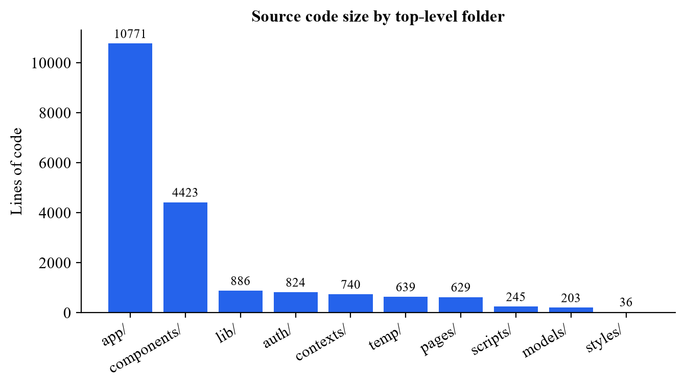
Figure 5.4. Lines of code by top-level folder
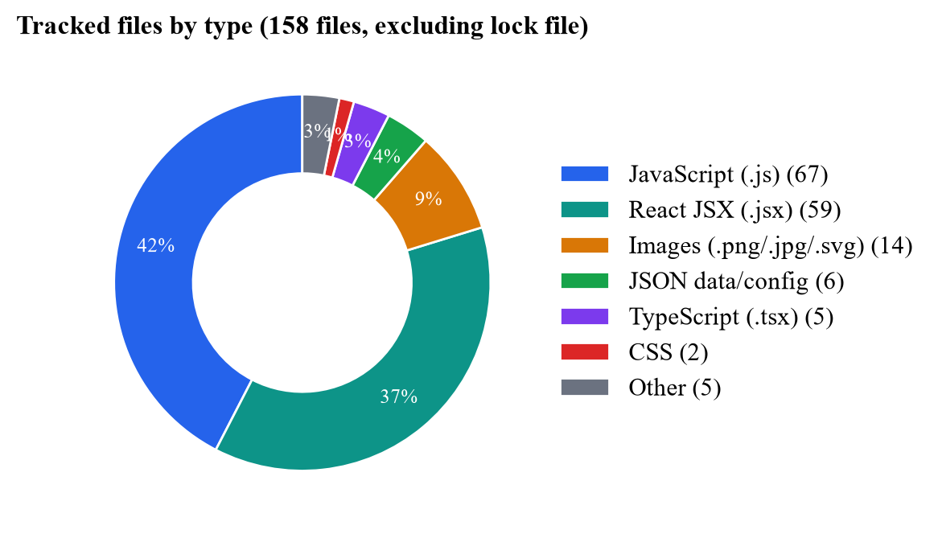
Figure 5.5. Tracked files by type
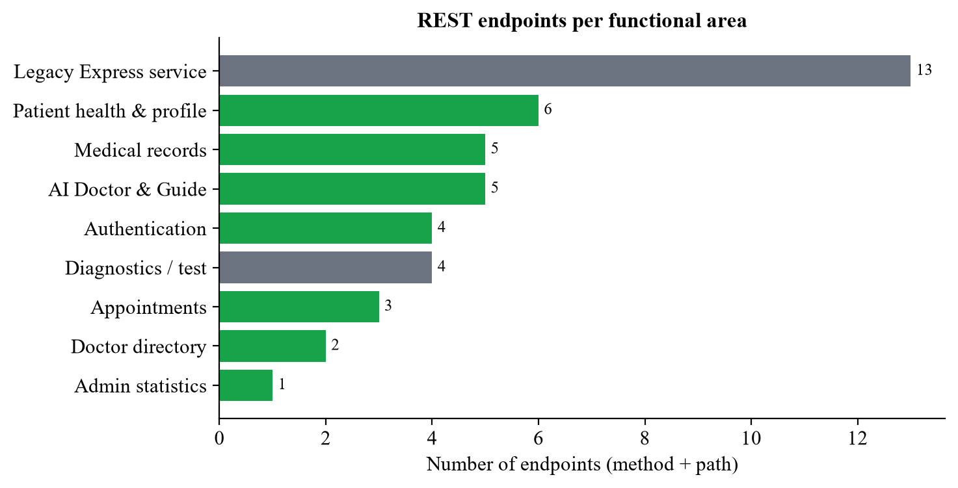
Figure 5.6. Number of REST endpoints per functional area
Figure 5.7 shows the activity in the shared GitHub repository. The first commit in June 2026 imported the code that had been developed locally until then, which is why it is so large. The busy days in August and September match the switch to Chatbase and the landing page redesign described in this chapter.
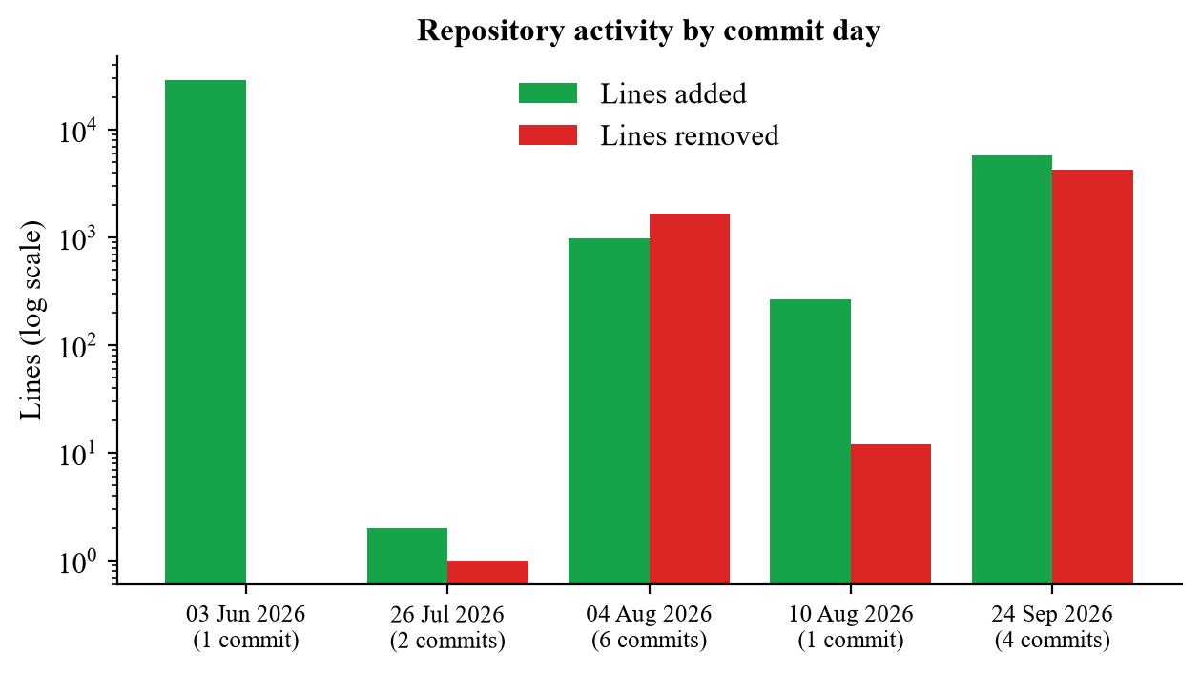
Figure 5.7. Repository activity by commit day (lines added and removed, log scale)

Authentication and session management
Registration and login are handled by two API routes in pages/api/auth. Passwords are never stored in plain text: the User model has a pre-save hook that hashes the password with bcrypt and a salt of cost 10. At login the server compares the submitted password with the stored hash and, if they match, issues a JWT signed with a secret from the environment. The token contains only the user ID, email and role, and expires after seven days.
// lib/jwt.js
export function generateToken(user) {
return jwt.sign(
{ id: user.id || user._id, email: user.email, type: user.userType || user.type },
JWT_SECRET,
{ expiresIn: '7d' }
);
}
On the client, AuthContext stores the returned user and token, restores the session when the page is reloaded and protects routes. Its logic can be summarised as follows:
ON every route change:
IF session is still loading: wait
IF no user AND page is not public: redirect to /login
IF user.type = patient AND page is doctor/admin dashboard: redirect to /dashboard/patient
IF user.type = doctor AND page is patient/admin dashboard: redirect to /dashboard/doctor
IF user.type = admin AND page is patient/doctor dashboard: redirect to /dashboard/admin
Registration is limited to patients on the server side: the register route returns HTTP 403 if any other user type is submitted, so doctor and administrator accounts cannot be created by the public. The password rules from the form are checked again on the server, so they cannot be skipped by calling the API directly. If the database cannot be reached, both routes fall back to the JSON store, which lets us demonstrate the system anywhere.
Client-side redirects are only a convenience; the real protection is on the server. All token handling lives in one helper, lib/jwt.js, which refuses to run in production without a JWT_SECRET. Every protected API route reads the caller from the token and checks ownership before touching any data:
// lib/jwt.js
export function getAuthUser(req) {
const decoded = verifyToken(getBearerToken(req));
if (!decoded || !decoded.id) return null;
return { id: String(decoded.id), email: decoded.email, type: decoded.type };
}
export function canAccessUser(user, ownerId) {
return !!user && (user.type === 'admin' || String(ownerId) === user.id);
}

// pages/api/patient/get-health-metrics.js
const authUser = getAuthUser(req);
if (!authUser) return res.status(401).json({ message: 'Authentication required' });
if (!canAccessUser(authUser, userId)) return res.status(403).json({ message: 'Not allowed' });

AI Doctor integration
The AI Doctor is the heart of Medisynix. It went through two versions. The first version, built in increment 1, sent the patient's symptoms directly to the Google Gemini API with a detailed system prompt that asked for possible conditions, next steps, warning signs and a disclaimer. It worked, but we ran into rate limits, key management problems and answers that were too generic to be useful for local hospital questions. In increment 2 we replaced it with two Chatbase agents trained on content from Aga Khan University Hospital and Al Shifa Hospital.
Each AI Doctor session starts with a call to /api/doctor/init. The route requires the patient's login token and takes the user ID from it, validates the requested mode, makes sure a health record exists for personal sessions, and returns a signed token that expires after one hour:
// app/api/doctor/init/route.js (simplified)
const authUser = getAuthUser(request); // login token required
if (!authUser) return NextResponse.json({ message: 'Authentication required' }, { status: 401 });

const { doctorType } = await request.json();
if (doctorType !== 'personal' && doctorType !== 'general')
return NextResponse.json({ message: 'Valid doctor type required' }, { status: 400 });

const userId = authUser.id; // never taken from the request body
if (doctorType === 'personal') {
const user = await db.collection('users').findOne({ userId });
if (!user) await db.collection('users').insertOne({ userId, healthData: {}, chatHistory: [] });
}
const token = signToken({ userId, doctorType }, { expiresIn: '1h' });
return NextResponse.json({ token, doctorType });
The General and Personal AI Doctor pages check the token before showing anything. If it is missing or belongs to the other mode, the user is returned to the selection page. The chat itself is embedded as an iframe pointing to the Chatbase agent, and a "Start New Chat" button reloads the iframe with a fresh conversation. The Personal AI Doctor page also calls /api/doctor/health-data and shows the patient's age, gender, conditions, medications and allergies in a banner above the chat.
Because the chat runs inside a cross-origin iframe, our page cannot silently inject the health profile into the conversation. We decided to show the profile to the patient and invite them to mention the relevant details, which also keeps the patient in control of what is shared. Passing the profile to the agent automatically, through Chatbase's identity and context features, is planned for FYP-2.

Guide assistant with model fallback
The guide assistant answers questions about how to use Medisynix, such as the difference between the two AI Doctors. It calls the Gemini REST API with a short system prompt that forbids it from answering medical questions. To cope with free-tier rate limits, it tries a list of models in order:
FOR model IN [gemini-2.5-flash, gemini-2.5-flash-lite]:
send system prompt + last 8 messages + new question
IF response OK and text present: RETURN text
IF error is invalid/missing key: STOP and report configuration problem
IF rate limited, model not found or empty reply: try next model
RETURN friendly "assistant is busy" message
The assistant also reads the API key at request time rather than at start-up, so a key added to the environment takes effect without restarting the build. If no key is configured, the user sees a clear message instead of a crash (see TC-19 in Chapter 4).

Health profile, BMI and metrics history
When a patient saves the profile, the update-profile route performs three writes: it updates the user's name and phone number, it upserts the health data used by the Personal AI Doctor (age, gender, blood type, conditions, medications and allergies), and it inserts a new, time-stamped health metrics entry. BMI is calculated on the server so that the value is always consistent:
// app/api/patient/update-profile/route.js
bmi = Math.round((weight / Math.pow(height / 100, 2)) * 10) / 10;
if (bmi < 18.5) bmiStatus = 'Underweight';
else if (bmi < 25) bmiStatus = 'Normal weight';
else if (bmi < 30) bmiStatus = 'Overweight';
else bmiStatus = 'Obese';
The age used by the Personal AI Doctor is worked out from the date of birth, taking into account whether the birthday has already passed this year. The ten most recent metric entries are returned by the get-health-metrics route and used to draw the dashboard.

Dashboard health signal
The patient dashboard turns raw numbers into something a patient can understand at a glance. Each vital sign is compared against commonly used reference ranges, listed in Table 5.4, and receives a status badge.
Table 5.4. Reference ranges used for dashboard status badges
Metric | Normal | Elevated | High / Other
Blood pressure (mmHg) | Below 120/80 | Systolic 120–129 and diastolic below 80 | High for any other reading
Heart rate (bpm) | 60–100 | – | Above 100 high; below 60 low
Glucose (mg/dL) | Below 100 | 100–125 | Above 125 high
BMI (kg/m²) | 18.5–24.9 | 25–29.9 (overweight) | Below 18.5 underweight; 30 and above obese

The badges are then combined into a short "AI health signal". It is intentionally rule-based rather than a machine learning model, so that every statement it makes can be traced to a specific reading. This makes it easy for a patient, or a doctor, to check why the system said what it did.
IF no metrics recorded: status = "Insufficient data"; suggest completing the profile
abnormal = number of metrics with status elevated, high or low
status = "Stable" IF abnormal = 0
= "Attention suggested" IF abnormal = 1
= "Needs follow-up" IF abnormal >= 2
confidence = 94 IF abnormal = 0 ELSE 88 - 4 x abnormal
FOR each metric: add a plain-language reason, e.g. "Your heart rate (74 bpm) is within a healthy range."
ALWAYS add: "Reviews are informational only - confirm with a clinician"

Appointments and the fallback data store
The appointments route supports GET (list, optionally filtered by status), POST (create) and PUT (update, used for both rescheduling and cancelling). It follows the same pattern as the other fallback-enabled routes: try MongoDB first, and if anything goes wrong with the connection, use the JSON store in the data folder and add "fallback: true" to the response so that the front end and our tests can tell which source was used.
try {
await dbConnect(); // 2-second timeout
const appointments = await Appointment.find({ patientId, status }).sort({ date: 1, time: 1 });
return res.status(200).json({ success: true, data: appointments });
} catch (error) {
const data = getUserAppointments(patientId); // lib/static-data.js
return res.status(200).json({ success: true, fallback: true, data });
}
The appointment schema defines compound indexes on patient ID with status and doctor ID with status, because these are the two queries the dashboards run most often.

Password reset
The password reset flow follows common security advice [23]. The forgot-password route always returns the same message whether or not the email exists, which prevents attackers from discovering registered emails. The token sent to the user is 32 random bytes, but only its SHA-256 hash is stored in the database, together with an expiry time one hour ahead. Both routes reject values that are not plain strings, so a request cannot smuggle in MongoDB query operators. The reset route hashes the token it receives, looks for a user with that hash and an unexpired time, saves the new bcrypt-hashed password and removes the token fields so the link cannot be reused. The reset link is never returned in the API response; during local development it is written to the server log, and sending it by email is planned for FYP-2.

Doctor and administrator dashboards
The doctor workspace shows today's statistics, appointments, AI-generated clinical insights, new patient requests and a patient search box. At this stage it is a working interface populated with sample data, which let us agree the layout with our supervisor before building the real data flows. The administrator dashboard is connected to a real endpoint, restricted to administrator tokens, that counts users by role and returns the most recent registrations, refreshing every 60 seconds. Both dashboards will be completed in FYP-2.

Screenshots of Prototype / System
This section presents screenshots of the working system. All screenshots were taken from the application running locally, using the demo accounts included in the project. The AI Doctor conversations are real responses from our Chatbase agents.

Public pages
Figure 5.8 shows the landing page that visitors see first, with the main message, call-to-action buttons and a preview of the assistant. Figure 5.9 shows the features section, and Figure 5.10 shows the "How it works" steps and the live assistant that visitors can try without signing in.
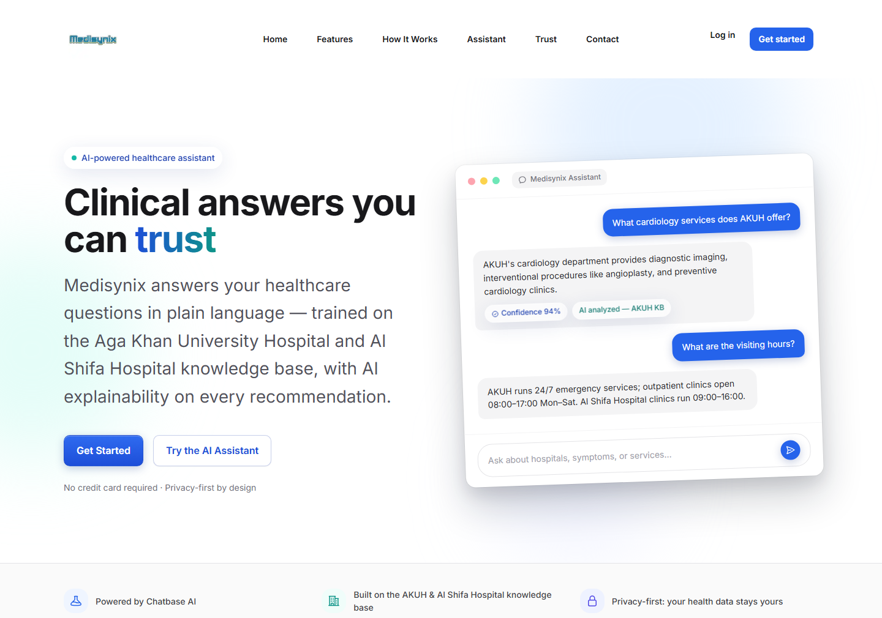
Figure 5.8. Landing page: hero section
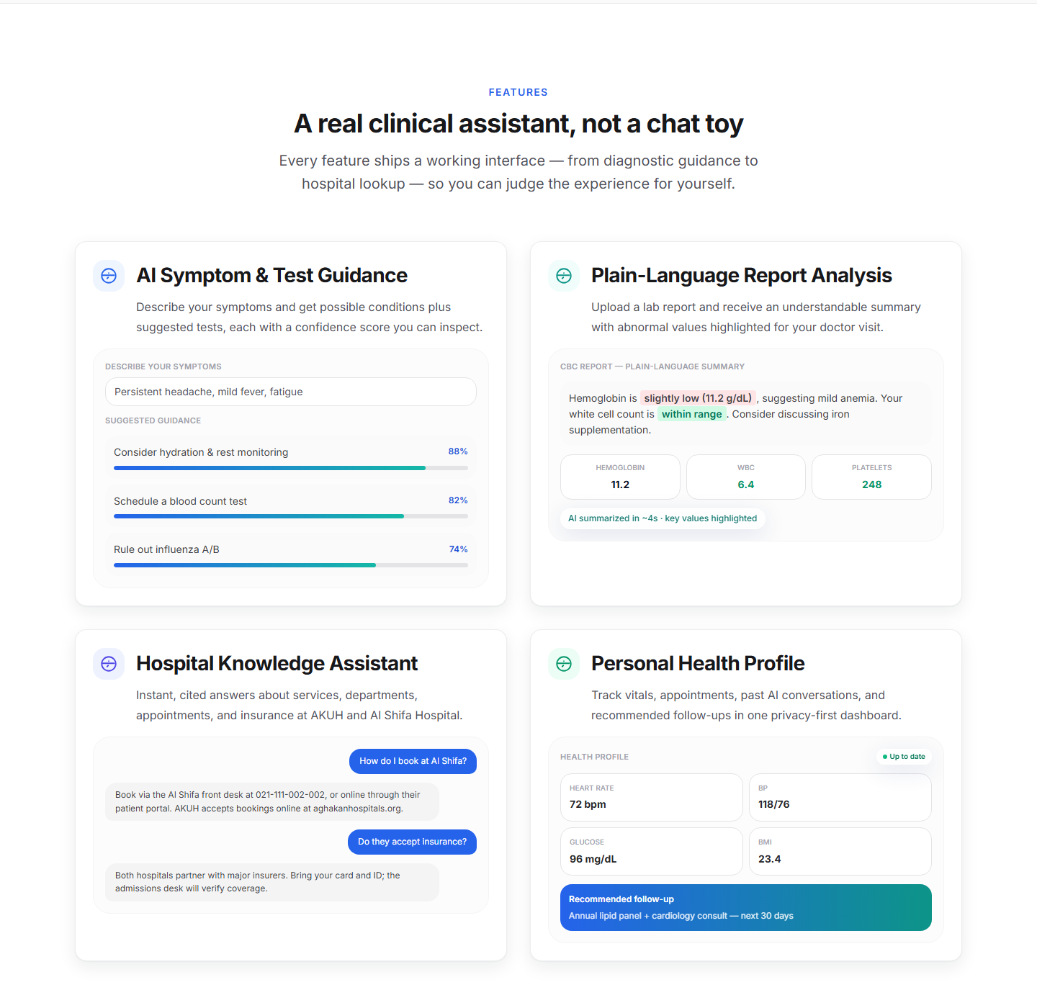
Figure 5.9. Landing page: features section
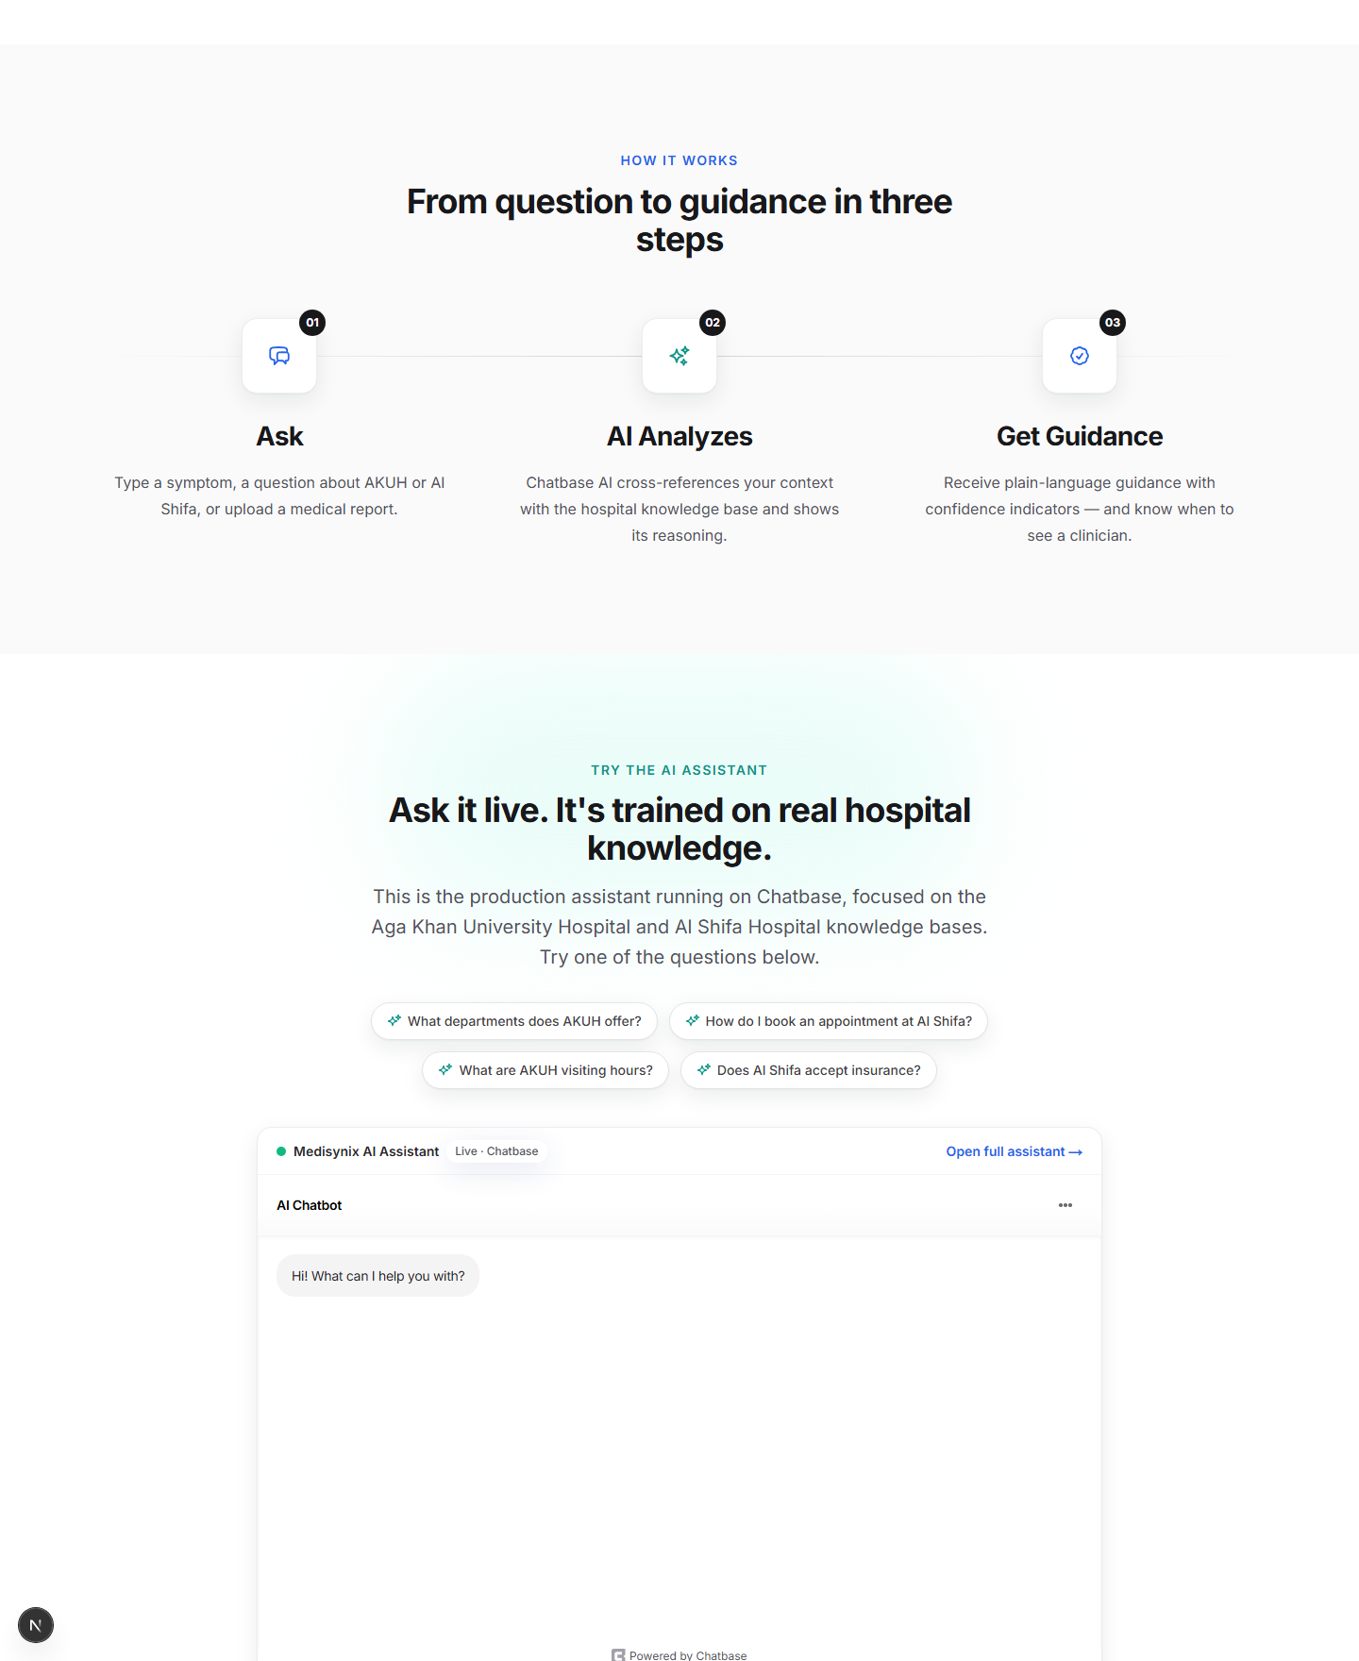
Figure 5.10. Landing page: "How it works" and live assistant
Figure 5.11, Figure 5.12 and Figure 5.13 show the login, registration and password recovery pages.
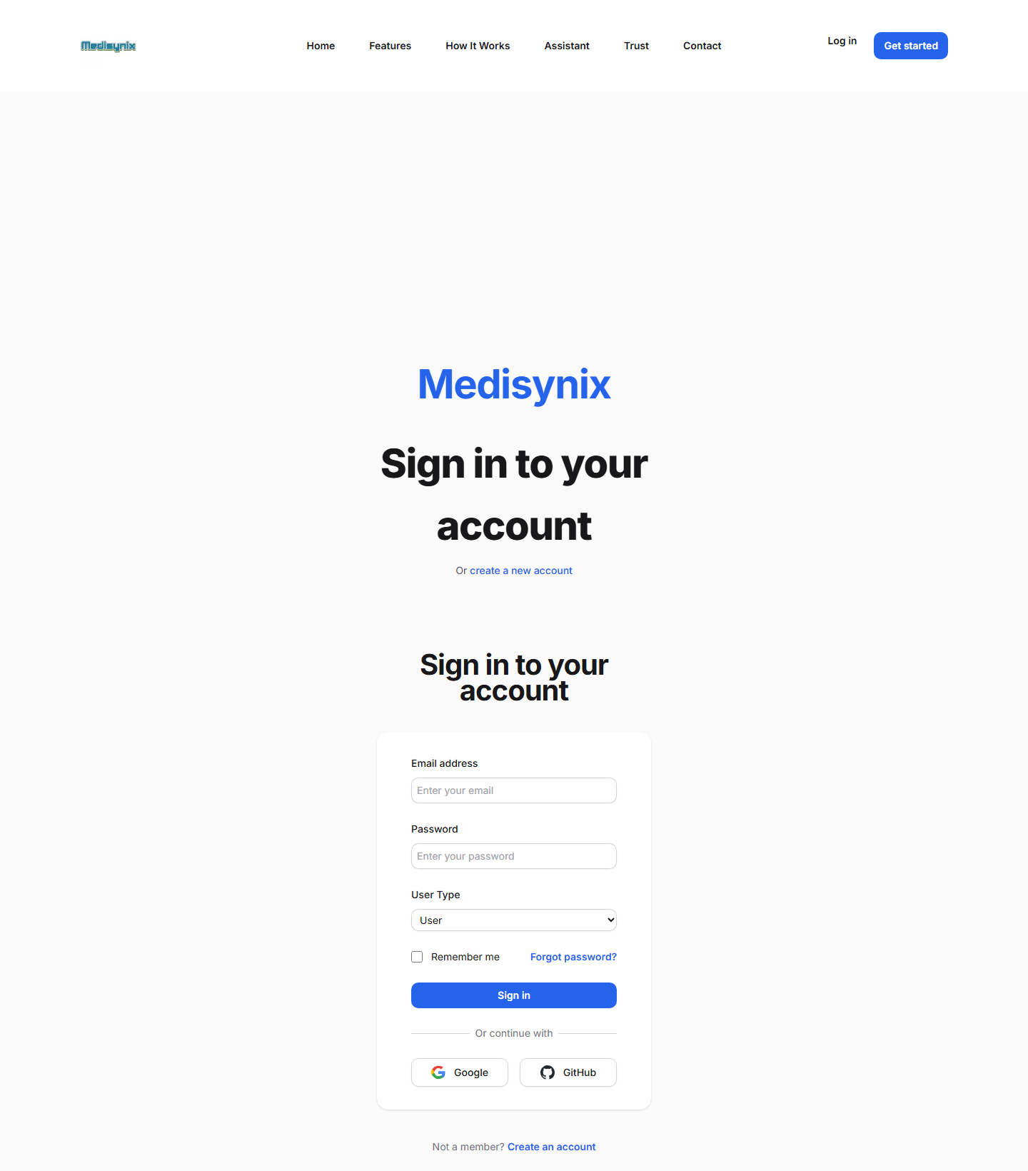
Figure 5.11. Login page
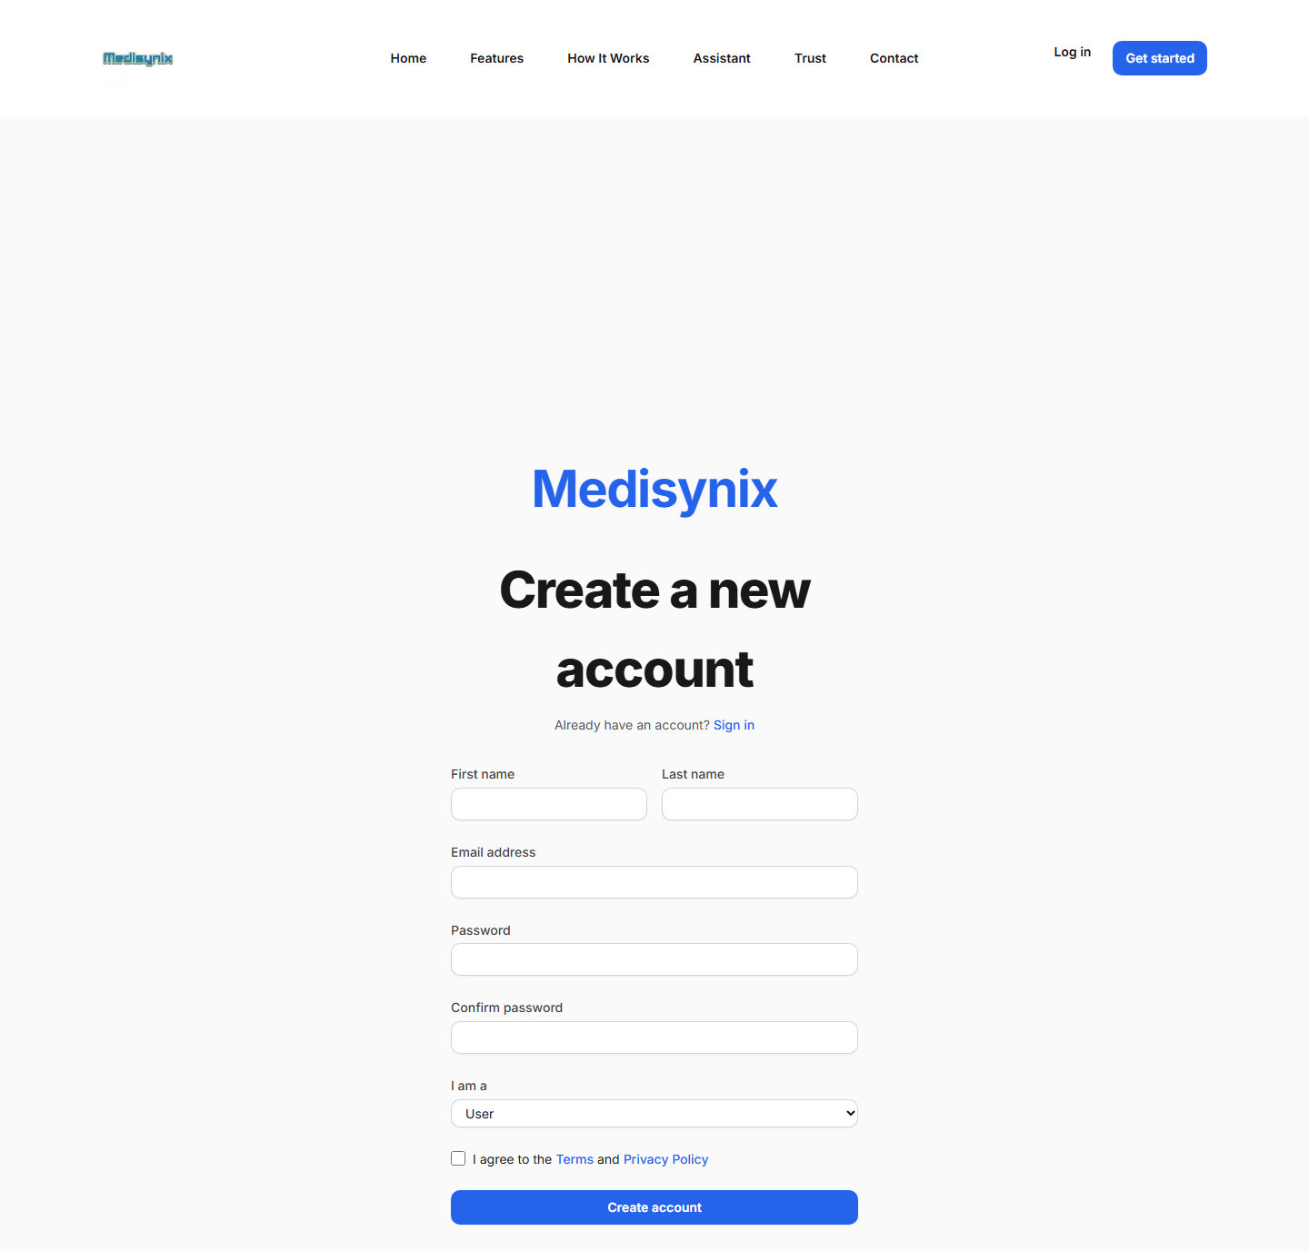
Figure 5.12. Registration page
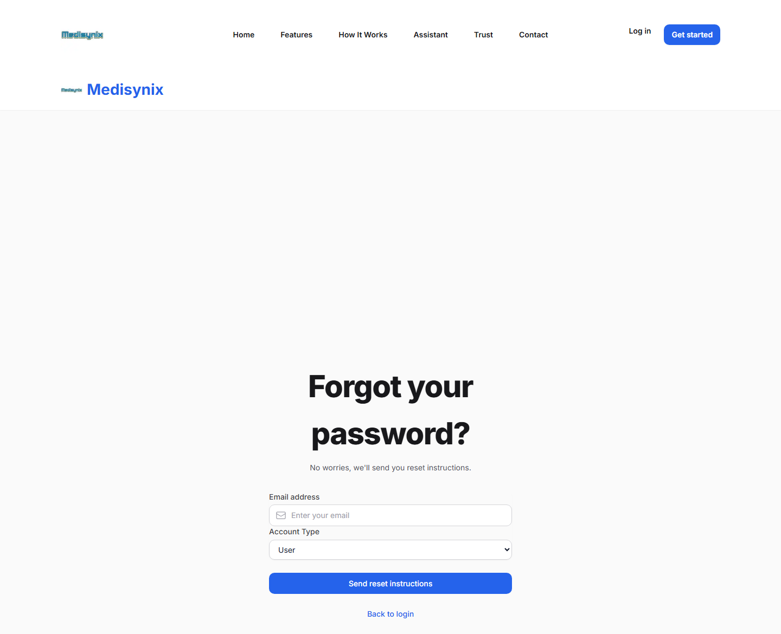
Figure 5.13. Forgot password page

Patient module
Figure 5.14 shows the patient dashboard with quick actions, health metrics, the AI health signal, the upcoming appointment panel, recent AI conversations and medical reports. Figure 5.15 shows the health profile with personal information, health metrics (including the automatically calculated BMI) and medical history.
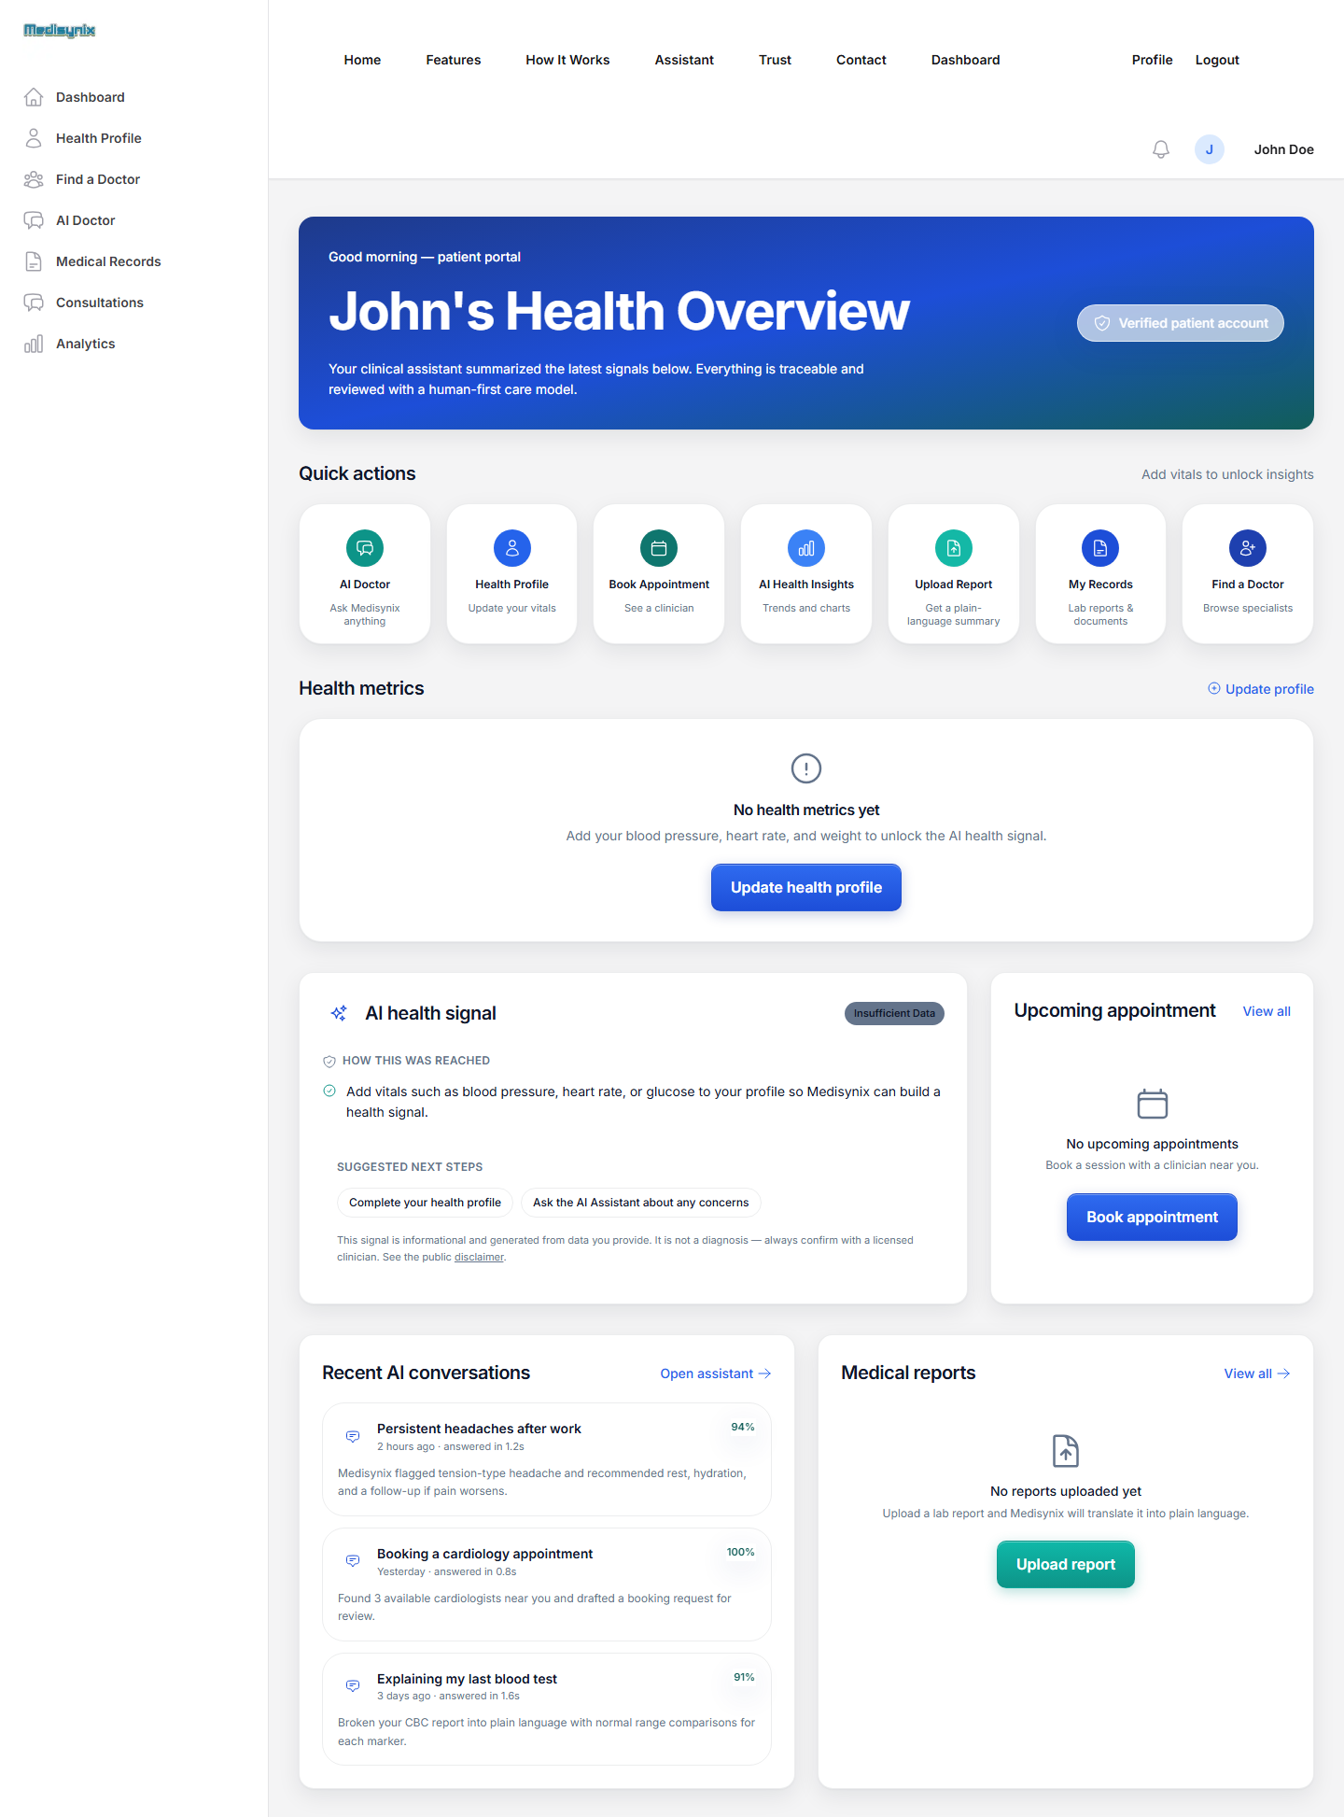
Figure 5.14. Patient dashboard
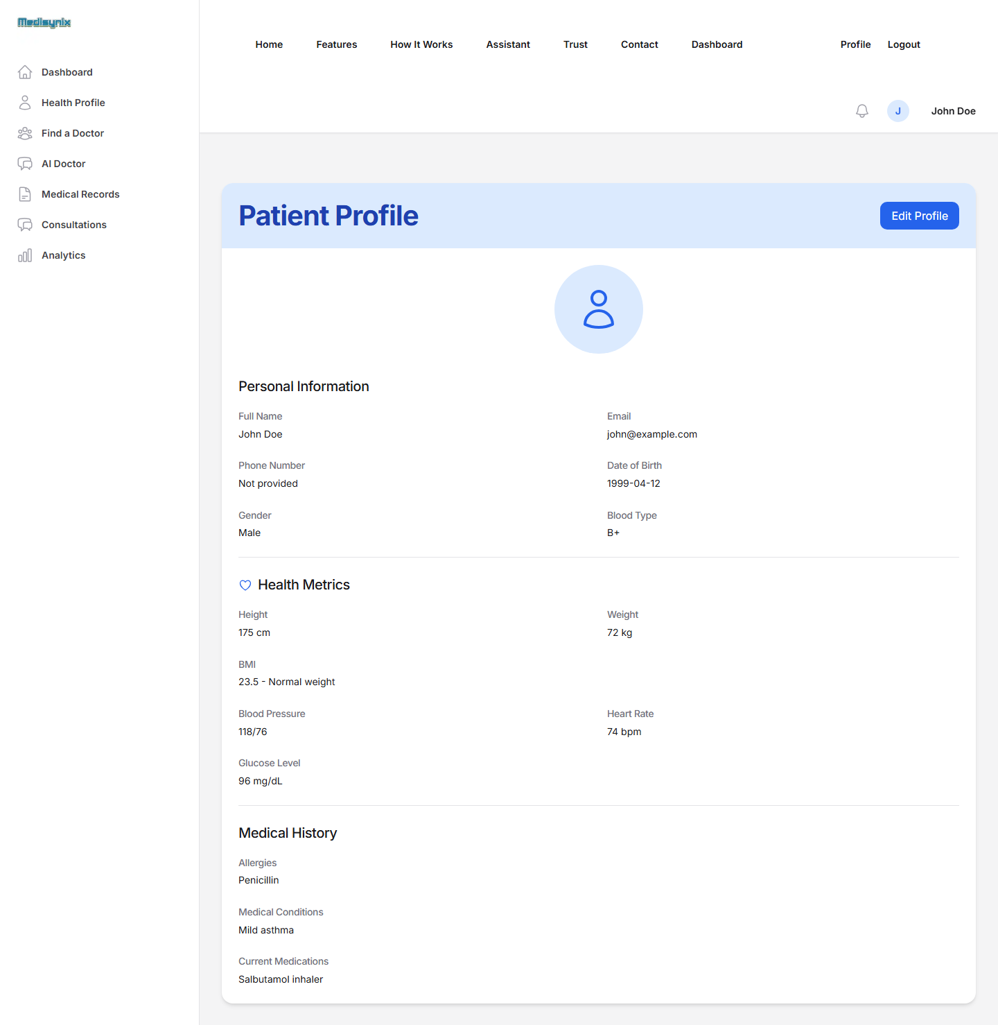
Figure 5.15. Patient health profile
Figure 5.16 shows the AI Doctor selection page. Figure 5.17 and Figure 5.18 show the General AI Doctor and a real answer to a question about cardiology services at AKUH. Figure 5.19 and Figure 5.20 show the Personal AI Doctor with its health profile banner and a personalised answer for a patient with mild asthma.
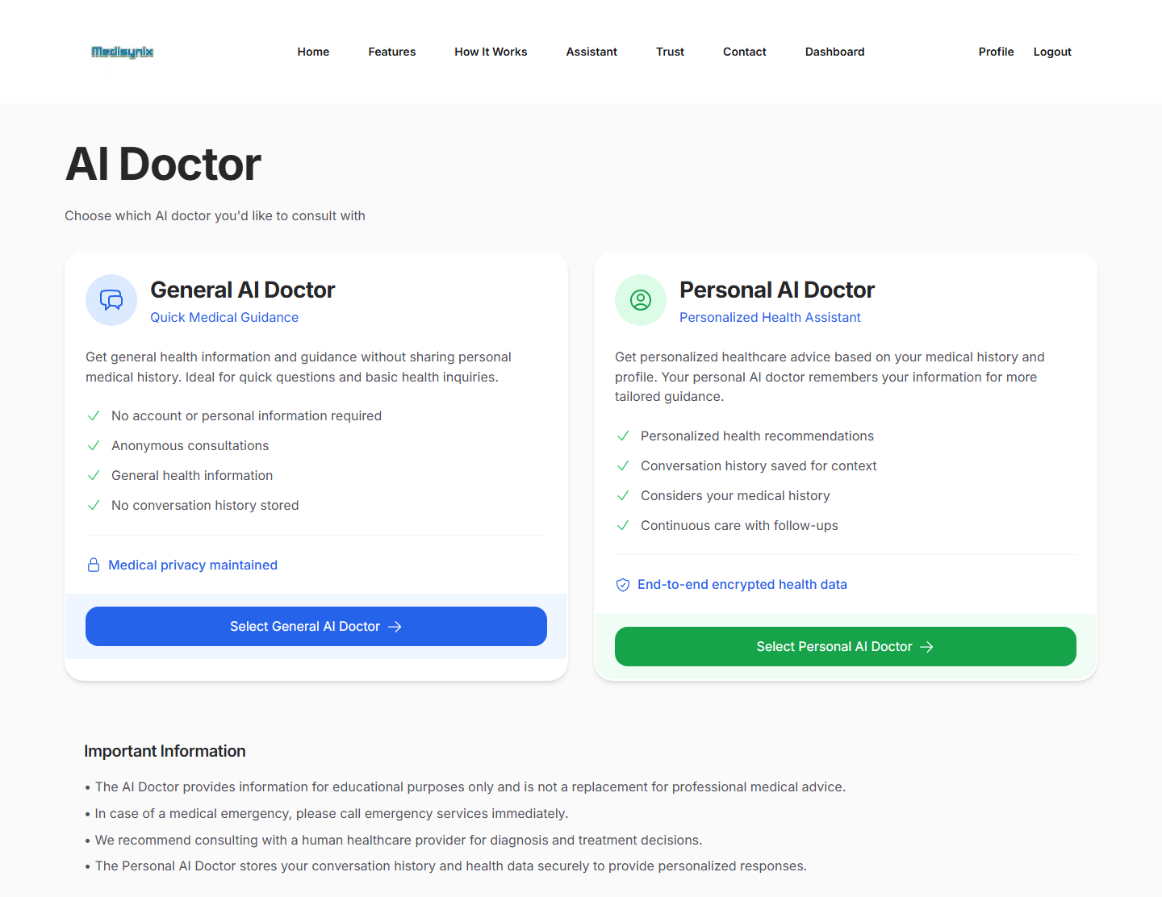
Figure 5.16. AI Doctor selection page
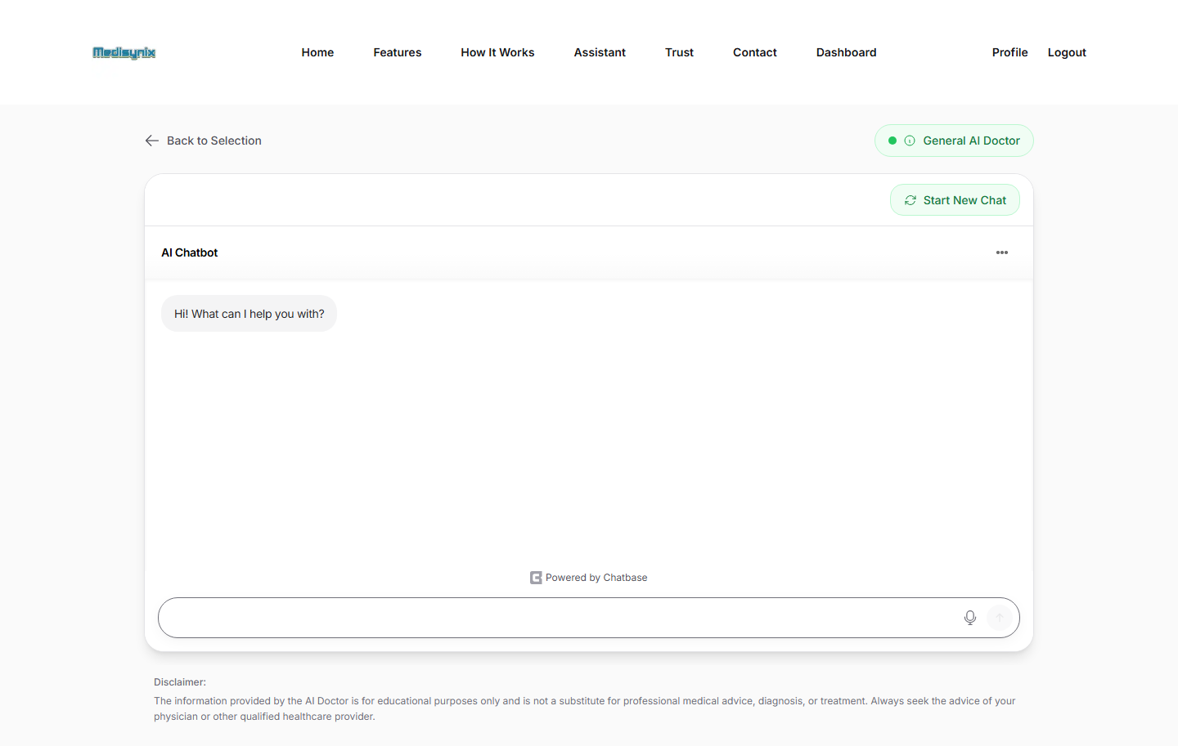
Figure 5.17. General AI Doctor page
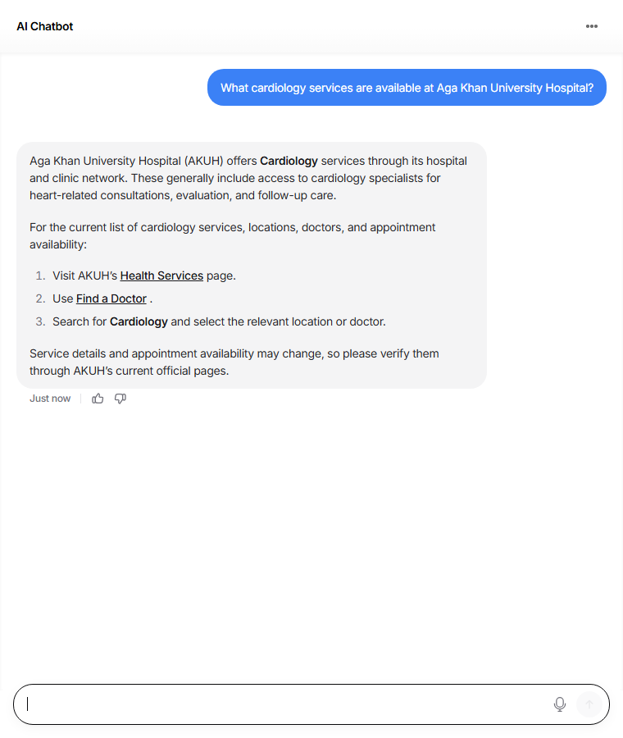
Figure 5.18. General AI Doctor answering a question about AKUH cardiology services
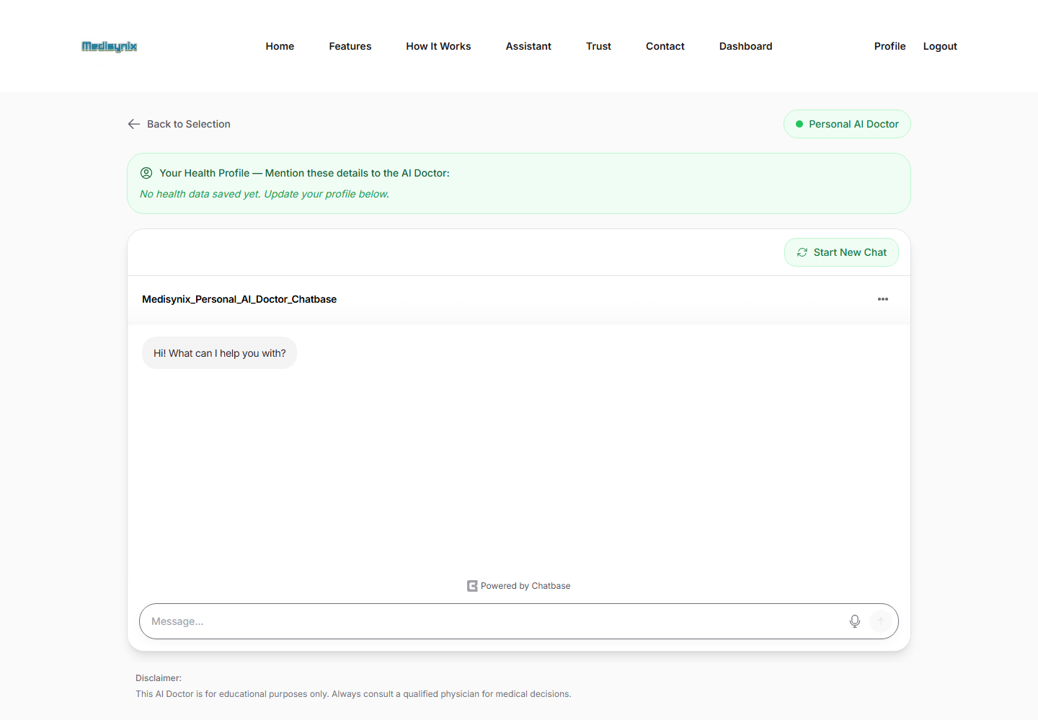
Figure 5.19. Personal AI Doctor page with health profile banner
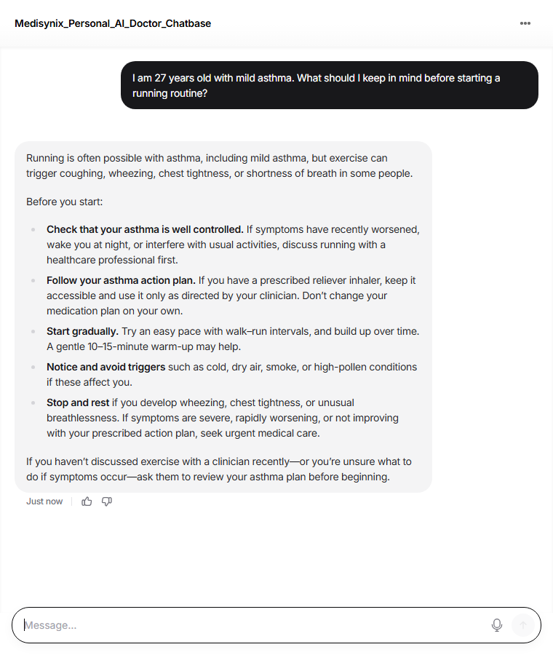
Figure 5.20. Personal AI Doctor giving safety-conscious guidance for a patient with asthma
Figure 5.21 shows the symptom checker after the symptoms "fever, headache, cough, body aches" were entered. Figure 5.22 and Figure 5.23 show the doctor search page and a doctor's profile page.
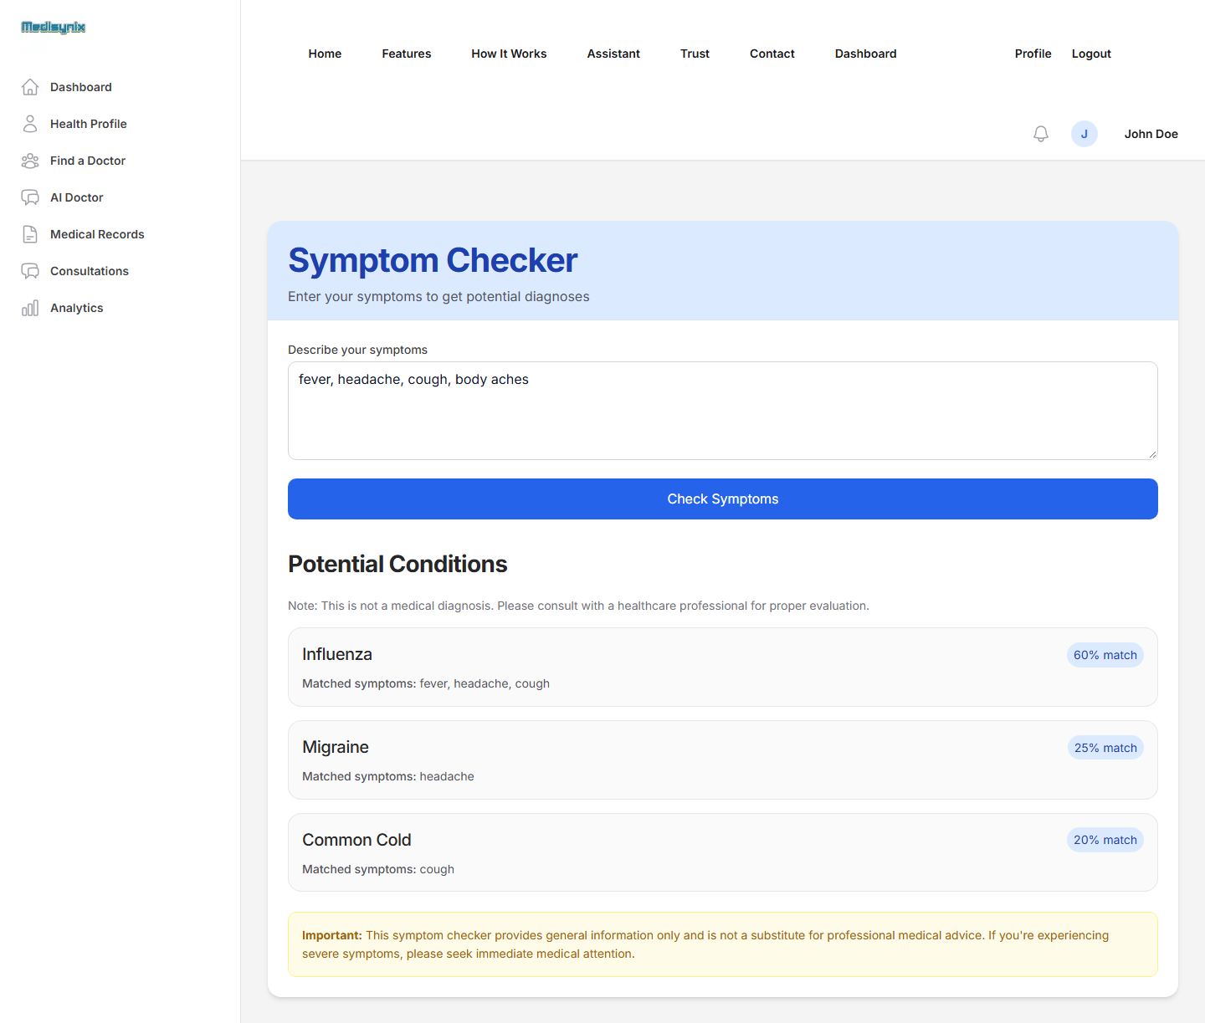
Figure 5.21. Symptom checker results
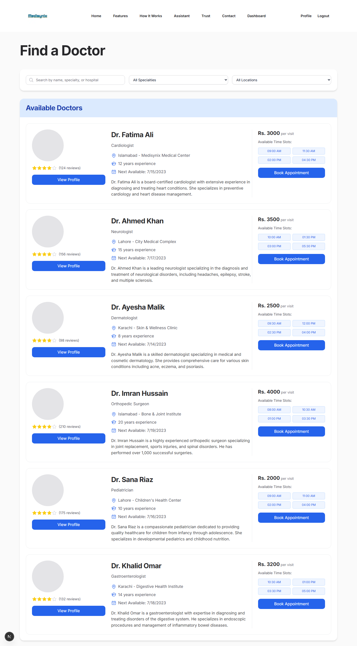
Figure 5.22. Find a Doctor page
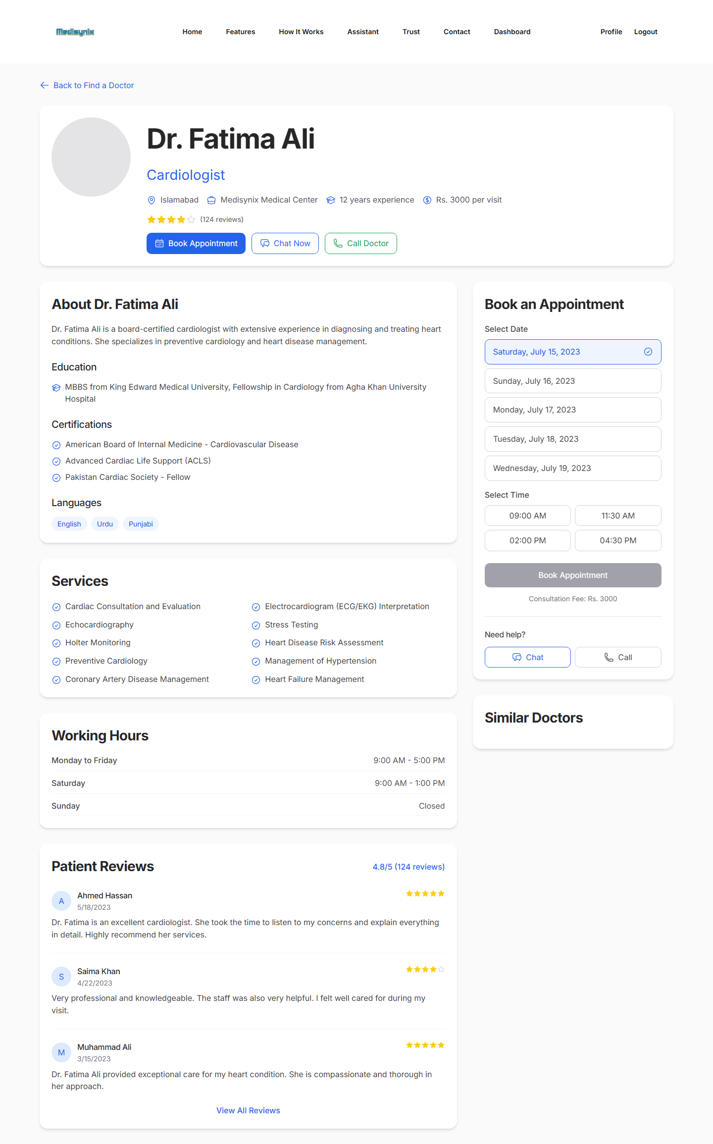
Figure 5.23. Doctor profile page
Figure 5.24, Figure 5.25, Figure 5.26 and Figure 5.27 show the appointments, medications, medical records and report upload pages.
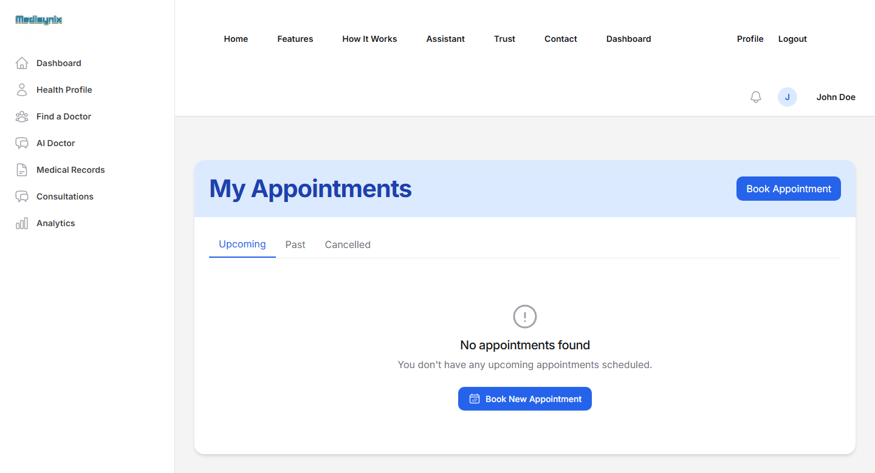
Figure 5.24. My Appointments page
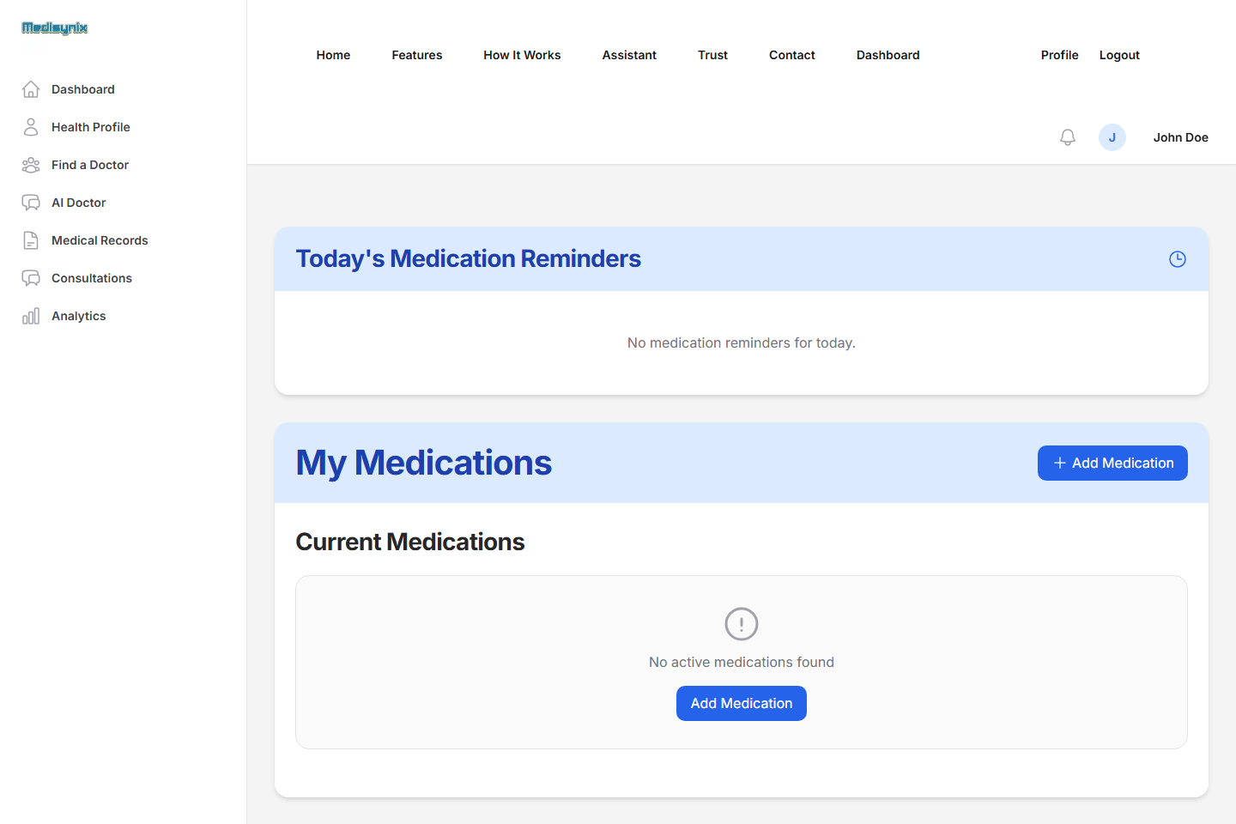
Figure 5.25. Medications page with reminders
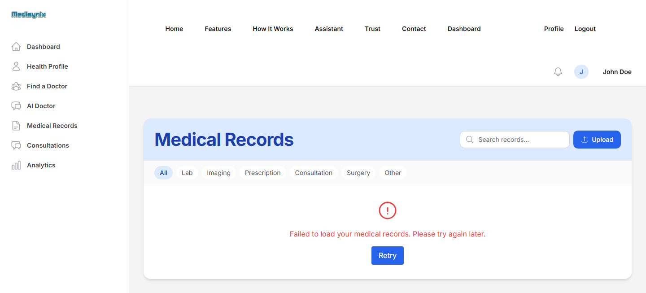
Figure 5.26. Medical records page
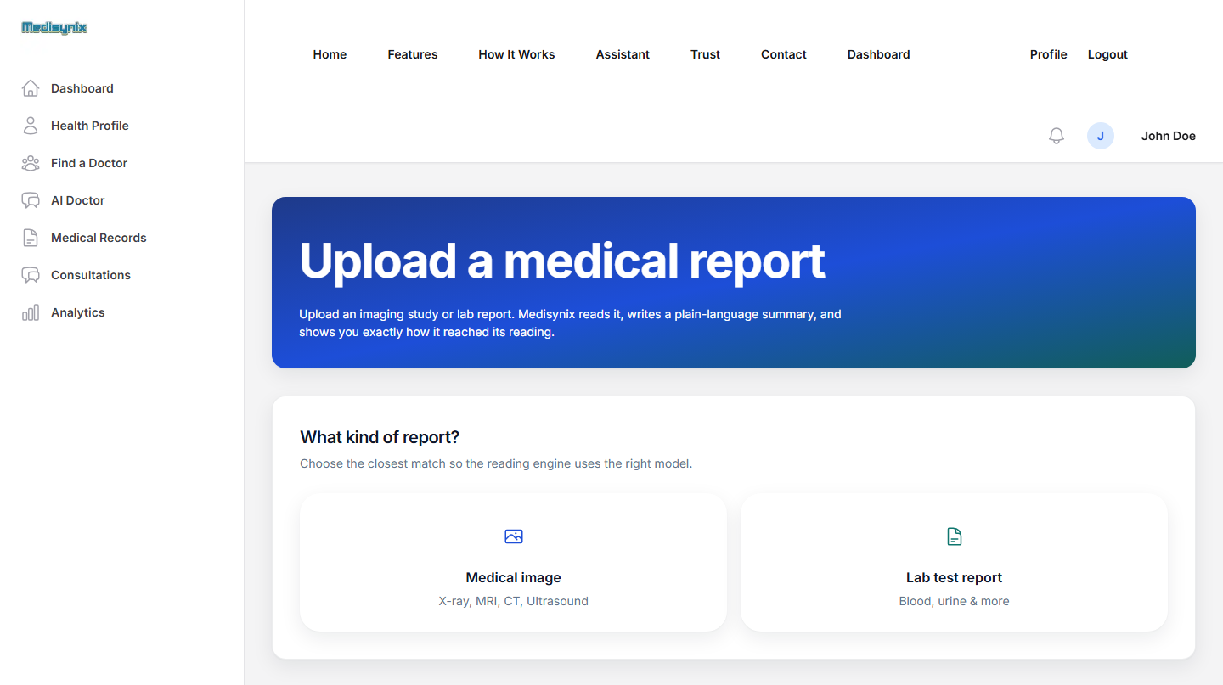
Figure 5.27. Upload medical report page

Doctor and administrator modules
Figure 5.28 shows the doctor workspace, Figure 5.29 the report upload tool for doctors and Figure 5.30 the doctor profile. Figure 5.31 shows the administrator dashboard.
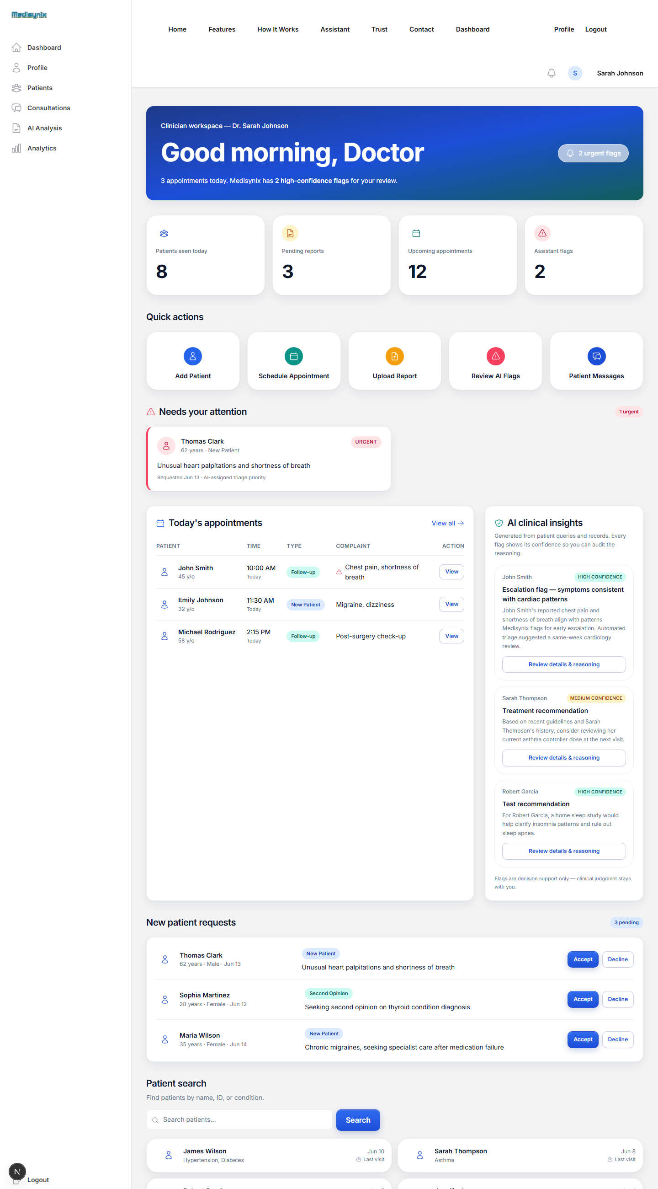
Figure 5.28. Doctor workspace
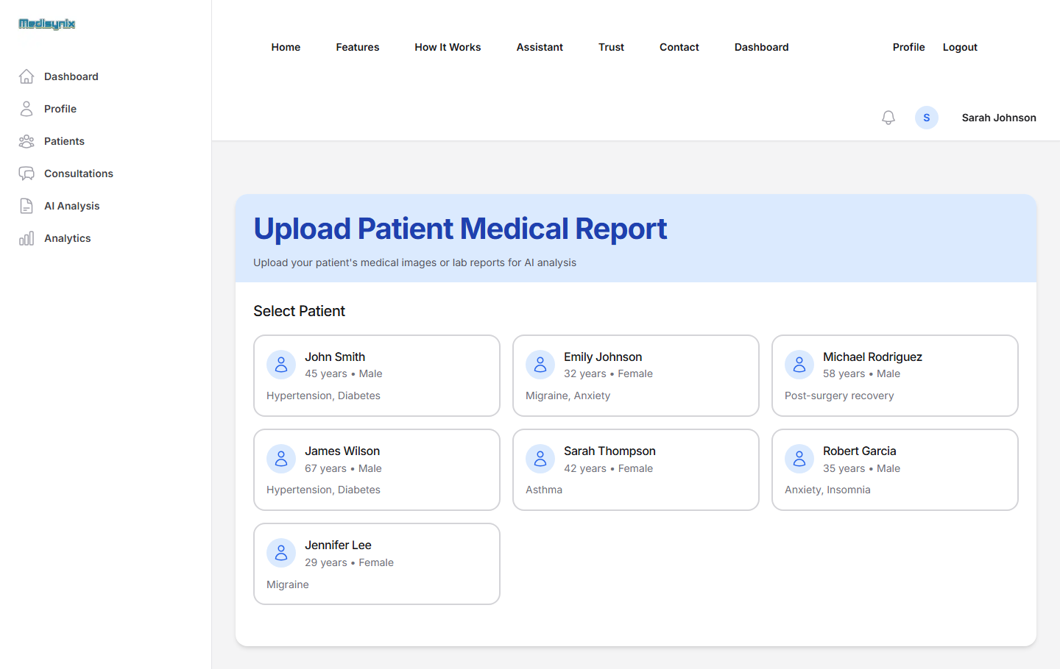
Figure 5.29. Doctor: upload patient medical report
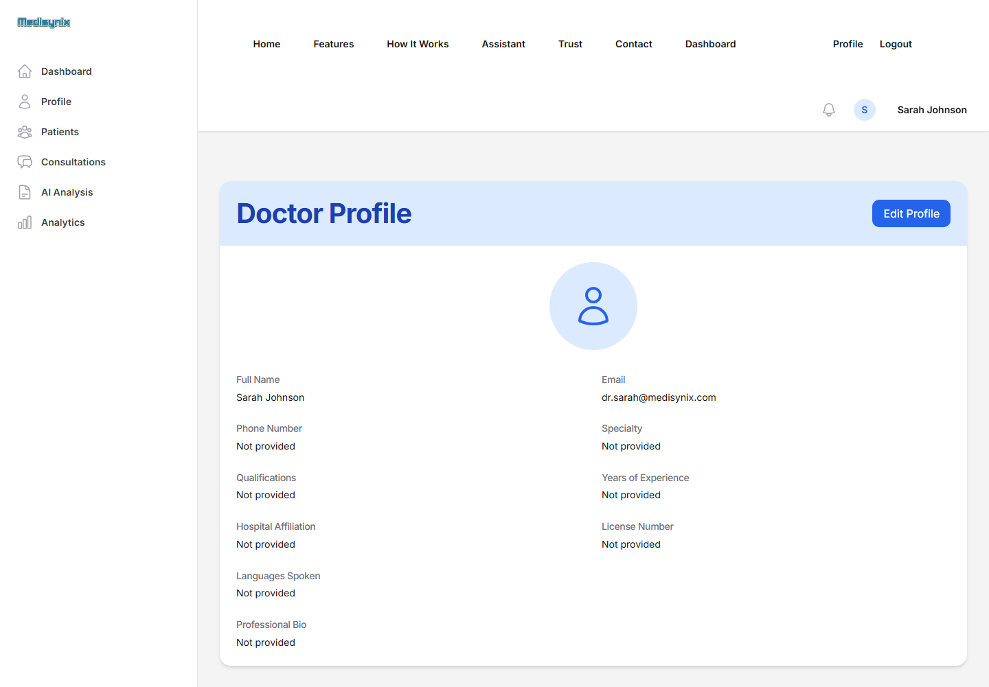
Figure 5.30. Doctor profile page
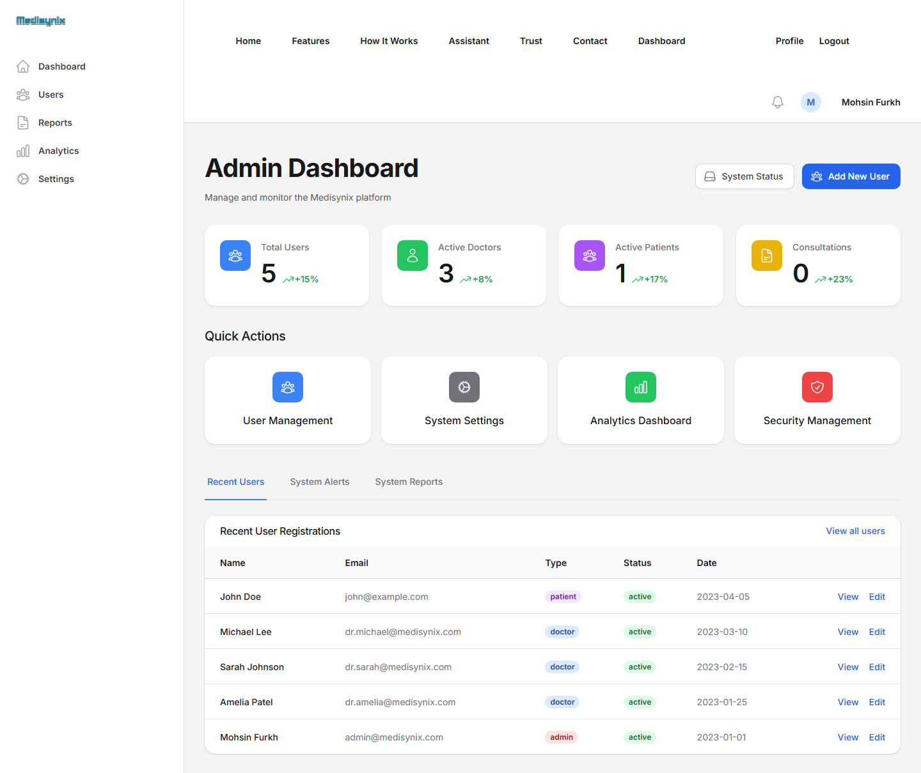
Figure 5.31. Administrator dashboard

Challenges During Implementation
Building Medisynix taught us a great deal, often the hard way. The main challenges, and how we dealt with them, are described below.
- Moving from Gemini to Chatbase. Our first AI Doctor called the Gemini API directly from a server route. We hit free-tier rate limits during demonstrations, and the answers, while fluent, knew nothing specific about the hospitals our users cared about. Switching to Chatbase fixed both problems, but it meant rewriting the AI Doctor pages around an embedded iframe and accepting less control over the conversation.
- Keeping secrets out of the repository. Early in the project an environment file with the database connection string was committed to GitHub by mistake. We removed it from tracking, added it to .gitignore and moved all secrets to environment variables. The episode made us far more careful. We also learned that removing a file from the latest commit does not remove it from Git history, so exposed keys must be rotated as well.
- Unreliable database connectivity. MongoDB Atlas was sometimes unreachable from the networks we worked on (it was unreachable during our final test run as well), and passwords with special characters broke the connection string. We wrote a helper that re-encodes the password part of the URI, set a short 2-second connection timeout, and added a JSON fallback store so that the key features keep working. The cost of this approach is visible in Chapter 4: fallback responses take about two seconds.
- Breaking changes in Node.js. After upgrading Node.js, the jsonwebtoken package crashed on start-up because a deprecated Buffer API it depends on had been removed. We added a small compatibility patch (lib/slowbuffer-patch.js) that restores the missing export before the library loads.
- Two routers and two database helpers. The project grew from an older Pages Router prototype into the App Router. For a while it was not obvious which folder a given endpoint lived in, and the two database helpers pointed to different database names, which caused users saved by one part of the system not to be found by another. The profile route now searches by several identifiers, and consolidating everything onto one router and one helper is a priority for FYP-2.
- Passing context to an embedded chatbot. Because the Chatbase chat runs in a cross-origin iframe, our page cannot send the health profile to it silently. We chose to show the profile to the patient instead, and we plan to use Chatbase's context features in FYP-2.
- Keeping the AI safe. It is easy to build a chatbot that sounds like a doctor. It is much harder to make one that knows its limits. We spent time on the agents' instructions, added disclaimers to every AI screen and tested the assistant with questions that invite a diagnosis. The agents consistently gave general guidance and pointed users to professionals, as seen in AT-07 and AT-08.
- Prototype pages versus finished features. To agree on the layout early we built several pages (doctor workspace, report analysis, chat with doctors) with sample data first. This helped the design discussions, but it also left some pages looking finished when the logic behind them is not. The defect log in Chapter 4 lists these honestly so they are not forgotten.
- Security review. Late in FYP-1 we reviewed the code against the OWASP Top 10 and found that several API routes trusted IDs sent by the browser, that hard-coded fallback secrets and an API key were still in the code, and that diagnostic endpoints leaked user emails. None of this was visible from the user interface, which is exactly why it had gone unnoticed. We fixed every finding, added 39 security regression tests (Section 4.3) and adopted a simple rule for the rest of the project: the server decides who the user is, never the request body.
- Team coordination. Several of us sometimes edited the same files, and merging parallel changes from GitHub needed care (several merge commits in the history come from this). We agreed to pull before starting work, keep commits small and review each other's changes before merging into the main branch.

Progress Summary and Plan for FYP-2
Figure 5.32 summarises the state of the 28 features we planned for the whole project. Thirteen work end-to-end, five work but have known defects, four are interface prototypes with sample data and six are planned for FYP-2.
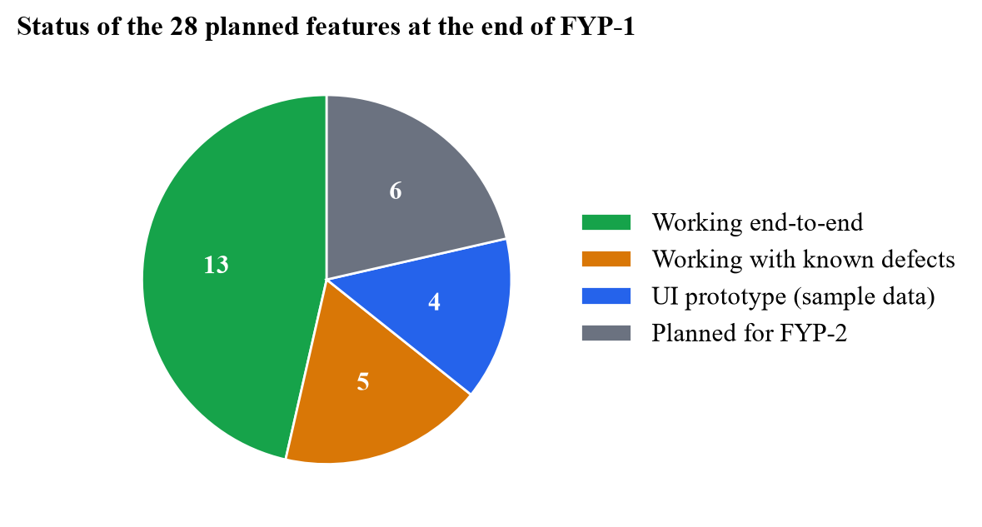
Figure 5.32. Status of planned features at the end of FYP-1
The main work planned for FYP-2 is listed in Table 5.5.
Table 5.5. Work planned for FYP-2
Area | Planned work
Defect fixing | Fix the remaining open functional defects (D-01 to D-03 and D-05 to D-11), starting with the analytics crash, record upload and file storage.
Security | Move session tokens to HTTP-only cookies, rate-limit login attempts, upgrade to Next.js 16 and rotate the credentials that were exposed in the repository history.
AI | Pass the patient's profile to the Personal AI Doctor automatically; implement real analysis of uploaded lab reports with plain-language explanations; add Urdu support.
Doctor module | Connect the workspace to real appointments; add patient lists, consultation notes and acceptance of patient requests.
Admin module | User management (create, edit, deactivate), reports and system settings.
Data layer | Merge the two routers and database helpers; store uploaded files in cloud storage.
Notifications | Email password reset links and appointment reminders.
Evaluation | Usability testing with real patients and a structured review of AI answers by medical professionals; performance tests against the live database.

References
[1] K. Singhal, S. Azizi, T. Tu, S. S. Mahdavi, J. Wei, H. W. Chung et al., "Large language models encode clinical knowledge," Nature, vol. 620, no. 7972, pp. 172–180, 2023.
[2] P. Lee, S. Bubeck and J. Petro, "Benefits, limits, and risks of GPT-4 as an AI chatbot for medicine," New England Journal of Medicine, vol. 388, no. 13, pp. 1233–1239, 2023.
[3] H. L. Semigran, J. A. Linder, C. Gidengil and A. Mehrotra, "Evaluation of symptom checkers for self diagnosis and triage: audit study," BMJ, vol. 351, p. h3480, 2015.
[4] S. Gilbert, A. Mehl, A. Baluch, C. Cawley, J. Challiner, H. Fraser et al., "How accurate are digital symptom assessment apps for suggesting conditions and urgency advice? A clinical vignettes comparison to GPs," BMJ Open, vol. 10, no. 12, p. e040269, 2020.
[5] Z. Ji, N. Lee, R. Frieske, T. Yu, D. Su, Y. Xu et al., "Survey of hallucination in natural language generation," ACM Computing Surveys, vol. 55, no. 12, pp. 1–38, 2023.
[6] I. Sommerville, Software Engineering, 10th ed. Boston, MA, USA: Pearson, 2016.
[7] L. Laranjo, A. G. Dunn, H. L. Tong, A. B. Kocaballi, J. Chen, R. Bashir et al., "Conversational agents in healthcare: a systematic review," Journal of the American Medical Informatics Association, vol. 25, no. 9, pp. 1248–1258, 2018.
[8] A. Palanica, P. Flaschner, A. Thommandram, M. Li and Y. Fossat, "Physicians' perceptions of chatbots in health care: cross-sectional web-based survey," Journal of Medical Internet Research, vol. 21, no. 4, p. e12887, 2019.
[9] K. Middleton, M. Butt, N. Hammerla, S. Hamblin, K. Mehta and A. Parsa, "Sorting out symptoms: design and evaluation of the 'babylon check' automated triage system," arXiv preprint arXiv:1606.02041, 2016.
[10] Ada Health GmbH, "Ada – your health companion," [Online]. Available: https://ada.com. [Accessed: Sep. 2026].
[11] J. W. Ayers, A. Poliak, M. Dredze, E. C. Leas, Z. Zhu, J. B. Kelley et al., "Comparing physician and artificial intelligence chatbot responses to patient questions posted to a public social media forum," JAMA Internal Medicine, vol. 183, no. 6, pp. 589–596, 2023.
[12] P. Lewis, E. Perez, A. Piktus, F. Petroni, V. Karpukhin, N. Goyal et al., "Retrieval-augmented generation for knowledge-intensive NLP tasks," in Advances in Neural Information Processing Systems 33 (NeurIPS 2020), 2020, pp. 9459–9474.
[13] Chatbase, "Chatbase documentation," [Online]. Available: https://www.chatbase.co/docs. [Accessed: Sep. 2026].
[14] Aga Khan University Hospital, "Aga Khan University Hospital, Karachi," [Online]. Available: https://hospitals.aku.edu/pakistan. [Accessed: Sep. 2026].
[15] Google, "Gemini API documentation," [Online]. Available: https://ai.google.dev/gemini-api/docs. [Accessed: Sep. 2026].
[16] Marham, "Marham – find and consult the best doctors in Pakistan," [Online]. Available: https://www.marham.pk. [Accessed: Sep. 2026].
[17] oladoc, "oladoc – book appointments with the best doctors in Pakistan," [Online]. Available: https://oladoc.com. [Accessed: Sep. 2026].
[18] Sehat Kahani, "Sehat Kahani – telemedicine platform," [Online]. Available: https://sehatkahani.com. [Accessed: Sep. 2026].
[19] World Health Organization, Global Strategy on Digital Health 2020–2025. Geneva, Switzerland: WHO, 2021.
[20] Meta Open Source, "React documentation," [Online]. Available: https://react.dev. [Accessed: Sep. 2026].
[21] MongoDB Inc., "MongoDB manual," [Online]. Available: https://www.mongodb.com/docs/manual/. [Accessed: Sep. 2026].
[22] Vercel, "Next.js documentation," [Online]. Available: https://nextjs.org/docs. [Accessed: Sep. 2026].
[23] OWASP Foundation, "OWASP Top 10:2021," [Online]. Available: https://owasp.org/Top10/. [Accessed: Sep. 2026].
[24] M. Jones, J. Bradley and N. Sakimura, "JSON Web Token (JWT)," Internet Engineering Task Force, RFC 7519, May 2015.
[25] N. Provos and D. Mazières, "A future-adaptable password scheme," in Proceedings of the 1999 USENIX Annual Technical Conference, FREENIX Track, Monterey, CA, USA, 1999.

