NAME: ATTIA RAWAID
COURSE: CYBER SECURITY

INSTRUCTOR: SAYED FAIZAN SHAH

Mini Project 1 – Kali Linux Package & Tool Installation

1. Update Package List

Command:
sudo apt update
Purpose:
Refreshes the package list from the official repositories so the latest software information is available.
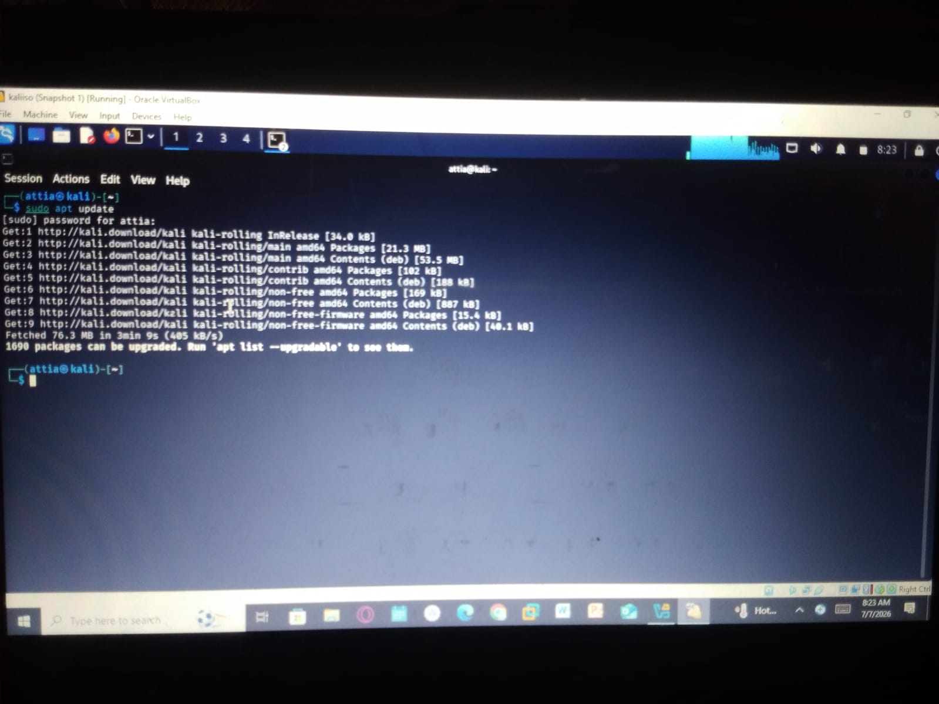

2. Install Nmap, Gobuster, Hydra, and Wireshark
Command:
sudo apt install -y nmap gobuster hydra wireshark
Purpose:
Installs common penetration testing and network security tools automatically without asking for confirmation.

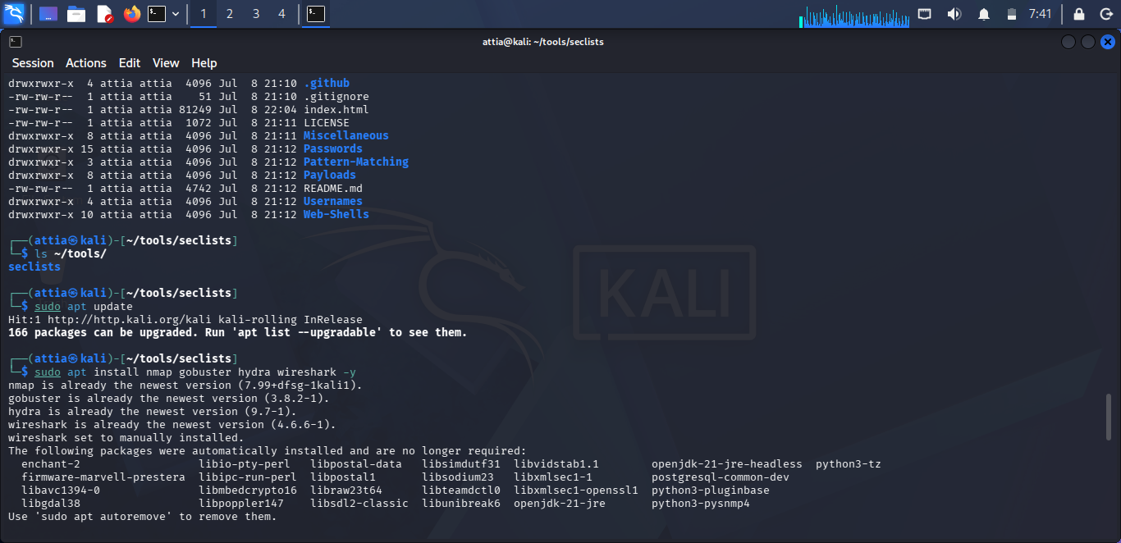

3. Verify Nmap Installation
Command:
nmap --version
Purpose:
Displays the installed version of Nmap to confirm successful installation.
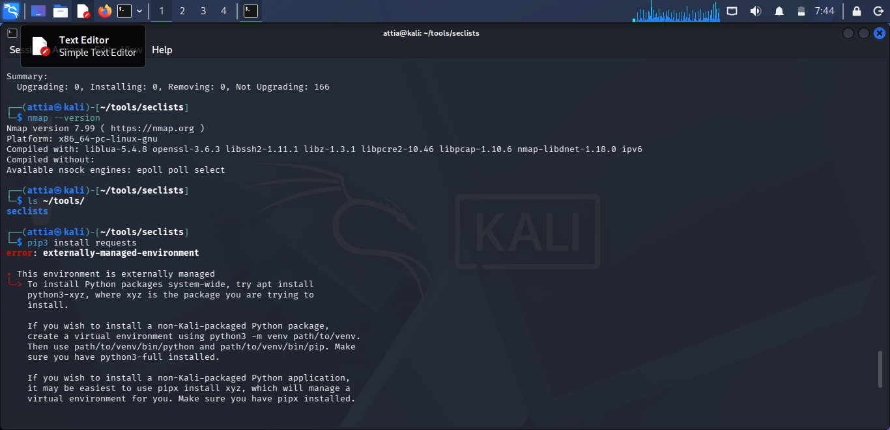

4. Install the Requests Python Library
Command:
pip3 install requests
Purpose:
Installs the Python requests library for sending HTTP requests in Python programs.
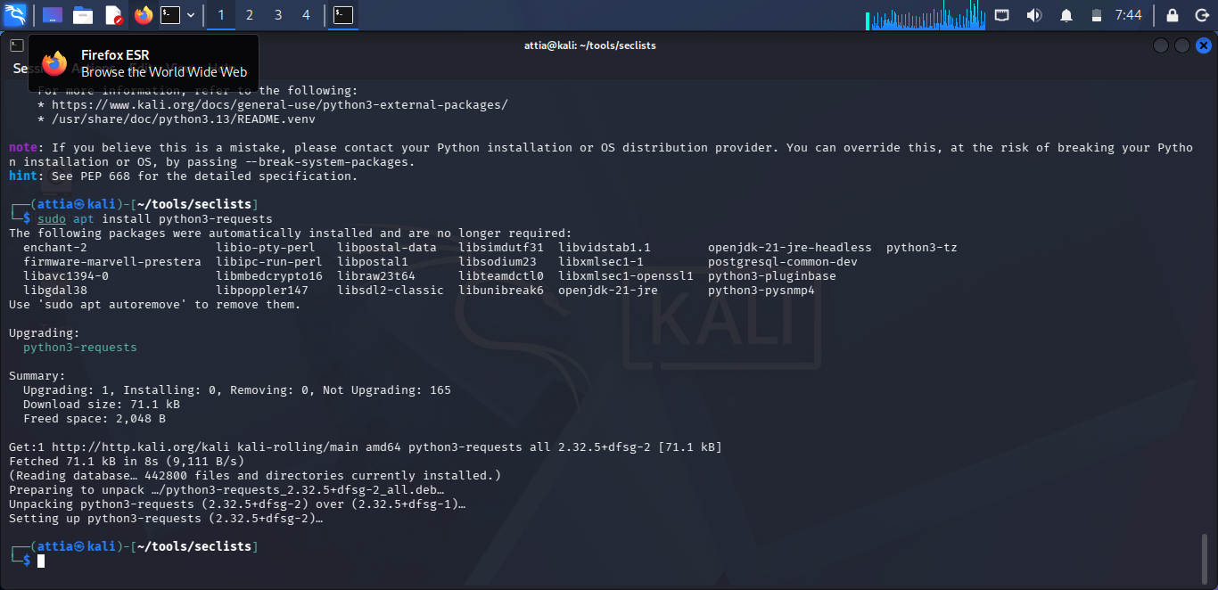
5. Download a File Using Wget
Command:
wget https://example.com
Purpose:
Downloads a file or webpage from the internet using the command line.
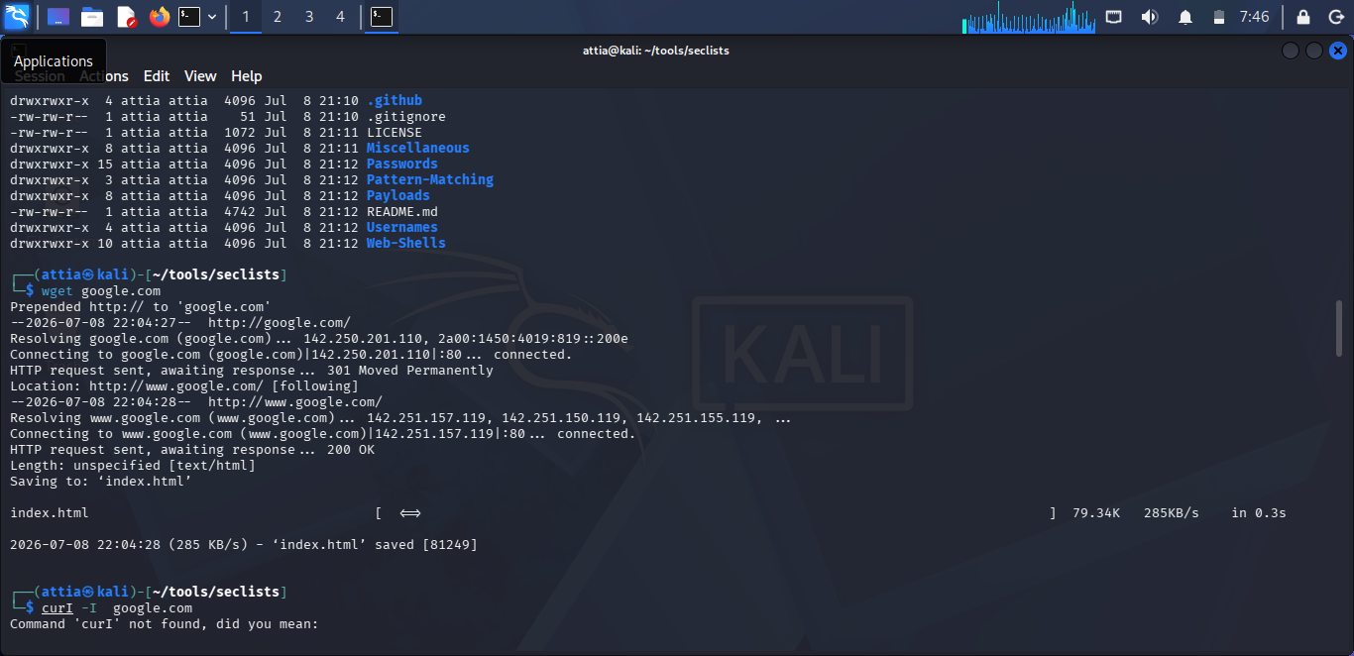

6. Read Website Server Headers
Command:
curl -I https://example.com
Purpose:
Displays the HTTP response headers returned by the web server.
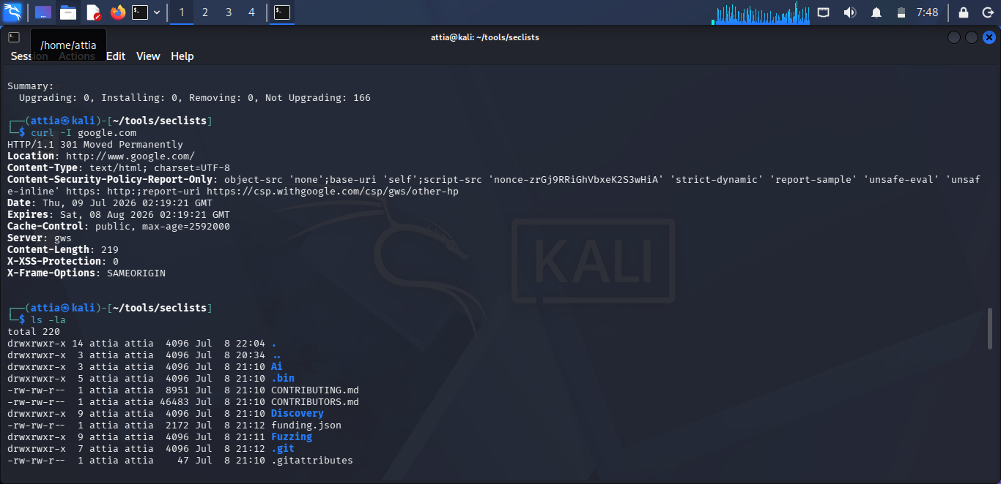

7. Clone SecLists from GitHub
Command:
git clone https://github.com/danielmiessler/SecLists.git ~/tools/
Purpose:
Downloads the SecLists repository from GitHub into the tools directory.
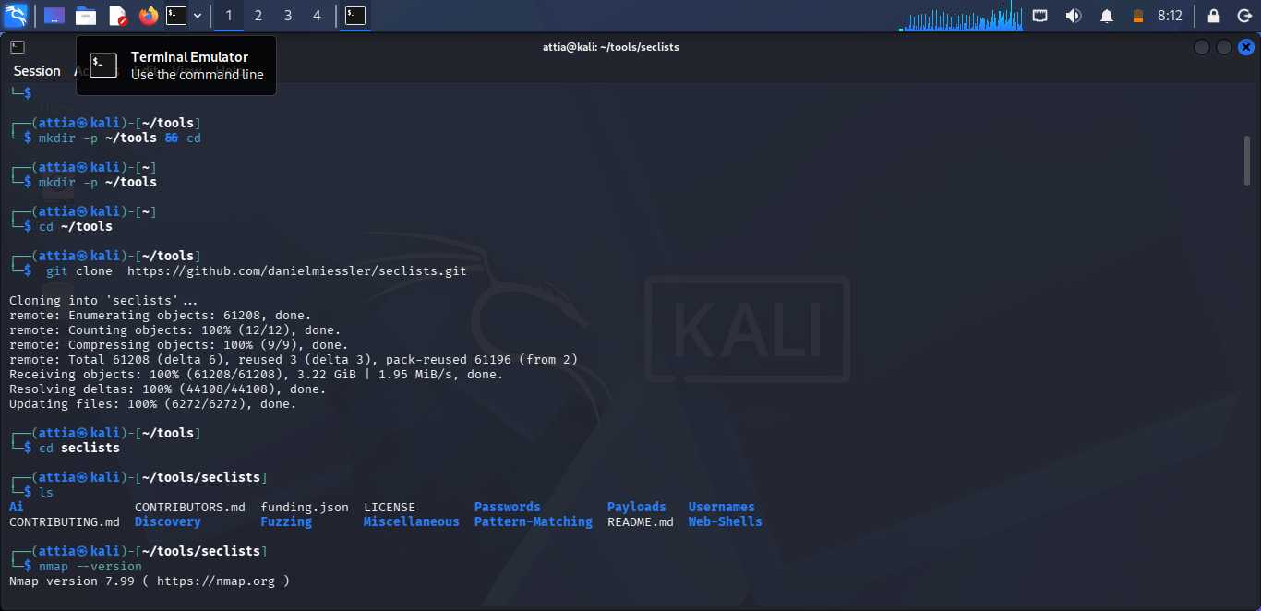
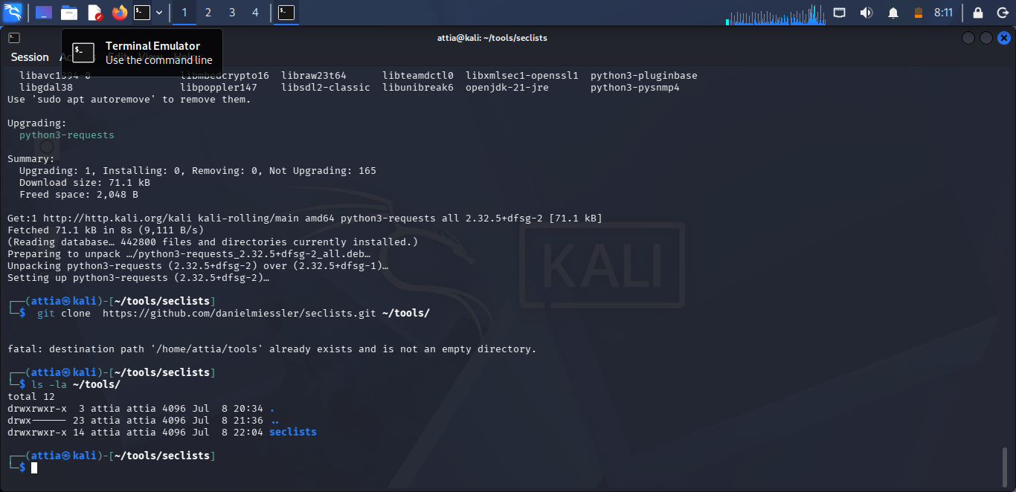
8. List the Contents of the Tools Directory
Command:
ls -la ~/tools/
Purpose: Shows all files and directories inside the tools folder, including hidden files.


