Attia Inayat
Sp23-bai-012
Question 1:
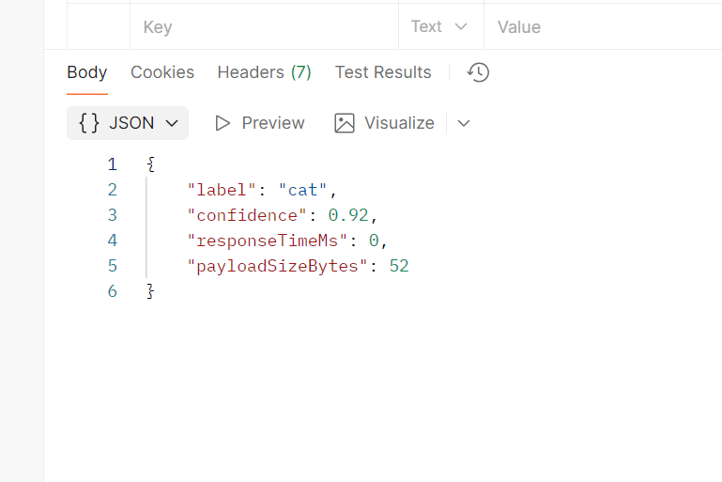
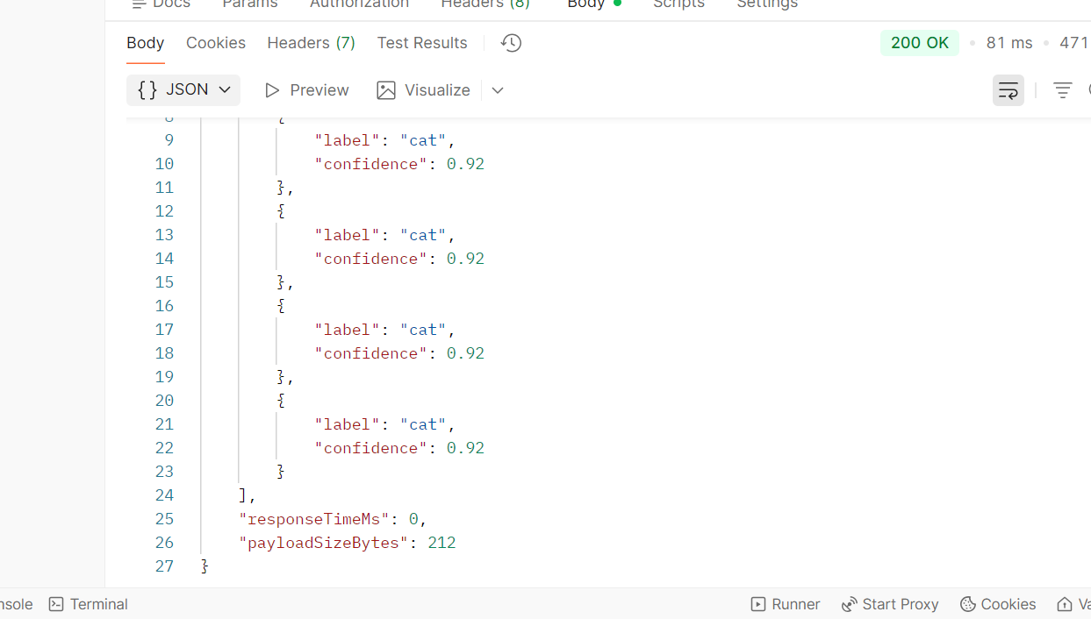
{
"count": 5,
"results": [
{
"label": "cat",
"confidence": 0.92
},
{
"label": "cat",
"confidence": 0.92
},
{
"label": "cat",
"confidence": 0.92
},
{
"label": "cat",
"confidence": 0.92
},
{
"label": "cat",
"confidence": 0.92
}
],
"responseTimeMs": 0,
"payloadSizeBytes": 212
}

Question 2:
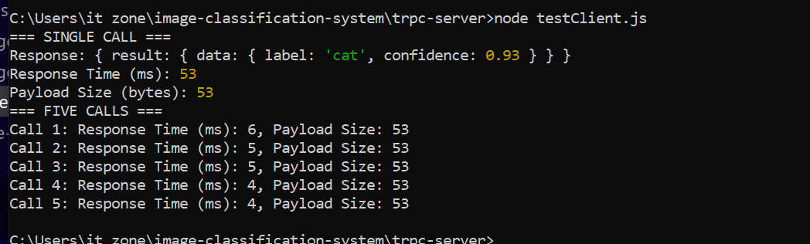
Question 3:
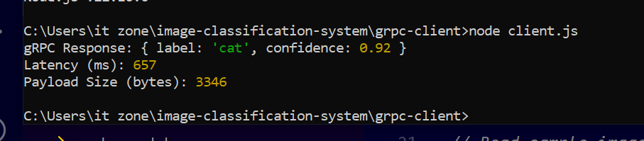
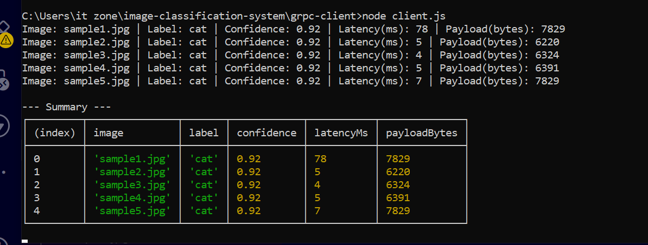

Comparison of Rest vs grpc:
The payload bytes and response time of Rest is less than the grpc. Boths answers are attached in above screenshots.

Question 4:
