DHCP作業(使用Wireshark)

S0954052 范家豪

1. UDP

2. It used 67 and 68 for port numbers.

DHCP-Discover

DHCP-Request

DHCP-Offer

DHCP-ACK

Source IP

0.0.0.0

Source IP

192.168.0.1

Destination IP

255.255.255.255

Destination IP

192.168.0.176

Time

15.124044

18.335920

18.337240

18.347223

3. 00:f4:8d:9f:ac:e5

4. 在DHCP Request裡 Option比較多。無論是Discover或是Request在Message Type有不同的值。

DHCP Discover

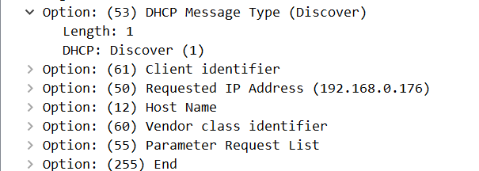

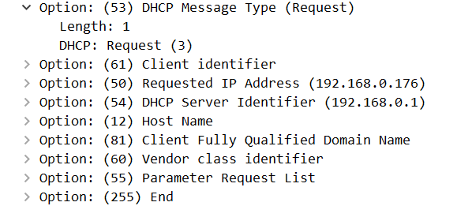

DHCP Request

5.

The first Transaction ID : 0xf24a877

The second Transaction ID : 0xca62af39

Purpose : Allow host to differentiate which requests is being asked by user.

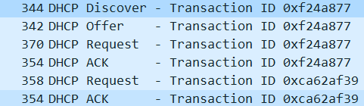

6.

Discover(0.0.0.0/255.255.255.255)

Offerr(192.168.0.1/192.168.0.176)

Request(0.0.0.0/255.255.255.255)

ACK(192.168.0.1/192.168.0.176)



7.

192.168.0.1

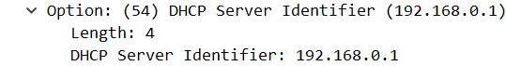

8.

192.168.0.176

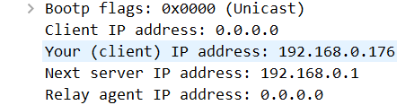

9.

Yes, and IP address is 0.0.0.0

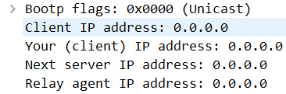

10.

在DHCP message裡，router 告訴client 哪個路由器是來傳遞訊息的，而

subnet mask告訴client應該用哪一種subnet mask。

11.

Option(50):192.168.0.176

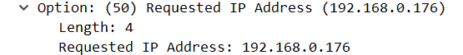



12.

**The amount of time the DHCP server assigns an IP address to the client.**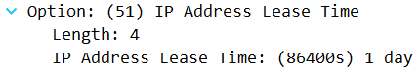

13.

The DHCP release message tells the DHCP server that you want to cancel the IP address offered. The DHCP server will not issue an ACK of the client’s DHCP request. If the release message is lost then the DHCP server retains the IP address until the lease time expires.

14.

The purpose of those ARP packets are to track IP addresses back to a physical server in a local area network.

