**Comsats University Islamabad, Lahore Campus**

**Course Title: Object Oriented Programming**

**Assignment #2**

**Submitted by: Attika Hussain (SP24-BSE-017)**

**Section: A**

**Submitted to: Sir Shahid Bhatti**

**Assigned Date: 29nd November 2024**

**Submission Date: 29rd November 2024**

Assignment 2:

Design a graphic User interface for a student admission form.

* Firstly will design a frame for the form. Assign a suitable width and height and set default close function.
* Suitable Padding is added to align the page and make the page look presentable.

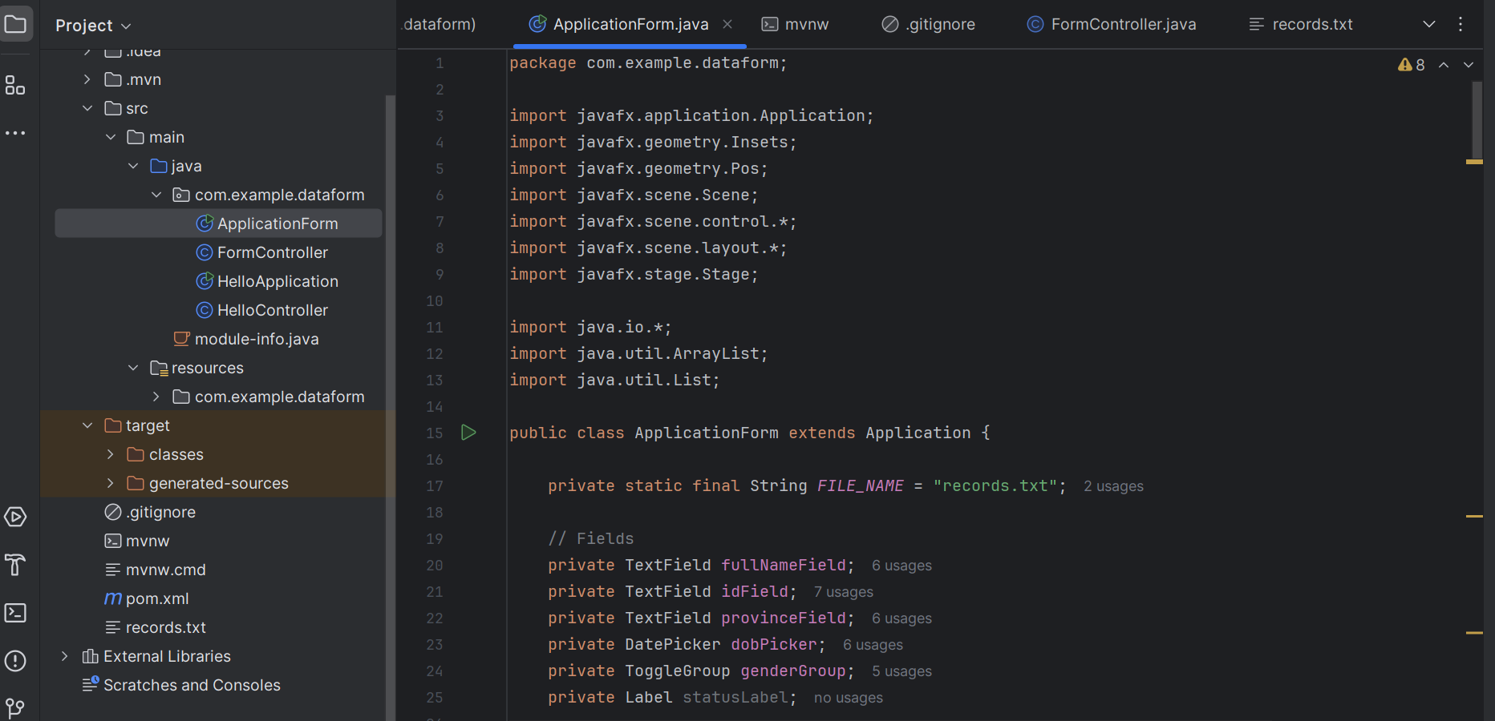

* Then scale it properly
* Add Array list

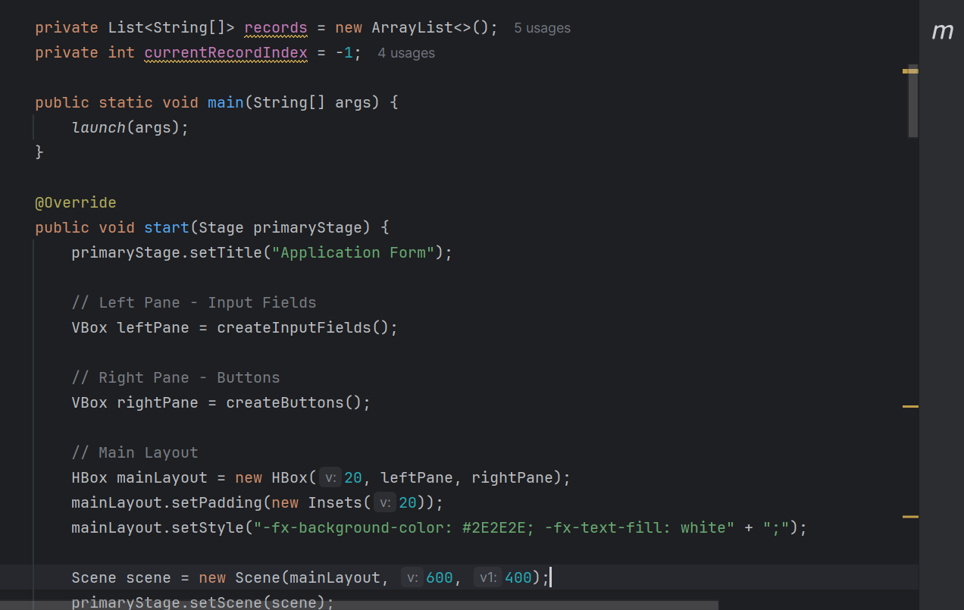

* Add fields like name, id, province, dob picker and gender in to the form.

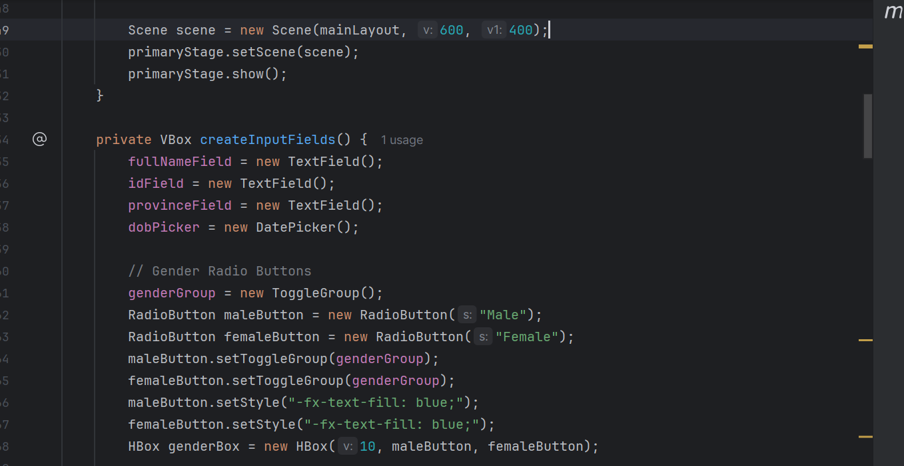

* Add styling

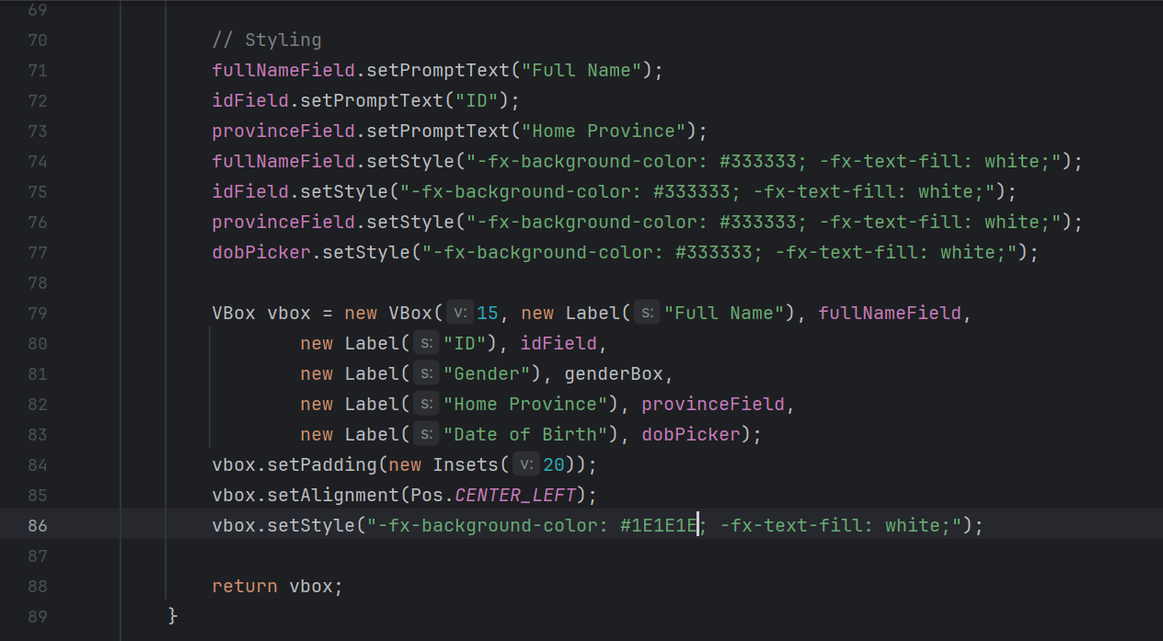

* Add code to for buttons

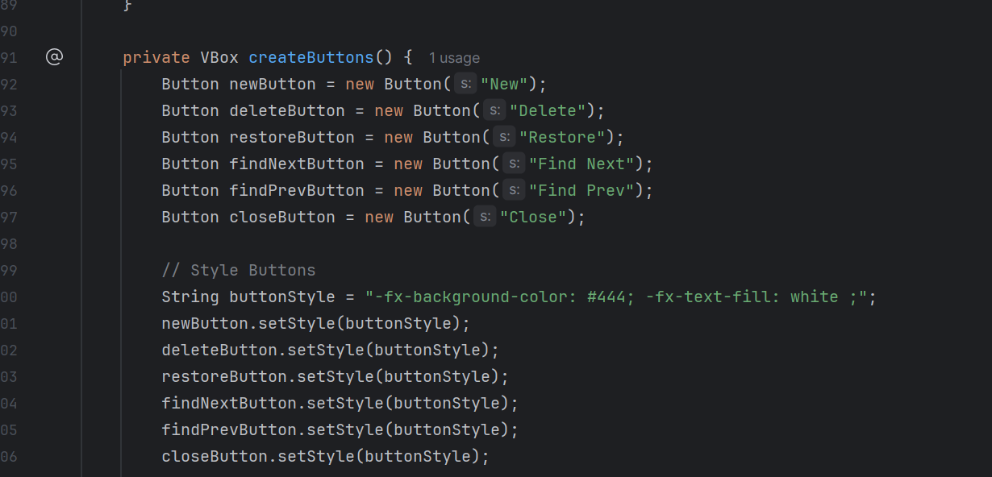

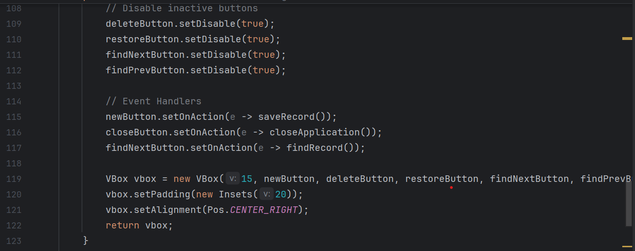

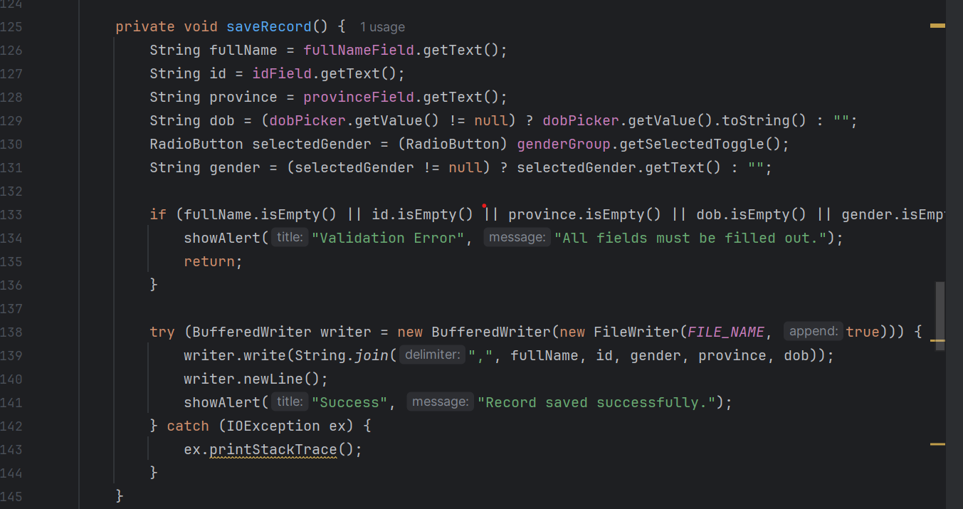

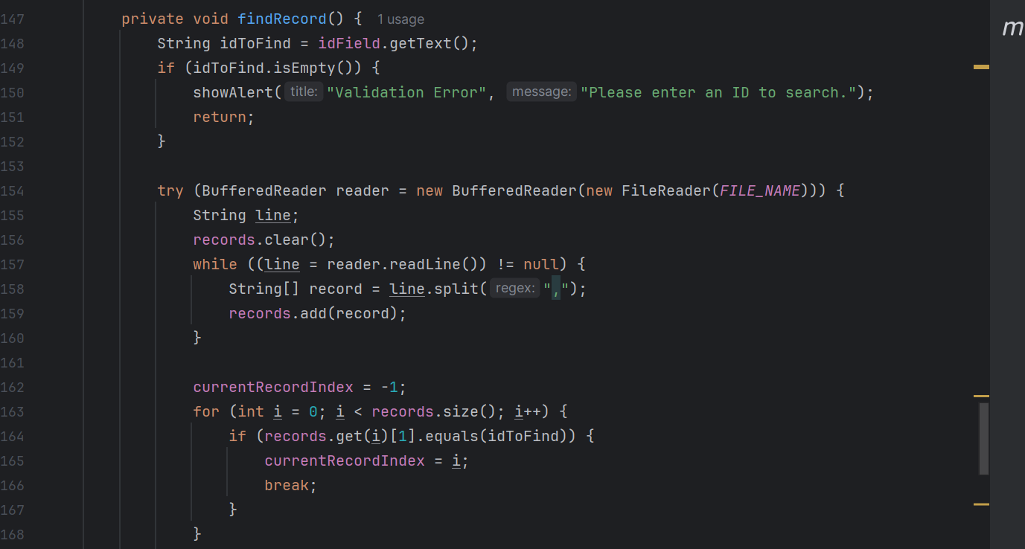

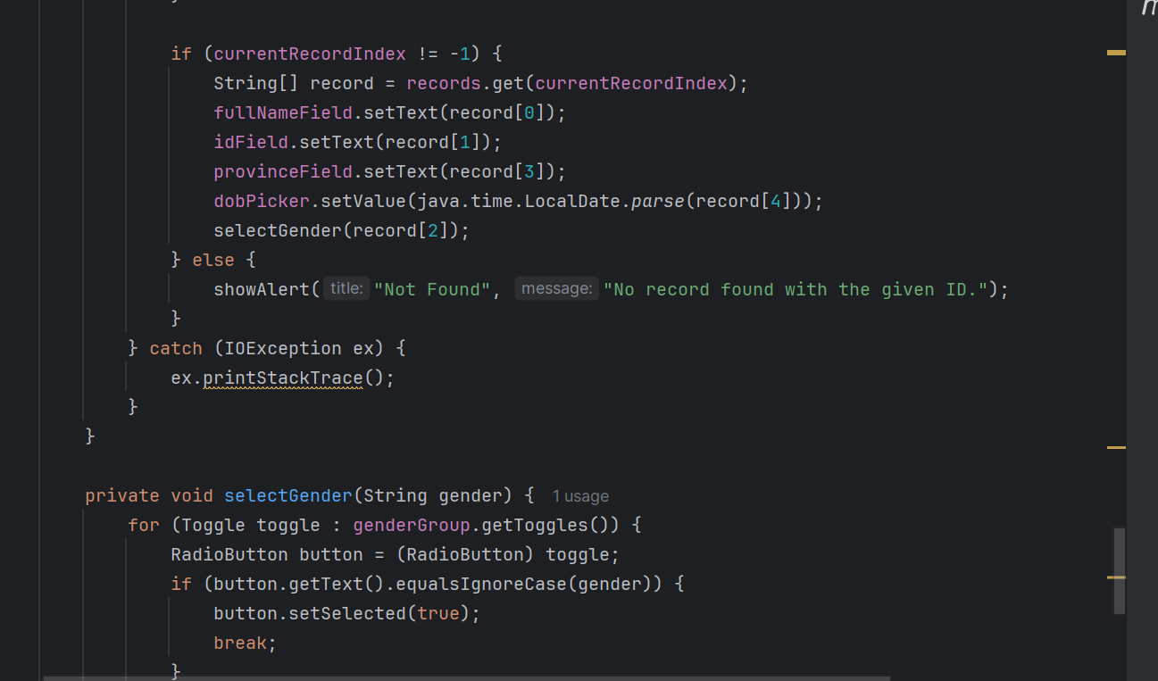

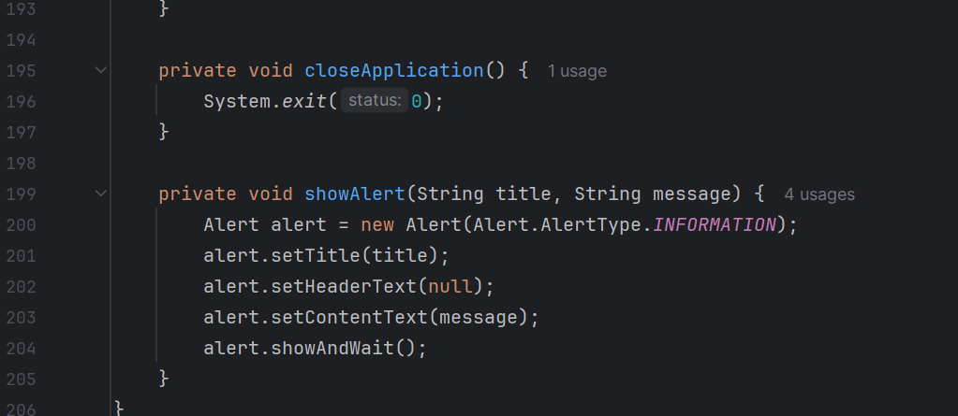

* The display of the form is shown below.

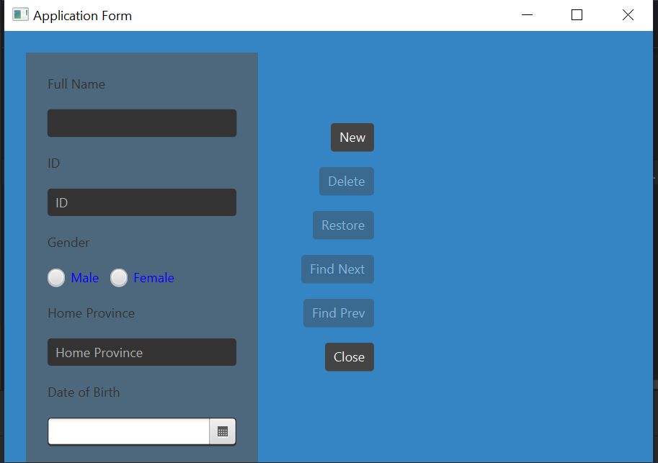

* Add Details

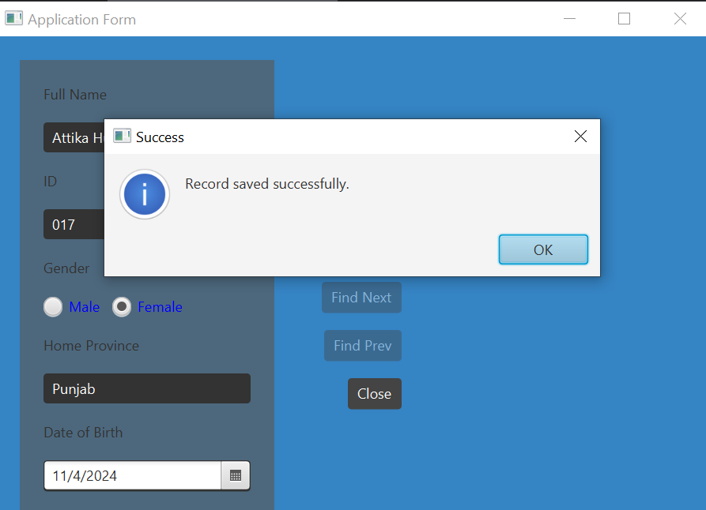

* Record is stored

