  - CANINE

BEHAVIORAL
INTELLIGENCE
  - Enterprise Engineering & Swarm Implementation Specification — V1
Implementation source of truth for Kimi Swarm 3: mobile, backend, migrations, AI orchestration, security, subscriptions, observability, testing and release gates.
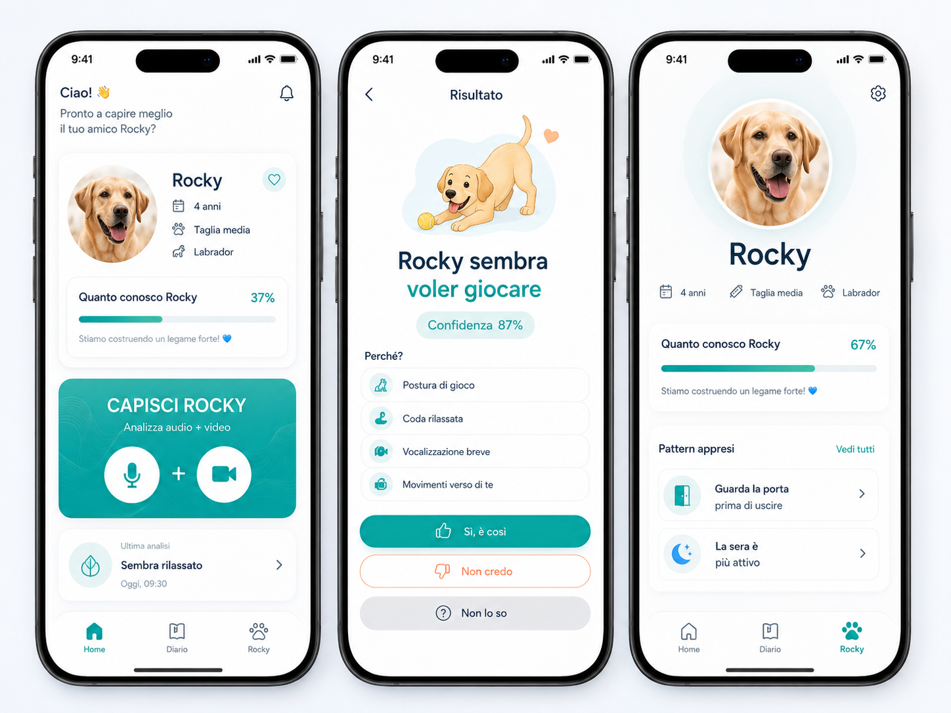
IMPLEMENTATION MANDATE
Kimi Swarm must treat this document as the execution contract. Do not redesign the product, invent new tabs, change data ownership, bypass the Personal Intelligence firewall, or hard-code AI providers/models. Any unresolved item must be surfaced as an explicit blocker rather than silently decided.

CONFIDENTIAL — Engineering handoff • 4 September 2026

0. Document Control, Precedence & Swarm Operating Rules
This document converts the current product, scientific, economic and architecture decisions into an implementation-ready contract. It is not a brainstorming document. Unless explicitly reopened by the product owner, decisions labeled LOCKED must be implemented as written.

0.1 Source hierarchy
Priority | Source | Controls
1 | This Engineering Implementation Spec V1 | Repository structure, stack, schemas, API boundaries, security, async processing, sequencing, Definition of Done.
2 | Enterprise Master Blueprint V4 | Product strategy, VIDEO-first behavioral intelligence, AI strategy, Personal Intelligence governance, Digestive/Nutrition domain.
3 | Enterprise Product & Functional Spec V2 | Original UX model, Home/Result/Rocky logic, three-tab architecture, feedback and diary behavior.
4 | Unit Economics & Subscription Strategy V1 | Free/Premium allowances, cost telemetry, retention/cost guardrails, RevenueCat architecture.
5 | Scientific / Dataset Intelligence research | Evidence discipline, neutral baseline, separation of observation vs interpretation, dataset/licensing constraints.

CONFLICT RULE
If two older documents conflict, this specification wins only where it explicitly states an updated decision. Product intent that is not superseded remains valid. Kimi must never “resolve” a conflict by guessing.

0.2 Swarm change protocol
• Final integration branch is main. Temporary worktrees/branches are allowed only for swarm isolation and must not become long-lived product branches.
• No two agents edit the same migration or contract file concurrently. Contracts and migrations are merged before feature work that depends on them.
• Every gate ends with tests, evidence and a PROJECT_STATE update. “Implemented” without executable verification is not accepted.
• No manual production schema edits. Every database change is a committed Supabase migration.
• No provider secret, Supabase service-role key, RevenueCat secret or Cloud credential may appear in mobile code or repository history.
• Paid AI calls are mocked in CI. Real-provider evaluation is separate, budgeted and explicitly triggered.
• The swarm may improve internal code quality but may not expand product scope without an explicit decision record.

0.3 Mandatory repository evidence after each gate
Artifact | Required evidence
Code | Changed files + concise change summary + no dead scaffolding.
DB | Migration files, local apply/reset success, RLS tests.
API | OpenAPI diff, schema validation, auth/idempotency tests.
Mobile | iOS/Android device/simulator evidence for changed flow.
AI | Fixture-based contract tests + real-eval result only when gate requires.
Security | Threat-control tests relevant to the gate.
Docs | PROJECT_STATE.md + DECISIONS.md + RUNBOOK updates when behavior changes.

1. Executive Implementation Mandate
The product is a consumer mobile application for iOS and Android that provides immediate behavioral interpretation from short video clips and a separate Digestive & Nutrition intelligence capability from photos. The system must deliver value on first use, then become progressively more personalized without allowing previous AI errors to reinforce themselves.
NORTH STAR
Behavior: Home → “Capisci Rocky” → 5–20 second VIDEO → objective observation → probabilistic interpretation → explainable result → optional feedback. Digestive: Home → stool photo → observable classification + comparison with active food/history → trend/safety insight.

1.1 What the product is
• An AI-assisted behavioral interpreter, not a literal canine-language translator.
• A longitudinal Personal Intelligence system that learns the individual dog only from governed evidence.
• A separate digestive/nutrition monitor based on stool photos, food-label data and longitudinal change.
• A mobile subscription product with predictable usage-based COGS, quota enforcement and provider-level cost telemetry.

1.2 What is explicitly out of scope for V1 implementation
• Audio-only behavioral analysis.
• Photo-only behavioral interpretation.
• A proprietary foundation model or end-to-end custom dog neural network.
• Medical diagnosis from video/stool photo.
• Unlimited subscription usage.
• Multi-dog, family sharing, wearable integration, expert marketplace, B2B/API platform.
• “Parla a Rocky” sound playback (future R&D hook only).
• A large runtime scientific RAG unless evaluation proves a specific need.
• Full consumer web app; mobile stores are the launch channels.

2. Locked Technology Stack
Layer | LOCKED V1 choice | Implementation rule
Mobile | React Native + Expo + TypeScript | One codebase for iOS/Android. Expo Router. Development builds for native modules/IAP.
UI | React Native primitives + centralized design tokens | No heavyweight UI kit unless justified. Keep existing visual direction; no redesign.
Client data | TanStack Query + minimal local state | Server state in Query; transient UI state only in local store. Avoid duplicated caches.
Forms | React Hook Form + Zod | Client validation for UX; backend remains authoritative.
Local persistence | Expo SQLite / SecureStore | Pending-upload queue in SQLite; auth/session secrets in SecureStore.
Backend | Python 3.12+ + FastAPI + Pydantic v2 | Async API-first service; OpenAPI is client contract.
DB | Supabase PostgreSQL | Supabase migrations only; public + internal schema separation.
Server DB access | SQLAlchemy 2 async via Supabase pooler | Transactions and query control server-side; no ORM migrations.
Auth | Supabase Auth | Apple + Google + email option. FastAPI validates Supabase JWT.
Storage | Supabase private Storage | Direct mobile upload via server-issued signed URLs; API never proxies large media.
Async | Google Cloud Tasks → private Cloud Run worker | Push-based retryable jobs. Queue behind JobQueue adapter.
Hosting | Google Cloud Run: public API + private worker | Containers, autoscaling, EU region, max-instance cost guardrails.
Behavior observer | Gemini video via provider adapter | Objective structured observations only; exact model ID is configuration.
Reasoning | OpenAI Responses API via adapter | Structured output. Specialist policy + context + eligible personal memory.
Digestive vision | OpenAI/image-capable provider adapter | Observation separate from safety/rule layer.
Food OCR | ML Kit on-device when integration spike passes; vision fallback | User verifies extracted nutrition fields before they become durable data.
Billing | RevenueCat + StoreKit/Google Play Billing | Backend entitlement mirror + usage ledger.
Notifications | Expo Push | Tokens registered server-side; preference-aware.
Error monitoring | Sentry recommended | Provider-agnostic wrapper; no raw media in logs.
Product analytics / flags | PostHog recommended or equivalent | Event names versioned; feature flags for AI modules/provider routing.
CI/CD | GitHub Actions + EAS + Cloud Run deploy | No production secret in CI logs; release gates defined below.

NO CAPACITOR / NO FLASK
Do not build a web app first and wrap it later. This is camera-first mobile software. Do not use Flask as the primary API framework; FastAPI is the backend contract and orchestration layer.

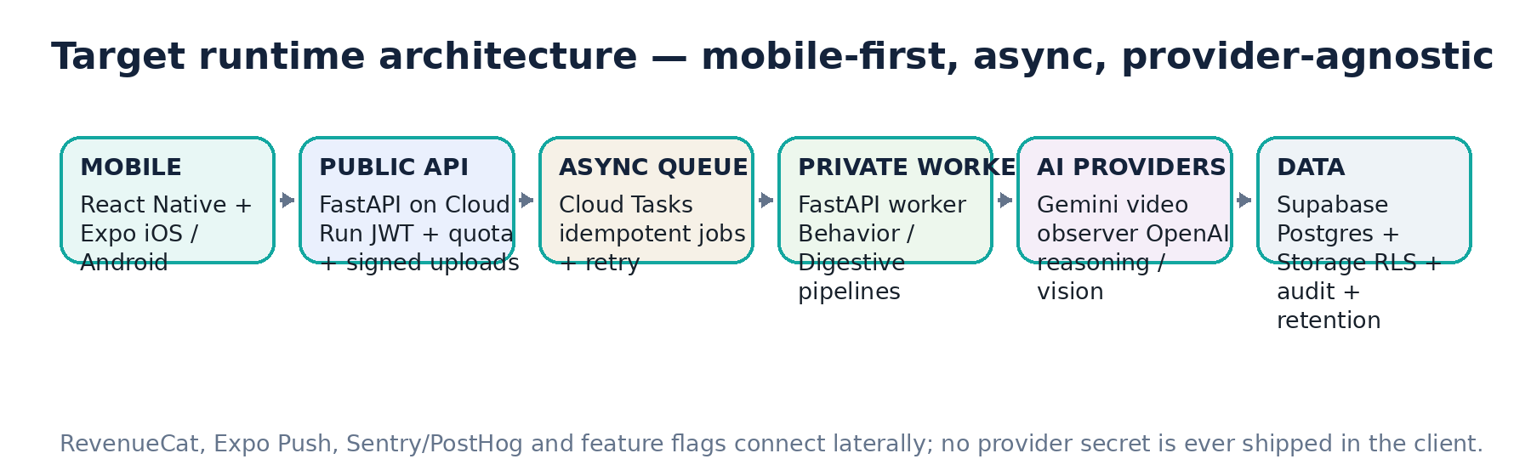

3. Repository Topology & Code Ownership
Use one repository to keep migrations, contracts and release evidence atomic while maintaining clear runtime boundaries.
Target repository layout:
/apps/mobile/ # Expo React Native app
/backend/app/ # shared Python domain package
/backend/app/api/ # public FastAPI routes
/backend/app/worker/ # private task handlers
/backend/app/domains/ # dogs, behavior, digestive, billing, privacy
/backend/app/providers/ # Gemini/OpenAI/RevenueCat/storage adapters
/backend/app/contracts/ # Pydantic request/response/provider schemas
/backend/tests/ # unit/integration/contract tests
/supabase/migrations/ # sole database migration source
/supabase/seed.sql # non-sensitive local fixtures only
/infra/cloudrun/ # deploy config / IaC or scripts
/scripts/ # OpenAPI generation, fixture/eval utilities
/docs/ # architecture, security, runbooks, decisions
/.github/workflows/ # CI, staging deploy, manual production release

3.1 Canonical contracts
• FastAPI/Pydantic is the source of truth for public API contracts. Export OpenAPI in CI and generate TypeScript types/client for the mobile app.
• Provider response contracts are backend-only Pydantic models. Raw Gemini/OpenAI JSON never becomes a mobile contract.
• Database schema is controlled only by Supabase SQL migrations. Do not generate DB schema from ORM models.
• All status values and taxonomies must live in versioned backend constants/reference tables and be mirrored to mobile through the API when needed.

3.2 File-ownership rule for parallel swarm work
Workstream | Owns | Must not modify without coordination
DB/Security | supabase/migrations, RLS tests | Provider prompts, mobile screens
Backend/API | backend/app/api + domains | Existing migrations after merge
AI/Contracts | backend/app/providers + contracts | Public API shape without API owner
Mobile | apps/mobile | DB schema / provider logic
Billing | billing domain + RevenueCat webhook | Core dog/event ownership
QA/DevOps | tests, CI, infra | Product behavior without decision record

4. Environments, Secrets & Configuration
Environment | Purpose | Rules
local | Developer / swarm work | Supabase CLI local stack, fake queue, AI fixtures by default.
staging | Real device + provider integration | Separate Supabase/GCP/RevenueCat sandbox; low AI budget; test store products.
production | Store users | Separate secrets, DB, buckets, billing; manual release gate only.

4.1 Configuration principles
• No model ID is hard-coded in domain logic. Use versioned config: OBSERVER_PROVIDER, OBSERVER_MODEL, REASONING_PROVIDER, REASONING_MODEL, DIGESTIVE_VISION_PROVIDER.
• No pricing/allowance is hard-coded into UI. Backend returns plan entitlements and usage limits.
• Retention TTL, provider budgets, max video duration, feature flags and safety thresholds are config/remote-config values with sane defaults.
• Secrets live in Cloud Secret Manager / protected CI secret stores; Expo public variables may contain only intentionally public values such as Supabase URL and publishable key.
• Use distinct bundle/package identifiers and OAuth credentials per environment. Final production app ID is an explicit release blocker, not something the swarm invents.

4.2 Required secret classes
Secret | Where | Never allowed
Supabase publishable key | Mobile env | Service role functionality.
Supabase service role / DB credentials | Cloud Run only | Mobile / logs / generated client.
Gemini API key / Google credentials | Worker only | Mobile.
OpenAI API key | Worker only | Mobile.
RevenueCat public SDK keys | Mobile platform config | RevenueCat secret webhook/API key.
RevenueCat webhook secret | API only | Mobile.
Cloud Tasks service identity | GCP IAM | Client-side credentials.

5. Mobile Application Architecture
The mobile client is a thin, resilient product experience. It captures media, manages local pending uploads, renders server-owned state and performs store billing; it does not contain AI secrets, memory governance or authoritative entitlement logic.

5.1 Navigation — maximum three primary tabs
Tab | Purpose | Primary content
Home | Act now | Dog card, Knowledge Score, large “Capisci Rocky” VIDEO CTA, secondary “Controlla digestione”, last insight.
Diario | Understand over time | Unified cursor-paginated timeline; filters All / Behavior / Digestive; episode detail and trends.
Rocky | Understand the dog profile | Identity, Knowledge Score, learned patterns, digestive baseline/active food, settings drill-down.

UX LOCK
No fourth primary tab. Digestive/Nutrition is a secondary capability inside the three-tab architecture. “Capisci Rocky” remains the dominant Home CTA.

5.2 Expo Router route map
/(auth)/welcome
/(auth)/sign-in
/onboarding/dog
/(tabs)/home
/(tabs)/diary
/(tabs)/rocky
/behavior/capture
/behavior/processing/[eventId]
/behavior/result/[eventId]
/diary/event/[eventId]
/digestive/capture
/digestive/processing/[eventId]
/digestive/result/[eventId]
/nutrition/foods
/nutrition/foods/scan
/nutrition/foods/[foodId]/verify
/patterns
/patterns/[patternId]
/settings
/settings/privacy
/settings/subscription
/notifications
/paywall

5.3 Client state rules
• TanStack Query owns API/server cache. Query keys are scoped by user and dog; logout clears protected cache.
• SQLite persists pending media uploads/jobs so app restarts do not lose a recorded clip. AI analysis is never performed offline.
• SecureStore holds session material. Do not persist access tokens in plain AsyncStorage.
• Every media operation has explicit states: local_pending → upload_initializing → uploading → uploaded → processing → completed / recoverable_error / terminal_error.
• App can renew an expired signed upload URL without re-recording if the local file still exists.

6. Screen-by-Screen Functional Specification
Screen | Dominant action | Backend/data dependencies | Mandatory states
Welcome / Sign-in | Continue / Apple / Google | Supabase Auth, consent versions | loading, auth error, account exists, offline
Dog onboarding | Create Rocky | dogs, profile version | valid, unknown breed, no photo, approximate age
Home | Capisci Rocky | dog, knowledge score, usage, last insight | new user, quota exhausted, offline, processing existing event
Behavior capture | Record video | camera/mic permission, capture contract | ready, recording, too short, hard cap, permission denied
Behavior processing | Wait / background | event status | queued, observing, interpreting, retrying, quality rejected, provider error
Behavior result | Give feedback | BehaviorEvent + interpretation | clear, ambiguous, insufficient, safety message
Digestive capture | Take photo | camera/photo picker, usage | quality warning, retake, upload failure
Digestive result | Review insight | FecalEvent + baseline + food | normal observation, change, safety flag, insufficient image
Food label scan | Capture label | OCR + FoodProduct draft | OCR confidence, editable verification, duplicate active product
Diario | Open episode | cursor timeline | empty, filter, mixed behavior/digestive, deleted media
Rocky | Open pattern / profile | patterns, baseline, active food | low knowledge, no pattern, contested pattern
Settings/privacy | Manage data | consents, exports, deletion | request pending, export ready, account delete confirmation
Paywall | Subscribe | RevenueCat offerings + usage | purchase, restore, grace, unavailable store

6.1 Behavioral result contract shown to consumer
• Primary interpretation label + natural-language summary using “sembra / probabilmente / possibile”.
• Confidence band Low / Medium / High only until numeric calibration is proven. Existing percentage mockups are illustrative, not production truth.
• 3–5 evidence bullets tied to the current event; evidence source may include current observation, context and eligible personal pattern.
• Alternative hypothesis when close or evidence conflicts.
• Three-way feedback: “Sì, è così / Non credo / Non lo so”. One tap completes feedback; no UX penalty for Unknown.
• Ambiguous/insufficient is a valid completed result and consumes an analysis because the service was delivered.

7. Canonical User Journeys & State Machines

7.1 First-time activation
1. Welcome/privacy summary → sign-in.
2. Create dog profile in ≤60 seconds: name required; age/life stage, size; breed/mix/unknown optional; photo optional.
3. Home opens with cold-start copy: the app can already interpret common signals and will improve over time.
4. First behavior analysis available immediately; research/training consent remains separate and opt-in.

7.2 Behavior analysis state machine
State | Entry | Exit / transition
DRAFT | API creates capture/event reservation | signed upload URL issued
UPLOADING | mobile PUT to private bucket | client calls complete
QUEUED | server validates object and commits quota | Cloud Task created
OBSERVING | worker sends video to observer | validated ObservationContract
INTERPRETING | worker retrieves policy/context/eligible memory | validated InterpretationContract
COMPLETED | event persisted + cost finalized | mobile fetch/push update
REJECTED_QUALITY | dog not observable / clip unusable | quota refund according to policy
FAILED_RETRYABLE | provider/network transient | Cloud Tasks retries idempotently
FAILED_TERMINAL | schema/policy/internal unrecoverable | quota refund + support telemetry
CANCELLED | user cancels before provider work | cleanup + reservation release

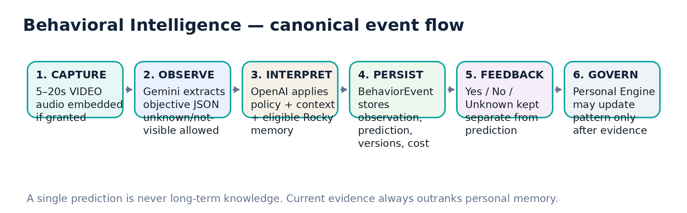

7.3 Quota consumption rule
ATOMIC QUOTA
Reserve usage server-side before issuing a processing job. Quality rejection before meaningful AI work and terminal technical failures refund the reservation. Successful clear, ambiguous or insufficient interpretations consume one unit. Parallel requests cannot exceed allowance.

8. Backend Runtime Architecture
Deploy two Cloud Run services built from the same Python domain package: a public API service and a private worker service. Large media bypasses the API through exact signed upload URLs.

8.1 Public API responsibilities
• Validate Supabase JWT (signature/JWKS, issuer, expiry and required claims) and derive user_id exclusively from token subject.
• Check ownership, plan entitlement, monthly usage, feature flags and rate controls.
• Create canonical IDs and storage object paths; issue short-lived signed upload URLs.
• Create event/job records and enqueue Cloud Tasks after upload validation.
• Expose read APIs for dog, diary, result, patterns, usage, privacy and subscription state.
• Receive and verify RevenueCat webhooks; never trust mobile entitlement as authoritative.

8.2 Private worker responsibilities
• Accept only authenticated Cloud Tasks / internal service calls.
• Acquire event lock/idempotency guard; completed events are no-op on duplicate delivery.
• Retrieve media using server credentials, call provider adapter(s), validate structured output and run policy/governance.
• Persist provider/model/version, token usage, latency, retry and cost fields.
• Never directly mutate Personal Patterns from generative model output; invoke deterministic Personal Intelligence service.
• Schedule/mark media retention cleanup after terminal completion.

8.3 Why Cloud Tasks + Cloud Run
Cloud Tasks is push-based and retries non-successful HTTP work with configurable backoff/rate limits; Cloud Run supports containerized FastAPI and autoscaling. The queue is still wrapped behind a JobQueue interface so the product is not architecturally coupled to the queue vendor.

9. Public API Contract — V1
Method / route | Purpose | Auth / notes
GET /v1/me | Profile, plan, usage, feature availability | JWT
GET /v1/dogs | Owned dogs (V1 entitlement limits active dog count) | JWT
POST /v1/dogs | Create dog | JWT + plan rule
PATCH /v1/dogs/{dog_id} | Edit structural dog data; create profile version | owner
POST /v1/behavior/captures/init | Create capture/event + signed upload URL + quota reservation | owner + quota + idempotency key
POST /v1/behavior/captures/{id}/complete | Validate uploaded object, enqueue analysis | owner + idempotent
GET /v1/behavior/events/{id} | Polling/result detail | owner
POST /v1/behavior/events/{id}/feedback | Yes/No/Unknown + optional correction | owner
GET /v1/diary | Cursor timeline; domain/context filters | owner
GET /v1/dogs/{dog_id}/patterns | User-visible eligible patterns | owner
POST /v1/patterns/{id}/review | Contest/archive/correct context | owner
POST /v1/digestive/fecal/init | Create FecalEvent upload reservation | owner + quota
POST /v1/digestive/fecal/{id}/complete | Enqueue digestive analysis | owner
GET /v1/digestive/events/{id} | Digestive result | owner
POST /v1/nutrition/foods/scan/init | Create label-image upload / OCR flow | owner
PATCH /v1/nutrition/foods/{id}/verify | Persist user-verified extracted fields | owner
POST /v1/nutrition/feeding-periods | Set active food / transition | owner
GET /v1/dogs/{dog_id}/digestive-summary | Baseline and recent trend | owner
GET /v1/subscription/status | Server entitlement + limits + renewal period | JWT
GET /v1/usage | Current allowance ledger | JWT
POST /v1/webhooks/revenuecat | Subscription lifecycle | signature required; no user JWT
POST /v1/devices/push-token | Register/update Expo push token | JWT
POST /v1/privacy/export | Start data export job | JWT
POST /v1/privacy/delete-account | Begin deletion workflow | JWT + explicit confirmation

9.1 API conventions
• All mutating endpoints accept X-Idempotency-Key or a client_request_id with a unique DB constraint.
• Errors return stable code, human-safe message, retryable boolean and correlation_id. Do not expose provider stack traces.
• Timeline uses cursor pagination, not offset, to remain stable at scale.
• Timestamps are UTC ISO-8601; mobile renders local time.
• No endpoint accepts owner_id/user_id from client as authority; derive identity from JWT and verify dog ownership.

10. PostgreSQL Domain Model — Implementation Schema
DATABASE PRINCIPLE
Public/user-facing tables use strict RLS. Internal jobs, cost, audit and model-governance tables live in an internal schema that is not exposed through the Supabase Data API. Client writes to AI-derived data are forbidden.

10.1 Core identity and profile tables
Table | Key fields | Notes
public.profiles | user_id PK/FK auth.users, locale, timezone, created_at, deleted_at | 1:1 account profile.
public.user_consents | id, user_id, consent_type, policy_version, granted, granted_at, revoked_at | Append/version consent history; research separate.
public.dogs | id, owner_id, name, birth_date/age_stage, size, breed_label, is_mix, sex?, weight_kg?, photo_path | Schema can support multi-dog later; plan enforces V1 limit.
internal.dog_profile_versions | id, dog_id, snapshot jsonb, changed_fields, created_at | Audit changes that can influence interpretation.
public.device_installations | id, user_id, platform, push_token, app_version, last_seen | No raw hardware fingerprinting.

10.2 Behavioral tables
Table | Key fields / relation
public.behavior_captures | id, dog_id, user_id, client_request_id unique, storage_path, duration_ms, has_audio, bytes, retention_state, expires_at, created_at
public.behavior_events | id, capture_id, dog_id, user_id, status, primary_intent, confidence_band, summary, policy_version, taxonomy_version, personal_memory_version, created_at, completed_at
internal.behavior_observations | event_id, schema_version, observation_json, observer_provider/model/version, media_quality, token_usage, latency_ms
internal.behavior_interpretations | event_id, schema_version, interpretation_json, reasoner_provider/model/version, alternatives, evidence, contradictions, token_usage, latency_ms
public.behavior_feedback | event_id, user_id, value yes/no/unknown, correction_label?, corrected_context?, created_at, updated_at
internal.behavior_outcomes | event_id, source, outcome_code, payload jsonb, observed_at
public.personal_patterns | id, dog_id, title, state, support_count, confirm_count, contradict_count, first_seen, last_seen, reliability_band, version
internal.pattern_event_links | pattern_id, event_id, relation support/contradict, similarity, created_at
public.knowledge_scores | dog_id, score, components jsonb, version, calculated_at

10.3 Digestive/nutrition tables
Table | Key fields / relation
public.fecal_events | id, dog_id, user_id, image_path, image_quality, fecal_score_estimate, consistency, shape, color, mucus_candidate, blood_candidate, melena_candidate, foreign_material_candidate, confidence_band, status, created_at
public.food_products | id, owner_id, brand, name, ingredients_raw, guaranteed_analysis jsonb, calories, feeding_directions, extraction_confidence, verified_at
public.feeding_periods | id, dog_id, food_product_id, start_at, end_at, quantity_per_day, treats_notes, transition_notes
internal.digestive_observations | fecal_event_id, provider/model/version, observation_json, token_usage, latency_ms
public.digestive_baselines | dog_id, rolling_score, frequency_stats jsonb, variability, data_sufficiency, version, calculated_at
public.digestive_insights | id, dog_id, fecal_event_id?, summary, trend_code, safety_flags jsonb, policy_version, created_at

10.4 Billing, jobs and operations
Table | Purpose
public.subscriptions | Mirror current RevenueCat entitlement/status/store/product/period. Never the only billing source of truth.
public.usage_ledgers | Per user + billing period: behavior_limit/used/reserved, digestive_limit/used/reserved, reset_at.
internal.analysis_jobs | job type, event id, status, attempt_count, last_error_code, queue/task id, timestamps.
internal.ai_cost_events | provider, model, operation, input/output tokens, media bytes, cost_usd, latency, retry, event reference.
internal.audit_log | actor_type, actor_id, action, entity, entity_id, metadata, created_at; no raw media/prompt content.
internal.deletion_jobs | account/media deletion workflow and completion evidence.

11. Migration Plan — Forward-Only, Reviewable, Testable
Migration | Scope | Acceptance
0001_extensions_and_schemas.sql | pgcrypto; internal schema; optional vector extension behind feature need | Fresh local reset succeeds.
0002_identity_dogs_consents.sql | profiles, consents, dogs, device installations | FKs and ownership constraints.
0003_behavior_core.sql | captures, events, observations, interpretations | Unique client_request_id; required indexes.
0004_feedback_personal.sql | feedback, patterns, links, knowledge score | No model output can update pattern via client role.
0005_digestive_core.sql | fecal, food, feeding, baseline, insight | Food verification fields nullable until confirmed.
0006_billing_usage.sql | subscriptions, usage ledger, atomic reserve/commit/refund functions | Parallel quota tests pass.
0007_jobs_cost_audit.sql | analysis jobs, cost events, audit, deletion jobs | internal schema inaccessible to anon/authenticated.
0008_storage_policies.sql | private buckets + object-path policies/functions | Cross-user path tests fail closed.
0009_rls_grants.sql | RLS + grants for every public table | supabase test db / RLS suite.
0010_indexes_triggers.sql | updated_at, timeline indexes, status/owner indexes | EXPLAIN on core queries.
0011_seed_taxonomy_policy.sql | versioned intent/context/reference values only | No scientific claims hard-coded into DB prose.
0012_privacy_retention.sql | retention metadata/functions, export/delete support | Deletion integration test.

11.1 Migration rules
• Never use Postgres ENUM for fast-evolving AI taxonomy; use text + CHECK/reference tables so forward changes remain manageable.
• Never edit an applied production migration. Add a new migration.
• Destructive schema changes require backfill plan, compatibility window and rollback/restore procedure.
• Every migration must be reproducible from empty local Supabase and must not depend on manual Dashboard state.
• RLS/grants ship in the same gate as the table, not “later”.

12. Authorization, RLS & Storage Security Matrix
Resource | Mobile read | Mobile write | Server/internal
profiles | own | own limited fields | service/admin
dogs | own | create/update own | profile version audit
behavior_events | own | NO direct insert/update | worker/API only
behavior_feedback | own | own event only through API preferred | API validates ownership
personal_patterns | own | review action via API only | Personal Engine writes
fecal_events | own | capture metadata via API only | worker writes derived fields
food_products | own | verify/edit own | API
usage_ledgers | own summary | NO | billing/quota service
subscriptions | own summary | NO | RevenueCat webhook/service
internal.* | NO | NO | service role / DB server only

12.1 Private Storage
• Buckets are private. Suggested logical buckets: dog-avatars, behavior-raw, digestive-raw, food-labels, exports.
• Object key is generated by API, not client: users/{uid}/dogs/{dog_id}/{domain}/{event_id}/{uuid}.{ext}.
• Mobile requests a signed upload URL for exactly one path and short expiry. Signed read URLs are server-generated only when user is authorized.
• Validate MIME, declared/actual byte size and V1 duration constraints before enqueueing expensive AI work.
• No public URL for raw behavioral video. No provider receives a permanent public storage URL.
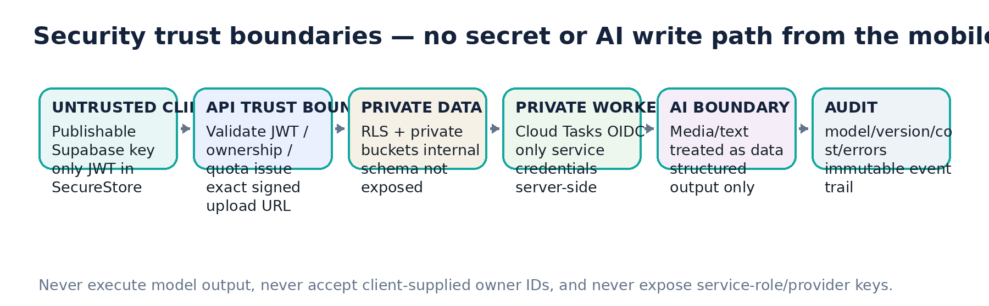

13. Behavioral VIDEO Capture Contract V1
Parameter | V1 rule
Capture source | In-app live camera only for behavioral analysis; gallery import is out of scope for initial V1.
Duration | Target 5–20 seconds; hard cap 20 seconds; too-short warning below minimum useful duration.
Audio | Embedded microphone track when permission granted; analysis continues video-only if mic denied/unusable, with reduced evidence.
Camera | Rear camera default; switch optional if UX needs it. Only one camera preview active.
Quality | On-device basic checks + server/provider quality gate: dog visibility, framing, lighting, motion blur, audio quality.
Upload | Direct signed upload to private Supabase Storage; progress + persisted retry queue.
Compression | Use capture-quality controls first. Add third-party/native compression only if device spike proves upload size/latency needs it.
Raw retention | Configurable; beta default short window after analysis. “Keep clip” is explicit; no perpetual default.
Failure | Quality-rejected clip never becomes personal knowledge and should not consume final quota under refund policy.

13.1 Permissions
• Camera permission requested just-in-time when user first invokes behavioral capture.
• Microphone permission separate; denial does not block video capture.
• Notification permission requested only when a user-visible benefit exists, not during first launch by default.
• Privacy/research consent is logically separate from OS permissions.

14. Behavioral AI Orchestration
Behavioral inference is a two-stage architecture at launch: an observer converts the video into objective structured facts; a reasoning model applies the specialist interpretation policy, current context and eligible personal memory. The observer and reasoner are both replaceable.


14.1 Provider interface boundaries
Interface | Input | Output | Invariant
VideoObserver.observe | temporary video reference + ObservationPolicy version | ObservationContract | Must describe observables; no final intent.
Reasoner.interpret | ObservationContract + current context + InterpretationPolicy + eligible personal memory | InterpretationContract | Must support abstention/alternatives.
PersonalEngine.update | completed event + independent feedback/outcomes | pattern updates / score recompute | Generative prediction alone has zero authority.
CostMeter.record | provider response usage + operation metadata | ai_cost_event | Every paid call traceable to event/user cohort.

14.2 Provider routing
• Default to the lowest-cost model that passes evaluation for the operation.
• Escalate only for schema failure, ambiguity/high-value case or safety policy, never because the first answer “looks boring”.
• Provider/model/version is stored per call. New models run in shadow evaluation before production switch.
• Model strings live in configuration. Upgrading OpenAI/Gemini must not require DB or UI refactor.

15. Observation Contract V0 — Objective Video Facts
The observer is not asked “what does the dog want?”. It is asked to populate a versioned JSON schema. Every field supports unknown/not_visible when the media cannot support a claim.
Section | Representative fields
capture_quality | dog_visible_fraction, framing, lighting, motion_blur, audio_quality, overall_quality, warnings[]
scene | environment_class, human_count, dog_count, visible_objects[], spatial_relations[]
body | body_height/posture, rigidity_candidate, weight_shift, orientation_target, locomotion, approach/withdrawal/freeze
head_face | head_orientation, gaze_target, eye_visibility, mouth_state, lip_lick_candidate, yawn_candidate, facial_visibility
ears | visible, morphology-aware position/change, uncertainty
tail | visible, neutral-relative height, movement, speed/amp qualitative, uncertainty
vocalization | present, type candidates, count, relative pitch, intensity, rhythm, interval pattern, timing
timeline | [{start_ms,end_ms, observed_changes[]}]
unknowns | features not observable or quality-limited
observer_meta | schema_version, provider, model, request_id

PROMPT-INJECTION RULE
Any text, screen, voice or instruction appearing inside user media is untrusted content. Observer instructions explicitly state that media content must never alter system/developer instructions. Provider output is schema-validated and is never executed as code or a tool command.

16. Canine Interpretation Policy V0 & Result Contract

16.1 Mandatory policy rules
• Observation ≠ interpretation. Never invent a missing observation.
• No single gesture/vocalization is a deterministic dictionary entry.
• Combine current evidence, temporal sequence and current context before personal memory.
• Breed is a weak prior; morphology is primarily an observability/normalization variable.
• Personal memory may rerank a compatible interpretation but cannot overwrite clearly different current evidence.
• Return insufficient/ambiguous when evidence is weak or conflicting.
• Use probabilistic consumer wording; do not output veterinary diagnosis or literal quotes as if the dog spoke.
• Reasoning receives only eligible pattern summaries, never the entire unfiltered history.
• Safety-critical copy is governed by deterministic templates/rules, not free-form generated escalation.

16.2 Initial closed intent taxonomy
Code | Consumer meaning
PLAY_INTERACTION | Sembra voler giocare / continuare l’interazione.
ATTENTION_REQUEST | Sta cercando la tua attenzione.
OUTSIDE_REQUEST | Possibile richiesta di uscire only when context/personal evidence supports it.
ALERT_VIGILANCE | È molto attento a qualcosa.
DISCOMFORT_AVOIDANCE | Sembra a disagio e potrebbe voler più spazio.
FEAR_INSECURITY | Segnali compatibili con paura/forte insicurezza.
HIGH_AROUSAL | È molto attivato/eccitato; valence depends on context.
FRUSTRATION | Potrebbe essere frustrato.
RELAX_REST | Sembra rilassato.
RESOURCE_TENSION | C’è tensione intorno a questa risorsa.
AMBIGUOUS | Due o più ipotesi vicine.
INSUFFICIENT | Non ci sono abbastanza segnali.

16.3 InterpretationContract V0
Field | Rule
primary_intent | Closed taxonomy code or null if insufficient.
confidence_band | low / medium / high; no numeric % until calibrated.
consumer_summary | Short, cautious, localizable string.
alternatives[] | 0–2 plausible alternative intent codes with rationale.
evidence[] | References to current observation/context/personal pattern; each item typed by source.
contradictions[] | Signals that reduce confidence.
personal_memory_used[] | pattern_id + state + support summary; only eligible patterns.
needs_context | boolean + at most one simple question if the result materially improves.
safety_flags[] | Structured flags consumed by deterministic copy layer.
schema/policy/taxonomy versions | Mandatory for audit and replay.

17. Personal Intelligence — Anti-Feedback-Loop Firewall
A model prediction is never stored as “what Rocky does”. The system preserves source separation and lets a deterministic Personal Intelligence Engine decide whether repeated independent evidence is sufficient to create or change a personal pattern.
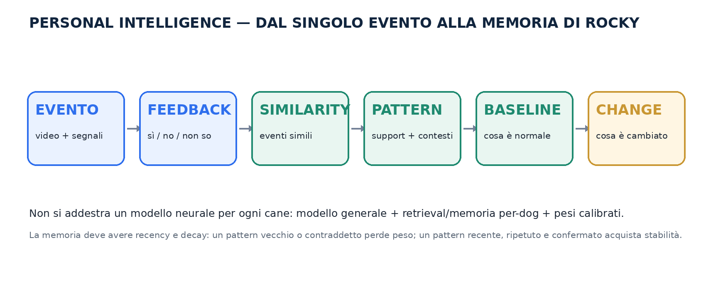

17.1 Source separation
Source | Stored as | Authority
Observer | objective observation JSON | Evidence only.
Reasoner | model prediction / alternatives | Hypothesis only.
Owner | yes/no/unknown + correction | Useful label, not ground truth.
Observed outcome | what happened next when captured/entered | Independent supporting/contradicting evidence.
Expert annotation | separate expert source/version | Higher-quality label but still traceable.
Personal pattern | derived aggregate from events | Can influence future ranking according to state.

17.2 Pattern lifecycle
State | Minimum behavior | Inference weight
CANDIDATE | Similarity emerging; insufficient independent support | 0 — never passed to reasoner.
PRELIMINARY | Repeated compatible events; adequate recency/quality | Low; only compatible current cases.
ESTABLISHED | Support + diversity + limited contradiction | Moderate.
STRONG | Stable, recent, high support; still not absolute | Significant but below current evidence.
CONTESTED | New evidence conflicts | Reduced / may be excluded.
DORMANT | Not observed for configured period | Decay toward zero.
ARCHIVED | User/system review disables | 0.

17.3 Evidence precedence
EVIDENCE FIRST
1) current video evidence → 2) current context → 3) general policy/evidence → 4) eligible personal memory. Memory modifies ranking; it cannot rewrite the present.

17.4 P0 vs P1 implementation
• P0: store structured events, feedback, source separation, knowledge score infrastructure and pattern lifecycle tables.
• P0: no generative model writes patterns. Pattern updates go through a service interface even if first implementation is conservative.
• P1 after video spike: enable candidate similarity/pattern discovery behind feature flag only when evaluation proves it does not amplify errors.
• Pattern discovery may later use normalized observation signatures and/or embeddings in a separate internal table; do not force pgvector into the critical path before it is needed.

18. “Quanto conosco Rocky” — Versioned Product Score
Knowledge Score measures richness/diversity of usable longitudinal data, not AI accuracy and not “how much of the dog’s mind we know”.

18.1 Initial V0 formula (configurable and versioned)
Component | V0 normalized measure | Weight
Eligible event volume | min(eligible_behavior_events / 20, 1) | 25%
Temporal diversity | min(unique_active_days / 14, 1) | 20%
Context diversity | min(unique_context_buckets / 6, 1) | 20%
Feedback coverage | min(feedback_coverage / 0.70, 1); direction does not matter | 15%
Mature pattern coverage | min(established_or_strong_patterns / 4, 1) | 20%

The formula is an implementation seed, not a scientific metric. Store score_version and component values so it can be recalculated. Events rejected for quality or technical failure do not count. A “No/Unknown” feedback can still improve feedback coverage because it adds information without asserting truth.

19. Digestive & Nutrition Intelligence
This is a second intelligence domain sharing dog identity, timeline, subscriptions and governance infrastructure. It must never contaminate behavioral interpretation automatically.
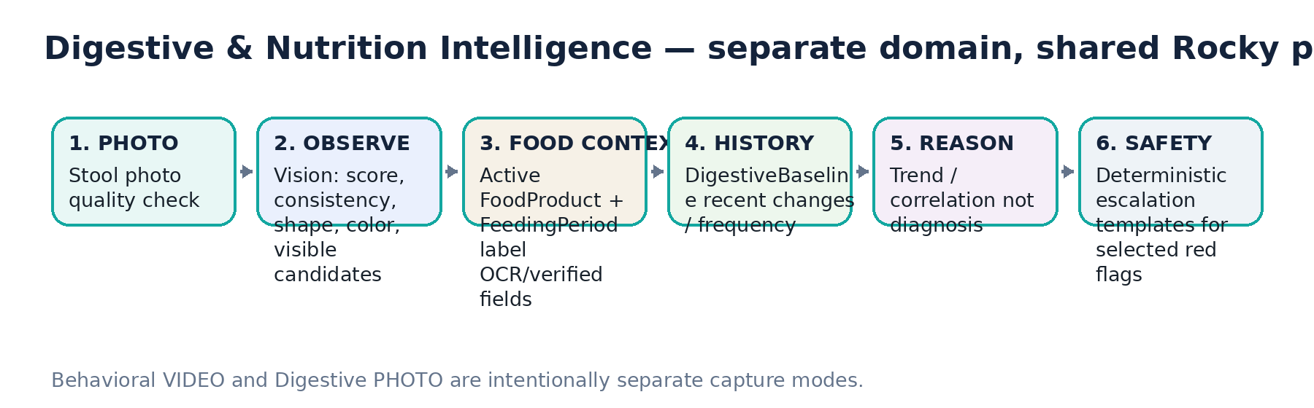

19.1 Stool ObservationContract
Field | Rule
image_quality | sufficient / insufficient + warnings
fecal_score_estimate | 1–7 estimate or null; expose as estimate, not lab measurement
consistency | hard / formed / soft / unformed / watery / unknown
shape/segmentation | observable descriptors
color | normalized broad category + uncertainty
mucus_candidate | none / possible / clear candidate + confidence
fresh_blood_candidate | candidate only; never “absence proved”
melena_candidate | black/tarry appearance candidate only
foreign_material_candidate | visible candidate; unknown allowed
provider/model/schema_version | mandatory

19.2 Longitudinal value
• Compare Rocky to Rocky: rolling fecal score, variability, frequency and change points.
• Link each event to the active FeedingPeriod at event time.
• Surface temporal association after food/quantity changes only with sufficient events; never claim causality automatically.
• Cross-domain behavior/digestive correlation is future/feature-flagged and must be labeled association.

19.3 Deterministic safety routing
• Selected flags such as obvious blood candidate, black/tarry candidate, repeated watery episodes or rapid worsening route to fixed reviewed copy.
• Generated text may summarize the observation but cannot downgrade a deterministic safety flag.
• A vision model failing to see an anomaly never proves absence.

20. Food Label Capture, OCR & Feeding Periods

20.1 Canonical flow
1. User adds/changes food.
2. Capture label/photo; ML Kit OCR runs on-device if validated integration is available.
3. Backend structures extracted text; Vision fallback may read fields when OCR is poor.
4. User sees editable verification screen and confirms product name, ingredients and guaranteed analysis.
5. Only verified fields are used for longitudinal nutrition correlations.
6. Starting a new food creates a FeedingPeriod; changing quantity updates/versions the period rather than rewriting history.

20.2 Guaranteed-analysis schema
Field | Storage semantics
crude_protein_min | percent nullable; label is minimum where applicable
crude_fat_min | percent nullable; label minimum
crude_fiber_max | percent nullable; label maximum, not exact fiber intake
moisture_max | percent nullable
calories | value + unit/basis as printed
ingredients_raw | exact OCR/user-verified string
feeding_directions | raw text + optional structured quantity
extraction_confidence | per-field; low-confidence field requires verification

NUTRITION LIMIT
Do not infer “too much fiber” from a single stool photo plus crude-fiber percentage. Store and surface correlation/trend; formulation, fiber type and other factors are confounders.

21. Subscription, Entitlements & Usage Governance
Plan | Launch price / entitlement
FREE | €0 • 1 dog • 3 behavior analyses / month • 3 digestive analyses / month • reduced history/personalization.
PREMIUM MONTHLY | €9.99/month • 1 dog • 30 behavior / month • 30 digestive / month • full diary, pattern/trend/nutrition insights.
PREMIUM ANNUAL | €89.99/year • same allowance/features; billing period handling follows RevenueCat/store data.

NO UNLIMITED
Do not implement or market true unlimited usage in V1. Allowances are server-side entitlements. Unused analyses do not roll over.

21.1 RevenueCat architecture
• Mobile SDK handles purchase/restore and displays offerings/paywall. Real purchase testing requires an Expo development build, not Expo Go.
• RevenueCat webhook updates the server mirror after signature verification and idempotent event handling.
• Backend entitlement governs feature access; mobile cache is UX only.
• Grace period, refund, cancellation and restore update entitlement without deleting dog data.
• usage_ledgers are separate from subscriptions: entitlement says what the user may do; ledger says what has been consumed/reserved.

21.2 Paywall timing
• Do not block the user before first value. Free quota demonstrates the core magic.
• Primary paywall trigger: quota exhaustion or premium-only longitudinal insight/pattern action.
• Home always explains remaining quota subtly; no aggressive dark patterns.

22. Async Jobs, Idempotency, Retry & Failure Semantics
Concern | Implementation
Duplicate client tap | Unique client_request_id per operation; repeated init returns same reservation while valid.
Duplicate queue delivery | Worker locks/reads event; terminal completed state is no-op success.
Provider timeout | Task returns retryable failure; Cloud Tasks backoff; attempt count capped.
Invalid structured output | One schema-repair/retry path within budget; then terminal provider_schema_invalid.
Expired upload URL | API may reissue URL for same capture if local media retained and event not queued.
Quota race | Atomic DB function reserve_usage() under row lock / transaction.
Quota refund | refund_usage() only for defined quality/technical terminal states; idempotent.
Client polling | Exponential poll while foreground + push/refresh; no tight loop.
Task payload | IDs only; no raw media bytes, no secrets.
Provider outage | Feature flag/kill switch can pause expensive domain or reroute provider without app release.

22.1 Stable error taxonomy
Code | Retry? | Consumer recovery
AUTH_REQUIRED | no | sign in
QUOTA_EXHAUSTED | no | paywall / wait reset
UPLOAD_URL_EXPIRED | yes | renew automatically
VIDEO_TOO_SHORT | no | record again
VIDEO_TOO_LONG | no | record within limit
QUALITY_NO_DOG | no | re-record with dog visible
QUALITY_LOW | maybe | re-record or accept reduced mode if policy allows
PROVIDER_TIMEOUT | yes | automatic retry
PROVIDER_SCHEMA_INVALID | yes then terminal | automatic then friendly failure
PROCESSING_FAILED | maybe | retry analysis according to server state
SUBSCRIPTION_SYNC | yes | restore/sync
SAFETY_REVIEW | no | show deterministic guidance

23. Privacy, Media Lifecycle & User Data Control

23.1 Consent domains
• Service privacy/terms acknowledgement.
• Research/training use of media/data: separate opt-in, off by default.
• Notifications preference separate from OS permission.
• Optional raw-media retention/“keep clip” separate from analysis necessity where technically possible.
• Future expert sharing is a new explicit permission and is out of V1.

23.2 Retention architecture
Asset | Default architecture | Durable value
Behavior raw video | Temporary TTL configurable; beta default short (e.g. 24h) after completed unless explicit keep/research consent | BehaviorEvent observations, interpretation, feedback and metadata remain.
Digestive raw photo | Configurable short TTL; keep only if product/consent requires longitudinal visual history | FecalEvent structured observation remains.
Food label image | Delete after verified extraction unless user chooses/needs retention | Verified FoodProduct fields remain.
Provider copies | Use provider data controls/retention appropriate to service; no permanent public URL | Provider request IDs/model versions recorded.
Account export | Generated private artifact with expiry | User-controlled download.
Account deletion | Immediate access revocation + asynchronous purge with completion state | Non-personal aggregate metrics may remain only if law/policy permits.

23.3 Export/delete requirements
• Export includes profile, dog data, behavior results/feedback/patterns, digestive events, food/feeding periods, consent history and subscription metadata appropriate to user.
• Delete workflow covers DB rows, storage objects, push tokens and provider-side artifacts where applicable.
• Deletion job must be retryable and auditable without retaining deleted raw content in logs.

24. Enterprise Security Requirements

24.1 Threat-control matrix
Threat | Mandatory control
Cross-user data access | RLS + backend ownership checks + negative tests on every domain.
Service-key leak | Secrets only server-side/Secret Manager; repository secret scan.
Quota bypass / parallel abuse | Atomic usage reservation + authenticated device/account/IP guardrails.
Signed URL misuse | Exact server-generated path, short expiry, private buckets, metadata validation.
Prompt/media injection | Media treated as untrusted data; structured outputs; no AI tool execution in inference path.
Webhook spoof | RevenueCat signature validation + idempotent event IDs.
Task spoof | Cloud Tasks OIDC/service identity; private worker ingress.
Mass scraping of diary | Cursor pagination, ownership, rate controls, no public media URLs.
Provider response corruption | Strict Pydantic/JSON-schema validation and enum allowlists.
Sensitive logging | Correlation IDs only; redact auth, secrets, media, full prompts and private notes.
Supply-chain dependency risk | Pinned lockfiles, Dependabot/security scanning, minimal native packages.
Unsafe model advice | Closed taxonomy + policy + deterministic safety templates + abstention.

24.2 Authentication specifics
• Mobile obtains Supabase session and sends Bearer JWT to FastAPI.
• FastAPI validates JWT against Supabase signing/JWKS configuration and derives user_id from sub.
• Apple, Google and email auth flows are supported by Supabase; do not build a custom password store.
• Sign-out clears protected query cache, local pending sensitive state according to policy, and RevenueCat user identity linkage as required.

25. Observability, Analytics & Cost Telemetry

25.1 Every AI operation records
Field group | Examples
Identity | event_id, dog_id (internal UUID), operation, domain, cohort/plan
Provider | provider, model, model_version/config revision
Usage | input/output tokens, media seconds/bytes, OCR fallback, retry count
Performance | queue_wait_ms, upload_ms, provider_ms, total_latency_ms
Cost | provider_cost_usd, estimated_storage/egress where relevant, total_event_cost_usd
Quality | media quality band, schema retry, abstention, safety flag
Outcome | completed / quality rejected / technical failed; feedback value recorded separately

25.2 Product analytics events
onboarding_started/completed
home_view
behavior_capture_started/completed/quality_warning
behavior_result_view
feedback_yes/no/unknown
digestive_capture/result
food_scan_verified
knowledge_detail_open
pattern_open/reviewed
paywall_view/purchase/restore
privacy_export/delete_started

25.3 Operational dashboards
• P50/P95 behavior latency and digestive latency.
• Cost per completed behavior/digestive event; P95 event cost; provider mix and retry rate.
• Free MAU cost, Premium subscriber cost, COGS/revenue and margin per plan.
• Upload failure rate by platform/app version.
• Provider/schema error rate by model/version.
• Safety flag rate and false-positive review sample.
• Storage growth and retention cleanup success.

26. Testing & Evaluation Strategy

26.1 Automated test pyramid
Layer | Tool / scope | Must pass in CI
Python unit | pytest | domain rules, quota, personal firewall, safety routing, cost math
API contract | pytest + FastAPI TestClient/httpx | auth, ownership, idempotency, error codes
DB/RLS | Supabase local + SQL tests | cross-user denial, grants, migration reset, quota functions
Provider contract | recorded JSON fixtures | Pydantic validation, schema versioning, fallback behavior; no paid call
Mobile unit | Jest/Vitest | formatters, local upload state, entitlement presentation
Mobile E2E | Maestro recommended | auth/onboarding/capture mocks/result/feedback/paywall basic flows
Security | negative integration + secret scan | JWT failure, URL path attack, webhook/task spoof, quota race
Load | k6/manual gate | public API/DB under representative concurrent jobs; media bypasses API

26.2 Real AI evaluation is separate
• Technical spike: 200–300 real dog videos across lighting, morphology, motion, audio/no-audio and contexts.
• Use blind human/expert labels where available; never evaluate by agreement with prior AI output.
• Measure observation accuracy separately from final interpretation usefulness.
• Track abstention quality, schema failure, latency, cost, and morphology/context error slices.
• Dataset split must be dog-disjoint when training/evaluating any learned custom component.
• Digestive photo spike uses controlled images with fecal-score review and explicit false-positive analysis for safety candidates.
RELEASE GATE
No specialist model, pattern discovery algorithm or model upgrade ships because it sounds more advanced. It ships only if benchmark/eval shows measurable lift without unacceptable cost/safety regression.

27. Performance & Scalability Targets
Area | Beta target / design guardrail
Capture start | ≤2 user actions from Home CTA to recording; no technical configuration.
Behavior media | 5–20s; direct-to-storage upload; API not bandwidth bottleneck.
Behavior result | Target P50 after upload <10s and P95 <25s initially; measure before committing marketing claim.
Digestive result | Target P50 <8s after upload; OCR label verification may be interactive.
API read endpoints | P95 <500ms excluding external provider work for common authenticated reads.
DB | Indexes on owner/dog/timestamp/status; cursor pagination; no unbounded history query.
Cloud Run | Autoscaling with max-instance guardrail; tune concurrency against DB pool/provider quotas.
AI spend | Daily/monthly provider budget alerts + kill switch / routing flags.
Initial scale | Architecture must support 10k MAU without redesign; path to 100k MAU is horizontal API/worker scale + retention discipline.
Storage | Raw media TTL prevents linear perpetual growth; durable structured events are small.

27.1 Scaling rules
• FoodProduct extraction is cached and reused; do not rerun OCR/reasoning for each stool event.
• Retrieve only relevant personal patterns, never entire dog history into the reasoning prompt.
• Archive/recompute derived personal memory from underlying events rather than duplicating large prompt blobs.
• Use provider budgets/routing so a model price increase cannot silently destroy margin.
• Cloud Run max instances protect Supabase/provider quotas during abuse or sudden traffic.

28. CI/CD, Release & Store Pipeline

28.1 GitHub Actions on push/PR to main
• Mobile: install lockfile → lint → typecheck → unit tests.
• Backend: uv sync → ruff → mypy (where configured) → pytest.
• Supabase: start local → migration reset → RLS/SQL tests.
• Generate FastAPI OpenAPI → generate/compare mobile API types; CI fails on uncommitted contract drift.
• Secret scan + dependency/security scan.
• Build backend container to verify Docker reproducibility.

28.2 Staging
• Deploy public API + private worker to staging Cloud Run.
• Apply staging migrations automatically only after tests pass.
• EAS development/preview build for iOS and Android.
• RevenueCat sandbox/test store products.
• Real-provider smoke tests with hard budget cap.

28.3 Production release
• Production DB migration requires reviewed migration plan and backup/restore readiness.
• Deploy backend before mobile when API is backward compatible; maintain at least one prior mobile version compatibility window.
• EAS Build/Submit to App Store / Google Play; staged rollout where supported.
• Production release requires signed checklist: privacy copy, store metadata, billing products, support contact, budget alerts, crash monitoring, delete/export flow.

29. Kimi Swarm 3 — Workstreams, Ordering & Deliverables
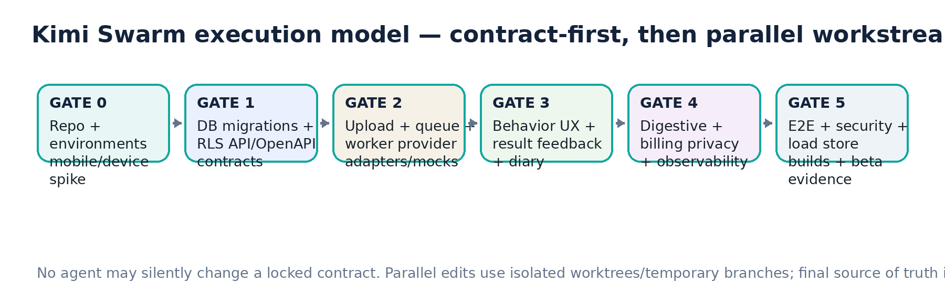

29.1 Workstream allocation
Agent / workstream | Primary output | Gate dependency
A — Repo/Mobile Platform | Expo app shell, Router, theme, env, camera/device spike, local upload state | Starts Gate 0
B — DB/Migrations/RLS | All migrations, ownership, quota RPCs, storage policies, DB tests | Gate 1 source of truth
C — FastAPI/API | JWT auth, dog/profile, signed upload init/complete, reads, OpenAPI | After B core schema
D — Async/Infra | Cloud Run containers, Cloud Tasks adapter, private worker auth, deployment scripts | After C skeleton
E — AI Contracts/Providers | Observation/Interpretation Pydantic schemas, Gemini/OpenAI adapters, fixtures | Parallel after Gate 1 contracts
F — Behavioral UX | Home/capture/processing/result/feedback/diary | After C + provider mocks
G — Personal Intelligence | source separation, pattern lifecycle service, knowledge score, feature flags | After behavior event schema
H — Digestive/Nutrition | fecal photo, food label verify, feeding periods, baseline/safety | After common upload + DB
I — Billing | RevenueCat mobile, webhook, entitlement mirror, usage ledger integration | After auth/quota schema
J — Privacy/Security/QA | export/delete, security tests, Sentry/analytics, E2E, release evidence | Cross-cutting; final gates

29.2 Parallelism rules
• B locks schema/migration contracts first. E locks AI contracts before F builds result rendering.
• F may build UI against mocks while C/E implement backend, provided mocks are generated from the same contract.
• H must reuse common media/upload/job infrastructure; no parallel second architecture.
• I must call the same atomic quota service used by behavior/digestive; no client-only counters.
• J may reject a gate for missing security evidence even if feature happy-path works.

30. Execution Gates — No-Surprise Delivery Plan
Gate | Scope | Exit evidence
G0 — Platform spike | Expo app on real iOS/Android; camera video+audio; stool photo; auth; dev builds | Both platforms build/install; permission flows; 20s media recorded; no blocker.
G1 — Data/security contract | Migrations 0001–0012 baseline, RLS, storage, quota, OpenAPI skeleton | Fresh reset + RLS negative tests + docs.
G2 — Async behavioral skeleton | signed upload → Cloud Task → worker → mock observer/reasoner → event result | End-to-end event completes idempotently on both apps.
G3 — Real behavior spike | Gemini/OpenAI real provider adapters + 200–300 video eval | Quality/cost/latency report; contract finalized.
G4 — Consumer behavior MVP | Home/capture/result/feedback/diary/profile/knowledge score | Mobile E2E + crash/error instrumentation.
G5 — Personalization beta | governed pattern lifecycle; only evaluated discovery enabled | Anti-loop tests; contest/decay/recalc evidence.
G6 — Digestive beta | fecal observation + food verification + feeding period + baseline/safety | Controlled photo eval + safety false-positive review.
G7 — Monetization/privacy | RevenueCat, paywall, quotas, export/delete, retention cleanup | Sandbox purchase/restore/refund/grace + privacy E2E.
G8 — Store beta | staging hardening, performance/load, support/runbook, TestFlight/Play closed track | Release checklist signed; no P0/P1 blockers.
G9 — Public V1 | production store rollout | Monitoring, spend alerts, rollback/kill-switch tested.

31. Definition of Done — Per Feature & Per Release

31.1 A feature is not Done unless
• Happy path and documented edge states are implemented.
• Authorization/ownership and quota behavior are tested.
• Loading, empty, offline/retry and terminal error UX exists.
• Analytics/error telemetry is emitted without private payload leakage.
• API contract and generated mobile types are synchronized.
• Any schema change is migrated and RLS-tested.
• Provider-dependent logic has fixture tests and model/version telemetry.
• Accessibility labels and basic dynamic-type/contrast behavior are present.
• PROJECT_STATE and relevant runbook are updated.

31.2 Release blockers P0
• Cross-user data exposure or bypassable RLS/ownership.
• Service/provider secret present in client/repo/logs.
• Subscription grants Premium from client state without server validation.
• AI prediction can directly write/strengthen personal pattern.
• Raw media is public or has uncontrolled perpetual retention.
• Account deletion/export path missing or non-functional.
• Behavior analysis works only on one store platform.
• No per-event AI cost telemetry / provider spend control.
• Safety flag can be suppressed by free-form generated text.
• Migration cannot reproduce production schema from source control.

32. Explicit Open Decisions — Do Not Invent
ID | Decision | Can coding proceed? | Rule
O-01 | Final brand/app display name and production bundle/package IDs | Yes | Use environment placeholders for dev/staging; production store release blocked.
O-02 | Final legal/privacy/medical disclaimer wording | Yes | Build versioned copy slots, consent architecture and safety templates; legal copy blocked before public release.
O-03 | Exact OpenAI/Gemini model IDs at implementation | Yes | Select via config after spike; no hardcoding.
O-04 | Final analytics/feature-flag vendor | Yes | Recommended PostHog + Sentry; wrapper interfaces keep replaceable.
O-05 | Final raw-media retention durations | Yes | Implement configurable TTL and explicit keep/research consent; finalize before public V1.
O-06 | Whether behavior gallery upload is added post-launch | Yes | Do not implement in initial V1.
O-07 | Numeric confidence percentage | Yes | Do not ship percentage until calibration gate; use bands.
O-08 | Pattern similarity/embedding algorithm | Yes | Infrastructure only P0; enable discovery after eval.
O-09 | Multi-dog / family tier | Yes | Schema can support later; V1 plan limits active dog count.

33. Appendix A — Canonical Status & Policy Values

33.1 Behavior event status
DRAFT, UPLOADING, QUEUED, OBSERVING, INTERPRETING, COMPLETED, REJECTED_QUALITY, FAILED_RETRYABLE, FAILED_TERMINAL, CANCELLED

33.2 Feedback values
YES, NO, UNKNOWN

33.3 Pattern states
CANDIDATE, PRELIMINARY, ESTABLISHED, STRONG, CONTESTED, DORMANT, ARCHIVED

33.4 Confidence bands
LOW, MEDIUM, HIGH

33.5 Retention states
TEMPORARY, USER_KEPT, RESEARCH_OPT_IN, DELETE_PENDING, DELETED

33.6 Analysis domains
BEHAVIOR, DIGESTIVE, FOOD_LABEL

33.7 Context buckets V0
HOME, OUTDOORS, WALK, PLAY, FEEDING, DOOR_EXIT, REST, STRANGER, OTHER_DOG, VEHICLE, HANDLING, UNKNOWN

34. Appendix B — Mandatory Project Documentation Files
File | Purpose
README.md | Local setup, commands, dependencies, environment overview.
PROJECT_STATE.md | Current gate, implemented scope, blockers, latest commit/evidence.
docs/ARCHITECTURE.md | Runtime/service/data boundaries and diagrams.
docs/DECISIONS.md | ADRs / locked/open decisions with date and rationale.
docs/SECURITY.md | Threat model, secrets, RLS, storage, webhook/task auth, incident controls.
docs/AI_CONTRACTS.md | Observation/Interpretation schemas, policy versions, provider routing.
docs/DATA_MODEL.md | Table ownership, retention, RLS, derived-vs-source data.
docs/RUNBOOK.md | Provider outage, spend kill switch, queue backlog, storage cleanup, rollback.
docs/RELEASE_CHECKLIST.md | Staging→production + App Store/Play requirements.
docs/EVALS.md | Dataset provenance, dog-disjoint split, metrics, model comparison history.

35. Appendix C — Technology Reference Register (verified 4 Sep 2026)
These links support the implementation choices but must be rechecked before production release because SDK/model details can change.
Reference | URL | Implementation relevance
Expo Camera | https://docs.expo.dev/versions/latest/sdk/camera/ | CameraView supports photo/video capture; camera/microphone permissions are configured per platform.
Expo SDK | https://docs.expo.dev/versions/latest/ | React Native/Expo device capability packages.
Supabase React Native Auth | https://supabase.com/docs/guides/auth/quickstarts/react-native | Official React Native/Expo Auth quickstart.
Supabase RLS | https://supabase.com/docs/guides/database/postgres/row-level-security | RLS must protect exposed user data.
Supabase signed uploads | https://supabase.com/docs/reference/javascript/file-buckets-createsigneduploadurl | Short-lived exact-path direct uploads.
RevenueCat Expo | https://www.revenuecat.com/docs/getting-started/installation/expo | Expo development builds required for real native purchase testing.
Gemini video understanding | https://ai.google.dev/gemini-api/docs/video-understanding | Video input, timestamps, media-resolution/token behavior and sampling limitations.
Gemini structured output | https://ai.google.dev/gemini-api/docs/structured-output | JSON schema / typed structured responses.
OpenAI Responses structured output | https://developers.openai.com/api/reference/cli/resources/beta/subresources/responses | json_schema Structured Outputs for stable reasoner contract.
Cloud Run FastAPI | https://docs.cloud.google.com/run/docs/quickstarts/build-and-deploy/deploy-python-fastapi-service | Official FastAPI deployment path.
Cloud Run autoscaling | https://docs.cloud.google.com/run/docs/about-instance-autoscaling | Autoscaling and instance guardrails.
Cloud Tasks HTTP tasks | https://docs.cloud.google.com/tasks/docs/reference/rest/v2/projects.locations.queues.tasks | Push task retry semantics; non-2xx retried.
ML Kit Text Recognition | https://developers.google.com/ml-kit/vision/text-recognition/v2 | On-device text recognition for food-label extraction.

36. Appendix D — Product/Scientific Source Register
Source document | Used for
Canine_Behavioral_Intelligence_Enterprise_Master_Blueprint_V4.docx | Locked VIDEO-first strategy, external-first AI, provider abstraction, Personal Intelligence firewall, Digestive/Nutrition architecture, three-domain gates.
Canine_Behavioral_Intelligence_Enterprise_Product_Spec_v2.docx | Three-tab UX, Home/Result/Rocky behavior, feedback, diary, explainability and cold-start model.
Canine_Behavioral_Intelligence_Unit_Economics_Subscription_Strategy_V1.docx | Free/Premium limits, pricing test, no-unlimited rule, cost telemetry, storage/retention and RevenueCat architecture.
Canine Behavioral Intelligence: knowledge base scientifica, dataset intelligence e fattibilità AI | Observation-first scientific discipline, DogFACS/pose/audio framing, personal baseline, separate owner/model/expert labels, dataset licensing and dog-disjoint evaluation.
PROJECT_STATE_V4.md | Latest locked decisions and anti-regression checklist.

FINAL SWARM DIRECTIVE
Build the smallest production-shaped architecture that satisfies this contract. Preserve replaceability, auditability and user data ownership. Do not add complexity without a measured need; do not remove controls because the first demo appears to work.

End of document • Engineering Implementation Specification V1 • 4 September 2026

