Attila Pinter
Kantonsschule im Lee Winterthur
Maturitätsarbeit HS 2025/26
Developing a playable simulation of markets and corporations
Attila Pinter, 4a
Patrik Hnilicka
2025-10-26

Motivation
During Economy Week (Deutsch: Wirtschaftwoche), as an exercise in business administration, we played a game, where you were the board of a company manufacturing some arbitrary product and had to make decisions to increase sales, lower cost and generally beat out you competition. For me, the aspect of being able to come up with novel management ideas and compete with your friends really hooked me into the concept. This may sound hyperbolic, but during that week I genuinely woke up exited to go to school, not to actually learn stuff (and whatever) but just to play a few more rounds and (aspirationally) completely destroy my competition.
The game we got to play during Economy Week, in my opinion, had a tantalising hook but the interface was utterly hostile to non-directed interaction: it was pretty much an excel table! Anyway, I set off to make a better, deeper version of this simulation.
“We do this not because it is easy, but because we thought it would be easy”
Not JFK.
This is the running motto of this project.

Concept and Design
The concept behind the game was originally to create a game where the company creates and runs a company that manufactures and sells a product while competing with there friends. Imagine a sort of Civilisation for digital entrepreneurs.
The most important part of the game is that you, as a player, have to balance many internal and external factors: production costs, consumer demands, labour unions, economic downturns and, most importantly, competition.
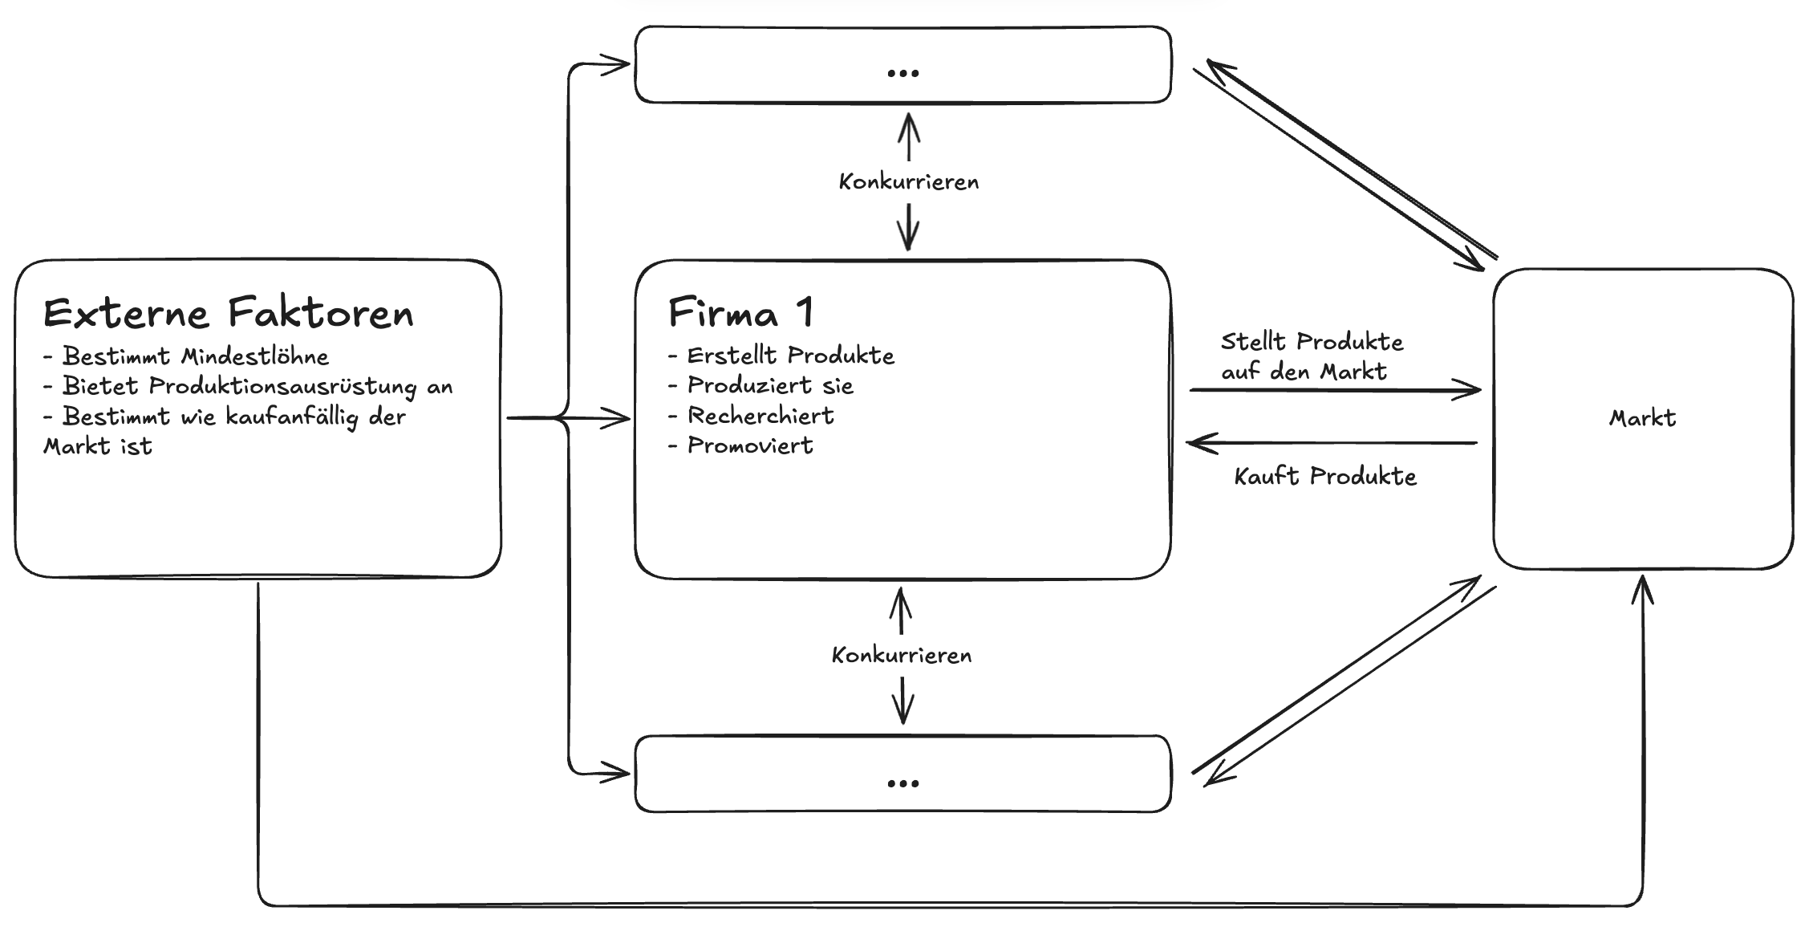
Diagram of factors influencing the player’s decisions

Design
The game would work in 2 phases: the decisions phase and the simulation phase.
During the decisions phase the player would set the values for various decisions like how many production machines they choose to buy. Just like the what we played during Economy Week, the interface was a thinly veiled Excel table.
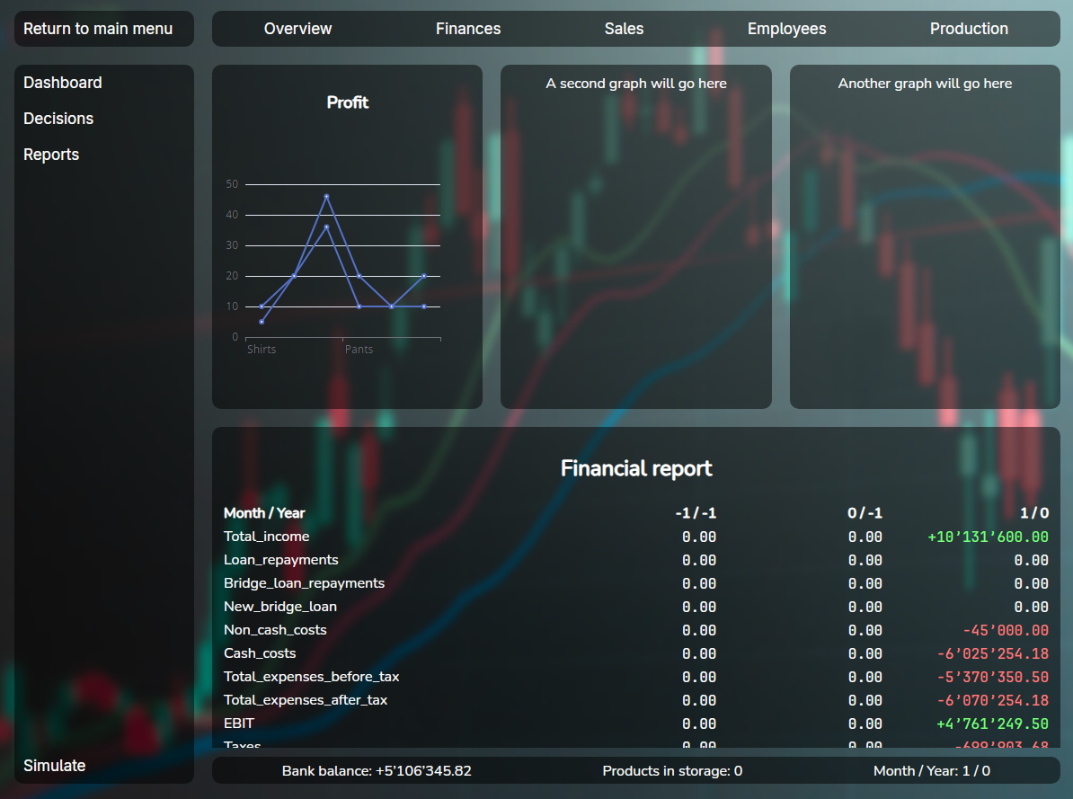
The first UI I made for the game
After trying to "play" this for a few minutes I simply thought to myself: "This can’t be fun, let alone would anyone care show this to their friends!", and so I gave myself a new blank canvas and actually tried thinking about what I wanted to make.

Mechanics

Technology

Iteration

Economic Simulation
When attempting to simulate a consumer market, there are quite a few approaches you could choose between. The vast majority of models fall into 2 categories:
- Statistical models: models where the simulation uses regressions and other statistical analysis tools to determine outcomes.
- Agent-based models: these models choose to, instead of simulating the whole market at once, instantiate individual agents that have the ability to independently make decisions.
There are 2 main advantages to statistical models: they are simpler to build, as you can often base them around simple regressions while still returning convincing results, and performance, unless the implementer makes grave mistakes, statistical models almost always outperform (in terms of speed) agent-based models of the same caliber.
For example, the cult classic city builder SimCity 4 was able to simulate regions with populations up to 100 million with very minor performance issues, while over 20 years later, games like Cities: Skylines 2 are still plagued by performance issues from simulating just 100’000 agents on modern multi-core hardware.
The biggest downside of statistical modelling for this project is flexibility. An agent-based model can simulate virtually anything, should the designer choose to, without necessarily major changes. This was the deciding factor for me, as the development of the game would take time, during which I would inevitably want to rework aspects of the simulation to optimise certain aspects.

The Market

The customers
The customer is simulated as a bundle of different characteristics, preferences, and needs; these all combine to produce unique behaviors for each individual agent. Taking inspiration from Economy Week, each customer has the following properties:
Property | Type | Description
Base Need | Number | The amount of products a customer wants. When their existing products wear out, they buy more.
Owned Products | List[number] | Keeps track of the remaining durability of owned products.
Purchasing Threshold | Number | How attractive a product has to be for the customer to buy it.
Savviness | Number | How well informed the customer is.
Loyalties | List[number] | How loyal the customer is to a certain company.
Loyalty Factor | Number | How much the customer’s loyalties influence their
Preferences | Dictionary[number] | Which aspects of a product impact the customer’s decisions the most. For example, a customer could value low prices more than they do the quality of the product.
Originally the preferences were determined by sampling a weighted normal distribution; however, after some playtesting and reading The Tipping Point by Malcom Gladwell, I reworked the generation of customers by instead creating archetypes and slightly modifying their preferences randomly.
Each of the archetypes has some preferences boosted and others diminished. For example, "the enthusiast" will not shy away from buying an expensive product, even multiple, if they perceive it to be unique and high quality. On the other hand, "the Everyman" will prefer a simpler, cheaper, long-lasting product.
archetypes have not yet been fleshed out

The Companies
During the decisions phase, companies were able to develop products and set up production chains. Now the products made by companies are put on the market along with corresponding marketing campaigns.

External Factors
Since the simulation is limited to the customers and products, external factors are able to add extra challenge and variety to the game. There are external factors that influence, for example, how easily people will spend money, resembling the credit cycle experienced in real life, where after a period of high consumer spending there is a period of low spending while consumers save back up and pay off loans.

The Marketing Phase
In this phase, the marketing campaigns of companies are simulated. Each marketing campaign has a style, a quality and a quantity.
The style is determined by the player, which can influence the perception of the product. This can be used to round out the less attractive parts of the product. For example, if a player had a high quality product that they wanted to market to a more eco-focused audience, instead of having to undertake the difficult and expensive process of actually producing in an environmentally friendly manner, they can just focus on promoting the product as eco-friendly.
The quality of a campaign influences how much the perception of the product is changed. This is mostly determined by the skill and motivation of the companies marketing staff.
Lastly, the quantity of a campaign, expressed in a monetary amount, determines who even sees the campaign. A high quantity of marketing means there is a high chance that people know about a product. A campaign could theoretically be extremely effective, however if no-one sees it, it isn’t actually successful since there are still few people who even know about the product’s existence.
All of these factors are mixed in with each customer’s "savviness" stat. People with more savviness are generally more informed on a market and thus have a higher chance of knowing about a product, however they are also less effected by marketing and thus perceive it more objectively. Other people with lower savviness will easily be swayed by effective marketing.

The Purchasing Phase
After the effects of marketing are evaluated, if the customer needs a product, it will evaluate the dot product of its preferences and the product’s properties (the decision factors) for each product.
$$\text{decision factors}=\left(\begin{matrix}\text{ quality } \\ ... \\ \text{ durability }\end{matrix}\right)⋅\left(\begin{matrix}\text{ quality preference } \\ ... \\ \text{ durability preference }\end{matrix}\right)$$
The customer then checks if the product is still available; if so, they try to buy enough to fulfill their needs.

Actually making it fun

This Kotaku article from 2014 shows off a city of over 100 million inhabitants, the Guinness world record, without any performance problems. Link to article: https://kotaku.com/simcity-megacity-has-over-100-000-000-million-people-li-1629131314; World record: https://www.guinnessworldrecords.com/world-records/418977-largest-simcity-4-city-region
The names provided the table may not be accurate to the corresponding implementations found in the code to simplify the explanation, as the implementation contains subtle differences for performance and technological reasons.
This technique is often labelled as Greenwashing. The most famous example is Volkswagen’s "clean diesel" emissions scandal in 2015 where Volkswagen programmed diesel engined cars to run efficiently when they were being tested while reverting to "dirty" operation when driven on the road. Further reading: https://en.wikipedia.org/wiki/Volkswagen_emissions_scandal

